Earthworm gut microbiome promotes biodegradation of albendazole in soil
Jiao Wang¹, Hongnuo Ge¹, Yinuo Liu¹, Chenyu Huang¹, Luqing Zhang¹, Yunlong Yu¹, Lihui Xu^{2*}, Hua Fang ^{1*}

¹ Zhejiang Key Laboratory of Biology and Ecological Regulation of Crop Pathogens and Insects, Ministry of Agriculture and Rural Affairs Key Laboratory of Molecular Biology of Crop Pathogens and Insect Pests, Zhejiang Engineering Research Center for Biological Control of Crop Pathogens and Insect Pests, Institute of Pesticide and Environmental Toxicology, College of Agriculture and Biotechnology, Zhejiang University, Hangzhou, China
² Institute of Eco-Environmental Protection, Shanghai Academy of Agricultural Sciences,
Shanghai, China

*Corresponding author
E-mail address: xulihui@saas.sh.cn (L. Xu); agri@zju.edu.cn (H. Fang)

Contents
Supplementary Tables
Table S1. Physiochemical properties of the collected soils
Table S2. Information of contigs and ORFs
Table S3. Composition of albendazole degradation genes database
Supplementary Figures
Fig. S1. Degradation dynamics ALB in different treated soils
Fig. S2. Heatmap of the abundance of functional enzyme genes among different treatments. based on common logarithmic transformed abundance in the soil.
Fig. S3. The increased relative abundance of functional enzyme genes in the earthworm gut under different treatments
Fig. S4. Linear-regression analysis between the relative abundance of ADGs and MGEs in the earthworm
Fig. S5. Proportions of BDGs located in chromosome and plasmid in the earthworm gut under different treatments
Fig. S6. The mapping relationship between BDGs and MGEs in the E-CK samples. The bars on the inner ring represents the co-occurrence of BDGs and MGEs on BCCs
Fig. S7. The co-occurrence arrangements of ARGs and MGEs on the contigs among different treatments
Fig. S8. Shifts of soil microbiome among different treatments
Fig. S9. Heatmap of the dominant bacterial genus (Top 50) based on the common logarithm of relative abundance in the earthworm gut
Fig. S10. Bacterial Shann on index in the earthworm gut among different treatments
Fig. S11. PCOA plot of earthworm gut microbiome in the different treatments
Fig. S12. Visualization based on the relative abundance and taxonomic assignment of the recovered MAGs carrying ADGs
Fig. S13. Relative abundance of BDG-carrying bacteria genera based on the recovered MAGs in the E-CK samples (a); relative abundance of ADG-carrying bacteria genera based on the recovered MAGs in the earthworm gut (b)

Total:
Supplementary Tables: 3
Supplementary Figures: 13
Supplementary Tables
Table S1. Physiochemical properties of the collected soils.
Soil type | pH | OM  (%) | Total N  (%) | Hydrolytic N (%) | Total P (%) | EP  (%) | CEC  (cmol/kg) | pH
Silty loam | 8.29 | 8.01 | 0.052 | 61.3 | 0.032 | 17.3 | 9.1 | 8.29
*OM, organic matter, Total N, total nitrogen, Total P, total phosphorus, EP, Effective phosphorous, CEC, cation exchange capacity.
Table S2. Information of contigs and ORFs.
Treatment | Raw reads | Clean reads | Contigs | N50
S-ALB-1 | 68,549,692 | 58,328,206 | 313,321 | 902
S-ALB-2 | 67,014,190 | 57,281,284 | 329,240 | 856
S-ALB-3 | 72,707,352 | 62,071,600 | 346,421 | 886
S-ZnO-1 | 68,595,744 | 59,150,484 | 346,466 | 891
S-ZnO-2 | 68,765,136 | 59,372,678 | 349,589 | 828
S-ZnO-3 | 69,102,604 | 63,373,768 | 422,797 | 873
S-ALB-ZnO-1 | 66,769,008 | 61,315,846 | 372,708 | 891
S-ALB-ZnO-2 | 72,134,286 | 65,941,356 | 402,005 | 858
S-ALB-ZnO-3 | 67,181,830 | 61,568,930 | 389,528 | 858
S-CK-1 | 82,403,762 | 70,398,934 | 444,653 | 889
S-CK-2 | 92,680,904 | 79,300,662 | 489,801 | 851
S-CK-3 | 66,325,112 | 56,372,602 | 292,129 | 903
E-ALB-1 | 77,025,792 | 71,509,048 | 301,504 | 967
E-ALB-2 | 76,334,258 | 63,342,908 | 277,578 | 1,586
E-ALB-3 | 69,471,168 | 62,115,396 | 361,083 | 1,419
E-ZnO-1 | 97,197,862 | 88,964,408 | 486,583 | 1,102
E-ZnO-2 | 72,835,722 | 66,523,692 | 284,298 | 1,316
E-ZnO-3 | 70,508,422 | 64,296,696 | 170,779 | 1,841
E-ALB-ZnO-1 | 68,514,872 | 61,819,418 | 332,279 | 1,234
E-ALB-ZnO-2 | 77,087,242 | 70,406,424 | 248,295 | 1,311
E-ALB-ZnO-3 | 70,394,132 | 63,175,780 | 335,776 | 1,221
E-CK-1 | 77,552,136 | 70,393,118 | 350,092 | 1,103
E-CK-2 | 68,527,838 | 69,863,474 | 349,016 | 1,094
E-CK-3 | 68,377,872 | 63,277,424 | 323,572 | 1,318

Table S3 Composition of albendazole degradation genes database.
Degradation pathway | Gene | Enzyme | Protein number
Albendazole → Albendazole S-oxide | mno | monooxygenase | 1,381,437
Albendazole S-oxide → Albendazole sulfone | mno | monooxygenase | 1,381,437
Albendazole sulfone → Albendazole-gamma-hydroxysulphone | mno | monooxygenase | 1,381,437
Albendazole sulfone → Albendazole-beta-hydroxysulphone | mno | monooxygenase | 1,381,437
Albendazole sulfone → Albendazole-2-aminosulfone | ami | aminotransferases | 218
Albendazole →Hydroxyalbendazole | hmr | hemoprotein reductase | 32,286

Supplementary Figures
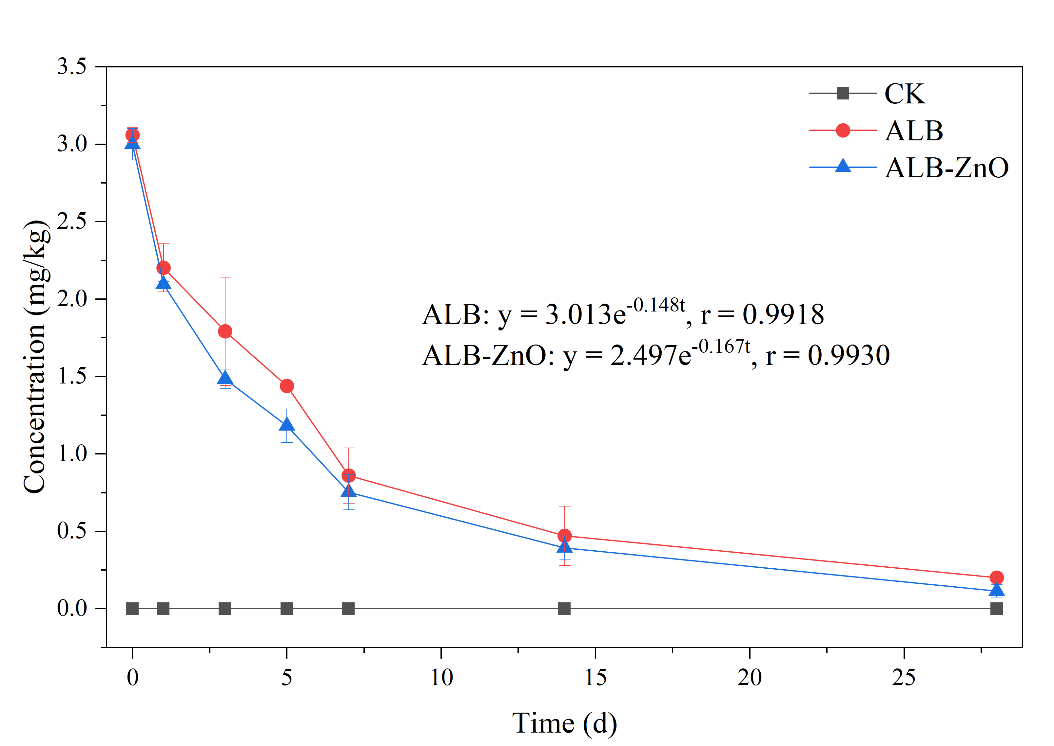
Fig. S1. Degradation dynamics ALB in different treated soils.

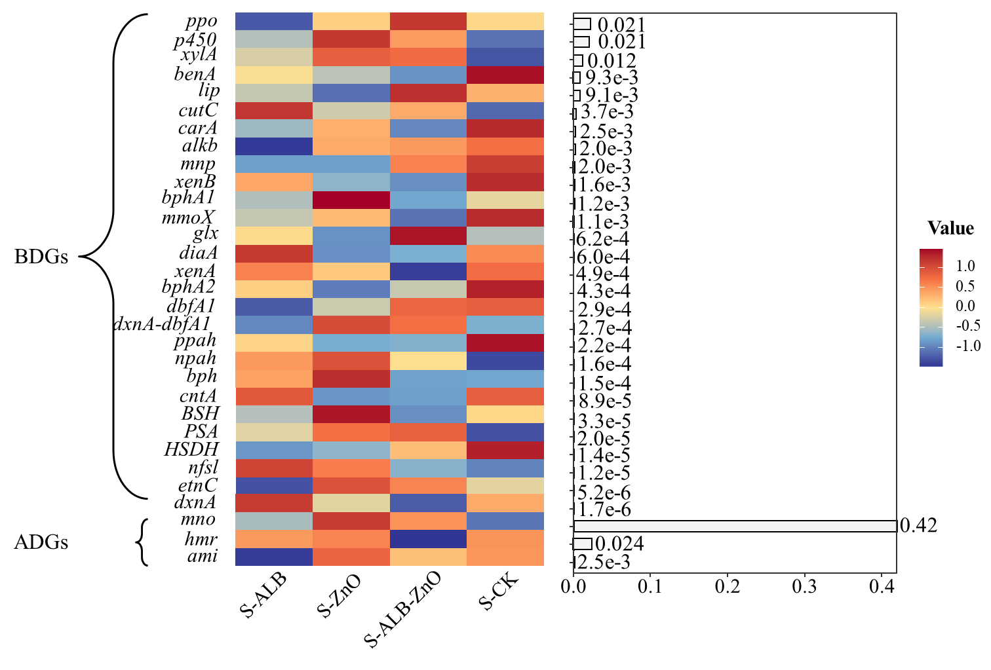
Fig. S2. Heatmap of the abundance of functional enzyme genes among different treatments. based on common logarithmic transformed abundance in the soil.
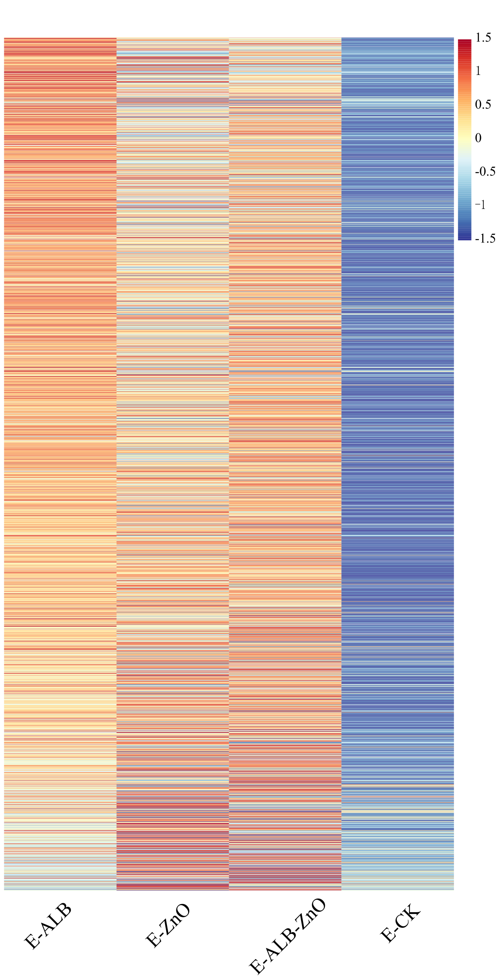
Fig. S3. The increased relative abundance of functional enzyme genes in the earthworm gut under different treatments.

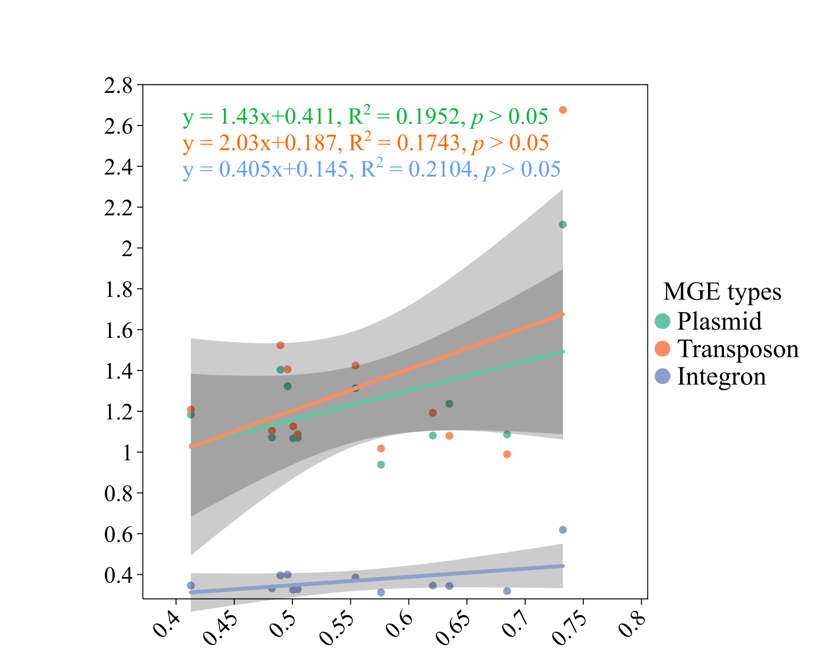
Fig. S4. Linear-regression analysis between the relative abundance of ADGs and MGEs in the earthworm.

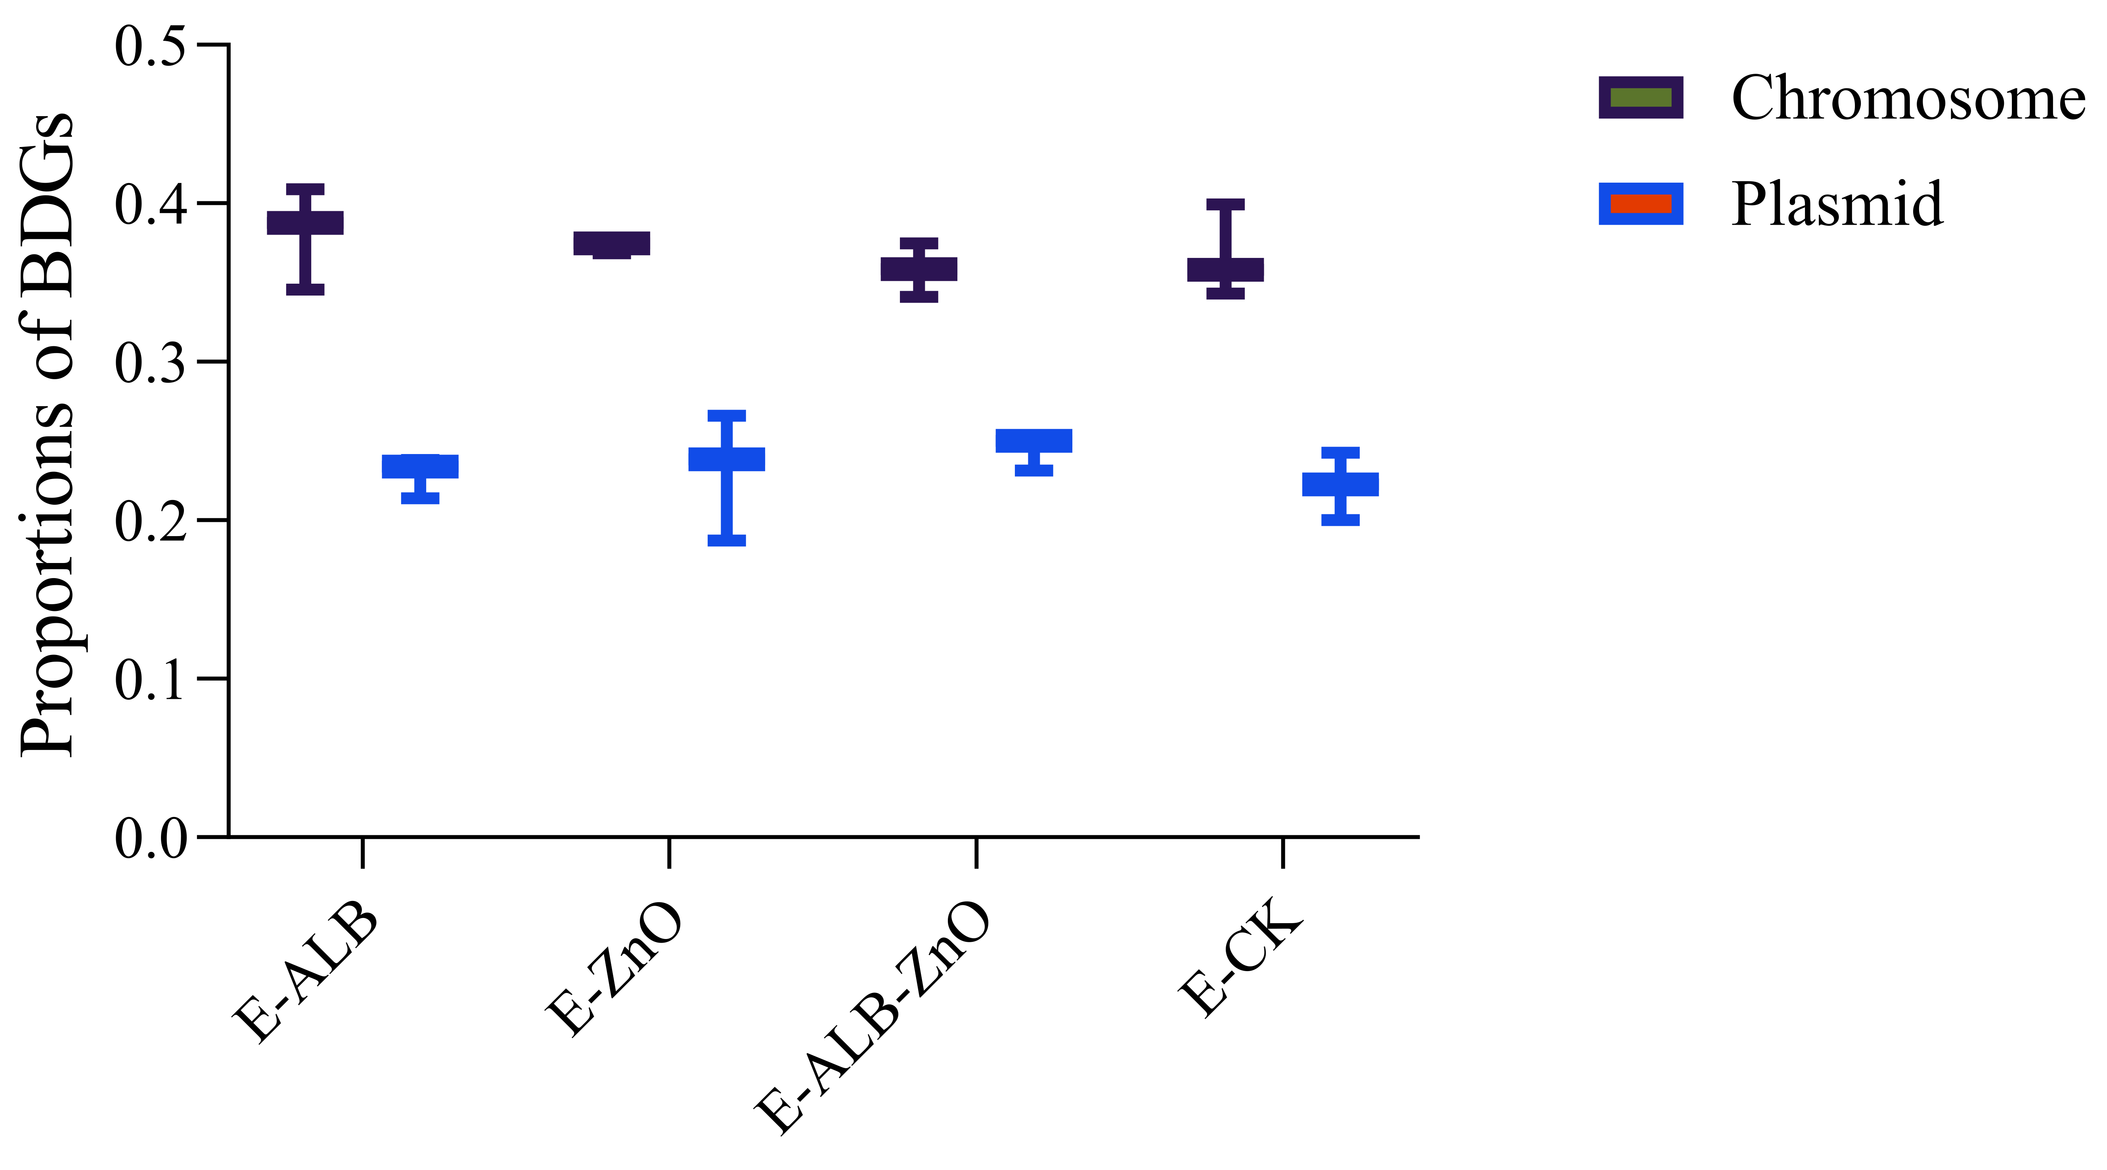
Fig. S5. Proportions of BDGs located in chromosome and plasmid in the earthworm gut under different treatments.

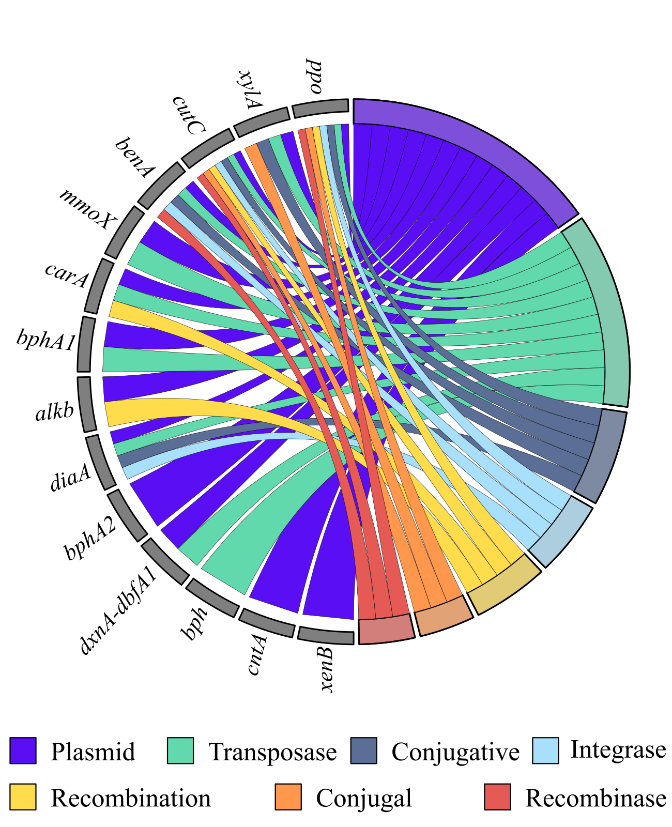
Fig. S6. The mapping relationship between BDGs and MGEs in the E-CK samples. The bars on the inner ring represents the co-occurrence of BDGs and MGEs on BCCs.
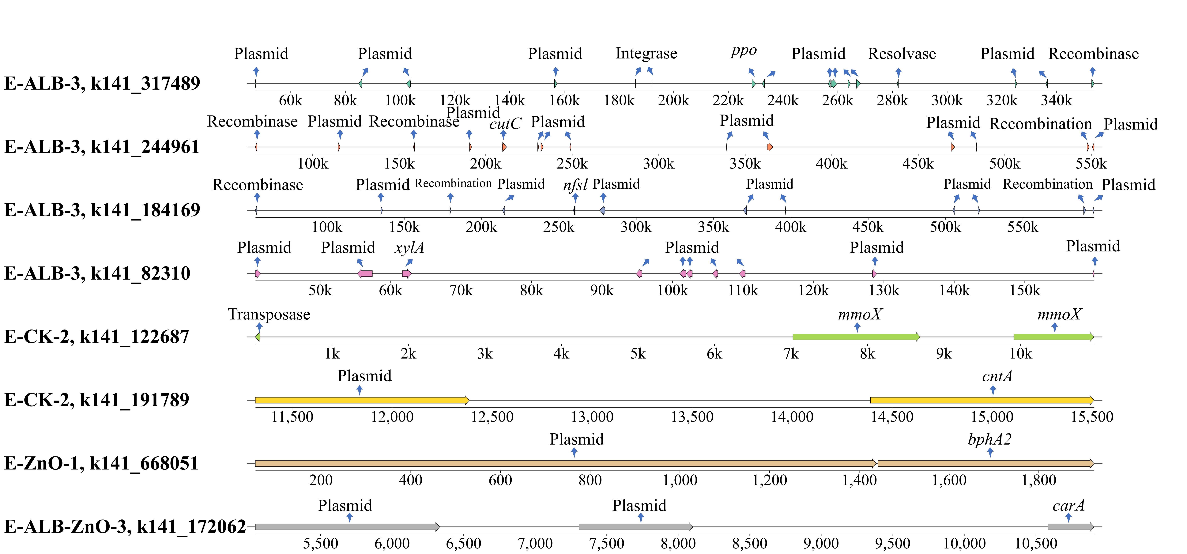
Fig. S7. The co-occurrence arrangements of ARGs and MGEs on the contigs among different treatments.
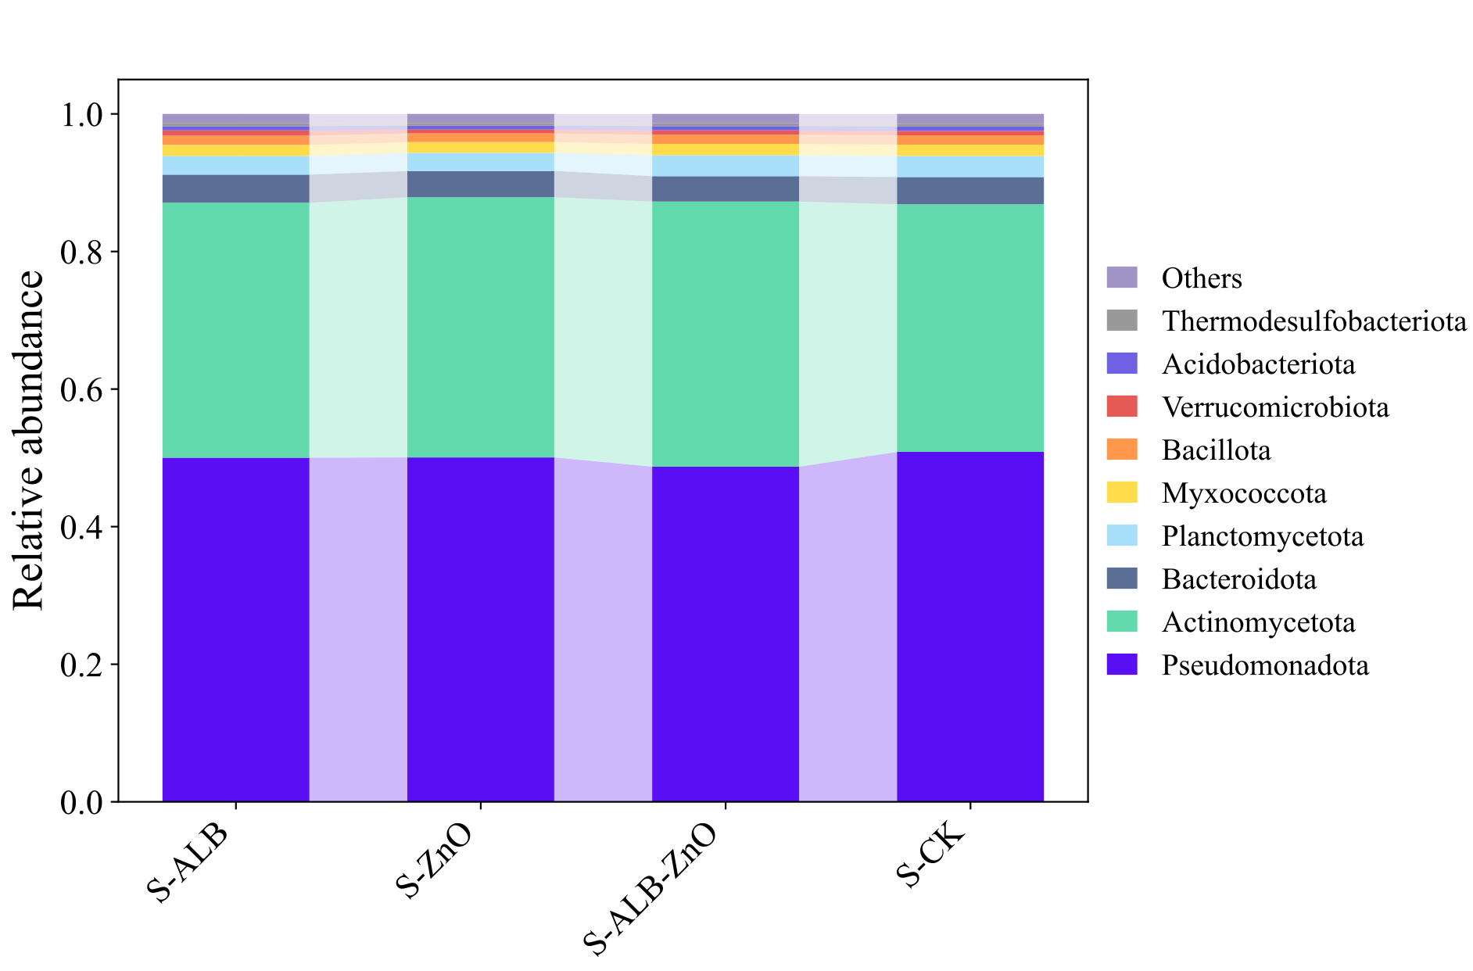
Fig. S8. Shifts of soil microbiome among different treatments.
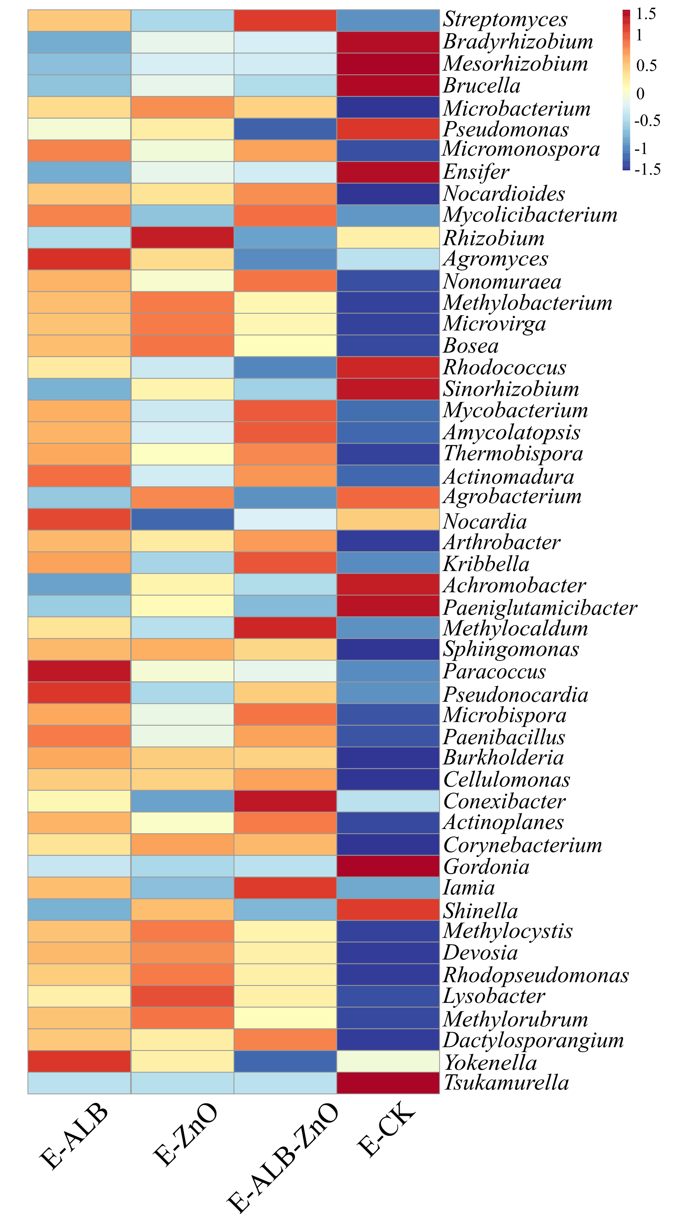
Fig. S9. Heatmap of the dominant bacterial genus (Top 50) based on the common logarithm of relative abundance in the earthworm gut.

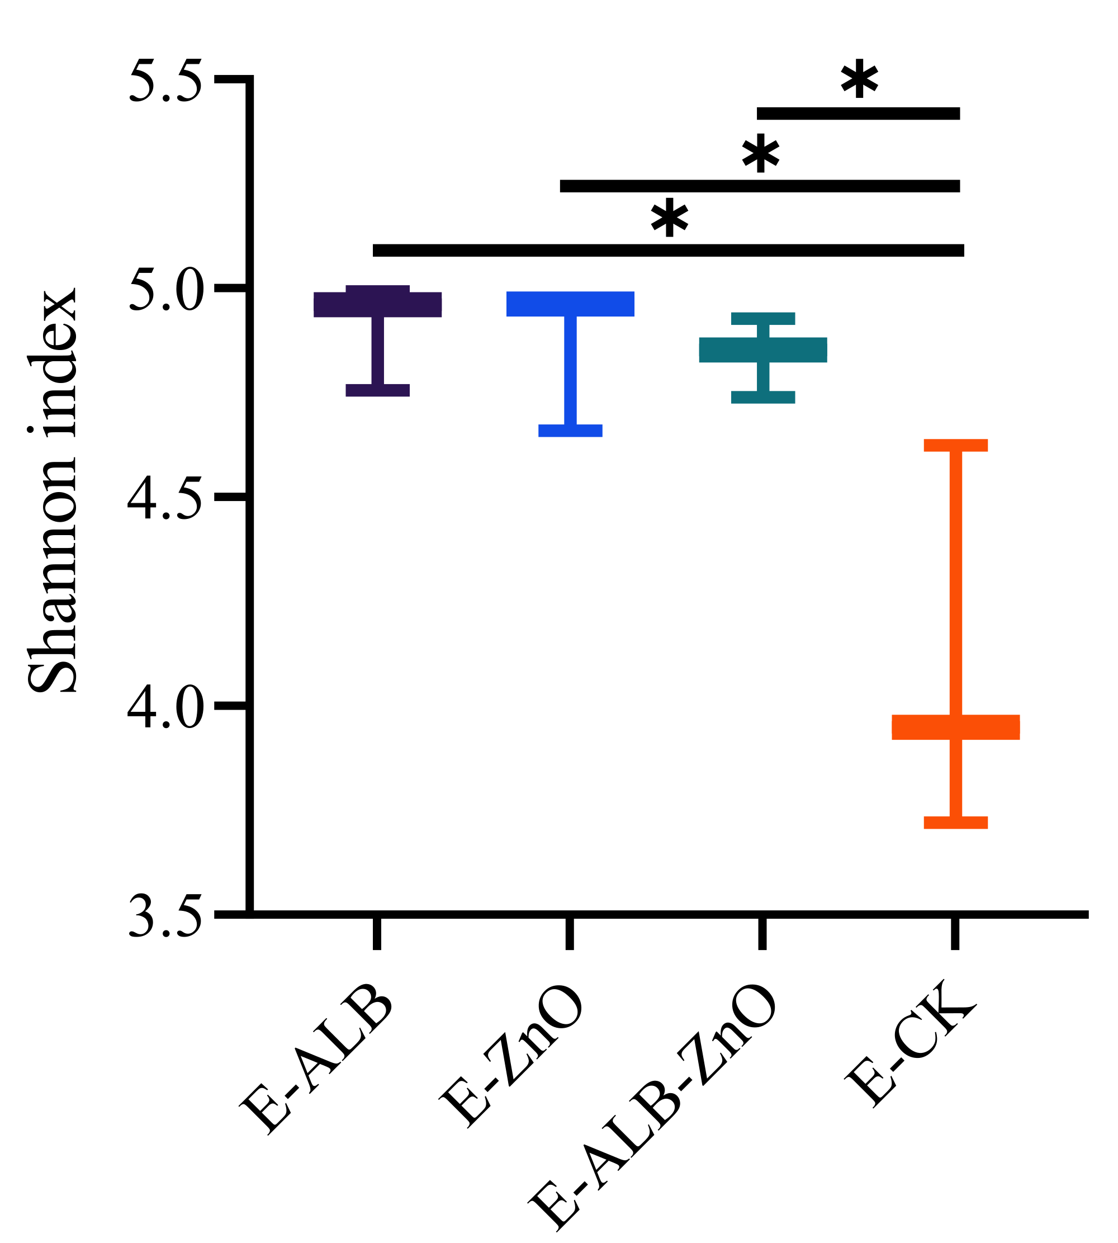
Fig. S10. Bacterial Shannon index in the earthworm gut among different treatments.
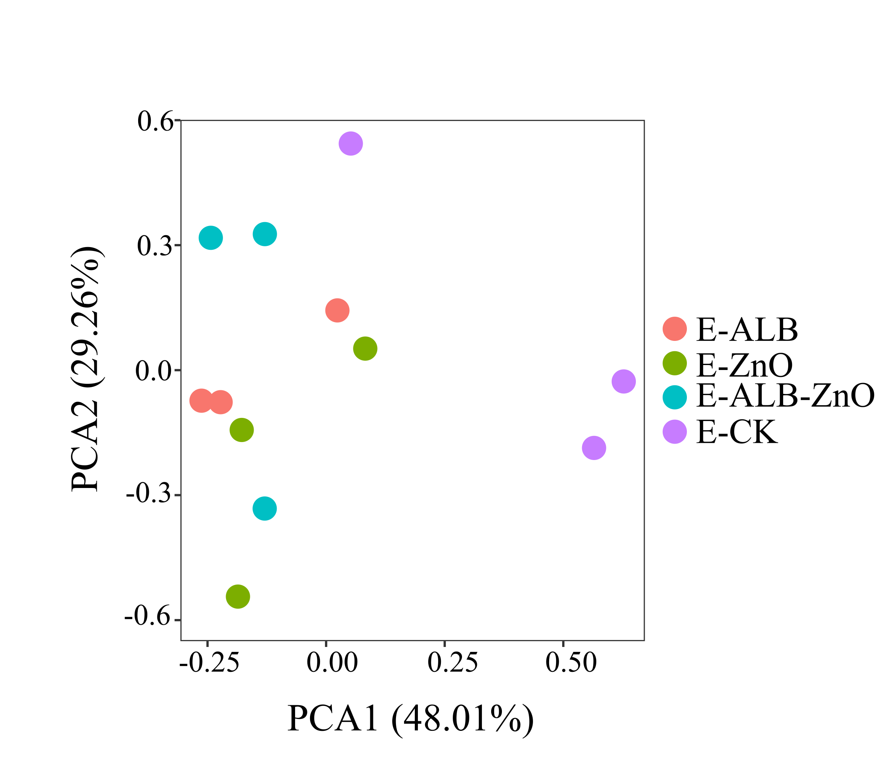
Fig. S11. PCOA plot of earthworm gut microbiome in the different treatments.

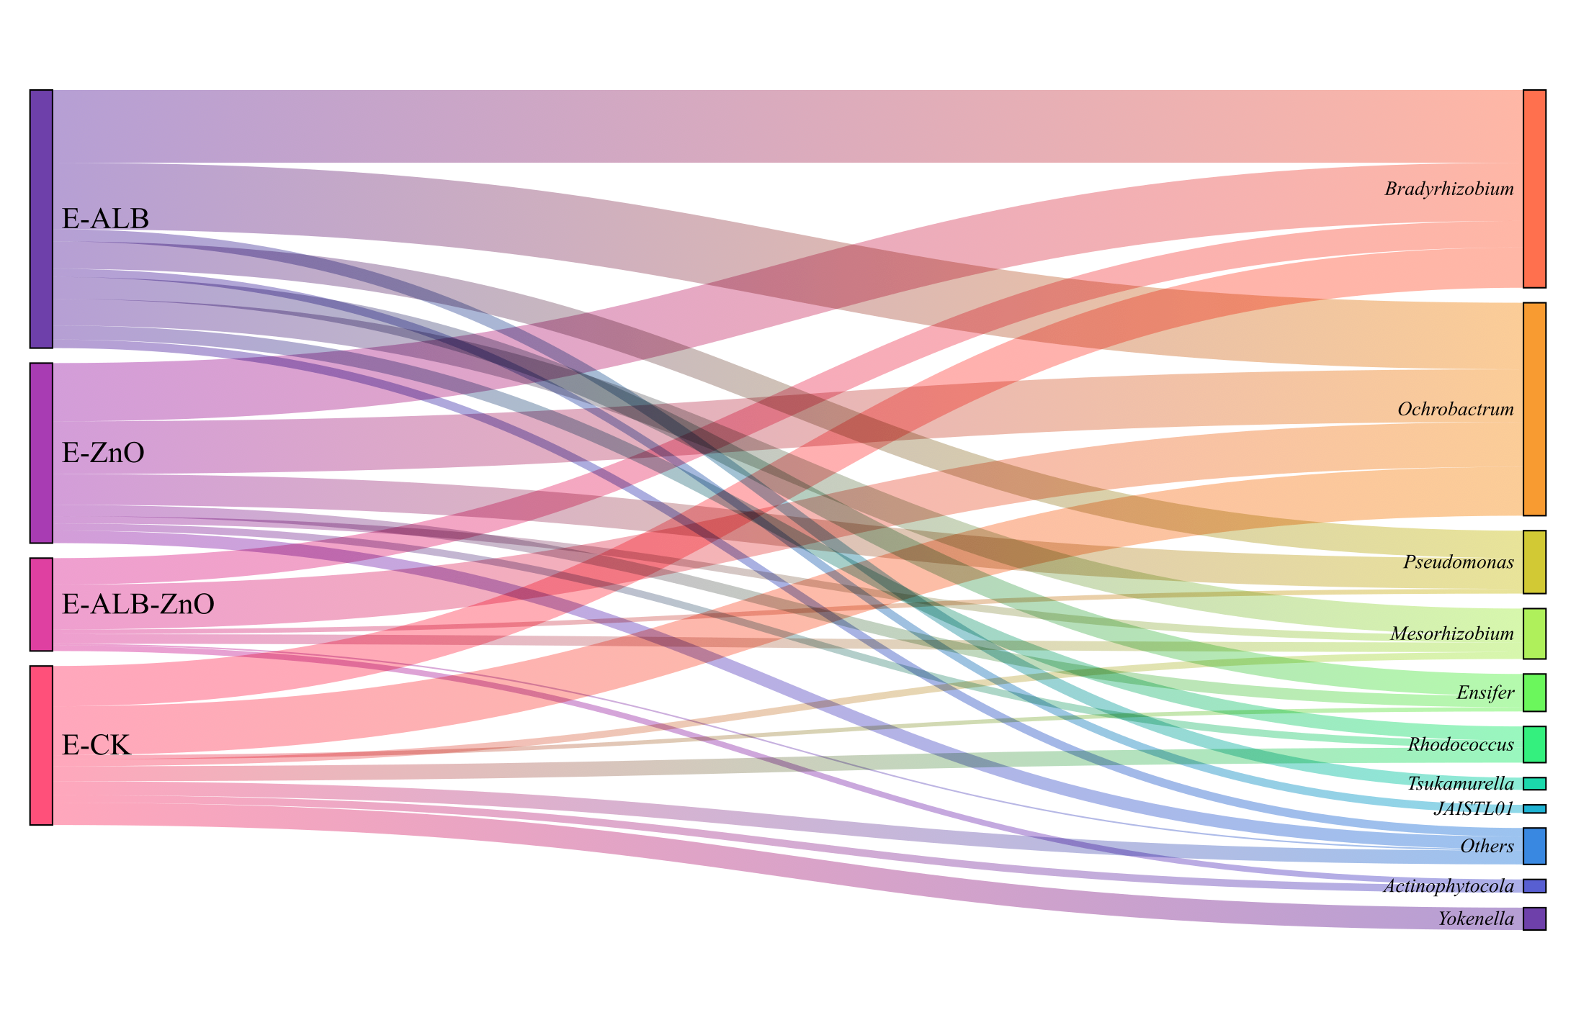
Fig. S12. Visualization based on the relative abundance and taxonomic assignment of the recovered MAGs carrying ADGs.
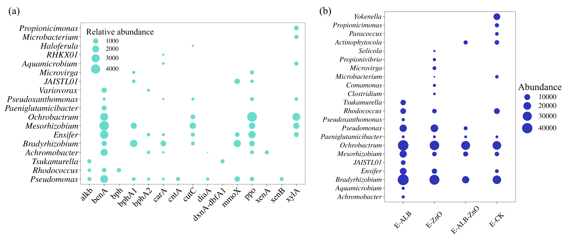 Fig. S13. Relative abundance of BDG-carrying bacteria genera based on the recovered MAGs in the E-CK samples (a); relative abundance of ADG-carrying bacteria genera based on the recovered MAGs in the earthworm gut (b).

