Mechanism of microbial action of the inoculated nitrogen-fixing bacterium for growth promotion and yield enhancement in rice (Oryza sativa L.)
Peng Li¹, Yunhe Tian², KunYang³, Meijie Tian², Yi Zhu⁴, Xinyu Chen², Ruiwen Hu², Tian Qin², Yongjun Liu³, Shuguang Peng³, Zhenxie Yi², Zhixuan Liu⁵*, Hejun Ao²*, Juan Li²*
¹ Hunan Soil and Fertilizer Institute, Hunan Academy of Agricultural Sciences, Changsha, 410125, China
² College of Agronomy, Hunan Agricultural University, Changsha, 410128, China
³ Hunan Tobacco Science Institute, Changsha, 410004, China
⁴ Hunan Tobacco Company Changde Branch, Changde, 415000, China
⁵ Hunan Rice Research Institute, Hunan Academy of Agricultural Sciences, Changsha, 410125, China
* Correspondence: Zhixuan Liu (zhixuanliu@hunaas.cn); Hejun Ao (aohejun@126.com); Juan Li (adalee619@163.com).

SM: table
Table S1 Physiological functions of endophytic Azotobacter R3
Strain | Siderophore production capacity | Solubilizing phosphate ability | Nitrogen fixation function | IAA production function
R3 | 1.20 | 1.20 | √ | √
Note: The strength of the iron-carrier/phosphorus-solubilizing capacity was expressed using the D/d value, where D is the diameter of the iron-carrier orange-yellow circle/phosphorus-solubilizing circle, and d is the diameter of the colony. Larger D/d values indicate greater iron carrier/dissolved phosphorus production capacity.

Table S2 Nutrient content of the tested soil
Treatment | pH | TN  /g·kg⁻¹ | TP  /g·kg⁻¹ | TK  /g·kg⁻¹ | NH₄-N  /mg·kg⁻¹ | NO₃-N  /mg·kg⁻¹ | AP  /mg·kg⁻¹ | AK  /mg·kg⁻¹ | SOM  /g·kg⁻¹
Original soil | 6.79 | 2.44 | 2.40 | 5.18 | 38.57 | 8.90 | 15.46 | 97.15 | 28.25

Table S3 Primer design
Gene name | Primer sequence (5’-3’) | Tm(℃) | Amplicon length (bp)
eEF-2 | F:TTTCACTCTTGGTGTGAAGCAGAT  R:GACTTCCTTCACGATTTCATCGTAA | 62  62 | 103
OsNRT1 | F:CGTGTCATCCCCACTCTACA  R:ACTGAGAAGACAGAACCGAGAGA | 58  60 | 176
OsPTR9 | F:TCCATGAAGGGAGTTCAGAGG  R:GGGCAGCATCCTGACGAGAA | 58  62 | 174

Table S4 Dry matter weight of rice plants at maturity
Treatment | Root/g·plant⁻¹ | Stem/g·plant⁻¹ | Leaf/g·plant⁻¹ | Grain/g·plant⁻¹
CK | 7.68±0.24b | 34.88±1.06b | 11.51±0.67b | 35.34±1.17b
R3 | 8.73±0.16a | 37.18±1.00a | 13.40±0.91a | 38.34±0.95a
Mean values (± S.D., n = 10) with different letters indicating significant differences between CK and R3 treatments based on Duncan test (P < 0.05), the same below.

Table S5 Dissimilarity test of communities based on three non-parametric tests
Sample | Treatment | MRPP |  | ANOSIM |  | PERMANOVA
Sample | Treatment | Delta | P | R value | P | F value | P
Rhizosphere | CK vs. R3 | 0.1690 | 0.001 | 0.5936 | 0.001 | 10.2859 | 0.001
Endophyte | CK vs. R3 | 0.3895 | 0.016 | 0.1125 | 0.013 | 2.6757 | 0.007
MRPP: multi-response permutation procedure; ANOSIM: analysis of similarities; PERMANOVA: permutational multivariate analysis of variance.

Table S6 Topological properties of the networks
Network Indices | Soil_CK | Soil_R3 | Plant_CK | Plant_R3
Similarity threshold | 0.770 | 0.770 | 0.850 | 0.850
Total nodes | 105 | 154 | 35 | 54
Total links | 138 | 289 | 157 | 298
R square of power-law | 0.859 | 0.815 | 0.073 | 0.14
Average degree (avgK) | 2.629 | 3.753 | 8.971 | 11.037
Average clustering coefficient (avgCC) | 0.13 | 0.13 | 0.249 | 0.197
Average path distance (GD) | 4.572 | 4.411 | 2.237 | 2.121
Geodesic efficiency (E) | 0.275 | 0.279 | 0.567 | 0.553
Harmonic geodesic distance (HD) | 3.641 | 3.589 | 1.764 | 1.809
Maximal degree | 9 | 15 | 17 | 28
Centralization of degree (CD) | 0.062 | 0.074 | 0.25 | 0.332
Maximal betweenness | 988.92 | 1486.826 | 79.92 | 328.987
Centralization of betweenness (CB) | 0.164 | 0.111 | 0.108 | 0.221
Maximal stress centrality | 3094 | 9101 | 1094 | 1909
Centralization of stress centrality (CS) | 0.523 | 0.708 | 1.548 | 1.18
Maximal eigenvector centrality | 0.366 | 0.316 | 0.278 | 0.269
Centralization of eigenvector centrality (CE) | 0.315 | 0.272 | 0.135 | 0.158
Density (D) | 0.025 | 0.025 | 0.264 | 0.208
Reciprocity | 1 | 1 | 1 | 1
Transitivity (Trans) | 0.097 | 0.081 | 0.314 | 0.275
Connectedness (Con) | 0.629 | 0.78 | 1 | 1
Efficiency | 0.974 | 0.976 | 0.758 | 0.807
Lubness | 1 | 1 | 1 | 1

Table S7 Summary of the basic taxonomies of putative keystone species in the networks
Network category | Treatment | OUT_ID | Classification
Network category | Treatment | OUT_ID | Phylum | Genus
Module hubs | CK_Soil | OTU_113 | Actinobacteria | Unclassified
Module hubs | R3_Soil | OTU_10 | Actinobacteria | Unclassified
Network hubs | R3_Soil | OTU_211 | Firmicutes | Unclassified
Network hubs | R3_Root | OTU_29 | Proteobacteria | Unclassified
Connectors | CK_Soil | OTU_193 | Actinobacteria | Corynebacterium
Connectors | R3_Soil | OTU_88 | Proteobacteria | Unclassified
Connectors | R3_Soil | OTU_114 | Proteobacteria | Unclassified
Connectors | R3_Soil | OTU_125 | Proteobacteria | Acidithiobacillus
Connectors | R3_Soil | OTU_140 | Proteobacteria | Myxococcus
Connectors | R3_Soil | OTU_149 | Firmicutes | Unclassified
Connectors | R3_Soil | OTU_162 | Proteobacteria | Chromobacterium
Connectors | R3_Soil | OTU_166 | Planctomycetes | Urbifossiella
Connectors | R3_Soil | OTU_185 | Cyanobacteria | Zehria
Connectors | R3_Soil | OTU_215 | Actinobacteria | Unclassified
Connectors | CK_Root | OTU_55 | Proteobacteria | Unclassified
Connectors | CK_Root | OTU_57 | Proteobacteria | Moraxella
Connectors | CK_Root | OTU_63 | Actinobacteria | Streptomyces
Connectors | CK_Root | OTU_75 | Proteobacteria | Sinorhizobium
Connectors | R3_Root | OTU_38 | Proteobacteria | Azospirillum
Connectors | R3_Root | OTU_66 | Proteobacteria | Pseudomonas
Connectors | R3_Root | OTU_82 | Proteobacteria | Escherichia

Table S8 Grouping and its factor composition in the path model
Treatment | Factor
α diversity of rhizosphere diazotrophs | Shannon, Simpson, Richness, Pielou_evenness
α diversity of endosphere diazotrophs | Shannon, Simpson, Richness, Pielou_evenness
Keystone taxa of rhizosphere | p_Actinobacteria, p_Cyanobacteria, g_Ralstonia, g_Azotobacter, g_Geobacter, g_Pseudomonas, g_Streptomyces
Keystone taxa of endosphere | p_Actinobacteria, p_Cyanobacteria, g_Frankia
Genes related to nitrogen absorption and transport | OsNRT1, OsPTR9
Available nitrogen content in soil | NO₃⁻-N, NH₄⁺-N
Theoretical yield of rice | Theoretical yield of rice
Note: This grouping was used for the Partial Least Squares Path Modeling (PLS-PM) analysis in this study.

SM: Figure
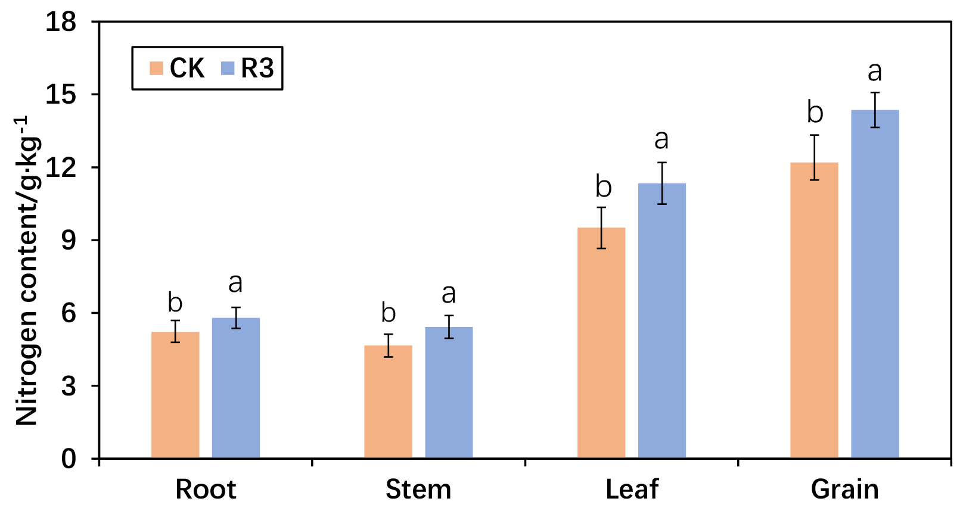
Fig. S1 Nitrogen content in various parts of rice plants. Different letters indicate that N content was significantly different between treatments (P < 0.05).

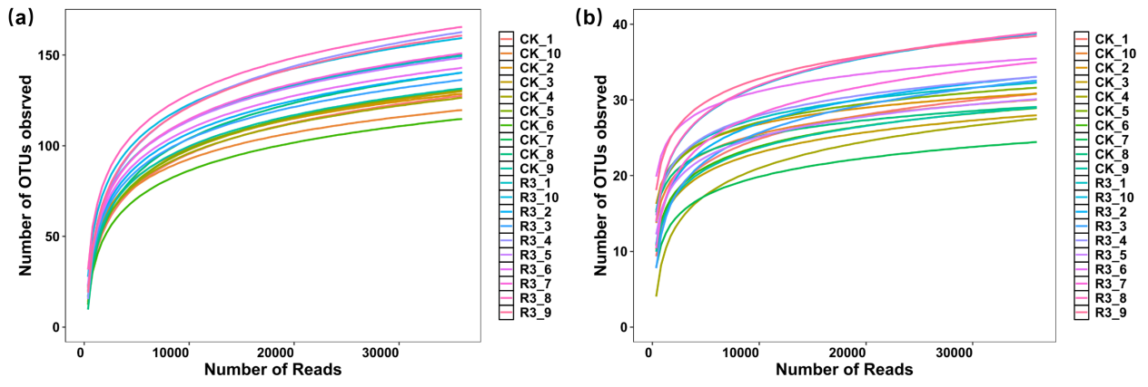
Fig. S2 Rarefaction curves of observed number of OTUs against the number of nifH gene sequences retrieved from the rice rhizosphere (a) and root endosphere (b).

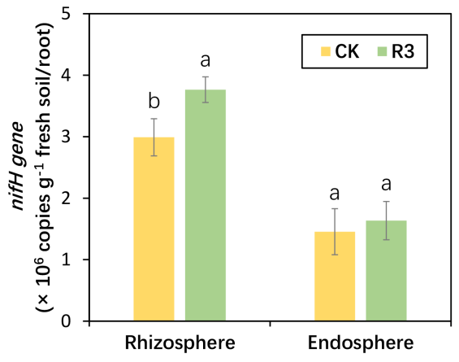
Fig. S3 nifH gene abundance in rhizosphere and root endosphere of rice. Different letters indicate that abundance was significantly different between treatments (P < 0.05).

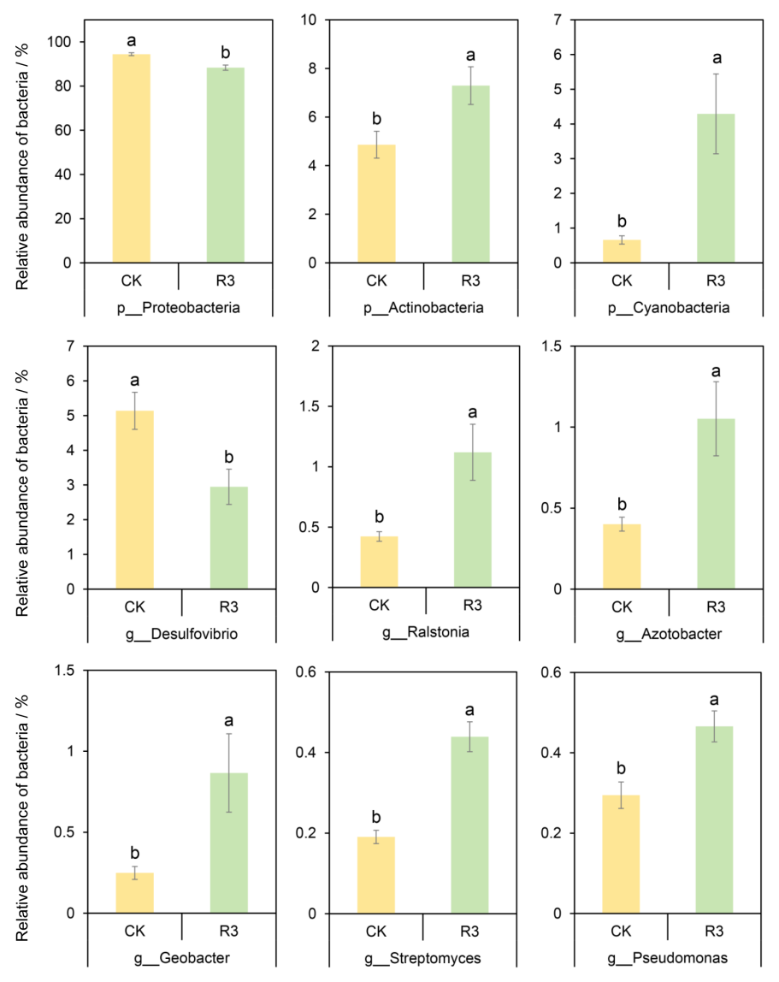
Fig. S4 The relative abundance of nitrogen-fixing bacteria (phylum and genus) in rice rhizosphere soil. Different letters indicate that the relative abundance of the taxon is significantly different between treatments (P < 0.05).

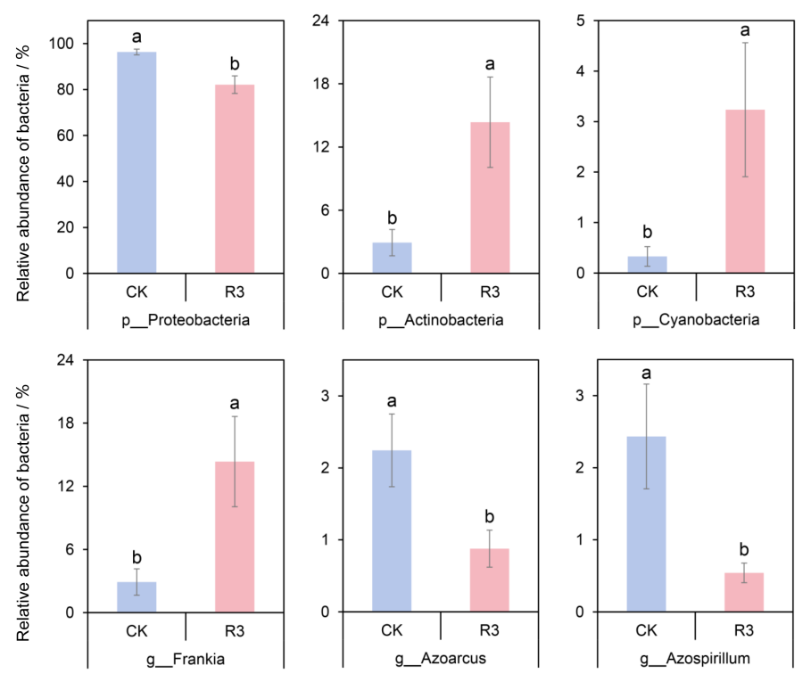
Fig. S5 The relative abundance of nitrogen-fixing bacteria (phylum and genus) in rice roots. Different letters indicate that the relative abundance of the taxon is significantly different between treatments (P < 0.05).

