Supporting Information:
Unlocking Durability and Efficiency in Perovskite Solar Cells via Sulfur -Based Thiazoline Engineered passivation

Ghada Abdelmageed¹(https://orcid.org/0000-0003-4429-0997), Anthony El-Halaby², Karim Tantawy^{1,2}, Adam F.G. Leontowich^{3,4}(https://orcid.org/0000-0002-1773-6458), Gurpreet Singh Selopal⁵(https://orcid.org/0000-0002-4703-8829), Sean Hinds¹*, Ghada Koleilat^{1,2}*( https://orcid.org/0000-0002-0338-8472)

¹ Department of Process Engineering and Applied Science, Dalhousie University, 1360 Barrington Street, Halifax, Nova Scotia, B3H 4R2, Canada.
² Department of Electrical and Computer Engineering, Dalhousie University, 1459 Oxford Street, Halifax, Nova Scotia, B3H 4R2 Canada.
³ Canadian Light Source Inc., 44 Innovation Boulevard, Saskatoon, SK, S7N 2 V3, Canada
⁴ Department of Chemistry, University of Saskatchewan, Saskatoon, SK, S7N 5C9, Canada⁵ Department of Engineering, Faculty of Agriculture, Dalhousie University, Truro, B2N 5E3, NS, Canada.
⁵ Department of Engineering, Faculty of Agriculture, Dalhousie University, Truro, B2N 5E3, NS, Canada.

*Corresponding authors, Sean Hinds, email: SeanHinds@dal.ca, Ghada Koleilate, email: ghada.koleilat@dal.ca

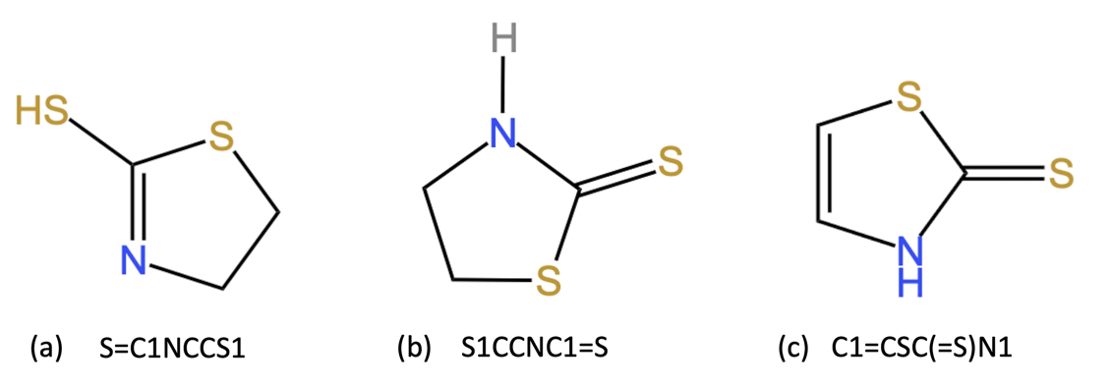
Figure S1 (a) and (b) show the thiol and thione tautomeric forms of 2MT (C₃H₅NS₂), respectively. (c) MTZ (C₃H₃NS₂).

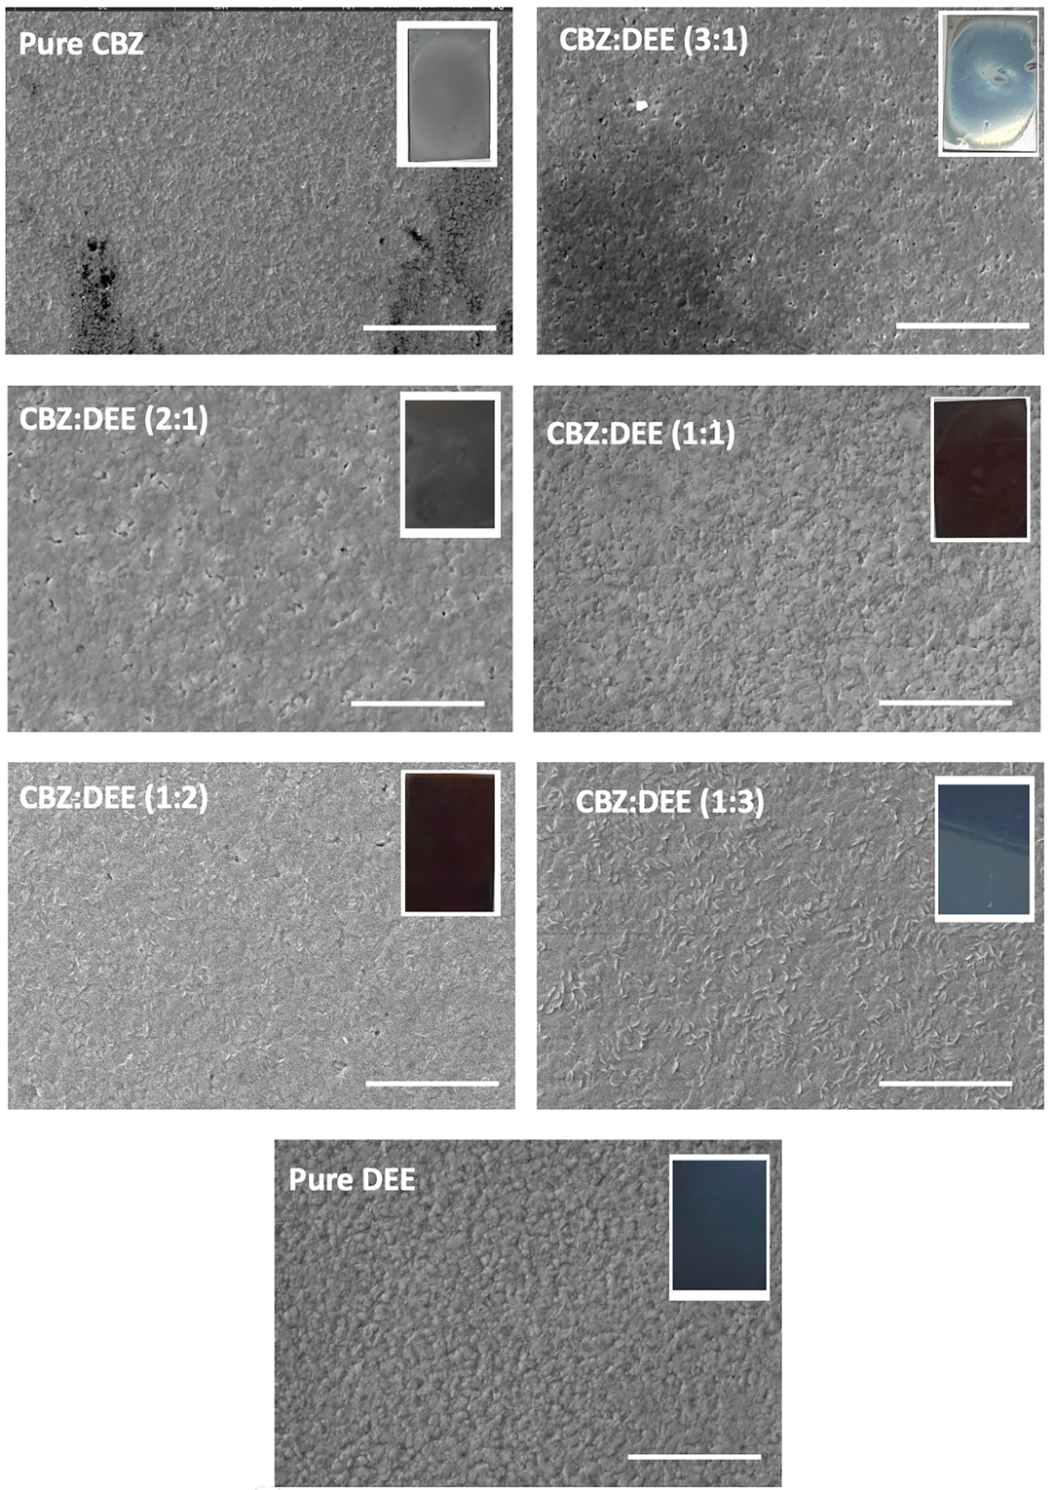
Figure S2: SEM images of (FAPbI₃)_{0.95}(MAPbBr₃)_{0.05} perovskite films prepared with different combinations of antisolvents (chlorobenzene (CBZ) and diethyl ether (DEE)). Insets are the photographic pictures of the prepared films. The scale bar in the images denotes 10μm. The CBZ:DEE 1:3 and pure DEE films showed the best film-forming properties with shiny, mirror-like films with fewer pinholes.

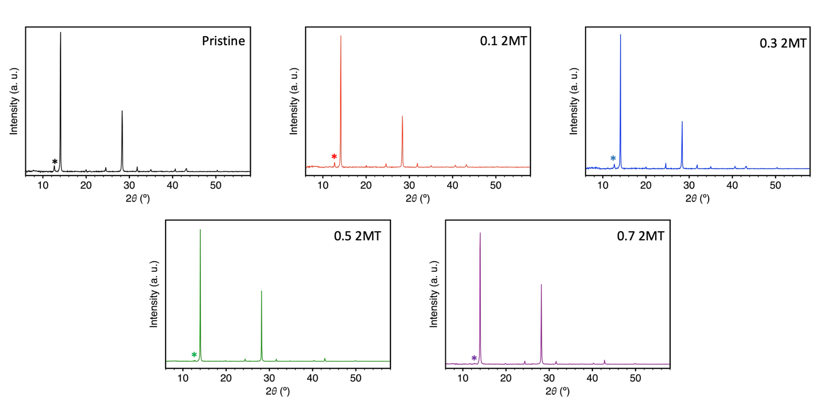
Figure S3: XRD patterns (Cu Kα source (λ = 1.5406 Å)) of (FAPbI₃)_{0.95}(MAPbBr₃)_{0.05} perovskite films treated with different weight percentages of 2MT. PbI₂ peak is marked with *.

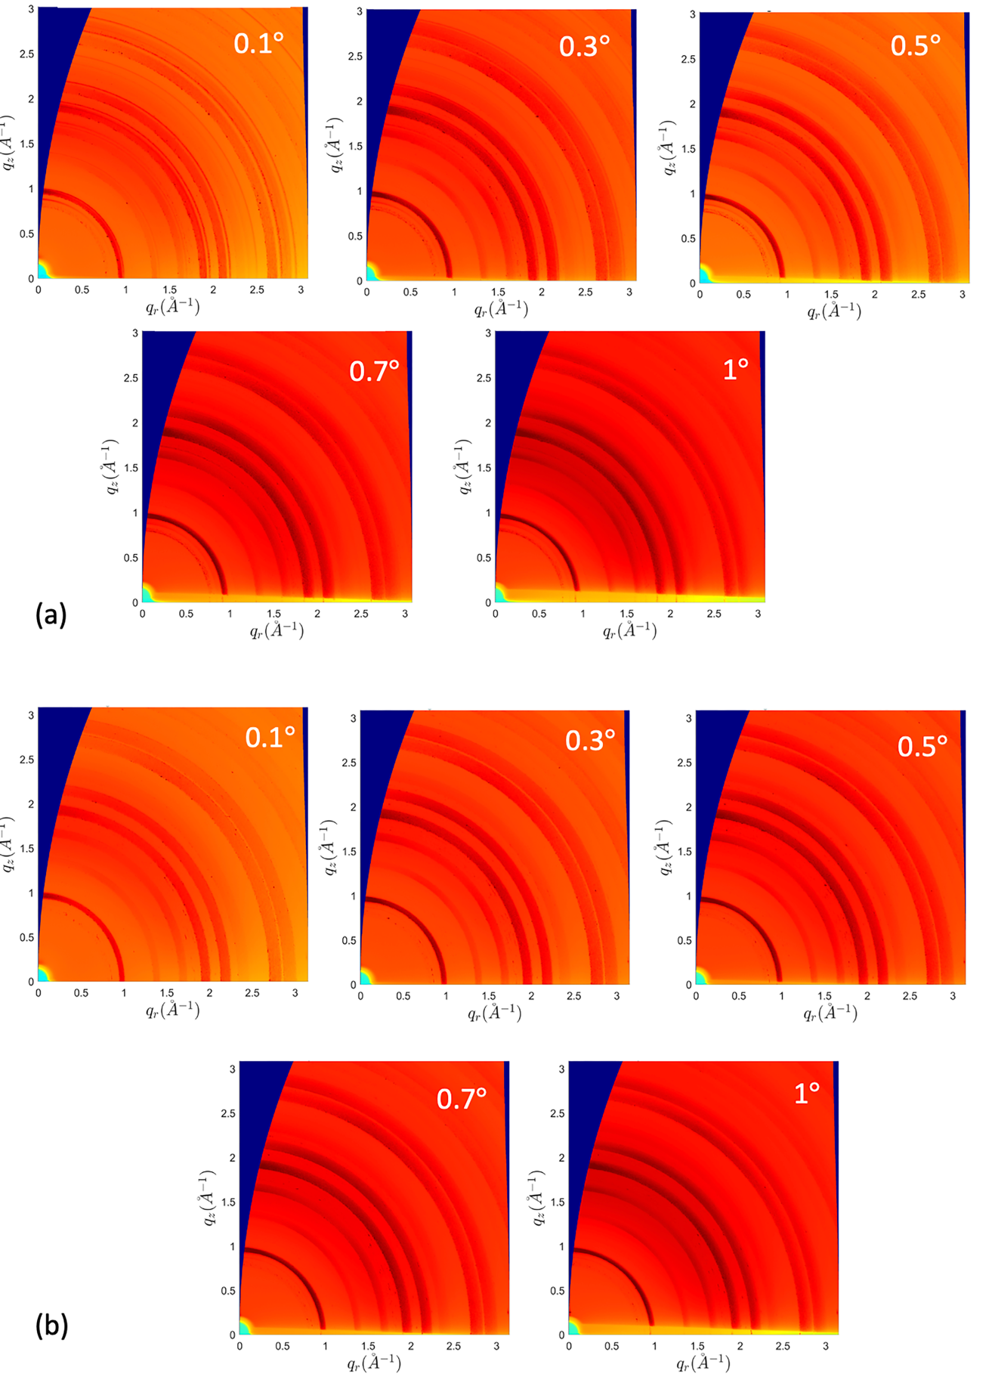
Figure S4: GIWAXS patterns (λ = 0.81931 Å) of (FAPbI₃)_{0.95}(MAPbBr₃)_{0.05} perovskite films at different incident angles. (a) pristine. (b) w/ 0.5 wt.% 2MT.

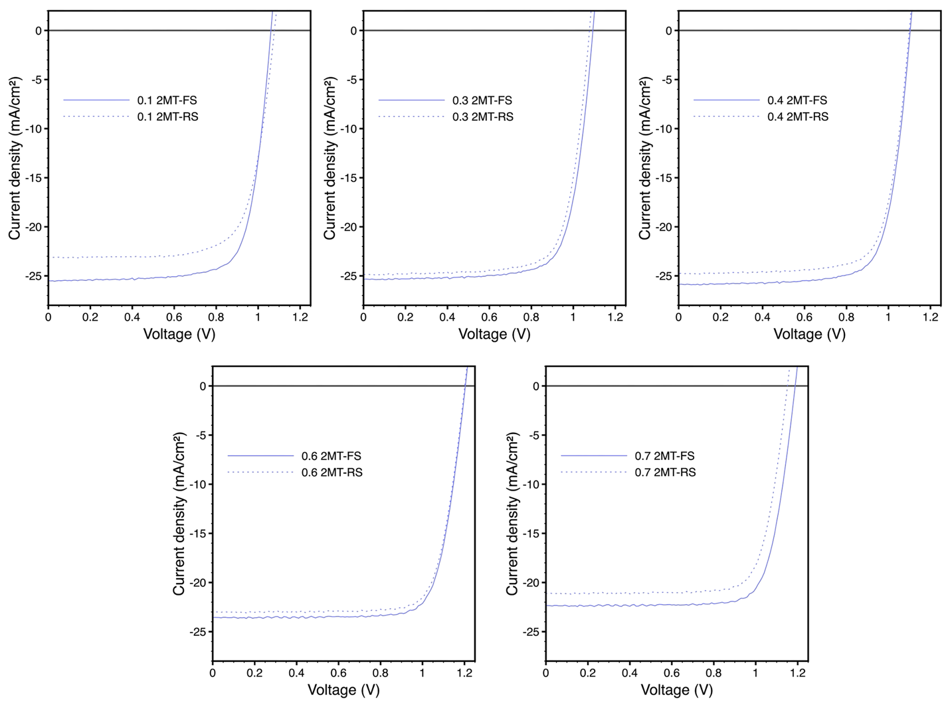
Figure S5: JV curves of (FAPbI₃)_{0.95}(MAPbBr₃)_{0.05} perovskite devices treated with 0.1, 0.3, 0.4, 0.6 and 0.7 wt.% 2MT, FS denotes forward scan, and RS denotes reverse scan.

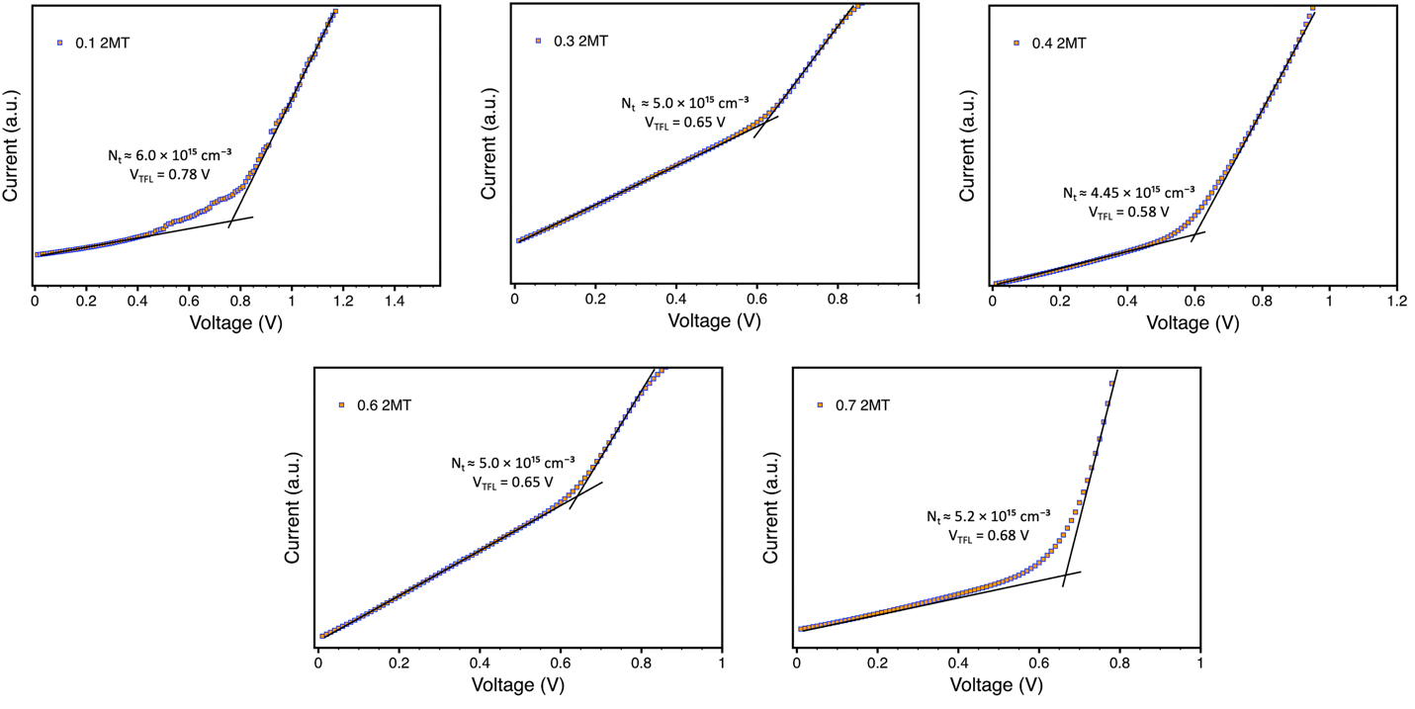
Figure S6: Dark IV curves (SCLC) showing the V_{TFL} values (FAPbI₃)_{0.95}(MAPbBr₃)_{0.05} perovskite treated with 0.1, 0.3, 0.4, 0.6 and 0.7 wt.% 2MT electron-only devices.

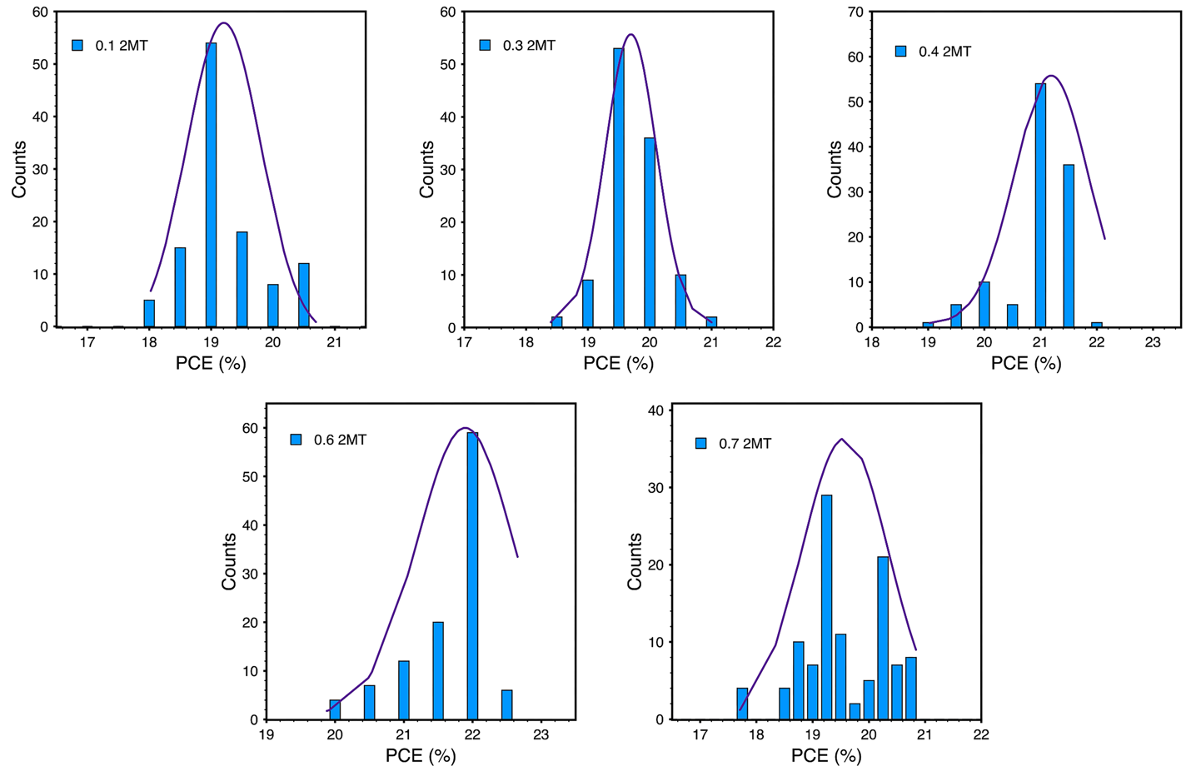
Figure S7: Statistical distributions of over 100 devices of (FAPbI₃)_{0.95}(MAPbBr₃)_{0.05} perovskite devices treated with 0.1, 0.3, 0.4, 0.6 and 0.7 wt.% 2MT.

