Supplement

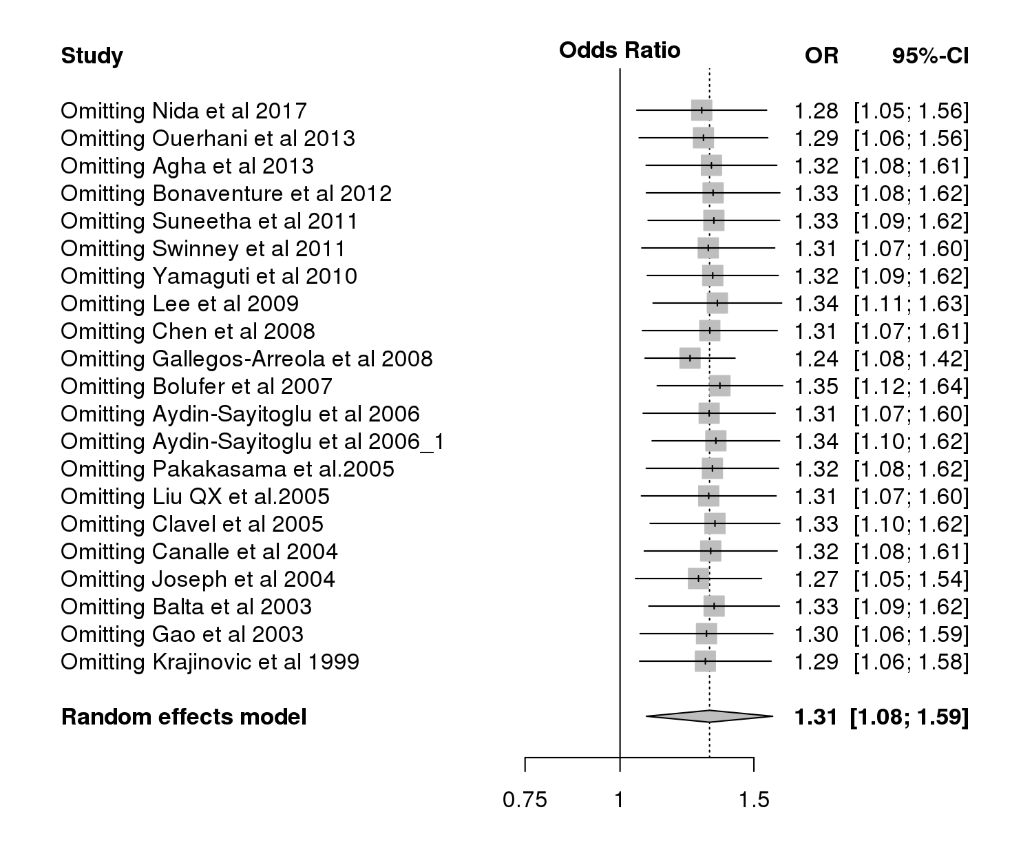  A | 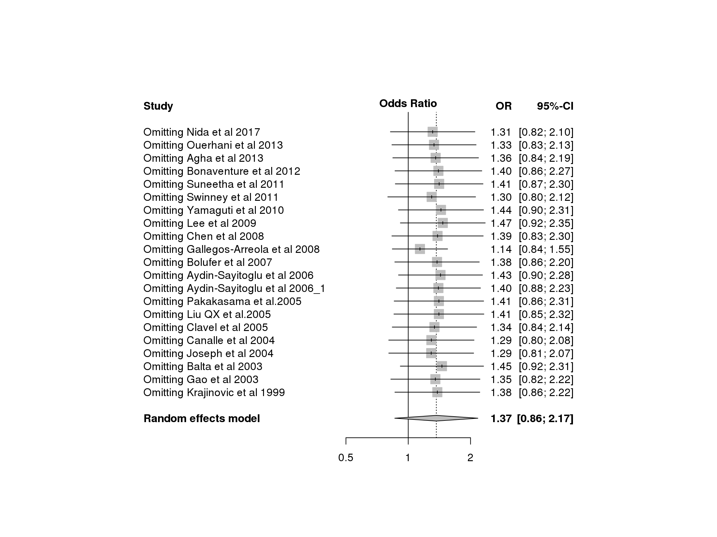  B | 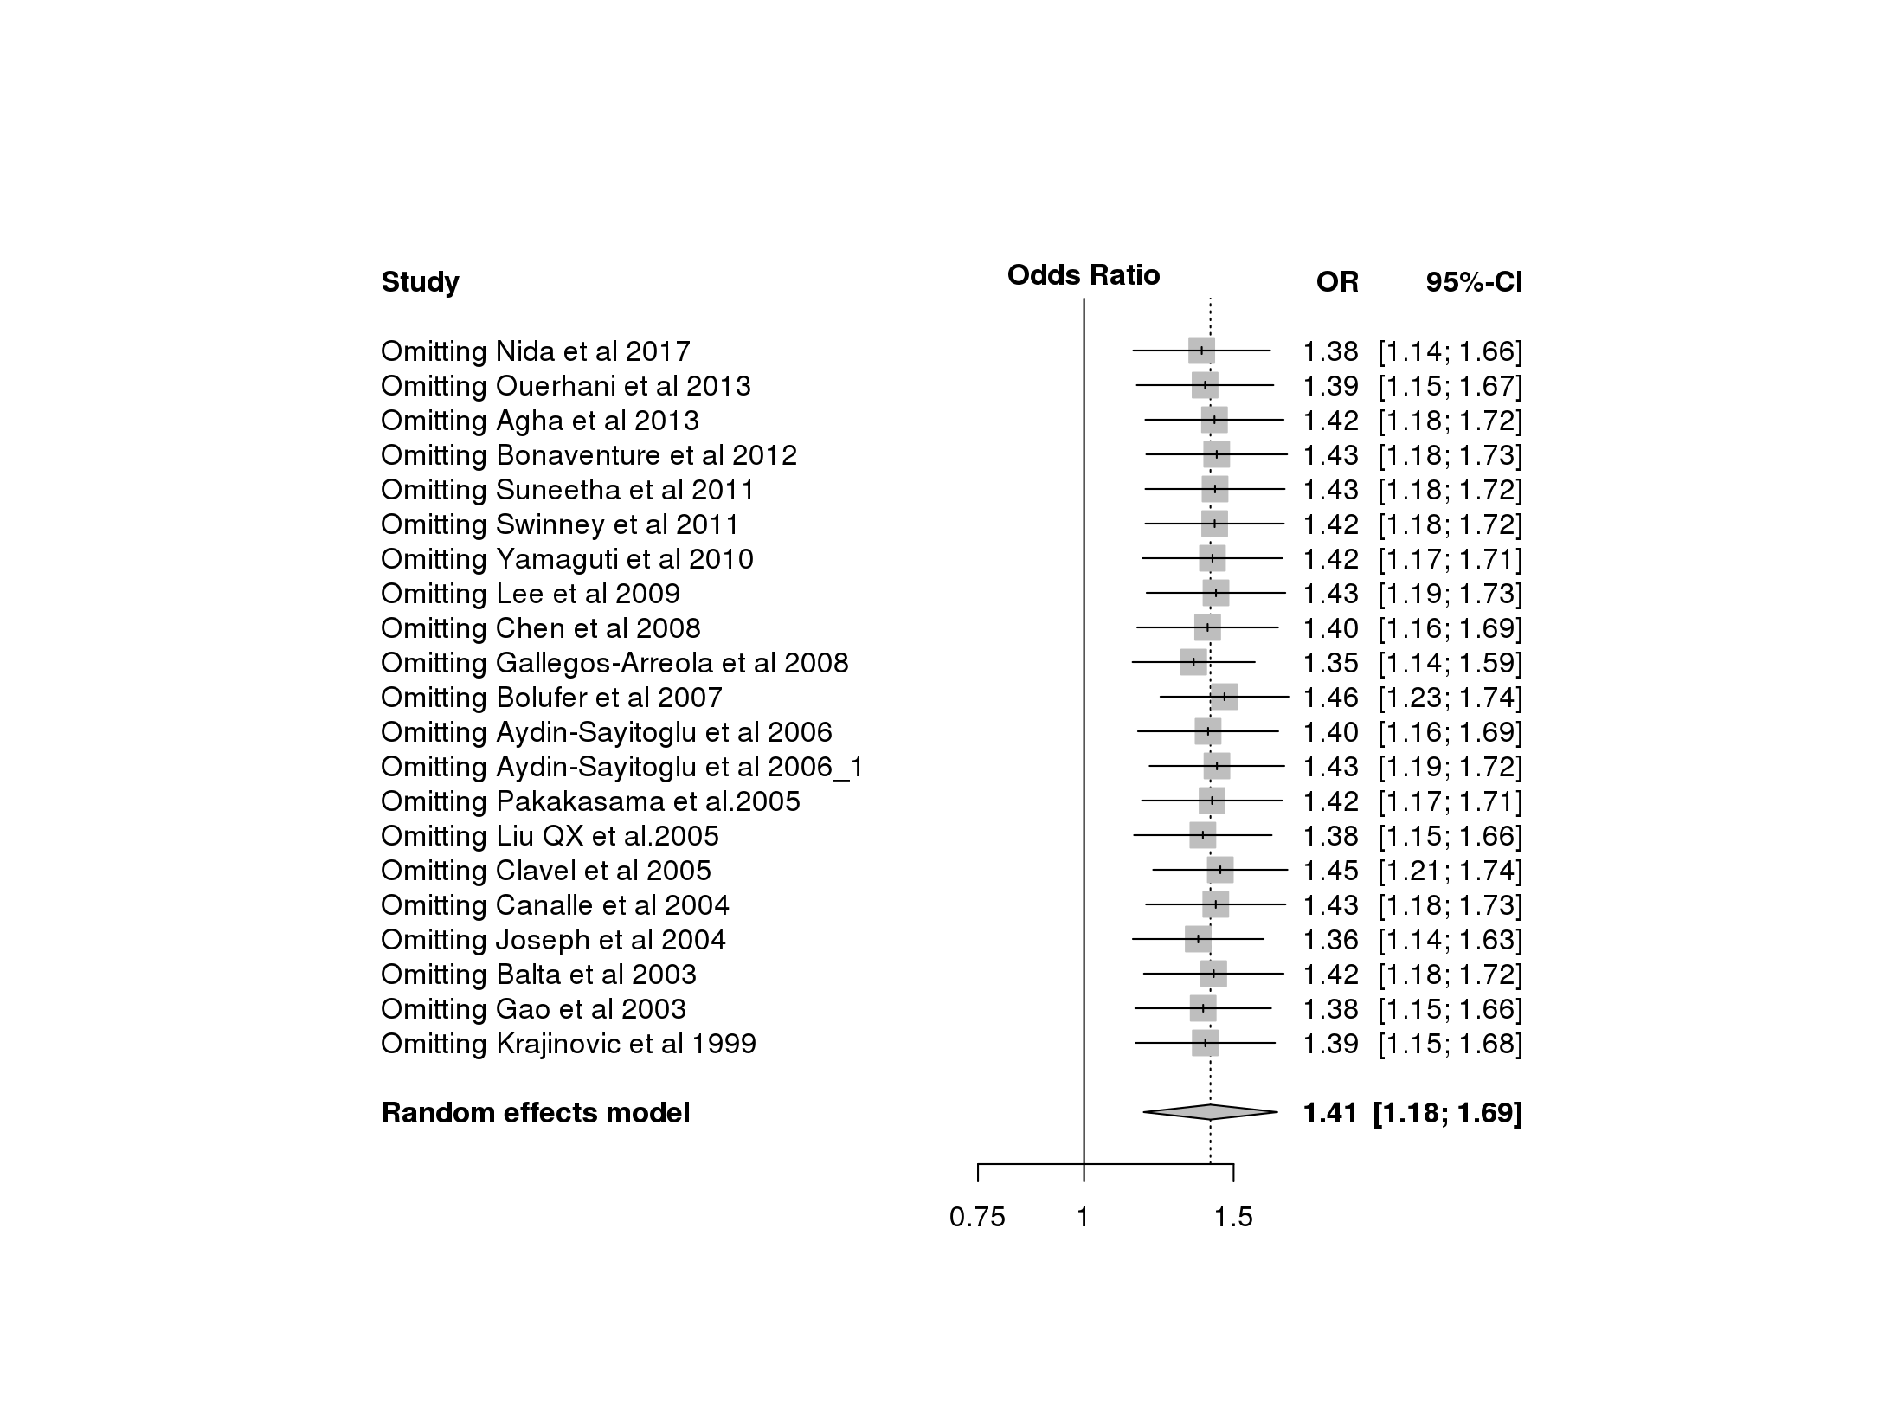  C
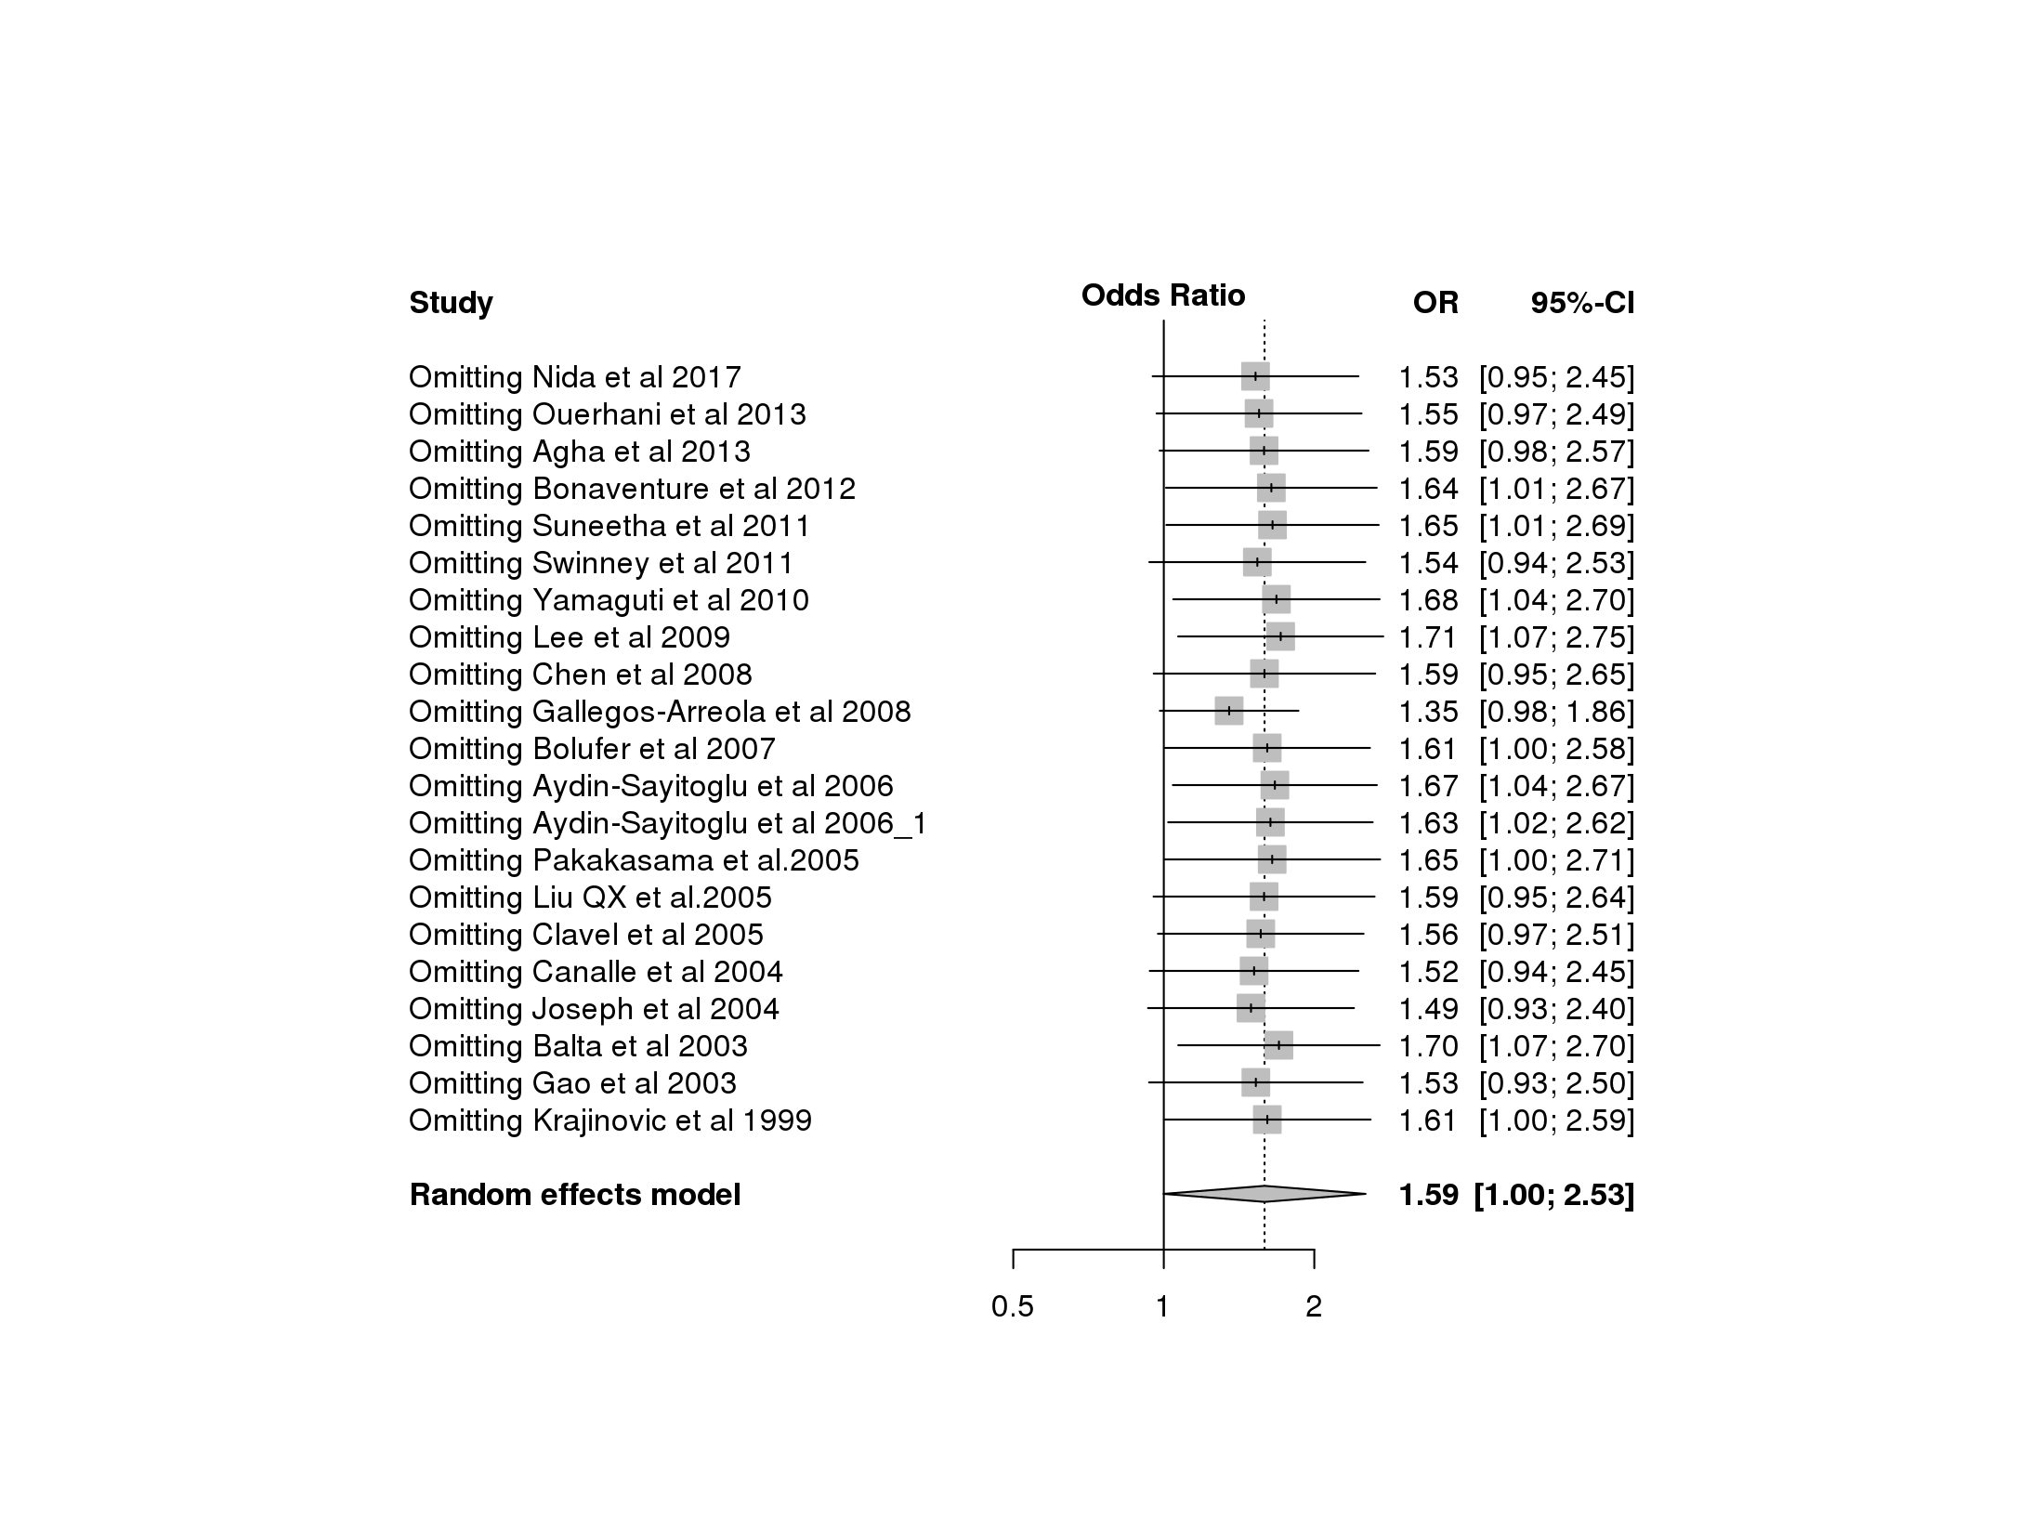  D | 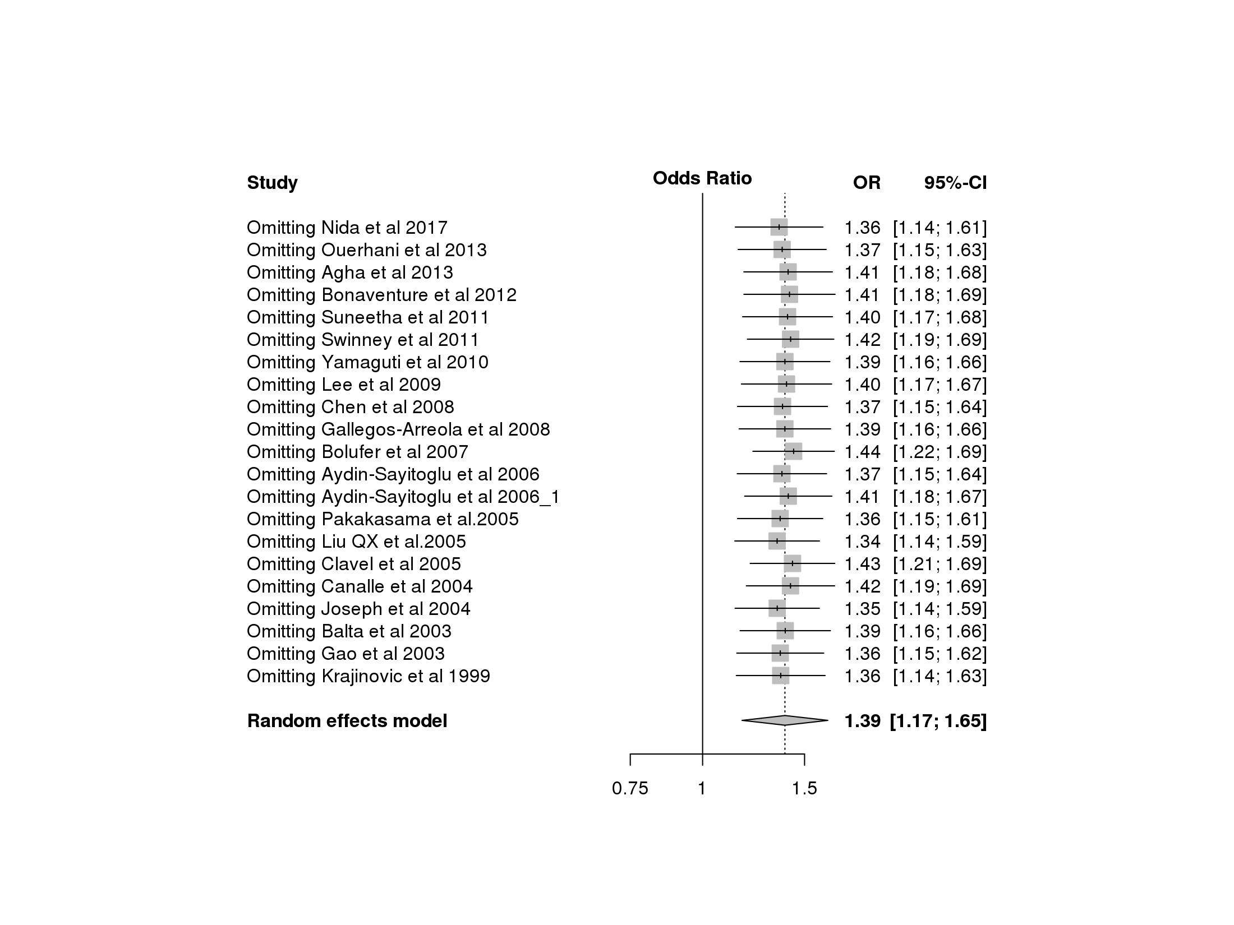  E | Figure S1: Sensitivity plot of the T3801C polymorphism under different models.  A : allele contrst model, B : recessive model, C : dominant model, D : homozygous model, E : heterozygous model.
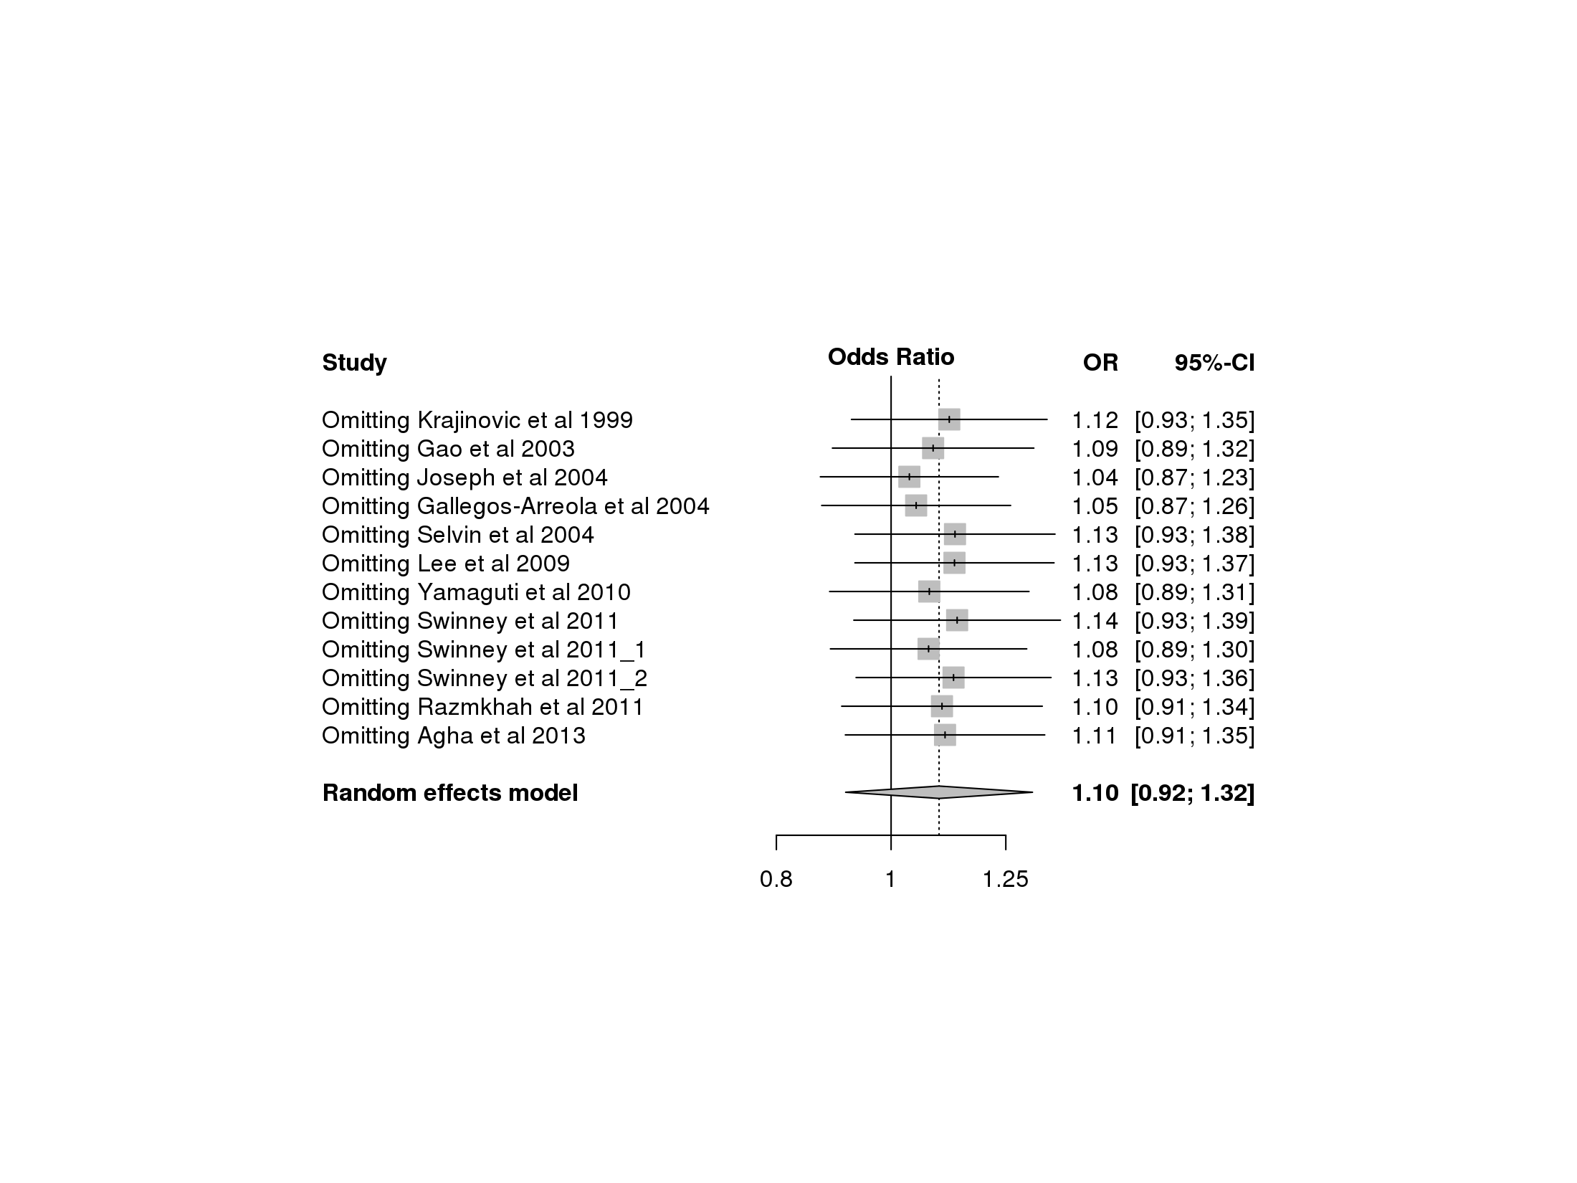  A | 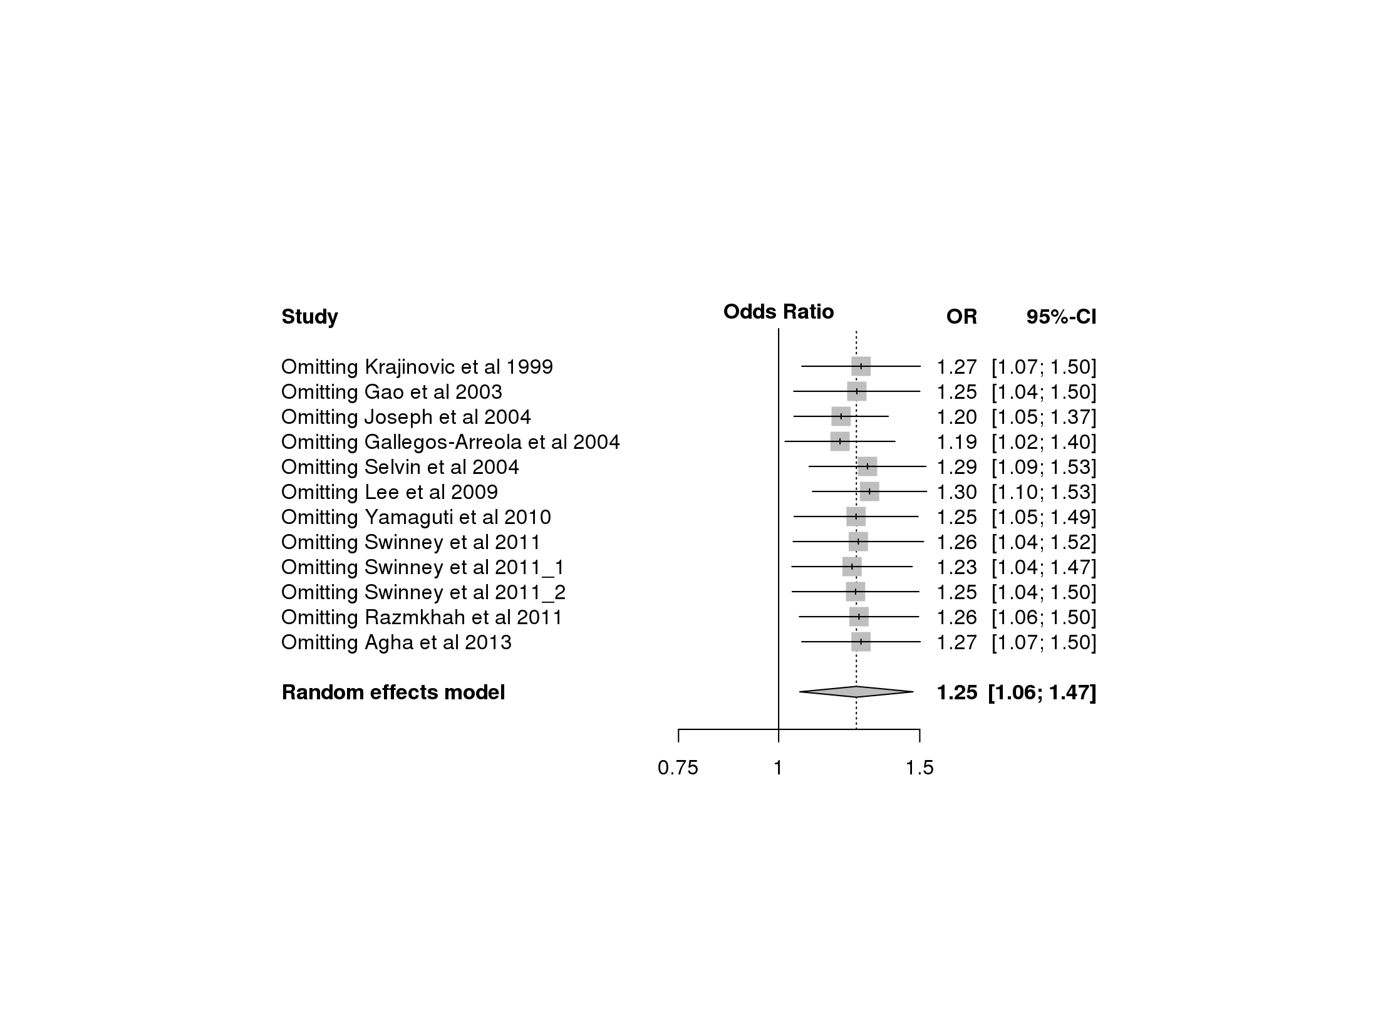  B | 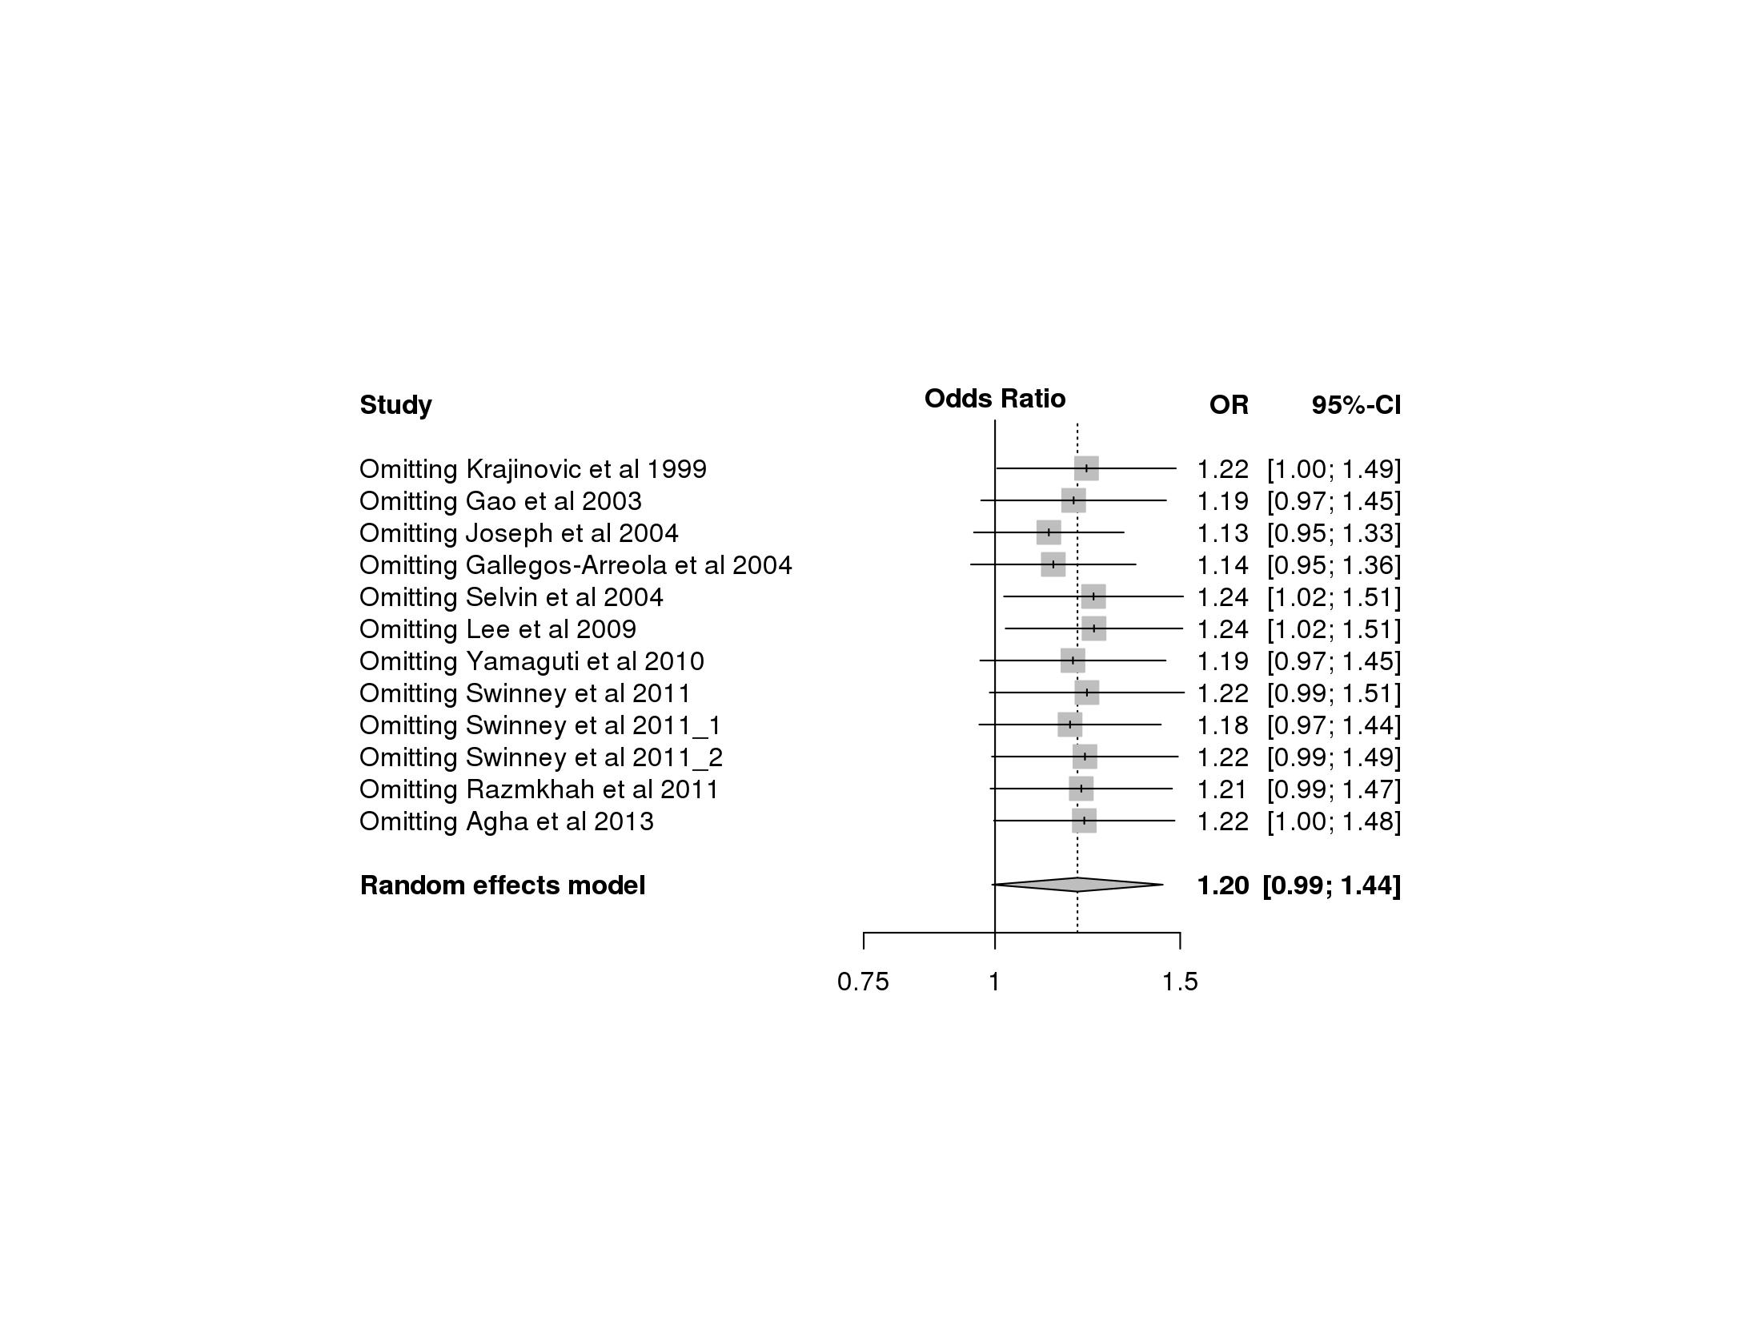  Figure S2: Sensitivity plot of the A2455G polymorphism under different models.  A : Allele contrast model, B : recessive model, C : dominant model, D : homozygous model, E : heterozygous model.  C
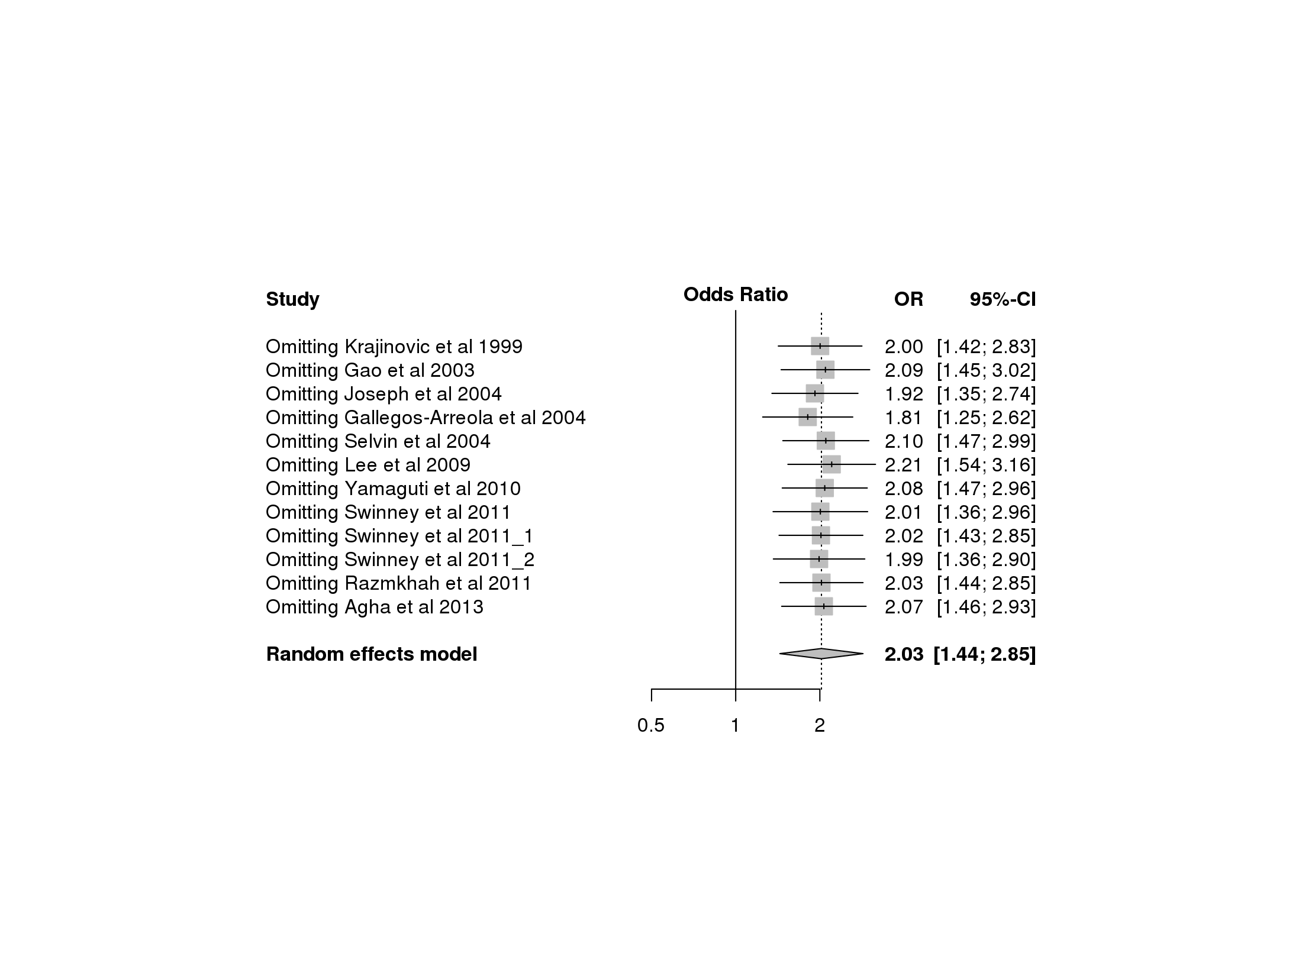  D | 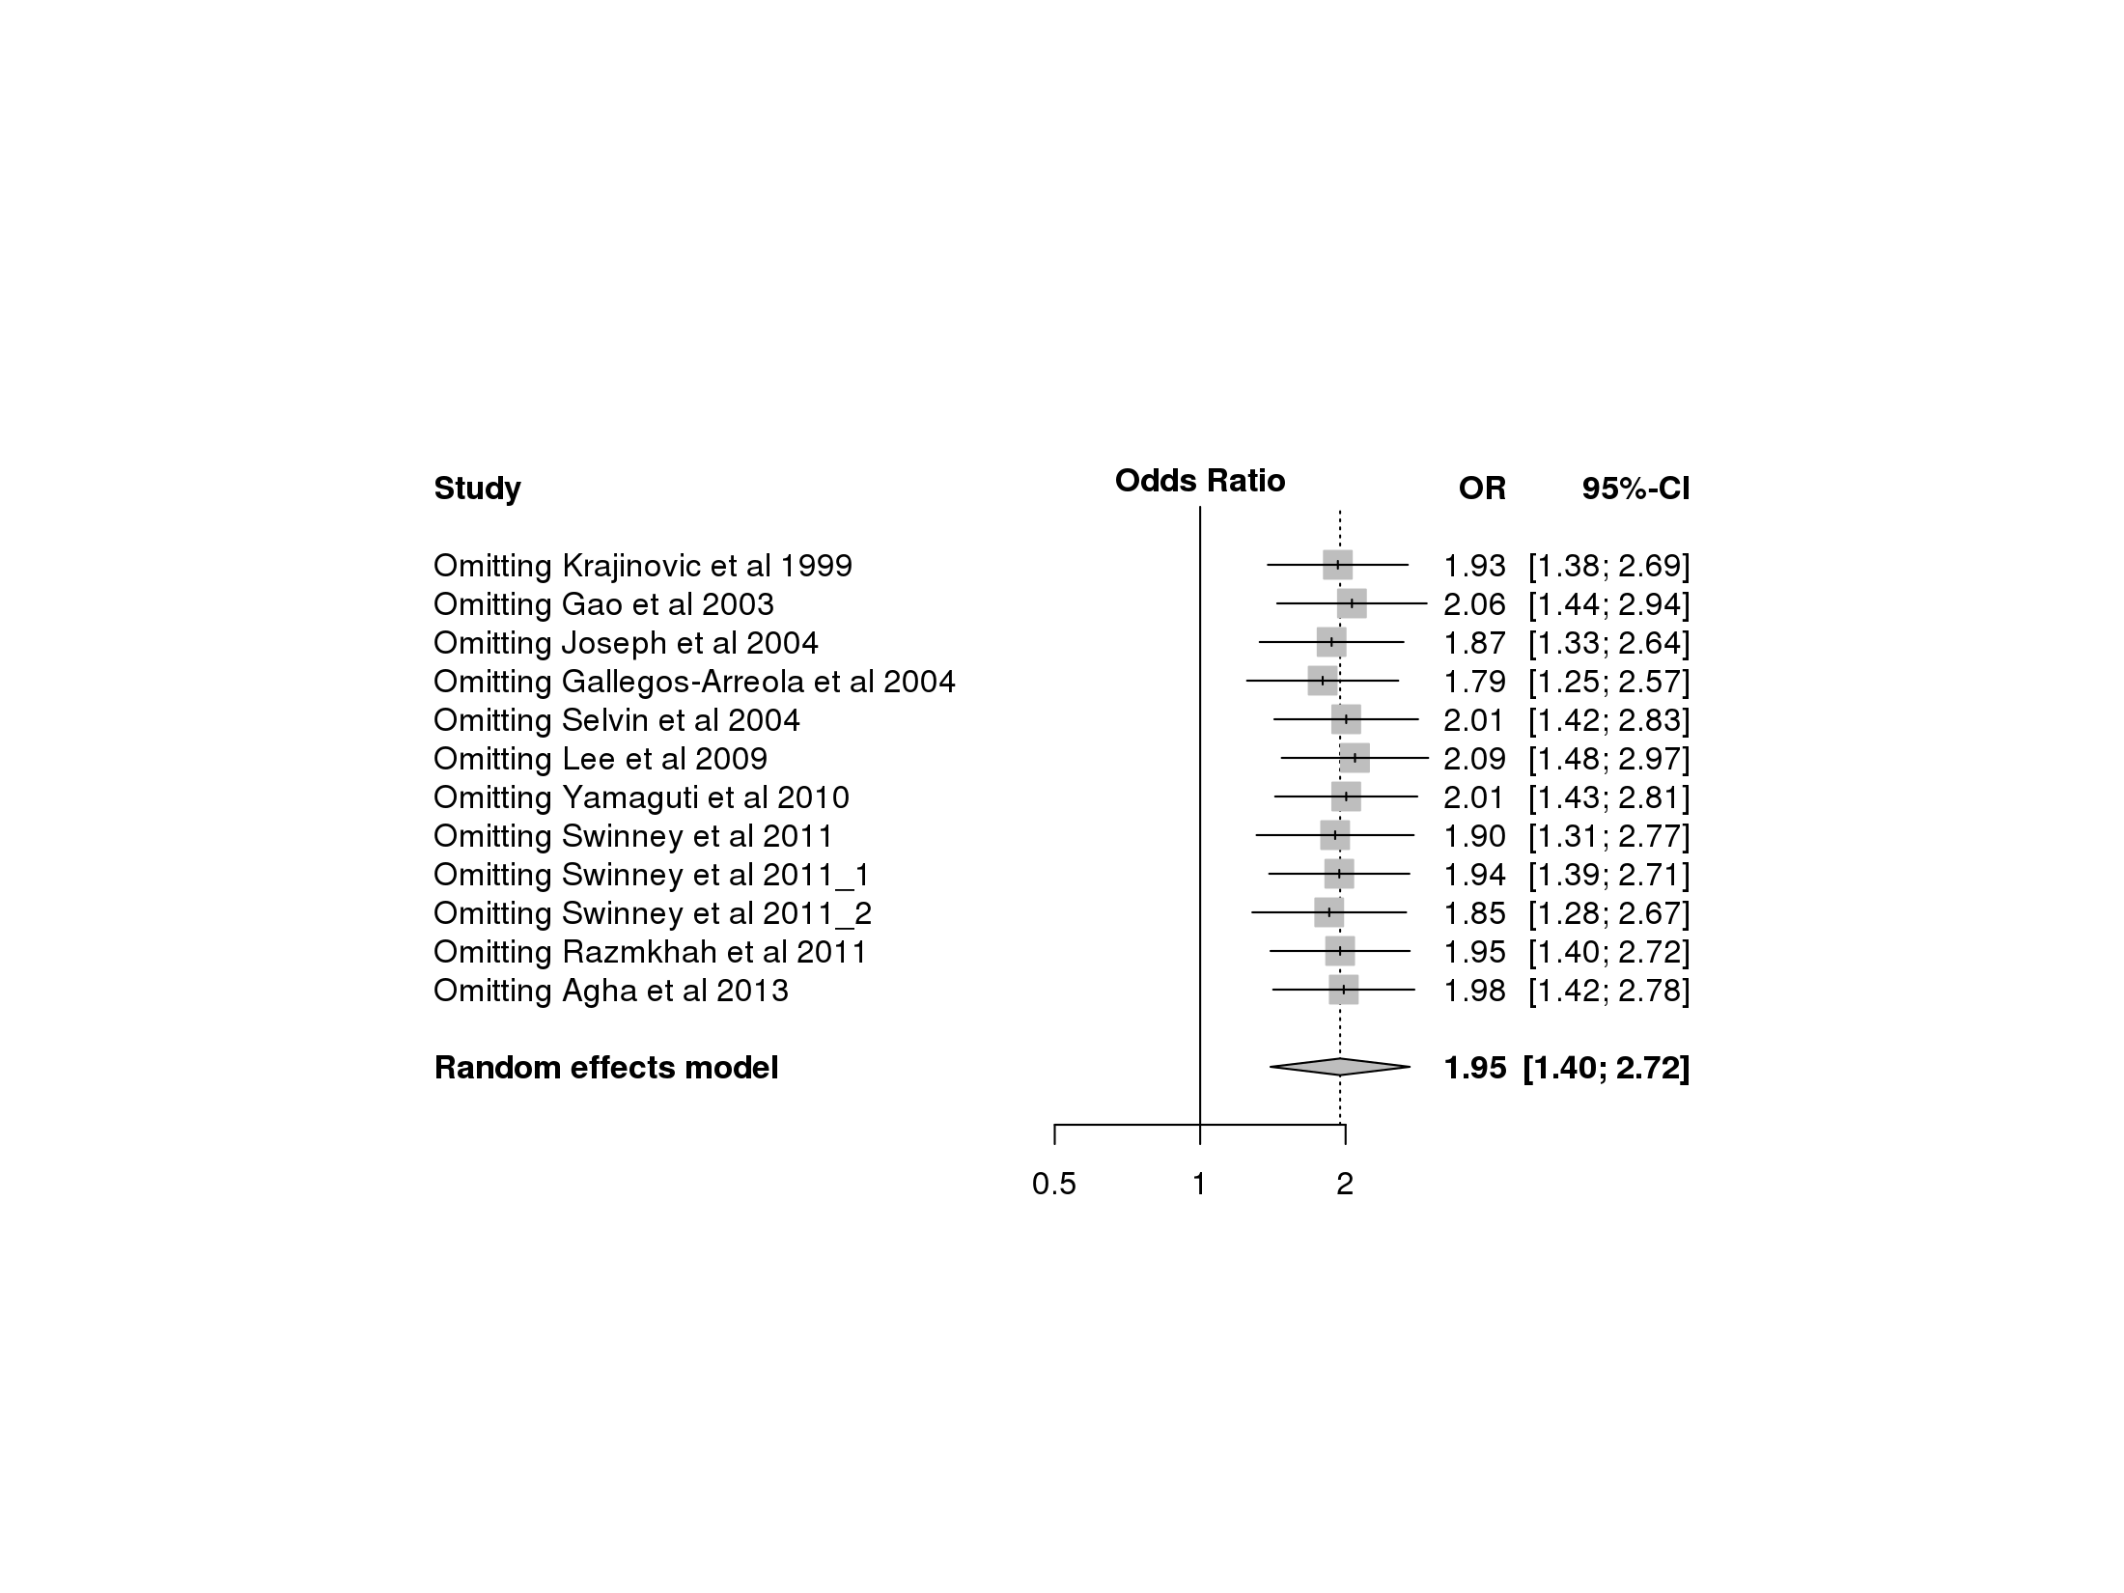  E
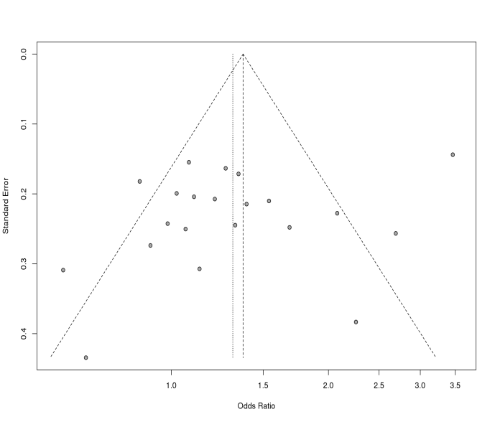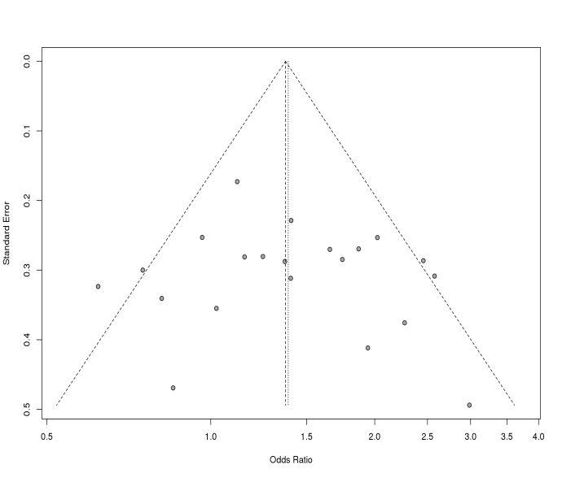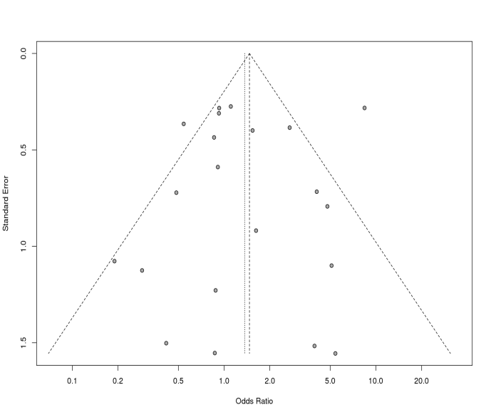
C
A
B
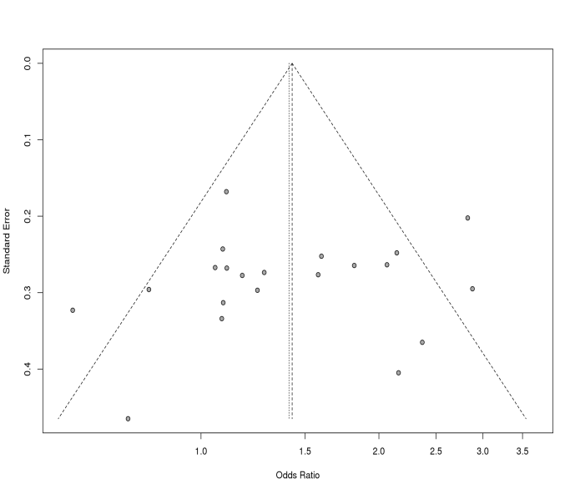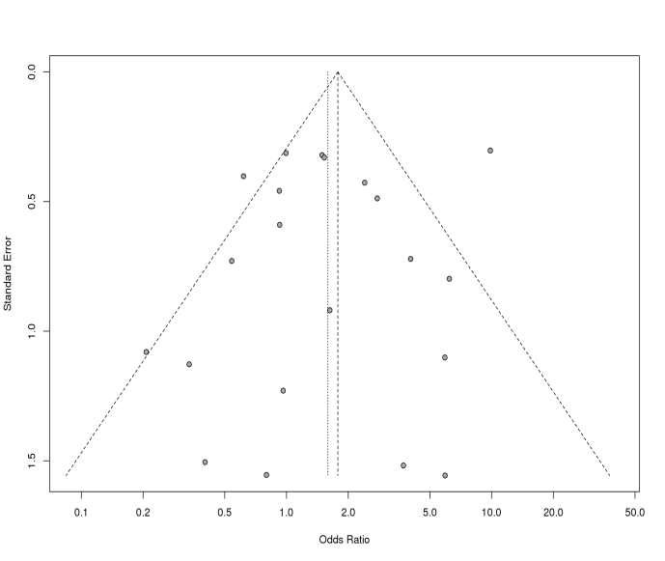
E
D
Figure S3: Funnel plots for different models of T3801C polymorphism
A : Allele contrast model ; B : Recessive model ; C : Dominant model ; D : Homozygous model ; E : Heterozygous model

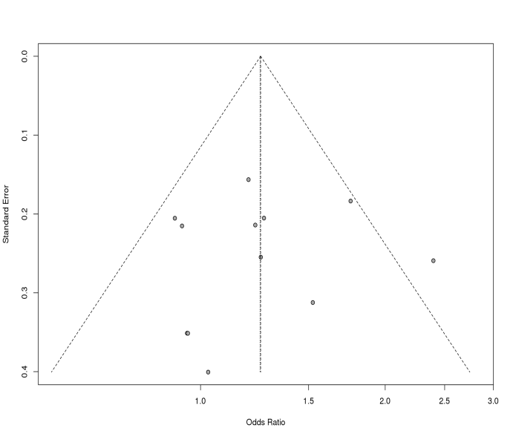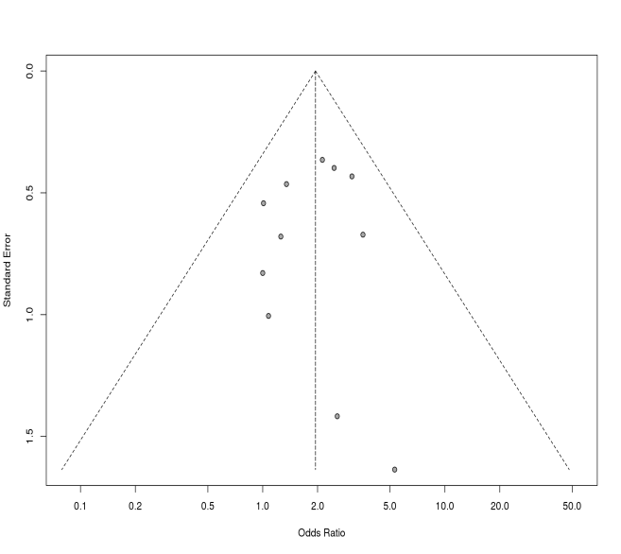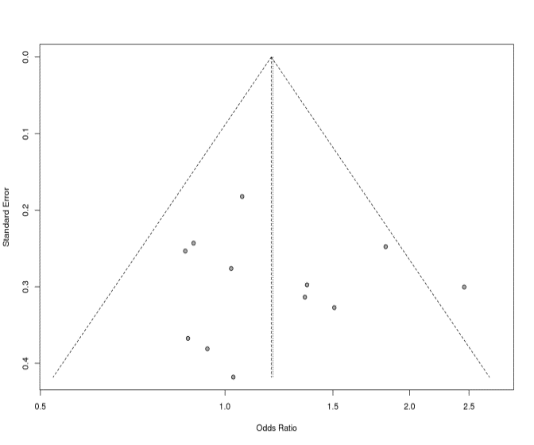
Figure S4: Funnel plots for different models of A2455G polymorphism
A : Allele contrast model ; B : Recessive model ; C : Dominant model ; D : Homozygous model ; E : Heterozygous model

C
B
A
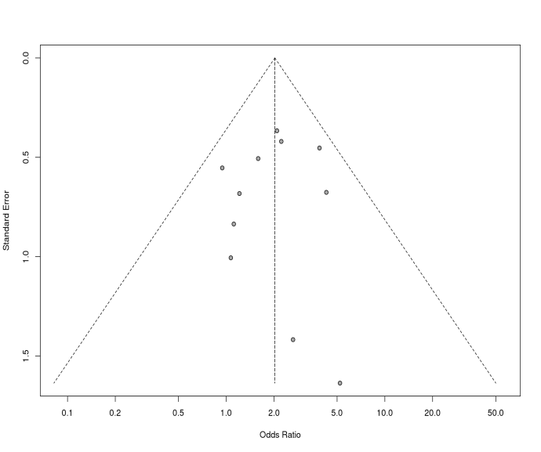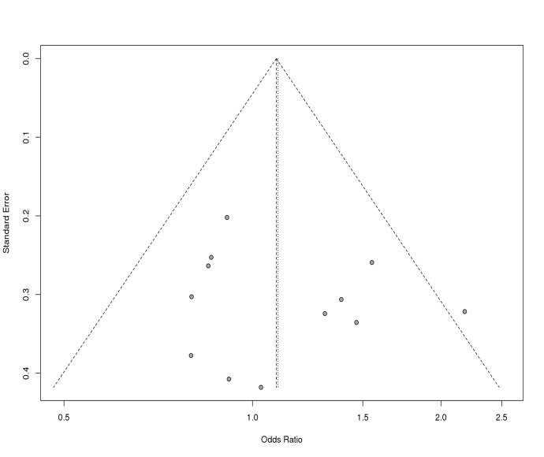
E
D

