Supplementary Information

Increased survival rate by the pediatric acute lymphoblastic leukemia therapy intensification based on minimal residual disease levels along with protocol-based risk classification by early response

Hyery Kim¹, Su Hyun Yoon¹, Sunghan Kang¹, Kyung-Nam Koh¹, Ho Joon Im¹, Chan-Jeoung Park², Mi Young Kim², Young-Uk Cho², Sang-Hyun Hwang², Seongsoo Jang², Jong Jin Seo^{1, 3}

¹Department of Pediatrics, University of Ulsan College of Medicine, Asan Medical Center, Seoul, South Korea
²Department of Laboratory Medicine, University of Ulsan College of Medicine, Asan Medical Center, Seoul, South Korea
³Korean Association for Children with Leukemia and Cancer

Corresponding Author: Hyery Kim, M.D., Ph. D
Email: taban@hanmail.net

Supplementary Table 1. Treatment regimens included in this study
Modified AALL0331
Phase | Treatment
Induction | Dexamethasone | 6 mg/㎡ #2 PO x 28 days, D1-28
 | Vincristine | 1.5 mg/㎡ (Max. 2 mg) IV push, D1, 8, 15, 22
 | L-asparaginase | 6,000 IU/㎡ IM x 9 doses beginning D4 or 5 or 6
 |  | (PEG-asparaginase 2,500 IU/㎡ IM x 1 dose, D4 or 5 or 6)
 | IT Ara-C | 30 mg (1-1.99 yrs), 50 mg (2-2.99 yrs), 70 mg (≥ 3 yrs), D1
 | IT MTX | 8 mg (1-1.99 yrs), 10 mg (2-2.99 yrs), 12 mg (3-8.99 yrs), 15 mg (≥ 9 yrs)
 |  | CNS 1 & 2 - D8, 29 / CNS 3 - D8, *15, *22, 29
Protocol based risk stratification | RER | M1 at day 8 or day 15
Protocol based risk stratification | SER | ㎡ or M3 at day 15
Consolidation | 6-MP | 50 mg/㎡/day PO, D1-14 & D29-42 (OT/PT<5 x UNL)
 | Cyclophophmide | 1,000 mg/㎡ in D5W 100 ml/㎡ IV over 1 hr, D1 & 29 with mesna
 | Ara-C | 75 mg/㎡ IV push or SC, D1-4, 8-11, 29-32, 36-39
 | Vincristine | 1.5 mg/㎡ (Max. 2 mg) IV push, D15, 22, 43, 50
 | L-asparaginase | 6,000 IU/㎡ IM, total 6 doses beginning D15 + total 6 doses beginning D43
 |  | (PEG-asparaginase 2,500 IU/㎡ IM x 1 dose, D4 or 5 or 6)
 | IT MTX | 8 mg (1-1.99 yrs), 10 mg (2-2.99 yrs), 12 mg (3-8.99 yrs), 15 mg (≥ 9 yrs)
 |  | CNS 1 & 2 - D1, 8, *15, *22 / CNS 3 - D1, 8
Interim maintenance (Standard) | Dexamethasone | 6 mg/㎡ #2 PO, D1-5, 29-33
 | Vincristine | 1.5 mg/㎡ (Max. 2 mg) IV push, D1 & 29
 | MTX | 20 mg/㎡/dose PO, D1, 8, 15, 22, 29, 36, 43, 50 (OT/PT<5 x UNL)
 | 6-MP | 50 mg/㎡/day PO, D1-50 (OT/PT<5 x UNL)
 | IT MTX | 8 mg (1-1.99 yrs), 10 mg (2-2.99 yrs), 12 mg (3-8.99 yrs), 15 mg (≥ 9 yrs), D29
Interim maintenance (Augmented)-1 | Vincristine | 1.5 mg/㎡ (Max. 2 mg) IV push, D1, 11, 21, 31, 41
 | MTX | 100 mg/㎡/dose escalate by 50 mg/㎡/dose IV push, D1, 11, 21, 31, 41
 |  | Discontinue excalation and resume at 80% of last dose if delay it necessary for myelosuppression or Gr3 mucositis
 | L-asparaginase | 6,000 IU/㎡ IM, 6 doses beginning D2 + 6 doses beginning D22
 |  | (PEG-asparaginase 2,500 IU/㎡ IM D2 & 22)
 | IT MTX | 8 mg (1-1.99 yrs), 10 mg (2-2.99 yrs), 12 mg (3-8.99 yrs), 15 mg (≥ 9 yrs), D1, 31
Delayed intensification (Standard) | Dexamethasone | 10 mg/㎡ #2 PO, D1-21 (Do not taper)
 | Vincristine | 1.5 mg/㎡ (Max. 2 mg) IV push, D1, 8, 15
 | Doxorubicin | 25 mg/㎡ IV over 5 mins, D1, 8, 15
 | L-asparaginase | 6,000 IU/㎡ IM x 6 doses, beginning D4 or 5 or 6
 |  | (PEG-asparaginase 2,500 IU/㎡ IM D4 or 5 or 6)
 | Cyclophophmide | 1,000 mg/㎡ in D5W 100 ml/㎡ IV over 1 hr, D29
 | Mesna | 200 mg/㎡ in D5W (≥ 10kg 50 ml, < 10kg 30 ml) IV over 15 mins, pre -15 mins & post HR3, 6, 9
 | 6-MP | 50 mg/㎡/day PO, D29-42 (OT/PT<5 x UNL)
 | Ara-C | 75 mg/㎡ IV push or SC, D29-32 & 36-39
 | IT MTX | 8 mg (1-1.99 yrs), 10 mg (2-2.99 yrs), 12 mg (3-8.99 yrs), 15 mg (≥ 9 yrs), D1, 29
Delayed intensification (Augmented)-1 | Dexamethasone | 10 mg/㎡ #2 PO, D1-21 (Do not taper)
 | Vincristine | 1.5 mg/㎡ (Max. 2 mg) IV push, D1, 8, 15, 43, 50
 | Doxorubicin | 25 mg/㎡ IV over 5 mins, D1, 8, 15
 | L-asparaginase | 6,000 IU/㎡ IM, 6 doses beginning D4 or 5 or 6 + 6 doses beginning D43
 |  | (PEG-asparaginase 2,500 IU/㎡ IM D4 or 5 or 6 and D43)
 | Cyclophophmide | 1,000 mg/㎡ in D5W 100 ml/㎡ IV over 1 hr, D29
 | Mesna | 200 mg/㎡ in D5W (≥ 10kg 50 ml, < 10kg 30 ml) IV over 15 mins, pre -15 mins & post HR3, 6, 9
 | 6-MP | 50 mg/㎡/day PO, D29-42 (OT/PT<5 x UNL)
 | Ara-C | 75 mg/㎡ IV push or SC, D29-32 & 36-39
 | IT MTX | 8 mg (1-1.99 yrs), 10 mg (2-2.99 yrs), 12 mg (3-8.99 yrs), 15 mg (≥ 9 yrs), D1, 29, 36
Interim maintenance (Augmented)-2 | Vincristine | 1.5 mg/㎡ (Max. 2 mg) IV push, D1, 11, 21, 31, 41
 | MTX | 50 mg/㎡/dose less than Max. dose from previous escalated dose in IM-1.
 |  | escalate by 50 mg/㎡/dose IV push, D1, 11, 21, 31, 41
 |  | Discontinue excalation and resume at 80% of last dose if delay it necessary for myelosuppression or Gr3 mucositis
 | L-asparaginase | 6,000 IU/㎡ IM, 6 doses beginning D2 + 6 doses beginning D22
 |  | (PEG-asparaginase 2,500 IU/㎡ IM D2 & 22)
 | IT MTX | 8 mg (1-1.99 yrs), 10 mg (2-2.99 yrs), 12 mg (3-8.99 yrs), 15 mg (≥ 9 yrs), D1, 31
Delayed intensification (Augmented)-2 | Dexamethasone | 10 mg/㎡ #2 PO, D1-21 (Do not taper)
 | Vincristine | 1.5 mg/㎡ (Max. 2 mg) IV push, D1, 8, 15, 43, 50
 | Doxorubicin | 25 mg/㎡ IV over 5 mins, D1, 8, 15
 | L-asparaginase | 6,000 IU/㎡ IM, 6 doses beginning D4 or 5 or 6 + 6 doses beginning D43
 |  | (PEG-asparaginase 2,500 IU/㎡ IM D4 or 5 or 6 and D43)
 | Cyclophophmide | 1,000 mg/㎡ in D5W 100 ml/㎡ IV over 1 hr, D29
 | Mesna | 200 mg/㎡ in D5W (≥ 10kg 50 ml, < 10kg 30 ml) IV over 15 mins, pre -15 mins & post HR3, 6, 9
 | 6-MP | 50 mg/㎡/day PO, D29-42 (OT/PT<5 x UNL) (Do not give to pts receiving Cranial RT)
 | Ara-C | 75 mg/㎡ IV push or SC, D29-32 & 36-39
 | IT MTX | 8 mg (1-1.99 yrs), 10 mg (2-2.99 yrs), 12 mg (3-8.99 yrs), 15 mg (≥ 9 yrs), D1, 29, *36 (Do not give to pts receiving Cranial RT)
 |  | * Omit D36 IT MTX and the 2 weeks of 6-MP (D29-42) for pts receiving cranial RT
Maintenance | Vincristine | 1.5 mg/㎡ (Max. 2 mg) IV push every 4 weeks, D1, 29, 57
 | Dexamethasone | 6 mg/㎡ #2 PO 5 days every 4 weeks, D1-5, 29-33, 57-61 (Do not taper)
 | 6-MP | 50 mg/㎡/day PO, D1-84 (OT/PT<5 x UNL). Dose escalation during Maintenance.
 | MTX | 20 mg/㎡/dose PO weekly, D8, 15, 22, 29, 36, 43, 50, 57, 64, 71, 78 (OT/PT<5 x UNL). Dose escalation during Main.
 | IT MTX | 8 mg (1-1.99 yrs), 10 mg (2-2.99 yrs), 12 mg (3-8.99 yrs), 15 mg (≥ 9 yrs), D1
Korean multicenter study 0601 regimen
Phase | Treatment
Induction | PD | 60 mg/㎡ #3 PO, D0-27, then taper over 2 wks
 | Vincristine | 1.5 mg/㎡ (Max. 2 mg) IV push, D0, 7, 14, 21
 | Daunomycin | 25 mg/㎡ IV over 5 mins, D0, 7, *14, *21
 |  | (*Day 14 & 21 ANC ≥500/μL, PLT ≥50K/μL / If Day 14 bone marrow shows M3, administer regardless of ANC)
 | L-asparaginase | 6,000 IU/㎡ IM x 3/wk, beginning D3, total 9 doses
 | IT Ara-C | 1-2 Yr 30 mg, 2-3 Yr 50 mg, ≥ 3 Yr 70 mg, D0
 | IT MTX | 8 mg(1-1.99 yrs), 10 mg(2-2.99 yrs), 12 mg(3-8.99 yrs), 15 mg(≥ 9 yrs)
Protocol based risk stratification | RER | M1 or ㎡ at day 8
Protocol based risk stratification | SER | M3 at day 8, or extramedullary involvement, MLL rearrangement
Consolidation | Cyclophosphamide | 1,000 mg/㎡ in D5W (≥ 10kg 100 ml, < 10kg 50 ml) IV over 30 mins, D0 & 28 with mesna
 | 6-MP | 50 mg/㎡/day PO, D0-13, D28-41
 | Ara-C | 75 mg/㎡ IV or SC x 16 doses, D0-3, 7-10, 28-31, 35-38
 | Vincristine | 1.5 mg/㎡ (Max. 2 mg) IV push, D14, 21, 42, 49
 | L-asparaginase | 6,000 IU/㎡ IM, D14, 16, 18, 21, 23, 25, 42, 44, 46, 49, 51, 53
 | IT MTX | 8 mg(1-1.99 yrs), 10 mg(2-2.99 yrs), 12 mg(3-8.99 yrs), 15 mg(≥ 9 yrs), D0, 7, 14, 21
Interim maintenance (RER) | Vincristine | 1.5 mg/㎡ (Max. 2 mg) IV push, D0, 10, 20, 30, 40
 | MTX | 100 mg/㎡(initial dose) IV push, D0, 10, 20, 30, 40 escalate by 50 mg/㎡/dose to toxicity
 | L-asparaginase | 15,000 IU/㎡ IM, D1, 11, 21, 31, 41
 | IT MTX | 8 mg(1-1.99 yrs), 10 mg(2-2.99 yrs), 12 mg(3-8.99 yrs), 15 mg(≥ 9 yrs), D0 & 20
Delayed intensification (RER) | Vincristine | 1.5 mg/㎡ (Max. 2 mg) IV push, D0, 7, 14, 42, 49
 | Adriamycin | 25 mg/㎡ IV over 5 mins, D0, 7, 14 (ANC≥500/ul, PLT≥50K/ul)
 | L-asparaginase | 6000 IU/㎡ x 12 doses IM, (D3-14 ; 6 doses) & (D42-53 ; 6 doses)
 | Dexamethasone | 10 mg/㎡/day #3 PO, D0-6 & D14-20 (no taper)
 | Cyclophophamide | 1,000 mg/㎡ in D5W 100 ml/㎡ IV over 1 hr, D28 with mesna
 | 6-MP | 50 mg/㎡/day PO, D28-41 (T-bil>2 mg/dl hold)
 | Ara-C | 75 mg/㎡/day IV or SC, D28-31, 35-38
 | IT MTX | 8 mg(1-1.99 yrs), 10 mg(2-2.99 yrs), 12 mg(3-8.99 yrs), 15 mg(≥ 9 yrs), D0, 28, 35
Interim maintenance (SER) #1 | Vincristine | 1.5 mg/㎡ (Max. 2 mg) IV push, D0, 10, 20, 30, 40
 | MTX | 100 mg/㎡(initial dose) IV push, D0, 10, 20, 30, 40 escalate by 50 mg/㎡/dose to toxicity
 | L-asparaginase | 15,000 IU/㎡ IM, D1, 11, 21, 31, 41
 | IT MTX | 8 mg(1-1.99 yrs), 10 mg(2-2.99 yrs), 12 mg(3-8.99 yrs), 15 mg(≥ 9 yrs), D0 & 20
Delayed intensification (SER) #1 | Vincristine | 1.5 mg/㎡ (Max. 2 mg) IV push, D0, 7, 14, 42, 49
 | Adriamycin | 25 mg/㎡ IV over 5 mins, D0, 7, 14 (ANC≥500/ul, PLT≥50K/ul)
 | L-asparaginase | 6,000 IU/㎡ x 12 doses IM, (D3-14 ; 6 doses) & (D42-53 ; 6 doses)
 | Dexamethasone | 10 mg/㎡/day #3 PO, D0-6 & D14-20 (no taper)
 | Cyclophophamide | 1,000 mg/㎡ in D5W 100 ml/㎡ IV over 1 hr, D28 with mesna
 | 6-MP | 50 mg/㎡/day PO, D28-41 (T-bil>2 mg/dl hold)
 | Ara-C | 75 mg/㎡/day IV or SC, D28-31, 35-38
 | IT MTX | 8 mg(1-1.99 yrs), 10 mg(2-2.99 yrs), 12 mg(3-8.99 yrs), 15 mg(≥ 9 yrs), D0, 28, 35
Interim maintenance (SER) #2 | Same as IM #1
Delayed intensification (SER) #2 | Vincristine | 1.5 mg/㎡ (Max. 2 mg) IV push, D0, 7, 14, 42, 49
 | Daunorubicin | 25 mg/㎡ IV over 5 mins, D0, 7, 14 (ANC≥500/ul, PLT≥50K/ul)
 | L-asparaginase | 6,000 IU/㎡ x 12 doses IM, (D3-14 ; 6 doses) & (D42-53 ; 6 doses)
 | Dexamethasone | 10 mg/㎡/day #3 PO, D0-6 & D14-20 (no taper)
 | Cyclophophamide | 1,000 mg/㎡ in D5W 100 ml/㎡ IV over 1 hr, D28 with mesna
 | 6-MP | 50 mg/㎡/day PO, D28-41 (*Omit when Cranial RT) (T-bil>2 mg/dl hold)
 | Ara-C | 75 mg/㎡/day IV or SC, D28-31, 35-38
 | IT MTX | 8 mg(1-1.99 yrs), 10 mg(2-2.99 yrs), 12 mg(3-8.99 yrs), 15 mg(≥ 9 yrs), D0, 28, **35 (Skip Day 35 if Cranial RT is given)
 | RT | Cranial or CSRT should begin by D29 of DI #2 therapy when ANC≥750/ul, PLT≥75K/ul
 |  | (all SER - Cranial RT(12Gy) / CNS3 - CSRT(cranial 18Gy, spinal 6Gy) /Exception : RER testicular ALL cases)
Maintenance | Vincristine | 1.5 mg/㎡ (Max. 2 mg) IV push every 4 weeks, D0, 28, 56
 | PD | 40 mg/㎡ #3 PO 5 days every 4 weeks, D0-4, 28-32, 56-60 (Do not taper)
 | 6-MP | 50 mg/㎡/day PO, D0-83 (Dose adjust ANC 750-1500/ul, PLT>75K/ul)
 | MTX | 20 mg/㎡/dose PO weekly, D7, 14, 21, (**28), 35, 42, 49, 56, 63, 70, 77 (**Omit when IT MTX is given)
 | IT MTX | 8 mg(1-1.99 yrs), 10 mg(2-2.99 yrs), 12 mg(3-8.99 yrs), 15 mg(≥ 9 yrs), D0 & *28 (Day 28 is administered up to 4 cycles only)
Korean multicenter study 1501 regimen
Phase | Treatment
Induction | PD | 60 mg/㎡ #3 PO, D0-27, then taper over 2 wks
 | Vincristine | 1.5 mg/㎡ (Max. 2 mg) IV push, D0, 7, 14, 21
 | Daunomycin | 25 mg/㎡ IV over 5 mins, D0, 7, 14, 21
 |  | (*Day 14 & 21 ANC ≥500/μL, PLT ≥50K/μL / If Day 14 bone marrow shows M3, administer regardless of ANC)
 | L-asparaginase | 6,000 IU/㎡ IM x 3/wk, beginning D3, total 9 doses
 | IT Ara-C | 1-2 Yr 30 mg, 2-3 Yr 50 mg, ≥ 3 Yr 70 mg, D0
 | IT MTX | 8 mg(1-1.99 yrs), 10 mg(2-2.99 yrs), 12 mg(3-8.99 yrs), 15 mg(≥ 9 yrs)
Protocol based risk stratification | RER | M1 or ㎡ at day 8 & M1 at day 15
Protocol based risk stratification | SER | other than RER, extramedullary involvement, WBC≥100,000/uL
Consolidation | Cyclophosphamide | 1,000 mg/㎡ in D5W (≥ 10kg 100 ml, < 10kg 50 ml) IV over 30 mins, D0 & 28 with mesna
 | 6-MP | 50 mg/㎡/day PO, D0-13, D28-41
 | Ara-C | 75 mg/㎡ IV or SC x 16 doses, D0-3, 7-10, 28-31, 35-38
 | Vincristine | 1.5 mg/㎡ (Max. 2 mg) IV push, D14, 21, 42, 49
 | L-asparaginase | 6,000 IU/㎡ IM, D14, 16, 18, 21, 23, 25, 42, 44, 46, 49, 51, 53
 | IT-Triple | Age-adjusted, D0, 7, 14, 21
Interim maintenance (RER) #1 | Vincristine | 1.5 mg/㎡ (Max. 2 mg) IV push, D0, 10, 20, 30, 40
 | MTX | 100 mg/㎡(initial dose) IV push, D0, 10, 20, 30, 40 escalate by 50 mg/㎡/dose to toxicity
 | L-asparaginase | 15,000 IU/㎡ IM, D1, 11, 21, 31, 41
 | IT-Triple | Age-adjusted, D0, 20
Interim maintenance (SER) #1 | Vincristine | 1.5 mg/㎡ (Max. 2 mg) IV push, D0, 28
 | MTX | 5,000 mg/㎡, D0, 7, 14, 28, 42, with leucovorin
 | 6-MP | 50 mg/㎡/day PO, D0-56, daily
 | IT-Triple | Age-adjusted, D0, 28
Delayed intensification #1 | Vincristine | 1.5 mg/㎡ (Max. 2 mg) IV push, D0, 7, 14, 42, 49
 | Adriamycin | 25 mg/㎡ IV over 5 mins, D0, 7, 14 (ANC≥500/ul, PLT≥50K/ul)
 | L-asparaginase | 6,000 IU/㎡ x 12 doses IM, (D3-14 ; 6 doses) & (D42-53 ; 6 doses)
 | Dexamethasone | 10 mg/㎡/day #3 PO, D0-6 & D14-20 (no taper)
 | Cyclophophamide | 1,000 mg/㎡ in D5W 100 ml/㎡ IV over 1 hr, D28 with mesna
 | 6-MP | 50 mg/㎡/day PO, D28-41 (T-bil>2 mg/dl hold)
 | Ara-C | 75 mg/㎡/day IV or SC, D28-31, 35-38
 | IT-Triple | Age-adjusted, D0, 28, 35
Interim maintenance (RER) #1 | Same as IM-RER #2
Interim maintenance (SER) #1 | Same as IM-SER #2
Delayed intensification #2 | Vincristine | 1.5 mg/㎡ (Max. 2 mg) IV push, D0, 7, 14, 42, 49
 | Daunomycin | 25 mg/㎡IV over 5 mins, D0, 7, 14 (ANC ≥500/ul, PLT ≥50K/ul)
 | L-asparaginase | 6,000 IU/㎡ x 12 doses IM, (D3-14 ; 6 doses) & (D42-53 ; 6 doses)
 | Dexamethasone | 10 mg/㎡/day #3 PO, D0-6 & D14-20 (no taper)
 | Cyclophophamide | 1,000 mg/㎡ in D5W 100 ml/㎡ IV over 1 hr, D28 with mesna
 | 6-MP | 50 mg/㎡/day PO, D28-41 (T-bil>2 mg/dl hold)
 | Ara-C | 75 mg/㎡/day IV or SC, D28-31, 35-38
 | IT-Triple | Age-adjusted, D0, 7, 14, 21
Maintenance (RER) | Vincristine | 1.5 mg/㎡ (Max. 2 mg) IV push every 4 weeks, D0, 28, 56
 | PD | 40 mg/㎡ #3 PO 5 days every 4 weeks, D0-4, 28-32, 56-60 (Do not taper)
 | 6-MP | 50 mg/㎡/day PO, D0-83 (Dose adjust ANC 750-1500/ul, PLT>75K/ul)
 | MTX | 20 mg/㎡/dose PO weekly, D7, 14, 21, (**28), 35, 42, 49, 56, 63, 70, 77 (**Omit when IT MTX is given)
 | IT-Triple | Age-adjusted, D0, 28 (up to cycle 4)
Maintenance (SER) | Vincristine | 1.5 mg/㎡ (Max. 2 mg) IV push every 4 weeks, D0, 28, 56
 | PD | 40 mg/㎡ #3 PO 5 days every 4 weeks, D0-4, 28-32, 56-60 (Do not taper)
 | 6-MP | 50 mg/㎡/day PO, D0-83 (Dose adjust ANC 750-1500/ul, PLT>75K/ul)
 | MTX | 20 mg/㎡/dose PO weekly, D7, 14, 21, (**28), 35, 42, 49, 56, 63, 70, 77 (**Omit when IT MTX is given)
 | IT-Triple | Age-adjusted, D0
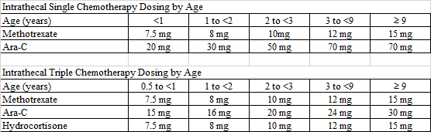
Abbreviations: ALL, acute lymphoblastic leukemia; PO, per os; IV, intravenous; IM, intramuscular; SC, subcutaneous; IT, intrathecal; ITT, intrathecal triple; MTX, methotrexate; Ara-C, cytarabine; 6-MP, 6-mercaptopurine; PD, prednisolone; CNS, central nervous system; RT, radiotherapy; CSRT, craniospinal radiotherapy; RER, rapid early responder; SER, slow early responder; ANC, absolute neutrophil count; PLT, platelets; WBC, white blood cell; PEG, polyethylene glycol; D5W, 5% dextrose in water; OT, SGOT (serum glutamic oxaloacetic transaminase); PT, SGPT (serum glutamic pyruvic transaminase); UNL, upper normal limit; HR, hour; T-bil, total bilirubin

Supplementary Fig. 1 Flowchart summarizing patient classification, minimal residual disease Status, and treatment intensification in the analytic cohort

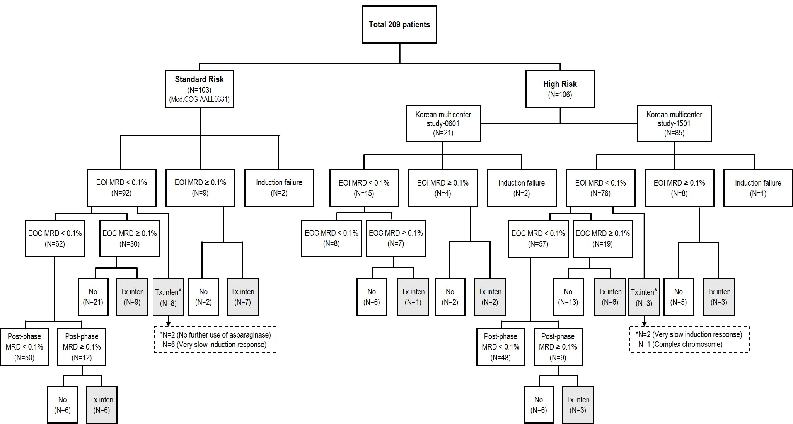
Supplementary Table 2. Results of minimal residual disease assessment
High MRD during the overall period
 | No. of Total |  | ~2015 (N = 55) |  | 2016–2019  (N = 77) |  | 2020–2023  (N = 72) |  | Subtotal | (%)
SR | 101 |  | 15 |  | 22 |  | 15 |  | 52 | 51.5
HR | 103 |  | 14 |  | 21 |  | 14 |  | 49 | 47.6
Total | 204 |  | 29 (52.7%) |  | 43 (55.8%) |  | 29 (40.3%) |  | 101 | 49.5
EOI High MRD
 | No. of Total |  | ~2015 (N = 55) |  | 2016–2019  (N = 77) |  | 2020–2023  (N = 72) |  | Subtotal | (%)
SR | 101 |  | 2 |  | 2 |  | 5 |  | 9 | 8.9
HR | 103 |  | 5 |  | 2 |  | 5 |  | 12 | 11.7
Total | 204 |  | 7 (12.7%) |  | 4 (5.2%) |  | 10 (13.9%) |  | 21 | 10.3
EOC High MRD
 | No. of Total |  | ~2015 (N = 55) |  | 2016–2019  (N = 77) |  | 2020–2023  (N = 72) |  | Subtotal | (%)
SR | 101 |  | 15 |  | 15 |  | 5 |  | 35 | 34.7
HR | 103 |  | 12 |  | 14 |  | 6 |  | 32 | 31.1
Total | 204 |  | 27 (49.1%) |  | 29 (37.7%) |  | 11 (15.3%) |  | 67 | 32.8
Post-phase (after consolidation blocks) High MRD
 | No. of Total | ~2015 (N = 55) |  | 2016–2019  (N = 77) |  | 2020–2023  (N = 72) |  | Subtotal |  | (%)
SR | 101 | 14 |  | 22 |  | 10 |  | 46 |  | 45.5
HR | 103 | 14 |  | 19 |  | 13 |  | 46 |  | 44.7
Total | 204 | 28 (50.9%) |  | 41 (53.2%) |  | 23 (31.9%) |  | 92 |  | 45.1
Post-phase (after consolidation blocks) High MRD Only
 | No. of Total | ~2015 (N = 55) |  | 2016–2019  (N = 77) |  | 2020–2023  (N = 72) |  | Subtotal |  | (%)
SR | 101 | 1 |  | 0 |  | 1 |  | 2 |  | 2.0
HR | 103 | 0 |  | 2 |  | 0 |  | 2 |  | 1.9
Total | 204 | 1 (1.8%) |  | 2 (2.6%) |  | 1 (1.4%) |  | 4 |  | 2.0
Treatment intensification d/t high MRD
 | No. of Total | ~2015 (N = 55) |  | 2016–2019  (N = 77) |  | 2020–2023  (N = 72) |  | Subtotal |  | (%)
SR | 101 | 1 |  | 14 |  | 7 |  | 22  (RER 19, SER 3) |  | 21.8
HR | 103 | 4 |  | 8 |  | 3 |  | 15  (RER 15) |  | 14.6
Total | 204 | 5 (9.1%) |  | 22 (28.6%) |  | 10 (13.9%) |  | 37 |  | 18.3
Proportion of treatment intensified patients among patients with high MRD
 | No. of Total | ~2015 (N = 29) |  | 2016–2019  (N = 43) |  | 2020–2023  (N = 29) |  | Subtotal |  | (%)
SR | 52 | 1 |  | 14 |  | 7 |  | 22  (RER 19, SER 3) |  | 42.3
HR | 49 | 4 |  | 8 |  | 3 |  | 15  (RER 15) |  | 30.6
Total | 101 | 5 (17.2%) |  | 22 (51.2%) |  | 10 (34.5%) |  | 37 |  | 36.6
Abbreviations: EOI, end of induction; EOC, end of consolidation; MRD, minimal residual disease; SR, standard risk; HR, high risk; RER, rapid early responder; SER, slow early responder
Supplementary Fig. 2 Five-year event-free survival rates using flow cytometric MRD grades

- Event-free survival by the end of induction (EOI) MRD
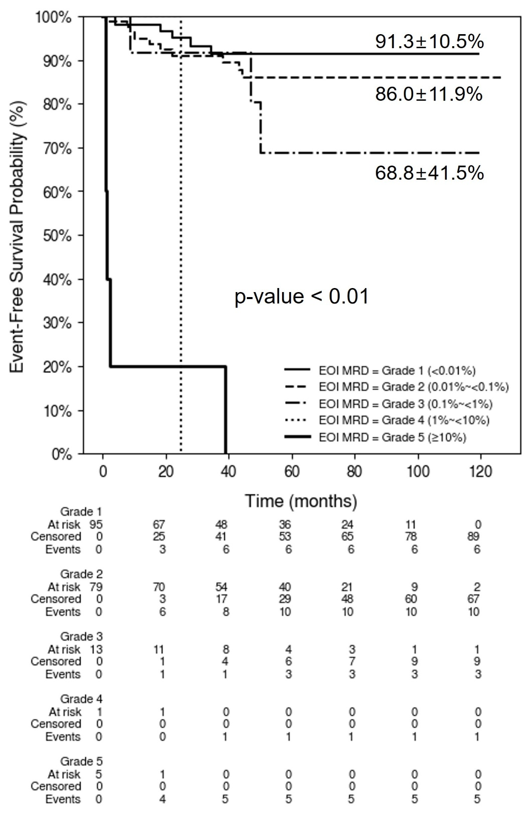

- Event-free survival by end of consolidation (EOC) MRD
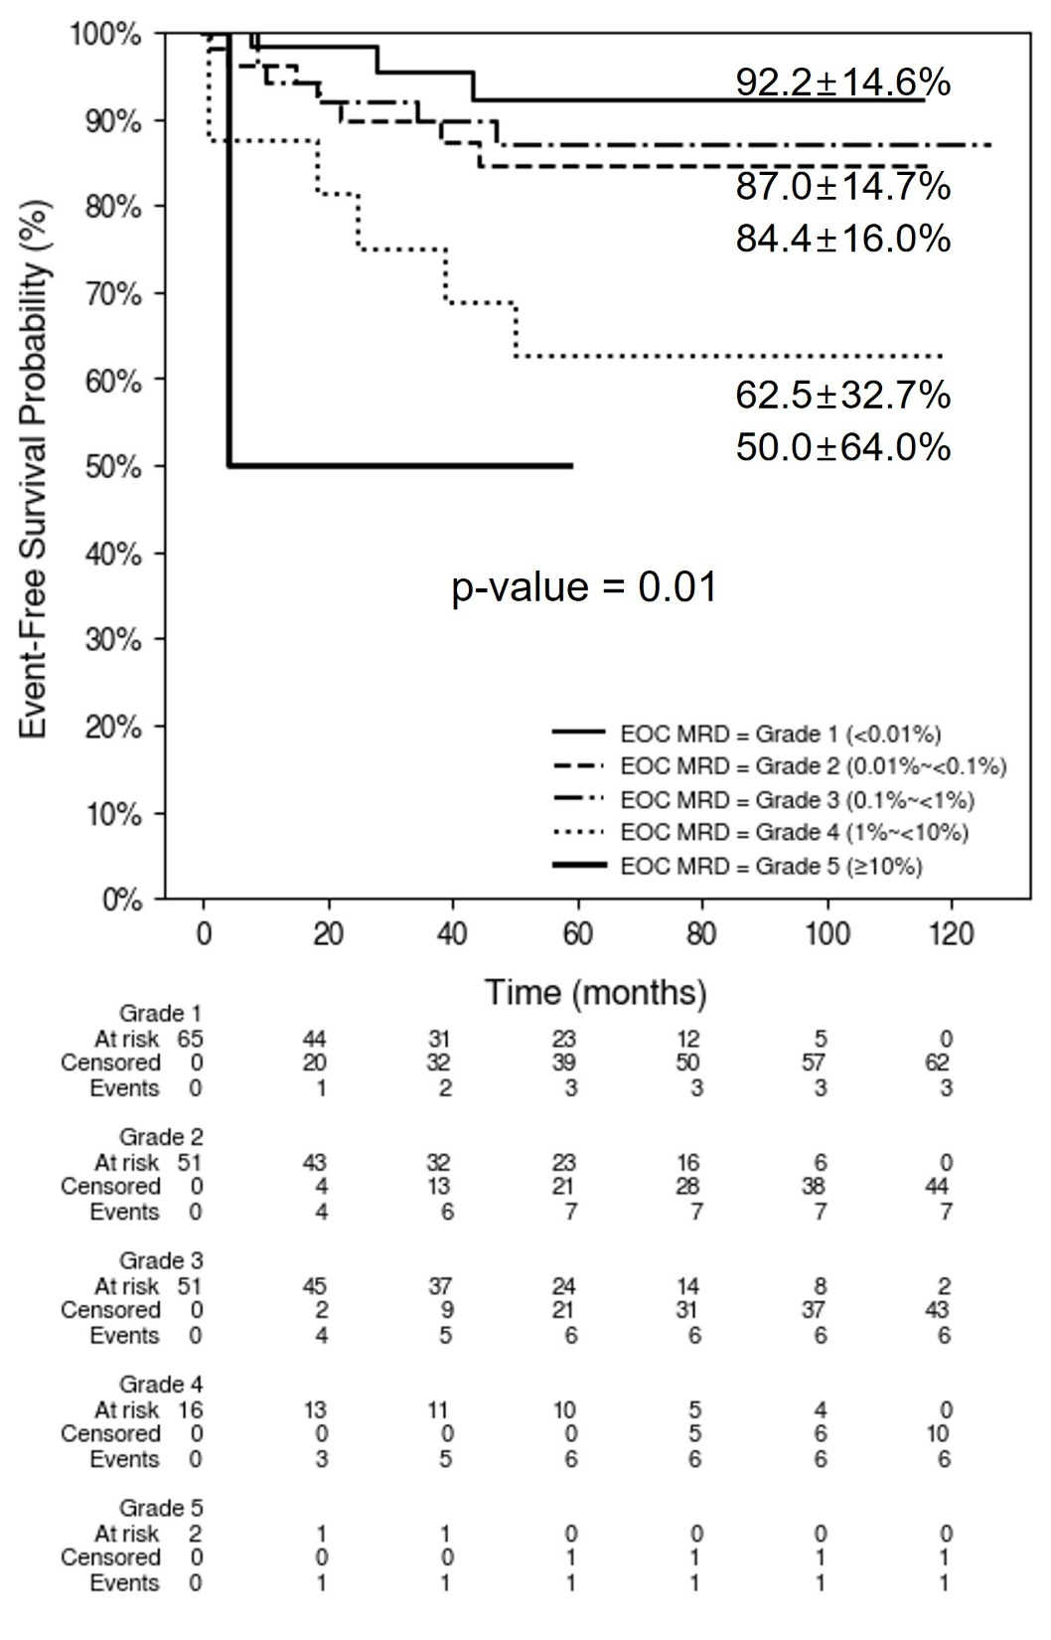

Supplementary Table 3. Characteristics of the patients by treatment intensification
 |  | No intensification |  | Treatment intensification |  | P
 |  | N=63 |  | N=38 |  | P
Age | median (range, years) | 5.2 (1.3~17) |  | 5.4 (1.3~14.6) |  | 0.06
WBC | median (range, /uL) | 22,600 (600~357,900) |  | 9,900 (500~441,000) |  | 0.16
Sex | F | 28 | 44.4% | 23 | 60.5% | 0.12
Sex | M | 35 | 55.6% | 15 | 39.5% | 0.12
Immunophenotype | B-cell | 58 | 92.1% | 37 | 97.4% | 0.27
Immunophenotype | T-cell | 5 | 7.9% | 1 | 2.6% | 0.27
Moleculargenetics | B lymphoblastic leukemia/lymphoma, NOS | 20 | 31.7% | 16 | 42.1% | 0.21
Moleculargenetics | B lymphoblastic leukemia/lymphoma with t(1;19)(q23;p13.3); E2A::PBX1 (TCF3::PBX1) | 8 | 12.7% | 1 | 2.6% | 0.21
Moleculargenetics | B lymphoblastic leukemia/lymphoma with t(12;21)(p13;q22); TEL::AML1 (ETV6::RUNX1) | 10 | 15.9% | 6 | 15.8% | 0.21
Moleculargenetics | B lymphoblastic leukemia/lymphoma with FUS::ERG | 0 | 0.0% | 1 | 2.6% | 0.21
Moleculargenetics | B lymphoblastic leukemia/lymphoma with hyperdiploidy | 19 | 30.2% | 10 | 26.3% | 0.21
Moleculargenetics | B lymphoblastic leukemia/lymphoma with iAMP21 | 0 | 0.0% | 0 | 0.0% | 0.21
Moleculargenetics | B lymphoblastic leukemia/lymphoma with t(v;11q23); MLL rearranged | 1 | 1.6% | 3 | 7.9% | 0.21
Moleculargenetics | T lymphoblastic leukemia/lymphoma, STIL::TAL1 | 4 | 6.3% | 0 | 0.0% | 0.21
Moleculargenetics | T lymphoblastic leukemia/lymphoma, NOS | 1 | 1.6% | 1 | 2.6% | 0.21
Risk group | Standard risk | 30 | 47.6% | 22 | 57.9% | 0.32
Risk group | High risk | 33 | 52.4% | 16 | 42.1% | 0.32
Chemotherapy regimen | modified COG-AALL0331 | 30 | 47.6% | 22 | 57.9% | 0.5
Chemotherapy regimen | Korean multicenter study-0601 | 9 | 14.3% | 3 | 7.9% | 0.5
Chemotherapy regimen | Korean multicenter study-1501 | 24 | 38.1% | 13 | 34.2% | 0.5
CNS status at diagnosis | 1 | 54 | 85.7% | 37 | 97.4% | 0.33
CNS status at diagnosis | 2 | 3 | 4.8% | 1 | 2.6% | 0.33
CNS status at diagnosis | 3 | 6 | 9.5% | 0 | 0.0% | 0.33
Abbreviations: NOS, not otherwise specified; COG, children’s oncology group

Supplementary Fig. 3 Five-year survival rates by the years of diagnosis in all patients

a. Overall survival
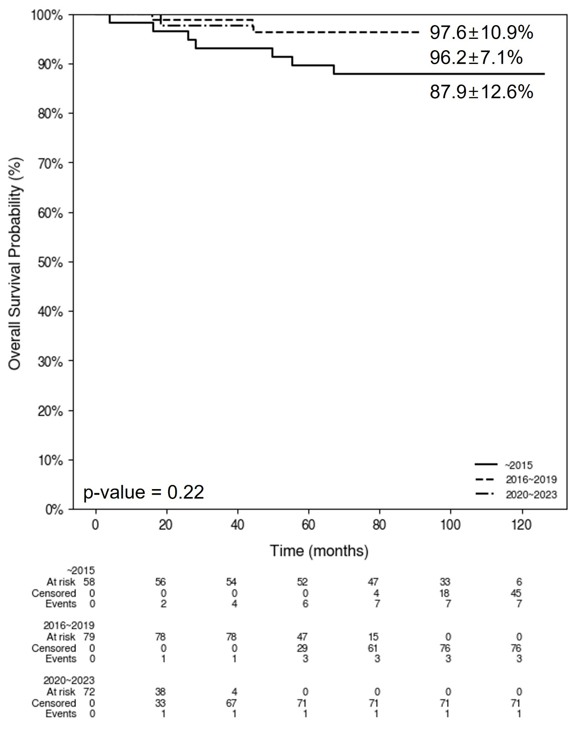

b. Event-free survival
