Nuanced treatment decision for newly diagnosed multiple myeloma patients between 65–75 years old

Naryllae Lee*, Seoyeon Kim*, Yugyeong Lee*, Sin Young Park, Hyunsoo Cho, Ja Min Byun, Youngil Koh, Junshik Hong, Dong-Yeop Shin, Chang-Ki Min, Seonggyu Byeon, Sung-Soo Park, and Dong Hyun Kim
*These three authors contribute equally.

Correspondence to:
Sung-Soo Park, MD, PhD
Department of Hematology, College of Medicine, Catholic Hematology Hospital, Seoul St. Mary’s Hospital, The Catholic University of Korea, 222 Banpo-daero, Seocho-Gu, Seoul 06591, Republic of Korea
E-mail sspark@catholic.ac.kr

Dong Hyun Kim, MD, MS
Department of Internal Medicine, Seoul National University Hospital, 101, Daehak-ro, Jongro-gu, Seoul 03080, Republic of Korea
E-mail judekim@snu.ac.kr

SUPPLEMENTARY TABLE
Supplementary Table 1. Baseline characteristics according to age and transplant status.
Variables | Age 65–69 vs. 70–75 |  | P-value | ASCT vs. non-ASCT |  | P-value
Variables | Group 1+2  N = 316 | Group 3+4  N = 245 | P-value | Group 1+3  N = 198 | Group 2+4  N = 363 | P-value
Age, years, median (IQR) | 67 (66–68) | 72 (71–74) | < 0.001 | 67 (66–69) | 71 (68–73) | < 0.001
Sex, n (%)  Male  Female | 166 (52.5)  150 (47.5) | 125 (51.0)  120 (49.0) | 0.787 | 101 (51.0)  97 (49.0) | 190 (52.3)  173 (47.7) | 0.831
M protein, n (%)  IgG  IgA  Light chain disease  Non-secretary  Others | 174 (55.1)  61 (19.3)  70 (22.2)  6 (1.9)  5 (1.6) | 143 (58.4)  48 (19.6)  47 (19.2)  2 (0.8)  5 (2.0) | 0.708 | 117 (59.1)  36 (18.2)  39 (19.7)  4 (2.0)  2 (1.0) | 200 (55.1)  73 (20.1)  78 (21.5)  4 (1.1)  8 (2.2) | 0.629
Hemoglobin, g/dL, median (IQR)  < 10.0 g/dL, n (%)  Missing, n (%) | 9.4 (8.0–11.1)  186 (58.9)  3 (0.9) | 9.4 (8.0–11.1)  151 (61.6)  3 (1.2) | 0.862  0.563 | 9.4 (8.3–11.3)  112 (56.6)  3 (1.5) | 9.4 (7.9–10.9)  225 (62.0)  3 (0.8) | 0.171  0.245
Calcium, mg/dL, median (IQR)  > 11.0 mg/dL, n (%)  Missing, n (%) | 9.2 (8.7–9.7)  18 (5.7)  10 (3.2) | 9.2 (8.7–9.6)  17 (6.9)  7 (2.9) | 0.635  0.669 | 9.2 (8.8–9.6)  7 (3.5)  6 (3.0) | 9.2 (8.7–9.7)  28 (7.7)  11 (3.0) | 0.619  0.076
CrCL, mL/min, median (IQR)  < 60.0 mL/min, n (%)  Missing, n (%) | 66.0 (42.9–83.4)  133 (42.1)  4 (1.3) | 66.2 (43.3–81.6)  105 (42.9)  6 (2.4) | 0.607  0.923 | 70.7 (42.4–83.5)  80 (40.4)  4 (2.0) | 64.4 (43.6–82.0)  158 (43.5)  6 (1.7) | 0.428  0.532
β2-microglobulin, mg/L, median (IQR)  ≥ 5.5 mg/L, n (%)  Missing, n (%) | 3.7 (2.5–6.0)  92 (29.1)  15 (4.7) | 3.6 (2.6–5.9)  60 (24.5)  27 (11.0) | 0.816  0.260 | 3.7 (2.6–6.2)  61 (30.8)  6 (3.0) | 3.6 (2.5–5.9)  91 (25.1)  36 (9.9) | 0.448  0.173
Albumin, g/dL, median (IQR)  < 3.5 g/dL, n (%)  Missing, n (%) | 3.5 (3.0–4.1)  146 (46.2)  5 (1.6) | 3.6 (3.0–3.9)  110 (44.9)  3 (1.2) | 0.489  0.824 | 3.7 (3.1–4.2)  78 (39.4)  3 (1.5) | 3.5 (3.0–3.9)  178 (49.0)  5 (1.4) | 0.001  0.036
LDH, IU/L, median (IQR)  > ULN, n (%)  Missing, n (%) | 224 (165–339)  149 (47.2)  15 (4.7) | 238 (176–353)  120 (49.0)  22 (9.0) | 0.233  0.730 | 193 (156–280)  69 (34.8)  8 (4.0) | 262 (176–390)  200 (55.1)  29 (8.0) | < 0.001  < 0.001
ISS stage, n (%)  I  II  III  Missing | 89 (28.2)  120 (38.0)  92 (29.1)  15 (4.7) | 67 (27.3)  94 (38.4)  62 (25.3)  22 (9.0) | 0.211  0.905  0.994  0.364 | 64 (32.3)  67 (33.8)  62 (31.3)  5 (2.5) | 92 (25.3)  147 (40.5)  92 (25.3)  32 (8.8) | 0.004  0.096  0.144  0.157
R-ISS stage, n (%)  I  II  III  Missing | 37 (11.7)  196 (62.0)  58 (18.4)  25 (7.9) | 21 (8.6)  150 (61.2)  39 (15.9)  35 (14.3) | 0.070  0.284  0.916  0.519 | 26 (13.1)  123 (62.1)  34 (17.2)  15 (7.6) | 32 (8.8)  223 (61.4)  63 (17.4)  45 (12.4) | 0.164  0.144  0.945  0.999
BMPC, %, median (IQR)  ≥ 60%, n (%)  Missing, n (%) | 41.0 (20.0–68.0)  102 (32.3)  6 (1.9) | 39.5 (20.0–60.0)  67 (27.3)  4 (1.6) | 0.302  0.242 | 40.0 (20.0–65.0)  60 (30.3)  3 (1.5) | 40.0 (20.0–64.1)  109 (30.0)  7 (1.9) | 0.999  0.999
Cytogenetics, n (%)  Standard-risk  High-risk  Missing | 183 (57.9)  75 (23.7)  58 (18.4) | 133 (53.4)  56 (22.9)  56 (22.9) | 0.418  0.440  0.886 | 106 (53.5)  54 (27.3)  38 (19.2) | 210 (57.9)  77 (21.2)  76 (20.9) | 0.268  0.370  0.129
BMPC, bone marrow plasma cell; CrCL, creatinine clearance; IQR, interquartile range; ISS, International Staging System; LDH, lactate dehydrogenase; R-ISS, Revised International Scoring System; ULN, upper limit normal.

Supplementary Table 2. P-value for between-group comparisons.
Variables | Group 1 vs. 2 | Group 3 vs. 4 | Group 1 vs. 3 | Group 2 vs. 4
Age, years, median (IQR) | 0.025 | < 0.001 | < 0.001 | < 0.001
Sex, n (%) | 0.548 | 0.999 | 0.999 | 0.529
M protein, n (%) | 0.120 | 0.618 | 0.176 | 0.273
Hemoglobin, g/dL, median (IQR)  < 10.0 g/dL, n (%) | 0.211  0.457 | 0.378  0.683 | 0.562  0.999 | 0.770  0.999
Calcium, mg/dL, median (IQR)  > 11.0 mg/dL, n (%) | 0.840  0.151 | 0.815  0.571 | 0.986  0.965 | 0.806  0.922
CrCL, mL/min, median (IQR)  < 60.0 mL/min, n (%) | 0.390  0.297 | 0.656  0.564 | 0.414  0.431 | 0.856  0.566
β2-microglobulin, mg/L, median (IQR)  ≥ 5.5 mg/L, n (%) | 0.666  0.759 | 0.374  0.258 | 0.508  0.609 | 0.970  0.427
Albumin, g/dL, median (IQR)  < 3.5 g/dL, n (%) | 0.017  0.066 | 0.001  0.023 | 0.051  0.061 | 0.586  0.351
LDH, IU/L, median (IQR)  > ULN, n (%) | < 0.001  < 0.001 | 0.164  0.129 | 0.836  0.682 | 0.041  0.025
ISS stage, n (%)  I  II  III | 0.009  0.131  0.482  0.577 | 0.078  0.403  0.020  0.296 | 0.008  0.708  0.042  0.642 | 0.896  0.580  0.999  0.654
R-ISS stage, n (%)  I  II  III | 0.150  0.276  0.348  0.229 | 0.077  0.999  0.044  0.124 | 0.005  0.709  0.035  0.171 | 0.353  0.999  0.473  0.119
BMPC, %, median (IQR)  ≥ 60%, n (%) | 0.494  0.531 | 0.889  0.999 | 0.804  0.979 | 0.227  0.186
Cytogenetics, n (%)  Standard-risk  High-risk | 0.328  0.422  0.175 | 0.079  0.051  0.497 | 0.048  0.057  0.805 | 0.669  0.433  0.648
BMPC, bone marrow plasma cell; CrCL, creatinine clearance; IQR, interquartile range; ISS, International Staging System; LDH, lactate dehydrogenase; R-ISS, Revised International Scoring System; ULN, upper limit normal.

Supplementary Table 3. Details of quadruplet regimens. Data are presented as n (%).
Quadruplet treatment | Total  N = 62 | Group 1  N = 35 | Group 2  N = 3 | Group 3  N = 4 | Group 4  N = 20
Daratumumab-based  Daratumumab-VMP  Daratumumab-VRd  Daratumumab-VTd | 12 (19.4)  3 (4.8)  39 (62.9) | 0  3  32 | 1  0  2 | 0  0  4 | 11  0  1
Non-daratumumab-based  Belantamab mafodotin-VRD | 8 (12.9) | 0 | 0 | 0 | 8
VMP, bortezomib + melphalan + prednisone; VRd, bortezomib + lenalidomide + dexamethasone; VTd, bortezomib + thalidomide + dexamethasone.

Supplementary Table 4. Maintenance therapy in ASCT group (Group 1 and 3).
Variables | Group 1 and 3  N = 198
Maintenance therapy, n (%) | 108 (54.5)
Maintenance regimen, n (%)  Thalidomide  Lenalidomide  Daratumumab-based  Others | 21 (19.4)  79 (73.1)  3 (2.8)  5 (4.6)

Supplementary Table 5. Univariate analysis of survival outcomes according to age group.
 | Progression-free survival |  | Overall survival
 | HR (95% CI) | P-value | HR (95% CI) | P-value
Patients aged 65–69 years
Male sex | 0.79 (0.59–1.07) | 0.124 | 1.14 (0.74–1.75) | 0.551
ISS  1  2  3 | 1.00  1.44 (0.99–2.11)  1.78 (1.20–2.66) | 0.059  0.005 | 1.00  2.32 (1.20–4.45)  3.03 (1.54–5.94) | 0.012  0.001
Cytogenetic risk  Standard-risk  High-risk | 1.00  1.21 (0.85–1.72) | 0.282 | 1.00  1.49 (0.90–2.47) | 0.123
LDH > ULN | 1.60 (1.18–2.17) | 0.003 | 2.41 (1.47–3.94) | < 0.001
BMPC ≥ 60% | 1.63 (1.20–2.21) | 0.002 | 1.98 (1.27–3.09) | 0.002
First-line therapy  Doublet or Triplet  Quadruplet | 1.00  0.55 (0.30–0.99) | 0.045 | 1.00  0.56 (0.20–1.55) | 0.267
ASCT | 0.36 (0.27–0.49) | < 0.001 | 0.25 (0.15–0.41) | < 0.001
Patients aged 70–75 years
Male sex | 0.93 (0.68–1.28) | 0.658 | 0.85 (0.55–1.30) | 0.454
ISS  1  2  3 | 1.00  1.68 (1.10–2.56)  2.02 (1.28–3.17) | 0.016  0.002 | 1.00  1.42 (0.80–2.54)  1.91 (1.05–3.49) | 0.232  0.034
Cytogenetic risk  Standard-risk  High-risk | 1.00  1.39 (0.92–2.10) | 0.113 | 1.00  1.29 (0.76–2.19) | 0.348
LDH > ULN | 1.68 (1.19–2.36) | 0.003 | 1.83 (1.11–3.01) | 0.017
BMPC ≥ 60% | 1.39 (0.98–1.97) | 0.062 | 0.91 (0.57–1.48) | 0.715
First-line therapy  Doublet or Triplet  Quadruplet | 1.00  0.35 (0.16–0.75) | 0.007 | 1.00  0.89 (0.39–2.05) | 0.786
ASCT | 0.44 (0.18–1.08) | 0.072 | 0.22 (0.03–1.61) | 0.136
ASCT, autologous stem cell transplantation; BMPC, bone marrow plasma cell; CI, confidence interval; HR, hazard ratio; ISS, International Staging System; LDH, lactate dehydrogenase; ULN, upper limit of normal.

Supplementary Table 6. Univariate analysis of survival outcomes according to ASCT status.
 | Progression-free survival |  | Overall survival
 | HR (95% CI) | P-value | HR (95% CI) | P-value
ASCT
Age  65–69  70–75 | 1.00  1.06 (0.43–2.62) | 0.907 | 1.00  0.81 (0.11–6.13) | 0.841
Male sex | 0.77 (0.50–1.19) | 0.240 | 1.03 (0.43–2.43) | 0.952
ISS  1  2  3 | 1.00  1.16 (0.67–2.01)  1.57 (0.91–2.71) | 0.589  0.109 | 1.00  2.15 (0.66–7.04)  2.35 (0.67–8.24) | 0.205  0.182
Cytogenetic risk  Standard-risk  High-risk | 1.00  1.28 (0.79–2.08) | 0.316 | 1.00  2.15 (0.87–5.31) | 0.097
LDH > ULN | 1.26 (0.81–1.96) | 0.297 | 1.34 (0.55–3.25) | 0.522
BMPC ≥ 60% | 1.84 (1.16–2.93) | 0.010 | 1.65 (0.68–4.01) | 0.266
First-line therapy  Doublet or Triplet  Quadruplet | 1.00  0.80 (0.41–1.55) | 0.504 | 1.00  0.82 (0.19–3.67) | 0.800
Non-ASCT
Age  65–69  70–75 | 1.00  0.79 (0.61–1.01) | 0.060 | 1.00  0.84 (0.61–1.17) | 0.311
Male sex | 0.87 (0.68–1.11) | 0.259 | 0.98 (0.71–1.36) | 0.924
ISS  1  2  3 | 1.00  1.56 (1.12–2.17)  2.09 (1.46–2.98) | 0.009  < 0.001 | 1.00  1.60 (1.01–2.54)  2.45 (1.52–3.95) | 0.045  < 0.001
Cytogenetic risk  Standard-risk  High-risk | 1.00  1.44 (1.05–1.99) | 0.024 | 1.00  1.44 (0.96–2.17) | 0.078
LDH > ULN | 1.46 (1.11–1.91) | 0.006 | 1.87 (1.27–2.75) | 0.002
BMPC ≥ 60% | 1.41 (1.09–1.84) | 0.010 | 1.28 (0.91–1.80) | 0.156
First-line therapy  Doublet or Triplet  Quadruplet | 1.00  0.43 (0.22–0.84) | 0.014 | 1.00  1.01 (0.50–2.07) | 0.969
ASCT, autologous stem cell transplantation; BMPC, bone marrow plasma cell; CI, confidence interval; HR, hazard ratio; ISS, International Staging System; LDH, lactate dehydrogenase; ULN, upper limit of normal.

Supplementary Table 7. Multivariate analysis of survival outcomes according to ASCT status.
 | Adjusted HR | 95% CI | P-value
ASCT
Progression-free survival  BMPC ≥ 60% | 2.03 | 1.23–3.34 | 0.005
Overall survival  - | - | - | -
Non-ASCT
Progression-free survival  ISS  1  2  3  First-line therapy  Doublet or Triplet  Quadruplet | 1.00  1.24  1.70  1.00  0.40 | 0.85–1.83  1.11–2.59  0.19–0.87 | 0.269  0.014  0.021
Overall survival  ISS  1  2  3  LDH > ULN | 1.00  1.68  2.93  1.84 | 0.97 – 2.91  1.67 – 5.14  1.17 – 2.89 | 0.067  < 0.001  0.009
ASCT, autologous stem cell transplantation; BMPC, bone marrow plasma cell; CI, confidence interval; HR, hazard ratio; ISS, International Staging System; LDH, lactate dehydrogenase; ULN, upper limit of normal.

Supplementary Figure 1. Changes in treatment response before and after ASCT in Group 1 & 3. (A) Differences in response rates before and after ASCT; (B) Sankey plot of response transitions before and after ASCT in Group 1; (C) Sankey plot of response transitions before and after ASCT in Group 3.
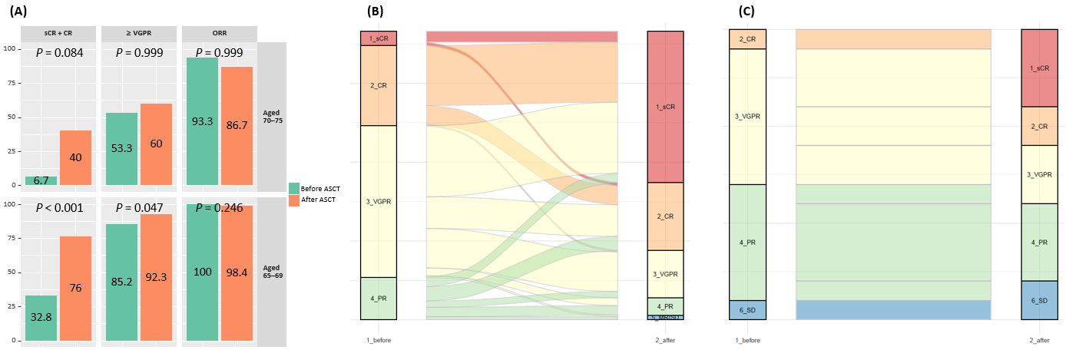

Supplementary Figure 2. Survival outcomes according to post-ASCT maintenance therapy in Group 1 and 3. (A) Progression-free survival; (B) Overall survival.
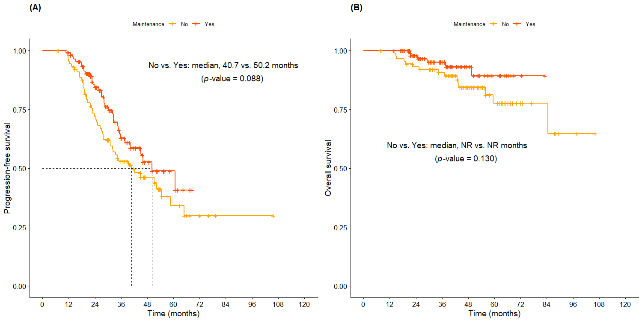

Supplementary Figure 3. Non-relapse mortality following ASCT according to age group.
