Long-Term Meteorological Characteristics and Extreme Climate Indices over Tirupati - A Rapidly Developing Tropical City
Venugopal Thandlam ^{1,2,3}, Venkatramana Kaagita^{4,5},Venkatramana Reddy Sakirevupalli⁴
- Air, Water and Landscape Science (LUVAL), Department of Earth Sciences, Uppsala University, Uppsala, Sweden
- The Center for Environment and Development Studies Research Forum, Uppsala University, Uppsala, Sweden
- Centre of Natural Hazards and Disaster Science, Uppsala University, Uppsala, Sweden
- Department of Physics, Sri Venkateshwara University, Tirupati, India.
- The Energy and Resources Institute, New Delhi, India
*Corresponding author's email: venux4@gmail.com
Supplementary material
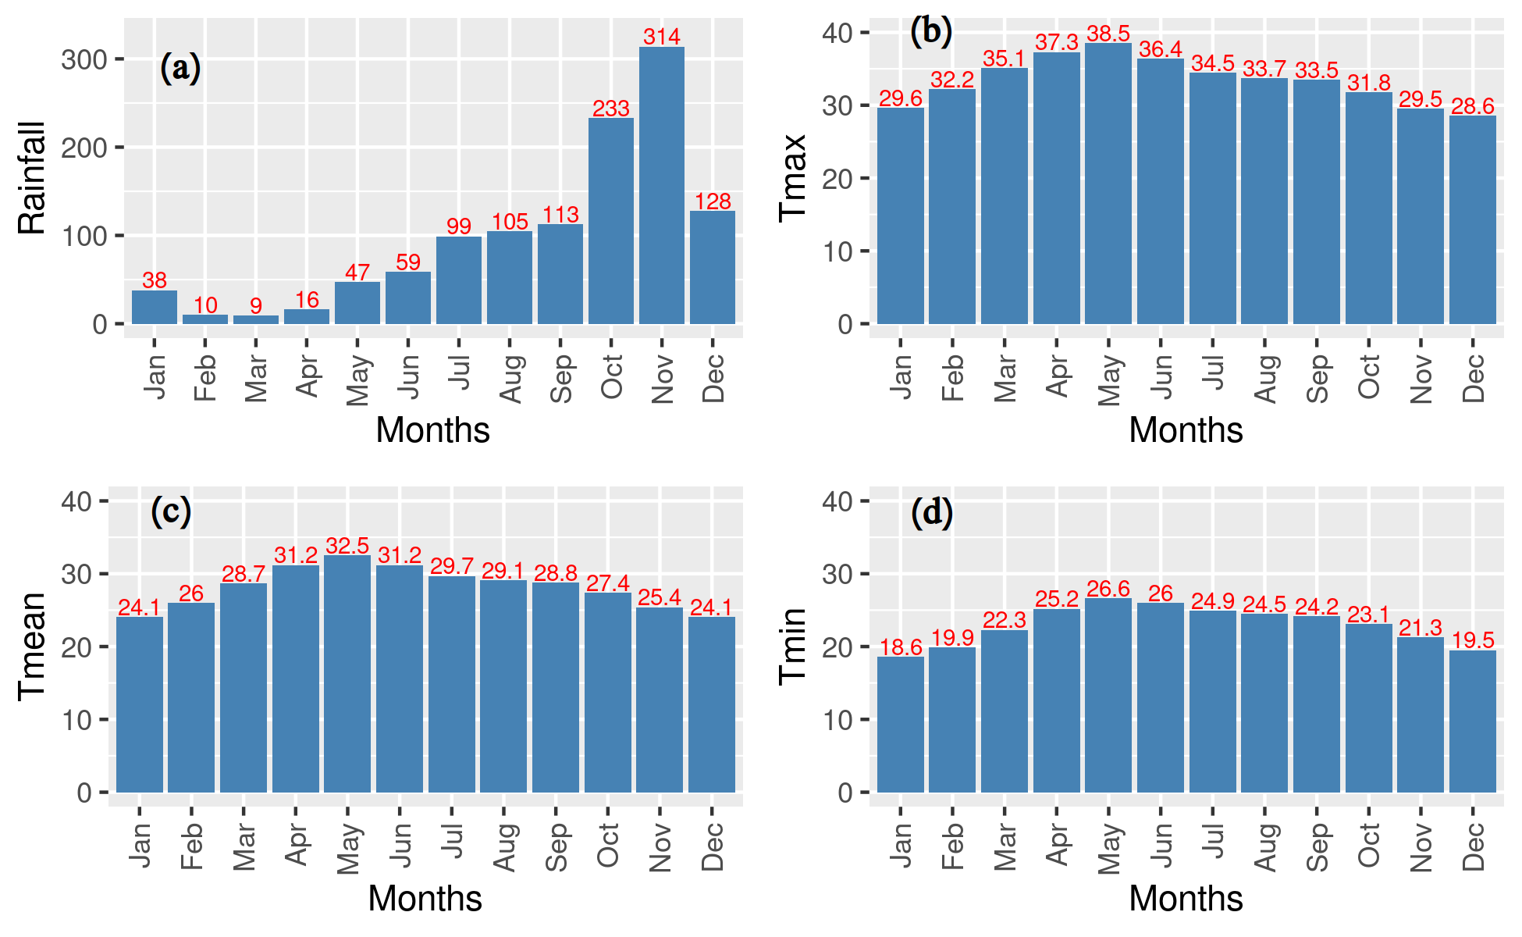
Figure S1: Monthly means of (a) precipitation (1901-2022), (b) Tmax, (c) Tmean and (d) Tmin of Tirupati (1969-2022)

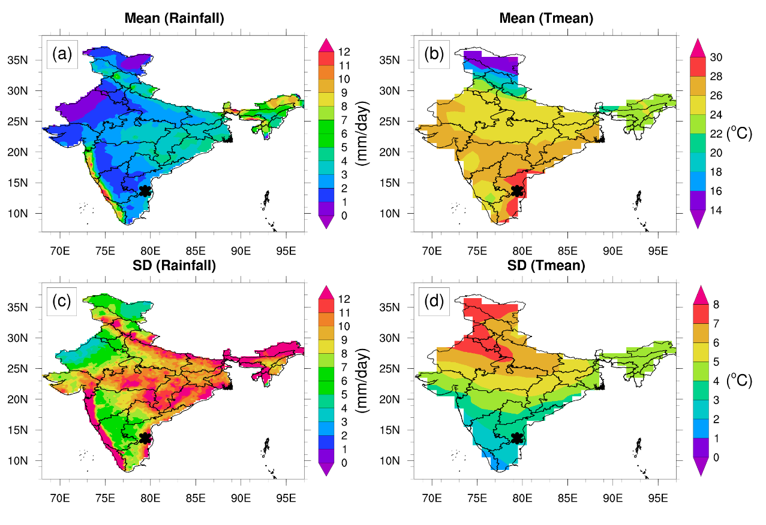
Figure S2: Climatology and standrad deviation of Rainfall (a,c) and T_{mean} (b,d) during 1901-2022 over Tirupati (black star) compared with patterns over the whole of India.

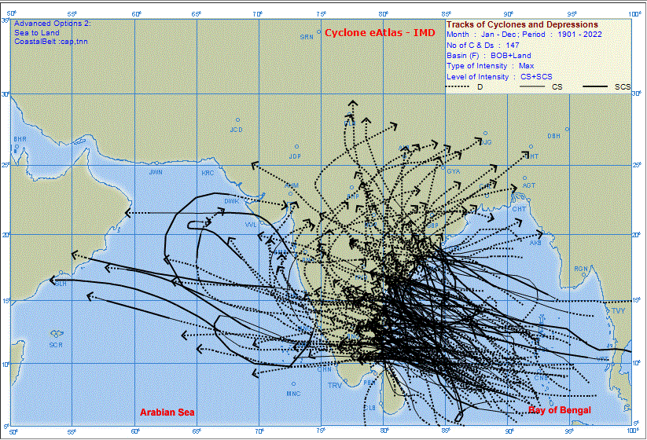
(a)
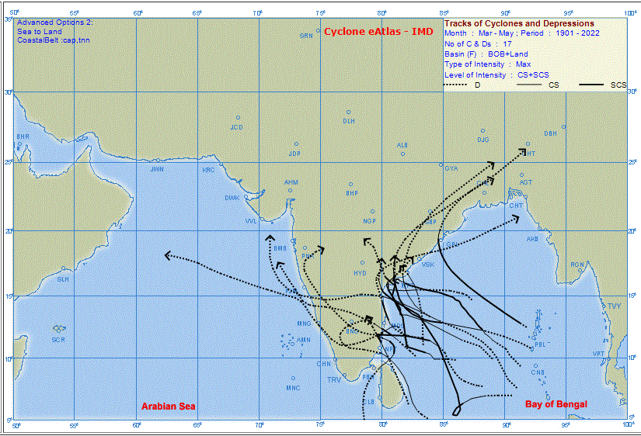
(b)
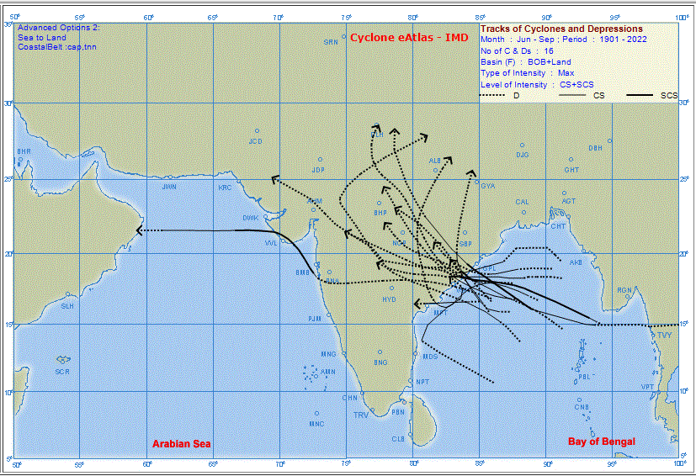
(c)
Figure S3: Tracks of cyclones and severe cyclonic storms (a) during Jan-Dec (total 147) (b) during Mar-May (total 17) (c) during the summer monsoon (JJAS) (total 15) passed through southern Andhra Pradesh and Northern Tamilnadu, affecting the weather over Tirupati (generated using IMD cyclone eAtlas).

“Michaung” over the Bay of Bengal during 1st-6th December 2023: According to data shared by the Andhra Pradesh state government, nearly 40,00,000 people from 194 villages and two towns were affected by Michaung's impact, including the inundation of 25 villages. The storm damaged 770-kilometre roads, uprooted 35 trees and killed 3 livestock, among others in Andhra Pradesh. As per media reports, 17 persons were killed in various incidents associated with Michaung in Tamil Nadu. More than 41,000 people were evacuated and temporarily relocated, including 32,158 in Tamil Nadu and 9,500 in Andhra Pradesh. Schools and offices were closed due to heavy rains and flooding.
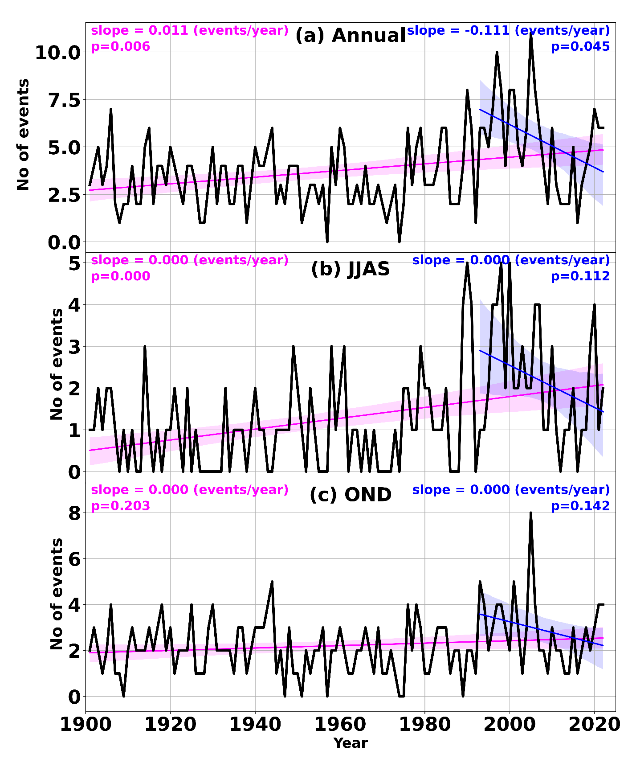
Figure S4: CWD events computed by taking 3 consecutive days with greater than 1 mm rainfall as one spell for annual, JJAS and OND seasons. Magenta is a trend of 122 years, and blue is the last 30 years.

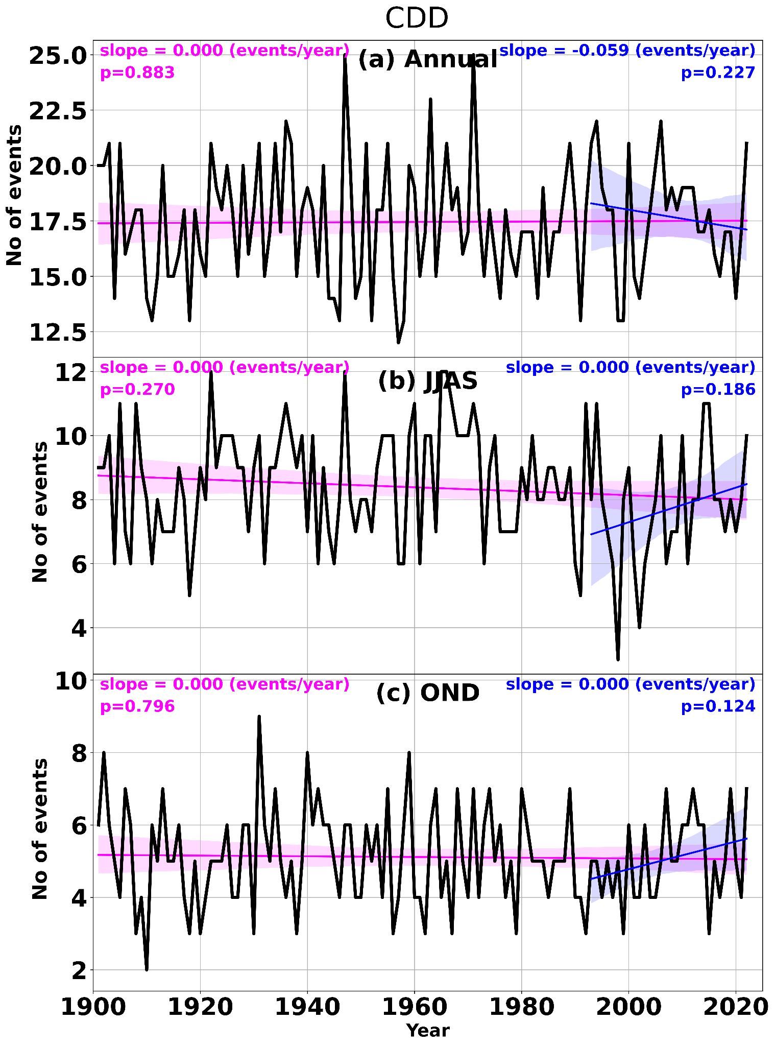
Figure S5: CDD events computed by taking 3 consecutive days with less than 1 mm rainfall as one spell for annual, JJAS and OND seasons. Magenta is a trend of 122 years, and blue is the last 30 years.

