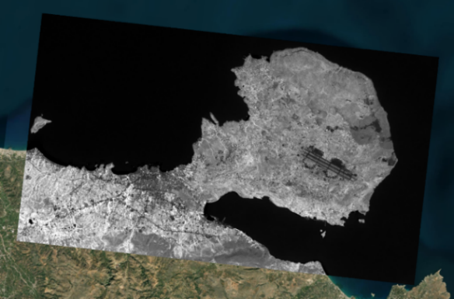 | 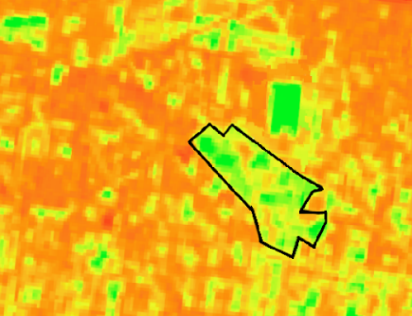
Figure S1. An image from Googe Earth engine for NDVI, 05/2023 (left) and NDVI raster (right).

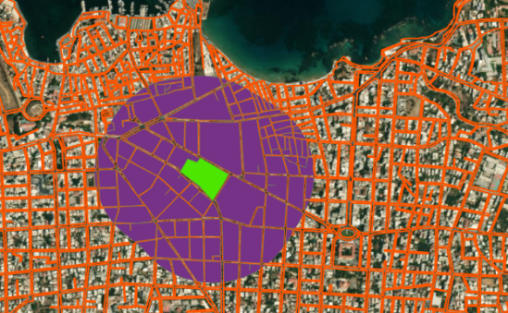 | 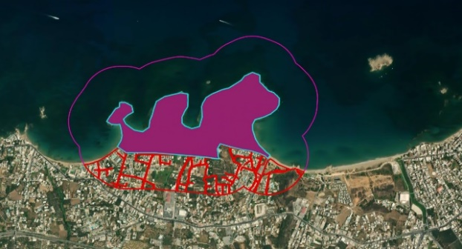
Figure S2. KPI 2.1 – Green Space Accessibility. Citizens within 300m around MGC (left) and SAP (right).

Figure S3. Mean monthly NDVI for both study areas

Figure S4. Annual carbon sequestration (left) and storage (right) in vegetation calculated for most common species in MGC (up) and SAP (down).

Table S1. Species with the greatest important values in terms of leaf area.
MGC |  |  |  | SAP
Species Name | Percent  Population | Percent  Leaf Area | IV | Species Name | Percent  Population | Percent  Leaf Area | IV
Benjamin fig | 2.2 | 13.3 | 15.5 | Aleppo pine | 85 | 70 | 155
Italian stone pine | 4.8 | 8.0 | 12.8 | Blue gum eucalyptus | 9 | 26.7 | 35.7
Black locust | 9.7 | 2.7 | 12.4 | Africam tamarisk | 5.2 | 2.5 | 7.7
Brazilian peppertree | 0.8 | 11.1 | 12.0 | African Olive | 0.4 | 0.5 | 0.9
Blue jacaranda | 9.7 | 2.2 | 11.9 | White poplar | 0.3 | 0.3 | 0.6
Chinese banyan | 0.4 | 11.1 | 11.5 | Canary island date palm | 0.1 | 0 | 0.2
Sour orange | 9.9 | 0.5 | 10.4
European Olive | 1.8 | 8.3 | 10.1
Japanese pittosporum | 7.9 | 1.4 | 9.3
Gum spp | 1.2 | 6.4 | 7.6

Table S2. KPI 1.4-1.8 - Additional indicators providing insights into the green space structure in terms of size, type and environmental qualities.
KPI | MGC | SAP
KPI 1.4 - Green space size (m²) | 32,721 m² | 540,000m²
KPI 1.5 - Presence of water or coastline | <500m close to the coastline (5min walk)  Other blue elements in the area:  A fountain & a small lake | <500m close to the coastline (5min walk)
KPI 1.6 - Diversity of Species  [Number of trees (trees), Number of tree species (species),  Tree species composition (% of tree population)] | 495 trees | 1991 trees
 | 61 trees species | 6 trees species
 | Sour orange (9.9%), Blue jacaranda (9.7%), Black locust (9.7%), Japanese pittosporum (7.9%), Italian stone pine (4.8%), Paper mulberry (4.0%), Queen palm (3.4%), Olive (3.0%), California palm (3.0%), Maple leaf viburnum (2.8%), Other (41.7 %) | Aleppo pine (85%), Blue gum eucalyptus (9%), African tamarisk (5.2%), Olive (0.4%), Other (0.4%)
KPI 1.7 - Trees size  [DBH Class (% of tree population),  Tree Height Class (% of tree population)] | 0-7.6cm (36%), 7.6-15.2cm (28%), 15.2-30.5cm (20%), 30.5-45.7cm (10%), 45.7-61 (4%), 61-76.2cm (2%) | 0-7.6cm (13%), 7.6-15.2cm (22%), 15.2-30.5cm (37%), 30.5-45.7cm (20%), 45.7-61 (3%), 61-76.2cm (1%), >76.2 (4%)
 | <5m (51.9%), 5-10m (25.7%), 10-15m (14.1%), >15m (8.3%) | <5m (32%), 5-10m (32%), 10-15m (17.8%), >15m (18.2%)
KPI 1.8 - Species origin (% of tree population) | Asia (27%), North America (25%), South America (15%), Europe (10%), Asia & Oceania (8%), Europe & Asia (7%), Other (8%) | Europe & Africa (90%), Oceania (10%)

Table S3. KPI 2.3 - Environmental attributes that can attract people or, conversely, inhibit citizens' visits due to their absence
 | MGC | SAP
Naturalness: Trees/ plants/ flowerbeds | • | •
Water feature | • | •
Gastronomic & Sanitary Facilities | • | •
Rest areas | • | •
BBQs & Tables | • | •
Lights | • | •
Walking Paths and Trails | • | •
Areas for active recreational exercises |  | •
Areas for cultural activities | •
Playground | • | •
Areas with nice views outside the area |  | •
Areas for laying, sunbathing, playing |  | •
Nature reserve areas
Libraries & Communication points | •
Areas for commercial use | •
Learning and working areas
Specific areas for energy generation
Dog Enclosure | • | •
Car park |  | •
Public transport | • | •

Table S4. KPI 2.2, 2.4-2.8 - Descriptive Statistics
 | MGC |  |  |  | SAP
 | Min. | Max. | Mean | Std. Dev. | Min. | Max. | Mean | Std. Dev.
KPI 2.2-Perceived Accessibility | 1 | 5 | 3.3 | 1.41 | 2 | 4 | 3.14 | 0.65
KPI 2.4-Perceived attractiveness in terms of amenities and facilities | 1 | 5 | 2.90 | 1.36 | 2 | 5 | 3.42 | 0.71
KPI 2.5-Perceived attractiveness in terms of aesthetics, colors, smells, sound. | 1 | 5 | 2.83 | 1.40 | 2 | 4 | 3.1 | 0.68
KPI 2.6-Perceived attractiveness in terms of cleanliness and maintenance. | 1 | 5 | 2.87 | 1.26 | 2 | 4 | 2.6 | 0.63
KPI 2.7-Realized Safety | 1 | 5 | 2.73 | 1.30 | 2 | 4 | 2.96 | 0.64
KPI 2.8-Perceived noise annoyance | 1 | 5 | 2.93 | 1.42 | 2 | 5 | 2.94 | 0.64

Figure S5. Representative temperature (left) and humidity (right) values for the 3rd of July 2023 at the SAP (up) and MGC (down).

Table S5. KPI 4.1. - Monthly mean value of daily maximum temperature during the summer months of 2023. Recordings from 5 monitoring stations for MGC and SAP.
 | MGC |  |  | SAP
 | June | July | August | June | July | August
F1 | 27.00 | 31.58 | 30.6 | 28.39 | 34.14 | 33.28
F2 | 31.16 | 33.56 | 36.33 | 26.24 | 31.77 | 30.52
F3 | 26.21 | 30.5 | 29.18 | 26.78 | 32.14 | 31.75
F4 | 26.43 | 30.72 | 29.4 | 27.7 | 33.41 | 31.12
Green Space mean | 27.70 | 31.60 | 31.40 | 27.30 | 32.90 | 31.70
Urban Space | 29.92 | 35.03 | 32.35 | 27.98 | 33.41 | 32.89

Figure S6. KPI 4.2. – Cooling of ambient air during the summer months of 2023. Recordings from 5 monitoring stations for MGC (left) and SAP (right).

Figure S7. KPI 4.3. –Maximum daily thermal stress during the summer months of 2023 as revealed by UTCI measurements. Recordings from 5 monitoring stations for MGC (up) and SAP (down).
Figure S8. KPI 4.3. – Maximum thermal stress distribution for two summer days of 2023. Recordings from Mobile weather station for MGC (left) and SAP (right).

