Supplementary Material

Section A – Search Information 2
Section B – Eligible Studies 4
Section C – Results 14
Section C.1 – Geographical distribution of eligible studies 14
Section C.2 - Broader methodological aspects of the eligible articles 16
Section C.3 - Urban green spaces in the eligible articles 26
Section C.4 – Subjective well-being in the eligible articles 35

Section A – Search Information
Table 1 – Boolean query and restrictions applied in each database search
 | Scopus | Web of Science (Core Collection)
Query | (("urban green space" OR "green space" OR "green area" OR "green infrastructures" OR "green-blue space" OR "greenness" OR "park") AND ("characteristics" OR "features" OR "attributes") AND ("subjective well-being" OR "subjective wellbeing" OR "perceived well-being" OR "well-being" OR "wellbeing" OR "life satisfaction" OR "hedonic" OR "eudaimonic" OR "emotions" OR "quality of life")) | ((ALL=("urban green space" OR "green space" OR "green area" OR "green infrastructures" OR "green-blue space" OR "greenness" OR "park" )) AND ALL=("characteristics" OR "features" OR "attributes")) AND ALL=(("subjective well-being" OR "subjective wellbeing" OR "perceived well-being" OR "well-being" OR "wellbeing" OR "life satisfaction" OR "hedonic" OR "eudaimonic" OR "emotions" OR "quality of life"))
Restrictions applied during the search | Search within: Article Title; Abstract; Keywords  Years: 2013-2023  Limited to subject areas:  - Environmental Science  - Social Sciences  - Engineering  - Computer Science  - Psychology  - Economics, Econometrics and Finance  - Arts and Humanities  - Multidisciplinary  - Decision Sciences  Document type: Articles  Language: English | Publication Years: 2013-2023  Limited to Web of Science Categories:  Environmental Studies; Environmental Sciences; Public Environmental Occupational Health; Urban Studies; Ecology; Forestry; Green Sustainable Science Technology; Plant Sciences; Geography; Medicice General Internal; Regional Urban Planning; Geography Physical; Health Care Sciences Services; Multidisciplinary Sciences; Psychiatry; Psychology Multidisciplinary; Health Policy Services; Biodiversity Conservation; Computer Science Information Systems; Neurosciences ; Social Sciences Biomedical; Economics; Psychology; Geosciences Multidisciplinary; Remote Sensing; Social Sciences Interdisciplinary; Psychology Experimental; Psychology Applied; Sociology; Psychology Social; Behavioral Sciences; Psychology Biological; Psychology Development; Psychology Mathematical  Document Types: Article  Language: English
No. of studies retrieved | (802) [16] 818 | (816) [45] 861

Section B – Eligible Studies
Table 2 – List of articles included in the review
No. | Article | Year | Country
1 | Dallimer, M., Tinch, D., Hanley, N., Irvine, K. N., Rouquette, J. R., Warren, P. H., Maltby, L., Boyle, K. J., & Armsworth, P. R. (2014). Quantifying Preferences for the Natural World Using Monetary and Nonmonetary Assessments of Value. Conservation Biology, 28(2), 404–413. https://doi.org/10.1111/cobi.12215 | 2014 | United Kingdom
2 | Carrus, G., Scopelliti, M., Lafortezza, R., Colangelo, G., Ferrini, F., Salbitano, F., Agrimi, M., Portoghesi, L., Semenzato, P., & Sanesi, G. (2015). Go greener, feel better? The positive effects of biodiversity on the well-being of individuals visiting urban and peri-urban green areas. Landscape and Urban Planning, 134, 221–228. https://doi.org/10.1016/j.landurbplan.2014.10.022 | 2015 | Italy
3 | Conedera, M., Del Biaggio, A., Seeland, K., Moretti, M., & Home, R. (2015). Residents’ preferences and use of urban and peri-urban green spaces in a Swiss mountainous region of the Southern Alps. Urban Forestry & Urban Greening, 14(1), 139–147. https://doi.org/10.1016/j.ufug.2015.01.003 | 2015 | Switzerland
4 | Gilchrist, K., Brown, C., & Montarzino, A. (2015). Workplace settings and wellbeing: Greenspace use and views contribute to employee wellbeing at peri-urban business sites. Landscape and Urban Planning, 138, 32–40. https://doi.org/10.1016/j.landurbplan.2015.02.004 | 2015 | United Kingdom
5 | Rostami, R., Lamit, H., Khoshnava, S. M., Rostami, R., & Rosley, M. S. F. (2015). Sustainable Cities and the Contribution of Historical Urban Green Spaces: A Case Study of Historical Persian Gardens. Sustainability, 7(10), Article 10. https://doi.org/10.3390/su71013290 | 2015 | Iran
6 | Akpinar, A. (2016). How is high school greenness related to students’ restoration and health? Urban Forestry and Urban Greening, 16, 1–8. https://doi.org/10.1016/j.ufug.2016.01.007 | 2016 | Turkey
7 | Krekel, C., Kolbe, J., & Wüstemann, H. (2016). The greener, the happier? The effect of urban land use on residential well-being. Ecological Economics, 121, 117–127. https://doi.org/10.1016/j.ecolecon.2015.11.005 | 2016 | Germany
8 | Tilley, S., Neale, C., Patuano, A., & Cinderby, S. (2017). Older people’s experiences of mobility and mood in an urban environment: A mixed methods approach using electroencephalography (EEG) and interviews. International Journal of Environmental Research and Public Health, 14(2), Article 2. https://doi.org/10.3390/ijerph14020151 | 2017 | United Kingdom
9 | Wood, L., Hooper, P., Foster, S., & Bull, F. (2017). Public green spaces and positive mental health – investigating the relationship between access, quantity and types of parks and mental wellbeing. Health & Place, 48, 63–71. https://doi.org/10.1016/j.healthplace.2017.09.002 | 2017 | Australia
10 | Zhang, Y., Van den Berg, A. E., Van Dijk, T., & Weitkamp, G. (2017). Quality over Quantity: Contribution of Urban Green Space to Neighborhood Satisfaction. International Journal of Environmental Research and Public Health, 14(5), Article 5. https://doi.org/10.3390/ijerph14050535 | 2017 | Netherlands
11 | Aoshima, I., Uchida, K., Ushimaru, A., & Sato, M. (2018). The influence of subjective perceptions on the valuation of green spaces in Japanese urban areas. Urban Forestry & Urban Greening, 34, 166–174. https://doi.org/10.1016/j.ufug.2018.06.018 | 2018 | Japan
12 | Dzhambov, A. M., Markevych, I., Hartig, T., Tilov, B., Arabadzhiev, Z., Stoyanov, D., Gatseva, P., & Dimitrova, D. D. (2018). Multiple pathways link urban green- and bluespace to mental health in young adults. Environmental Research, 166, 223–233. https://doi.org/10.1016/j.envres.2018.06.004 | 2018 | Bulgaria
13 | Kim, D., & Jin, J. (2018). Does happiness data say urban parks are worth it? Landscape and Urban Planning, 178, 1–11. https://doi.org/10.1016/j.landurbplan.2018.05.010 | 2018 | South Korea
14 | Southon, G. E., Jorgensen, A., Dunnett, N., Hoyle, H., & Evans, K. L. (2018). Perceived species-richness in urban green spaces: Cues, accuracy and well-being impacts. Landscape and Urban Planning, 172, 1–10. https://doi.org/10.1016/j.landurbplan.2017.12.002 | 2018 | United Kingdom
15 | Ayala-Azcárraga, C., Diaz, D., & Zambrano, L. (2019). Characteristics of urban parks and their relation to user well-being. Landscape and Urban Planning, 189, 27–35. https://doi.org/10.1016/j.landurbplan.2019.04.005 | 2019 | Mexico
16 | Navarrete-Hernandez, P., & Laffan, K. (2019). A greener urban environment: Designing green infrastructure interventions to promote citizens’ subjective wellbeing. Landscape and Urban Planning, 191, 103618. https://doi.org/10.1016/j.landurbplan.2019.103618 | 2019 | France
17 | Schebella, M. F., Weber, D., Schultz, L., & Weinstein, P. (2019). The Wellbeing Benefits Associated with Perceived and Measured Biodiversity in Australian Urban Green Spaces. Sustainability, 11(3), Article 3. https://doi.org/10.3390/su11030802 | 2019 | Australia
18 | Schwartz, A. J., Dodds, P. S., O’Neil-Dunne, J. P. M., Danforth, C. M., & Ricketts, T. H. (2019). Visitors to urban greenspace have higher sentiment and lower negativity on Twitter. People and Nature, 1(4), 476–485. https://doi.org/10.1002/pan3.10045 | 2019 | United States
19 | Bonilla-Bedoya, S., Estrella, A., Santos, F., & Herrera, M. Á. (2020). Forests and urban green areas as tools to address the challenges of sustainability in Latin American urban socio-ecological systems. Applied Geography, 125, 102343. https://doi.org/10.1016/j.apgeog.2020.102343 | 2020 | Ecuador
20 | Cameron, R. W. F., Brindley, P., Mears, M., McEwan, K., Ferguson, F., Sheffield, D., Jorgensen, A., Riley, J., Goodrick, J., Ballard, L., & Richardson, M. (2020). Where the wild things are! Do urban green spaces with greater avian biodiversity promote more positive emotions in humans? Urban Ecosystems, 23(2), 301–317. https://doi.org/10.1007/s11252-020-00929-z | 2020 | United Kingdom
21 | Deng, L., Li, X., Luo, H., Fu, E.-K., Ma, J., Sun, L.-X., Huang, Z., Cai, S.-Z., & Jia, Y. (2020). Empirical study of landscape types, landscape elements and landscape components of the urban park promoting physiological and psychological restoration. Urban Forestry and Urban Greening, 48, 126488. https://doi.org/10.1016/j.ufug.2019.126488 | 2020 | China
22 | Paul, A., Nath, T. K., Noon, S. J., Islam, M. M., & Lechner, A. M. (2020). Public Open space, Green exercise and well-being in Chittagong, Bangladesh. Urban Forestry and Urban Greening, 55, 126825. https://doi.org/10.1016/j.ufug.2020.126825 | 2020 | Bangladesh
23 | Wenjie, W., Chen, Y., & Ye, L. (2020). Perceived spillover effects of club-based green space: Evidence from Beijing golf courses, China. Urban Forestry & Urban Greening, 48, 126518. https://doi.org/10.1016/j.ufug.2019.126518 | 2020 | China
24 | Cheng, Y., Zhang, J., Wei, W., & Zhao, B. (2021). Effects of urban parks on residents’ expressed happiness before and during the COVID-19 pandemic. Landscape and Urban Planning, 212, 104118. https://doi.org/10.1016/j.landurbplan.2021.104118 | 2021 | China
25 | Chu, Y.-T., Li, D., & Chang, P.-J. (2021). Effects of Urban Park Quality, Environmental Perception, and Leisure Activity on Well-Being among the Older Population. International Journal of Environmental Research and Public Health, 18(21), Article 21. https://doi.org/10.3390/ijerph182111402 | 2021 | Republic of China (Taiwan)
26 | Fisher, J. C., Bicknell, J. E., Irvine, K. N., Hayes, W. M., Fernandes, D., Mistry, J., & Davies, Z. G. (2021). Bird diversity and psychological wellbeing: A comparison of green and coastal blue space in a neotropical city. Science of the Total Environment, 793, 148653. https://doi.org/10.1016/j.scitotenv.2021.148653 | 2021 | Guyana
27 | Han, B., Li, D., & Chang, P.-J. (2021). The effect of place attachment and greenway attributes on well-being among older adults in Taiwan. Urban Forestry & Urban Greening, 65, 127306. https://doi.org/10.1016/j.ufug.2021.127306 | 2021 | Republic of China (Taiwan)
28 | Hussein, H., Ishak, S. A., & Wan Mohd Yunus, W. M. A. (2021). Does Spending Time in a Neighbourhood Park Reduce Stress? A preliminary psychological study. Environment-Behaviour Proceedings Journal, 6(16), Article 16. https://doi.org/10.21834/ebpj.v6i16.2683 | 2021 | Malaysia
29 | Lopez, B., Kennedy, C., Field, C., & McPhearson, T. (2021). Who benefits from urban green spaces during times of crisis? Perception and use of urban green spaces in New York City during the COVID-19 pandemic. Urban Forestry & Urban Greening, 65, 127354. https://doi.org/10.1016/j.ufug.2021.127354 | 2021 | United States
30 | Maric, J., Aleksandra, D., Antonic, B., Furundzic, D., & Parezanin, V. (2021). The Effects of Open Space on Reducing Workplace Stress: Case Study of Business Park in the Post-Socialist Urban Setting. Sustainability, 13(1), Article 1. https://doi.org/10.3390/su13010336 | 2021 | Serbia
31 | Maurer, M., Zaval, L., Orlove, B., Moraga, V., & Culligan, P. (2021). More than nature: Linkages between well-being and greenspace influenced by a combination of elements of nature and non-nature in a New York City urban park. Urban Forestry & Urban Greening, 61, 127081. https://doi.org/10.1016/j.ufug.2021.127081 | 2021 | United States
32 | Mayen Huerta, C., & Utomo, A. (2021). Evaluating the association between urban green spaces and subjective well-being in Mexico city during the COVID-19 pandemic. Health & Place, 70, 102606. https://doi.org/10.1016/j.healthplace.2021.102606 | 2021 | Mexico
33 | Nghiem, T. P. L., Wong, K. L., Jeevanandam, L., Chang, C. c., Tan, L. Y. C., Goh, Y., & Carrasco, L. R. (2021). Biodiverse urban forests, happy people: Experimental evidence linking perceived biodiversity, restoration, and emotional wellbeing. Urban Forestry & Urban Greening, 59, 127030. https://doi.org/10.1016/j.ufug.2021.127030 | 2021 | Singapore
34 | Sharifi, F., Nygaard, A., & Stone, W. M. (2021). Heterogeneity in the subjective well-being impact of access to urban green space. Sustainable Cities and Society, 74, 103244. https://doi.org/10.1016/j.scs.2021.103244 | 2021 | Australia
35 | Wan, C., Shen, G. Q., & Choi, S. (2021). Eliciting users’ preferences and values in urban parks: Evidence from analyzing social media data from Hong Kong. Urban Forestry & Urban Greening, 62, 127172. https://doi.org/10.1016/j.ufug.2021.127172 | 2021 | China
36 | Wang, R., Feng, Z., Pearce, J., Liu, Y., & Dong, G. (2021). Are greenspace quantity and quality associated with mental health through different mechanisms in Guangzhou, China: A comparison study using street view data. Environmental Pollution, 290, 117976. https://doi.org/10.1016/j.envpol.2021.117976 | 2021 | China
37 | Zhang, Z., Wang, M., Xu, Z., Ye, Y., Chen, S., Pan, Y., & Chen, J. (2021). The influence of Community Sports Parks on residents’ subjective well-being: A case study of Zhuhai City, China. Habitat International, 117, 102439. https://doi.org/10.1016/j.habitatint.2021.102439 | 2021 | China
38 | Zhu, W., Wang, J., & Qin, B. (2021). Quantity or quality? Exploring the association between public open space and mental health in urban China. Landscape and Urban Planning, 213, 104128. https://doi.org/10.1016/j.landurbplan.2021.104128 | 2021 | China
39 | Allard-Poesi, F., Matos, L. B. S., & Massu, J. (2022). Not all types of nature have an equal effect on urban residents’ well-being: A structural equation model approach. Health & Place, 74, 102759. https://doi.org/10.1016/j.healthplace.2022.102759 | 2022 | France
40 | Chen, S., Liu, L., Chen, C., & Haase, D. (2022). The interaction between human demand and urban greenspace supply for promoting positive emotions with sentiment analysis from twitter. Urban Forestry & Urban Greening, 78, 127763. https://doi.org/10.1016/j.ufug.2022.127763 | 2022 | Germany
41 | Jeong, A., Galliker, F., Imboden, M., Keidel, D., de Hoogh, K., Vienneau, D., Siegrist, M., Crivelli, L., Lovison, G., & Probst-Hensch, N. (2022). Residential exposure to greenspace and life satisfaction in times of COVID-19: A cross-sectional analysis of 9444 participants from a population-based study in Basel-Stadt and Basel-Landschaft. In SWISS MEDICAL WEEKLY (Vol. 152). https://doi.org/10.4414/SMW.2022.w30204 | 2022 | Switzerland
42 | Jiang, Y., & Huang, G. (2022). Urban residential quarter green space and life satisfaction. Urban Forestry & Urban Greening, 69, 127510. https://doi.org/10.1016/j.ufug.2022.127510 | 2022 | China
43 | Knight, S. J., McClean, C. J., & White, P. C. L. (2022). The importance of ecological quality of public green and blue spaces for subjective well-being. Landscape and Urban Planning, 226, 104510. https://doi.org/10.1016/j.landurbplan.2022.104510 | 2022 | United Kingdom
44 | Kong, L., Liu, Z., Pan, X., Wang, Y., Guo, X., & Wu, J. (2022). How do different types and landscape attributes of urban parks affect visitors’ positive emotions? Landscape and Urban Planning, 226, 104482. https://doi.org/10.1016/j.landurbplan.2022.104482 | 2022 | China
45 | Lin, Y., Wood, S. A., & Lawler, J. J. (2022). The relationship between natural environments and subjective well-being as measured by sentiment expressed on Twitter. Landscape and Urban Planning, 227, 104539. https://doi.org/10.1016/j.landurbplan.2022.104539 | 2022 | United States
46 | Nawrath, M., Elsey, H., Rijal, M. L., & Dallimer, M. (2022). Greenspaces and Human Well-Being: Perspectives from a Rapidly Urbanising Low-Income Country. Environments, 9(12), Article 12. https://doi.org/10.3390/environments9120148 | 2022 | Nepal
47 | Olszewska-Guizzo, A., Sia, A., Fogel, A., & Ho, R. (2022). Features of urban green spaces associated with positive emotions, mindfulness and relaxation. Scientific Reports, 12(1), Article 1. https://doi.org/10.1038/s41598-022-24637-0 | 2022 | Singapore
48 | Samus, A., Freeman, C., van Heezik, Y., Krumme, K., & Dickinson, K. J. M. (2022). How do urban green spaces increase well-being? The role of perceived wildness and nature connectedness. Journal of Environmental Psychology, 82, 101850. https://doi.org/10.1016/j.jenvp.2022.101850 | 2022 | Germany
49 | Sheng, Y. Z., & Lian, C. W. (2022). Quality of life and its association with individual and park characteristics among elderly qi gong practitioners in Malaysia: 10.55131/jphd/2022/200120. Journal of Public Health and Development, 20(1), Article 1. https://doi.org/10.55131/jphd/2022/200120 | 2022 | Malaysia
50 | Shentova, R., de Vries, S., & Verboom, J. (2022). Well-Being in the Time of Corona: Associations of Nearby Greenery with Mental Well-Being during COVID-19 in The Netherlands. Sustainability, 14(16), Article 16. https://doi.org/10.3390/su141610256 | 2022 | Netherlands
51 | Song, R., Chen, Q., Zhang, Y., Jia, Q., He, H., Gao, T., & Qiu, L. (2022). Psychophysiological restorative potential in cancer patients by virtual reality (VR)-based perception of natural environment. Frontiers in Psychology, 13. https://doi.org/10.3389/fpsyg.2022.1003497 | 2022 | China
52 | van Dinter, M., Kools, M., Dane, G., Weijs-Perrée, M., Chamilothori, K., van Leeuwen, E., Borgers, A., & van den Berg, P. (2022). Urban Green Parks for Long-Term Subjective Well-Being: Empirical Relationships between Personal Characteristics, Park Characteristics, Park Use, Sense of Place, and Satisfaction with Life in The Netherlands. Sustainability, 14(9), Article 9. https://doi.org/10.3390/su14094911 | 2022 | Netherlands
53 | Wang, R., Yang, L., Yao, Y., & Wu, W. (2022). Exploring the association between neighbourhood streetscape vegetation and subjective well-being in a high-density built environment: Evidence from Beijing, China. Health & Social Care in the Community, 30(6), e5457–e5469. https://doi.org/10.1111/hsc.13968 | 2022 | China
54 | Cernicova-Buca, M., Gherheș, V., & Obrad, C. (2023). Residents’ Satisfaction with Green Spaces and Daily Life in Small Urban Settings: Romanian Perspectives. Land, 12(3), Article 3. https://doi.org/10.3390/land12030689 | 2023 | Romania
55 | Chiang, Y.-C., Weng, P.-Y., Li, D., & Ho, L.-C. (2023). Quantity and quality: Role of vegetation in park visitation and physical activity. Landscape and Ecological Engineering, 19(3), 337–350. https://doi.org/10.1007/s11355-023-00558-6 | 2023 | Republic of China (Taiwan)
56 | Fleckney, P. (2023). ‘A little escape dome’: Exploring how older adolescents experience urban parks as sites of mental wellbeing in Melbourne, Australia. Landscape and Urban Planning, 235, 104753. https://doi.org/10.1016/j.landurbplan.2023.104753 | 2023 | Australia
57 | Huang, Y., Lin, X., Lin, S., Chen, Z., Fu, W., Wang, M., & Dong, J. (2023). Pocket Parks: A New Approach to Improving the Psychological and Physical Health of Recreationists. Forests, 14(10), Article 10. https://doi.org/10.3390/f14101983 | 2023 | China
58 | Niu, J., Xiong, J., Qin, H., Wu, H., Zhang, K., Yan, J., Ye, L., & Han, G. (2023). Thermal Comfort Influences Positive Emotions but Not Negative Emotions When Visiting Green Spaces during Summer. In FORESTS (Vol. 14, Issue 8). https://doi.org/10.3390/f14081512 | 2023 | China
59 | Patino, J. E., Martinez, L., Valencia, I., & Duque, J. C. (2023). Happiness, life satisfaction, and the greenness of urban surroundings. Landscape and Urban Planning, 237, 104811. https://doi.org/10.1016/j.landurbplan.2023.104811 | 2023 | Colombia
60 | Wu, L., & Chen, C. (2023). Does pattern matter? Exploring the pathways and effects of urban green space on promoting life satisfaction through reducing air pollution. Urban Forestry & Urban Greening, 82, 127890. https://doi.org/10.1016/j.ufug.2023.127890 | 2023 | China
61 | Wu, W., Tan, W., Wang, R., & Chen, W. Y. (2023). From quantity to quality: Effects of urban greenness on life satisfaction and social inequality. Landscape and Urban Planning, 238, 104843. https://doi.org/10.1016/j.landurbplan.2023.104843 | 2023 | China
62 | Wu, Y., Liu, J., Quevedo, J. M. D., Cheng, H., Yu, K., & Kohsaka, R. (2023). Critical factors influencing visitor emotions: Analysis of “restorativeness” in urban park visits in Fuzhou, China. Frontiers in Public Health, 11. https://doi.org/10.3389/fpubh.2023.1286518 | 2023 | China
63 | Zhang, R. (2023). Integrating ergonomics data and emotional scale to analyze people’s emotional attachment to different landscape features in the Wudaokou Urban Park. Frontiers of Architectural Research, 12(1), 175–187. https://doi.org/10.1016/j.foar.2022.06.007 | 2023 | China

Section C – Results

Section C.1 – Geographical distribution of eligible studies

Table 3 – Number of studies per Country (of case study)
World Regions | Country | Number of Articles
East Asia and Pacific | China | 17
Europe and Central Asia | United Kingdom | 6
East Asia and Pacific | Australia | 4
North America | United States of America | 4
Europe and Central Asia | Germany | 3
Europe and Central Asia | Netherlands | 3
East Asia and Pacific | Republic of China (Taiwan) | 3
Europe and Central Asia | France | 2
East Asia and Pacific | Malaysia | 2
Latin America and Caribbean | Mexico | 2
East Asia and Pacific | Singapore | 2
Europe and Central Asia | Switzerland | 2
South Asia | Bangladesh | 1
Europe and Central Asia | Bulgaria | 1
Latin America and Caribbean | Colombia | 1
Latin America and Caribbean | Ecuador | 1
Latin America and Caribbean | Guyana | 1
Middle East and North Africa | Iran | 1
Europe and Central Asia | Italy | 1
East Asia and Pacific | Japan | 1
South Asia | Nepal | 1
Europe and Central Asia | Romania | 1
Europe and Central Asia | Serbia | 1
East Asia and Pacific | Republic of Korea (South Korea) | 1
Europe and Central Asia | Turkey | 1
Total |  | 63

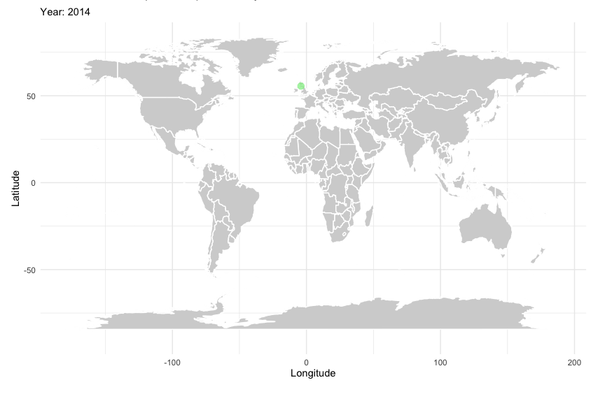
Fig. C1 – Eligible articles per year and county.

Section C.2 - Broader methodological aspects of the eligible articles
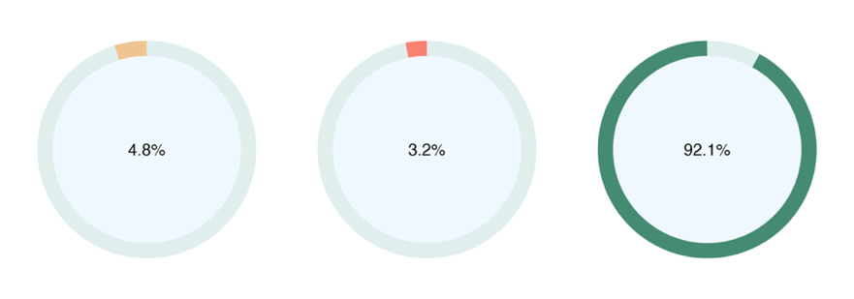
Fig. C2.1 – Prevalence of data collection approach for sample population: Mixed Methods (4.8%); Qualitative Methods (3.2%); Quantitative Methods (92.1%).
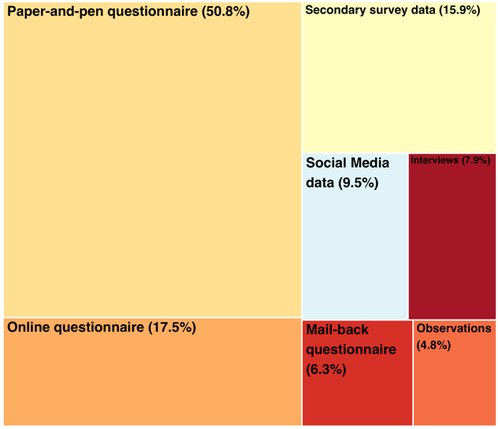
Fig. C2.2 – Frequency of research tools employed by the eligible studies to collect data about the sample population.

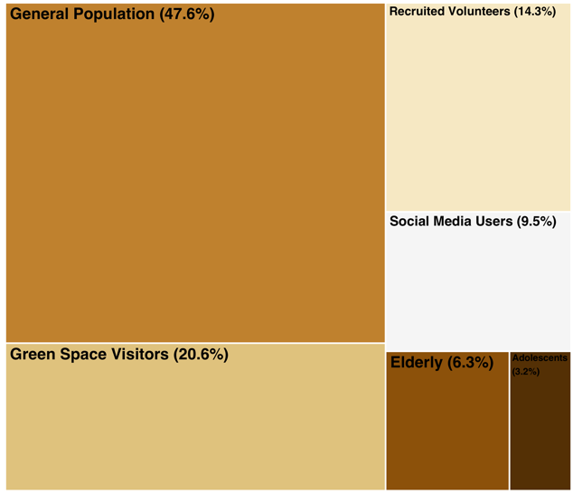
Fig. C2.3 – Frequency of sample population groups.
- Green Space Visitors: this category was used when studies collected data in situ, targeting the users present in the green space without imposing additional limitations such as age.
- Elderly and Adolescents: these two categories were used when the study explicitly targeted these age groups.
- General Population: this category was used when the data were neither collected in situ nor specific age groups were targeted.
- Recruited Volunteers: the category was used for studies in which participants were specifically recruited to participate in the experiment through formal solicitation, again without imposing age limitations.
- Social Media Users: the category was utilized for studies that derived data from social media platforms.
Table 4 – Overview of the coding outcomes per eligible article. Category: Methodological Aspects
Authors | Data Collecting Method | Study Design | Research Tool |  |  |  |  |  |  | Sample Population Groups
Authors | Data Collecting Method | Study Design | RT.1 | RT.2 | RT.3 | RT.4 | RT.5 | RT.6 | RT.7 | SP.1 | SP.2 | SP.3 | SP.4 | SP.5 | SP.6
Dallimer et al., 2014 | Quantitative Methods | Cross-sectional | X |  |  |  |  |  |  | X
Carrus et al., 2015 | Quantitative Methods | Cross-sectional | X |  |  |  |  |  |  | X
Rostami et al., 2015 | Mixed Methods | Cross-sectional | X |  |  |  | X | X |  | X
Gilchrist et al., 2015 | Quantitative Methods | Cross-sectional |  | X |  |  |  |  |  |  |  |  |  |  | X
Conedera et al., 2015 | Quantitative Methods | Cross-sectional |  |  | X |  |  |  |  |  |  |  |  |  | X
Krekel et al., 2016 | Quantitative Methods | Longitudinal |  |  |  | X |  |  |  |  |  |  |  |  | X
Akpinar, 2016 | Quantitative Methods | Cross-sectional | X |  |  |  |  |  |  |  |  | X
Tilley et al., 2017 | Qualitative Methods | Experimental (Field/Lab) |  |  |  |  | X |  |  |  |  |  | X
Wood et al., 2017 | Quantitative Methods | Longitudinal |  |  | X |  |  |  |  |  |  |  |  |  | X
Y. Zhang et al., 2017 | Quantitative Methods | Cross-sectional |  |  | X |  |  |  |  |  |  |  |  |  | X
Kim & Jin, 2018 | Quantitative Methods | Cross-sectional |  |  |  | X |  |  |  |  |  |  |  |  | X
Dzhambov et al., 2018 | Quantitative Methods | Cross-sectional | X |  |  |  |  |  |  |  |  |  |  |  | X
Southon et al., 2018 | Quantitative Methods | Cross-sectional | X |  |  |  |  |  |  | X
Aoshima et al., 2018 | Quantitative Methods | Cross-sectional |  | X |  |  |  |  |  |  |  |  |  |  | X
Navarrete-Hernandez & Laffan, 2019 | Quantitative Methods | Experimental (Field/Lab) | X |  |  |  |  |  |  |  | X
Schwartz et al., 2019 | Quantitative Methods | Cross-sectional |  |  |  |  |  |  | X |  |  |  |  | X
Ayala-Azcárraga et al., 2019 | Quantitative Methods | Cross-sectional | X |  |  | X |  |  |  | X
Schebella et al., 2019 | Quantitative Methods | Cross-sectional |  |  | X |  |  |  |  |  |  |  |  |  | X
Cameron et al., 2020 | Quantitative Methods | Experimental (Field/Lab) |  | X |  |  |  |  |  |  | X
Wenjie et al., 2020 | Quantitative Methods | Cross-sectional |  |  |  | X |  |  |  |  |  |  |  |  | X
Paul et al., 2020 | Mixed Methods | Cross-sectional | X |  |  |  | X | X |  | X
Deng et al., 2020 | Quantitative Methods | Experimental (Field/Lab) | X |  |  |  |  |  |  |  | X
Bonilla-Bedoya et al., 2020 | Quantitative Methods | Cross-sectional | X |  |  |  |  |  |  | X
Cheng et al., 2021 | Quantitative Methods | Cross-sectional |  |  |  |  |  |  | X |  |  |  |  | X
Sharifi et al., 2021 | Quantitative Methods | Longitudinal |  |  |  | X |  |  |  |  |  |  |  |  | X
Maurer et al., 2021 | Mixed Methods | Cross-sectional | X |  |  |  | X | X |  | X
Z. Zhang et al., 2021 | Quantitative Methods | Cross-sectional | X |  |  |  |  |  |  |  |  |  |  |  | X
Hussein et al., 2021 | Quantitative Methods | Cross-sectional | X |  |  |  |  |  |  | X
Chu et al., 2021 | Quantitative Methods | Cross-sectional | X |  |  |  |  |  |  |  |  |  | X
Wang et al., 2021 | Quantitative Methods | Cross-sectional | X |  |  |  |  |  |  |  |  |  |  |  | X
Mayen Huerta & Utomo, 2021 | Quantitative Methods | Cross-sectional |  | X |  |  |  |  |  |  |  |  |  |  | X
Maric et al., 2021 | Quantitative Methods | Cross-sectional | X |  |  |  |  |  |  |  |  |  |  |  | X
Wan et al., 2021 | Quantitative Methods | Cross-sectional |  |  |  |  |  |  | X |  |  |  |  | X
Fisher et al., 2021 | Quantitative Methods | Cross-sectional | X |  |  |  |  |  |  |  |  |  |  |  | X
Lopez et al., 2021 | Quantitative Methods | Cross-sectional |  | X |  |  |  |  |  |  |  |  |  |  | X
Han et al., 2021 | Quantitative Methods | Cross-sectional | X |  |  |  |  |  |  |  |  |  | X
Zhu et al., 2021 | Quantitative Methods | Cross-sectional | X |  |  |  |  |  |  |  |  |  |  |  | X
Nghiem et al., 2021 | Quantitative Methods | Experimental (Field/Lab) | X |  |  |  |  |  |  |  | X |  |  |  | X
Samus et al., 2022 | Quantitative Methods | Experimental (Field/Lab) | X | X |  |  |  |  |  |  | X
Allard-Poesi et al., 2022 | Quantitative Methods | Cross-sectional |  | X |  |  |  |  |  |  |  |  |  |  | X
Lin et al., 2022 | Quantitative Methods | Cross-sectional |  |  |  |  |  |  | X |  |  |  |  | X
Knight et al., 2022 | Quantitative Methods | Longitudinal |  |  |  | X |  |  |  |  |  |  |  |  | X
Shentova et al., 2022 | Quantitative Methods | Cross-sectional |  | X |  |  |  |  |  |  |  |  |  |  | X
Kong et al., 2022 | Quantitative Methods | Cross-sectional |  |  |  |  |  |  | X |  |  |  |  | X
Olszewska-Guizzo et al., 2022 | Quantitative Methods | Experimental (Field/Lab) | X |  |  |  |  |  |  |  | X
Wang et al., 2022 | Quantitative Methods | Cross-sectional |  |  |  | X |  |  |  |  |  |  |  |  | X
Song et al., 2022 | Quantitative Methods | Experimental (Field/Lab) | X |  |  |  |  |  |  |  | X
Jeong et al., 2022 | Quantitative Methods | Cross-sectional |  | X |  |  |  |  |  |  |  |  |  |  | X
Chen et al., 2022 | Quantitative Methods | Cross-sectional |  |  |  |  |  |  | X |  |  |  |  | X
Nawrath et al., 2022 | Quantitative Methods | Cross-sectional | X |  |  |  |  |  |  |  |  |  |  |  | X
Jiang & Huang, 2022 | Quantitative Methods | Cross-sectional | X |  |  |  |  |  |  | X
van Dinter et al., 2022 | Quantitative Methods | Cross-sectional |  | X |  |  |  |  |  |  |  |  |  |  | X
Sheng & Lian, 2022 | Quantitative Methods | Cross-sectional |  | X |  |  |  |  |  |  |  |  | X
Cernicova-Buca et al., 2023 | Quantitative Methods | Cross-sectional | X |  |  |  |  |  |  |  |  |  |  |  | X
Patino et al., 2023 | Quantitative Methods | Cross-sectional |  |  |  | X |  |  |  |  |  |  |  |  | X
W. Wu et al., 2023 | Quantitative Methods | Cross-sectional |  |  |  | X |  |  |  |  |  |  |  |  | X
Fleckney, 2023 | Qualitative Methods | Cross-sectional |  |  |  |  | X |  |  |  |  | X
Chiang et al., 2023 | Quantitative Methods | Cross-sectional | X |  |  |  |  |  |  | X
Niu et al., 2023 | Quantitative Methods | Cross-sectional | X |  |  |  |  |  |  | X
R. Zhang, 2023 | Quantitative Methods | Experimental (Field/Lab) | X |  |  |  |  |  |  |  | X
L. Wu & Chen, 2023 | Quantitative Methods | Cross-sectional |  |  |  | X |  |  |  |  |  |  |  |  | X
Huang et al., 2023 | Quantitative Methods | Experimental (Field/Lab) | X |  |  |  |  |  |  |  | X
Y. Wu et al., 2023 | Quantitative Methods | Cross-sectional | X |  |  |  |  |  |  | X
Total |  |  | 32 | 11 | 4 | 10 | 5 | 3 | 6 | 13 | 9 | 2 | 4 | 6 | 30

Section C.3 - Urban green spaces in the eligible articles
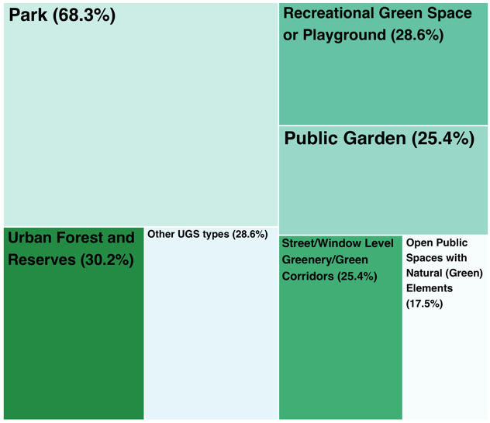
Fig. C3.1 – Prevalence of urban green space type examined in the eligible articles.
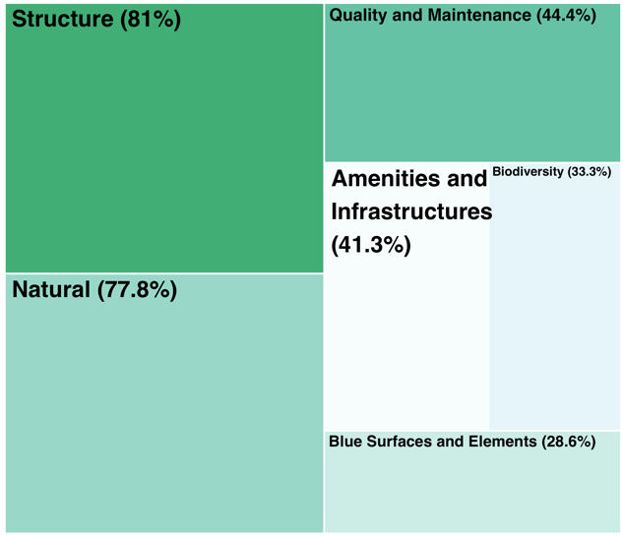
Fig. C3.2 – Frequency of urban green space groups of attributes in eligible articles.

Table 5 – Overview of the coding outcomes per eligible article. Category: Urban Green Spaces
Authors | Types of Urban Green Spaces |  |  |  |  |  |  | Urban Green Space Attribute Categories |  |  |  |  |  | Types of Metrics
Authors | UGS.1 | UGS.2 | UGS.3 | UGS.4 | UGS.5 | UGS.6 | UGS.7 | ATTR.1 | ATTR.2 | ATTR.3 | ATTR.4 | ATTR.5 | ATTR.6 | Types of Metrics
Dallimer et al., 2014 |  |  |  |  | X |  |  |  | X | X |  |  |  | Subjective
Carrus et al., 2015 | X |  | X |  |  |  |  |  | X |  |  |  |  | Objective; Distinctive
Rostami et al., 2015 |  | X |  |  |  |  |  | X |  | X |  | X | X | Subjective; Distinctive
Gilchrist et al., 2015 | X |  |  |  |  |  |  |  |  | X |  |  | X | Subjective
Conedera et al., 2015 | X |  |  | X | X | X | X | X | X | X |  | X |  | Subjective
Krekel et al., 2016 | X | X |  |  | X |  | X | X |  | X |  |  |  | Objective
Akpinar, 2016 |  |  | X |  |  |  |  |  |  | X |  |  |  | Subjective; Distinctive
Tilley et al., 2017 | X |  |  |  |  |  |  | X |  | X | X | X |  | Objective; Distinctive
Wood et al., 2017 | X |  |  | X | X | X |  | X | X | X | X |  | X | Objective; Distinctive
Y. Zhang et al., 2017 |  |  |  |  |  |  | X | X |  | X | X | X |  | Subjective; Distinctive
Kim & Jin, 2018 | X |  |  | X |  |  |  | X |  |  |  |  |  | Objective
Dzhambov et al., 2018 | X | X |  | X |  |  |  | X |  | X |  | X |  | Objective; Subjective
Southon et al., 2018 |  |  |  |  | X |  |  | X | X | X |  |  |  | Subjective; Distinctive
Aoshima et al., 2018 | X |  |  | X | X |  | X | X |  |  |  |  |  | Objective; Subjective
Navarrete-Hernandez & Laffan, 2019 |  |  |  |  |  | X |  | X |  | X |  |  |  | Objective
Schwartz et al., 2019 | X |  | X | X |  |  |  | X |  | X |  |  |  | Objective
Ayala-Azcárraga et al., 2019 | X |  |  |  |  |  |  | X | X | X | X | X |  | Subjective
Schebella et al., 2019 | X |  |  | X | X | X |  | X | X | X |  | X |  | Objective; Subjective; Distinctive
Cameron et al., 2020 | X | X | X |  |  |  |  | X | X | X |  |  |  | Objective; Subjective; Distinctive
Wenjie et al., 2020 |  |  |  | X |  |  |  | X |  |  |  |  | X | Objective
Paul et al., 2020 | X |  | X | X |  |  |  | X | X |  | X | X |  | Subjective
Deng et al., 2020 | X |  |  |  |  |  |  | X |  | X | X |  | X | Subjective
Bonilla-Bedoya et al., 2020 |  |  |  |  | X |  |  |  |  | X |  |  |  | Objective
Cheng et al., 2021 | X |  |  |  |  |  |  | X |  | X |  |  |  | Objective
Sharifi et al., 2021 | X | X | X | X | X | X |  | X |  |  |  |  |  | Objective
Maurer et al., 2021 | X |  |  |  |  |  |  | X |  | X |  |  | X | Subjective
Z. Zhang et al., 2021 |  |  |  | X |  |  |  | X |  |  | X |  |  | Objective; Distinctive
Hussein et al., 2021 | X |  |  |  |  |  |  | X | X |  | X | X | X | Subjective
Chu et al., 2021 | X |  |  |  |  |  |  | X |  | X | X | X |  | Subjective; Distinctive
Wang et al., 2021 |  |  |  |  |  |  | X | X |  | X |  | X |  | Objective; Subjective
Mayen Huerta & Utomo, 2021 | X | X | X | X | X | X | X | X |  |  | X | X |  | Subjective
Maric et al., 2021 |  |  | X |  |  |  |  | X |  | X | X |  |  | Subjective
Wan et al., 2021 | X | X | X |  |  |  |  | X | X | X | X |  | X | Subjective
Fisher et al., 2021 | X | X |  |  |  |  | X | X | X | X |  |  | X | Distinctive
Lopez et al., 2021 | X | X |  |  | X | X | X | X | X | X | X | X | X | Subjective
Han et al., 2021 |  |  |  |  |  | X |  | X |  | X | X | X |  | Objective; Distinctive
Zhu et al., 2021 | X |  |  | X |  |  | X | X | X | X | X | X | X | Distinctive
Nghiem et al., 2021 |  | X |  |  | X |  |  |  | X |  |  |  |  | Subjective
Samus et al., 2022 | X |  |  |  | X |  |  |  | X | X |  |  |  | Subjective
Allard-Poesi et al., 2022 | X | X |  | X | X | X |  | X |  | X | X | X |  | Subjective
Lin et al., 2022 | X |  |  |  |  | X |  | X |  | X |  |  |  | Objective
Knight et al., 2022 | X | X | X | X | X | X |  |  | X |  |  |  |  | Objective
Shentova et al., 2022 |  |  |  |  |  | X | X | X | X | X | X | X |  | Subjective
Kong et al., 2022 | X | X |  | X |  |  |  | X |  |  |  |  | X | Objective
Olszewska-Guizzo et al., 2022 | X | X |  |  |  |  | X | X | X | X |  |  |  | Distinctive
Wang et al., 2022 |  |  |  |  |  | X |  | X |  | X |  |  |  | Objective
Song et al., 2022 |  |  |  |  |  |  | X | X |  | X |  |  | X | Subjective; Distinctive
Jeong et al., 2022 | X |  |  |  | X |  | X |  |  | X |  |  |  | Objective
Chen et al., 2022 | X | X |  |  | X |  | X | X | X | X | X |  | X | Objective
Nawrath et al., 2022 |  |  |  |  |  |  | X |  | X |  |  |  |  | Subjective
Jiang & Huang, 2022 |  |  |  |  |  |  | X | X |  | X | X | X |  | Objective; Distinctive
van Dinter et al., 2022 | X |  |  |  |  |  |  | X |  | X | X | X | X | Objective; Subjective
Sheng & Lian, 2022 | X |  |  |  |  |  |  | X |  | X |  | X |  | Subjective
Cernicova-Buca et al., 2023 | X |  |  | X | X | X |  | X |  | X | X | X |  | Subjective
Patino et al., 2023 | X |  |  |  |  |  | X |  |  | X | X | X |  | Objective; Subjective
W. Wu et al., 2023 |  |  |  |  |  | X |  | X |  | X | X | X | X | Objective; Distinctive
Fleckney, 2023 | X | X |  | X | X | X |  | X |  |  | X | X |  | Subjective
Chiang et al., 2023 | X |  |  |  |  |  |  |  |  | X | X | X | X | Subjective
Niu et al., 2023 | X |  | X |  |  |  |  | X |  | X |  |  |  | Objective
R. Zhang, 2023 | X |  |  |  |  |  |  | X |  | X |  | X |  | Subjective; Distinctive
L. Wu & Chen, 2023 |  |  |  |  |  |  | X | X |  | X |  |  |  | Objective
Huang et al., 2023 | X |  |  |  |  |  |  | X |  | X | X | X |  | Objective; Distinctive
Y. Wu et al., 2023 | X |  |  |  |  |  |  | X |  | X |  | X | X | Objective; Subjective; Distinctive
Total | 43 | 16 | 11 | 18 | 19 | 16 | 18 | 51 | 21 | 49 | 26 | 28 | 18

Section C.4 – Subjective well-being in the eligible articles
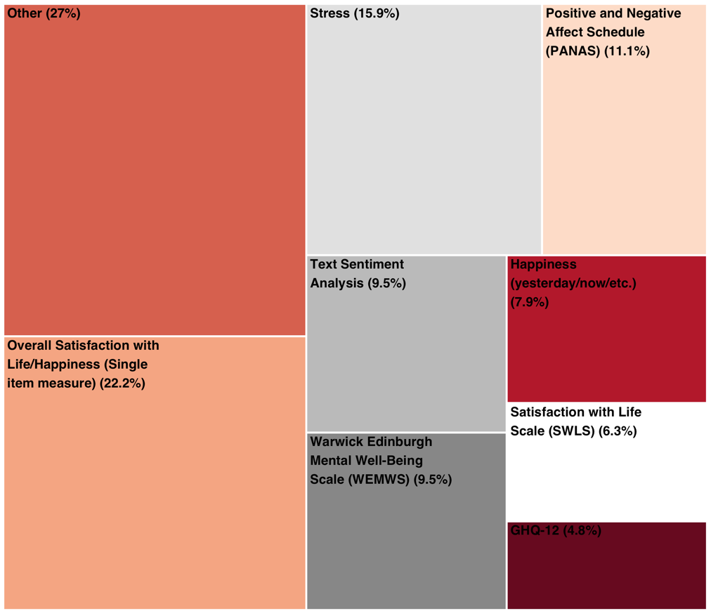
Fig. C4.1 – Prevalence of specific tools employed for measuring subjective well-being.

Table 6 - Overview of the coding outcomes per eligible article. Category: Subjective Well-Being
Authors | Subjective Well-Being Dimensions | Mode of Assessment |  |  | Subjecttive Well-Being Measures
Authors | Subjective Well-Being Dimensions | Single-item | Multi-item | Content Anal. | SWB.1 | SWB.2 | SWB.3 | SWB.4 | SWB.5 | SWB.6 | SWB.7 | SWB.8 | SWB.9
Dallimer et al., 2014 | Momentary (Positive/Negative Affect); Eudaimonic |  | X |  |  | X |  |  |  |  |  |  | X
Carrus et al., 2015 | Momentary (Positive/Negative Affect) | X |  |  |  |  |  |  |  |  |  |  | X
Rostami et al., 2015 | Momentary (Positive/Negative Affect) |  | X |  |  |  |  |  |  |  |  |  | X
Gilchrist et al., 2015 | Momentary (Positive/Negative Affect); Eudaimonic |  | X |  |  |  |  | X
Conedera et al., 2015 | Momentary (Positive/Negative Affect) | X |  |  |  |  | X
Krekel et al., 2016 | Evaluative (Life Evaluation) | X |  |  |  |  |  |  | X
Akpinar, 2016 | Evaluative (Life Evaluation); Momentary (Positive/Negative Affect) |  | X |  |  |  | X |  |  |  |  |  | X
Tilley et al., 2017 | Momentary (Positive/Negative Affect) |  | X | X |  |  |  |  |  |  |  |  | X
Wood et al., 2017 | Momentary (Positive/Negative Affect); Eudaimonic |  | X |  |  |  |  | X
Y. Zhang et al., 2017 | Momentary (Positive/Negative Affect) | X |  |  |  | X
Kim & Jin, 2018 | Evaluative (Life Evaluation) | X |  |  |  |  |  |  | X
Dzhambov et al., 2018 | Evaluative (Life Evaluation); Momentary (Positive/Negative Affect); Eudaimonic |  | X |  |  |  |  |  |  |  |  | X
Southon et al., 2018 | Momentary (Positive/Negative Affect); Eudaimonic |  | X |  |  |  |  | X
Aoshima et al., 2018 | Evaluative (Life Evaluation) | X |  |  |  |  |  |  | X
Navarrete-Hernandez & Laffan, 2019 | Momentary (Positive/Negative Affect) |  | X |  |  | X | X
Schwartz et al., 2019 | Momentary (Positive/Negative Affect) |  |  | X |  |  |  |  |  |  | X
Ayala-Azcárraga et al., 2019 | Evaluative (Life Evaluation) | X |  |  |  |  |  |  | X
Schebella et al., 2019 | Momentary (Positive/Negative Affect); Eudaimonic |  | X |  |  |  | X |  |  |  |  |  | X
Cameron et al., 2020 | Momentary (Positive/Negative Affect) | X |  |  |  |  |  |  |  |  |  |  | X
Wenjie et al., 2020 | Evaluative (Life Evaluation) | X |  |  |  |  |  |  | X
Paul et al., 2020 | Momentary (Positive/Negative Affect); Eudaimonic |  | X |  |  |  |  |  |  |  |  |  | X
Deng et al., 2020 | Momentary (Positive/Negative Affect) |  | X |  |  |  |  |  |  |  |  |  | X
Bonilla-Bedoya et al., 2020 | Evaluative (Life Evaluation); Momentary (Positive/Negative Affect); Eudaimonic |  | X |  |  |  |  |  |  |  |  |  | X
Cheng et al., 2021 | Momentary (Positive/Negative Affect) |  |  | X |  |  |  |  |  |  | X
Sharifi et al., 2021 | Evaluative (Life Evaluation) | X |  |  |  |  |  |  | X
Maurer et al., 2021 | Momentary (Positive/Negative Affect) |  | X |  |  | X
Z. Zhang et al., 2021 | Momentary (Positive/Negative Affect); Eudaimonic |  | X |  |  |  |  | X
Hussein et al., 2021 | Momentary (Positive/Negative Affect) |  | X |  |  |  | X
Chu et al., 2021 | Evaluative (Life Evaluation) |  | X |  |  |  |  |  |  | X
Wang et al., 2021 | Evaluative (Life Evaluation); Momentary (Positive/Negative Affect) |  | X |  |  |  | X |  |  | X |  |  | X
Mayen Huerta & Utomo, 2021 | Momentary (Positive/Negative Affect); Eudaimonic |  | X |  |  |  |  | X
Maric et al., 2021 | Momentary (Positive/Negative Affect) |  | X |  |  |  | X
Wan et al., 2021 | Momentary (Positive/Negative Affect) |  |  | X |  |  |  |  |  |  | X
Fisher et al., 2021 | Momentary (Positive/Negative Affect) |  | X |  | X
Lopez et al., 2021 | Momentary (Positive/Negative Affect) | X |  |  |  |  | X |  |  |  |  |  | X
Han et al., 2021 | Momentary (Positive/Negative Affect); Eudaimonic |  | X |  |  |  |  |  |  |  |  |  | X
Zhu et al., 2021 | Momentary (Positive/Negative Affect); Eudaimonic |  | X |  |  |  |  | X
Nghiem et al., 2021 | Momentary (Positive/Negative Affect) |  | X |  | X
Samus et al., 2022 | Momentary (Positive/Negative Affect) |  | X |  | X
Allard-Poesi et al., 2022 | Evaluative (Life Evaluation); Momentary (Positive/Negative Affect); Eudaimonic |  | X |  |  |  |  |  |  |  |  |  | X
Lin et al., 2022 | Momentary (Positive/Negative Affect) |  |  | X |  |  |  |  |  |  | X
Knight et al., 2022 | Evaluative (Life Evaluation); Momentary (Positive/Negative Affect); Eudaimonic |  | X |  |  |  |  |  | X |  |  | X
Shentova et al., 2022 | Evaluative (Life Evaluation); Momentary (Positive/Negative Affect); Eudaimonic |  | X |  |  |  |  |  |  |  |  | X
Kong et al., 2022 | Momentary (Positive/Negative Affect) |  |  | X |  |  |  |  |  |  | X
Olszewska-Guizzo et al., 2022 | Momentary (Positive/Negative Affect) |  | X |  |  |  |  |  |  |  |  |  | X
Wang et al., 2022 | Evaluative (Life Evaluation) | X |  |  |  |  |  |  | X
Song et al., 2022 | Momentary (Positive/Negative Affect) |  | X |  | X
Jeong et al., 2022 | Evaluative (Life Evaluation) | X |  |  |  |  |  |  | X
Chen et al., 2022 | Momentary (Positive/Negative Affect) |  |  | X |  |  |  |  |  |  | X
Nawrath et al., 2022 | Momentary (Positive/Negative Affect) | X |  |  |  |  | X
Jiang & Huang, 2022 | Evaluative (Life Evaluation) | X |  |  |  |  |  |  | X
van Dinter et al., 2022 | Evaluative (Life Evaluation) |  | X |  |  |  |  |  |  | X
Sheng & Lian, 2022 | Momentary (Positive/Negative Affect) | X |  |  |  |  | X
Cernicova-Buca et al., 2023 | Evaluative (Life Evaluation) | X |  |  |  |  |  |  | X
Patino et al., 2023 | Evaluative (Life Evaluation); Momentary (Positive/Negative Affect) |  | X |  |  | X |  |  | X
W. Wu et al., 2023 | Evaluative (Life Evaluation) | X |  |  |  |  |  |  | X
Fleckney, 2023 | Momentary (Positive/Negative Affect) |  |  | X |  |  |  |  |  |  |  |  | X
Chiang et al., 2023 | Evaluative (Life Evaluation) |  | X |  |  |  |  |  |  | X
Niu et al., 2023 | Momentary (Positive/Negative Affect) |  | X |  | X
R. Zhang, 2023 | Momentary (Positive/Negative Affect) |  | X |  | X
L. Wu & Chen, 2023 | Evaluative (Life Evaluation) | X |  |  |  |  |  |  | X
Huang et al., 2023 | Momentary (Positive/Negative Affect) |  | X |  |  |  |  |  |  |  |  |  | X
Y. Wu et al., 2023 | Momentary (Positive/Negative Affect) |  | X |  | X
Total |  | 19 | 37 | 8 | 7 | 5 | 10 | 6 | 14 | 4 | 6 | 3 | 17

According to the World Bank
Research Tool Codes: RT.1 - Paper-and-pen questionnaire (Researcher was present); RT.2 - Online questionnaire; RT.3 - Mail-back questionnaire (Researcher was not present); RT.4 - Secondary survey data; RT.5 – Interview; RT.6 – Observation; RT.7 - Social Media Data
Sample Population Groups Codes: SP.1 - Green space visitors; SP.2 - Recruited volunteers; SP.3 – Adolescents; SP.4 – Elderly; SP.5 - Social Media users; SP.6 - General population
UGS Type Codes: UGS.1 - Park; UGS.2 - Public Garden; UGS.3 - Open Public Spaces with Natural (Green) Elements; UGS4. - Recreational Green Space or Playground; UGS5. - Urban Forest and Reserves; UGS6. - Street/Window Level Greenery/Green Corridors; UGS7. – Other
UGS Attributes: ATTR.1 - Structure; ATTR.2 - Biodiversity; ATTR.3 - Natural; ATTR.4 - Amenities and Infrastructure; ATTR.5 - Quality and Maintenance; ATTR.6 - Blue Surfaces and Elements
SWB Measures codes: SWB.1 - Positive and Negative Affect Schedule (PANAS); SWB.2 - Happiness (yesterday/now/etc.); SWB.3 - Stress; SWB.4 - Warwick Edinburgh Mental Well-Being Scale (WEMWS); SWB.5 - Overall Satisfaction with Life/Happiness (Single item measure); SWB.6 - Satisfaction with Life Scale (SWLS); SWB.7 - Text sentiment analysis; SWB.8 - GHQ-12; SWB.9 - Other

