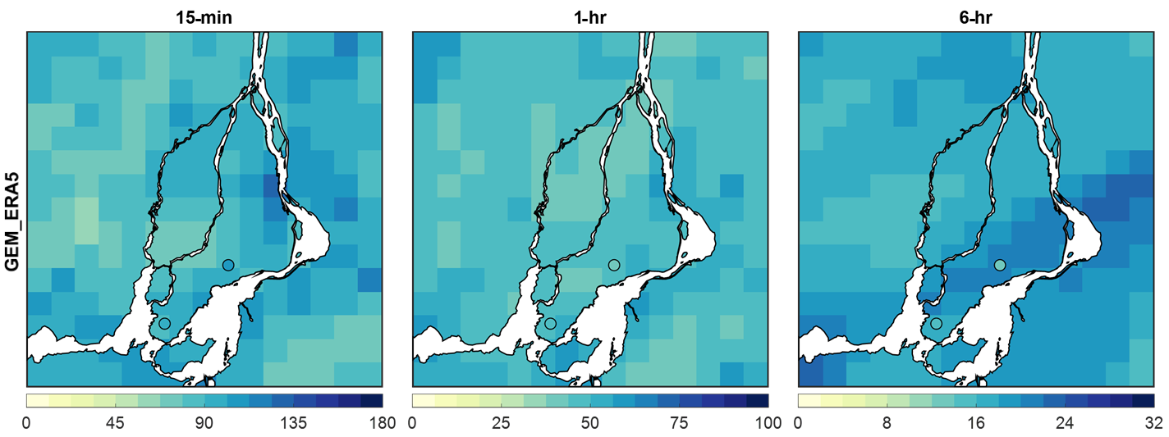
Figure S1. GEM_ERA5-based 100-year return levels of 15-min (left), 1-hr (middle), and 6-hr (right) rainfall events (mm/hr) over Montreal Island. Circles denote Environment and Climate Change Canada observation stations (Ste. Anne de Bellevue and Pierre Elliott Trudeau International).

Table S1. Station-wise bias in 100-year rainfall return levels between GEM-ERA5 simulations and observed IDF data for the two Montreal Island stations.
Station | Duration | Observed return level (mm/hr) | GEM_ERA5 return level (mm/hr) | Bias (mm/hr) | Relative bias
Trudeau Intl | 15-min | 101.4 | 80.6 | -20.8 | -21%
Trudeau Intl | 1-hr | 38 | 46.8 | 8.8 | 23%
Trudeau Intl | 6-hr | 12.2 | 21.1 | 8.9 | 73%
Ste-Anne-de-Bellevue | 15-min | 101.2 | 84.8 | -16.4 | -16%
Ste-Anne-de-Bellevue | 1-hr | 45.7 | 44.5 | -1.2 | -3%
Ste-Anne-de-Bellevue | 6-hr | 14 | 17.3 | 3.3 | 24%

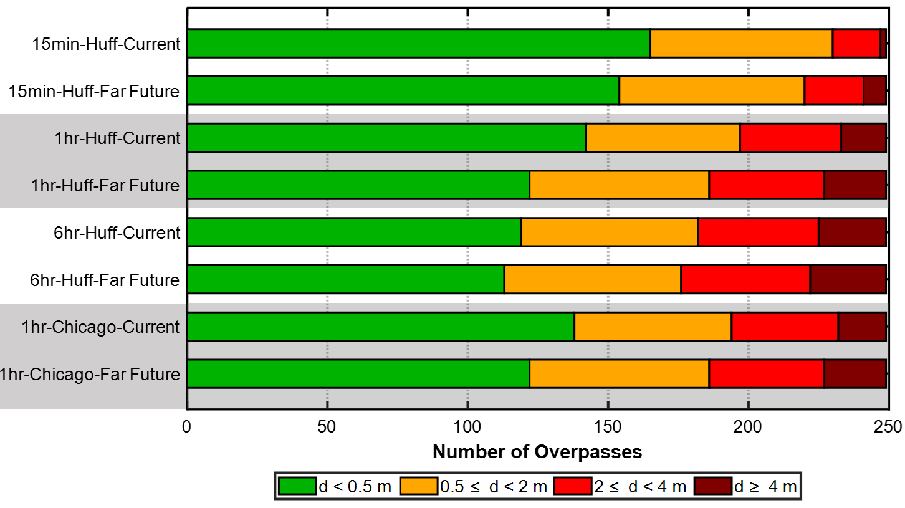
Figure S2: Number of overpasses subjected to different levels of maximum flood depth for the considered design storms with a 100-year return period, for the current period (1991-2020) and the far future (2071-2100) periods.

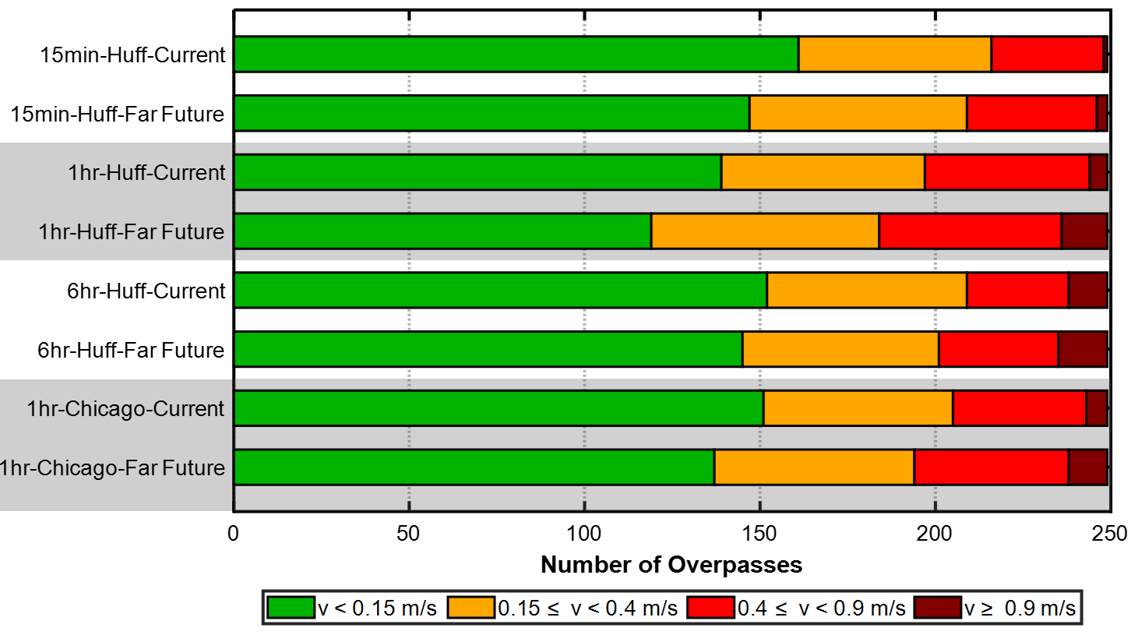
Figure S3: Same as Figure 10, but for the maximum flood velocity (m/s).

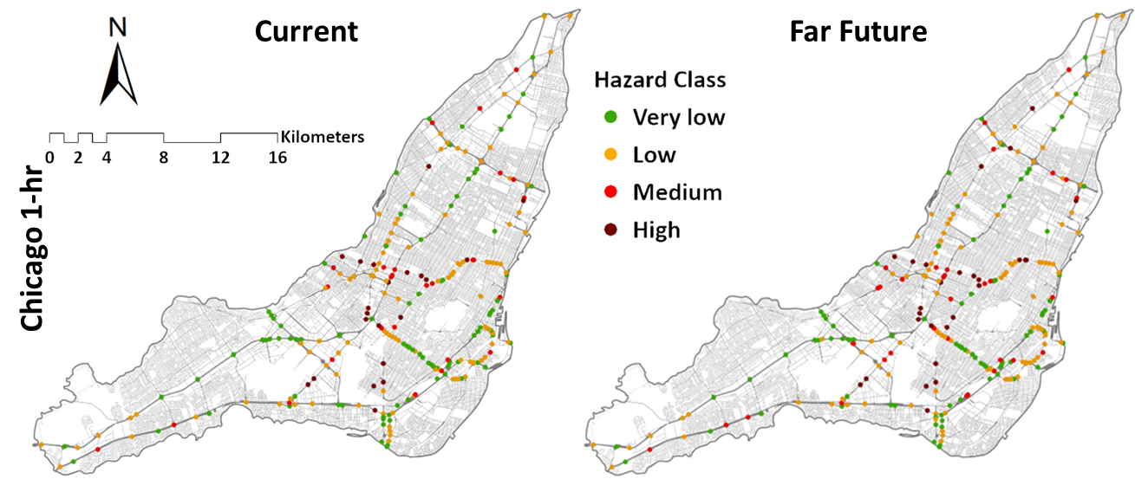
Figure S4: Flood risk categories of urban overpasses corresponding to 100-yr return levels of 1-hr rainfall event based on the Chicago design storm for the current (1991-2020) period (left) and the far future (2071-2100) period (right).

