Supplementary Table S1. Harmonized Municipal Solid Waste (MSW) Dataset for South Asia
Country | Year | Per Capita (kg/person/day) | Urban Population (millions) | Total MSW (Mt/year)
India | 2015 | 0.520 | 429.0 | 81.4
 | 2020 | 0.575 | 485.0 | 101.9
 | 2025 | 0.635 | 549.2 | 127.3
Bangladesh | 2015 | 0.450 | 56.0 | 9.2
 | 2020 | 0.497 | 65.0 | 11.8
 | 2025 | 0.548 | 75.3 | 15.1
Pakistan | 2015 | 0.600 | 72.0 | 15.8
 | 2020 | 0.644 | 82.6 | 19.4
 | 2025 | 0.691 | 94.7 | 23.9
Nepal | 2015 | 0.450 | 6.0 | 1.0
 | 2020 | 0.484 | 6.9 | 1.2
 | 2025 | 0.521 | 8.0 | 1.5
Sri Lanka | 2015 | 0.850 | 4.0 | 1.2
 | 2020 | 0.894 | 4.3 | 1.4
 | 2025 | 0.940 | 4.7 | 1.6
Maldives | 2015 | 1.600 | 0.15 | 0.1
 | 2020 | 1.640 | 0.17 | 0.1
 | 2025 | 1.680 | 0.19 | 0.1

Values are harmonized estimates of per capita MSW generation, urban population, and total MSW. Per capita = kg/person/day; Urban population = millions; Total MSW = million tonnes per year (Mt/year). Sources: CPCB (India), DoE (Bangladesh), Pak-EPA, CEA (Sri Lanka), MoE (Maldives), MoUD (Nepal), World Bank (2018, 2020), UN WUP (2022), Agamuthu & Babel (2023). Interpolations applied where annual data unavailable.

Supplementary Figure S1. Thematic Word Map
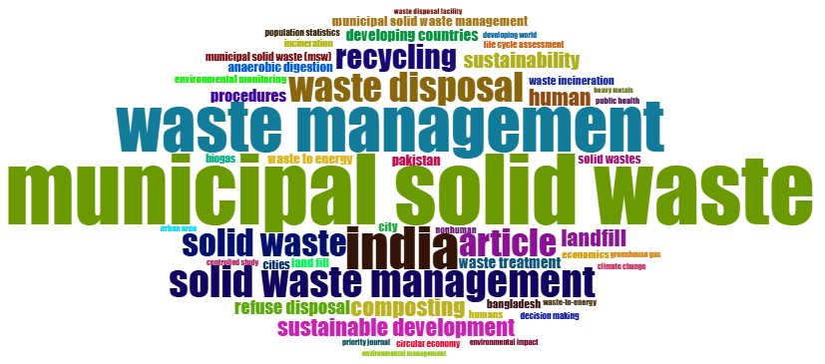

Supplementary Figure S2. Thematic Word tree map
