Urban freight mobility challenges and logistics circuit optimization for sustainable city development in Ouagadougou, West Africa.

Issaka Abdou Razakou Kiribou*^{a,b}, Mohamed Ibrahim Ballo^{b,c}, Pawendkisgou Isidore Yanogo^{c}, Sawadogo W. Abel^{b}, Yembi Kiendrebeogo^{d}; Diallo Hamadou^{b}

_______________________________________________

Affiliations
ªAfrica Centre of Excellence for Climate Smart Agricultural and Biodiversity Conservation (ACE-Climate SAB) Haramaya University, P.0. Box 138 Dire Dawa Ethiopia.
ORCID : https://orcid.org/0000-0002-3410-6204
^{b}Ministère en charge de la mobilité urbaine 03 BP 7034, Ouagadougou, Burkina Faso.

^{c}Département de Géographié, Université Norbert ZONGO, BP376, Koudougou, Burkina Faso.

^{d}Comité International de la Croix-Rouge, Délégation de Ouagadougou, Rue 56 664, secteur 54, 11 BP 892 CMS Ouaga 11 Burkina Faso.

*Corresponding author:
kiribou.i@edu.wascal.org ; Krazakou200248@gmail.com
ORCID: https://orcid.org/0000-0002-3410-6204

Supplementary information

- Supplementary figures

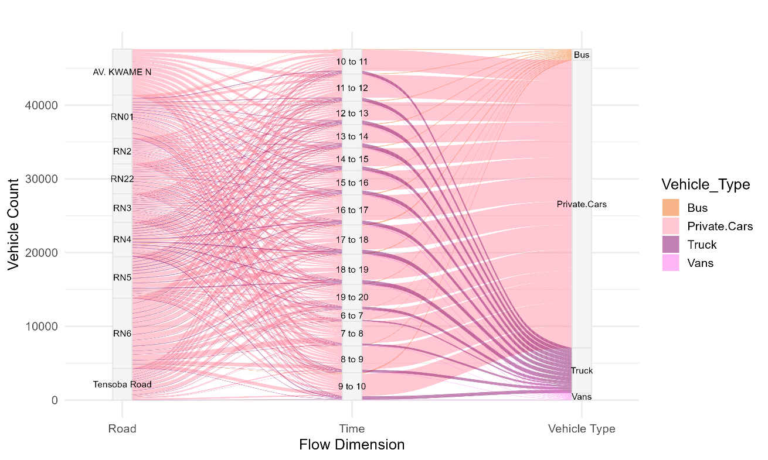
Figure S1: Shared of daily urban traffic in the mobility
- Table

Table S1: Land use classes statistics for the years 2000, 2012 and, 2024

Year 2000
LULC Class | Builtup | Agricultural | Waterbody | Forest | Total
Builtup | 122 | 5 | 0 | 0 | 127
Agricultural land | 2 | 263 | 0 | 0 | 265
Waterbody | 0 | 0 | 186 | 0 | 186
Forest | 0 | 0 | 4 | 102 | 106
Total | 124 | 268 | 190 | 102 | 684
Kappa | 0.82
Test Accuracy | 0.87

Year 2012
LULC Class | Builtup | Agricultural | Waterbody | Forest | Total
Builtup | 225 | 21 | 0 | 0 | 246
Agricultural land | 0 | 301 | 0 | 0 | 301
Waterbody | 11 | 0 | 111 | 0 | 122
Forest | 0 | 0 | 8 | 98 | 106
Total | 236 | 322 | 119 | 98 | 775
Kappa | 0.88
Test Accuracy | 0.89

Year 2024
LULC Class | Builtup | Agricultural | Waterbody | Forest
Builtup | 325 | 21 | 0 | 0
Agricultural land | 0 | 201 | 0 | 0
Waterbody | 11 | 0 | 81 | 0
Forest | 0 | 0 | 8 | 91
Total | 336 | 222 | 89 | 91
Kappa | 0.81
Test Accuracy | 0.85

