2004
OBJECTID * | ClassValue | Vegetation | Built-up | Waterbody | Sandbar | Barren land | Agricultural land | Total | U_Accuracy | Kappa
1 | Vegetation | 31 | 0 | 1 | 0 | 3 | 0 | 35 | 0.885714 | 0
2 | Built-up | 1 | 19 | 1 | 0 | 2 | 0 | 23 | 0.826087 | 0
3 | Waterbody | 1 | 0 | 14 | 0 | 0 | 0 | 15 | 0.933333 | 0
4 | Sandbar | 0 | 0 | 2 | 29 | 0 | 0 | 31 | 0.935484 | 0
5 | Barren land | 5 | 1 | 1 | 0 | 39 | 2 | 48 | 0.8125 | 0
6 | Agricultural land | 3 | 1 | 0 | 0 | 2 | 43 | 49 | 0.877551 | 0
7 | Total | 41 | 21 | 19 | 29 | 46 | 45 | 201 | 0 | 0
8 | P_Accuracy | 0.756098 | 0.904762 | 0.736842 | 1 | 0.847826 | 0.955556 | 0 | 0.870647 | 0
9 | Kappa | 0 | 0 | 0 | 0 | 0 | 0 | 0 | 0 | 0.841087
2014
OBJECTID * | ClassValue | Vegetation | Built-up | Waterbody | Sandbar | Barren land | Agricultural land | Total | U_Accuracy | Kappa
1 | Vegetation | 41 | 0 | 0 | 0 | 1 | 1 | 43 | 0.953488 | 0
2 | Built-up | 1 | 22 | 1 | 0 | 1 | 2 | 27 | 0.814815 | 0
3 | Waterbody | 0 | 0 | 16 | 0 | 0 | 0 | 16 | 1 | 0
4 | Sandbar | 0 | 0 | 0 | 22 | 1 | 0 | 23 | 0.956522 | 0
5 | Barren land | 0 | 1 | 0 | 0 | 33 | 2 | 36 | 0.916667 | 0
6 | Agricultural land | 2 | 2 | 0 | 0 | 10 | 40 | 54 | 0.740741 | 0
7 | Total | 44 | 25 | 17 | 22 | 46 | 45 | 199 | 0 | 0
8 | P_Accuracy | 0.931818 | 0.88 | 0.941176 | 1 | 0.717391 | 0.888889 | 0 | 0.874372 | 0
9 | Kappa | 0 | 0 | 0 | 0 | 0 | 0 | 0 | 0 | 0.845353
OBJECTID * | ClassValue | Vegetation | Built-up | Waterbody | Sandbar | Barren land | Agricultural land | Total | U_Accuracy | Kappa
1 | Vegetation | 39 | 2 | 0 | 0 | 2 | 0 | 43 | 0.906977 | 0
2 | Built-up | 2 | 30 | 0 | 0 | 2 | 1 | 35 | 0.857143 | 0
3 | Waterbody | 0 | 0 | 16 | 0 | 0 | 0 | 16 | 1 | 0
4 | Sandbar | 1 | 0 | 0 | 14 | 0 | 0 | 15 | 0.933333 | 0
5 | Barren land | 4 | 2 | 0 | 2 | 46 | 1 | 55 | 0.836364 | 0
6 | Agricultural land | 4 | 1 | 0 | 0 | 7 | 25 | 37 | 0.675676 | 0
7 | Total | 50 | 35 | 16 | 16 | 57 | 27 | 201 | 0 | 0
8 | P_Accuracy | 0.78 | 0.857143 | 1 | 0.875 | 0.807018 | 0.925926 | 0 | 0.845771 | 0
9 | Kappa | 0 | 0 | 0 | 0 | 0 | 0 | 0 | 0 | 0.807661
Supplementary file
Table S1- Accuracy assessment table

Table S2: Correlation matrix between LST, NDVI, NDBI, and MNDWI in Cuttack city and its periphery (2004 – 2024).
2004
 | LST | NDVI | NDBI | MNDWI
LST | 1 | 0.051 | 0.682 | -0.658
NDVI | 0.051 | 1 | -0.205 | -0.478
NDBI | 0.682 | -0.205 | 1 | -0.745
MNDWI | -0.658 | -0.478 | -0.745 | 1
2014
 | LST | NDVI | NDBI | MNDWI
LST | 1 | -0.058 | 0.758 | -0.676
NDVI | -0.058 | 1 | -0.372 | -0.466
NDBI | 0.758 | -0.372 | 1 | -0.581
MNDWI | -0.676 | -0.466 | -0.581 | 1
2024
 | LST | NDVI | NDBI | MNDWI
LST | 1 | -0.016 | 0.670 | -0.716
NDVI | -0.016 | 1 | -0.476 | -0.468
NDBI | 0.670 | -0.476 | 1 | -0.511
MNDWI | -0.716 | -0.468 | -0.511 | 1

Figure S1. Prediction residuals (Observed − Predicted LST)
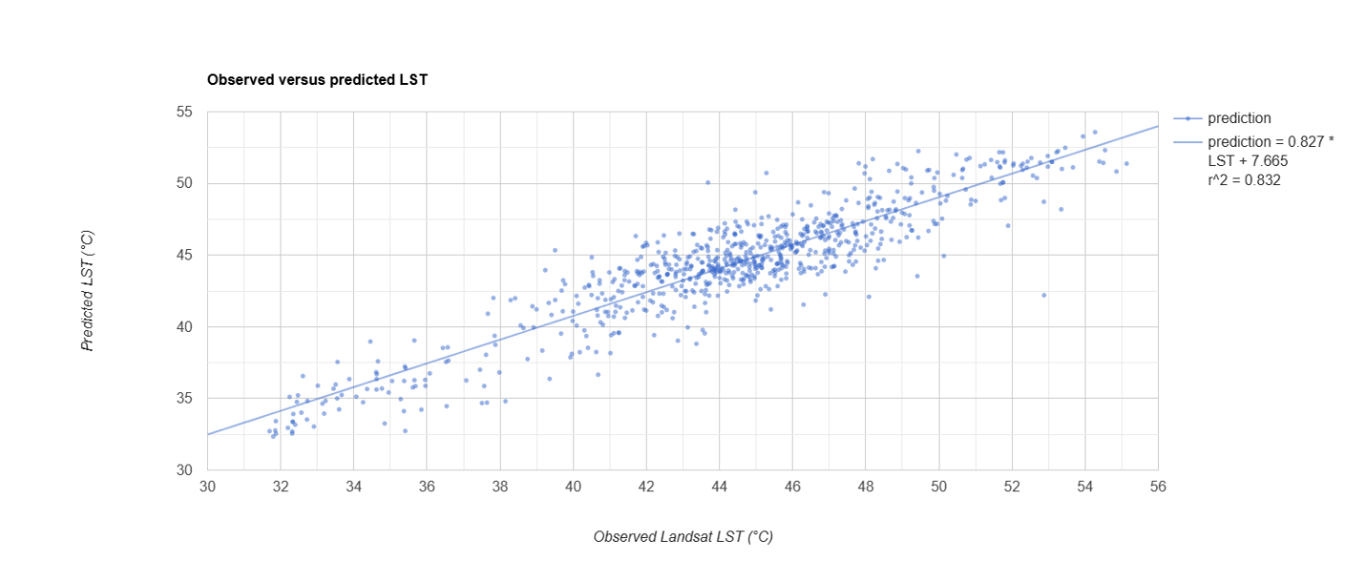
Figure. S2. Feature importance of parameters based on Random Forest Model
