Supplementary Material for “SyncDIT: High-Fidelity Video Synthesis Synchronized to Complex Audio”

1. Dataset Details
In this paper, we constructed a dataset of musical instrument videos (MIV). After segmentation and careful screening, the high-quality subset consists of high-definition videos with precise audio-visual synchronization. The video duration ranges from a minimum of 4 seconds to a maximum of 60 seconds. All videos are captured with a fixed camera, focusing on the performers’ hands. The audio tracks correspond closely to the instruments being played in the videos.
Figure 1 showcases some examples of our MIV dataset.
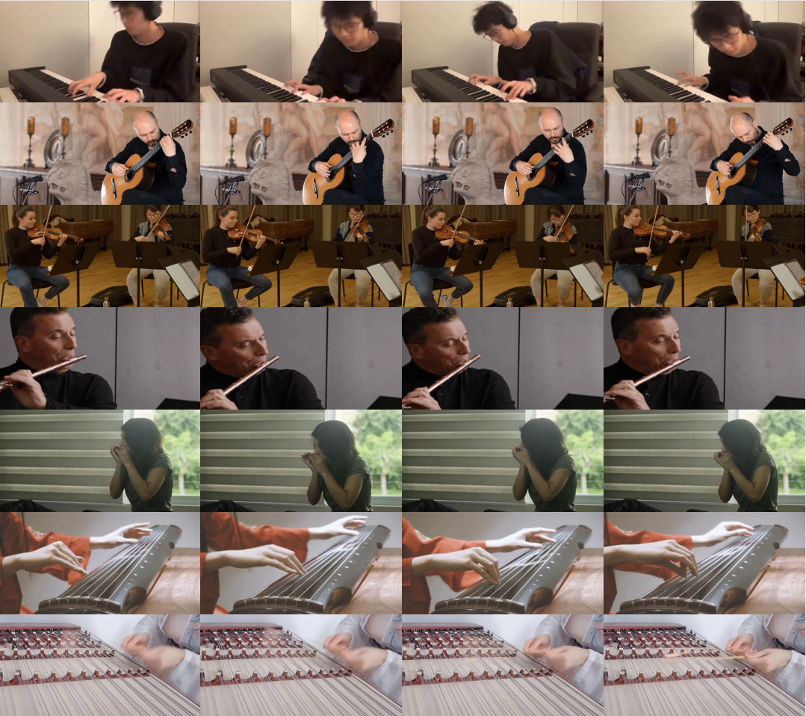
Figure 1: MIV dataset

2. Implementation Details
In all experiments and evaluations, we use 50 sampling steps, with the text CFG set to 4.0 and the audio CFG set to 4.5. We observed that enabling teacache led to incorrect and limited hand movements. Thus, it was not employed. To improve hand clarity, we experimented with the FusionX LoRA. While LoRA produced sharper hands, it also resulted in smaller and less natural hand movements in the generated videos. Consequently, LoRA was excluded from our evaluations.
Figure 2 showcases some examples of using LoRA and teacache.
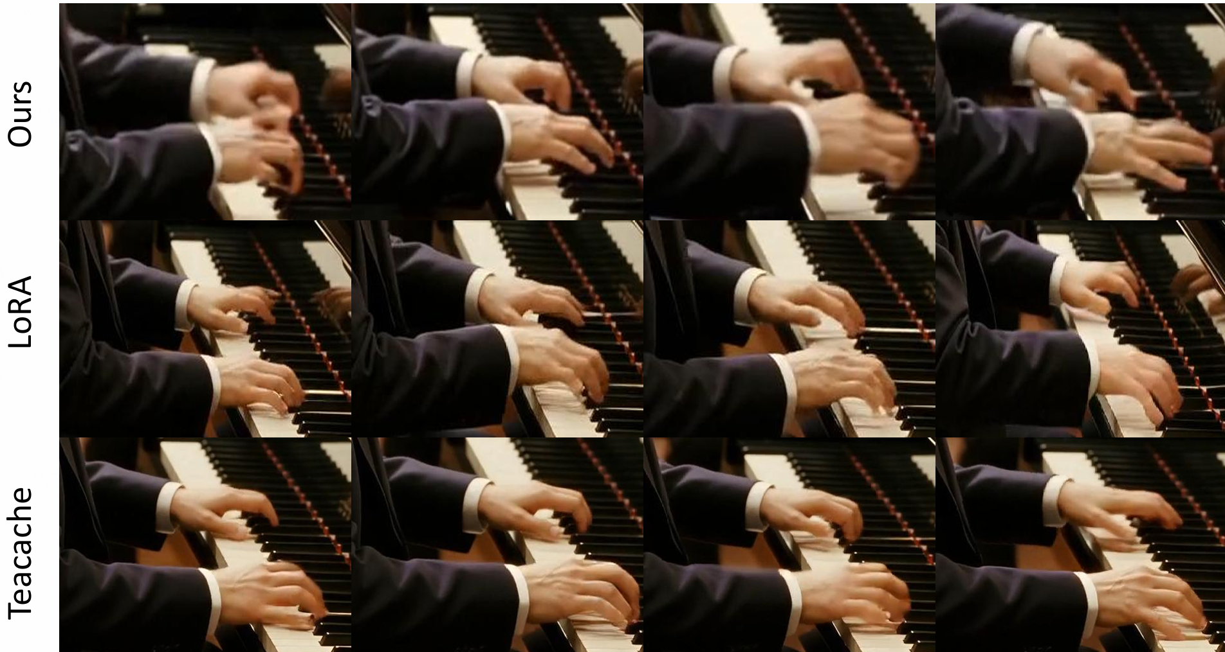
Figure2: Examples of using LoRA and teacache.

3.Failure Cases
In some cases, the generated videos exhibit frozen or static character movements. Figure 3 illustrates an example driven by flute audio, where the character remains largely stationary, with only the fingers moving.
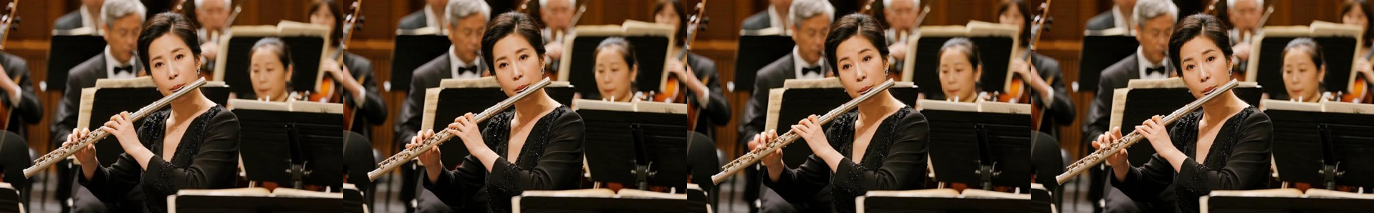
Figure3: Failure case.

4. Video Demonstrations
Video demonstrations of our results are provided in the supplementary material package. It includes comparative experimental samples as well as samples from the ablation studies. We also provide a demo generated by our model, using a reference image produced by a T2I model.

