Sensitivity and heterogeneity analysis

CAD/CAM vs CtrlBrace SMD：
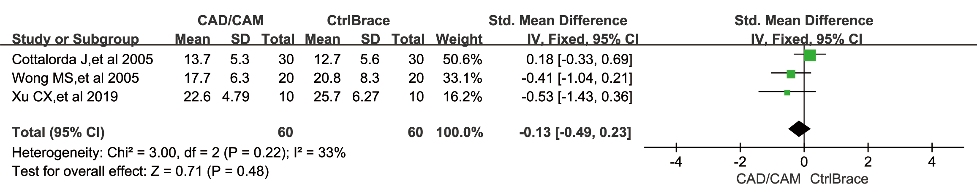

CAD/CAM+FEM vs CtrlBrace SMD：
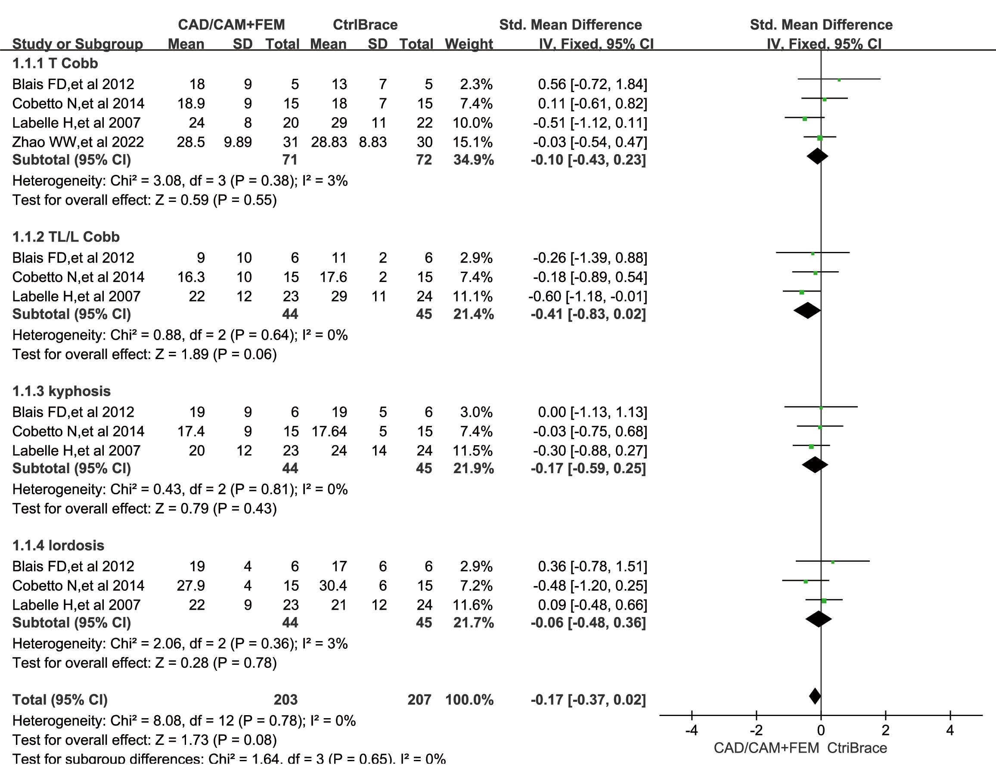
CAD/CAM+FEM vs CAD/CAM Parietal Rotation SMD:
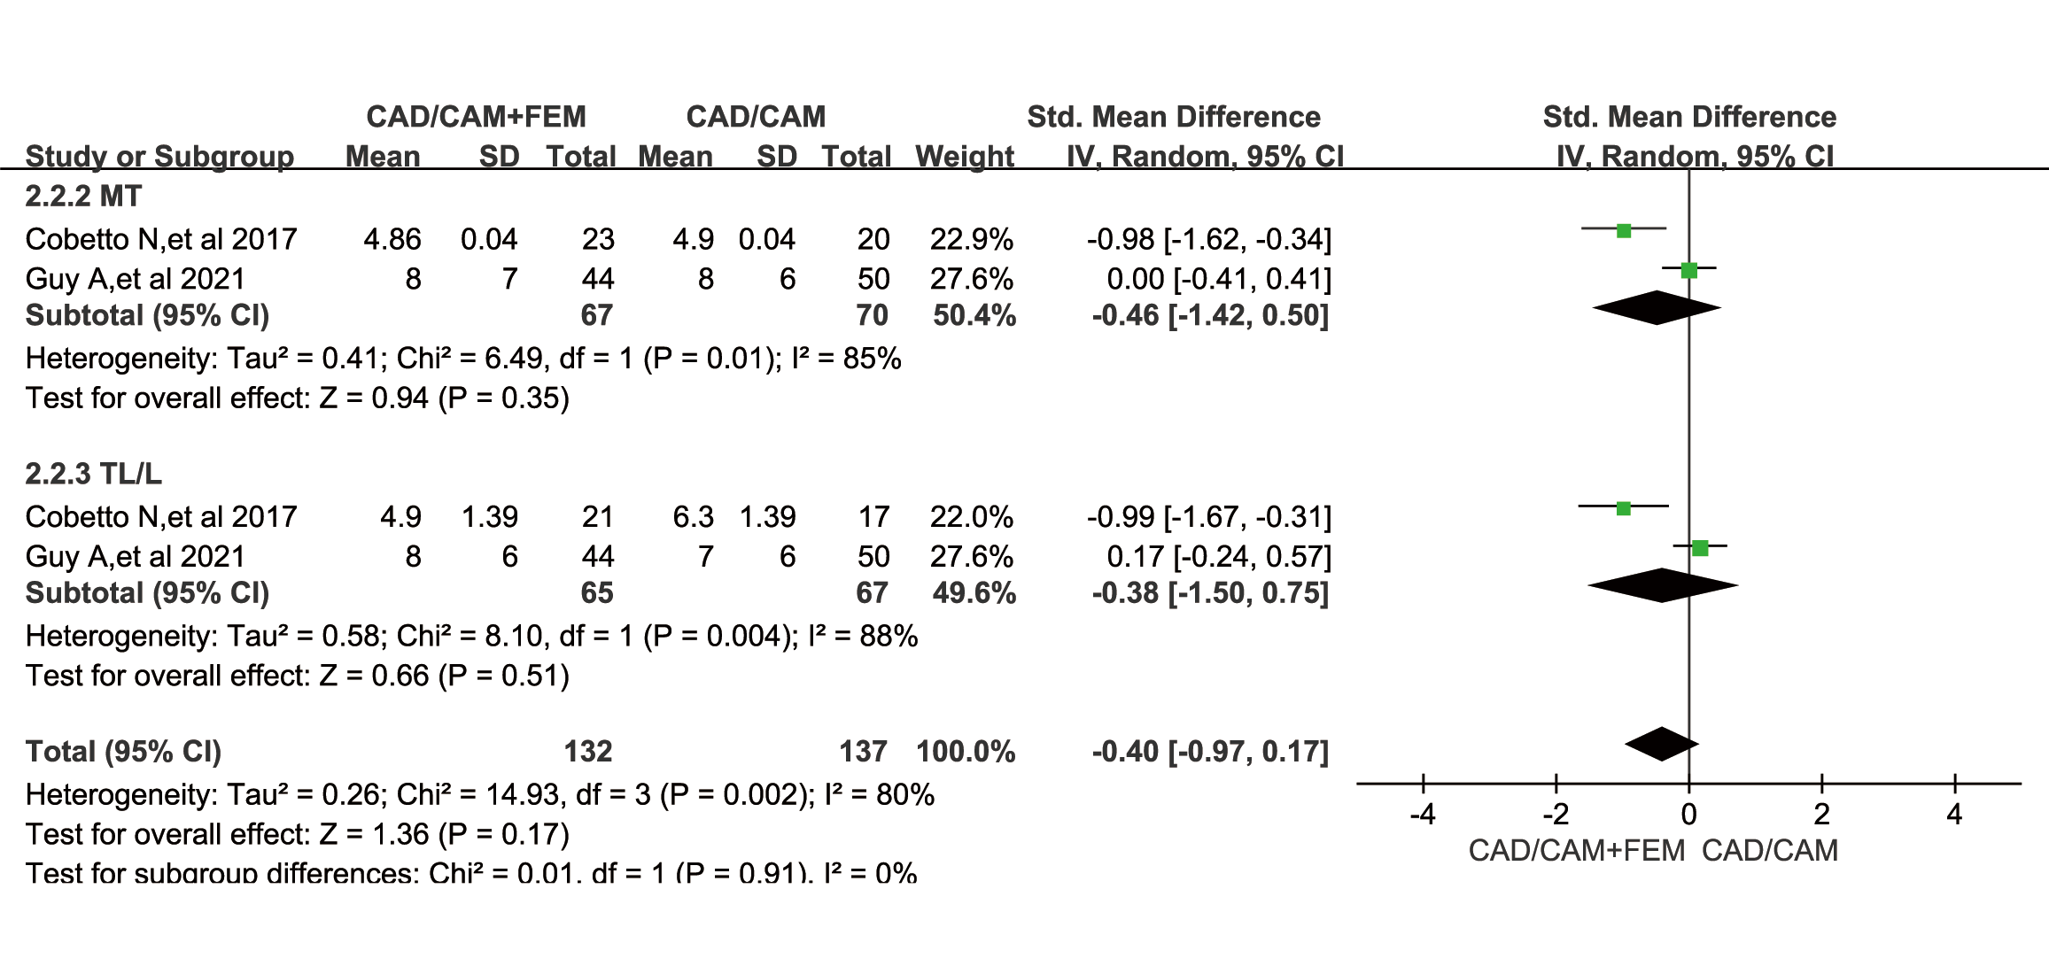
CAD/CAM+FEM vs CAD/CAM for thoracic curvature, lumbar curvature, lordosis, and kyphotic SMD:
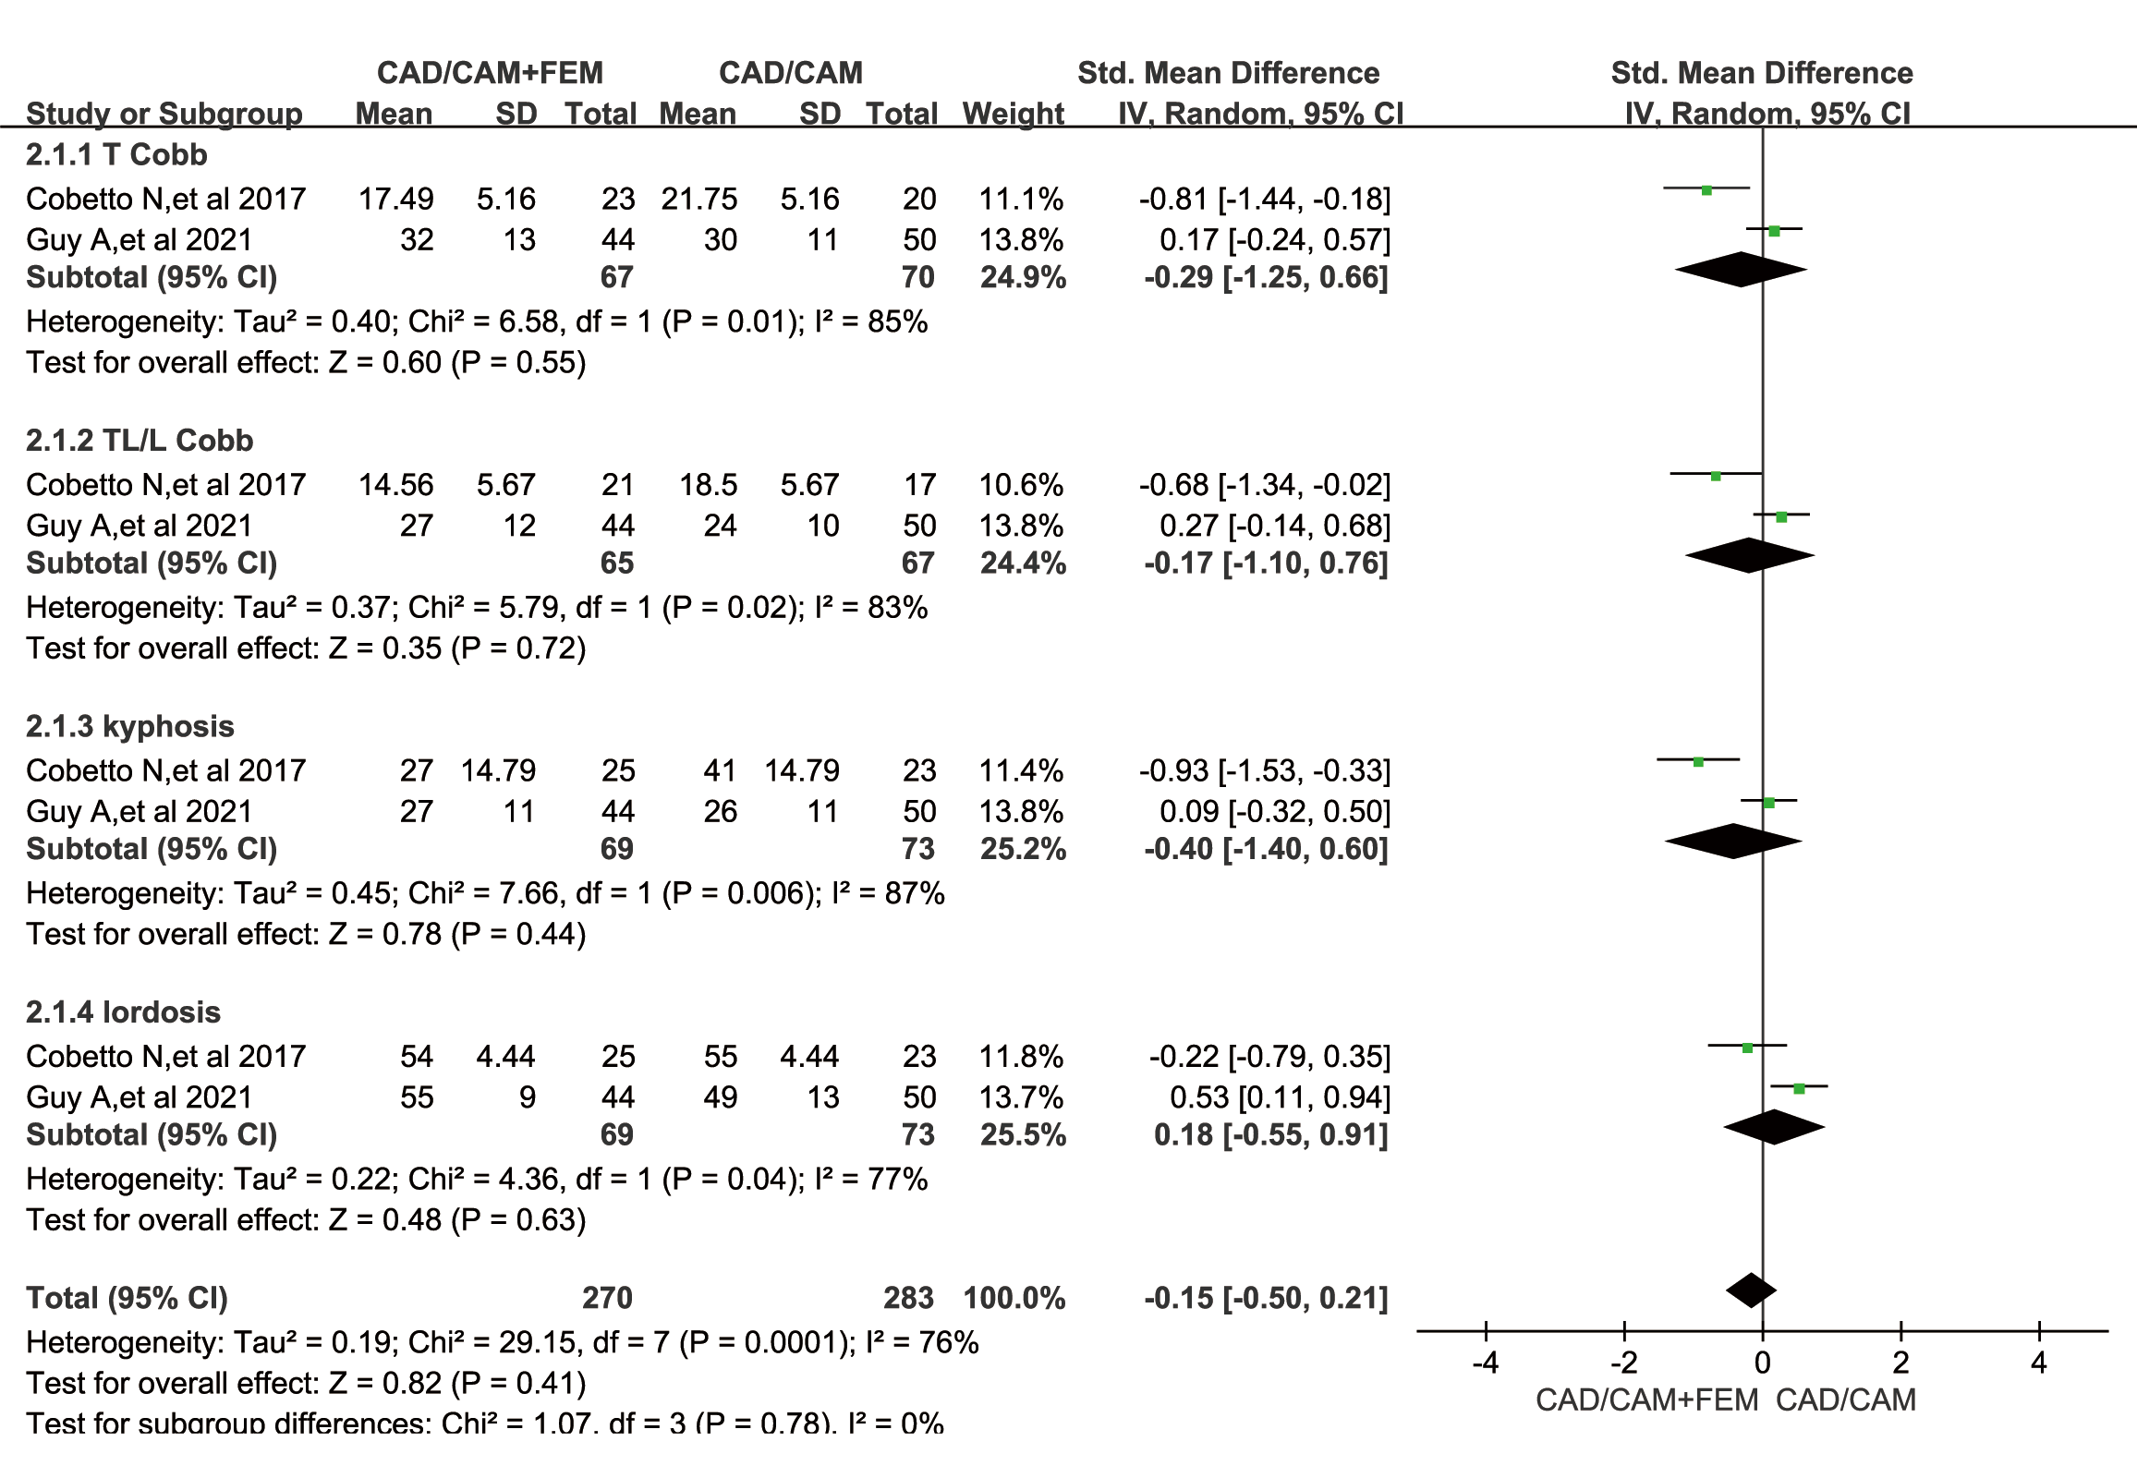
CAD/CAM+FEM vs CAD/CAM kyphosis difference MD:

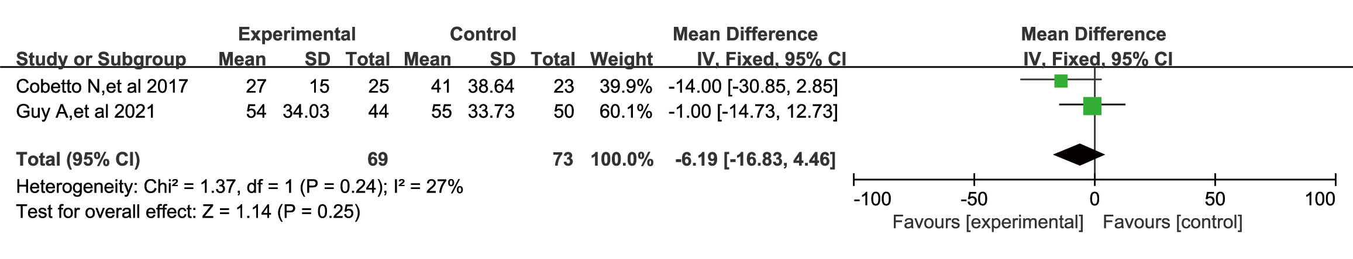
CADCAM+3D vs CtrlBrace's SMD:

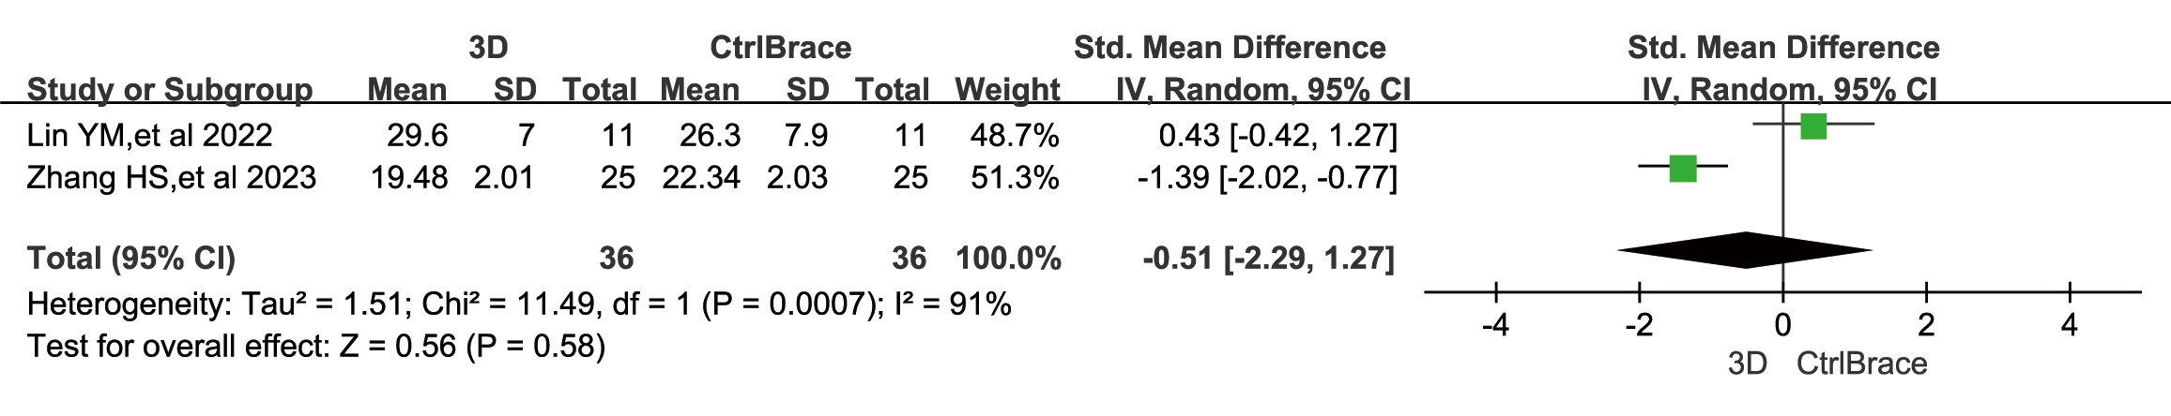

MD of CADCAM+FEM vs CAD/CAM (Cobetto N, et al 2017 borrowed the standard deviation from Cobetto N, et al 2016)：

