Supplemental material

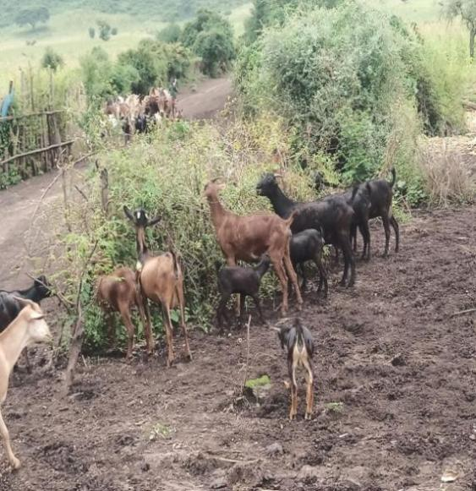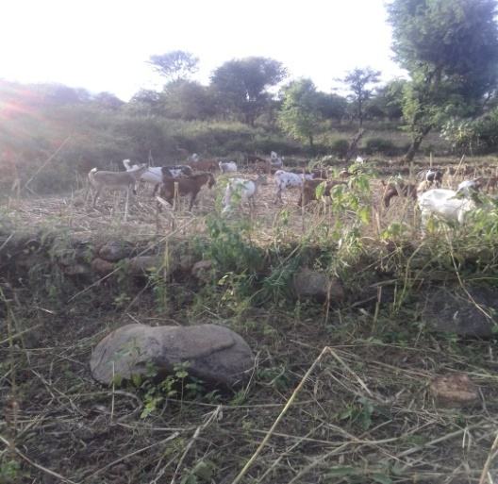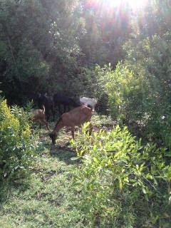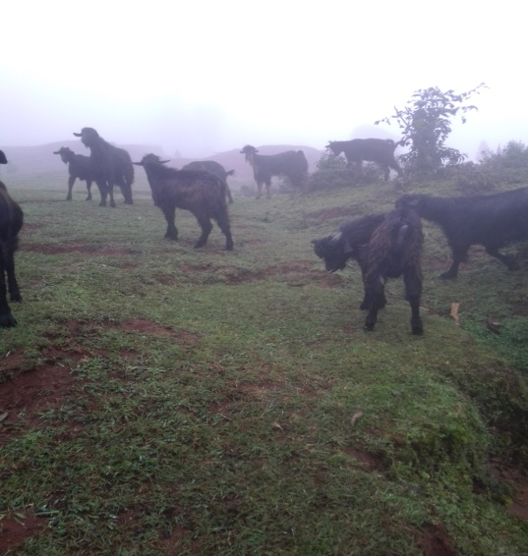
1.d
1.a
1.c
1.b
Appendix Figure 1: Feed resources in study districts: Fig.1a indicates roadside browsing feed resource at AMZ. Fig.1.b indicates a crop aftermath browsing at Garda-Marta district, Fig.1.c displays a hillside browsing feed source observed at Kucha Zuria and Figure 1.d shows a common grazing land observed at Geressie zuria. Roadside browsing (1.a, AMZ), crop aftermath browsing (1.b, GAM), hillside browsing (1.c, KUZ), and common grazing land (1.d, GEZ).

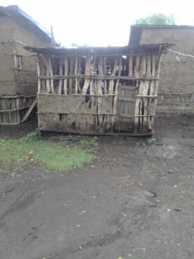
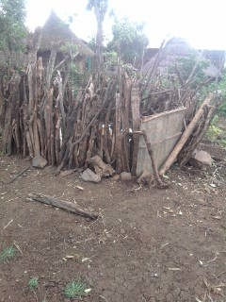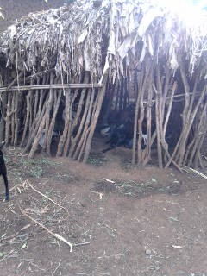
2.c
2.b
2.a
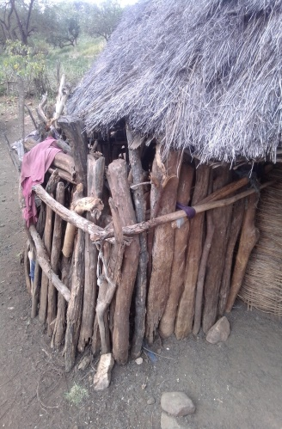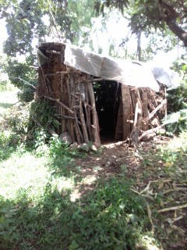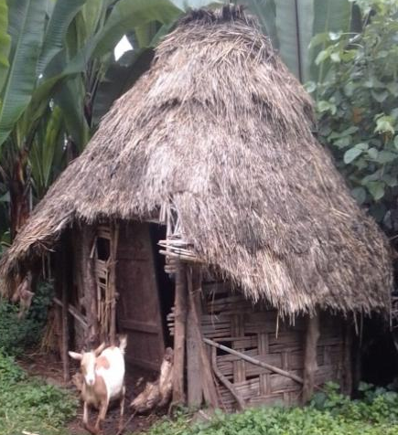
2.f
2.e
2.d
Appendix Figure 2: Housing practices in study districts: Fig. 2. a,b,c shows metal with wood, wood with open shade, and banana’s leaves, respectively, at A/Minch Zuria), and Fig. 2. d indicates kids’ house beside adult goats’ house in G/Marta, like Fig. 2. e indicates metal/plaster with wood at Kucha Zuria, and Fig.2.f indicates wood and grass goat house in Geressie zuria.

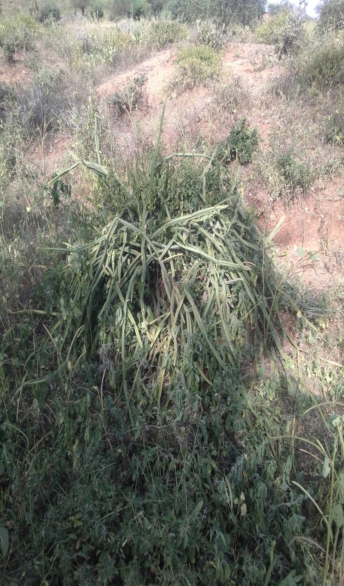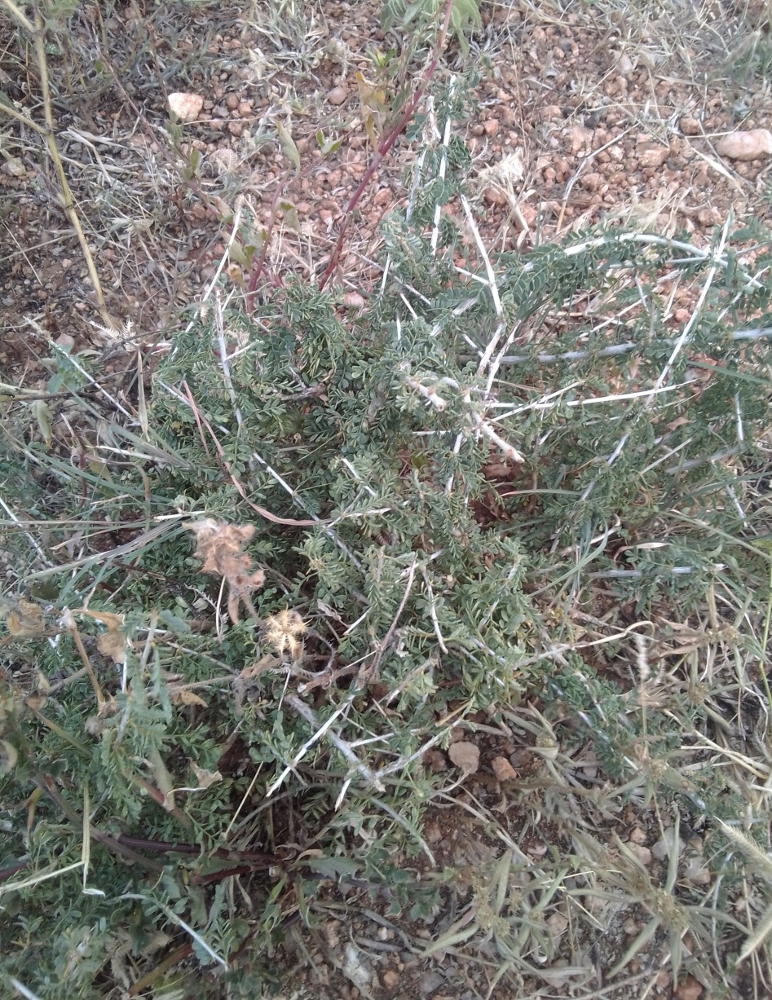
3.b

3.a

Appendix Figure 3: Medicinal herbs Zirzer (Fig. 3.a) and Moshito (Fig.3.b) in study districts

