Appendixes
Appendix 1: Different stages of the oyster mushroom cultivation process carried out during the experiment.
(A) (B) (C)
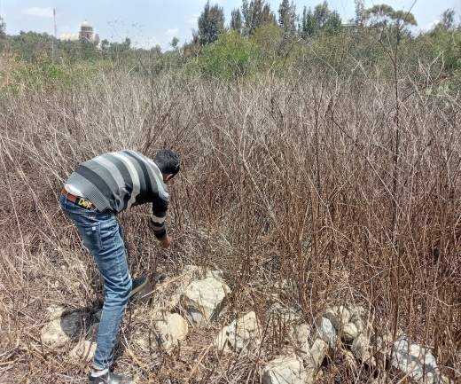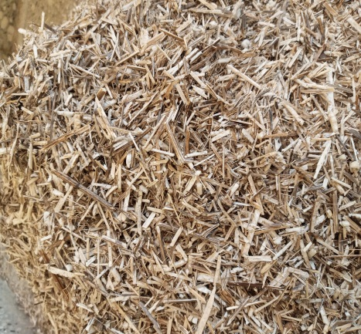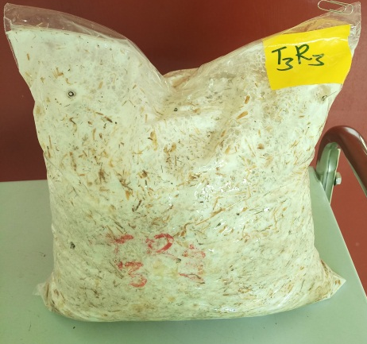
(D) (E) (F)
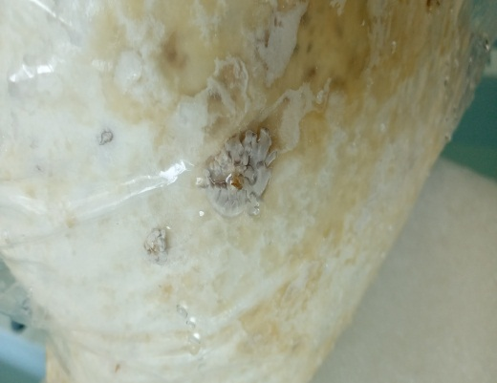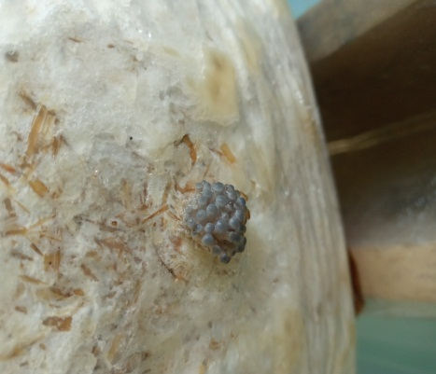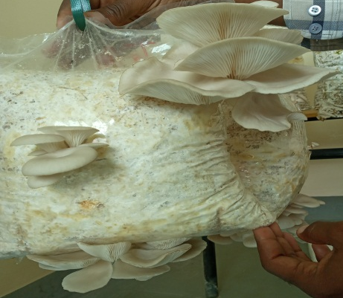
Key: (A) Reaping of the naturally dried Black-jack substrate from Endayesus campus, Mekelle University; (B) Chopped Black-jack substrate; (C) A mixture of Black-jack and wheat straw colonized by oyster mycelium; (D) Primordia formation; (E) Pinhead formation; (F) Matured oyster fruiting body/mushroom.

