Supplemental Material

Figure S1. Antegrade tunneling (first generation indwelling peritoneal catheter). a) After insertion of the guide wire, the catheter is tunneled towards the peritoneal puncture site (black arrow) first and then inserted into the peritoneal cavity. b) The tunnel needs to be dilated to allow entry of the cuff (white arrow). c) As is not fixed by tissue, the indwelling peritoneal catheter needs an anchoring suture (arrowhead).
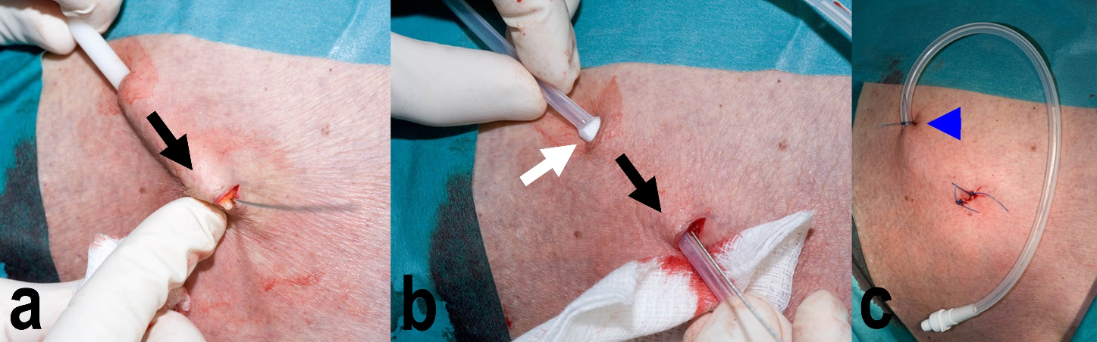

Figure S2. Example of retrograde tunnelling with the Aspira® Drainage System. a) The catheter is inserted into the ascites first, b) then tunneled out towards the skin exit site (black arrows), pulling the cuff (white arrow) under the skin. c) The cuff (white arrow) cannot displace through the skin and the tunnel exit. d) An anchoring suture is not required.
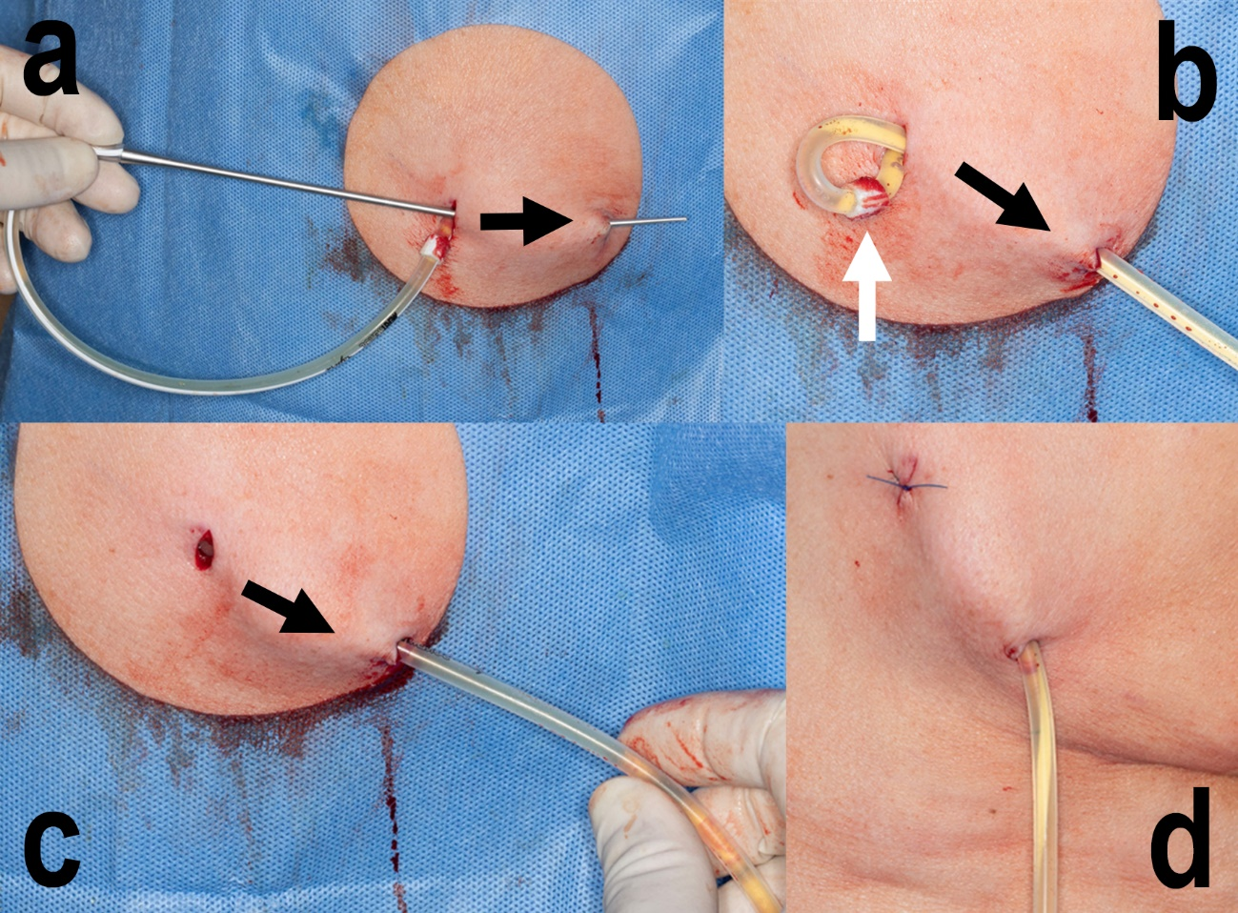

Table S1. Analysis of ascitic fluid.
Characteristic | Patients (N=124)
Biochemical analysis of ascitic fluid, mean ±SD (range)
Albumin [g/l] | 22.0 ±6.8 (2.2, 37.0)
Relative weight | 1.0 ± 0.01 (1.00, 1.03)
Polymorphonuclear neutrophils [/µl] | 492.0 ± 1678.7 (39.0, 14202.0)
Glucose [mmo/l] | 5.5 ± 2.4 (0.2, 13.8)
Creatinine [µmo/l] | 87.5 ± 79.1 (15.0, 732.0)
Lactate dehydrogenase (LDH) [U/l] | 449.6 ± 752.7 (30.0, 4500.0)
Cholesterol [mmo/l] | 1.6 ± 0.9 (0.2, 5.0)
Total protein [g/l] | 28.4 ± 11.2 (4.2, 66.8)
Polymorphonuclear neutrophils in ascites, n (%)
>250 cells/mm³ | 37 (29.8)
<250 cells/mm³ | 87 (70.2)
pH of Ascites Fluid, n (%)
5 | 1 (0.8)
7 | 2 (1.6)
8 | 120 (96.8)
9 | 1 (0.8)
Serum-ascites albumin gradient (SAAG), n (%)
>1.1 g/dL | 33 (26.6)
< 1.1 g/dL | 91 (73.4)
Ascites type, n (%)
Transudate | 33 (26.6)
Exudate | 91 (73.4)
Cytological analysis of ascites fluid, n (%)
Tumor cells absent | 68 (54.8)
Tumor cells present | 56 (45.2)
Adenocarcinoma | 43 (76.8)
Atypical cells | 11 (19.6)
Renal cell carcinoma | 3 (5.4)
Cause of malignant ascites, n (%)
Peritoneal carcinomatosis | 53 (42.7)
Portal hypertension: liver metastases or liver cancer | 33 (26.6)
Peritoneal carcinomatosis in combination with portal hypertension: liver metastases or liver cancer | 38 (30.6)
Macroscopic appearance of ascitic fluid, n (%)
Serous | 78 (62.9)
Fibrinous | 21 (16.9)
Hemorrhagic | 22 (17.7)
Chylous | 3 (2.4)

Table S2. Correlational analyses of ascitic fluid.
 | Macroscopic Appearance |  |  |  | Total  (N=124) | p value
 | Serous  (N=78) | Fibrinous  (N=21) | Hemorrhagic  (N=22) | Chylous  (N=3) | Total  (N=124) | p value
Oncological disease, n (%)
Liver cancer | 11 (14.1) | 1 (4.8) | 3 (13.6) | 0 (0.0) | 15 (12.4) | --
Ovarian cancer | 14 (17.9) | 6 (28.6) | 4 (18.2) | 0 (0.0) | 24 (19.4) | --
Breast cancer | 14 (17.9) | 5 (23.8) | 4 (18.2) | 0 (0.0) | 23 (18.5) | --
Lung cancer | 2 (2.6) | 1 (4.8) | 0 (0.0) | 0 (0.0) | 3 (2.4) | --
Colon cancer | 10 (12.8) | 3 (14.3) | 5 (22.7) | 0 (0.0) | 18 (14.5) | --
Uterine cancer | 1 (1.3) | 1 (4.8) | 1 (4.5) | 0 (0.0) | 3 (2.4) | --
Kidney cancer | 3 (3.8) | 0 (0.0) | 0 (0.0) | 0 (0.0) | 3 (2.4) | --
Stomach cancer | 6 (7.7) | 2 (9.5) | 2 (9.1) | 0 (0.0) | 10 (8.1) | --
Pancreas cancer | 13 (16.7) | 2 (9.5) | 0 (0.0) | 0 (0.0) | 15 (12.1) | --
Prostate cancer | 0 (0.0) | 0 (0.0) | 1 (4.5) | 0 (0.0) | 1 (0.8) | --
Mesothelioma of the peritoneum | 1 (1.3) | 0 (0.0) | 0 (0.0) | 3 (100) | 4 (3.2) | --
Melanoma | 1 (1.3) | 0 (0.0) | 0 (0.0) | 0 (0.0) | 1 (0.8) | --
Gallbladder cancer | 1 (1.3) | 0 (0.0) | 1 (4.5) | 0 (0.0) | 2 (1.6) | --
Testicular cancer | 0 (0.0) | 0 (0.0) | 1 (4.5) | 0 (0.0) | 1 (0.8) | --
Endometrial cancer | 1 (1.3) | 0 (0.0) | 0 (0.0) | 0 (0.0) | 1 (0.8) | --
Pathogenetic mechanism, n (%)
Peritoneal carcinomatosis | 29 (37.2) | 10 (47.6) | 12 (54.5) | 2 (66.7) | 53 (42.7) | 0.673
Portal hypertension  (metastasis/HCC) | 23 (29.5) | 4 (19.0) | 5 (22.7) | 1 (33.3) | 33 (26.6) | 0.673
Peritoneal carcinomatosis  and portal hypertension | 26 (33.3) | 7 (33.3) | 5 (22.7) | 0 (0.0) | 38 (30.6) | 0.673
Cytology
Positive | 46 (59.0) | 10 (47.6) | 9 (40.9) | 3 (100.0) | 68 (54.8) | 0.170
Negative | 32 (41.0) | 11 (52.4) | 13 (59.1) | 0 (0.0) | 56 (45.2) | 0.170
Cell Type
Atypical cells | 52 (66.7) | 12 (57.1) | 13 (59.1) | 2 (66.7) | 79 (63.7) | 0.744
Adenocarcinoma | 25 (32.1) | 9 (42.9) | 8 (36.4) | 1 (33.3) | 43 (34.7) | 0.744
Renal cell carcinoma | 1 (1.3) | 0 (0.0) | 1 (4.5) | 0 (0.0) | 2 (1.6) | 0.744
Polymorphonuclear neutrophils in ascites
Neutrophils Count
>250 cells/mm³ | 15 (19.2) | 12 (57.1) | 9 (40.9) | 1 (33.3) | 37 (29.8) | 0.003
<250 cells/mm³ | 63 (80.8) | 9 (42.9) | 13 (59.1) | 2 (66.7) | 87 (70.2) | 0.003
Complications
Absent | 58 (74.4) | 16 (76.2) | 22 (100.0) | 2 (66.7) | 98 (79.0) | 0.021
Present | 20 (25.6) | 5 (23.8) | 0 (0.0) | 1 (33.3) | 26 (21.0) | 0.021

Table S3. Eastern Cooperative Oncology Group Performance Status correlational analyses.
Variable | Eastern Cooperative Oncology Group Performance Status |  |  |  |  |  | p value
Variable | 1  (N=7) |  | 2  (N=37) |  | 3  (N=74) | 4  (N=6) | p value
Treatment, n (%)
Chemotherapy | 5 (71.4) |  | 31 (83.8) |  | 49 (66.2) | 6 (100.0) | 0.099
Palliative care | 2 (28.6) |  | 6 (16.2) |  | 25 (33.8) | 0 (0.0) | 0.099
Sex, n/N (%)
Males | 0 / 40 (0.0) |  | 12 / 40 (30.0) |  | 26 / 40 (65.0) | 2 / 40 (5.0) | 0.306
Females | 7 / 84 (8.3) |  | 25 / 84 (29.8) |  | 48 / 84 (57.1) | 4 / 84 (4.8) | 0.306
Age
Mean ±SD (range) | 55.7 ± 11.7 (42.0, 74.0) |  | 60.0 ± 9.8  (40.0, 77.0) | 61.9 ± 11.3 (33.0, 87.0) |  | 53.5 ± 17.4 (34.0, 79.0) | 0.30
Catheter days
Mean ±SD (range) | 283.14 ± 76.0 (187, 391.0) | 149.8 ± 73.4 (28.0, 372) |  | 69.3 ± 34.5  (26.0, 210) |  | 26.0 ± 10.6 (8.0, 39.0) | <0.001
Oncological disease, n (%)
Liver cancer | 1 (14.3) | 1 (2.7) |  | 11 (14.9) |  | 2 (33.3) | --
Ovarian cancer | 3 (42.9) | 7 (18.9) |  | 13 (17.6) |  | 1 (16.7) | --
Breast cancer | 0 (0.0) | 9 (24.3) |  | 13 (17.6) |  | 1 (16.7) | --
Lung cancer | 1 (14.3) | 0 (0.0) |  | 2 (2.7) |  | 0 (0.0) | --
Large intestine | 1 (14.3) | 6 (16.2) |  | 11 (14.9) |  | 0 (0.0) | --
Uterine cancer | 0 (0.0) | 2 (5.4) |  | 1 (1.4) |  | 0 (0.0) | --
Kidney cancer | 0 (0.0) | 1 (2.7) |  | 1 (1.4) |  | 1 (16.7) | --
Stomach cancer | 1 (14.3) | 3 (8.1) |  | 6 (8.1) |  | 0 (0.0) | --
Pancreatic cancer | 0 (0.0) | 3 (8.1) |  | 11 (14.9) |  | 1 (16.7) | --
Prostate cancer | 0 (0.0) | 0 (0.0) |  | 1 (1.4) |  | 0 (0.0) | --
Mesothelioma of the peritoneum | 0 (0.0) | 2 (5.4) |  | 2 (2.7) |  | 0 (0.0) | --
Melanoma | 0 (0.0) | 1 (2.7) |  | 0 (0.0) |  | 0 (0.0) | --
Gallbladder cancer | 0 (0.0) | 0 (0.0) |  | 2 (2.7) |  | 0 (0.0) | --
Testicular cancer | 0 (0.0) | 1 (2.7) |  | 0 (0.0) |  | 0 (0.0) | --
Endometrial cancer | 0 (0.0) | 1 (2.7) |  | 0 (0.0) |  | 0 (0.0) | --
Complication, n (%)
Absent | 1 (14.3) | 31 (83.8) |  | 62 (83.8) |  | 4 (66.7) | 0.001
Present | 6 (85.7) | 6 (16.2) |  | 12 (16.2) |  | 2 (33.3) | 0.001

Table S4. Catheter days across patient and clinical characteristics.
Characteristic | N | Catheter Days, Mean ± SD (range) | p value
Sex
Male | 40 | 94.6 ± 73.4 (8.0, 372.0) | 0.340
Female | 84 | 107.4 ± 79.9 (21.0, 391.0) | 0.340
Number of hospital visits
Number of visits to hospital 30 days prior to catheter insertion | 124 | 4.2 ± 1.7 (2.0, 110.) | <0.001
Number of visits to hospital 30 days after catheter placement | 110 | 1.1 ± 0.6 (0.0, 3.0) | <0.001
Number of visits 90 days after catheter placement | 59 | 0.6 ± 0.5 (0.0, 2.0) | <0.001
Complication
Absent | 98 | 93.1 ± 60.9 (21.0, 379.0) | 0.048
Presentª | 26 | 141.7 ± (8.0, 391.0) | 0.048
Macroscopic view of ascites fluid
Serous | 78 | 99.2 ± 64.3 (8.0, 356.0) | 0.820
Fibrinous | 21 | 110.8 ± 106.6 (28.0, 391.0) | 0.820
Hemorrhagic | 22 | 110.9 ± 94.9 (27.0, 379.0) | 0.820
Chylous | 3 | 99.7 ± 51.3 (41.0, 136.0) | 0.820
Ascites type
Transudate | 33 | 100.8 ± 78.0 (21.0, 391.0) | 0.398
Exudate | 91 | 110.3 ± 78.0 (8.0, 372.0) | 0.398
Oncological disease
Liver cancer | 15 | 78.1 ± 55.2 (21.0, 244.0) | --
Ovarian cancer | 24 | 122.6 ± 95.5 (29.0, 391.0) | --
Breast cancer | 23 | 85.7 ± 40.7 (26.0, 156.0) | --
Lung cancer | 3 | 120.0 ± 149.2 (26.0, 292.0) | --
Colon cancer | 18 | 97.1 ± 66.4 (26.0, 241.0) | --
Uterine cancer | 3 | 108.7 ± 37.9 (65.0, 132.0) | --
Kidney cancer | 3 | 120.3 ± 125.0 (8.0, 255.0) | --
Stomach cancer | 10 | 146.9 ± 129.1 (34.0, 379.0) | --
Pancreatic cancer | 15 | 91.5 ± 44.7 (39.0, 202.0) | --
Prostate cancer | 1 | 29.0 ± 0.0 (29.0, 29.0) | --
Mesothelioma | 4 | 100.3 ± 41.9 (41.0, 136.0) | --
Melanoma | 1 | 98.0 ± 0.0 (98.0, 98.0) | --
Gallbladder cancer | 2 | 34.5 ± 10.6 (27.0, 42.0) | --
Testicular cancer | 1 | 329.0 ± 0.0 (329.0, 329.0) | --
Endometrial cancer | 1 | 159.0 ± 0.0 (159.0, 159.0) | --
ª Of the 26 complications, 16 were mild (2 valve defects, 5 leakages from implantation site, 7 cellulitis; 2 subcutaneous hematoma) and 10 were moderate (1 device obstruction due to adjacent tumor overgrowth, 1 device dislocation, 8 secondary bacterial peritonitis).

Table S5. Correlation analyses of complications.
Variable | Complication Status |  | p value
Variable | Absent (N=98) | Present (N=26) | p value
Sex, n (%)
Males | 32 (32.7) | 8 (30.8) | 0.855
Females | 66 (67.3) | 18 (69.2) | 0.855
Indicator, mean ±SD (range)
Years | 60.32 ± 11.7 (33.0, 87.0) | 61.58 ± 9.9 (42.0, 79.0) | 0.570
Relative weight  of ascites | 1.0 ± 0.01 (1.0, 1.03) | 1.0 ± 0.01 (1.0, 1.02) | 0.997
Neutrophils in ascites | 539.1 ± 1877.8 (39.0, 14202.0) | 314.2 ± 375.8 (59.0, 1600.0) | 0.842
Glucose - ascites | 5.7 ± 2.4 (0.2, 13.8) | 5.0 ± 2.5 (1.0, 13.8) | 0.123
lactate dehydrogenase (LDH) - ascites | 435.4 ± 764.6 (30.0, 4500.0) | 503.2 ± 718.1 (44.0, 2822.0) | 0.135
Cholesterol-ascites | 1.6 ± 0.95 (0.2, 5.0) | 1.7 ± 0.8 (0.6, 3.6) | 0.572
Total protein - ascites | 27.8 ± 11.0 (4.2, 56.0) | 30.4 ± 11.9 (9.1, 66.8) | 0.396
Hemoglobin | 114.6 ± 17.6 (87.0, 171.0) | 113.4 ± 18.3 (82.0, 150.0) | 0.871
Platelets | 307.6 ± 163.8 (54.0, 798.0) | 331.5 ± 153.5 (88.0, 727.0) | 0.390
International Normalized Ratio (INR) | 1.2 ± 0.2 (0.17, 1.8) | 1.1 ± 0.14 (0.9, 1.4) | 0.042
C-reactive protein (CRP) | 67.7 ± 55.5 (1.9, 251.0) | 87.6 ± 59.9 (12.0, 251.0) | 0.069
Oncological disease, n (%)
Liver cancer | 13 (13.3) | 2 (7.7) | --
Ovarian cancer | 14 (14.3) | 10 (38.5) | --
Breast cancer | 20 (20.4) | 3 (11.5) | --
Lung cancer | 2 (2.0) | 1 (3.8) | --
Colon cancer | 14 (14.3) | 4 (15.4) | --
Uterine cancer | 3 (3.1) | 0 (0.0) | --
Kidney cancer | 2 (2.0) | 1 (3.8) | --
Stomach cancer | 9 (9.2) | 1 (3.8) | --
Pancreatic cancer | 13 (13.3) | 2 (7.7) | --
Prostate cancer | 1 (1.0) | 0 (0.0) | --
Mesothelioma | 3 (3.1) | 1 (3.8) | --
Melanoma | 1 (1.0) | 0 (0.0) | --
Gallbladder cancer | 2 (2.0) | 0 (0.0) | --
Testicular cancer | 1 (1.0) | 0 (0.0) | --
Endometrial cancer | 0 (0.0) | 1 (3.8) | --
Pathogenetic mechanism leading to occurrence of ascites, n (%)
Peritoneal carcinomatosis | 41 (41.8) | 12 (46.2) | 0.320
Liver metastases and portal hypertension | 24 (24.5) | 9 (34.6) | 0.320
Carcinosis and metastasis and portal hypertension | 33 (33.7) | 5 (19.2) | 0.320
Tumor cells, n (%)
Negative | 56 (57.1) | 12 (46.2) | 0.317
Positive | 42 (42.9) | 14 (53.8) | 0.317
Treatment, n (%)
Chemotherapy | 73 (74.5) | 18 (69.2) | 0.590
Palliative care | 25 (25.5) | 8 (30.8) | 0.590

