Supporting Information
Theoretical insights into metal-doped nanostructured hematite catalyst supported by graphene underlayer for photoelectrochemical water splitting applications
Labanya Bhattacharya¹, Maytal Caspary Toroker^{1,2,3*}
¹Department of Materials Science and Engineering,
Technion-Israel Institute of Technology, Haifa-3200003, Israel
²The Nancy and Stephen Grand Technion Energy Program,
Technion-Israel Institute of Technology, Haifa-3200003, Israel
³Resnick Sustainability Center for Catalysis,
Technion-Israel Institute of Technology, Haifa-3200003, Israel
*Email: maytalc@technion.ac.il

Table S1.
Corrections added to the free energy calculation of molecules involved in water oxidation
Molecule | E_{total} | ZPE | TS
H₂ | -6.77 | 0.27 | 0.40
O₂ | -9.87 | 0.10 | 0.63
H₂O | -14.23 | 0.57 | 0.67

Table S2.
Zero Point Energy corrections (${(∆ZPE-T∆S)}_{1-5}$) added to the free energy calculation of water oxidation (equations (6)-(10) in manuscript)
Reaction | Al doped hematite | Graphene-Al doped hematite | Graphitic-N_1 doped graphene-Al doped hematite | Graphitic-N_2 doped graphene-Al doped hematite | Graphitic-N_3 doped graphene-Al doped hematite
1 | 0.761 | 0.751 | 0.682 | 0.756 | 0.753
2 | -0.343 | -0.339 | -0.213 | -0.290 | -0.298
3 | -0.361 | -0.435 | -0.546 | -0.453 | -0.505
4 | 0.369 | 0.445 | 0.554 | 0.463 | 0.462
5 | -1.016 | -1.011 | -1.068 | -1.067 | -1.000

Table S3.
Bader net charge (e) on the atoms of *OH intermediate
Atoms | Hematite | Graphene-Hematite | Al doped hematite | Graphene-Al doped hematite | N doped graphene-Al doped hematite
O1 | -1.2266 | -1.2031 | -1.3408 | -1.3046 | -1.3031
O2 | -1.1908 | -1.1919 | -1.3028 | -1.3002 | -1.3083
O3 | -1.1907 | -1.2227 | -1.2957 | -1.3407 | -1.3431
O4 | -1.2030 | -1.2289 | -1.3023 | -1.3249 | -1.3377
O5 | -1.2013 | -1.2170 | -1.2998 | -1.3264 | -1.3012
O6 | -1.2334 | -1.2117 | -1.3438 | -1.2923 | -1.2935
Fe1 | +1.8649 | +1.8384 | +1.8717 | +1.861 | +1.8596
Fe2/Al for Al doped system | +1.8651 | +1.8401 | +2.4748 | +2.4779 | +2.48
H1 | +0.5758 | +0.6052 | +0.569 | +0.6038 | +0.5777
H2 | +0.6124 | +0.6144 | +0.618 | +0.5912 | +0.604
H3 | +0.5789 | +0.6151 | +0.5816 | +0.6141 | +0.6166
H4 | +0.5714 | +0.5702 | +0.5778 | +0.5692 | +0.5763
H5 | +0.5676 | +0.5805 | +0.5744 | +0.5729 | +0.5716
H6 | +0.6096 | +0.5964 | +0.6181 | +0.5848 | +0.5874
C1 | -- | +0.0668 |  | +0.1387 | +0.3756
C2 | -- | -0.0013 |  | +0.0448 | +0.2095
C3 | -- | +0.0606 |  | +0.1304 | +0.1228
C4 | -- | -0.0005 |  | +0.0451 | +0.2857
C5 | -- | -0.0521 |  | -0.1242 | +0.0842
C6 | -- | -0.0005 |  | -0.0465 | +0.0566
C7 | -- | -0.0535 |  | -0.1246 | -0.0211
C8/N1 (for N doped systems) | -- | -0.0047 |  | -0.0500 | -2.0994

Table S4.
Bader net charge (e) on the atoms of *O intermediate
Atoms | Hematite | Graphene-Hematite | Al doped hematite | Graphene-Al doped hematite | N doped graphene-Al doped hematite
O1 | -1.1138 | -1.1394 | -1.2208 | -1.2392 | -1.2276
O2 | -1.1557 | -1.1035 | -1.2265 | -1.2516 | -1.2553
O3 | -1.1753 | -1.147 | -1.2677 | -1.2906 | -1.2902
O4 | -1.157 | -1.1287 | -1.2864 | -1.2793 | -1.2528
O5 | -0.8914 | -1.1205 | -1.0049 | -1.2655 | -1.2886
O6 | -1.1808 | -0.8871 | -1.2944 | -0.9868 | -1.0033
Fe1 | 1.8356 | 1.6606 | 1.8337 | 1.8428 | 1.8318
Fe2/Al for Al doped system | 1.8457 | 1.8452 | 2.4767 | 2.48 | 2.4793
H1 | 0.6210 | 0.629 | 0.6275 | 0.6035 | 0.6252
H2 | 0.5884 | 0.6165 | 0.612 | 0.6194 | 0.5892
H3 | 0.5852 | 0.6247 | 0.573 | 0.6066 | 0.5976
H4 | 0.6037 | 0.5594 | 0.5869 | 0.5677 | 0.5648
H5 | 0.5945 | 0.5735 | 0.5909 | 0.5756 | 0.554
H6
C1 | -- | -0.0195 |  | 0.0049 | 0.4489
C2 | -- | -0.046 |  | -0.0297 | 0.258
C3 | -- | -0.0258 |  | -0.0023 | 0.1239
C4 | -- | -0.045 |  | -0.0285 | 0.3616
C5 | -- | 0.0335 |  | 0.0101 | -0.053
C6 | -- | 0.0454 |  | 0.0297 | 0.0105
C7 | -- | 0.0322 |  | 0.0089 | 0.0177
C8/N1 (for N doped systems) | -- | 0.0424 |  | 0.0243 | -2.0917

Table S5.
Magnetization (units of Bohr Magneton) of the atoms of *OH intermediate
Atoms | Hematite | Graphene-Hematite | Al doped hematite | Graphene-Al doped hematite | N doped graphene-Al doped hematite
O1 | 0.003 | -0.006 | 0.095 | 0.083 | 0.084
O2 | -0.006 | 0.002 | 0.083 | 0.086 | 0.087
O3 | 0.002 | -0.005 | 0.086 | 0.096 | 0.096
O4 | 0.001 | -0.006 | 0.084 | 0.086 | 0.086
O5 | -0.005 | 0.008 | 0.083 | 0.097 | 0.097
O6 | 0.003 | 0.006 | 0.094 | 0.084 | 0.084
Fe1 | 4.331 | 4.266 | 4.295 | 4.291 | 4.29
Fe2/Al for Al doped system | -4.33 | -4.265 | 0.003 | 0.003 | 0.003
H1 | 0.000 | -0.003 | 0.003 | 0.003 | 0.003
H2 | 0.000 | 0.003 | 0.003 | 0.005 | 0.005
H3 | 0.000 | 0.000 | 0.003 | 0.003 | 0.003
H4 | 0.000 | 0.000 | 0.003 | 0.003 | 0.003
H5 | 0.000 | -0.001 | 0.003 | 0.003 | 0.003
H6 | 0.000 | 0.001 | 0.003 | 0.003 | 0.003
C1 |  | 0.000 |  | 0.000 | 0.053
C2 |  | 0.000 |  | 0.000 | 0.043
C3 |  | 0.000 |  | 0.000 | 0.082
C4 |  | 0.000 |  | 0.000 | 0.046
C5 | -- | 0.000 |  | 0.000 | -0.001
C6 | -- | 0.000 |  | 0.000 | -0.002
C7 | -- | 0.000 |  | 0.000 | -0.001
C8/N1 (for N doped systems) | -- | 0.000 |  | 0.000 | 0.061

Table S6.
Magnetization (units of Bohr Magneton) of the atoms of *O intermediate
Atoms | Hematite | Graphene-Hematite | Al doped hematite | Graphene-Al doped hematite | N doped graphene-Al doped hematite
O1 | -0.103 | -0.085 | -0.016 | -0.006 | -0.003
O2 | -0.096 | -0.059 | -0.012 | 0.022 | 0.021
O3 | -0.01 | -0.028 | 0.071 | 0.05 | 0.051
O4 | -0.031 | -0.044 | 0.057 | 0.049 | 0.049
O5 | -0.042 | -0.019 | 0.053 | 0.074 | 0.075
O6 | -0.029 | -0.051 | 0.06 | 0.056 | 0.052
Fe1 | 3.639 | 3.572 | 3.659 | 3.621 | 3.692
Fe2/Al for Al doped system | -4.269 | -4.235 | 0.009 | 0.008 | 0.008
H1 | -0.002 | -0.001 | 0.003 | 0.003 | 0.003
H2 | -0.002 | -0.002 | 0.003 | 0.003 | 0.003
H3 | -0.001 | 0.000 | 0.001 | 0.002 | 0.002
H4 | 0.000 | -0.001 | 0.002 | 0.002 | 0.002
H5 | 0.002 | 0.000 | 0.002 | 0.002 | 0.002
H6
C1 | -- | 0.000 |  | 0.000 | 0.057
C2 | -- | 0.000 |  | 0.000 | 0.051
C3 | -- | 0.000 |  | 0.000 | 0.088
C4 | -- | 0.000 |  | 0.000 | 0.052
C5 | -- | 0.000 |  | 0.000 | 0.000
C6 | -- | 0.000 |  | 0.000 | -0.002
C7 | -- | 0.000 |  | 0.000 | 0.000
C8/N1 (for N doped systems) | -- | 0.000 |  | 0.000 | 0.065

Table S7.
Spatial Grid density convergence test results for Graphene-Al doped Hematite system (*OH intermediate). Spatial spacing is denoted by 'dx'. Initial Total Energy is E₀, Initial potential energy is V₀ and Initial Kinetic energy is T₀. 'Num' denotes numerically calculated energy values. 'Cal' denotes theoretically calculated energy values.
Samples#, N | dx  [Å] | E₀num [eV] | T₀num [eV] | T₀cal  [ev] | V₀num [ev] | V₀cal  [ev]
2000 | 0.012808 | -2.76897 | 12.93043 | 12.9175 | -15.6994 | -15.6994
3000 | 0.008538 | -2.77328 | 12.92612 | 12.9175 | -15.6994 | -15.6994
4000 |  | -2.77544 | 12.92396 | 12.9175 | -15.6994 | -15.6994
  0.006404
5000 | 0.005123 | -2.77673 | 12.92267 | 12.9175 | -15.6994 | -15.6994
6000 | 0.004269 | -2.77759 | 12.92181 | 12.9175 | -15.6994 | -15.6994
7000 | 0.003659 | -2.77821 | 12.92119 | 12.9175 | -15.6994 | -15.6994
8000 | 0.003202 | -2.77867 | 12.92073 | 12.9175 | -15.6994 | -15.6994
9000 | 0.002846 | -2.77903 | 12.92037 | 12.9175 | -15.6994 | -15.6994
10000 | 0.002562 | -2.77932 | 12.92008 | 12.9175 | -15.6994 | -15.6994
11000 | 0.002329 | -2.77955 | 12.91985 | 12.9175 | -15.6994 | -15.6994

Table S8. Valence Band Maxima (VBM) energy values for *OH intermediate. VBM energies are not referred to vacuum energy.
System | VBM in eV
Hematite | -4.14
Graphene-Hematite | -2.83
Al doped hematite | -3.88
Graphene-Al doped hematite | -2.78
N doped graphene-Al doped hematite | -1.35

Table S9. Valence Band Maxima (VBM) energy values for *O intermediate. VBM energies are not referred to vacuum energy.
System | VBM in eV
Hematite | -4.64
Graphene-Hematite | -2.94
Al doped hematite | -4.43
Graphene-Al doped hematite | -2.76
N doped graphene-Al doped hematite | -1.94

Table S10. Reaction activation energy ($E_{a}$), Gibbs free energy difference ($∆G$) and reorganization energy (λ) from NEB calculations and Marcus Theory for different dopants (Al, Ni and Co) in hematite. The zero-point energy corrections and entropic contributions are added to each parameter. Equations (8), (22), (23) and (24) are mentioned in the main manuscript. Core electrons of Ni and Co atoms such as Ni 1s2s2p3s3p and Co 1s2s2p3s3p are represented by PAW potential during DFT calculations. Ni and Co are doped in the same atomic site of Al in case of Al doped hematite.
System | $E_{a}$ (eV)  from equation (22) | $∆G$ (eV) from equation (23) | λ (eV) from Marcus theory, equation (24) | $∆G$ (eV)  from equation (8) | $E_{a}$ (eV) from Marcus Theory  equation (24) | Overpotential (V) from Table 1
Hematite | 0.66 | 0.13 | 2.37 | 1.88 | 1.91 | 0.77
Al doped hematite | 0.75 | 0.19 | 2.61 | 2.07 | 2.10 | 0.96
Ni doped hematite | 0.61 | 0.032 | 2.375 | 1.53 | 1.605 | 0.42
Co doped hematite | 0.65 | -0.062 | 2.722 | 1.43 | 1.583 | 0.32

- Hematite (side view) | - Hematite (top view)
- Graphene-Hematite (side view) | - Graphene-Hematite (top view)
- Al doped hematite (side view) | - Al doped hematite (top view)
- Graphene-Al doped hematite (side view) | - Graphene-Al doped hematite (top view)
- N doped Graphene-Al doped hematite (side view) | - N doped Graphene-Al doped hematite (top view)
Figure S1. Unit cell of *OH intermediate (side and top view along b and c axis, respectively) with atom numbers (a-b) Hematite, (c-d) Graphene-Hematite, (e-f) Al doped hematite, (g-h) Graphene-Al doped hematite, and (i-j) N doped Graphene-Al doped hematite, respectively. Fe1 is the active site.

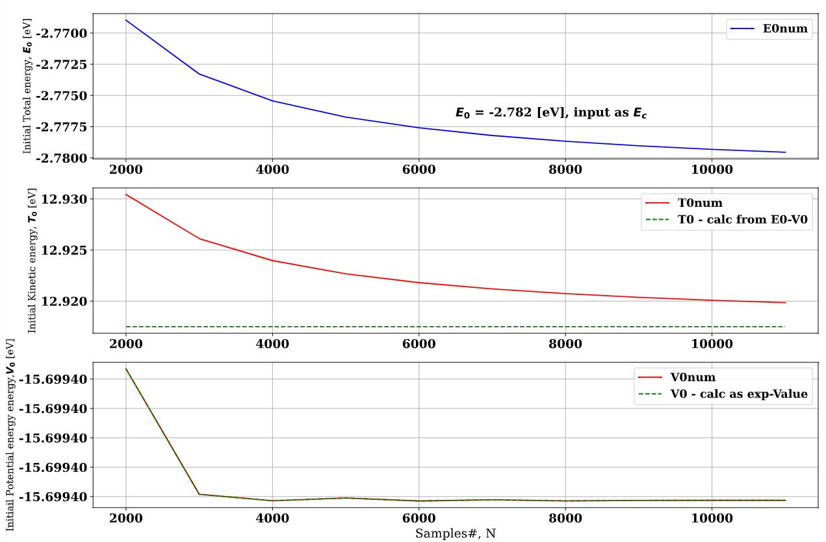
Figure S2. Convergence plots vs N, samples. Spatial Grid density convergence test for Graphene-Al doped Hematite (*OH intermediate). Wave propagates from hematite to graphene. Initial wavefunction is located at oxygen atom near the interface and the flux is measured at barrier.

Figure S3. Time convergence test results for Graphene-Al doped Hematite (*OH intermediate). Number of time steps = 200. Wave propagates from hematite to graphene. Initial wavefunction is located at oxygen atom near the interface and the flux is measured at barrier.

(a)
(b)
Figure S4. Projected density of states (states/eV/atom) for studied anode material Al-doped hematite below ~-6 eV.

(a)
(b)
Figure S5. Cumulative probability when wave propagates from hematite to graphene. Initial wavefunction located at oxygen atom near the interface and the flux is measured at iron atom. (a) is for *OH intermediate and (b) is for *O intermediate.

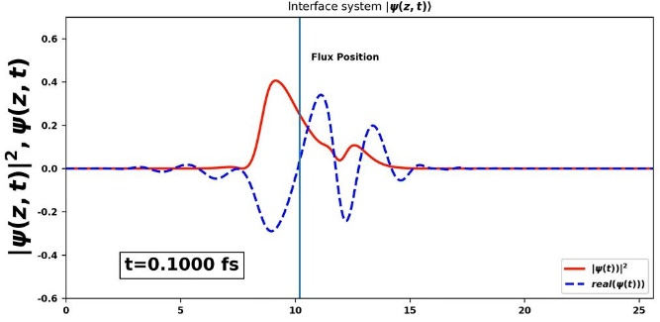 | 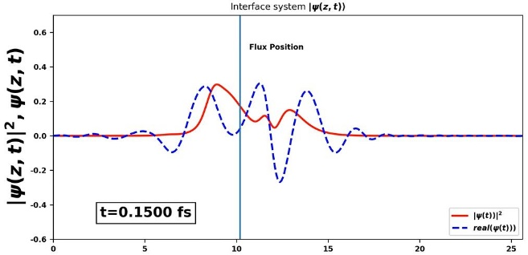
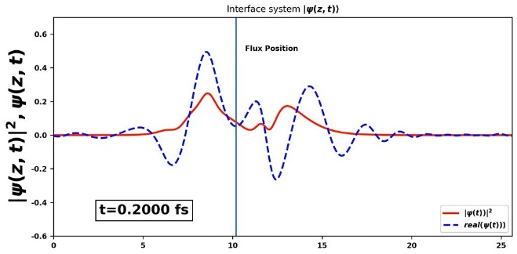 | 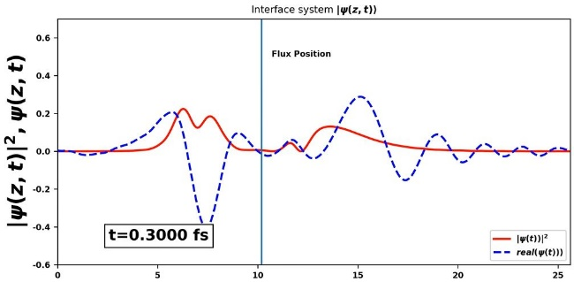
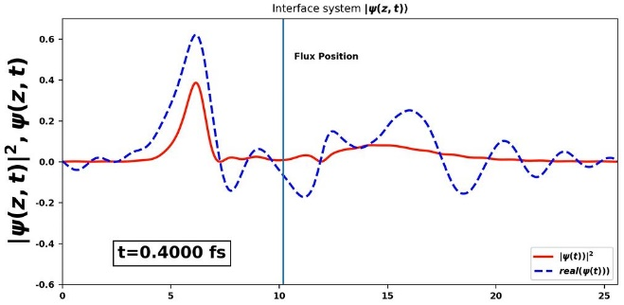
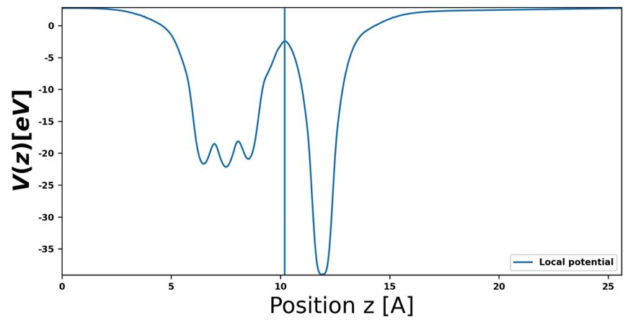
Figure S6. Dynamics of charge propagation from Al doped Hematite to Graphene at different time steps in fsec for Graphene-Al doped Hematite (*OH intermediate). At each time step, the absolute value squared and the real part of the wave packet is shown in red and blue color respectively. Initial wavefunction located at oxygen atom near the interface. Flux is measured at barrier. Maximum flux is observed at t=0.2 fs and after t=0.4 fs the wavefunction begins to cross the edges.

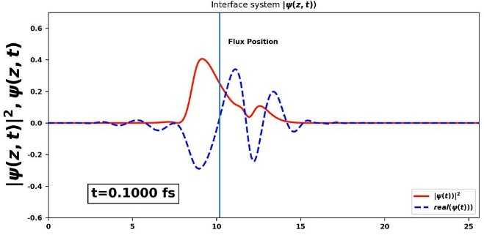
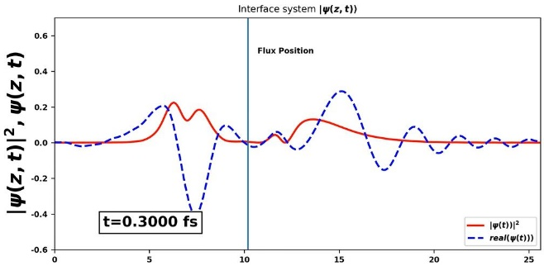
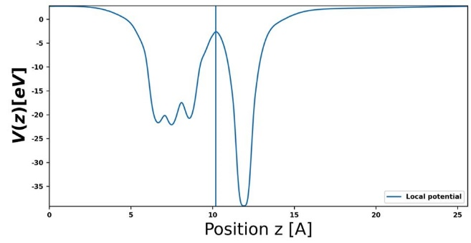
Figure S7. Dynamics of charge propagation from Al doped Hematite to Graphene at different time steps in fsec for Graphene-Al doped Hematite (*O intermediate). At each time step, the absolute value squared and the real part of the wave packet is shown in red and blue color respectively. Initial wavefunction located at oxygen atom near the interface. Flux is measured at barrier. Maximum flux is observed at t=0.2 fs and after t=0.4 fs the wavefunction begins to cross the edges.

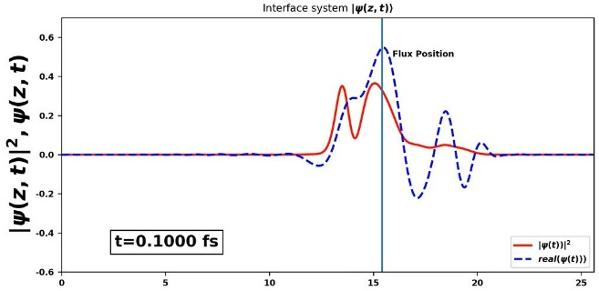 | 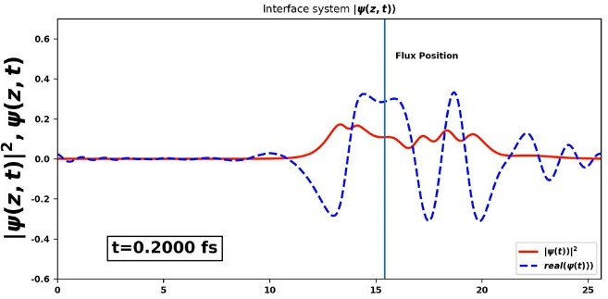
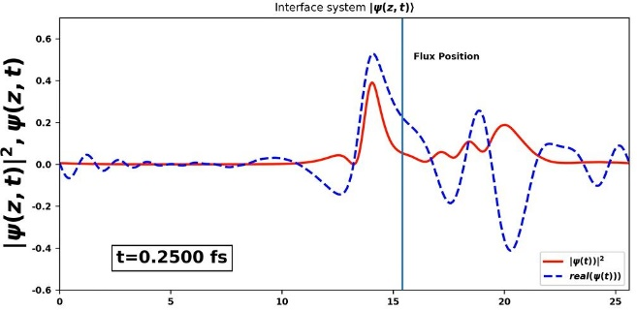 | 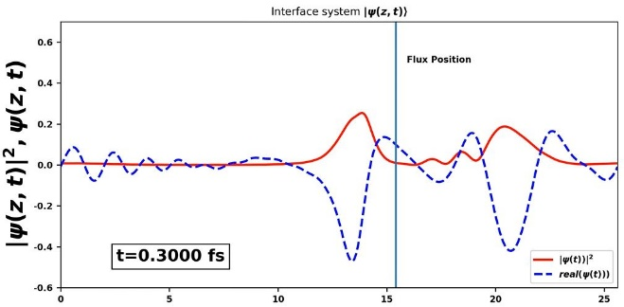
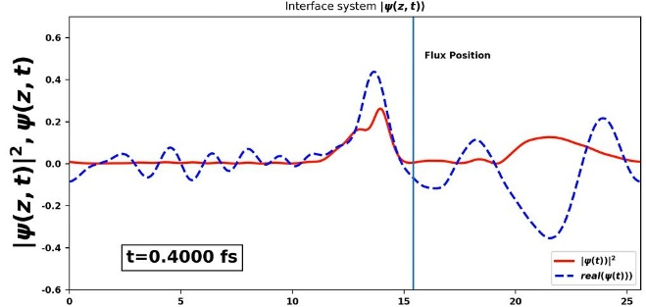
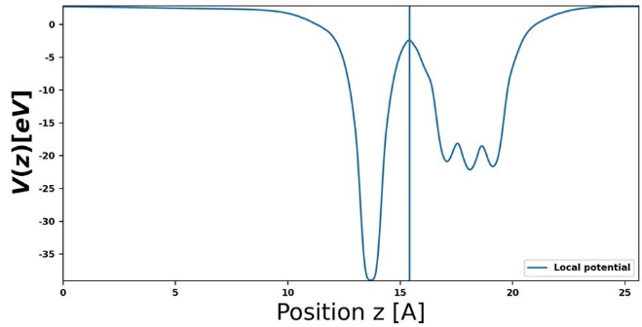
Figure S8. Dynamics of charge propagation from Graphene to Al doped Hematite at different time steps in fsec for Graphene-Al doped Hematite (*OH intermediate). At each time step, the absolute value squared and the real part of the wave packet is shown in red and blue color respectively. Initial wavefunction located at carbon atom near the interface. Flux is measured at barrier. Maximum flux is observed around t=0.2 fs and after t=0.4 fs the wavefunction begins to cross the edges.

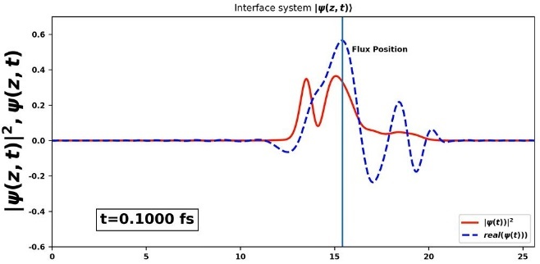 | 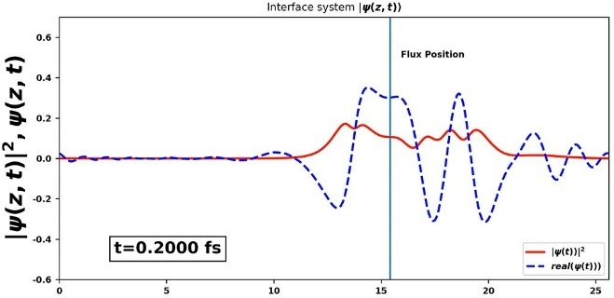
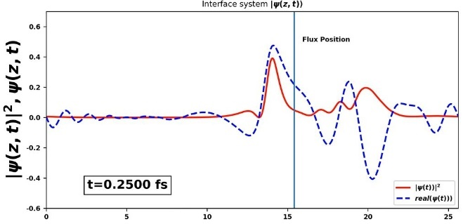 | 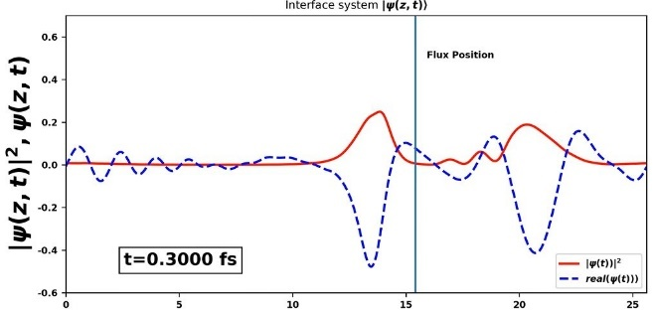
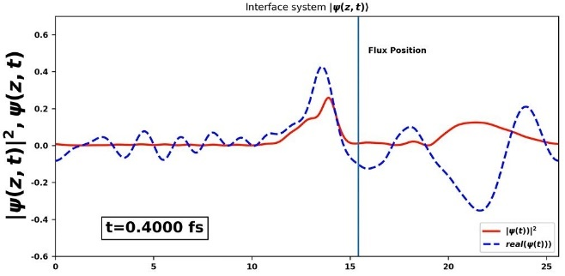
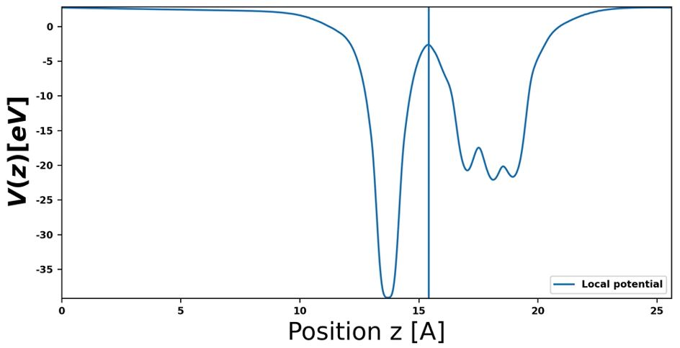
Figure S9. Dynamics of charge propagation from Graphene to Al doped Hematite at different time steps in fsec for Graphene-Al doped Hematite (*O intermediate). At each time step, the absolute value squared and the real part of the wave packet is shown in red and blue color respectively. Initial wavefunction located at carbon atom near the interface. Flux is measured at barrier. Maximum flux is observed around t=0.2 fs and after t=0.4 fs the wavefunction begins to cross the edges.

Figure S10. Electrostatic local potential along interface direction (Z-direction) of *O intermediate of Al-doped hematite and graphene supported heterostructures with respect to vacuum. Data for hematite and graphene-hematite are taken from our previous work [S1].

Initial image: *OH intermediate | Transition state: H atom is between *O and Cl. | Final state: *O intermediate on the surface and H atom is captured by Cl.
- Two Cl sinks both side of the hematite slab following N. Snir et al. [S2]. The computed reaction activation energy is 0.64 eV. Red, gold, white and green spheres represent oxygen, iron, hydrogen and chlorine atoms, respectively. Oxygen and hydrogen atoms of the surfaces both side of the slab are allowed to move in all three directions during initial and final image optimization and CI-NEB calculations (except H4 is fixed at c and allowed to move in a and b direction). Iron and chlorine atoms are fixed in all three directions.
Initial image: *OH intermediate | Transition state: H atom is between *O and Cl. | Final state: *O intermediate on the surface and H atom is captured by Cl.
- Two Cl sinks both side of the hematite slab. Second chlorine atom is placed just to balance the dipole moment created by the first chlorine atom. The computed reaction activation energy is 0.64 eV. Oxygen and hydrogen atoms of the surfaces both side of the slab are allowed to move in all three directions during initial and final image optimization and CI-NEB calculations. Iron and chlorine atoms are fixed in all three directions.
Initial image: *OH intermediate | Transition state: H atom is between *O and Cl. | Final state: *O intermediate on the surface and H atom is captured by Cl.
- One Cl sink is placed in one side of the hematite slab. Dipole correction has been considered. The computed reaction activation energy is 0.66 eV. Oxygen and hydrogen atoms of the surface (marked in black box) where deprotonation reaction takes place are allowed to move in all three directions during initial and final image optimization and CI-NEB calculations. All other atoms are fixed in all three directions.
Figure S11. Deprotonation of *OH intermediate of hematite monolayer considering (a) two chlorine sinks, (b) two chlorine sinks; Second chlorine atom is placed to balance the dipole moment created by the first chlorine atom and (c) one chlorine sink including dipole correction.

Initial image: *OH intermediate | Transition state: H atom is between *O and Cl. | Final state: *O intermediate on the surface and H atom is captured by Cl.
- Graphene-Hematite. Selective dynamics constraints are the same as mentioned in Figure 11(c) including the carbon atoms in graphene are fixed in all three directions during initial and final image optimization and CI-NEB calculations.
Initial image: *OH intermediate | Transition state: H atom is between *O and Cl. | Final state: *O intermediate on the surface and H atom is captured by Cl.
(b) Al doped Hematite. Selective dynamics constraints are the same as mentioned in Figure 11(c) during initial and final image optimization and CI-NEB calculations
Initial image: *OH intermediate | Transition state: H atom is between *O and Cl. | Final state: *O intermediate on the surface and H atom is captured by Cl.
(c) Graphene- Al doped Hematite. Selective dynamics constraints are the same as mentioned in Figure 11(c) including the carbon atoms in graphene are fixed in all three directions during initial and final image optimization and CI-NEB calculations.
Initial image: *OH intermediate | Transition state: H atom is between *O and Cl. | Final state: *O intermediate on the surface and H atom is captured by Cl.
(d) N doped Graphene- Al doped Hematite. Selective dynamics constraints are the same as mentioned in Figure 11(c) including the carbon atoms in graphene are fixed in all three directions during initial and final image optimization and CI-NEB calculations.
Figure S12. Deprotonation of *OH intermediate of (a) Graphene-Hematite, (b) Al doped Hematite, and (c) Graphene- Al doped Hematite (d) N doped Graphene- Al doped Hematite

Python module for the numerical simulation of wave function propagation

Y. Reichman, M. Caspary Toroker, A Numeric Approach for Investigating Electron Dynamics in Zinc-Blende Semiconductor Heterostructures, Adv Theory Simul (2023). https://doi.org/10.1002/adts.202300155.

INCAR used for geometry optimization of Graphene-Al doped Hematite:
SYSTEM = Graphene-Al doped Hematite
ISTART = 0
ICHARG = 2
PREC = Accurate
ALGO = Very_Fast
NPAR = 4
EDIFF = 1E-4
NELM = 200
MAGMOM = 6*0 1*4 1*0.12 6*0 8*0
LVTOT = .TRUE.
ISMEAR = 0
SIGMA = 0.05
EMIN = -8.5
EMAX = 5
NEDOS = 1500
LWAVE = .TRUE.
LCHARG = .FALSE.
ISPIN = 2
ISYM = 0
EDIFFG = -3.0E-2
LORBIT = 10
IBRION = 2
NSW = 50
ISIF = 2
POTIM = 0.3
LREAL = .FALSE. # Real space projection
ENCUT = 700 eV
LDAU = .TRUE.
LDAUTYPE = 2
LDAUL = -1 2 -1 -1 -1
LDAUU = 0 4.3 0 0 0
LDAUJ = 0 0 0 0 0
LDAUPRINT = 0
IVDW = 20
LVDW_EWALD =.TRUE.
During Bader charge analysis. ICHARG =1 is taken which reads the charge density from CHGCAR outputted in geometry optimization. In INCAR, LCHARG = .TRUE., LAECHG = .TRUE. are also added.

INCAR used for calculating Zero-point energy (ZPE) corrections and entropic contribution
ISTART = 1
ICHARG = 1
PREC = Accurate
ALGO = Very_Fast
NPAR = 4
EDIFF = 1E-4
NELM = 200
MAGMOM = 6*0 1*4 1*0.12 6*0 8*0
LVTOT = .TRUE.
ISMEAR = 0
SIGMA = 0.05
EMIN = -8.5
EMAX = 5
NEDOS = 1500
LWAVE = .TRUE.
LCHARG = .FALSE.
ISPIN = 2
ISYM = 0
EDIFFG = -3.0E-2
LORBIT = 10
IBRION = 5 #ZPE and entropic calculations
NSW = 1 #ZPE and entropic calculations
ISIF = 2
POTIM = 0.3
NFREE = 2 #ZPE and entropic calculations
LREAL = .FALSE. # Real space projection
ENCUT = 700 eV
LDAU = .TRUE.
LDAUTYPE = 2
LDAUL = -1 2 -1 -1 -1
LDAUU = 0 4.3 0 0 0
LDAUJ = 0 0 0 0 0
LDAUPRINT = 0
IVDW = 20
LVDW_EWALD =.TRUE.
VASP outputs of Zero-point energy (ZPE) corrections and entropic calculations are processed with the code available in https://github.com/ftherrien/VaspGibbs.git to calculate ${(∆ZPE-T∆S)}_{1-5}$ values.

INCAR used for CI-NEB calculations for Graphene-Al doped hematite heterostructure
# This is one of the input files for a vasp DFT bulk calculation.
SYSTEM = Graphene-Al doped hematite
ISTART = 1
PREC = Accurate
ALGO = Very_Fast
NPAR = 4
EDIFF = 1E-4
NELM = 200
MAGMOM = 6*0 1*4 1*0.12 6*0 8*0 1*0
# DOS related values:
ISMEAR = 0
SIGMA = 0.05
NEDOS = 500
LWAVE = .TRUE.
LCHARG = .FALSE.
ISPIN = 2
ISYM = 0
EDIFFG = -3.0E-2
LORBIT = 10
IBRION = 3
NSW = 50
ISIF = 0
POTIM = 0
LDIPOL = .TRUE.
IDIPOL = 3
LREAL = .FALSE.
ENCUT = 700 eV
LDAU = .TRUE.
LDAUTYPE = 2
LDAUL = -1 2 -1 -1 -1 -1
LDAUU = 0 4.3 0 0 0 0
LDAUJ = 0 0 0 0 0 0
LDAUPRINT = 0 ## 2
#VDW correction for graphene
IVDW = 20
LVDW_EWALD =.TRUE.
# NEB Calculations
IMAGES = 8
SPRING = -5
LCLIMB = .TRUE.
IOPT = 3

The relaxed geometries (CONTCAR outputted by VASP) and the total energy of the *OH intermediate of Al doped hematite, Graphene-Al doped hematite and N doped graphene- Al doped hematite are given according to the following order: title, lattice vectors in Cartesian coordinates, atom types and numbers, and atom locations in fractional coordinates.
*OH_ Al doped hematite
1.00000000000000
5.0980000496000004 0.0000000000000000 0.0000000000000000
-2.5490000248000002 4.4149975513999999 0.0000000000000000
0.0000000000000000 0.0000000000000000 25.6149997710999990
O Fe Al H
6 1 1 6
Direct
0.6901238524363222 0.7360656003887627 0.3192470874727320
0.3043520230519192 0.0179809003962461 0.3192286843512449
0.0172654286355893 0.3541404904834309 0.3187446911819265
0.6897000001227411 0.0314595254986543 0.2356247808480774
0.0214404424687515 0.7356050783886516 0.2343963911679836
0.3056576452877664 0.3514926144467481 0.2338426965261817
0.3416151151035791 0.7005570264859671 0.2764708723056444
0.0054705365301473 0.0373558187383054 0.2767246217355890
0.0862786444305641 0.7967083327593656 0.1986874579182114
0.4991485284000703 0.3538294844543302 0.2324007889457604
0.7029219630978432 0.9853982626319748 0.1993407313980526
0.0844913905796361 0.3462479412137043 0.3538493531292701
0.2322208442760996 0.9416944630646285 0.3541017813571514
0.6887635471355651 0.5431544515217368 0.3210200124990266

Total Energy= -79.16890429 eV

*OH_ Graphene-Al doped hematite
1.00000000000000
5.0082168578999999 0.0000000000000000 0.0000000000000000
-2.5041084290000000 4.3372430266000004 0.0000000000000000
0.0000000000000000 0.0000000000000000 25.6149997710999990
O Fe Al H C
6 1 1 6 8
Direct
0.7110245982882404 0.6735746492183736 0.3345303562545752
0.3345596072181038 0.9713980793852528 0.3352592300997088
0.0378266398649956 0.3022564663982479 0.3362031896934354
0.7128733915176610 0.9564084172675180 0.2491898593497766
0.3283441583324702 0.2974000893862154 0.2502794244440167
0.0204903957847264 0.6622568492489762 0.2506587771516067
0.3565798483575264 0.6470399242749352 0.2918862297790596
0.0286855954311065 0.9874311348191753 0.2935944490402917
0.5455109136667033 0.3538064636328428 0.2494030757492851
0.7551408579694865 0.1531396354304562 0.2348031397895198
0.8427765894520007 0.3038973260109827 0.3377630024684422
0.2561589103748290 0.8946970709292188 0.3699752548691677
0.7002905068339587 0.7427638936328549 0.3694333062169193
0.0813433559158412 0.7452380580988844 0.2155907524044594
0.1670680542275775 0.3189213344260722 0.4642219198558806
0.1670009637852488 0.8187807367246265 0.4642780469853278
0.6671682223722826 0.3189356890549107 0.4642248851572646
0.6670762553424368 0.8188934761339013 0.4642311738044569
0.0005263060656375 0.9858555893054159 0.4642716853769926
0.0003123213938920 0.4852809009115617 0.4642592896056001
0.5005792930803779 0.9857760390669910 0.4642573989379954
0.5001865042806060 0.4852851177638371 0.4642634371308247

Total Energy = -154.39829169 eV

*OH_ N doped graphene-Al doped hematite
1.00000000000000
5.0082168578999999 0.0000000000000000 0.0000000000000000
-2.5041084290000000 4.3372430266000004 0.0000000000000000
0.0000000000000000 0.0000000000000000 25.6149997710999990
O Fe Al H C N
6 1 1 6 7 1
Direct
0.7096740263813928 0.6722376515239716 0.3348284794107457
0.3349876786147519 0.9712974413870228 0.3352395940163007
0.0388377582017867 0.3024848809809697 0.3367068004950511
0.7133370189226511 0.9561107308261469 0.2493825073463753
0.3261934156404465 0.2961692800116396 0.2503978420704485
0.0186672549332343 0.6602540134551020 0.2510757903749763
0.3563283785874134 0.6467082450243637 0.2919145064202340
0.0277732543346048 0.9868783126881766 0.2940265020341073
0.5430545622648566 0.3519816702698222 0.2491594706334368
0.7572791119204538 0.1549023631824298 0.2356996531232483
0.8459046822508896 0.3081153248056481 0.3385156555862707
0.2626474475943041 0.8964462395552601 0.3702954156137608
0.6898117020785008 0.7357380312686743 0.3697252428560773
0.0793247045479077 0.7403325747182947 0.2158470890759077
0.1682040248288317 0.3207190802625632 0.4637687609275289
0.1684052333540293 0.8195980874740911 0.4636114579489643
0.6680758310981432 0.3200135608679702 0.4637352889937887
0.6672439976993871 0.8197933323253466 0.4635405058485134
0.0002315188791187 0.4863514495976489 0.4637987124447989
0.5020951893374672 0.9884826332650221 0.4637158318986394
0.5017335260296463 0.4863771823280061 0.4637599289762164
0.0017128173043659 0.9880448936685013 0.4638328331560970

Total Energy = -152.23336712 eV

The relaxed geometries (CONTCAR outputted by VASP) and the total energy of the initial state, transition state and final state from NEB calculations for hematite, Al doped hematite, Graphene-hematite, Graphene-Al doped hematite and N doped graphene- Al doped hematite are given according to the following order: title, lattice vectors in Cartesian coordinates, atom types and numbers, and atom locations in fractional coordinates.
Hematite
Initial state:
Hematite_Initial state
1.00000000000000
5.0980000496000004 0.0000000000000000 0.0000000000000000
-2.5490000247999998 4.4149975513999999 0.0000000000000000
0.0000000000000000 0.0000000000000000 25.6149997710999990
O Fe H Cl
6 2 6 1
Selective dynamics
Direct
0.6740766762877044 0.7185456752957933 0.3215393424009534 F F F
0.3222995698639082 0.0231369641343520 0.3214666247348674 F F F
0.0180896557408801 0.3750866950027785 0.3219198286428835 F F F
0.6720352092274631 0.0341552189933221 0.2339151135178719 T T T
0.0242229829245717 0.7230136634937931 0.2333982519885388 T T T
0.3275817471758642 0.3781750637777839 0.2315847047344171 T T T
0.3412569463543775 0.7015897630606318 0.2765461206442055 F F F
0.0041295727295463 0.0404457524429134 0.2766691446156386 F F F
0.0780595839920000 0.7534219249967189 0.1961382889251797 T T T
0.5166964515285807 0.3695157489273340 0.2288032149804726 T T T
0.6705158510166465 0.9800658056369064 0.1972561827870697 T T T
0.1064543276942729 0.3694939614366746 0.3552833795558996 F F F
0.2344870568196811 0.9307311177776256 0.3549360335055596 F F F
0.6784994602312509 0.5277824997345917 0.3225114643694269 F F F
0.2339938879646368 0.5903573632047667 0.1176049485816790 F F F
Total Energy = -78.23345890 eV, Zero Point Energy corrections (ZPE-TS) = 1.034806 eV
Transition state:
Hematite_transition state
1.00000000000000
5.0980000496000004 0.0000000000000000 0.0000000000000000
-2.5490000247999998 4.4149975513999999 0.0000000000000000
0.0000000000000000 0.0000000000000000 25.6149997710999990
O Fe H Cl
6 2 6 1
Selective dynamics
Direct
0.6740766762877044 0.7185456752957933 0.3215393424009534 F F F
0.3222995698639082 0.0231369641343520 0.3214666247348674 F F F
0.0180896557408374 0.3750866950027785 0.3219198286428835 F F F
0.6841455620659218 0.0277072571528549 0.2339973394013626 T T T
0.0886868302098023 0.7200328044732771 0.2259039944544483 T T T
0.3383007510717846 0.3684833798033793 0.2360826590746896 T T T
0.3412569463543207 0.7015897630606318 0.2765461206442055 F F F
0.0041295727295463 0.0404457524429134 0.2766691446156386 F F F
0.1529055551607854 0.6611090862716296 0.1763241465995264 T T T
0.5234579352209963 0.3563647049541032 0.2316039474094183 T T T
0.6678394307198801 0.9797302860537940 0.1966952495162104 T T T
0.1064543313751756 0.3694939614366746 0.3552833795558996 F F F
0.2344870568196384 0.9307311177776256 0.3549360335055596 F F F
0.6784994602312509 0.5277824997345917 0.3225114643694269 F F F
0.2339938806026964 0.5903573632047667 0.1176049485816790 F F F
Total Energy = -77.38131571 eV, Zero Point Energy corrections (ZPE-TS) = 0.845239 eV
Final state:
Hematite_final state
1.00000000000000
5.0980000496000004 0.0000000000000000 0.0000000000000000
-2.5490000247999998 4.4149975513999999 0.0000000000000000
0.0000000000000000 0.0000000000000000 25.6149997710999990
O Fe H Cl
6 2 6 1
Selective dynamics
Direct
0.6740766762877044 0.7185456752957933 0.3215393424009534 F F F
0.3222995698639083 0.0231369641343520 0.3214666247348674 F F F
0.0180896557408183 0.3750866950027784 0.3219198286428835 F F F
0.6744086665217985 0.0200226309232579 0.2330234572719047 T T T
0.0631696180496058 0.7207602374205258 0.2392379686174950 T T T
0.3316455010354000 0.3709304644098972 0.2348868552456873 T T T
0.3412569463542929 0.7015897630606317 0.2765461206442055 F F F
0.0041295727295463 0.0404457524429134 0.2766691446156386 F F F
0.1053404561753202 0.6063717244340416 0.1602959886176007 T T T
0.5158193760831249 0.3560121456918233 0.2318082223510219 T T T
0.6477547989848857 0.9522112402229612 0.1966637187018034 T T T
0.1064543343199025 0.3694939614366746 0.3552833795558996 F F F
0.2344870568196166 0.9307311177776256 0.3549360335055596 F F F
0.6784994602312509 0.5277824997345917 0.3225114643694269 F F F
0.2339938747131581 0.5903573632047667 0.1176049485816790 F F F
Total Energy = -78.03307374 eV, Zero Point Energy corrections (ZPE-TS) = 0.961954 eV

Al doped Hematite
Initial state:
Al doped hematite_initial state
1.00000000000000
5.0980000496000004 0.0000000000000000 0.0000000000000000
-2.5490000248000002 4.4149975513999999 0.0000000000000000
0.0000000000000000 0.0000000000000000 25.6149997710999990
O Fe Al H Cl
6 1 1 6 1
Selective dynamics
Direct
0.6901238560239733 0.7360656261223752 0.3192470967821848 F F F
0.3043520152217027 0.0179808996665969 0.3192287087281471 F F F
0.0172654205521070 0.3541404904073389 0.3187446892430472 F F F
0.6907342309398175 0.0266613451022943 0.2360052300430698 T T T
0.0320021029757023 0.7401889801440307 0.2351232623728298 T T T
0.3085816937126369 0.3548457822359081 0.2350289658216049 T T T
0.3416151105828362 0.7005570530881116 0.2764708697749043 F F F
0.0054705361238589 0.0373558177733742 0.2767246365544480 F F F
0.0738789940957486 0.7592146197726385 0.1975519324258315 T T T
0.4993081369890159 0.3549019641190536 0.2297629670249513 T T T
0.6901174951320803 0.9910237220230741 0.1985805236976607 T T T
0.0844913795135724 0.3462479412961983 0.3538493513955174 F F F
0.2322208135829413 0.9416943788975871 0.3541017770858446 F F F
0.6887635588612895 0.5431544781354631 0.3210200071240052 F F F
0.2339938730568321 0.5903573632047667 0.1176049485816790 F F F
Total Energy = -79.98685881 eV, Zero Point Energy corrections (ZPE-TS) = 1.058524 eV
Transition state:
Al doped hematite_transition state
1.00000000000000
5.0980000496000004 0.0000000000000000 0.0000000000000000
-2.5490000247999998 4.4149975513999999 0.0000000000000000
0.0000000000000000 0.0000000000000000 25.6149997710999990
O Fe Al H Cl
6 1 1 6 1
Selective dynamics
Direct
0.6901238560239733 0.7360656261223752 0.3192470967821847 F F F
0.3043520152217027 0.0179808996665969 0.3192287087281471 F F F
0.0172654205521064 0.3541404904073389 0.3187446892430472 F F F
0.7018925496278949 0.0058626033798381 0.2352761180402762 T T T
0.0969358192322177 0.7317024037518921 0.2265169407550772 T T T
0.3120210860222051 0.3468050310260440 0.2380414294209625 T T T
0.3416151105828278 0.7005570530881116 0.2764708697749043 F F F
0.0054705361238588 0.0373558177733742 0.2767246365544480 F F F
0.1557519302399638 0.6671515382704217 0.1767150451789004 T T T
0.4952447879157513 0.3440902765550606 0.2279399454324429 T T T
0.6968077523252545 0.9838425554843132 0.1974205986029240 T T T
0.0844913795135724 0.3462479412961983 0.3538493513955175 F F F
0.2322208135829413 0.9416943788975871 0.3541017770858446 F F F
0.6887635588612895 0.5431544781354631 0.3210200071240053 F F F
0.2339938730568238 0.5903573632047667 0.1176049485816790 F F F
Total Energy = -79.04444562 eV, Zero Point Energy corrections (ZPE-TS) = 0.864657 eV
Final state
Al doped hematite_final state
1.00000000000000
5.0980000496000004 0.0000000000000000 0.0000000000000000
-2.5490000248000002 4.4149975513999999 0.0000000000000000
0.0000000000000000 0.0000000000000000 25.6149997710999990
O Fe Al H Cl
6 1 1 6 1
Selective dynamics
Direct
0.6901238560239733 0.7360656261223752 0.3192470967821848 F F F
0.3043520152217027 0.0179808996665969 0.3192287087281471 F F F
0.0172654205521070 0.3541404904073389 0.3187446892430472 F F F
0.6963259096652161 0.0101590063654959 0.2354369566316660 T T T
0.0724779251962233 0.7365076966875258 0.2388650153850565 T T T
0.3100913484008578 0.3520286177914432 0.2372487999358063 T T T
0.3416151105828362 0.7005570530881116 0.2764708697749043 F F F
0.0054705361238589 0.0373558177733742 0.2767246365544480 F F F
0.1407857352156112 0.6489213186184607 0.1610460861160618 T T T
0.4975072898378411 0.3477502378615560 0.2311303948707380 T T T
0.6893264139529393 0.9807340440838915 0.1977670026592298 T T T
0.0844913795135724 0.3462479412961983 0.3538493513955174 F F F
0.2322208135829413 0.9416943788975871 0.3541017770858446 F F F
0.6887635588612895 0.5431544781354631 0.3210200071240052 F F F
0.2339938730568321 0.5903573632047667 0.1176049485816790 F F F
Total Energy = -79.72685144 eV, Zero Point Energy corrections (ZPE-TS) = 0.992408 eV
Graphene-Hematite
Initial state
Graphene-Hematite_Initial state
1.00000000000000
5.0082168578999999 0.0000000000000000 0.0000000000000000
-2.5041084290000000 4.3372430266000004 0.0000000000000000
0.0000000000000000 0.0000000000000000 25.6149997710999990
O Fe H C Cl
6 2 6 8 1
Selective dynamics
Direct
0.6976631283975649 0.6492146849348543 0.3363840281865436 F F F
0.3540635706317516 0.9660570026403619 0.3372179567905178 F F F
0.0373229569720408 0.3140996097394009 0.3379423618331074 F F F
0.6911739070439680 0.9780258196344747 0.2494181989651096 T T T
0.3472426762560445 0.3086600199049983 0.2477670216685510 T T T
0.0291979113507423 0.6578181385614741 0.2487647540821882 T T T
0.3582273721089777 0.6428706645903048 0.2913401126952095 F F F
0.0322250686696677 0.9854547381336261 0.2928015589702255 F F F
0.5432190903141176 0.3063572162987924 0.2456703473413100 T T T
0.6915603958715479 0.9348492465488789 0.2122371028023124 T T T
0.8403651715473828 0.3135318458430945 0.3392430841949121 F F F
0.2561011612799717 0.8706268071310106 0.3701723515804218 F F F
0.6821497677939519 0.7244980930808680 0.3705992996615350 F F F
0.0833937726312612 0.6922566510737767 0.2112794563070182 T T T
0.1662684083029831 0.3280515371801442 0.4647158384295693 F F F
0.1662444324475700 0.8280113936375955 0.4647733569153445 F F F
0.6663798093957283 0.3280641435754248 0.4647429883419747 F F F
0.6663601994926722 0.8281518817302072 0.4647321402840987 F F F
0.9998077155007650 0.9950747489893956 0.4647403955642844 F F F
0.9995384813602755 0.4944500625968189 0.4647669494196833 F F F
0.4998469949066049 0.9950086475516287 0.4647792875810239 F F F
0.4994052647863825 0.4944134354124472 0.4647734165288568 F F F
0.2381887286982263 0.6009407639864719 0.1321067952855444 F F F
Total Energy = -153.25987998 eV, Zero Point Energy corrections (ZPE-TS) = 0.968151 eV
Transition state
O Fe H C Cl
Graphene-hematite_transition state
5.0082168578999999 0.0000000000000000 0.0000000000000000
-2.5041084290000000 4.3372430266000004 0.0000000000000000
0.0000000000000000 0.0000000000000000 25.6149997710999990
O Fe H C Cl
6 2 6 8 1
Selective dynamics
Direct
0.6976631283975649 0.6492146849348543 0.3363840281865436 F F F
0.3540635706317730 0.9660570026403619 0.3372179567905178 F F F
0.0373229569720408 0.3140996097394009 0.3379423618331074 F F F
0.7077545091531476 0.9732806295065899 0.2492734984242304 T T T
0.3653045198118363 0.3163245102756491 0.2509822715281516 T T T
0.0994716630517161 0.6721419615767132 0.2423958190800022 T T T
0.3582273721089777 0.6428706645903048 0.2913401126952095 F F F
0.0322250686696677 0.9854547381336261 0.2928015589702255 F F F
0.5568103167789431 0.3085794490689366 0.2471679983153194 T T T
0.6970324331118860 0.9298918173013959 0.2118313887292018 T T T
0.8403651715473828 0.3135318458430945 0.3392430841949121 F F F
0.2561011612799717 0.8706268071310106 0.3701723515804218 F F F
0.6821497677939519 0.7244980930808680 0.3705992996615350 F F F
0.1632916652747198 0.6393095754162559 0.1920824837432562 T T T
0.1662684083029831 0.3280515371801442 0.4647158384295693 F F F
0.1662444324475700 0.8280113936375955 0.4647733569153445 F F F
0.6663798093957283 0.3280641435754248 0.4647429883419747 F F F
0.6663601994926722 0.8281518817302072 0.4647321402840987 F F F
0.9998077155007650 0.9950747489893956 0.4647403955642844 F F F
0.9995384813602755 0.4944500625968189 0.4647669494196833 F F F
0.4998469949066049 0.9950086475516287 0.4647792875810239 F F F
0.4994052647863825 0.4944134354124472 0.4647734165288568 F F F
0.2381887286982263 0.6009407639864719 0.1321067956325734 F F F
Total Energy = -152.61722942 eV, Zero Point Energy corrections (ZPE-TS) = 0.830039 eV

Final state
Graphene-hematite_final
1.00000000000000
5.0082168578999999 0.0000000000000000 0.0000000000000000
-2.5041084290000000 4.3372430266000004 0.0000000000000000
0.0000000000000000 0.0000000000000000 25.6149997710999990
O Fe H C Cl
6 2 6 8 1
Selective dynamics
Direct
0.6976631283975649 0.6492146849348543 0.3363840281865436 F F F
0.3540635706317516 0.9660570026403619 0.3372179567905178 F F F
0.0373229569720408 0.3140996097394009 0.3379423618331074 F F F
0.6998726306443928 0.9938785104076402 0.2503067034821882 T T T
0.3455190231990386 0.3142579117232955 0.2491516292853717 T T T
0.0441940016308280 0.7060799212773858 0.2538920143717078 T T T
0.3582273721089777 0.6428706645903048 0.2913401126952095 F F F
0.0322250686696677 0.9854547381336261 0.2928015589702255 F F F
0.5264064447644969 0.2874482122594770 0.2446828283297009 T T T
0.7154394564547673 0.9438439390701703 0.2139558296112938 T T T
0.8403651715473828 0.3135318458430945 0.3392430841949121 F F F
0.2561011612799717 0.8706268071310106 0.3701723515804218 F F F
0.6821497677939519 0.7244980930808680 0.3705992996615350 F F F
0.1303043108081212 0.6608879384476651 0.1738598320404492 T T T
0.1662684083029831 0.3280515371801442 0.4647158384295693 F F F
0.1662444324475700 0.8280113936375955 0.4647733569153445 F F F
0.6663798093957283 0.3280641435754248 0.4647429883419747 F F F
0.6663601994926722 0.8281518817302072 0.4647321402840987 F F F
0.9998077155007650 0.9950747489893956 0.4647403955642844 F F F
0.9995384813602755 0.4944500625968189 0.4647669494196833 F F F
0.4998469949066049 0.9950086475516287 0.4647792875810239 F F F
0.4994052647863825 0.4944134354124472 0.4647734165288568 F F F
0.2381887286982263 0.6009407639864719 0.1321067959101825 F F F
Total Energy = -153.15656939 eV, Zero Point Energy corrections (ZPE-TS) = 0.949389 eV
Graphene-Al doped hematite
Initial state
Graphene-Al doped hematite_initial
1.00000000000000
5.0082168578999999 0.0000000000000000 0.0000000000000000
-2.5041084290000000 4.3372430266000004 0.0000000000000000
0.0000000000000000 0.0000000000000000 25.6149997710999990
O Fe Al H C Cl
6 1 1 6 8 1
Selective dynamics
Direct
0.7110245822858943 0.6735746263427984 0.3345303237389814 F F F
0.3345596491945955 0.9713981151530646 0.3352591991310092 F F F
0.0378266313267375 0.3022564649847794 0.3362032174880696 F F F
0.7071278698333288 0.9779746557869018 0.2520859888238505 T T T
0.3331464537484692 0.3052160808056072 0.2514108891617823 T T T
0.0362531148162262 0.6810998097388676 0.2516048610938810 T T T
0.3565798401556535 0.6470399499840624 0.2918862402425404 F F F
0.0286855865709441 0.9874311090557626 0.2935944497444396 F F F
0.5322652819971481 0.3120929850155321 0.2478931468422090 T T T
0.7088011966414882 0.9484173360066492 0.2144710214729599 T T T
0.8427765965859209 0.3038973211591625 0.3377630114508676 F F F
0.2561589180176398 0.8946970700514285 0.3699752688536933 F F F
0.7002905011314198 0.7427638770164577 0.3694333434145349 F F F
0.0756720424580024 0.6977346785125675 0.2137945525970792 T T T
0.1670680492228911 0.3189213275614691 0.4642219245465711 F F F
0.1670009493768347 0.8187807201995412 0.4642780423296244 F F F
0.6671681999787467 0.3189356922165345 0.4642248749662699 F F F
0.6670762301852307 0.8188934922985496 0.4642311632739577 F F F
0.0005262775623152 0.9858555794029158 0.4642716944084242 F F F
0.0003123060285688 0.4852809012756580 0.4642592966726085 F F F
0.5005792975451939 0.9857760666806924 0.4642573594873483 F F F
0.5001865030324737 0.4852851332266610 0.4642634391672829 F F F
0.2381887286982263 0.6009407639864719 0.1338986599121341 F F F
Total Energy = -155.45516267 eV, Zero Point Energy corrections (ZPE-TS) = 1.03276 eV
Transition state
Graphene-Al doped hematite_transition state
1.00000000000000
5.0082168578999999 0.0000000000000000 0.0000000000000000
-2.5041084290000000 4.3372430266000004 0.0000000000000000
0.0000000000000000 0.0000000000000000 25.6149997710999990
O Fe Al H C Cl
6 1 1 6 8 1
Selective dynamics
Direct
0.7110245822858943 0.6735746263427984 0.3345303237389814 F F F
0.3345596491945955 0.9713981151530645 0.3352591991310093 F F F
0.0378266313267375 0.3022564649847793 0.3362032174880696 F F F
0.7208280637808517 0.9575592170566284 0.2512502513338600 T T T
0.3366003471546708 0.2994384579104423 0.2535195545377280 T T T
0.0999484672679969 0.6870494906876154 0.2444133141796881 T T T
0.3565798401556535 0.6470399499840623 0.2918862402425404 F F F
0.0286855865709441 0.9874311090557625 0.2935944497444396 F F F
0.5295019128522478 0.3028531801978867 0.2458116490918374 T T T
0.7197215798043550 0.9370758187930209 0.2133762424521993 T T T
0.8427765965859211 0.3038973211591623 0.3377630114508676 F F F
0.2561589180176667 0.8946970700514285 0.3699752688536933 F F F
0.7002905011314198 0.7427638770164577 0.3694333434145349 F F F
0.1602482867997722 0.6471721783659437 0.1940104950379968 T T T
0.1670680492228911 0.3189213275614690 0.4642219245465711 F F F
0.1670009493768348 0.8187807201995412 0.4642780423296244 F F F
0.6671681999787467 0.3189356922165345 0.4642248749662699 F F F
0.6670762301852307 0.8188934922985496 0.4642311632739577 F F F
0.0005262775623153 0.9858555794029157 0.4642716944084241 F F F
0.0003123060285690 0.4852809012756580 0.4642592966726085 F F F
0.5005792975451938 0.9857760666806924 0.4642573594873483 F F F
0.5001865030324737 0.4852851332266609 0.4642634391672829 F F F
0.2381887286982263 0.6009407639864719 0.1338986603285690 F F F
Total Energy = -154.72017940 eV, Zero Point Energy corrections (ZPE-TS) = 0.85232 eV

Final state
Graphene-Al doped hematite_final
1.00000000000000
5.0082168578999999 0.0000000000000000 0.0000000000000000
-2.5041084290000000 4.3372430266000004 0.0000000000000000
0.0000000000000000 0.0000000000000000 25.6149997710999990
O Fe Al H C Cl
6 1 1 6 8 1
Selective dynamics
Direct
0.7110245822858943 0.6735746263427984 0.3345303237389814 F F F
0.3345596491945955 0.9713981151530646 0.3352591991310092 F F F
0.0378266313267375 0.3022564649847794 0.3362032174880696 F F F
0.7154505520787424 0.9557473964113044 0.2510558260500062 T T T
0.3328347629995321 0.3001309543396857 0.2527489325500270 T T T
0.0807721868974127 0.6803308880834109 0.2549241193936496 T T T
0.3565798401556535 0.6470399499840624 0.2918862402425404 F F F
0.0286855865709441 0.9874311090557626 0.2935944497444396 F F F
0.5274459481139999 0.3039947315714855 0.2465611663514053 T T T
0.7115613651511481 0.9308629463071654 0.2132714012315517 T T T
0.8427765965859209 0.3038973211591625 0.3377630114508676 F F F
0.2561589180176398 0.8946970700514285 0.3699752688536933 F F F
0.7002905011314198 0.7427638770164577 0.3694333434145349 F F F
0.1446377716052609 0.6198209409301043 0.1806618448251385 T T T
0.1670680492228911 0.3189213275614691 0.4642219245465711 F F F
0.1670009493768347 0.8187807201995412 0.4642780423296244 F F F
0.6671681999787467 0.3189356922165345 0.4642248749662699 F F F
0.6670762301852307 0.8188934922985496 0.4642311632739577 F F F
0.0005262775623152 0.9858555794029158 0.4642716944084242 F F F
0.0003123060285688 0.4852809012756580 0.4642592966726085 F F F
0.5005792975451939 0.9857760666806924 0.4642573594873483 F F F
0.5001865030324737 0.4852851332266610 0.4642634391672829 F F F
0.2381887286982263 0.6009407639864719 0.1338986605367722 F F F
Total Energy = -155.23095968 eV, Zero Point Energy corrections (ZPE-TS) = 0.996686 eV
N doped graphene-Al doped hematite
Initial state
N doped graphene-Al doped hematite_initial
1.00000000000000
5.0082168578999999 0.0000000000000000 0.0000000000000000
-2.5041084290000000 4.3372430266000004 0.0000000000000000
0.0000000000000000 0.0000000000000000 25.6149997710999990
O Fe Al H C N Cl
6 1 1 6 7 1 1
Selective dynamics
Direct
0.7096740007477393 0.6722376346260717 0.3348284959844747 F F F
0.3349877000104868 0.9712975026217094 0.3352395892147726 F F F
0.0388377682309837 0.3024848699862801 0.3367067873539824 F F F
0.7073278189981735 0.9765740825694920 0.2524329349932728 T T T
0.3313569726172716 0.3021284877615713 0.2518458629327540 T T T
0.0327571432580953 0.6772503922999604 0.2525108010490129 T T T
0.3563283681235774 0.6467082501020940 0.2919144928291715 F F F
0.0277732369451940 0.9868783355576412 0.2940264940192350 F F F
0.5285844809172033 0.3064633523496809 0.2476052316180457 T T T
0.7084803641457142 0.9445039666510624 0.2149170393014685 T T T
0.8459047079173203 0.3081153333590336 0.3385156691191185 F F F
0.2626474499679077 0.8964462279735130 0.3702954053781227 F F F
0.6898117064386611 0.7357380389868311 0.3697252571395708 F F F
0.0691401846898785 0.6891663300056621 0.2145986596739249 T T T
0.1682040243560721 0.3207190930895223 0.4637687504257926 F F F
0.1684052199633399 0.8195980788253507 0.4636114537622760 F F F
0.6680758595921148 0.3200135529615551 0.4637352824184688 F F F
0.6672440171198630 0.8197933436502183 0.4635404944409274 F F F
0.0002315420636521 0.4863514901201142 0.4637986719564111 F F F
0.5020951628419752 0.9884826540054020 0.4637158215164803 F F F
0.5017335414238246 0.4863771497382956 0.4637599289539196 F F F
0.0017128302817895 0.9880449176396198 0.4638328254214841 F F F
0.2381887436736179 0.6009407639864719 0.1362062543500926 F F F
Total Energy = -153.36673802 eV, Zero Point Energy corrections (ZPE-TS) = 1.039799 eV
Transition state
N doped graphene-Al doped hematite_transition state
1.00000000000000
5.0082168578999999 0.0000000000000000 0.0000000000000000
-2.5041084290000000 4.3372430266000004 0.0000000000000000
0.0000000000000000 0.0000000000000000 25.6149997710999990
O Fe Al H C N Cl
6 1 1 6 7 1 1
Selective dynamics
Direct
0.7096740007477393 0.6722376346260717 0.3348284959844747 F F F
0.3349877000104868 0.9712975026217093 0.3352395892147726 F F F
0.0388377682309837 0.3024848699862801 0.3367067873539824 F F F
0.7198609591060723 0.9604014950966341 0.2516235431740941 T T T
0.3341800372575817 0.2998382378698894 0.2536049396977271 T T T
0.0959146655135297 0.6888390013973669 0.2464966672816292 T T T
0.3563283681235774 0.6467082501020940 0.2919144928291715 F F F
0.0277732369451940 0.9868783355576412 0.2940264940192350 F F F
0.5278762498443914 0.3043018702675047 0.2460766276226012 T T T
0.7186266431187829 0.9356865681685022 0.2137923258407604 T T T
0.8459047079173203 0.3081153333590336 0.3385156691191185 F F F
0.2626474499679077 0.8964462279735130 0.3702954053781227 F F F
0.6898117064386611 0.7357380389868310 0.3697252571395708 F F F
0.1630777013302588 0.6443565210815969 0.1919541065671002 T T T
0.1682040243560721 0.3207190930895222 0.4637687504257926 F F F
0.1684052199633399 0.8195980788253507 0.4636114537622760 F F F
0.6680758595921148 0.3200135529615550 0.4637352824184688 F F F
0.6672440171198630 0.8197933436502183 0.4635404944409274 F F F
0.0002315420636521 0.4863514901201142 0.4637986719564111 F F F
0.5020951628419751 0.9884826540054020 0.4637158215164803 F F F
0.5017335414238246 0.4863771497382955 0.4637599289539196 F F F
0.0017128302817895 0.9880449176396197 0.4638328254214841 F F F
0.2381887436736179 0.6009407639864719 0.1362062543500926 F F F
Total Energy = -152.71868125 eV, Zero Point Energy corrections (ZPE-TS) = 0.84874 eV

Final state
N doped graphene-Al doped hematite_final
1.00000000000000
5.0082168578999999 0.0000000000000000 0.0000000000000000
-2.5041084290000000 4.3372430266000004 0.0000000000000000
0.0000000000000000 0.0000000000000000 25.6149997710999990
O Fe Al H C N Cl
6 1 1 6 7 1 1
Selective dynamics
Direct
0.7096740007477393 0.6722376346260717 0.3348284959844747 F F F
0.3349877000104868 0.9712975026217094 0.3352395892147726 F F F
0.0388377682309837 0.3024848699862801 0.3367067873539824 F F F
0.7153531257359234 0.9567676255602606 0.2513908935478852 T T T
0.3324023977857706 0.2995680679981305 0.2531301799350629 T T T
0.0780069423375593 0.6799608066486371 0.2553017689150323 T T T
0.3563283681235774 0.6467082501020940 0.2919144928291715 F F F
0.0277732369451940 0.9868783355576412 0.2940264940192350 F F F
0.5270695204751163 0.3033522476274442 0.2470893274298547 T T T
0.7116769477405001 0.9314853766485882 0.2136105171874618 T T T
0.8459047079173203 0.3081153333590336 0.3385156691191185 F F F
0.2626474499679077 0.8964462279735130 0.3702954053781227 F F F
0.6898117064386611 0.7357380389868311 0.3697252571395708 F F F
0.1434302170319484 0.6244474475956920 0.1826612510168815 T T T
0.1682040243560721 0.3207190930895223 0.4637687504257926 F F F
0.1684052199633399 0.8195980788253507 0.4636114537622760 F F F
0.6680758595921148 0.3200135529615551 0.4637352824184688 F F F
0.6672440171198630 0.8197933436502183 0.4635404944409274 F F F
0.0002315420636521 0.4863514901201142 0.4637986719564111 F F F
0.5020951628419752 0.9884826540054020 0.4637158215164803 F F F
0.5017335414238246 0.4863771497382956 0.4637599289539196 F F F
0.0017128302817895 0.9880449176396198 0.4638328254214841 F F F
0.2381887436736179 0.6009407639864719 0.1362062543500926 F F F
Total Energy = -153.08153799 eV, Zero Point Energy corrections (ZPE-TS) = 0.967994 eV

References:
[S1] Labanya Bhattacharya, Avi Cohen, Maytal Caspary Toroker, Theoretical understanding of graphene supported hematite photoanode for solar-driven water splitting applications, Catal Today 442 (2024) 114912. https://doi.org/10.1016/j.cattod.2024.114912.
[S2] N. Snir, M. Caspary Toroker, Kinetic Properties of Oxygen Evolution Reaction Catalysis in Hematite, Adv Theory Simul 6 (2023). https://doi.org/10.1002/adts.202300182.

