Supporting Information

AuRh Based Bimetallic Catalyst for Electrochemical Nitroarene Reduction: Reaction Development and Mechanistic Insights

Anju Rani, Biplab Banerjee* and Krishna Kanta Haldar*
Department of Chemistry, Central University of Punjab, Bathinda, 151001, India.
Corresponding authors: biplab.banerjee@cup.edu.in
krishankant.haldar@cup.edu.in

Table of Contents
- General information……………………………………………………….. S1-S1
- NMR Characterization data of anilines……………………………………..S2-S3
- Copies of NMR spectra recorded …………………………………………..S4-S11
- Electrochemical nitroarene reduction by pure Au and Rh catalyst………....S12-S12
- Recent studies on electrochemical nitroarene reduction…………………....S13-S13
- References…………………………………………………………………..S14-S14
- General Information.
Chloroauric acid (HAuCl₄, S. D. Fine Chem. Ltd.), rhodium (III) chloride hydrate (>99.9%, spectrogram), sulfuric acid (98%, Loba Chemie), ethanol (AR), and 5% Nafion 117 solution (Sigma-Aldrich) were employed. The chemicals used in this work were of analytical grade and were utilized directly after purchase without further purification. The reactions were monitored by thin-layer chromatography (TLC) using silica gel GF₂₅₄. Column chromatography was carried out on silica gel (60-120 mesh) using ethyl acetate-petroleum ether as eluents. NMR spectra were recorded on JEOL RESONANCE ECZ600R, 600MHz spectrometer (¹H: 600 MHz and ¹³C {¹H}: 150 MHz) in chloroform-d, DMSO – d₆ (¹H, δ = 2.50; ¹³C, δ = 39.52). Tetramethylsilane (TMS; δ = 0.00 ppm) served as an internal standard for ¹H NMR, and the corresponding solvent signal (CDCl₃; δ = 77.00 ppm) was used as an internal standard for (¹³C {¹H}) NMR. The Data for 1H NMR were recorded as follows: chemical shift (δ, ppm), multiplicity (s = singlet, d = doublet, t = triplet, q = quartet, m = multiplet, coupling constant in Hz, integration).
3. NMR Characterization Data of Anilines

2-aminophenol (1)
Following the general procedure, the reaction was done with nitroarene . The reaction mixture was purified by column chromatography to obtain the product 1 as a white solid (x mg, y%). ¹H NMR (600 MHz, DMSO-D₆) δ 8.88 (s, 1H), 6.56 (t, 1H), 6.55 – 6.45 (m, 2H), 6.34 (t, J = 7.2 Hz, 1H), 4.41 (s, 2H). ¹³C{¹H} NMR (150 MHz, DMSO-D₆) δ 149.3, 141.8, 124.8, 121.7, 119.8, 119.6.
2-aminobenzenethiol (2)
Following the general procedure, the reaction was done with nitroarene. The reaction mixture was purified by column chromatography to obtain the product 2 as a white solid (x mg, y%). ¹H NMR (600 MHz, CDCl₃) δ 7.35 (d, J = 7.7 Hz, 1H), 7.09 (t, J = 7.8 Hz, 1H), 6.72 (d, J = 8.0 Hz, 1H), 6.67 (t, J = 7.5 Hz, 1H), 4.13 (s, 2H), 2.91 (s, 1H). ¹³C{¹H} NMR (150 MHz, CDCl₃) δ 147.4, 135.1, 129.2, 118.9, 115.3, 111.9.
4-aminophenol (3)
Following the general procedure, the reaction was done with nitroarene. The reaction mixture was purified by column chromatography to obtain the product 3 as a white solid (x mg, y%).¹H NMR (600 MHz, DMSO-D₆) δ 8.29 (s, 1H), 6.43 (t, J = 8.4 Hz, 2H), 6.37 (t, J = 8.8 Hz, 2H), 4.33 (s, 2H). ¹³C{¹H} NMR (150 MHz, DMSO-D₆) δ 148.7, 141.2, 116.1, 115.8.
4-bromo-3-methylaniline (4)
Following the general procedure, the reaction was done with nitroarene. The reaction mixture was purified by column chromatography to obtain the product 4 as a white solid (x mg, y%).¹H NMR (600 MHz, CDCl₃) δ 7.24 (d, J = 8.3 Hz, 1H), 6.57 (s, 1H), 6.39 (d, J = 8.5 Hz, 1H), 3.57 (s, 2H), 2.28 (s, 3H). ¹³C{¹H} NMR (150 MHz, CDCl₃) δ 145.7, 138.5, 132.8, 117.5, 114.4, 113.0, 22.9.
4-chlorobenzene-1,3-diamine (5)
Following the general procedure, the reaction was done with nitroarene . The reaction mixture was purified by column chromatography to obtain the product 5 as a white solid (x mg, y%).¹H NMR (600 MHz, CDCl₃) δ 6.98 (d, J = 8.3 Hz, 1H), 6.09 (s, 1H), 6.05 (d, J = 8.3 Hz, 1H), 3.76 (s, 4H). ¹³C{¹H} NMR (150 MHz, CDCl₃) δ 146.2, 143.5, 129.9, 109.4, 106.8, 102.3.

2,5-dibromoaniline (6)
Following the general procedure, the reaction was done with nitroarene . The reaction mixture was purified by column chromatography to obtain the product 6 as a white solid (x mg, y%).¹H NMR (600 MHz, CDCl₃) δ 7.23 (d, J = 8.5 Hz, 1H), 6.89 (d, J = 2.2 Hz, 1H), 6.71 (dd, J = 8.4, 2.3 Hz, 1H), 4.13 (s, 2H). ¹³C{¹H} NMR (150 MHz, CDCl₃) δ 145.4, 133.7, 122.2, 121.8, 118.2, 107.8.
4-methoxyaniline (7)
Following the general procedure, the reaction was done with nitroarene . The reaction mixture was purified by column chromatography to obtain the product 7 as a white solid (x mg, y%).¹H NMR (600 MHz, CDCl₃) δ 6.74 (d, J = 8.9 Hz, 2H), 6.64 (d, J = 10.7 Hz, 2H), 3.73 (s, 3H). ¹³C{¹H} NMR (150 MHz, CDCl₃) δ 152.9, 140.0, 116.5, 114.9, 55.8.

4. Copies of NMR Spectra
¹H of 2-aminophenol
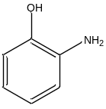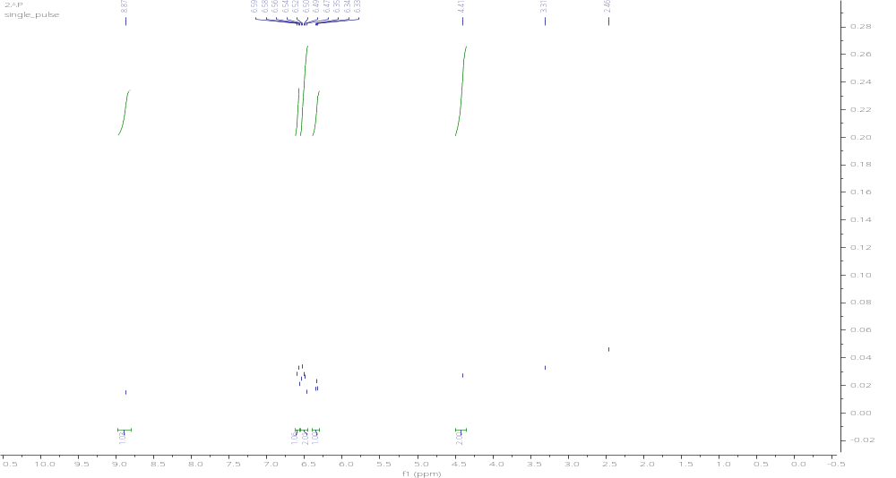

¹³C{¹H} of 2-aminophenol
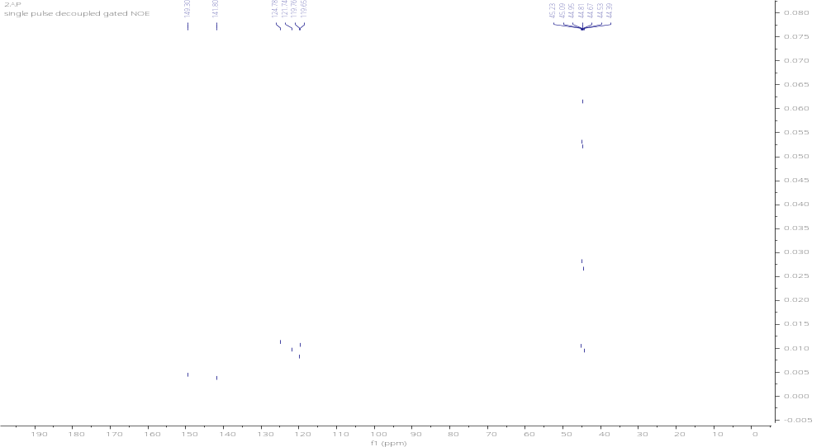

¹H of 2-aminobenzenethiol
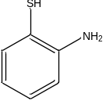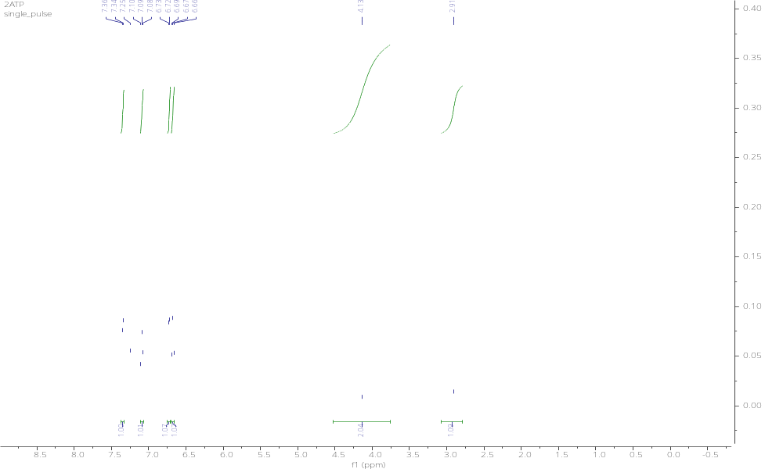

¹³C{¹H} of 2-aminobenzenethiol
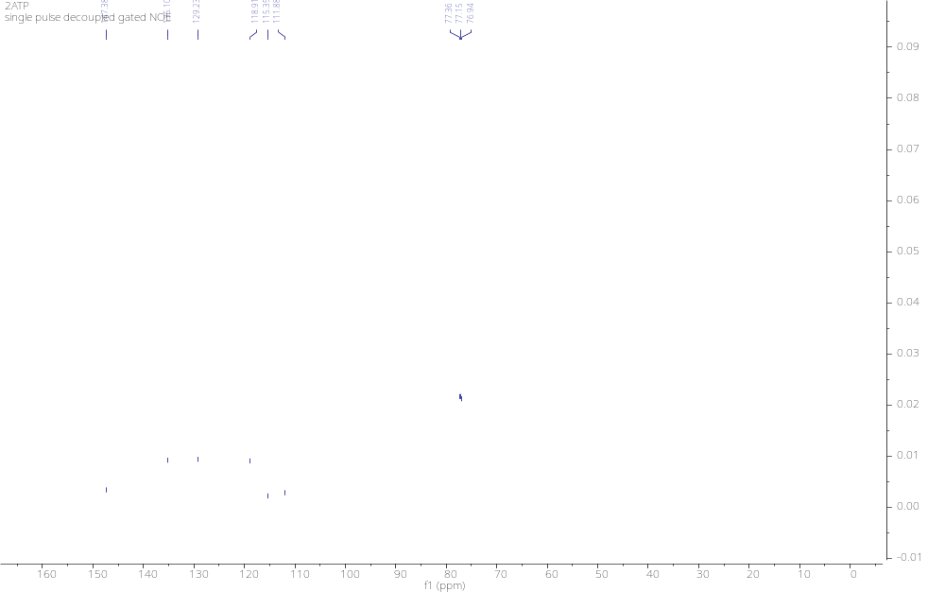
¹H of 4-aminophenol
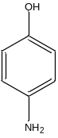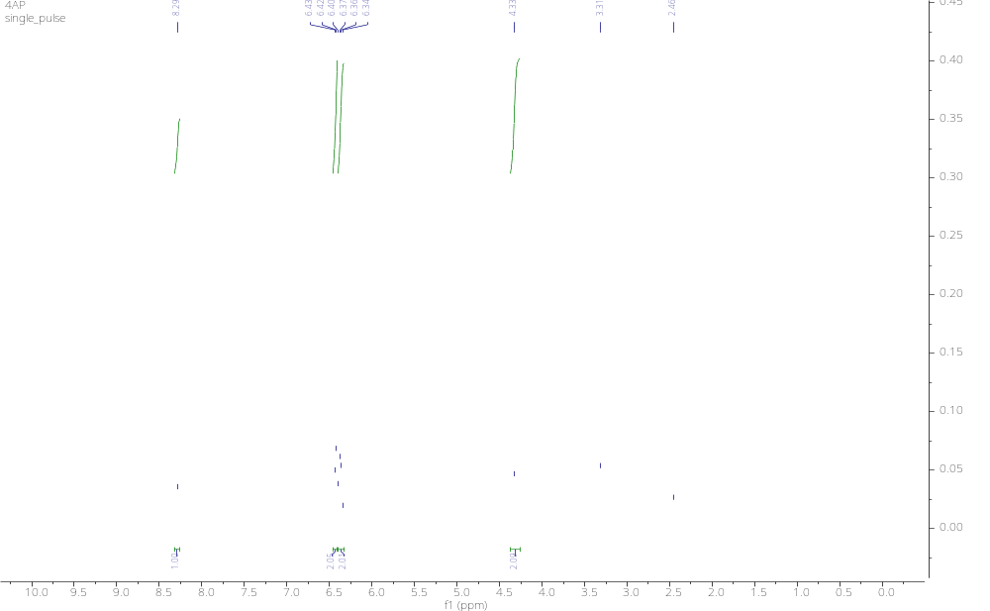

¹³C{¹H} of 4-aminophenol
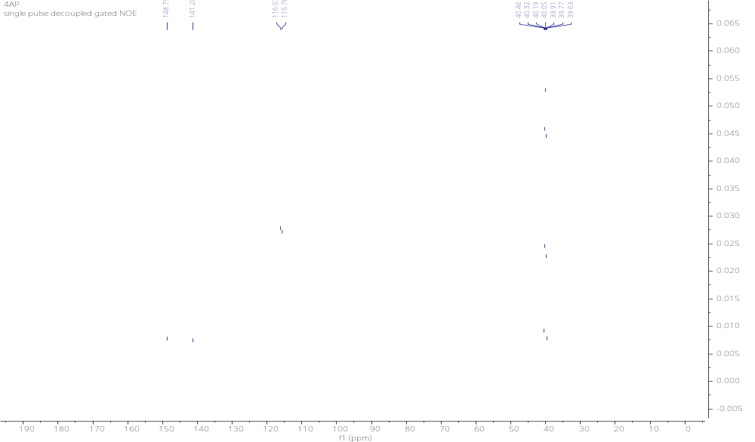
¹H of 4-bromo-3-methylaniline
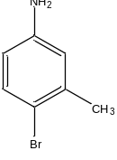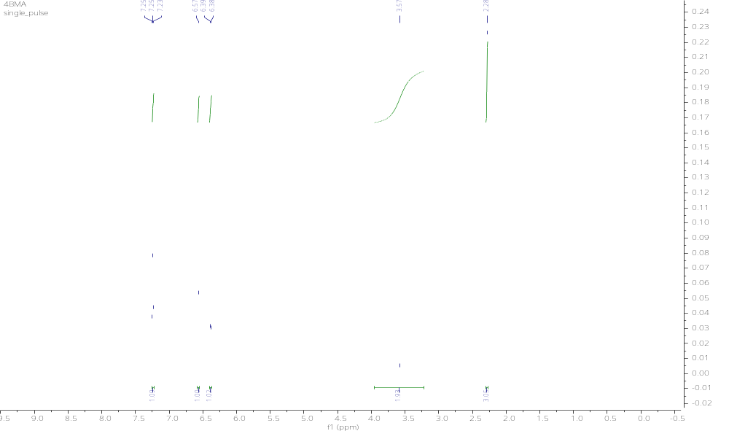

¹³C{¹H} of 4-bromo-3-methylaniline
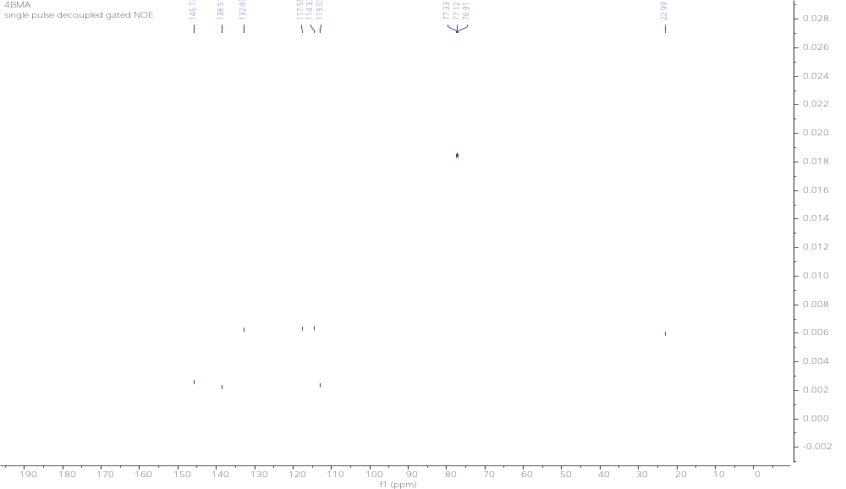

¹H of 4-chlorobenzene-1,3-diamine
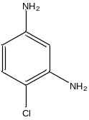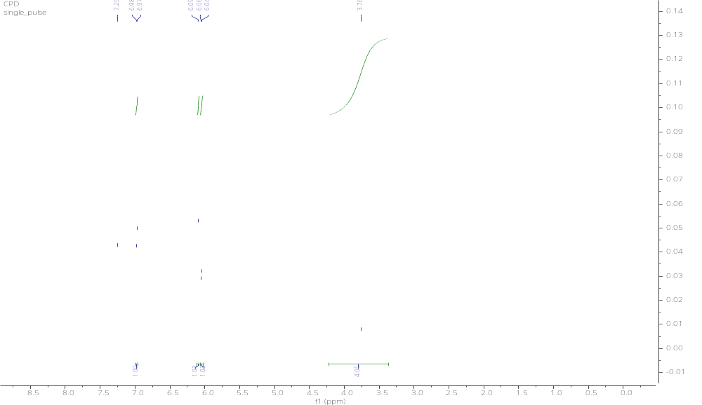

¹³C{¹H} of 4-chlorobenzene-1,3-diamine
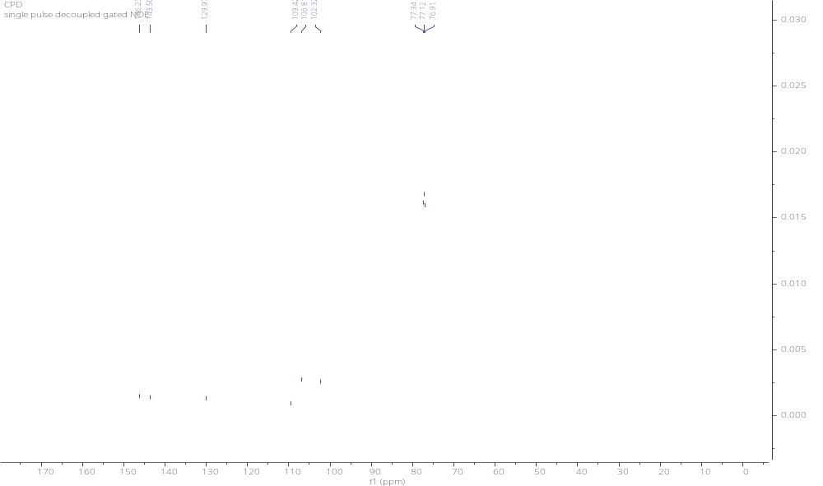

¹H of 2,5-dibromoaniline
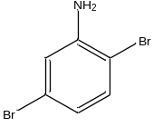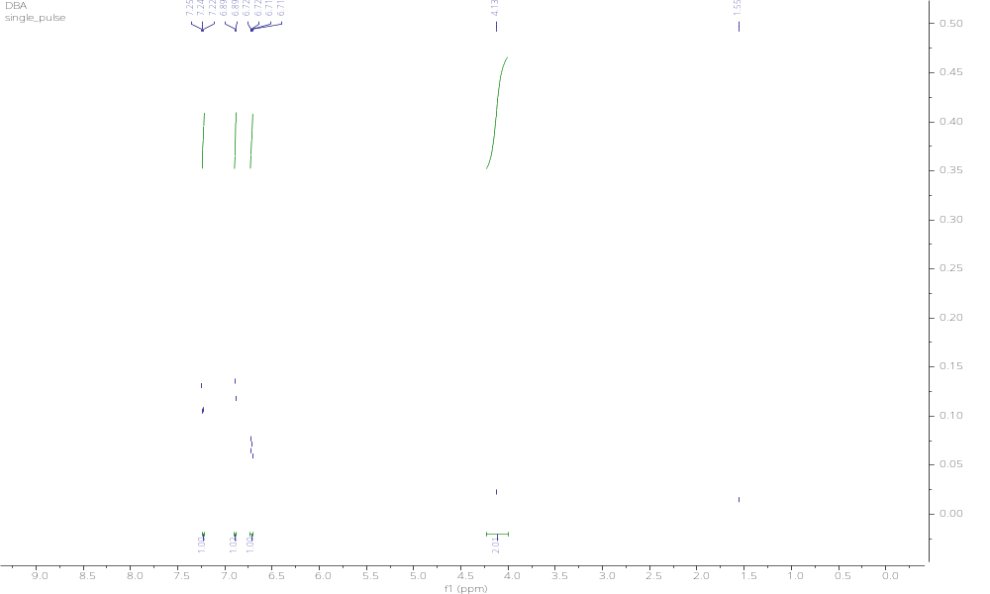

¹³C{¹H} of 2,5-dibromoaniline
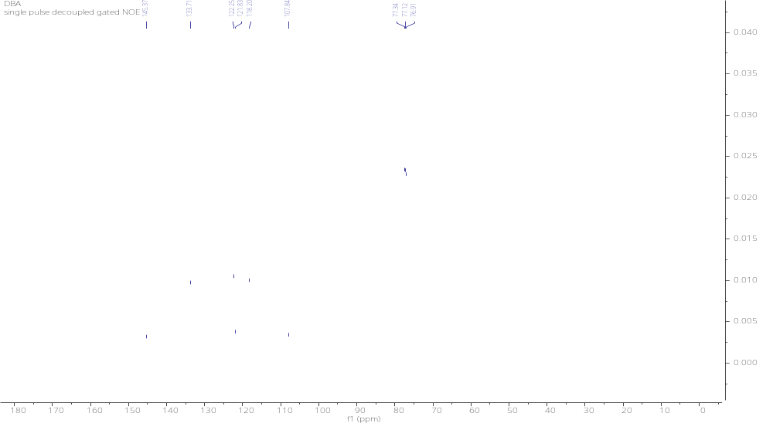

¹H of 4-methoxyaniline
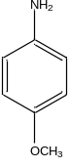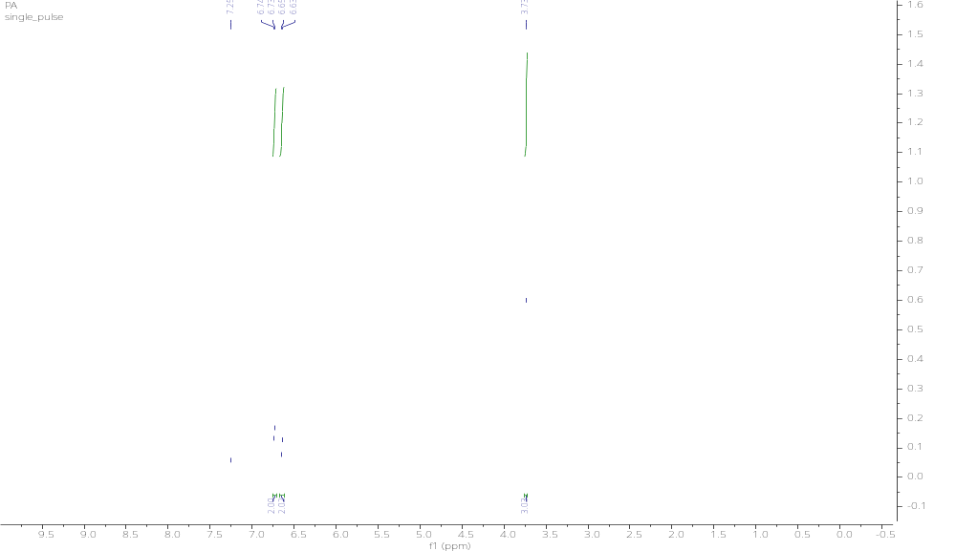

¹³C{¹H} of 4-methoxyaniline
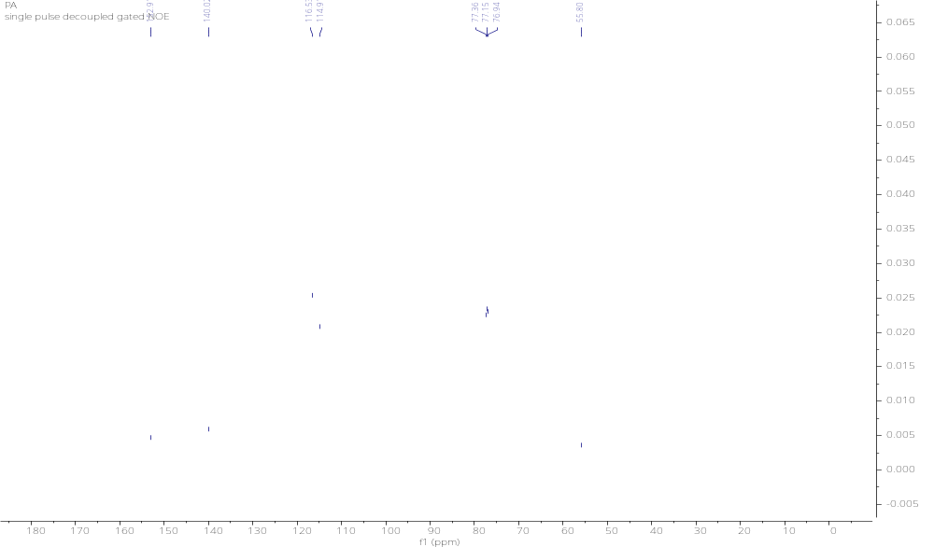

Table S1. Electrochemical reduction of nitroarenes by using pure Au and Rh Catalysts.
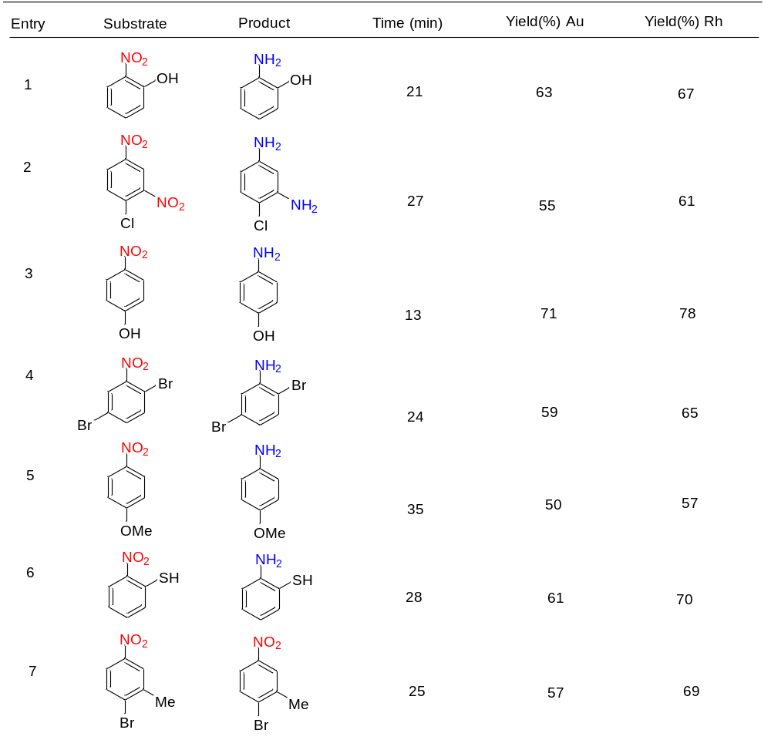

Table S2. A brief summary of recent studies on the electrochemical nitroarene reduction.

Sr. No. | Catalyst | Reactant | Conversion (%) | References
1. | 𝛼-RhS2−x | Nitrobenzene | 95 | [1]
2. | Ti mesh-supported Co3S4−x NS | Nitrobenzene | 98 | [2]
3. | Fe/Au particles | Nitrobenzene | 97 | [3]
4. | N-doped ordered mesoporous carbons | Nitrobenzene | 61 | [4]
5. | Au micropillars | 4-nitrophenol | 99 | [5]
6. | Cu/MWCNT-H₂ | Nitrobenzene | 44 | [6]
7. | Cu-Cu_{x}O supported on Norit-activated carbon | Nitrobenzene | 51 | [7]
8. | Cu/MWCNT-H₂ | Nitrobenzene | 44 | [8]
9. | nitrogen-doped carbons containing non-noble metals | Nitrobenzene | 54 | [9]
10. | Au_{0.5} Rh_{0.5} | Nitroarene | 92 | This work

References
- Mao Q, et al. Sulfur vacancy-rich amorphous Rh metallene sulfide for electrocatalytic selective synthesis of aniline coupled with efficient sulfion degradation. ACS Nano. 2022; 17(1):790-800.
- Zhao, Y, et al. Sulfur vacancy-promoted highly selective electrosynthesis of functionalized aminoarenes via transfer hydrogenation of nitroarenes with H2O over a Co3S4− x nanosheet cathode. CCS Chemistry. 2021;3(1):507-515.
- Chen, Z, et al. Electrochemical study of nitrobenzene reduction on galvanically replaced nanoscale Fe/Au particles. Journal of Hazardous Materials. 2011;197: 424-429.
- Daems, N, et al. Doped ordered mesoporous carbons as novel, selective electrocatalysts for the reduction of nitrobenzene to aniline. Journal of Materials Chemistry A. 2018;6(27): 13397-13411.
- Tranchant, M, et al. Efficient and green electrochemical synthesis of 4-aminophenol using porous Au micropillars. Applied Catalysis A: General. 2020;602:117698.
- Sheng, X, et al. Cu/CuxO and Pt nanoparticles supported on multi-walled carbon nanotubes as electrocatalysts for the reduction of nitrobenzene. Applied Catalysis B: Environmental. 2014;147:330-339.
- Sheng, X, et al. Pure and Alloyed Copper‐Based Nanoparticles Supported on Activated Carbon: Synthesis and Electrocatalytic Application in the Reduction of Nitrobenzene. ChemElectroChem. 2014;1(7):1198-1210.
- Wouters, B, et al. The electrocatalytic behaviour of Pt and Cu nanoparticles supported on carbon nanotubes for the nitrobenzene reduction in ethanol. Electrochimica Acta. 2013;111:405-410.
- Daems, N, et al. Selective reduction of nitrobenzene to aniline over electrocatalysts based on nitrogen-doped carbons containing non-noble metals. Applied Catalysis B: Environmental. 2018;226:509-522.

