Machine learning-guided catalyst design: optimization by combining targeted screening, intrinsic properties and techno-economic criteria for volatile organic compounds (VOC’s) oxidation
Jose-Luis Valverde ^{1*}, Weidong Zhang ²,Victor-Roberto Ferro ³, Anne Giroir-Fendler ⁴

¹ Department of Chemical Engineering, University of Castilla La Mancha, Avenida Camilo José Cela 10, 13071 Ciudad Real, Spain.
² School of Chemistry and Chemical Engineering, Anhui Province Key Laboratory of Coal Clean Conversion and Low Carbon Utilization, Anhui University of Technology, Ma’anshan 243002, China
³ Department of Chemical Engineering, Universidad Autónoma de Madrid, C. Francisco Tomás y Valiente 7, Fuencarral-El Pardo, 28049 Madrid, Spain.
⁴ Université Claude Bernard Lyon 1, CNRS, IRCELYON, 2 Avenue Albert Einstein, Villeurbanne F-69622, France.

SUPPLEMENTARY MATERIALS

NEURAL NETWORK TRAINING AND VALIDATION

For this study, a multilayer perceptron was constructed. It had the following three layers: i) one input layer, ii) one output layer, and iii) one or more hidden layers. Neurons were connected from one layer to the next without feedback, this means a non-recurrent ANN. The information was transferred from the input to the output layers. The scalar input (p_{i}) from a neuron in each layer was multiplied by the corresponding scalar weight (w_{ij}) of the layer forming the term w_{ij}p_{i}, which was sent to the sum¹. The sum had also as input the multiplication of a constant [1] by a bias (b_{j}). During the learning process, the weight that corresponded to the connection of units from i to j as well as the bias were continuously adjusted. The output (n_{j}), which is also referred to as the net input was expressed as:

$n_{j}=\sum_{i=1}^{N}{w_{ij}p_{i}}+b_{j}$ (1)

the n_{j} went into an activation function (f) which produced the scalar neuron output (a_{j}) that can be expressed as:

$a_{j}=f\left(n_{j}\right)$ (2)

For example, for the Log-Sigmoid activation function, the scalar neuron output (a_{j}) would be:

$a_{j}=\frac{1}{1+e^{-n_{j}}}$ (3)

In the input layer, the number of input variables (independent variables) fixed the number of neurons whereas in the output layer (just including linear activation functions) they were fixed by the number of output variables (dependent variables).

Levenberg-Marquardt algorithm [2] coupled to an ANOVA analysis (with α= 0.05) was used for training the network [3-6]. The training process was performed by minimizing the function χ_{j}² by nonlinear regression:

$χ_{j}^{2}=\sum_{i=1}^{m}{\left[\sum_{k=1}^{n}{{\left(y_{ik}-a_{ikj}^{s}\right)}^{2}}\right] }$ (4)

where m is the number or experiments, n is the number of output variables, y_{ik} and${ a}_{ikj}^{s}$ are the values of the output experimental variables and the values predicted by the neural network that corresponds to scenario j, respectively.

The regression procedure was maintained whenever the relative error (RE) was lower than 10⁻⁴. The RE was defined as follows:

$RE=\left|\frac{{\left(χ_{k}^{2}\right)}_{j+1}-{\left(χ_{k}^{2}\right)}_{j}}{{\left(χ_{k}^{2}\right)}_{j}}\right|$ (5)

with j being the number of iterations in the non-linear regression procedure, comparing the results of the prediction made by the ANN in the scenario j and in the scenario j+1.

Once the fitting process for a given scenario is finished, the above defined function χ_{j}², the Pearson's ratio coefficient for the model, r, and the root mean squared error (RSME) were collected. The RMSE was defined as:

$RMSE_{J}= \sqrt{\frac{χ_{j}^{2}}{M}}$ (6)

To minimize overfitting in the validation process, a discrimination procedure was established. For this purpose, a function presented by equation (4) was defined for the experiments used for the validation (m_{v}), obtaining equation (7):

${\left(χ_{j}^{2}\right)}_{V}=\sum_{i=1}^{m_{V}}{\left[\sum_{k=1}^{n}{{\left(y_{ik}-a_{ikj}^{s}\right)}^{2}}\right] }$ (7)

This way, a new function was defined from equations (4) and (7):

${\left(χ_{j}^{2}\right)}_{T}=χ_{j}^{2}+{\left(χ_{j}^{2}\right)}_{V}$ (8)

The scenario with the lower value of the function represented by equation (8), was selected, since it was the scenario that led to an optimized result. Finally, non-linear regression was taken as the reference of the selected model until a new value of RE lower than 10⁻⁶ was reached. With the values of the parameters finally obtained, the validation procedure was completed. In both cases, the final fitting and validation, the above defined function χ_{j}² plus those defined for each output variable k, can be expressed as χ_{jk}²:

$χ_{jk}^{2}=\sum_{i=1}^{m}{{\left(y_{ik}-a_{ikj}^{s}\right)}^{2} }$ (9)

TABLES

Table S1. Activation functions used in this study for generating ANNs [4,7-12].
Activation function | ID code | Mathematical expression
Log-Sigmoid | LOGSIG | $$a_{j}=\frac{1}{1+e^{-n_{j}}}$$
Hyperbolic Tangent Sigmoid | HTANSIG | $$a_{j}=\frac{e^{n_{j}}-e^{-n_{j}}}{e^{n_{j}}+e^{-n_{j}}}$$
Linear | LINEAR | $$a_{j}=n_{j}$$
Swish | SWISH | $$a_{j}=\frac{n_{j}}{1+e^{-n_{j}}}$$
ELU | ELU | $$a_{j}=\left\{\begin{aligned}α\left(e^{n_{j}}-1\right) n_{j}<0 \\ n_{j} n_{j}≥0\end{aligned}\right.$$
RELU | RELU | $$a_{j}=\left\{\begin{aligned}0.01n_{j} n_{j}≤0 \\ n_{j} n_{j}>0\end{aligned}\right.$$
Polynomial* | POL | $$a_{j}=n_{j}^{i}$$
* where i is in the range from 1 to the total neurons in layer j

FIGURES

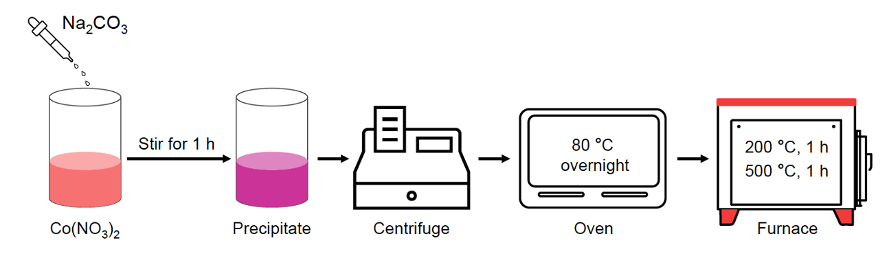
Figure S1. Schematic diagram of Co₃O₄ synthesis using sodium carbonate as the precipitant.

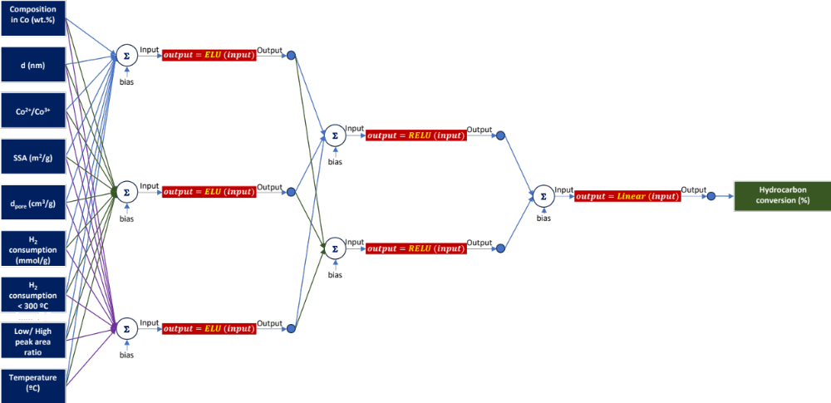
Figure S2. Representation of the 9-ELU-3-RELU-2-LINEAR-1 artificial neural network.
REFERENCES

- Hagan MT, Demuth HB, Beale M. Neural network design. PWS Publishing Co.; 1997.
- Hagan MT, Menhaj MB. Training feedforward networks with the Marquardt algorithm. IEEE Trans Neural Networks. 1994;5(6):989–93. https://doi.org/10.1109/72.329697.
- Barbero-Sánchez J, Megía-Ortega A, Ferro VR, Valverde J-L. Exploring alternatives to create digital twins from and for process simulation. J Comput Sci Res. 2024;6(1):16–30.
- Valverde JL, Ferro VR, Giroir-Fendler A. Prediction of the solid-liquid equilibrium of ternary and quaternary salt-water systems. Influence of the e-NRTL interaction parameters. Fluid Phase Equilib. 2023;572:113832. https://doi.org/10.1016/j.fluid.2023.113832.
- Valverde JL, Ferro VR, Giroir-Fendler A. Application of the e-NRTL model to electrolytes in mixed solvents methanol-, ethanol-water, and PEG-water. Fluid Phase Equilib. 2022;560:113516. https://doi.org/10.1016/j.fluid.2022.113516.
- García, N. M.; Luis Valverde, J.; Cano, B. D.; Heitz, M.; Avalos Ramirez, A. Selective Recovery of Zinc from Alkaline Batteries via a Basic Leaching Process and the Use of a Machine Learning-Based Digital Twin for Predictive Purposes. 2024. https://doi.org/10.3390/en17246292.
- (55) Jagtap, A. D.; Karniadakis, G. E. How Important Are Activation Functions in Regression and Classification? A Survey, Performance Comparison, and Future Directions. Journal of Machine Learning for Modeling and Computing 2023, 4 (1).
- (56) Alzubaidi, L.; Zhang, J.; Humaidi, A. J.; Al-Dujaili, A.; Duan, Y.; Al-Shamma, O.; Santamaría, J.; Fadhel, M. A.; Al-Amidie, M.; Farhan, L. Review of Deep Learning: Concepts, CNN Architectures, Challenges, Applications, Future Directions. J Big Data 2021, 8, 1–74.
- (57) Reyad, M.; Sarhan, A. M.; Arafa, M. A Modified Adam Algorithm for Deep Neural Network Optimization. Neural Comput Appl 2023, 35 (23), 17095–17112.
- (58) Hagan, M. T.; Demuth, H. B.; Beale, M. Neural Network Design; PWS Publishing Co., 1997.
- (59) Nanni, L.; Brahnam, S.; Paci, M.; Ghidoni, S. Comparison of Different Convolutional Neural Network Activation Functions and Methods for Building Ensembles for Small to Midsize Medical Data Sets. Sensors 2022, 22 (16), 6129.
- Valverde JL, Ferro VR, Giroir-Fendler A. Estimation of e-NRTL binary interaction parameters and its impact on the prediction of thermodynamic properties of multicomponent electrolyte systems. Fluid Phase Equilib. 2022;551:113264. https://doi.org/10.1016/j.fluid.2021.113264.

