SUPPORTING INFORMATION

Improving hydrodeoxygenation over Ni-Mo/Al₂O₃ by tuning the textural properties of the support via doping with lanthanoid group metals
Tove A. Kristensen^{a,b,}*, Jon Selimi^{a,b}, Jonas Elmroth Nordlanderª, Omar Y. Abdelaziz^{c,d}, Christian P. Hulteberg^{a,b}, Sara Blombergª
ªDivision of Chemical Engineering, Department of Process and Life Science Engineering, Lund University, SE-221 00 Lund, Sweden
^{b}Hulteberg Chemistry & Engineering AB, SE-212 25 Malmö, Sweden
^{c}Department of Chemical Engineering, King Fahd University of Petroleum & Minerals, Dhahran 31261, Saudi Arabia
^{d}Interdisciplinary Research Center for Refining & Advanced Chemicals, King Fahd University of Petroleum & Minerals, Dhahran 31261, Saudi Arabia

*E-mail: tove.kristensen@ple.lth.se

Number of pages: 3
Number of tables: 5
Number of figures: 1
Table S1. Experimental design matrix defining the amounts of La and Ce used for the preparation of the different supports, using impregnation method A-C, respectively.
Sample # | La [wt%] | Ce [wt%]
1 | 5 | 5
2 | 2.5 | 5
3 | 2.5 | 0
4 | 0 | 0
5 | 2.5 | 2.5
6 | 0 | 2.5
7 | 5 | 0
8 | 5 | 2.5
9 | 2.5 | 2.5
10 | 0 | 5
11 | 2.5 | 2.5

Table S2. Regression models and fit statistics for the pore diameter (PD) and surface area (SA) generated for impregnation approach A.
Property | Regression Model | Fit Statistics | Significant Term
Pore Diameter | PD=29.90-0.065A+1.35B-1.34A² | Significant | B
Surface Area | SA=66.91-4.82A-1.82B | Significant | A

Table S3. Regression models and fit statistics for the pore diameter (PD) and surface area (SA) generated for impregnation approach B.
Property | Regression Model | Fit Statistics | Significant Term
Pore Diameter | PD=27.72-0.6983A+1.19B | Significant | A and B
Surface Area | SA=73-0.22A+0.28B-2.61AB-0.9B²-3AB² | Significant | AB

Table S4. Regression models and fit statistics for the pore diameter (PD) and surface area (SA) generated for impregnation approach C.
Property | Regression Model | Fit Statistics | Significant Term
Pore Diameter | PD=31.83-0.0317A+1.72B | Significant | B
Surface Area | SA=59.61-3.06A-2.80B | Significant | A and B

Table S5. Distribution of the carbon in the outgoing liquid and gas streams.
Catalyst | Liquid [wt%] | Gas [wt%]
NiMo/A_{ref.1_1} | 99.97 | 0.025
NiMo/A_{opt.5_0.9} | 99.98 | 0.018
NiMo/B_{ref.5_3.3} | 99.98 | 0.016
NiMo/B_{opt.5_0} | 99.98 | 0.023
NiMo/C_{ref.1_1} | 99.97 | 0.027
NiMo/C_{opt.5_0} | 99.98 | 0.022
NiMo/A_{Al2O3} | 99.98 | 0.022

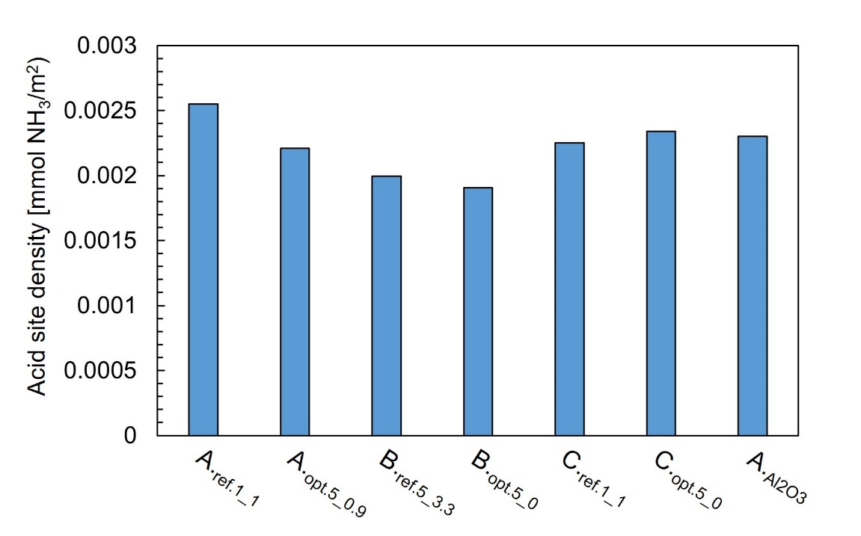
Fig. S1 Measured adsorbed amount of NH₃ per surface area determined for each catalyst, respectively

