Medium-Energy Mechanosynthesis Parameters Enhancing the Dry Reforming of Methane over Ni/CeO₂ Catalysts

Rudy Calligaro ª, Silvia Mauri ^{b}, Marta Boaro ^{a*},
Jordi Llorca ^{c}, Piero Torelli ^{b}, Alessandro Trovarelli ª
ª Università degli Studi di Udine and INSTM, Dipartimento Politecnico, via del Cotonificio 108, 33100 Udine, Italy.
^{b} CNR- Istituto Officina dei Materiali, TASC, 34149 Trieste, Italy.
^{c} Universitat Politècnica de Catalunya, Departament d’Enginyeria Química, Institut de Tècniques Energètiques, Centre de Recerca de Ciència i Enginyeria Multiescala de Barcelona, EEBE, Eduard Maristany 10-14, 08019 Barcelona, Spain.

Supporting Information

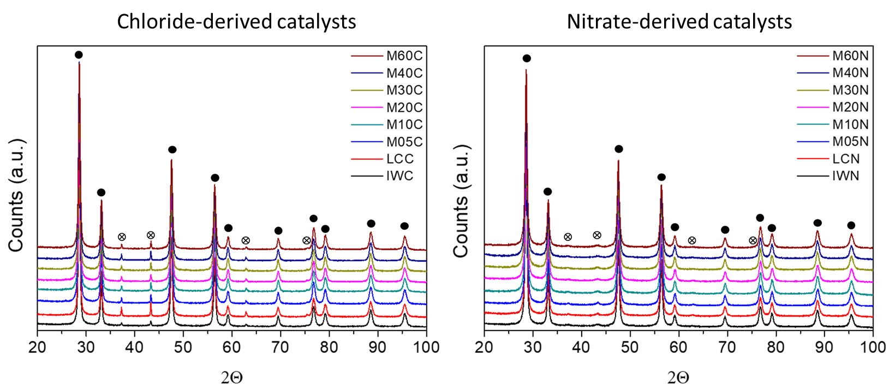
Figure S1: XRD diffraction patterns of the catalysts obtained from chloride (left) and nitrate (right) of Ni. Full circles () are related to the CeO₂ fluorite phase while the crossed circles ( ) to the FCC phase of NiO.

Table S1: ratio between moles of consumed hydrogen and moles of Nickel of the catalyst (S_{r}) derived from the two precursors.
 | Nitrate Series |  | Chloride Series
Catalyst | S_{r} First Cycle | S_{r} Second Cycle | S_{r} First Cycle | S_{r} Second Cycle
IW | 1.23 | 0.94 | 1.31 | 1.15
LC | 1.17 | 0.99 | 1.14 | 0.80
M05 | 1.29 | 1.10 | 1.28 | 0.99
M10 | 1.29 | 0.98 | 1.26 | 1.02
M20 | 1.23 | 0.99 | 1.19 | 1.15
M30 | 1.27 | 1.04 | 1.23 | 1.10
M40 | 1.36 | 1.00 | 1.10 | 1.14
M60 | 1.29 | 0.98 | 1.17 | 1.09

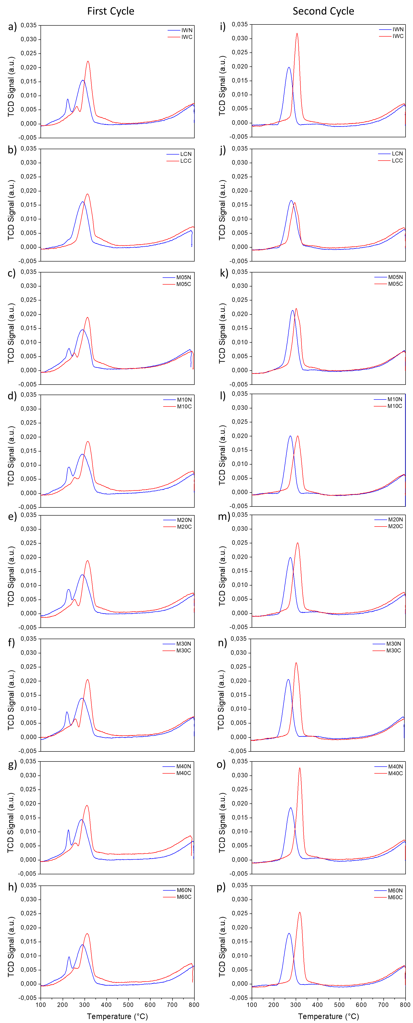
Figure S2: H₂-TPR profiles of the different catalysts obtained from the nitrate precursor (blue curves) and the chloride precursor (red curves) during the first cycle (panels a-h) and secondo cycle (panels i-p).
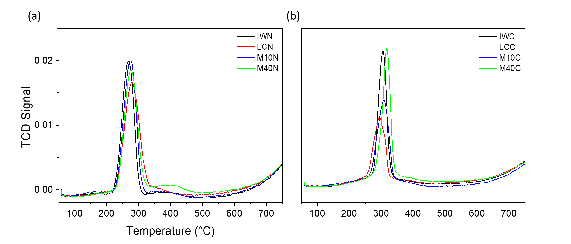
Figure S3: TPR profiles (second cycle) of the IW, LC, M10 and M40 catalysts from the (a) nitrate and (b) chloride series.

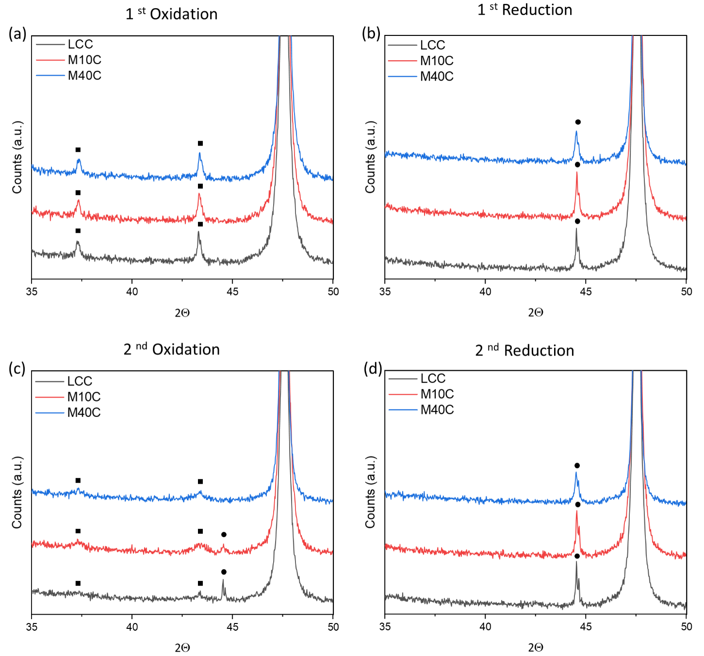
Figure S4: in situ-XRD profiles of three samples from the chloride series during the different steps of the TPR experiment: a) first oxidation step; b) first reduction step; c) second oxidation step; d) second reduction step. Black squares: NiO phase; black circles Ni phase.

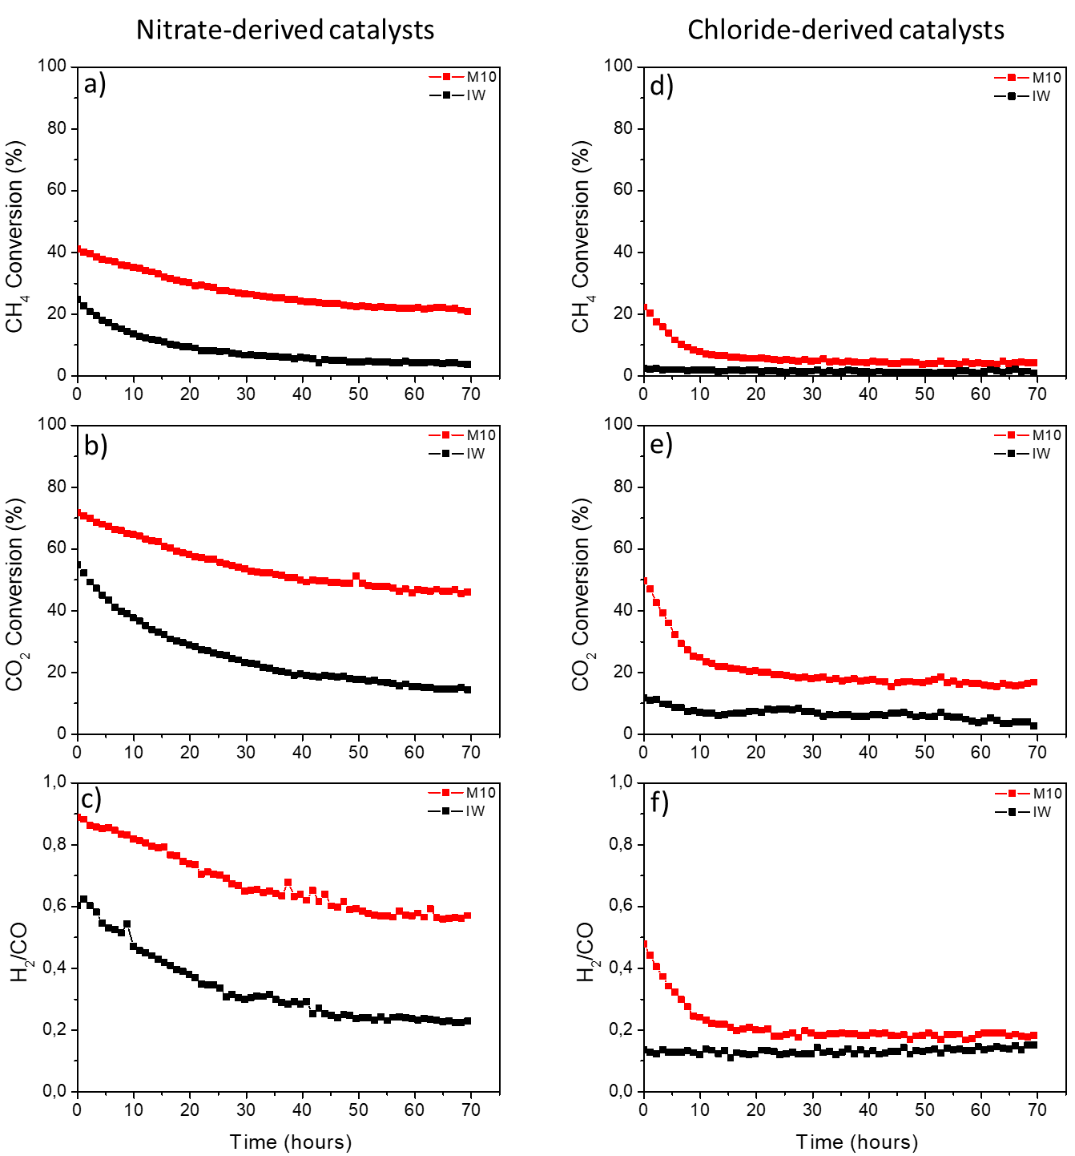
Figure S5: stability performances of the IW (black) and M10 (red) samples obtained from the nitrate (left side) and chloride (right side) in terms of CH₄ conversion (a and d), CO₂ conversion (b and e) and H₂/CO ratio (c and f).

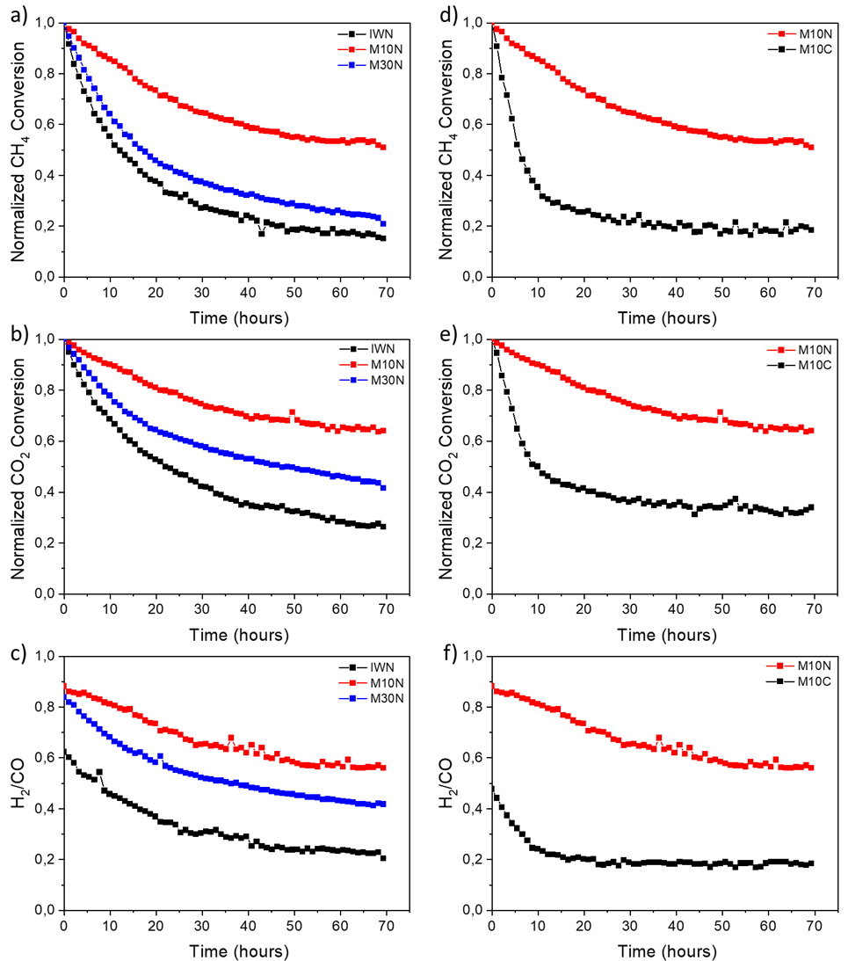
Figure S6: Stability performances of the IWN (black), M10N (red) and M30N (blue) catalysts from NO₃⁻ in terms of a) CH₄ conversion; b) CO₂ conversion; c) H₂/CO ratio. Comparison between the stability tests conducted over the M10N and M10C catalysts in terms of d) CH₄ conversion; e) CO₂ conversion; f) H₂/CO ratio.

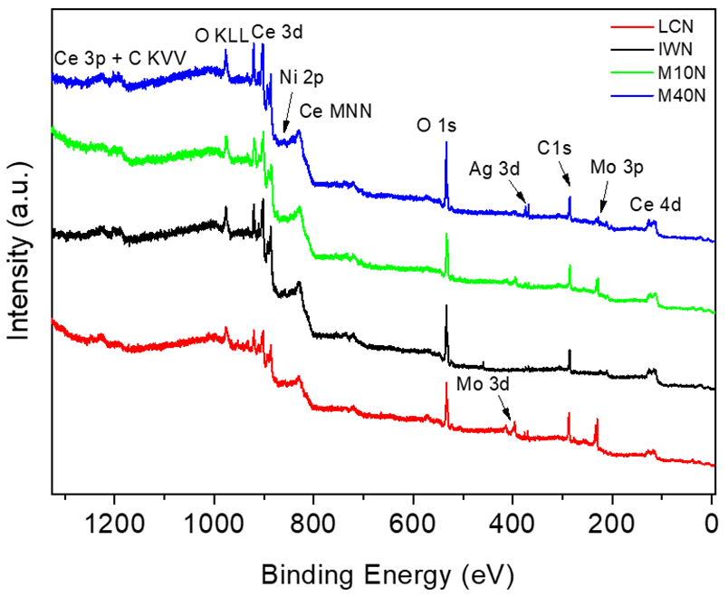
Figure S7: XPS survey spectra acquired for LC (red), IW (black), M10 (green) and M40 (blue) Ni-CeO₂ samples

All spectra have been measured with a photon energy of 1480.95 eV (from an Al K alpha X-Ray source). The samples have been measured as introduced in the UHV chamber. Looking at the survey spectra we detected the presence of peaks related to Ce (3d, 4d and Auger MNN), Ni 2p, O (1s and Auger KLL), C1s, Ag 3d, and Mo (3d and 3p). The Mo peaks are due to the sample holder (made of Mo) and the Ag is present in the glue used to stick the sample on the sample holder. Thus, these two elements are present in the field of view of the analyzer but not on the sample surface. On the contrary, the presence of the carbon (peak at ≈ 282 eV) on the surface of the sample is due to air exposure of the sample before being measured in the UHV chamber.
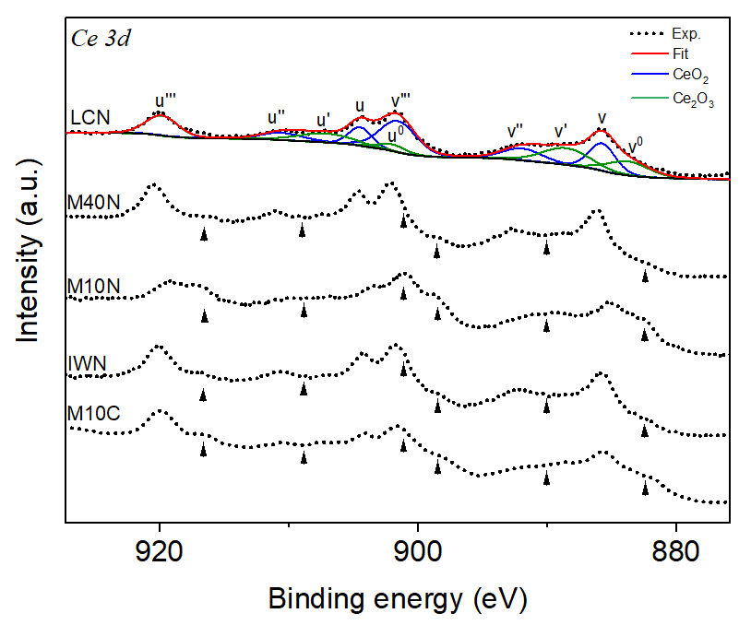
a

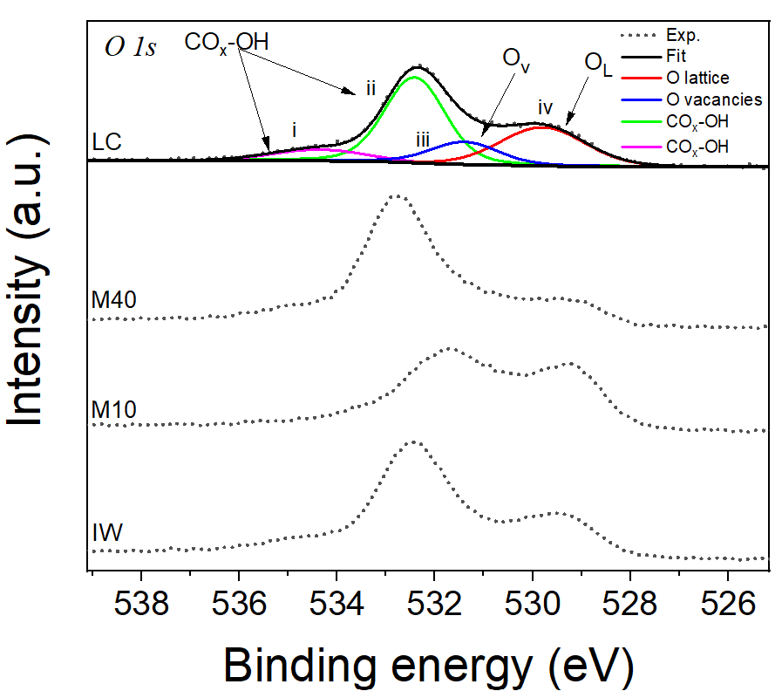
b
Intensity (a.u.)
Binding Energy (EV)

Figure S8: a) Ce 3d XPS spectra of nitrate derivate catalysts, compared with Ce 3d XPS of the M10C as representative of chlorides series; b) O 1s XPS spectra of the four Ni-CeO₂ nitrate-derivate samples, LC spectrum fitted with four components representing lattice O (iv), adsorbed surface O (iii) and adsorbed COx and OH species (i and ii), Spectra of other catalysts have not been deconvoluted due to distortion caused by charging phenomena.

Figure S8a shows the Ce 3d core level spectra of the catalysts. These spectra are complex and display a rich multiplet structure. By following a fitting procedure reported in a recent review, [53] CeO₂ spectrum can be deconvoluted in two multiplets (the blue components in the fitting of LC sample), corresponding respectively to electronic transitions related to the 3d3/2 and 3d5/2 orbitals, with a spin orbit splitting of about 18.3 eV. U’’’ and v’’’ structures are related to a Ce 3d94f0 O 2p6 ﬁnal state, while the lowest binding energy states u, v, u’’, v’’ structures are the result of Ce 3d94f2 O 2p4 and Ce 3d94f1 O 2p5 final states. The green components in the fit have been attributed to Ce₂O₃. Also in this case, u and v labels are referred to the 3d3/2 and 3d5/2 spin orbits. The spin orbit splitting is about 17.9 eV, in agreement with literature data^{54,55}. Each spin orbit is made of two structures: the ones with the higher BEs (u’ and v’) are related to a 3d94f1 O 2p6 final state, while u⁰ and v⁰ can be attributed to a Ce 3d94f2 O 2p5 state. These contributions provide an excellent fit to the Ce 3d spectrum of the LC sample, for which significant interaction with Ni is not expected. (references in the main text). Figure S8b shows O1s XPS spectra for the nitrates derivate series. The spectrum of LC sample, which does not present charging phenomena can be deconvoluted in four components. The blue line represents oxygen associated with the anion vacancies of support. The spectra of the other samples are distorted due to charging phenomena. Interestingly, the M10N catalyst shows the largest bias.
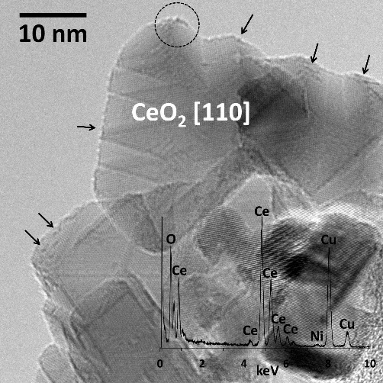

Figure S9: HRTEM image and EDX analysis the as-prepared M10N sample (prior to calcination at 500°C). The EDX analysis corresponds to the area enclosed to the circle.

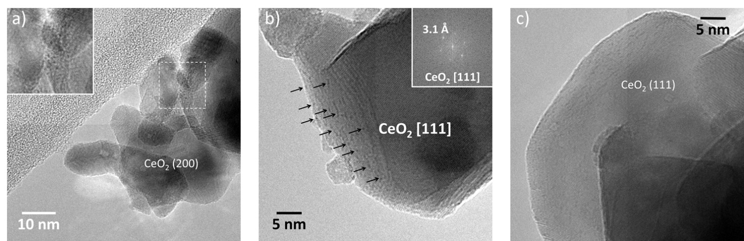
Figure S10: HRTEM images of different Nitrate catalysts after calcination at 500°C for 1h; a) IWN; b) M10N; c) M40N.

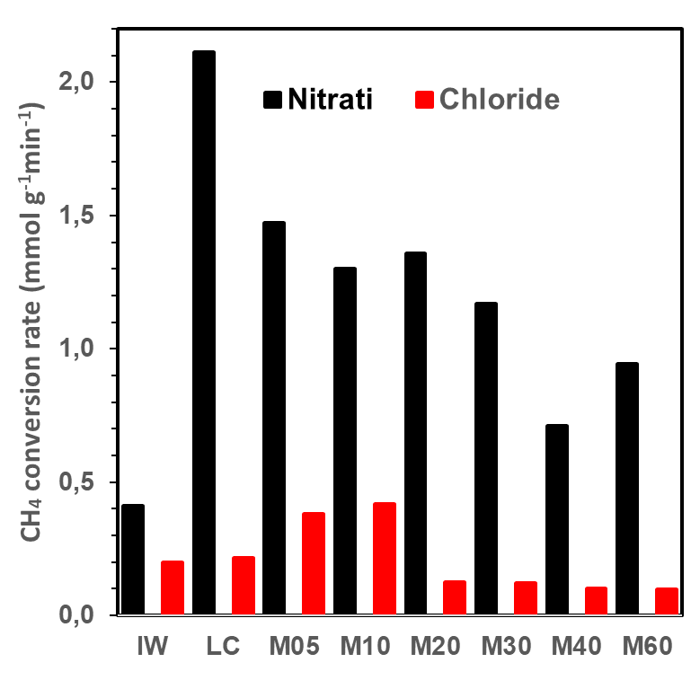
Figure S11. Methane conversion rates at 550°C normalized by catalyst mass for nitrate-derived and chloride-derived Ni/CeO₂ catalysts. Rates were calculated from the measured CH₄ conversions below 10% using $r=F_{CH4,in}⋅X_{CH4}/W$, where F_{CH4,in} is the inlet molar flow rate of methane and W is the catalyst mass. All catalysts were tested under identical operating conditions (82 mL min-1 total flow, 44% CH₄ in the feed, 80 mg catalyst, 4 wt% nominal Ni).

Figure S12: Comparison between the two Impregnated samples.

