Exploring the Potential of Thiazole Derivatives in Modulating the Wnt/β-Catenin Pathway for Colon Cancer Therapy
Prashanth D. P^{1,†}, Ningaraju G. N^{1,†}, Shobith Rangappa², K. S. Rangappa^{3,*}, Karthik C. S^{1,*}

¹Department of Chemistry, SJCE, JSS Science and Technology University, Mysuru-570 006, Karnataka, India
²Adichunchanagiri Institute for Molecular Medicine, BG Nagara 571448, Nagamangala Taluk, India
³Institute of Excellence, Vijnana Bhavan, University of Mysore, Manasagangotri, Mysuru, Karnataka, 570 006, India.
*Corresponding authors: csk@jssstuniv.in (CSK) and rangappaks@ioe.uni-mysore.ac.in (KSR)
†Equally contributed

Sl. No | Contents | Page No.
1 | Table S1. Thiazole derivatives investigated in the current study are derived from our previously published in-house article | 2-3
2 | Table S2. Displaying the predicted activity of 3D-QSAR sets | 4-5
3 | Table S3. Predictions of drug-likeness for potential anti-tumour compounds with binding energies above -7 kcal/mol, based on Lipinski's rule, GSK's rule, and Veber's rule | 6
4 | Table S4. ADMET parameter values were evaluated for compounds with binding energies above -7 kcal/mol. | 7

Table S1. Thiazole derivatives investigated in the current study are derived from our previously published in-house article.
Compound | Structure
4q | 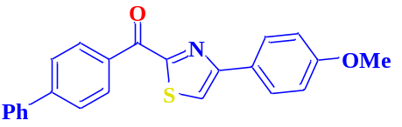
4f | 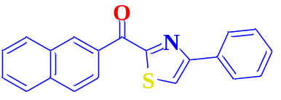
4o | 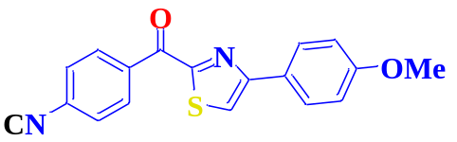
4h | 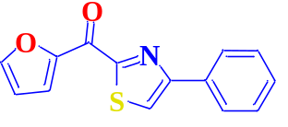
4g | 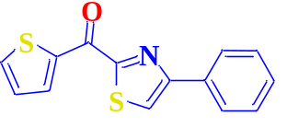
4n | 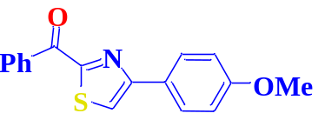
4i | 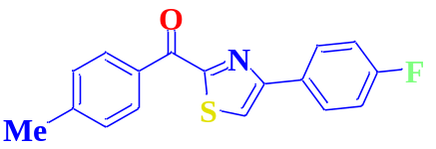
4j | 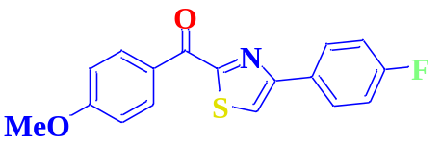
4b | 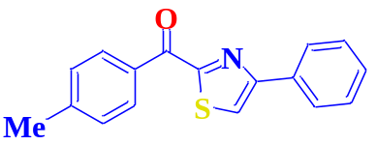
4r | 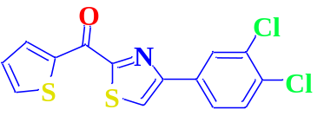
4e | 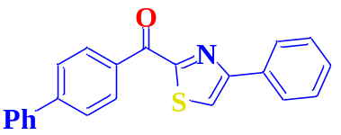
4l | 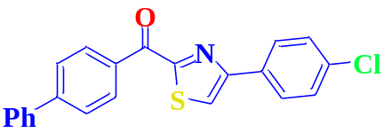
4k | 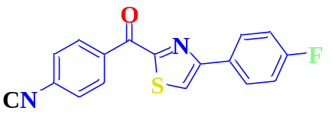
4m | 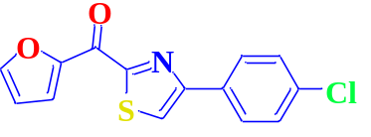
4d | 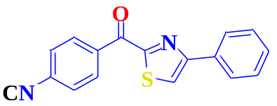
4c | 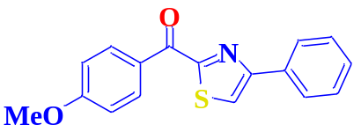
4a | 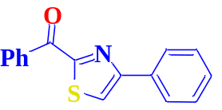
4p | 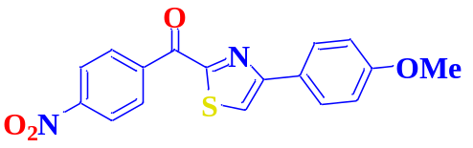

Table S2. Displaying the predicted activity of 3D-QSAR sets.
Compound | QSAR Set | Predicted activity (IC50) | Compound | QSAR Set | Predicted activity (IC50)
1a | Training | 7.40237 | 7b | Training | 7.50141
1b | Test | 7.3984 | 7c | Training | 7.41584
1c | Training | 7.37405 | 7d | Training | 7.42522
1d | Training | 7.38243 | 7e | Training | 7.42309
1e | Training | 7.39324 | 7f | Training | 7.44832
1f | Test | 7.42663 | 7g | Training | 7.505
1g | Training | 7.49936 | 7h | Training | 7.44776
1h | Test | 7.39533 | 7i | Training | 7.43859
1i | Test | 7.41427 | 7j | Training | 7.50495
1j | Training | 7.44396 | 7k | Training | 7.45789
1k | Training | 7.40504 | 7l | Test | 7.43927
1l | Training | 7.37724 | 8a | Training | 7.4133
2a | Training | 7.43102 | 8b | Training | 7.40708
2b | Test | 7.37938 | 8c | Training | 7.39691
2c | Test | 7.41204 | 8d | Training | 7.4171
2d | Training | 7.43073 | 8e | Training | 7.40227
2e | Training | 7.39407 | 8f | Test | 7.40534
2f | Test | 7.38673 | 8g | Test | 7.41545
2g | Training | 7.42431 | 8h | Training | 7.40746
2h | Training | 7.39228 | 8i | Training | 7.4176
2i | Training | 7.4476 | 8j | Training | 7.4007
2j | Training | 7.43189 | 8k | Test | 7.40467
2k | Training | 7.40247 | 8l | Test | 7.4575
2l | Training | 7.4335 | 9a | Test | 7.39553
3a | Training | 7.39019 | 9b | Test | 7.38568
3b | Training | 7.39522 | 9c | Training | 7.40787
3c | Training | 7.385 | 9d | Test | 7.41446
3d | Training | 7.38105 | 9e | Training | 7.41011
3e | Test | 7.39015 | 9f | Training | 7.41326
3f | Training | 7.42505 | 9g | Training | 7.44369
3g | Training | 7.44808 | 9h | Training | 7.3924
3h | Training | 7.3636 | 9i | Training | 7.41012
3i | Test | 7.42118 | 9j | Training | 7.42134
3j | Training | 7.42655 | 9k | Training | 7.40398
3k | Training | 7.3813 | 9l | Training | 7.45073
3l | Training | 7.44745 | 10a | Test | 7.38364
4a | Training | 7.40563 | 10b | Training | 7.35204
4b | Test | 7.38867 | 10c | Test | 7.37921
4c | Test | 7.39761 | 10d | Training | 7.3932
4d | Training | 7.39365 | 10e | Training | 7.37894
4e | Training | 7.40013 | 10f | Training | 7.38221
4f | Test | 7.39375 | 10g | Training | 7.44961
4g | Training | 7.45874 | 10h | Training | 7.38181
4h | Test | 7.41939 | 10i | Training | 7.40321
4i | Training | 7.37498 | 10j | Training | 7.38302
4j | Test | 7.37128 | 10k | Test | 7.41119
4k | Test | 7.38777 | 10l | Training | 7.4055
4l | Training | 7.40972 | 11a | Training | 7.37673
5a | Training | 7.3864 | 11b | Training | 7.41445
5b | Training | 7.39005 | 11c | Training | 7.38789
5c | Training | 7.42035 | 11d | Training | 7.4004
5d | Training | 7.39774 | 11e | Training | 7.41802
5e | Test | 7.40819 | 11f | Test | 7.3872
5f | Training | 7.39518 | 11g | Training | 7.46934
5g | Training | 7.45996 | 11h | Training | 7.36814
5h | Training | 7.3956 | 11i | Test | 7.40222
5i | Test | 7.40137 | 11j | Training | 7.35702
5j | Training | 7.37 | 11k | Training | 7.40985
5k | Training | 7.37557 | 11l | Training | 7.43421
5l | Test | 7.41538 | 12a | Training | 7.43712
6b | Test | 7.38573 | 12b | Test | 7.40221
6c | Training | 7.39596 | 12c | Training | 7.43348
6d | Test | 7.40083 | 12d | Training | 7.41892
6e | Training | 7.40222 | 12e | Training | 7.39789
6f | Training | 7.4128 | 12f | Test | 7.39712
6g | Test | 7.44107 | 12g | Training | 7.4491
6h | Training | 7.42505 | 12h | Training | 7.36263
6i | Test | 7.40628 | 12i | Training | 7.41421
6k | Training | 7.37019 | 12j | Training | 7.412
6l | Training | 7.41242 | 12k | Test | 7.4118
7a | Training | 7.44122 | 12l | Test | 7.38381

Table S3. Predictions of drug-likeness for potential anti-tumor compounds with binding energies above -7 kcal/mol, based on Lipinski's rule, GSK's rule, and Veber's rule.
Compound | MW | LOGP | nHB-D | nHBA | TPSA | nR-ot | nRig | nHet | fChar | LogS | LP | V | Gsk
 |  |  |  |  |  |  |  |  |  |  | Violation
Lipinsk-i  (LP) | ≤500 | ≤5 | ≤5 | ≤10 | - | - | - | - |  |  | - | - | -
Veber  (V) | - | - | - | - | ≤140 | ≤10 | - | - |  |  | - | - | -
GSK | 100 to  600 |  | ≤7 | ≤12 | ≤140 | ≤11 | ≤30 | ≤15 | -4 to  4 | -4 to  0.5 | - | - | -
3f | 317.01 | 5.081 | 0 | 3 | 58.2 | 3 | 18 | 5 | 0 | -6.405 | 0 | 0 | 1
3l | 343.01 | 4.745 | 1 | 4 | 95.5 | 4 | 19 | 6 | 0 | -4.368 | 0 | 0 | 1
6d | 360.96 | 5.186 | 0 | 3 | 58.2 | 3 | 18 | 5 | 0 | -6.485 | 0 | 0 | 1
6g | 328.03 | 4.262 | 0 | 5 | 104.02 | 4 | 19 | 7 | 0 | -6.317 | 0 | 0 | 1
6i | 313.06 | 4.496 | 0 | 4 | 67.43 | 4 | 18 | 5 | 0 | -5.892 | 0 | 0 | 1
7b | 324.06 | 4.627 | 0 | 4 | 104.02 | 4 | 19 | 6 | 0 | -6.445 | 0 | 0 | 1
7g | 355.03 | 3.987 | 0 | 6 | 149.84 | 5 | 20 | 9 | 0 | -6.337 | 0 | 1 | 1
7i | 340.05 | 4.189 | 0 | 5 | 113.25 | 5 | 19 | 7 | 0 | -6.269 | 0 | 0 | 1
7l | 354.03 | 3.996 | 1 | 6 | 141.32 | 5 | 20 | 8 | 0 | -4.351 | 0 | 1 | 1
8f | 299.04 | 4.003 | 1 | 4 | 78.43 | 3 | 18 | 5 | 0 | -4.608 | 0 | 0 | 1
8g | 326.04 | 3.823 | 1 | 5 | 124.25 | 4 | 19 | 7 | 0 | -4.938 | 0 | 0 | 1
8l | 325.04 | 3.847 | 2 | 5 | 115.73 | 4 | 19 | 6 | 0 | -3.67 | 0 | 0 | 0
9g | 340.05 | 4.189 | 0 | 5 | 113.25 | 5 | 19 | 7 | 0 | -6.269 | 0 | 0 | 1
12a | 309.05 | 4.188 | 1 | 4 | 95.5 | 4 | 19 | 5 | 0 | -4.332 | 0 | 0 | 1
12b | 323.06 | 4.545 | 1 | 4 | 95.5 | 4 | 19 | 5 | 0 | -4.551 | 0 | 0 | 1
12g | 354.03 | 3.996 | 1 | 6 | 141.32 | 5 | 20 | 8 | 0 | -4.351 | 0 | 1 | 1
12k | 353.07 | 4.482 | 1 | 5 | 104.73 | 6 | 19 | 6 | 0 | -4.533 | 0 | 0 | 1

Table S4. ADMET parameter values were evaluated for compounds with binding energies above -7 kcal/mol.
Compound | HIA | Pgp-inh | VDss | BBB | CYP2C19-inh | CYP3A4-inh | T12 | Carcinogenicity | Ames
3f | 0.002 | 0.966 | 0.524 | 0.03 | 0.711 | 0.088 | 0.023 | 0.591 | 0.364
3l | 0.004 | 0.029 | 0.475 | 0.014 | 0.3 | 0.016 | 0.205 | 0.173 | 0.009
6d | 0.003 | 0.998 | 0.592 | 0.057 | 0.683 | 0.076 | 0.02 | 0.524 | 0.051
6g | 0.003 | 0.962 | 0.551 | 0.059 | 0.584 | 0.157 | 0.032 | 0.884 | 0.981
6i | 0.003 | 0.985 | 0.601 | 0.07 | 0.656 | 0.244 | 0.036 | 0.701 | 0.742
7b | 0.003 | 0.6 | 0.548 | 0.035 | 0.646 | 0.211 | 0.05 | 0.869 | 0.978
7g | 0.005 | 0.772 | 0.552 | 0.087 | 0.547 | 0.221 | 0.047 | 0.92 | 0.992
7i | 0.004 | 0.947 | 0.513 | 0.076 | 0.625 | 0.305 | 0.057 | 0.92 | 0.984
7l | 0.008 | 0.013 | 0.22 | 0.042 | 0.224 | 0.034 | 0.206 | 0.795 | 0.968
8f | 0.004 | 0.017 | 0.57 | 0.19 | 0.814 | 0.202 | 0.085 | 0.69 | 0.256
8g | 0.007 | 0.011 | 0.478 | 0.212 | 0.796 | 0.356 | 0.144 | 0.892 | 0.964
8l | 0.013 | 0.005 | 0.309 | 0.123 | 0.156 | 0.037 | 0.696 | 0.192 | 0.011
9g | 0.004 | 0.947 | 0.513 | 0.076 | 0.625 | 0.305 | 0.057 | 0.92 | 0.984
12a | 0.008 | 0.009 | 0.442 | 0.077 | 0.193 | 0.012 | 0.391 | 0.114 | 0.01
12b | 0.005 | 0.006 | 0.481 | 0.029 | 0.32 | 0.031 | 0.272 | 0.209 | 0.012
12g | 0.008 | 0.013 | 0.22 | 0.042 | 0.224 | 0.034 | 0.206 | 0.795 | 0.968
12k | 0.004 | 0.054 | 0.469 | 0.026 | 0.267 | 0.027 | 0.178 | 0.395 | 0.026

