Table S1. Crystallographic data and reﬁnement parameters for drugmanite
Temperature, °C | 27 | 100 | 200 | 300 | 400
Temperature point | T01 | T02 | T03 | T04 | T05
Space group, Z | P2₁/c, 2
a, Å | 4.6499(3) | 4.6505(3) | 4.6605(4) | 4.6674(3) | 4.6745(4)
b, Å | 7.9866(5) | 7.9966(5) | 8.0166(6) | 8.0311(4) | 8.0443(5)
c, Å | 11.1030(7) | 11.1290(6) | 11.1497(8) | 11.1635(6) | 11.1754(9)
β, ° | 90.541(5) | 90.476(6) | 90.558(7) | 90.571(5) | 90.626(7)
Volume, Å³ | 412.31(4) | 413.85(4) | 416.55(6) | 418.44(4) | 420.20(6)
Data collection
Wavelength, Å | 0.71073
Max. θ° | 24.992 | 24.995 | 24.998 | 24.995 | 24.973
Index ranges | –5 ≤ h ≤ 5 | –5 ≤ h ≤ 5 | –5 ≤ h ≤ 5 | –5 ≤ h ≤ 5 | –5 ≤ h ≤ 5
 | –9 ≤ k ≤ 9 | –9 ≤ k ≤ 9 | –9 ≤ k ≤ 9 | –9 ≤ k ≤ 9 | –9 ≤ k ≤ 9
 | –13 ≤ l ≤ 13 | –13 ≤ l ≤ 12 | –13 ≤ l ≤ 12 | –13 ≤ l ≤ 11 | –13 ≤ l ≤ 9
No. meas. reﬂ. | 4774 | 3286 | 2825 | 2987 | 2940
No. uniq. reﬂ. | 724 | 728 | 734 | 740 | 742
No. obs. reﬂ. | 641 | 621 | 609 | 620 | 573
(I > 2σ(I))
Reﬁnement of the structure
No. of variables | 70 | 70 | 70 | 70 | 70
R_{int} | 0.1574 | 0.1290 | 0.1089 | 0.1033 | 0.1374
R₁, all data | 0.0653 | 0.0752 | 0.0789 | 0.0697 | 0.0974
R₁, I > 2σ(I) | 0.0590 | 0.0646 | 0.0713 | 0.0598 | 0.0738
wR₂, all data | 0.1559 | 0.1705 | 0.1784 | 0.1627 | 0.1856
wR₂, I > 2σ(I) | 0.1505 | 0.1620 | 0.1740 | 0.1560 | 0.1733
GooF | 1.059 | 1.094 | 1.119 | 1.058 | 1.075

Table S2. Bond distances (Å) and polyhedral volumes (Å³) in the crystal structure of drugmanite
Temperature, °C | 27 | 100 | 200 | 300 | 400
Temperature point | T01 | T02 | T03 | T04 | T05
PO₄ tetrahedra
P–O4 | 1.521(14) | 1.515(15) | 1.505(18) | 1.515(15) | 1.48(2)
P–O2 | 1.524(14) | 1.531(16) | 1.535(16) | 1.547(16) | 1.51(2)
P–O3 | 1.526(14) | 1.530(15) | 1.551(18) | 1.542(16) | 1.54(3)
P–O1 | 1.560(14) | 1.552(15) | 1.555(16) | 1.553(14) | 1.55(2)
<P–O> | 1.533(15) | 1.532(2) | 1.537(17) | 1.539(17) | 1.52(3)
V(PO₄) | 1.84(5) | 1.84(5) | 1.86(6) | 1.87(6) | 1.80(7)
MO₆ (M = Fe, Al) octahedra
M–O5 x2 | 1.958(14) | 1.977(14) | 1.981(16) | 1.975(15) | 1.98(2)
M–O2 x2 | 2.018(14) | 2.009(14) | 2.012(15) | 2.027(14) | 2.057(18)
M–O4 x2 | 2.028(14) | 2.039(15) | 2.058(18) | 2.057(15) | 2.076(18)
<M–O> | 2.001(14) | 2.008(19) | 2.017(17) | 2.020(15) | 2.04(3)
V(MO₆) | 10.6(3) | 10.7(3) | 10.9(3) | 10.9(3) | 11.2(3)
PbO₁₀ polyhedra
Pb-O3 | 2.277(14) | 2.285(17) | 2.287(17) | 2.288(15) | 2.279(19)
Pb-O4 | 2.528(15) | 2.518(16) | 2.535(17) | 2.525(16) | 2.565(19)
Pb-O5 | 2.533(14) | 2.545(13) | 2.565(15) | 2.579(14) | 2.582(19)
Pb-O1 | 2.606(14) | 2.611(17) | 2.619(13) | 2.611(13) | 2.595(17)
Pb-O5 | 2.626(11) | 2.611(12) | 2.631(17) | 2.638(15) | 2.66(3)
Pb-O2 | 2.972(13) | 2.983(14) | 2.981(15) | 2.974(15) | 2.987(19)
Pb-O3 | 3.170(13) | 3.181(15) | 3.153(17) | 3.179(16) | 3.215(17)
Pb-O1 | 3.406(14) | 3.405(18) | 3.407(18) | 3.426(17) | 3.43(3)
Pb-O3 | 3.409(14) | 3.416(16) | 3.441(18) | 3.441(15) | 3.433(19)
Pb-O1 | 3.416(16) | 3.422(18) | 3.448(18) | 3.443(15) | 3.45(3)
<Pb–O> | 2.894(14) | 2.898(18) | 2.907(17) | 2.910(17) | 2.92(3)
V(PbO₁₀) | 47.6(7) | 47.8(8) | 48.2(9) | 48.4(9) | 48.8(10)

Table S3. Most intense lines in the Raman spectra of herderite group.
Drugmanite | Hydroxylherderite | Interpretation | Bergslagite | Interpretation
Pb₂Fe³⁺□₂P₂O₇(OH)(OH)₂ | Ca₂□Be₂P₂O₈(OH)₂ | Interpretation | Ca₂□Be₂As₂O₈(OH)₂ | Interpretation
This work | [28] | Interpretation | [30] | Interpretation
119 | 120 | Atomic displacements, ν(Ca/Pb-O) | 123 | Atomic displacements,  ρ(O-As-O)
 | 143 | Atomic displacements, ν(Ca/Pb-O) | 132 | Atomic displacements,  ρ(O-As-O)
 | 168 | Atomic displacements, ν(Ca/Pb-O) | 175 | ρ(O-As-O), ρ(O-Be-O), ν(Ca-O)
 | 184 | Atomic displacements, ν(Ca/Pb-O) |  | ρ(O-As-O), ρ(O-Be-O), ν(Ca-O)
204 | 198 | Atomic displacements, ν(Ca/Pb-O) |  | ρ(O-As-O), ρ(O-Be-O), ν(Ca-O)
211 |  | Atomic displacements, ν(Ca/Pb-O) |  | ρ(O-As-O), ρ(O-Be-O), ν(Ca-O)
 | 226 | Atomic displacements, ν(Ca/Pb-O) | 230 | ρ(O-As-O), ρ(O-Be-O), ν(Ca-O)
246 | 256 | Atomic displacements, ν(Ca/Pb-O) |  | ρ(O-As-O), ρ(O-Be-O), ν(Ca-O)
266 |  | ν(Ca/Pb-O), ν(Be-O), ν(Fe-O) |  | ρ(O-As-O), ρ(O-Be-O), ν(Ca-O)
 |  | ν(Ca/Pb-O), ν(Be-O), ν(Fe-O) | 287 | ρ(O-As-O), ρ(O-Be-O), ν(Ca-O)
303 | 300 | ν(Ca/Pb-O), ν(Be-O), ν(Fe-O) |  | ρ(O-As-O), ρ(O-Be-O), ν(Ca-O)
 |  | ν(Ca/Pb-O), ν(Be-O), ν(Fe-O) | 314 | ρ(O-As-O), ρ(O-Be-O), ν(Ca-O)
 |  | ν(Ca/Pb-O), ν(Be-O), ν(Fe-O) | 325 | ρ(O-As-O), ρ(O-Be-O), ν(Ca-O)
 | 345 | ν(Ca/Pb-O), ν(Be-O), ν(Fe-O) |  | ρ(O-As-O), ρ(O-Be-O), ν(Ca-O)
 |  | ν(Ca/Pb-O), ν(Be-O), ν(Fe-O) | 370 | δ(As-O), δ(Be-O), ν(Ca-O)
 |  | ν(Ca/Pb-O), ν(Be-O), ν(Fe-O) | 387 | δ(As-O), δ(Be-O), ν(Ca-O)
 |  | ν(Ca/Pb-O), ν(Be-O), ν(Fe-O) | 413 | δ(As-O), δ(Be-O), ν(Ca-O)
432 | 426 | δ(P-O), δ(H₃PO₄) |  | δ(As-O), δ(Be-O), ν(Ca-O)
 | 447 | δ(P-O), δ(H₃PO₄) |  | δ(As-O), δ(Be-O), ν(Ca-O)
 |  | δ(P-O), δ(H₃PO₄) | 487 | δ(As-O), δ(Be-O), ν(Ca-O)
504 |  | δ(P-O), δ(H₃PO₄) | 494 | δ(As-O), δ(Be-O), ν(Ca-O)
 | 517 | δ(P-O), δ(H₃PO₄)
534 |  | δ(P-O), δ(H₃PO₄)
555 |  | δ(P-O), δ(H₃PO₄)
 |  | ν(Be-O), ν(P-O), ν(H₃PO₄) | 572 | δ(As-O), ν(Be-O)
 | 597 | ν(Be-O), ν(P-O), ν(H₃PO₄)
626 | 637 | ν(Be-O), ν(P-O), ν(H₃PO₄)
 |  | ν(Be-O), ν(P-O), ν(H₃PO₄) | 672 | ν(Be-O)
791 | 780 | ν(Be-O), ν(P-O), ν(H₃PO₄) | 799 | δ(Be-OH), ν(Be-O), ν(As-O)
 |  | ν(Be-O), ν(P-O), ν(H₃PO₄) | 810 | δ(Be-OH), ν(Be-O), ν(As-O)
 |  | ν(Be-O), ν(P-O), ν(H₃PO₄) | 828 | δ(Be-OH), ν(Be-O), ν(As-O)
 |  | ν(Be-O), ν(P-O), ν(H₃PO₄) | 832 | δ(Be-OH), ν(Be-O), ν(As-O)
 |  | ν(Be-O), ν(P-O), ν(H₃PO₄) | 895 | δ(Be-OH), ν(Be-O), ν(As-O)
 |  | ν(Be-O), ν(P-O), ν(H₃PO₄) | 900 | δ(Be-OH), ν(Be-O), ν(As-O)
 |  | ν(Be-O), ν(P-O), ν(H₃PO₄) | 912 | δ(Be-OH), ν(Be-O), ν(As-O)
967 |  | δ(P-O), δ(HOPO₃), ν(P-OH)
 | 985 | δ(P-O), δ(HOPO₃), ν(P-OH)
998 | 1000 | δ(P-O), δ(HOPO₃), ν(P-OH)
1064 |  | δ(P-O), δ(HOPO₃), ν(P-OH)
1089 |  | δ(P-O), δ(HOPO₃), ν(P-OH)
 | 1128 | δ(P-O), δ(HOPO₃), ν(P-OH)

Table S4. Bond valence sums for A and M sites in the structure of drugmanite. Bond lengths are given in Å.
Bond | Bond length | Valence | Bond | Bond length | Valence |  | Bond | Bond length | Valence
 |  |  |  |  | Fe | Al | Bond | Bond length | Valence
Pb-O3 | 2.277 | 0.640 | M-O5 x2 | 1.958 | 0.584 | 0.401 | P-O4 | 1.521 | 1.296
Pb-O4 | 2.528 | 0.325 | M-O2 x2 | 2.018 | 0.497 | 0.341 | P-O2 | 1.524 | 1.286
Pb-O5 | 2.533 | 0.321 | M-O4 x2 | 2.028 | 0.483 | 0.332 | P-O3 | 1.526 | 1.279
Pb-O1 | 2.606 | 0.263 | Sum |  | 2.721 | 0.279 | P-O1 | 1.56 | 1.167
Pb-O5 | 2.626 | 0.249 | Full sum |  | 3.000 |  | Sum |  | 5.027
Pb-O2 | 2.972 | 0.098
Pb-O3 | 3.17 | 0.057
Pb-O1 | 3.406 | 0.030
Pb-O3 | 3.409 | 0.030
Pb-O1 | 3.416 | 0.029
Sum |  | 2.043

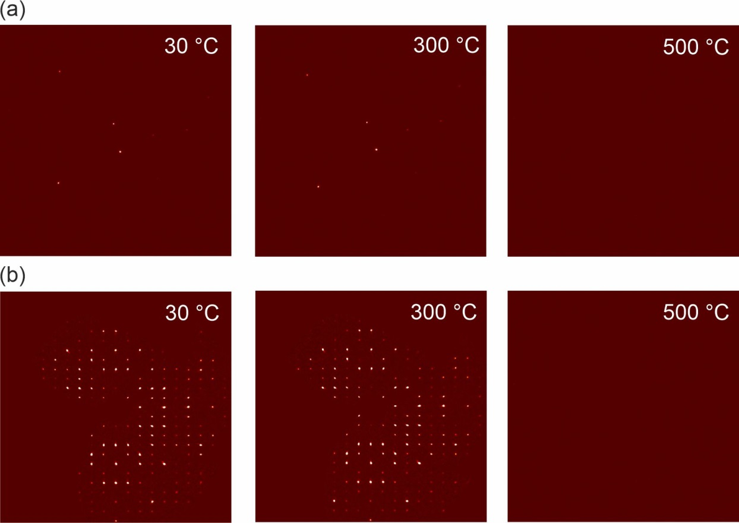

Figure S1. 2D X-ray diffraction data (a) and reciprocal space reconstructions in (0kl) plane (b) for drugmanite at different temperatures.

