Supporting Information

Polymerization of rac-Lactide and Copolymerization with ε-Caprolactone Catalyzed by a Cyclopentadienyl-Silsesquioxane Titanium Complex

Shoaib Anwar, Joan Vinueza-Vaca, Salvatore Impemba, Gerardo Jiménez, Vanessa Tabernero, Alejandro Marín-Díaz ,Stefano Milione*

Department of Chemistry and Biology, University of Salerno, Via Giovanni Paolo II, 84084 Fisciano, Salerno, Italy
Departamento de Química Orgánica y Química Inorgánica, Instituto de Investigación
Química “Andrés M. del Río”, Universidad de Alcalá, Campus Universitario, 28805
Alcalá de Henares, Madrid, Spain.

Contents
 | pag.
Figure S1: Pseudo-first-order kinetic plots for ROP of rac-LA. | 3
Figure S2: Pseudo-first-order kinetic plots for ROP of ε-CL in presence of catalyst, one equivalents of BnOH | 3
Figure S3:¹H NMR spectra of copolymer of Entry 2 reported in Table 2 | 4
Figure S4: ¹H NMR spectra comparison of copolymers reported in Table 2. | 4
Figure S5. Carbonyl range of ¹³C NMR spectra of copolymers reported in Table 1. | 5
Figure S6. Monomer consumption during copolymerization of L-LA/ε-CL using catalyst/BnOH | 5
Figure S7. Methine region of the homonuclear decoupled ¹H[¹H] NMR spectrum for rac-PLA | 6
Figure S8. ¹H NMR of an aliquot from PCL reaction, used for monomer conversion determination | 6
Figure S9. ¹H NMR of an aliquot from PLA reaction, used for monomer conversion determination. | 7
Figure S10. GPC of copolymer obtained using catalyst/BnOH as initiator after quenching with wet n-hexane | 7
Figure S11. DSC thermograms of the L-LA/ε-CL copolymers obtained with catalyst/BnOH | 8
Figure S12. Thermogravimetric (TGA) and derivative thermogravimetric curves (DTG) of copolymers obtained with catalyst/BnOH | 9
Table S1. Computed Energies and Gibbs free energies for all the optimized structures | 10
Cartesian coordinates of all the structures optimized in the computational analysis | 11

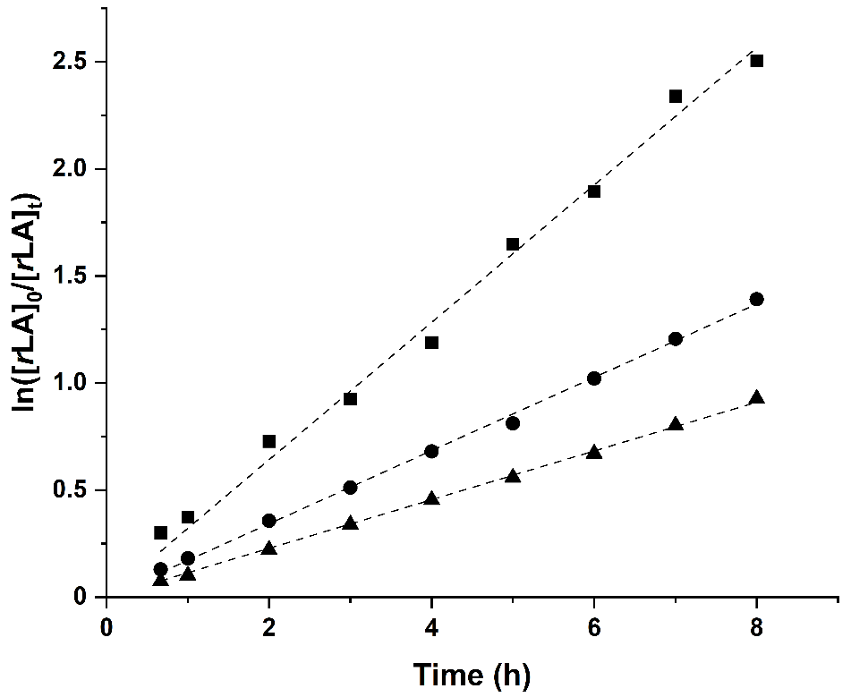
Figure S1. Pseudo-first-order kinetic plots for ROP of rac-LA in presence of catalyst D and one (k_{app} = 0.1138 ± 0.0007 h⁻¹, R² = 0.999, ), two (k_{app} = 0.1711 ± 0.0014 h⁻¹, R² = 0.999, •) and three equivalents of BnOH (k_{app} = 0.3208 ± 0.0051 h⁻¹, R² = 0.998, ■). Conditions: [r-LA]₀ = 1.0 M, [r-LA]₀/[catalyst]₀ = 150, T = 100 °C, toluene (2.0 mL) as solvent.
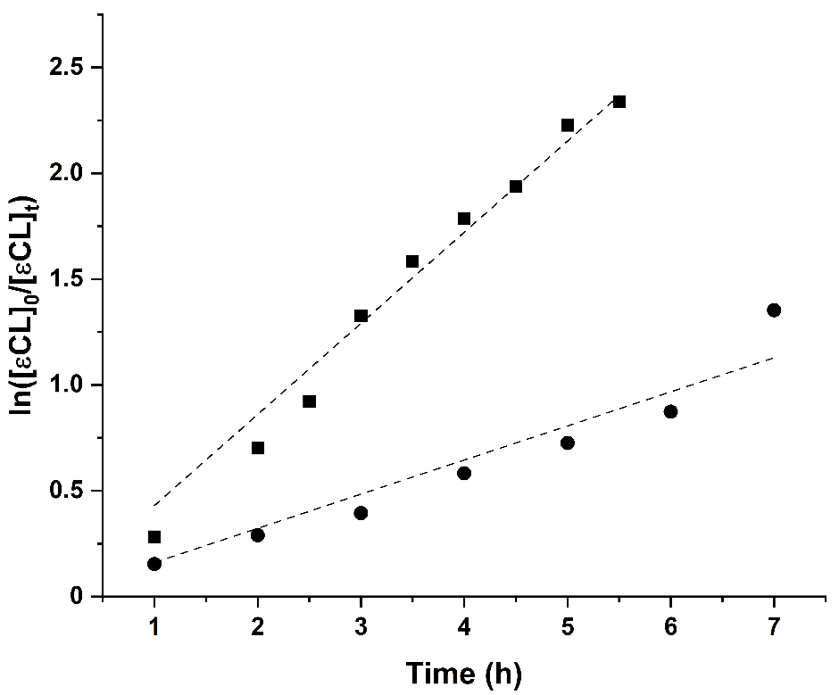
Figure S2. Pseudo-first-order kinetic plots for ROP of ε-CL in presence of catalyst, one equivalents of BnOH and starting from [ε-CL] = 3 M (k_{app} = 0.1613 ± 0.0097 h⁻¹, R² = 0.979, •) and [ε-CL] = 1 M (k_{app} = 0.4304 ± 0.0095 h⁻¹, R² = 0.996, ■). Conditions: [catalyst]₀ = 6.7 mM, [catalyst]₀/[BnOH]₀ = 1, T = 100 °C, toluene (2.0 mL) as solvent.
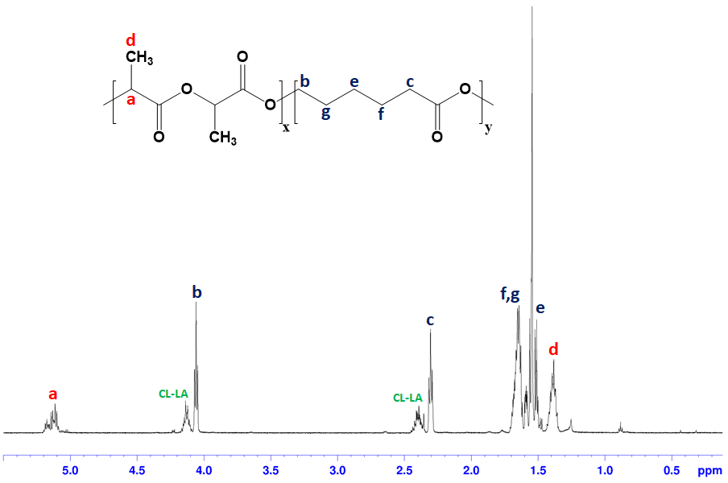
Figure S3. ¹H NMR spectra of copolymer of Entry 2 reported in Table 2 (25 °C, CDCl₃, 600 MHz).
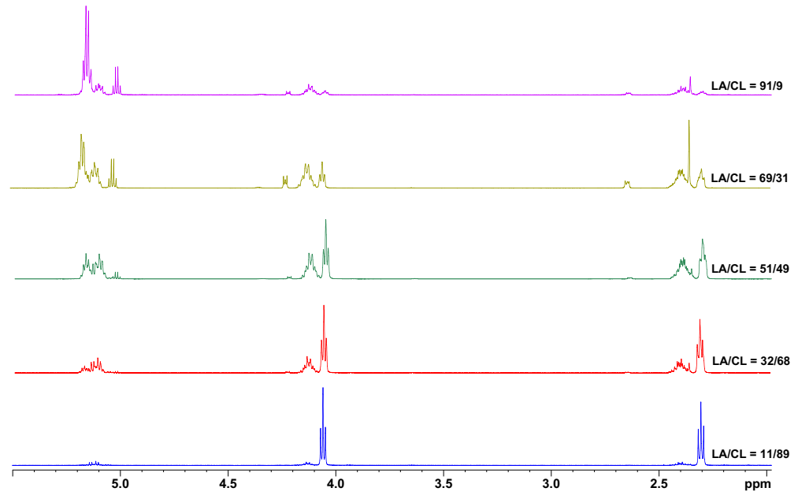
Figure S4. ¹H NMR spectra comparison of copolymers reported in Table 2 (25 °C, CDCl₃, 600 MHz).

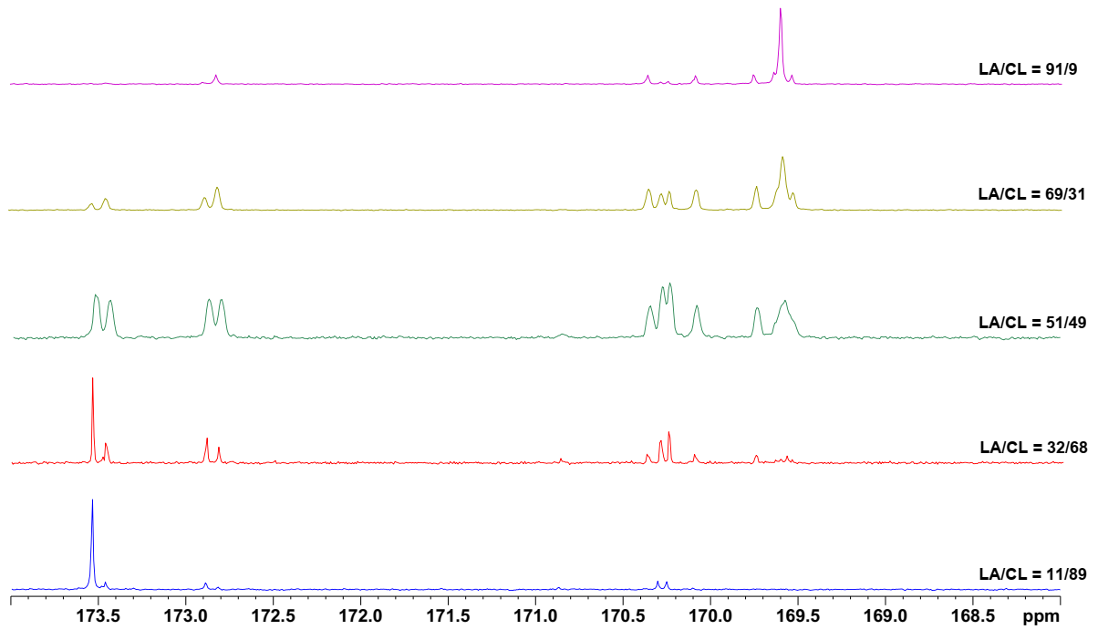
Figure S5. Carbonyl range of ¹³C NMR spectra of copolymers reported in Table 1 (25 °C, CDCl₃, 600 MHz).

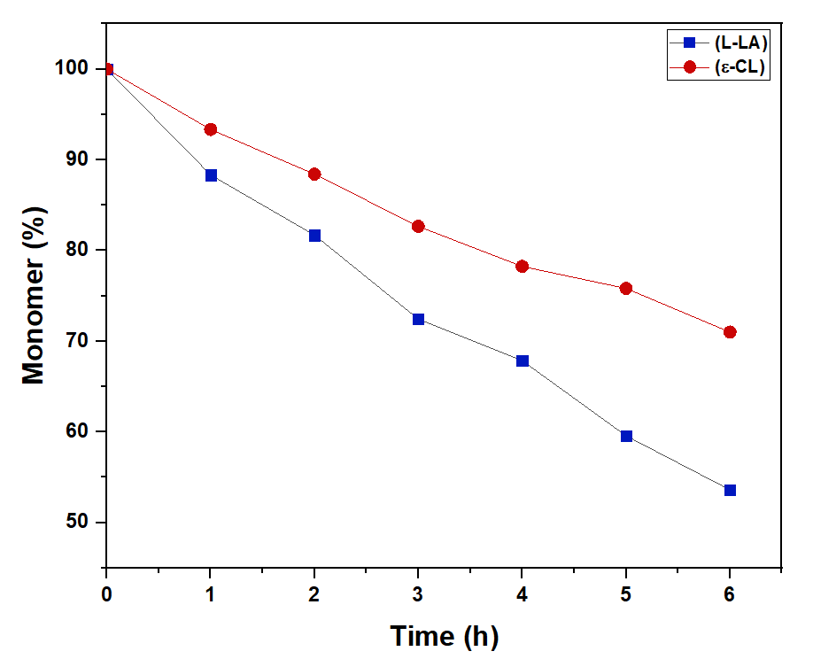
Figure S6. Monomer consumption during copolymerization of L-LA/ε-CL using catalyst/BnOH

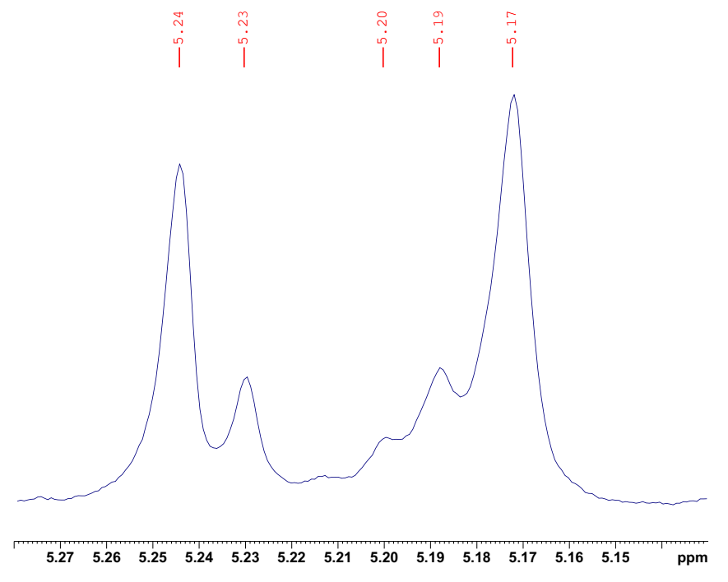
Figure S7. Methine region of the homonuclear decoupled ¹H[¹H] NMR spectrum for rac-PLA obtained by catalyst/BnOH (Entry 2 in Table 2) (25 °C, CDCl₃, 300 MHz).

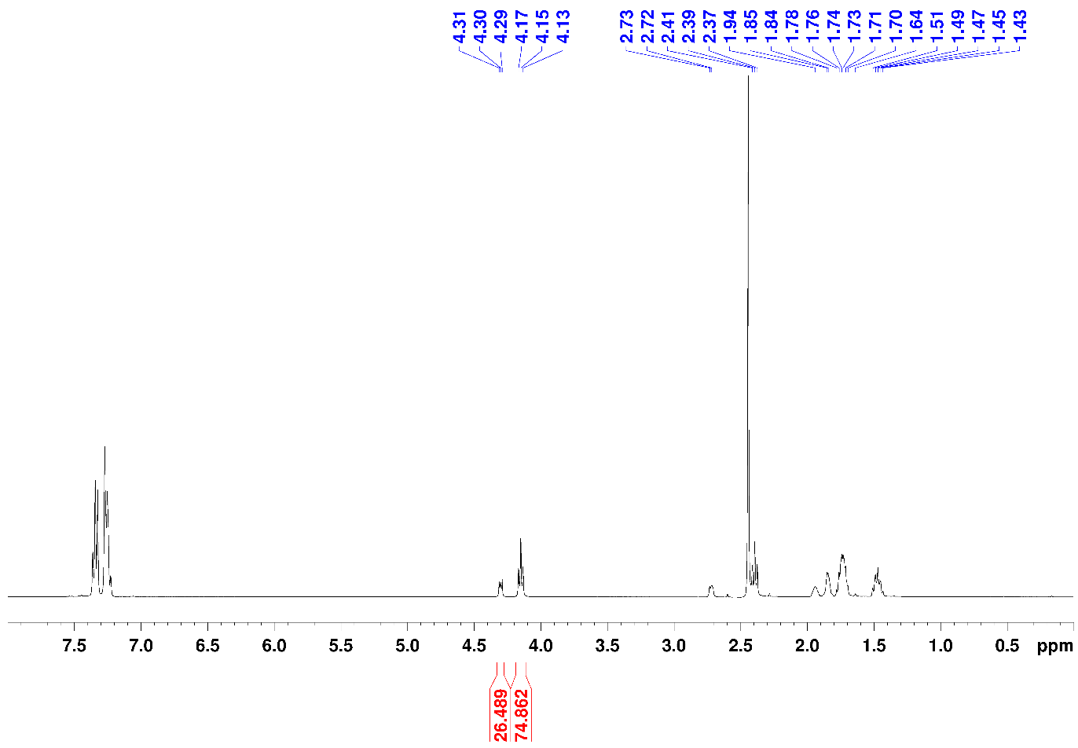

Figure S8. ¹H NMR of an aliquot from PCL reaction, used for monomer conversion determination (25 °C, CDCl₃, 400 MHz).

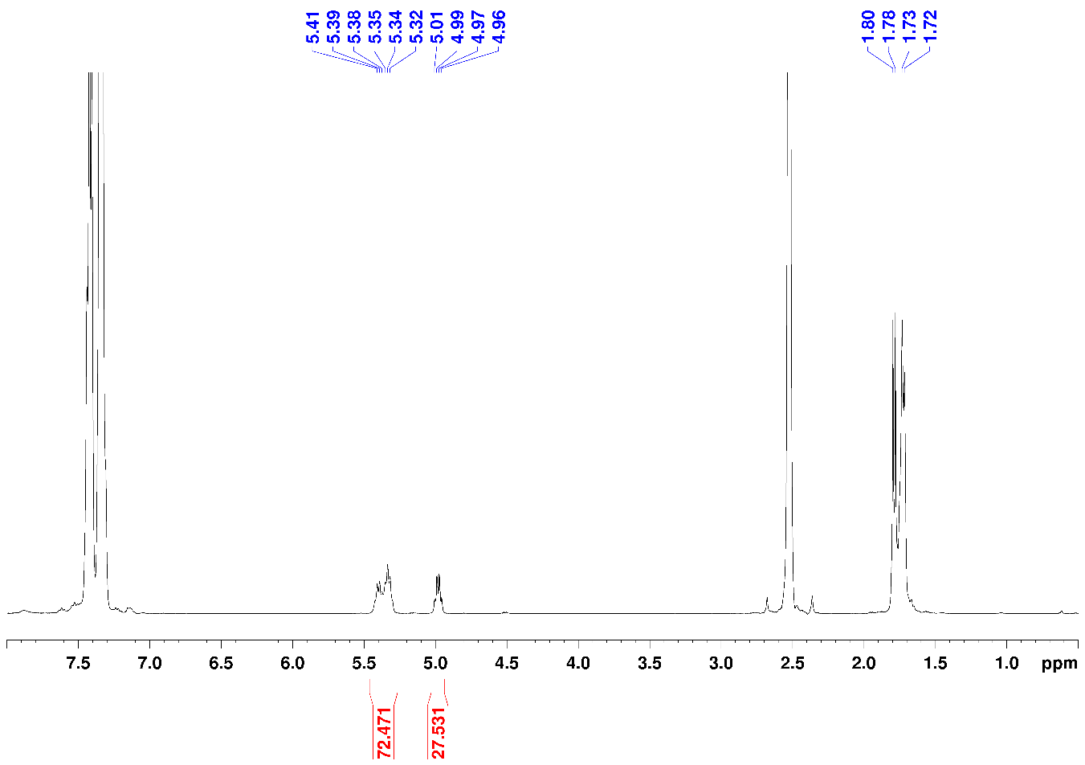
Figure S9. ¹H NMR of an aliquot from rac-PLA reaction, used for monomer conversion determination (25 °C, CDCl₃, 400 MHz).

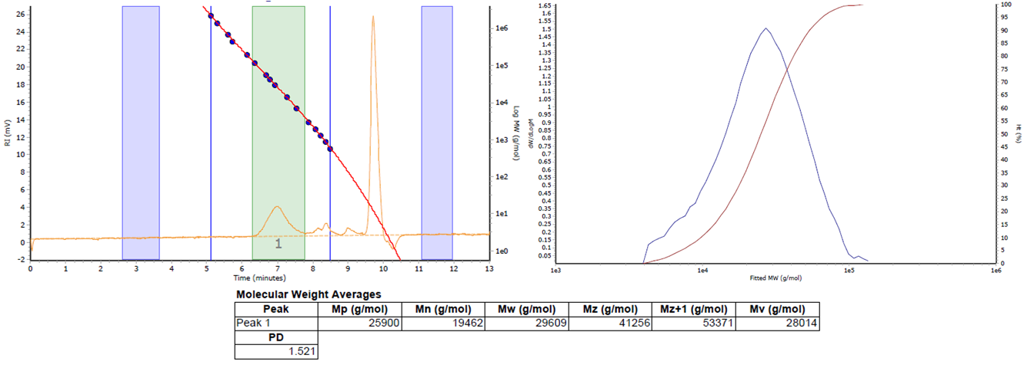
Figure S10. GPC of copolymer obtained using catalyst/BnOH as initiator after quenching with wet n-hexane (Entry 3 in Table 1).
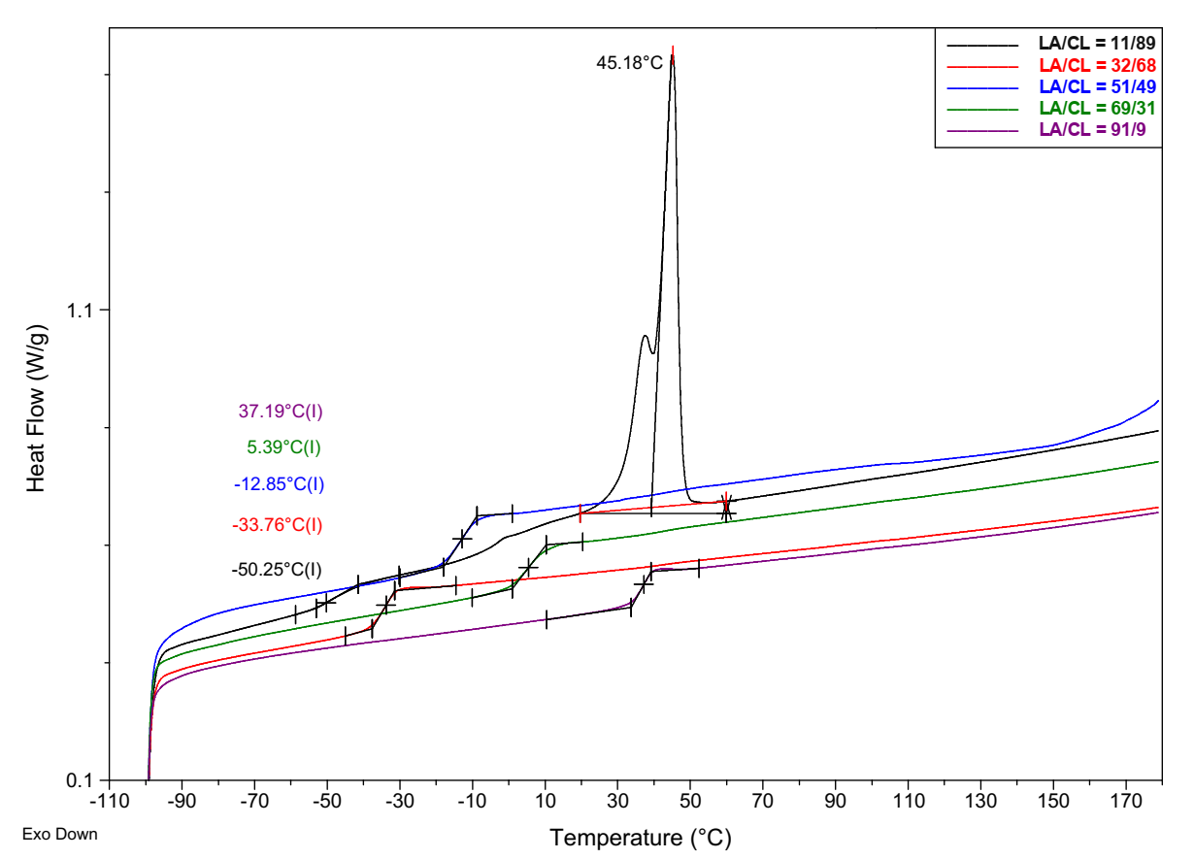
Figure S11. DSC thermograms of the L-LA/ε-CL copolymers obtained with catalyst/BnOH (Entries 1-5 of Table 1, second heating cycle, 10 °C min⁻¹).

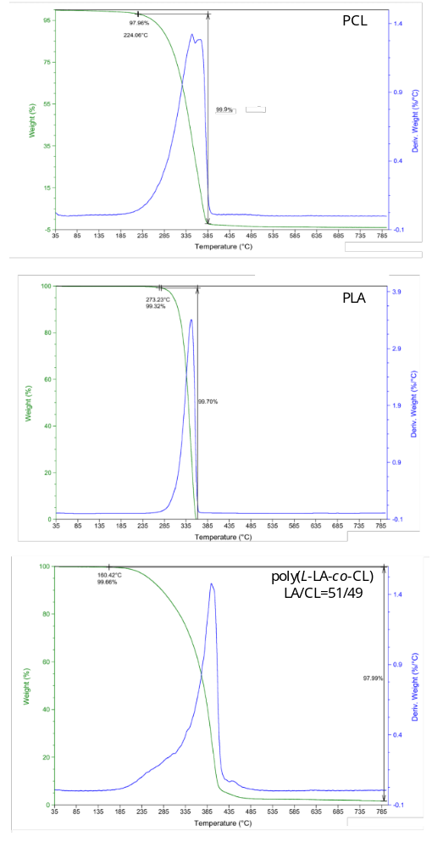

Figure S12. Thermogravimetric (TGA) and derivative thermogravimetric curves (DTG) of copolymers obtained with catalyst/BnOH

Table S1. Computed Energies and Gibbs free energies (in Hartrees) for all the structures optimized in the computational analysis (BP86-D3/TZVP/Lanl2DZ - CPCM(toluene)//BP86/6-31G(d)/Lanl2DZ).

label | E(solv) | G(solv)
Ti complex | -4213.693420 | -4213.212001
L-LA | -534.584010 | -534.482580
int0h | -4748.290973 | -4747.687780
TS1-2h | -4748.263706 | -4747.654490
int1h | -4748.277851 | -4747.669078
int2h | -4748.276600 | -4747.667538
TS2-3h | -4748.268385 | -4747.657701
int3h | -4748.294870 | -4747.685335
int4h | -4748.293994 | -4747.692743
int0i | -4748.296134 | -4747.691683
TS1-2i | -4748.263776 | -4747.653287
int1i | -4748.284585 | -4747.673649
int2i | -4748.282564 | -4747.673081
TS2-3i | -4748.260234 | -4747.647936
int3i | -4748.283550 | -4747.674425
int4i | -4748.296815 | -4747.695564

XYZ Coordinates of Computed Structures

Ti complex
Ti -1.86835300 0.46963900 0.78159400
Si -0.23685000 3.84209700 -0.10582900
Si 2.54404300 2.26900600 0.19862300
Si 2.54931800 0.44839200 -2.41297100
Si 0.51433800 -3.10534100 -0.44396500
Si 0.12260300 -1.66767500 2.38235300
Si 2.95795600 -0.35639500 1.98550500
Si 3.52846700 -2.00416300 -0.62531800
Si -0.45908900 -0.54427400 -2.03180200
O -0.86012700 0.44508900 -0.75679400
O 1.26061600 3.28380200 0.40343800
O -0.80643300 -0.33642500 2.04966100
O 2.60712400 1.74103400 -1.37517400
O 2.34814800 0.98633300 1.23103100
O 3.41811800 -0.81976800 -1.78278700
O 0.97660700 -0.00645700 -2.67712200
O 2.15429300 -2.92989400 -0.62810400
O -0.28244500 -2.11664100 -1.51404000
O 0.08135500 -2.74500900 1.11458900
O 1.69454800 -1.19105000 2.66030200
O 3.74656600 -1.30740500 0.86977500
C -1.59779500 2.88850600 0.78356000
C -2.90409700 2.57333200 0.26883700
C -3.67727400 1.96925500 1.30080100
C -2.86111900 1.88615100 2.46815700
C -1.59104300 2.44744700 2.14914100
H -4.69368100 1.59235800 1.18679900
H -3.13242400 1.41321600 3.41439800
H -3.23827000 2.71027200 -0.76121000
H -0.72463000 2.46775100 2.81228400
C 0.04823400 -4.87602100 -0.80774500
H 0.56564700 -5.56584700 -0.11923100
H -1.03899300 -5.02576800 -0.69183700
H 0.32462700 -5.14792800 -1.84086900
C -1.76525700 -0.48857900 -3.36789100
H -2.76644100 -0.65412200 -2.93558000
H -1.76966300 0.50058400 -3.85751600
H -1.57852900 -1.25549600 -4.13927500
C 5.00092000 -3.08631100 -1.00055900
H 4.89306800 -3.56487900 -1.98893700
H 5.93118400 -2.49280900 -1.00490600
H 5.10310000 -3.88088900 -0.24172900
C -0.50141800 -2.53501100 3.91787900
H -1.53579200 -2.89137800 3.77190200
H 0.13144700 -3.40559000 4.16201900
H -0.49219200 -1.84808000 4.78165400
C 4.16258900 0.08983600 3.34196300
H 4.52504100 -0.81873500 3.85301700
H 5.03817100 0.62628500 2.93755400
H 3.67846600 0.73594000 4.09447400
C 4.11904800 3.20444700 0.58577000
H 5.00359000 2.55125100 0.48356400
H 4.24642300 4.05610600 -0.10491300
H 4.09999400 3.60175000 1.61545200
C 3.30788700 0.94714800 -4.04387600
H 4.36391700 1.23888700 -3.91217600
H 3.26828700 0.11164800 -4.76364700
H 2.76588200 1.80338000 -4.48062600
C -0.33490900 5.64755300 0.45100400
H -1.31807900 6.08668100 0.20166100
H -0.19534800 5.73135400 1.54335400
H 0.44569400 6.25672700 -0.03975700
C -0.43477600 3.70406500 -1.97603800
H 0.33179700 4.30693800 -2.49487100
H -0.32836700 2.65604800 -2.29984100
H -1.42656800 4.07000000 -2.29987500
O -3.10058500 -0.81919900 0.46771300
C -4.31390400 -1.48946100 0.31671900
H -4.09758200 -2.50812000 -0.06934200
C -5.06393600 -1.62818100 1.65790600
H -4.41224700 -2.14168900 2.38389500
H -5.32282400 -0.63542700 2.06395700
H -5.98881900 -2.21347200 1.52517000
C -5.19329600 -0.79743800 -0.74835900
O -4.98058900 0.28890800 -1.26625700
O -6.26409600 -1.58660900 -1.04328300
C -7.16702800 -1.03841000 -2.03501200
H -7.59235100 -0.08345700 -1.68514000
H -6.63671900 -0.86869100 -2.98623400
H -7.95582300 -1.79354700 -2.15819400

L-Lactide
O 1.94033600 1.71471500 -0.41302000
C 1.04614200 0.96641700 -0.06795800
C -1.04616400 -0.96640700 -0.06792200
O -1.94029400 -1.71468200 -0.41311400
O -0.25939800 1.36927300 -0.11436500
O 0.25941400 -1.36929800 -0.11418400
C -1.26428100 0.46474100 0.44546700
H -1.13795500 0.45717100 1.54932900
C 1.26427900 -0.46470200 0.44543200
H 1.13804400 -0.45697800 1.54933100
C -2.63211600 1.01743900 0.07562100
H -3.41749000 0.37316200 0.50048500
H -2.74455300 2.04029100 0.46949200
H -2.75458800 1.03535300 -1.01910900
C 2.63208100 -1.01748700 0.07557900
H 3.41751700 -0.37289000 0.49981900
H 2.74471400 -2.04011100 0.46998900
H 2.75420400 -1.03606600 -1.01918500

int0_{h}
Ti 0.79449100 0.94897200 -0.15986800
Si -1.72326400 3.88550700 -0.67250500
Si -3.97291000 1.63782700 -1.22835600
Si -4.35272100 0.45256400 1.68541200
Si -1.21500800 -2.85730200 1.30835700
Si -0.28261000 -1.99564300 -1.55348500
Si -3.29329500 -1.31288000 -2.24160000
Si -4.30653600 -2.48591600 0.50188700
Si -1.18305800 0.18233100 2.36572800
O -0.39007200 1.12319500 1.24715400
O -2.90640000 2.88831200 -1.32056500
O 0.20662900 -0.46739200 -1.12793100
O -4.47179100 1.41893700 0.34287200
O -3.19695400 0.27441300 -1.77246000
O -4.77431000 -1.10945500 1.30609700
O -2.80606000 0.49248300 2.27135400
O -2.85239900 -3.01505000 1.09599400
O -0.88757300 -1.42973500 2.08968200
O -0.44457400 -2.90447200 -0.16337400
O -1.75122800 -1.91136200 -2.33176000
O -4.18204400 -2.16909000 -1.12568400
C -0.03493500 3.11148700 -0.97988700
C 1.17246100 3.34130900 -0.22556900
C 2.26184000 2.70376800 -0.88170400
C 1.74864100 2.05194400 -2.04581000
C 0.34871700 2.31293200 -2.10772100
H 3.29137500 2.64037300 -0.52706800
H 2.32130700 1.40411000 -2.71382000
H 1.23048200 3.88217400 0.72245000
H -0.34064900 1.90391700 -2.84862900
C -0.59638900 -4.28025300 2.34602500
H -0.79392600 -5.24254000 1.84332700
H 0.49108600 -4.19896600 2.51537900
H -1.09796500 -4.29601700 3.32880100
C -0.60909400 0.60716000 4.09730200
H 0.46262100 0.38173400 4.23364300
H -0.76397900 1.68007000 4.30525200
H -1.17635500 0.02735100 4.84619500
C -5.59704500 -3.80687900 0.76242300
H -5.70905500 -4.03874400 1.83537500
H -6.57697800 -3.47660900 0.37738900
H -5.31536300 -4.73507700 0.23642400
C 0.95686400 -2.79754800 -2.70102100
H 1.94859400 -2.32907500 -2.57726600
H 1.03437800 -3.88202900 -2.51266100
H 0.64737200 -2.65015600 -3.75002000
C -4.10064800 -1.50139600 -3.91533000
H -4.11880200 -2.56219800 -4.21927400
H -5.14082800 -1.13290300 -3.90048600
H -3.54443200 -0.93502600 -4.68207500
C -5.46977600 2.03461000 -2.27881000
H -6.20221800 1.20864200 -2.25442000
H -5.97402200 2.94395800 -1.90824400
H -5.18043100 2.21029200 -3.32936900
C -5.52618200 1.09222400 2.98800800
H -6.56623200 1.07315000 2.61971600
H -5.47321800 0.47378300 3.90039500
H -5.27724000 2.13198700 3.26101800
C -1.81384100 5.50480500 -1.64633900
H -1.02971000 6.21013800 -1.31565500
H -1.66980600 5.32335000 -2.72609400
H -2.79442000 5.99598800 -1.51006900
C -2.01399200 4.19387900 1.16546200
H -2.98515700 4.69433100 1.32927600
H -2.01125500 3.24244000 1.72165200
H -1.22546300 4.84332900 1.58879500
O 3.91232300 -0.60505500 -2.70854900
C 4.83451800 -0.69302700 -1.90991000
C 6.80900000 -0.76844100 0.18019700
O 7.60277300 -0.67268600 1.10396900
O 2.23869000 0.24948000 0.74544200
C 2.86646300 0.47629000 1.98330800
H 2.26191600 1.17654800 2.59797900
C 3.00830600 -0.85635300 2.74931500
H 3.42300600 -0.68221000 3.75618600
H 2.01324200 -1.32310000 2.83588100
H 3.68015600 -1.54244900 2.20624200
C 4.25081000 1.12430100 1.78301800
O 4.82774300 1.27078400 0.71079900
O 4.76416800 1.50525500 2.97870700
C 6.10836600 2.05451100 2.92570700
H 6.35809700 2.29986500 3.96726800
H 6.80785600 1.30712700 2.51849700
H 6.12533500 2.96099900 2.29846900
C 4.79854800 -1.75947200 -0.81809800
H 3.80560100 -1.66441900 -0.34793500
C 4.98259900 -3.16282500 -1.41177000
H 4.90116900 -3.91551300 -0.61038500
H 4.20274400 -3.35502500 -2.16574800
H 5.97192000 -3.26627200 -1.89103400
O 5.74234300 -1.59533800 0.28380300
O 5.90467900 0.12393300 -2.01989900
C 7.04056000 0.00819200 -1.11507300
H 7.24935200 1.04414200 -0.80440100
C 8.23758000 -0.56335700 -1.88739700
H 8.04665600 -1.60299200 -2.20615700
H 8.42703400 0.04879400 -2.78432400
H 9.13126100 -0.54992400 -1.24264100

TS_{1-2h}
Ti 1.22998500 0.64565200 -0.67411700
Si -1.24460800 3.61086200 -0.77337700
Si -3.99068200 1.95743800 -0.82191900
Si -3.61480500 0.73344400 2.04336100
Si -1.08106100 -2.88703000 1.05752900
Si -0.86842900 -1.73271700 -1.83086600
Si -4.00970600 -1.09408600 -1.87163000
Si -4.20917800 -2.18666600 1.12718300
Si -0.42899900 0.03553900 2.08850200
O 0.56050500 0.87008100 1.05407100
O -2.49155700 2.56240600 -1.15851500
O -0.20756600 -0.30752000 -1.29593300
O -4.16913900 1.70326100 0.81613800
O -4.17224300 0.53731300 -1.65047800
O -4.34125900 -0.76137700 1.97820000
O -1.98289300 0.55442600 1.85314300
O -2.70821800 -2.84750400 1.38114800
O -0.32638800 -1.60490000 1.80415100
O -0.81955700 -2.84546000 -0.58379700
O -2.44663700 -1.46074300 -2.26873000
O -4.44657300 -1.90196200 -0.48767200
C 0.38778400 2.82446200 -1.28425400
C 1.66673500 3.02303500 -0.65159900
C 2.68524500 2.44309500 -1.45410900
C 2.05648100 1.86737400 -2.59992200
C 0.65861600 2.10744300 -2.50011300
H 3.73867900 2.35397300 -1.18733300
H 2.55424800 1.27597400 -3.36900900
H 1.81772200 3.49182100 0.32319800
H -0.10170700 1.74507000 -3.19340600
C -0.37519700 -4.47708900 1.73686300
H -0.83795900 -5.34878200 1.24313300
H 0.71488300 -4.52984000 1.57324800
H -0.56358400 -4.55621700 2.82127000
C 0.07444300 0.36010800 3.86636100
H 1.10032900 0.00987600 4.07161300
H 0.03018600 1.43957900 4.09413700
H -0.60512000 -0.16428400 4.56123400
C -5.51264200 -3.37010700 1.74342600
H -5.37271000 -3.58178500 2.81732200
H -6.52091900 -2.94368800 1.60508300
H -5.46427300 -4.32610100 1.19453000
C 0.00903000 -2.42993800 -3.32591200
H 1.09735600 -2.45872300 -3.15722900
H -0.35215900 -3.44785100 -3.55377300
H -0.18364200 -1.79262900 -4.20659700
C -5.13177300 -1.62944400 -3.26388000
H -5.04827300 -2.71594000 -3.43785900
H -6.18512300 -1.39783100 -3.03031500
H -4.86480400 -1.10967100 -4.20009100
C -5.33585700 3.13806400 -1.36561900
H -6.33362000 2.70868600 -1.16984900
H -5.26643000 4.09711100 -0.82310500
H -5.25835100 3.34880400 -2.44619300
C -4.04836400 1.53328500 3.67480300
H -5.14073600 1.66373600 3.76328100
H -3.70975100 0.91260100 4.52224900
H -3.57691100 2.52714100 3.76284100
C -1.46737200 5.17505300 -1.81916500
H -0.63026200 5.87955200 -1.66182500
H -1.50148300 4.92794800 -2.89511200
H -2.40557900 5.69926400 -1.56058600
C -1.23209900 4.04749700 1.06297500
H -2.17599500 4.54239900 1.35449100
H -1.11290600 3.13828100 1.67429600
H -0.40371700 4.73976400 1.30147200
O 2.32643100 -0.87200700 -1.55712000
C 3.49330700 -0.98247500 -1.00968100
C 6.14997700 -1.62421500 -0.19149300
O 7.27065100 -1.77208900 0.26423400
O 3.03911700 0.18529500 0.33235800
C 3.46566600 0.60713700 1.61768800
H 2.64249800 1.23961600 2.00811600
C 3.66093500 -0.55599000 2.61183900
H 3.87748500 -0.16019400 3.61765300
H 2.73008500 -1.14646900 2.65527400
H 4.48737700 -1.21906900 2.31027100
C 4.70423000 1.51940200 1.54681000
O 5.32931000 1.83656400 0.54029700
O 5.01630800 1.98038800 2.78878900
C 6.16276700 2.86512200 2.84193300
H 6.26811600 3.13824500 3.90108200
H 7.06614100 2.34717400 2.48094200
H 5.98846900 3.76036500 2.22285300
C 3.80153100 -2.30877700 -0.31521300
H 3.07795600 -2.43792500 0.50247800
C 3.70628100 -3.47686600 -1.30481800
H 3.98297200 -4.41161600 -0.78965800
H 2.67496900 -3.56511800 -1.68126400
H 4.38537000 -3.33082300 -2.16270600
O 5.10814400 -2.33310000 0.33129600
O 4.50487200 -0.43591100 -1.72463600
C 5.88956200 -0.59400100 -1.29115500
H 6.16595200 0.37841700 -0.84788700
C 6.73562700 -0.87906800 -2.53496800
H 6.45094400 -1.83765700 -3.00213600
H 6.59592400 -0.07237200 -3.27306800
H 7.79728500 -0.92607800 -2.24578200

int1_{h}
Ti 1.08197100 0.82284400 -0.58782000
Si -1.44479100 3.73659300 -0.12174100
Si -4.12443700 2.01383200 -0.42859000
Si -3.57101700 0.32309000 2.16425500
Si -1.08171800 -3.05509400 0.54173800
Si -0.95429700 -1.33594400 -2.09654000
Si -4.10597000 -0.81329000 -1.98367500
Si -4.20342700 -2.41355700 0.78803400
Si -0.42071500 -0.37568900 2.08240800
O 0.65131900 0.52656900 1.19405500
O -2.67790800 2.76217900 -0.69969200
O -0.36917100 0.04255800 -1.36401000
O -4.21441500 1.45751800 1.14069300
O -4.26440900 0.75915400 -1.49707500
O -4.25628700 -1.16639000 1.89075900
O -1.94245400 0.24507300 1.86271400
O -2.71179000 -3.13914400 0.84387900
O -0.37391000 -1.96491200 1.58298800
O -0.81522500 -2.61620600 -1.03711900
O -2.55183400 -1.10123200 -2.47750800
O -4.50270400 -1.83399700 -0.73510400
C 0.20984800 3.08215500 -0.73521900
C 1.45824600 3.16276000 -0.02473600
C 2.52034700 2.78781000 -0.89113700
C 1.94932900 2.44658200 -2.15510400
C 0.54218600 2.63716600 -2.06297300
H 3.56654100 2.67748100 -0.60579700
H 2.49376200 2.04372400 -3.01004600
H 1.56682800 3.42629000 1.02943100
H -0.18332900 2.41702400 -2.84766200
C -0.33002700 -4.73800300 0.83646600
H -0.77659600 -5.48582200 0.15898700
H 0.75885500 -4.72143900 0.65840700
H -0.50400800 -5.06759200 1.87507500
C 0.04546400 -0.31856400 3.89797000
H 1.04863700 -0.74409100 4.07072400
H 0.04505800 0.72059000 4.27077500
H -0.67384500 -0.89968400 4.50158400
C -5.50882200 -3.66643200 1.23986800
H -5.33274400 -4.06689200 2.25289200
H -6.51180500 -3.20684800 1.22062900
H -5.50282000 -4.51089000 0.52967700
C -0.02778000 -1.72082400 -3.67060000
H 1.05826700 -1.69943200 -3.48262000
H -0.30896500 -2.71314400 -4.06356600
H -0.25939100 -0.96620800 -4.44231300
C -5.25968800 -1.12826700 -3.41616900
H -5.17055700 -2.17020300 -3.76843300
H -6.30856400 -0.95248600 -3.12179000
H -5.02240300 -0.45832100 -4.26041200
C -5.55229100 3.19097000 -0.69971700
H -6.51688500 2.67552400 -0.55100300
H -5.50765600 4.03873700 0.00610400
H -5.53433100 3.59762700 -1.72555700
C -3.93897300 0.82880900 3.92460300
H -5.02830500 0.90740900 4.08372900
H -3.54345100 0.08886800 4.64168200
H -3.48817300 1.80952800 4.15426300
C -1.68790300 5.45954600 -0.86880800
H -0.86444100 6.13751000 -0.57928800
H -1.71096800 5.40959300 -1.97190900
H -2.63736200 5.91214200 -0.52903700
C -1.44823200 3.82767800 1.76498000
H -2.40840900 4.22905600 2.13614200
H -1.30172400 2.82604900 2.20237500
H -0.64439700 4.49154500 2.13274800
O 2.21832600 -0.50170300 -1.45008800
C 3.46654600 -0.52919400 -0.92207100
C 6.22509900 -1.06982600 -0.60260300
O 7.38615600 -1.14701700 -0.23244900
O 3.28884200 0.34251600 0.28312800
C 3.75135500 0.23203500 1.64920700
H 3.07340700 0.94867000 2.15210800
C 3.57872300 -1.12190100 2.34779000
H 3.69225000 -0.97053000 3.43451200
H 2.56539600 -1.51095000 2.15654500
H 4.33571300 -1.85715100 2.03756400
C 5.16236100 0.85148300 1.75980900
O 5.55428700 1.79301800 1.07899700
O 5.89667300 0.25905600 2.72951500
C 7.25281700 0.76359100 2.86218600
H 7.66285300 0.25555500 3.74575600
H 7.82709000 0.50188800 1.95916800
H 7.24647300 1.85662800 2.99890100
C 3.94184300 -1.96896400 -0.64968000
H 3.34171400 -2.40288400 0.16294700
C 3.84798200 -2.85435200 -1.89201200
H 4.28255200 -3.84328800 -1.66922300
H 2.79189700 -2.98253800 -2.17757600
H 4.38795500 -2.40555100 -2.74200400
O 5.31320500 -1.97569200 -0.13526300
O 4.34728900 0.09140200 -1.83215200
C 5.75797700 0.06718000 -1.51956700
H 6.00015200 0.99137100 -0.96146200
C 6.52936200 0.05067800 -2.84436500
H 6.31296200 -0.86515600 -3.42076700
H 6.23519800 0.92327400 -3.45071000
H 7.61083700 0.09857900 -2.64082100

int2_{h}
Ti 0.78696200 0.93996400 -1.08903700
Si -1.42515400 3.87632900 0.33756700
Si -4.00313500 1.95397400 0.14405000
Si -3.39438700 -0.00923500 2.53191300
Si -1.01721900 -3.17586100 0.25860600
Si -0.98819100 -1.63132900 -2.50023600
Si -3.91498000 -0.57475300 -1.78684000
Si -4.10100300 -2.50171900 0.74088000
Si -0.24360100 -0.46661300 1.78211600
O 0.14566700 0.63001000 0.58543500
O -2.94151300 3.21054700 0.07097100
O 0.02066000 -0.37806300 -2.07985200
O -3.98662000 1.27359300 1.66041300
O -3.53071200 0.83207700 -0.99328400
O -4.10215700 -1.41602800 1.99787100
O -1.75365700 -0.09012400 2.34621600
O -2.62371200 -3.25101300 0.66228700
O -0.25012000 -2.00632600 1.15270400
O -0.86272300 -2.83632700 -1.36084000
O -2.55456600 -1.08435400 -2.58345000
O -4.41683900 -1.71556100 -0.69009500
C -0.23718600 3.16873200 -0.94282200
C 1.19127500 3.32353200 -0.97686700
C 1.67845100 2.86697700 -2.23647800
C 0.56626900 2.39935100 -2.99263000
C -0.60517100 2.57579800 -2.19704200
H 2.72474300 2.82000300 -2.53700000
H 0.60932900 1.92212100 -3.97359300
H 1.81789300 3.68346400 -0.15888200
H -1.61500800 2.26222400 -2.46747500
C -0.23981900 -4.83526600 0.60909100
H -0.73496400 -5.62632100 0.02021400
H 0.83221400 -4.83417300 0.34918000
H -0.33580800 -5.09171200 1.67806900
C 0.99392200 -0.36124700 3.17346800
H 2.01606500 -0.44596800 2.76709900
H 0.90946700 0.61102100 3.68920500
H 0.83132600 -1.16178400 3.91560300
C -5.42662000 -3.77814900 1.03891900
H -5.24143500 -4.31997600 1.98211400
H -6.41972700 -3.30181600 1.10514100
H -5.45135300 -4.51439100 0.21743000
C -0.49974900 -2.32339900 -4.16477200
H 0.54873600 -2.66722800 -4.15012600
H -1.14023300 -3.18036300 -4.43552800
H -0.60032400 -1.55597100 -4.95150500
C -5.26931400 -0.31476800 -3.04674600
H -5.48761000 -1.25558900 -3.58080800
H -6.20146900 0.02790400 -2.56543400
H -4.96920700 0.44060200 -3.79341700
C -5.72569000 2.59612600 -0.19944900
H -6.46859400 1.78021100 -0.16030700
H -6.01313800 3.35025400 0.55352000
H -5.78226500 3.06991500 -1.19463300
C -3.82433400 0.23584800 4.33041400
H -4.91767500 0.30136500 4.46449900
H -3.45307800 -0.60589900 4.93978400
H -3.37420400 1.16629900 4.71661200
C -1.59555000 5.72711900 -0.01119900
H -0.62573400 6.24414500 0.10674800
H -1.94893000 5.90388400 -1.04231900
H -2.31737700 6.19456500 0.68281100
C -0.84422900 3.59177100 2.10833200
H -1.49040300 4.13436900 2.82157400
H -0.86769200 2.51986300 2.36126500
H 0.19112200 3.95375700 2.24679100
O 2.54733400 0.31720700 -1.02435300
C 3.66842500 0.35537500 -0.23379500
C 6.16184900 1.17353100 0.81323500
O 7.21545300 1.37514300 1.39145600
O 3.57464300 -0.58656600 0.84505800
C 3.77002900 -2.01517300 0.65705000
H 3.29124400 -2.42438800 1.56381600
C 3.09461600 -2.63862300 -0.56596100
H 3.21937800 -3.73513900 -0.51713100
H 2.01987700 -2.40135200 -0.55964100
H 3.51883900 -2.29913900 -1.52266600
C 5.27303400 -2.33141800 0.84803400
O 5.84710400 -2.20941700 1.91895200
O 5.87648400 -2.75219800 -0.29872200
C 7.30843900 -2.95652200 -0.17363000
H 7.63463800 -3.32963700 -1.15465800
H 7.79787400 -2.00016200 0.06947200
H 7.52321100 -3.69123600 0.61882300
C 4.94823900 0.19278400 -1.09860900
H 5.02021600 -0.83767700 -1.47709500
C 5.02961100 1.17923600 -2.26160300
H 6.00472100 1.07211000 -2.76570300
H 4.22820900 0.97456200 -2.99010600
H 4.93033100 2.21645900 -1.89922800
O 6.14492300 0.33637300 -0.27021600
O 3.72597800 1.62533000 0.40212600
C 4.83654300 1.76583800 1.31823700
H 4.60619800 1.20181500 2.24348400
C 4.98426800 3.25342100 1.63914300
H 5.18904600 3.83401100 0.72315200
H 4.05599500 3.63180600 2.09869200
H 5.82092200 3.39321100 2.34083300

TS_{2-3h}
Ti 1.42762000 1.02777200 -0.80289500
Si -1.13738300 3.82250200 0.47300300
Si -3.88963700 2.10564400 -0.02619800
Si -3.40915600 0.02527800 2.22103800
Si -0.78820300 -3.15962500 0.25950300
Si -0.38255800 -1.47276900 -2.29950300
Si -3.42637100 -0.41802700 -1.98790700
Si -3.88435900 -2.46245600 0.45389000
Si -0.20918100 -0.39922700 1.77819000
O 0.58400000 0.69032100 0.81131300
O -2.63379200 3.14893400 0.17024100
O 0.75976200 -0.47782800 -1.61057100
O -4.15580500 1.24544200 1.37483400
O -3.52251500 1.07487200 -1.27785900
O -4.04449000 -1.44249500 1.76179500
O -1.79696300 0.07537000 1.84706700
O -2.42372000 -3.24045200 0.54375000
O -0.10991000 -1.94213300 1.16981000
O -0.52507000 -2.83725800 -1.35607100
O -1.83512400 -0.67298600 -2.37135700
O -3.97792700 -1.58850500 -0.95537000
C 0.08073000 3.09206300 -0.77056400
C 1.45513900 3.45586500 -0.98125100
C 1.88415600 2.93552700 -2.23657100
C 0.79881200 2.21248300 -2.80418200
C -0.30398500 2.30631900 -1.90886000
H 2.88713900 2.99778500 -2.65284600
H 0.83558300 1.63202900 -3.72719400
H 2.07542000 4.03185600 -0.29096200
H -1.27537200 1.82682400 -2.03281500
C -0.03783400 -4.80245200 0.70848800
H -0.45899400 -5.59767300 0.06907300
H 1.05736800 -4.79419900 0.57785300
H -0.26599800 -5.05529800 1.75862100
C 0.52622000 -0.40566200 3.50245100
H 1.57176400 -0.75828000 3.48996600
H 0.51236700 0.60317300 3.94992800
H -0.04905300 -1.08004000 4.16133100
C -5.26172800 -3.71792100 0.49781500
H -5.22090600 -4.30794500 1.42936200
H -6.24506300 -3.21976500 0.44875400
H -5.18369200 -4.41444200 -0.35437600
C 0.13580700 -1.98540300 -4.02060200
H 1.12740400 -2.46876800 -4.00162700
H -0.58766800 -2.69967400 -4.45055400
H 0.19543400 -1.11019200 -4.69046700
C -4.45758700 -0.44379900 -3.54500200
H -4.38462200 -1.42380300 -4.04742000
H -5.52052100 -0.25556300 -3.31512500
H -4.11710000 0.33153100 -4.25286800
C -5.44274000 3.06380200 -0.42595700
H -6.30182500 2.38263800 -0.55347800
H -5.68575500 3.77122700 0.38553400
H -5.31866900 3.64098700 -1.35837700
C -3.72196000 0.26507100 4.04580400
H -4.80594400 0.26913800 4.25329600
H -3.26552300 -0.54775100 4.63657900
H -3.30342200 1.22491000 4.39380400
C -1.26511700 5.66810300 0.07410000
H -0.29655600 6.17751900 0.23128100
H -1.56268700 5.82746200 -0.97722200
H -2.01511100 6.15925100 0.72031100
C -0.66160400 3.60035700 2.28423000
H -1.38535700 4.12350200 2.93518500
H -0.65011800 2.53454600 2.56105400
H 0.33918900 4.02343000 2.48657600
O 3.30899800 0.44961100 -2.02572400
C 4.18240400 0.27174200 -1.11709900
C 5.17233800 0.91083800 1.59857100
O 5.74009800 0.73981000 2.66542300
O 4.52566700 -0.97453700 -0.66968200
C 3.61430400 -2.07553500 -0.91852700
H 2.59215100 -1.67618000 -1.05665900
C 4.04750400 -2.83884600 -2.17152100
H 3.41537800 -3.73193100 -2.29873500
H 3.94307500 -2.18377500 -3.05100300
H 5.09804800 -3.16488800 -2.08423600
C 3.60187800 -2.98151100 0.31820500
O 3.31219200 -4.17126200 0.27279400
O 3.90972400 -2.31588300 1.45701400
C 3.90627400 -3.12931000 2.65755000
H 4.31020600 -2.47693100 3.44376500
H 2.87943000 -3.45056100 2.89723100
H 4.54106300 -4.01876400 2.51888700
C 5.41975800 1.16204900 -0.89040400
H 6.23181000 0.71916700 -1.49870300
C 5.26368000 2.62878900 -1.26721800
H 6.19987100 3.16279700 -1.03337700
H 5.07276400 2.72240200 -2.34956500
H 4.43464100 3.09425200 -0.71229100
O 5.93738500 1.02863200 0.46936600
O 3.14736200 1.06247000 0.23110000
C 3.63470600 1.04139800 1.55899000
H 3.25253000 0.14471900 2.08318300
C 3.21947500 2.30084700 2.33866800
H 3.60967300 3.21068000 1.84861700
H 2.12025600 2.35709600 2.37622300
H 3.62286600 2.25215800 3.36329500

int3_{h}
Ti 1.22595300 1.07823900 -0.41453300
Si -1.42280100 3.93706000 0.10660100
Si -3.94720000 1.96066900 -0.54063000
Si -3.86045200 0.07009400 1.93821700
Si -0.80853600 -3.09876400 0.71630000
Si 0.01264200 -1.64348300 -1.95039600
Si -3.01899800 -0.67984900 -2.20519100
Si -3.87279100 -2.55495700 0.27296700
Si -0.59435200 -0.24402600 2.09959000
O 0.20229700 0.80812000 1.07638200
O -2.84224800 3.15685500 -0.31025900
O 1.06307000 -0.55934500 -1.23575900
O -4.36607300 1.27913600 0.91948200
O -3.27909900 0.81232700 -1.53700000
O -4.38039400 -1.39959300 1.35891500
O -2.20686300 0.09010800 1.99434800
O -2.46294100 -3.23701000 0.82463500
O -0.29687000 -1.81863200 1.65776500
O -0.38773000 -2.83170400 -0.86478400
O -1.37936700 -0.84485700 -2.40143300
O -3.62196000 -1.86223600 -1.21496800
C -0.02708900 3.13694700 -0.87463600
C 1.37694700 3.44892800 -0.85989000
C 2.01667500 2.77565500 -1.94336000
C 1.02330300 2.02504300 -2.63210100
C -0.22414600 2.24273200 -1.98175900
H 3.08619400 2.74159100 -2.15315200
H 1.20422600 1.35292100 -3.47227300
H 1.88260100 4.07847500 -0.12362300
H -1.17112700 1.76718600 -2.23597500
C -0.03150500 -4.68653000 1.30468500
H -0.52687900 -5.54525200 0.81930400
H 1.03555400 -4.70834100 1.02612800
H -0.12770700 -4.80813000 2.39717500
C 0.00019400 0.00346900 3.85700100
H 1.07559100 -0.22451800 3.95515000
H -0.15966900 1.04468400 4.18646800
H -0.55110800 -0.66159900 4.54472600
C -5.18883200 -3.86841000 0.13540100
H -5.35361400 -4.35737900 1.11077800
H -6.14584400 -3.43042700 -0.19604100
H -4.89273800 -4.64317700 -0.59233300
C 0.81669100 -2.44047900 -3.43565000
H 1.68810000 -3.03261800 -3.10641200
H 0.11236600 -3.12337200 -3.94145000
H 1.15610800 -1.68782900 -4.16792500
C -3.85304200 -0.79566300 -3.87284100
H -3.67760500 -1.78492000 -4.32977600
H -4.94323200 -0.65073900 -3.77960700
H -3.46144500 -0.02652000 -4.56080700
C -5.48655700 2.68266600 -1.31552300
H -6.24859400 1.90100800 -1.47902200
H -5.92598400 3.45529400 -0.66126800
H -5.25573300 3.14939400 -2.28861800
C -4.60181700 0.35359100 3.62687800
H -5.70394100 0.35367900 3.57003500
H -4.29608300 -0.44053400 4.32956900
H -4.28016900 1.32516600 4.03941000
C -1.58600700 5.72938800 -0.47425000
H -0.66699200 6.30291400 -0.25357900
H -1.75937000 5.77759000 -1.56368000
H -2.43022800 6.23368100 0.02986200
C -1.15310400 3.88411300 1.97337100
H -1.96108000 4.42162100 2.50149900
H -1.13093500 2.84302600 2.33326800
H -0.19463900 4.36319400 2.24692300
O 4.60500800 0.75943500 -2.23812100
C 5.06135200 0.45436300 -1.14349300
C 4.81609700 0.62994300 1.96185700
O 5.08867300 0.11645500 3.03618600
O 5.08437700 -0.79212800 -0.61614000
C 4.28961100 -1.81307800 -1.27202300
H 3.46135800 -1.31688400 -1.80905900
C 5.15415700 -2.62427300 -2.24144500
H 4.56703000 -3.46447100 -2.64577000
H 5.48470600 -1.98034800 -3.07225000
H 6.04055400 -3.02982100 -1.72422300
C 3.66383500 -2.70227400 -0.18882300
O 3.03020100 -3.71611800 -0.46213200
O 3.89632900 -2.24026500 1.05665800
C 3.34638800 -3.02000600 2.14693000
H 3.80696400 -2.59523900 3.04940400
H 2.25111100 -2.90326000 2.17450300
H 3.60568700 -4.08435200 2.02837200
C 5.82025700 1.42395400 -0.22262500
H 6.88398400 1.32597700 -0.51728100
C 5.41516200 2.88631500 -0.39475400
H 6.04388400 3.51960200 0.25315100
H 5.57092600 3.19036500 -1.44317300
H 4.35524100 3.03256300 -0.13980700
O 5.86769000 0.99288800 1.16136100
O 2.92569500 1.09839700 0.34160600
C 3.32612800 0.97702300 1.69663000
H 2.78365300 0.13327300 2.16182900
C 3.00613800 2.26236500 2.49275800
H 3.55015000 3.12969700 2.08037800
H 1.92269200 2.45952900 2.43793400
H 3.29651400 2.13228100 3.54859900

int4_{h}
Ti 0.38613600 0.80910200 0.09371100
Si -1.82097100 4.00084800 0.38682300
Si -4.15097000 2.11755000 -0.73716600
Si -4.78150300 0.20085200 1.72473100
Si -1.88287000 -3.10280300 0.52309900
Si -0.68576600 -1.62341500 -2.01265300
Si -3.58856300 -0.44305100 -2.54276900
Si -4.87304200 -2.24316600 -0.29922200
Si -1.70991400 -0.45749600 2.28154900
O -1.07285600 0.63908600 1.20253500
O -3.06948100 3.34303100 -0.52426000
O 0.07092700 -0.32151500 -1.30722900
O -4.62705600 1.52529900 0.73937500
O -3.40453500 0.92606800 -1.62545900
O -5.29567400 -1.10414800 0.83163600
O -3.33223900 -0.14172000 2.45590900
O -3.50530100 -3.04056700 0.18944300
O -1.50099000 -2.00982800 1.71326100
O -1.01452300 -2.77145700 -0.85453000
O -2.09083300 -1.12433100 -2.74417300
O -4.60701500 -1.50450700 -1.76667000
C -0.19911300 3.19105600 -0.12247900
C 0.99365500 3.06034200 0.67370000
C 2.04382200 2.52822300 -0.13286200
C 1.50888300 2.29576900 -1.43257500
C 0.13886200 2.69784200 -1.42494700
H 3.03698900 2.23982800 0.21479900
H 2.03160400 1.82480300 -2.26772600
H 1.07660900 3.29585200 1.73782600
H -0.56012900 2.58903500 -2.25647600
C -1.44371100 -4.81846400 1.11006300
H -1.67999200 -5.56828700 0.33577100
H -0.36732600 -4.89221800 1.34173600
H -2.00969300 -5.07457800 2.02204100
C -0.88588900 -0.31534500 3.95231400
H 0.20334100 -0.46184600 3.85503000
H -1.06050800 0.68417400 4.38655500
H -1.27929200 -1.07046600 4.65447500
C -6.26985900 -3.46434100 -0.48602100
H -6.47298900 -3.97510200 0.47072400
H -7.19434400 -2.95454700 -0.80703500
H -6.01950800 -4.23034300 -1.23976200
C 0.41784400 -2.38855900 -3.31311400
H 1.36302100 -2.74580000 -2.86902500
H -0.08231300 -3.24808600 -3.79170600
H 0.66209200 -1.65155700 -4.09749500
C -4.29343700 -0.06627800 -4.23102500
H -4.37464800 -0.98815100 -4.83231200
H -5.30004300 0.37921200 -4.15207200
H -3.64454700 0.64157800 -4.77506600
C -5.64816300 2.78950900 -1.63779300
H -6.39441500 1.99519000 -1.81611900
H -6.13467000 3.58206700 -1.04310300
H -5.36381300 3.22265800 -2.61245400
C -6.04810100 0.56511200 3.04537200
H -7.03443400 0.77157000 2.59577800
H -6.15455200 -0.29314600 3.73070900
H -5.74956200 1.44532900 3.64007900
C -1.74493500 5.82965700 -0.08920700
H -0.91375600 6.34020600 0.43050100
H -1.58673700 5.94791300 -1.17573600
H -2.68394100 6.34776500 0.17735800
C -2.12974800 3.80215200 2.23674900
H -3.06007100 4.31704000 2.53605800
H -2.22217500 2.73602300 2.49990300
H -1.30108800 4.23549400 2.82689600
O 6.66806900 -2.32530800 1.94147900
C 6.77657200 -1.45564900 1.09535900
C 3.94260000 -0.81473700 0.47825600
O 4.40952800 0.30352100 0.66586000
O 7.57384800 -0.37710000 1.36213600
C 7.58346200 0.82082800 0.55514400
H 6.55392400 1.03528800 0.21209000
C 8.06117200 1.95180100 1.47295400
H 8.08692100 2.90338100 0.91958300
H 7.36764500 2.04623100 2.32385800
H 9.07012700 1.73625200 1.86285700
C 8.48820000 0.61109600 -0.67048000
O 8.90403200 -0.46890800 -1.06555900
O 8.73743900 1.79653500 -1.28610600
C 9.54848300 1.69718900 -2.48421500
H 9.63916300 2.72643700 -2.85777300
H 10.53905700 1.27880300 -2.24337900
H 9.05662000 1.05117700 -3.22959100
C 6.07025100 -1.60517200 -0.27413100
H 6.14553100 -0.70446000 -0.90112600
C 6.60318900 -2.83534700 -1.00391500
H 6.03144100 -2.99995600 -1.93265400
H 7.66351700 -2.67548600 -1.25591100
H 6.51119300 -3.72027300 -0.35411900
O 4.65049800 -1.86067000 -0.02456600
O 1.66375200 -0.15535100 0.96775400
C 2.50432200 -1.26421300 0.79590500
H 2.14803500 -1.87117500 -0.06286100
C 2.50216900 -2.13501900 2.06878600
H 2.85837900 -1.54559300 2.93069600
H 1.47134400 -2.47189300 2.26651800
H 3.15950400 -3.01084000 1.94083800

int0_{i}
Ti 1.15149300 1.10692300 -0.56009500
Si -1.86027100 3.45182900 -1.34906500
Si -4.02192900 0.98951000 -1.43006500
Si -3.98730800 0.15616900 1.67706800
Si -0.40109800 -2.68855100 1.83735100
Si 0.53924300 -2.07562700 -1.03813300
Si -2.57842400 -1.82453700 -1.88314900
Si -3.46001300 -2.87086100 0.98092000
Si -0.80987100 0.49793200 2.10168900
O -0.22556500 1.05625000 0.64561100
O -3.05808600 2.31390300 -1.58733700
O 1.47895500 -0.71047000 -0.85789400
O -4.37448700 0.70936000 0.16491500
O -3.23920200 -0.32104100 -2.09444300
O -4.06792200 -1.50414400 1.70375800
O -2.46156400 0.65828600 2.08115300
O -1.95849200 -3.21248700 1.59985600
O -0.39360400 -1.09667300 2.29791100
O 0.46790500 -2.87134100 0.42486300
O -0.98524100 -1.59821700 -1.49058400
O -3.35415800 -2.63836300 -0.66333300
C -0.21415400 2.67279400 -1.84137300
C 1.10723600 3.21798400 -1.70855800
C 2.02871000 2.38175300 -2.41378600
C 1.29304000 1.30085200 -2.97282800
C -0.07606400 1.46989700 -2.61362000
H 3.11011800 2.51637800 -2.46375300
H 1.71283900 0.45660800 -3.52212700
H 1.38102800 4.09939600 -1.12471500
H -0.89033400 0.78000000 -2.83927600
C 0.38685800 -3.73154500 3.16745100
H 0.43386500 -4.78913700 2.85642900
H 1.41397500 -3.38895100 3.37951500
H -0.19420100 -3.67267100 4.10362500
C -0.14536700 1.48458900 3.54134600
H 0.95654500 1.52557600 3.53891100
H -0.52305200 2.52130600 3.50644700
H -0.47420700 1.03704500 4.49563400
C -4.60191100 -4.30409300 1.32282700
H -4.70444900 -4.46973900 2.40891700
H -5.60582100 -4.11027300 0.90796000
H -4.21342100 -5.23143100 0.86835100
C 1.24986700 -3.23539800 -2.32460200
H 2.25474200 -3.60861600 -2.06517200
H 0.59280100 -4.11605400 -2.43739500
H 1.31127500 -2.73426600 -3.30695900
C -2.76667000 -2.79223500 -3.47055700
H -2.30319500 -3.79035100 -3.38536200
H -3.83422500 -2.93322800 -3.71277300
H -2.29313400 -2.26253000 -4.31520800
C -5.62061800 1.27509500 -2.35364400
H -6.28563100 0.39883600 -2.26351900
H -6.15502400 2.15347500 -1.95246200
H -5.42736700 1.45166100 -3.42577100
C -5.21110300 0.83550600 2.91041200
H -6.23916200 0.53040500 2.65035900
H -4.98866700 0.46433600 3.92554100
H -5.17408400 1.93817700 2.93108800
C -2.19542800 4.87039800 -2.55524700
H -1.42112200 5.65510100 -2.47111000
H -2.19705600 4.51055200 -3.59920600
H -3.17616100 5.33779000 -2.35287400
C -1.87793100 4.08896100 0.42602600
H -2.77808300 4.70128800 0.61468700
H -1.87180800 3.24824100 1.13778400
H -0.99105900 4.71724000 0.62670300
O 5.87502500 0.08757400 1.24362000
C 5.33496000 -0.70984900 0.49453900
C 4.40982600 -1.84134700 0.95169000
C 4.74861900 -1.54143400 -1.69838200
H 3.36733200 -1.54791000 0.70996900
C 4.82047600 -2.97046900 -1.14579500
H 3.68832400 -1.21474300 -1.65561200
O 5.52838100 -0.62958700 -0.85318800
O 4.71704500 -3.06948900 0.20976900
O 4.94331000 -3.96718300 -1.83676100
C 4.55492600 -2.15992900 2.43157300
H 5.59190400 -2.44862700 2.66791200
H 4.29695900 -1.27121700 3.02857900
H 3.87899700 -2.98723800 2.70161700
C 5.29830900 -1.43148500 -3.11256600
H 6.35768500 -1.73389800 -3.14202100
H 4.73150000 -2.09993200 -3.77936900
H 5.20909700 -0.39415000 -3.47458600
O 2.57112000 1.58190200 0.45177900
C 3.57383400 2.37829500 1.06844100
H 4.15103100 1.70922200 1.73045500
C 4.52609100 3.02404800 0.05536800
H 4.99441000 2.23790800 -0.55894500
H 3.99801000 3.74466500 -0.58914200
H 5.33101800 3.55807400 0.59125400
C 2.91652100 3.41219600 2.00608300
O 2.93413900 3.34400200 3.22650000
O 2.32065300 4.42713800 1.31606300
C 1.69351900 5.42919000 2.15492500
H 0.86836300 4.98343400 2.73349600
H 2.42901300 5.86111900 2.85263500
H 1.31598800 6.19473300 1.46256400

TS_{1-2i}
Ti 1.28117000 0.98770700 -0.58181900
Si -1.65434900 3.61615900 -0.57919300
Si -4.18008700 1.68638600 -0.80865000
Si -3.62182700 0.42103700 1.98789100
Si -0.74789600 -2.87914900 0.99168600
Si -0.57576100 -1.52689100 -1.86264200
Si -3.76425600 -1.27261600 -1.96798500
Si -3.89514000 -2.52690600 0.99602900
Si -0.42943900 0.06072800 2.10382200
O 0.61572100 0.92724700 1.15082500
O -2.73433600 2.44049900 -1.08002300
O -0.03220600 -0.05865100 -1.29709900
O -4.35504300 1.33595500 0.81334100
O -4.22086700 0.29982600 -1.71091900
O -4.14539500 -1.15398500 1.90757600
O -1.98713700 0.47579400 1.70664900
O -2.36772200 -3.11042000 1.28754900
O -0.20129000 -1.57254900 1.86985000
O -0.50099100 -2.64498200 -0.62997500
O -2.15480900 -1.34070100 -2.34244000
O -4.07757100 -2.17724400 -0.61224300
C 0.09657500 3.07835700 -1.01495500
C 1.28765000 3.41413700 -0.27896800
C 2.42588800 3.10760800 -1.06701500
C 1.96516900 2.56360600 -2.30648400
C 0.54507000 2.55432900 -2.27518500
H 3.46284300 3.19299900 -0.74244100
H 2.58753500 2.16620400 -3.10811000
H 1.31028400 3.79018400 0.74571200
H -0.10500200 2.15484900 -3.05490400
C 0.17711200 -4.40125300 1.54658900
H -0.16448400 -5.28867300 0.98682200
H 1.25991300 -4.28177000 1.37364700
H 0.01466600 -4.58894600 2.62180100
C -0.10813100 0.44705000 3.91129900
H 0.91707400 0.16706700 4.20656600
H -0.24060000 1.52446900 4.11250300
H -0.80869100 -0.11128300 4.55706000
C -5.14534900 -3.81481400 1.50256100
H -5.04035400 -4.06132000 2.57299900
H -6.17207400 -3.44819300 1.33232100
H -5.00898900 -4.74231300 0.92060700
C 0.41087400 -2.14845800 -3.31923200
H 1.48239800 -2.17545000 -3.06480900
H 0.08235800 -3.16245300 -3.60612100
H 0.27815400 -1.48280700 -4.18963500
C -4.75467900 -1.95293700 -3.39634000
H -4.48514800 -3.00495300 -3.59237900
H -5.83623400 -1.90844700 -3.18198700
H -4.56165500 -1.37206000 -4.31461700
C -5.62212000 2.76216900 -1.31943900
H -6.57730600 2.23132000 -1.16461600
H -5.65236400 3.69505100 -0.72974100
H -5.54894400 3.03258100 -2.38694200
C -4.08469700 1.11526700 3.65966700
H -5.18079000 1.10381600 3.78904200
H -3.64042800 0.52018100 4.47607600
H -3.73963700 2.15843700 3.76267100
C -2.01055600 5.18233000 -1.58475300
H -1.27758500 5.97778800 -1.35751400
H -1.95736700 4.97423000 -2.66815500
H -3.01935800 5.57690700 -1.36417700
C -1.79437400 3.99144000 1.26707400
H -2.81333900 4.33594700 1.52000800
H -1.57515800 3.09482400 1.86924800
H -1.09025200 4.79183500 1.56025600
O 2.56147600 -0.28753600 -1.64764100
C 3.58967800 -0.62986900 -0.96080600
C 5.02642100 -0.25806000 -1.39216200
C 4.78151400 -2.45473900 0.05870700
H 5.60179400 0.02697700 -0.49441000
C 5.65305500 -2.57788100 -1.19813500
H 5.29406600 -1.78192800 0.77684600
O 3.51068200 -1.83430100 -0.32997800
O 5.65092600 -1.45555100 -1.97613200
O 6.28282300 -3.56873200 -1.51736700
C 5.10848400 0.81864900 -2.45854200
H 4.50411800 0.54249300 -3.33722700
H 4.73982100 1.77400800 -2.05587400
H 6.15901000 0.94585000 -2.76743300
C 4.46707400 -3.79742800 0.69575700
H 3.92300200 -4.44211200 -0.01318900
H 5.40802200 -4.30202700 0.96635200
H 3.85721000 -3.65580800 1.60271800
O 3.17864200 0.69235400 0.33358000
C 3.48390600 0.88315000 1.71711900
H 2.78042800 1.64345700 2.09858500
C 3.36763400 -0.38690400 2.57230500
H 3.40539600 -0.12342100 3.64545200
H 2.41430000 -0.89562800 2.36131500
H 4.19919600 -1.08115300 2.37311800
C 4.91273900 1.44534800 1.79464500
O 5.93393100 0.80255500 1.55874000
O 4.92089100 2.76191800 2.13001200
C 6.23877700 3.36525900 2.20120300
H 6.06346700 4.41212300 2.48476600
H 6.85536800 2.85197700 2.95679900
H 6.74407800 3.30304400 1.22372000

int1_{i}
Ti -0.76616100 1.02911700 0.88025100
Si 1.51171200 4.01595600 -0.18347600
Si 3.92947700 1.93882400 -0.01764200
Si 3.40567600 0.11581100 -2.56093500
Si 0.89868100 -3.06425400 -0.45391000
Si 0.82349700 -1.59495200 2.37434800
Si 3.78713200 -0.65508000 1.82941100
Si 4.00409000 -2.45654100 -0.77652200
Si 0.29078400 -0.29954300 -1.95219000
O 0.11748500 0.79857800 -0.70690600
O 2.95998200 3.25841900 0.19409700
O -0.04925900 -0.23411700 1.97848900
O 3.79644100 1.39817300 -1.58208400
O 3.43044000 0.76773500 1.04969100
O 4.06800200 -1.27477500 -1.94255400
O 1.75706800 -0.02150800 -2.68401000
O 2.52082500 -3.19098100 -0.80479000
O 0.23107500 -1.85035900 -1.37164500
O 0.72150900 -2.71260000 1.15696000
O 2.41576300 -1.16229400 2.60875400
O 4.29065500 -1.78198200 0.71750800
C 0.15325300 3.30006000 0.91058600
C -1.26488800 3.38524100 0.69845300
C -1.94511300 2.89573300 1.85463100
C -0.95683300 2.48277200 2.79239600
C 0.32480800 2.71771300 2.21135900
H -3.02404100 2.77112900 1.95203500
H -1.14325100 1.99681100 3.75189400
H -1.74813000 3.73724000 -0.21619200
H 1.28497000 2.45106600 2.65669600
C 0.06053100 -4.68030200 -0.83706400
H 0.51776100 -5.49768900 -0.25307800
H -1.01131500 -4.62812200 -0.58026600
H 0.15729600 -4.92712700 -1.90846300
C -1.07288600 -0.07256200 -3.20865300
H -2.05129600 -0.21395100 -2.71781100
H -1.04336400 0.94197600 -3.64212400
H -0.98143700 -0.80364800 -4.03043900
C 5.32711800 -3.72420700 -1.12543100
H 5.16346600 -4.19800400 -2.10842100
H 6.32707300 -3.25763200 -1.12969900
H 5.31909000 -4.51550400 -0.35641700
C 0.16520700 -2.35099600 3.94958400
H -0.88604200 -2.65695700 3.81291000
H 0.75054500 -3.24525900 4.22461500
H 0.21742700 -1.63324000 4.78638600
C 5.13199900 -0.42987100 3.10706700
H 5.33546900 -1.38236300 3.62612000
H 6.07248100 -0.08733800 2.64214500
H 4.82991400 0.31415800 3.86429400
C 5.70211800 2.44518000 0.30560300
H 6.38761900 1.58761300 0.18653500
H 6.01637900 3.22952200 -0.40467800
H 5.82129100 2.84428100 1.32778700
C 4.10774200 0.41934900 -4.26331100
H 5.20718800 0.50473400 -4.22409400
H 3.85073300 -0.41036200 -4.94392300
H 3.70460000 1.35308000 -4.69140200
C 1.73393600 5.83245500 0.29444100
H 0.80476600 6.40573500 0.12199600
H 1.99767200 5.92993000 1.36233300
H 2.53905600 6.30080200 -0.30024200
C 1.08983600 3.85494500 -2.01426200
H 1.85339400 4.35626500 -2.63558200
H 1.04255000 2.79440700 -2.30919000
H 0.11319300 4.32212700 -2.23978600
O -2.42025700 0.32945500 0.50289800
C -3.76015700 0.00895100 0.56476200
C -4.08678300 -0.92573600 1.76207400
C -4.53177200 -2.00390700 -0.61469700
H -5.18206500 -1.07291800 1.74403600
C -3.66705400 -2.81744000 0.35884900
H -5.57886400 -2.02747200 -0.24427900
O -4.10570100 -0.61359400 -0.66569100
O -3.42624700 -2.20985800 1.55611500
O -3.23085900 -3.93240800 0.12689200
C -3.64010900 -0.40720700 3.11900100
H -2.54316300 -0.30916900 3.15534900
H -4.10486700 0.57291300 3.31353900
H -3.95910300 -1.11037700 3.90675300
C -4.46485500 -2.55259000 -2.03358700
H -3.42709500 -2.54419500 -2.40343800
H -4.82790600 -3.59243800 -2.04558700
H -5.09365200 -1.94280600 -2.70350600
O -4.54148000 1.19459400 0.78189400
C -5.37047500 1.71383300 -0.26277200
H -5.84020800 2.59139100 0.22610600
C -4.61330300 2.21419200 -1.50199900
H -5.30070000 2.76034600 -2.16832000
H -3.81198300 2.89966500 -1.18036000
H -4.16201400 1.38053700 -2.05896300
C -6.54818600 0.76248000 -0.56050700
O -6.92819500 -0.15444900 0.15747700
O -7.19424800 1.14485300 -1.69495300
C -8.39109000 0.38569400 -1.99659300
H -8.79978400 0.84011800 -2.90981400
H -8.14277200 -0.67450200 -2.16685100
H -9.11228700 0.45584700 -1.16602800

int2_{i}
Ti 1.03996000 0.82546000 -0.39929700
Si -1.04932700 3.86564100 0.55697400
Si -3.78163100 2.29147400 -0.20250300
Si -3.67139800 0.16595900 2.19714200
Si -1.28655900 -3.03103800 0.01837800
Si -0.85938600 -1.10980800 -2.40990500
Si -3.91560500 -0.20800900 -2.23433200
Si -4.33677100 -2.22568800 0.18366300
Si -0.56780500 -0.63155200 2.11235700
O 0.34180500 0.47221600 1.25503900
O -2.35621200 3.11815100 -0.17001000
O -0.18247600 0.16010700 -1.57518600
O -4.01241300 1.45393600 1.21116300
O -3.72228100 1.25676800 -1.49279900
O -4.22421400 -1.24214600 1.51626400
O -2.03490700 0.07883500 2.44088600
O -2.94834400 -3.12188200 0.02325100
O -0.79940800 -1.99453400 1.20739700
O -0.77350800 -2.48308700 -1.47100200
O -2.44047800 -0.75196000 -2.76130800
O -4.58046500 -1.29891700 -1.17352900
C 0.52561500 3.16135900 -0.20285100
C 1.78733700 2.94183200 0.45826600
C 2.75069600 2.52260300 -0.49697000
C 2.10673000 2.48446200 -1.77522600
C 0.75579100 2.88503800 -1.59615500
H 3.77873400 2.21774700 -0.29974400
H 2.56142200 2.13235500 -2.70316800
H 1.95151000 3.00611500 1.53585900
H -0.01323100 2.89631800 -2.37038800
C -0.56152900 -4.72215000 0.31307400
H -0.81976800 -5.41365800 -0.50710500
H 0.53751100 -4.65502900 0.38559900
H -0.94035000 -5.14836000 1.25774800
C 0.27224100 -1.06562800 3.72223700
H 1.22203400 -1.59972400 3.54949600
H 0.48029000 -0.15478800 4.31038400
H -0.37960700 -1.72087900 4.32644100
C -5.78293100 -3.38474800 0.39472100
H -5.66462900 -3.99422400 1.30695300
H -6.72787000 -2.82087100 0.47685800
H -5.86304200 -4.06845200 -0.46768500
C 0.04102700 -1.41374600 -4.01957900
H 1.11238300 -1.60741900 -3.84247900
H -0.38679600 -2.28284400 -4.54859000
H -0.04560300 -0.53270100 -4.67884400
C -5.04437700 -0.03459300 -3.71115600
H -5.14448800 -0.99747500 -4.24087500
H -6.05149500 0.29280800 -3.40064500
H -4.64451900 0.70911600 -4.42176400
C -5.21205400 3.47794600 -0.41832400
H -6.17061300 2.93272200 -0.46891300
H -5.26912000 4.18646200 0.42639300
H -5.09957500 4.06214400 -1.34801500
C -4.52965500 0.42362100 3.83506200
H -5.61934000 0.52756500 3.69511900
H -4.34976500 -0.43118400 4.50945900
H -4.15770100 1.33661300 4.33091800
C -1.13445500 5.70355600 0.11199200
H -0.25876700 6.24820700 0.50995900
H -1.14988100 5.84446800 -0.98333300
H -2.04451600 6.17241900 0.52849200
C -1.05633000 3.62614400 2.42687200
H -1.94402600 4.10573500 2.87759200
H -1.07554600 2.55385600 2.68270000
H -0.16116200 4.08053500 2.89030500
O 2.40211800 -0.42125000 -0.55020400
C 3.71229400 -0.79233200 -0.44722600
C 3.82474900 -2.34280100 -0.54837200
C 4.68310700 -1.32739400 1.75706100
H 4.89638300 -2.62168700 -0.55740400
C 3.66088700 -2.47000300 1.84357200
H 5.65550700 -1.75440000 1.42637100
O 4.26119100 -0.32848200 0.79098800
O 3.22324800 -2.94004800 0.63698800
O 3.25033600 -2.96114200 2.88114700
C 3.11771200 -2.93308000 -1.75788200
H 2.03611600 -2.73415000 -1.70080800
H 3.51905200 -2.48073800 -2.67994700
H 3.28128800 -4.02302100 -1.79579400
C 4.87603200 -0.62256000 3.09236900
H 3.93405200 -0.15372300 3.41971500
H 5.18663200 -1.35306800 3.85593100
H 5.65797200 0.14748000 2.99312300
O 4.40835000 -0.14791900 -1.52502000
C 5.84566600 -0.22532300 -1.51980100
H 6.18864800 -1.26998400 -1.39526100
C 6.31005900 0.31169100 -2.87785900
H 5.88361000 -0.30247400 -3.68833900
H 5.97821300 1.35453900 -3.00585700
H 7.41092500 0.27667900 -2.94875000
C 6.50759100 0.55032400 -0.36248100
O 6.15501800 1.86309900 -0.36761500
O 7.32343500 0.05927000 0.40836600
C 6.76687300 2.65939500 0.67547900
H 7.86394500 2.56358300 0.64087500
H 6.45436000 3.69320300 0.47307400
H 6.40568800 2.33253800 1.66456900

TS_{2-3i}
Ti 1.41219900 0.42773800 -0.29566700
Si -0.66835600 3.76032500 0.29219500
Si -3.51355500 2.46737000 -0.69344500
Si -3.76976800 0.68316900 1.80030800
Si -1.64159300 -3.13157200 0.52303100
Si -0.64395800 -1.73328100 -2.03707000
Si -3.42669100 -0.26364400 -2.33365800
Si -4.51187100 -1.89530600 0.24692100
Si -0.77933100 -0.40621400 2.04213800
O 0.52434500 0.34883800 1.31980200
O -2.15656900 3.31956400 -0.31996700
O 0.15594500 -0.61829100 -1.11550200
O -4.21221700 1.83209000 0.68030000
O -3.08719000 1.25280700 -1.74593000
O -4.52944900 -0.75901000 1.46781500
O -2.12464300 0.50897000 1.67746500
O -3.30458300 -2.99758900 0.53335100
O -0.98660900 -1.94109200 1.46585100
O -1.10470100 -2.99365300 -1.04729400
O -1.99578700 -1.01320400 -2.70013900
O -4.27485600 -1.13242800 -1.20638600
C 0.66816400 2.73675300 -0.55569800
C 2.07817900 2.76320900 -0.27467900
C 2.77862400 2.14743800 -1.34695500
C 1.81806000 1.72693300 -2.31331400
C 0.53021900 2.08292500 -1.83077400
H 3.84810200 1.93894900 -1.37353400
H 2.03020500 1.14496900 -3.21126700
H 2.53359000 3.13478000 0.64529700
H -0.42412600 1.84258900 -2.30163100
C -1.16448000 -4.80341600 1.19512700
H -1.52824000 -5.61171900 0.53790500
H -0.06683000 -4.88121000 1.27433000
H -1.59199500 -4.95522300 2.20095800
C -0.53729700 -0.48455200 3.89531400
H 0.36484700 -1.07395800 4.12794700
H -0.42754400 0.52299800 4.33357900
H -1.40556600 -0.97424700 4.37142800
C -6.15112500 -2.78555000 0.22695100
H -6.33668200 -3.28056900 1.19558600
H -6.97691500 -2.07861800 0.03748700
H -6.16725500 -3.55682600 -0.56199600
C 0.38019400 -2.41106200 -3.44530700
H 1.33655300 -2.80672000 -3.06660300
H -0.16165200 -3.22045900 -3.96462200
H 0.60486200 -1.61805700 -4.17918500
C -4.44226500 -0.14377400 -3.89825900
H -4.63594900 -1.14754800 -4.31411100
H -5.41514400 0.33996300 -3.70382700
H -3.91099900 0.44768100 -4.66385800
C -4.75894500 3.61419700 -1.48870200
H -5.68805100 3.07339600 -1.73961000
H -5.02075800 4.44104500 -0.80605700
H -4.35319500 4.05162900 -2.41719200
C -4.30314900 1.24543300 3.50037500
H -5.39316800 1.41684900 3.52649600
H -4.05894200 0.48690700 4.26393900
H -3.80064700 2.18845600 3.77582800
C -0.38242400 5.55574100 -0.24093700
H 0.60069700 5.92271100 0.10673900
H -0.40848400 5.65117900 -1.34077300
H -1.16093700 6.21899900 0.17816200
C -0.61468400 3.64639900 2.17385300
H -1.32581600 4.36094000 2.62658700
H -0.87227200 2.63115400 2.51293000
H 0.39533500 3.89095000 2.55140800
O 2.68236200 -1.02422000 -1.45420200
C 3.80857800 -1.12392400 -0.92149200
C 4.15442300 -2.27243700 0.04283300
C 3.44715300 -0.37880400 1.97086000
H 5.03857100 -2.01229600 0.64990500
C 2.82242800 -1.78052400 2.03298600
H 4.54712000 -0.53085400 2.05951000
O 3.21260000 0.20780500 0.69696000
O 3.05385300 -2.58121600 0.91992600
O 2.14650400 -2.23903300 2.93552700
C 4.41459800 -3.55258200 -0.76692500
H 3.51672700 -3.80912700 -1.35218700
H 5.26391600 -3.42518800 -1.46051700
H 4.63997300 -4.38102200 -0.07611500
C 3.03304000 0.51005100 3.14710800
H 1.96107200 0.74439900 3.09921700
H 3.25393200 0.00469700 4.10288300
H 3.60926700 1.45093400 3.10592000
O 4.82111300 -0.47930400 -1.57299300
C 6.21084100 -0.50683500 -1.12619500
H 6.48710700 -1.51925900 -0.78973700
C 7.05094600 -0.09676200 -2.33384700
H 6.89698300 -0.81367300 -3.15738200
H 6.76704300 0.91065100 -2.67548200
H 8.12169500 -0.09252800 -2.06616100
C 6.38113600 0.42414600 0.08713100
O 6.24661400 1.72268500 -0.26175300
O 6.62404500 0.02318900 1.21950500
C 6.30351500 2.66183600 0.84366900
H 7.23410100 2.52454700 1.41649100
H 6.26693500 3.65643100 0.37930800
H 5.43528000 2.50488100 1.50338900

int3_{i}
Ti 1.18455200 0.57233200 0.09932800
Si -0.97156600 3.90707300 -0.00544500
Si -3.55931000 2.28301400 -1.14518900
Si -4.24003400 0.77966400 1.50454700
Si -1.74141200 -3.01901500 1.00938300
Si -0.34051900 -2.01679700 -1.61254400
Si -3.03413400 -0.59455600 -2.40503700
Si -4.53608400 -1.99901600 0.12212800
Si -1.21537400 -0.08946600 2.30581200
O 0.04262100 0.68010900 1.53670300
O -2.36478500 3.33490200 -0.73284400
O 0.51171400 -0.84131900 -0.78492200
O -4.40915600 1.79712800 0.20185700
O -2.84934200 0.97285100 -1.88498600
O -4.86463400 -0.71538000 1.13338200
O -2.62553900 0.66092200 1.85825600
O -3.40114200 -2.97990000 0.83633400
O -1.25748500 -1.68634900 1.87322700
O -1.06669700 -3.01539300 -0.50524800
O -1.52240000 -1.26492000 -2.51940300
O -3.97756600 -1.43008300 -1.33118000
C 0.48494500 2.84524600 -0.54474100
C 1.82944800 2.91594600 -0.03495500
C 2.69533000 2.18521500 -0.89802700
C 1.90269500 1.62523800 -1.93978700
C 0.55066600 2.02644200 -1.72220700
H 3.76014100 2.01116200 -0.74554700
H 2.26632000 0.94063400 -2.70729100
H 2.13211800 3.43071000 0.88064700
H -0.31209600 1.71762500 -2.31591600
C -1.25160200 -4.57027900 1.91600600
H -1.58761400 -5.46456700 1.36374500
H -0.15295500 -4.61201500 2.00545100
H -1.69407400 -4.60001300 2.92638300
C -1.00121700 0.04173800 4.16169700
H -0.05825200 -0.42945500 4.48706000
H -0.98447200 1.09875000 4.47964700
H -1.83291300 -0.46235300 4.68455700
C -6.10432700 -2.97393300 -0.14209900
H -6.48947000 -3.35904800 0.81762200
H -6.88583000 -2.34234400 -0.59815000
H -5.92117800 -3.83388300 -0.80883700
C 0.77830100 -2.99761500 -2.73193000
H 1.55841600 -3.49014800 -2.12801500
H 0.20806500 -3.77009900 -3.27628200
H 1.27450000 -2.34031200 -3.46563000
C -3.82858500 -0.64770700 -4.09597700
H -3.92163500 -1.68899900 -4.44968300
H -4.83790700 -0.20124500 -4.07742700
H -3.21940300 -0.09102700 -4.82893100
C -4.75752000 3.14222800 -2.29620500
H -5.59100500 2.47353000 -2.57349400
H -5.18700700 4.03545800 -1.81042000
H -4.25139000 3.46661400 -3.22173300
C -5.19507500 1.47809500 2.94920600
H -6.25914100 1.60506800 2.68542900
H -5.13719500 0.80554400 3.82232100
H -4.79456000 2.46327600 3.24350800
C -0.68641100 5.64654300 -0.69634200
H 0.22775100 6.09782900 -0.26873600
H -0.56786200 5.62271000 -1.79394800
H -1.53721200 6.31049400 -0.45798000
C -1.16797200 3.98636300 1.86954300
H -1.92277400 4.74259800 2.15163100
H -1.48581300 3.00897500 2.26612100
H -0.21451500 4.26199500 2.35701800
O 4.01219300 -0.77507200 -2.38005100
C 4.86627300 -0.75872900 -1.51619400
C 5.12536900 -1.95265000 -0.57371600
C 3.15571400 -1.26308900 1.53079500
H 5.50581400 -1.62134200 0.40549200
C 2.99805200 -2.49335900 0.60093500
H 4.22001200 -1.13475900 1.80964000
O 2.78586300 -0.09293000 0.80210800
O 3.90578400 -2.70710900 -0.41409700
O 2.07891300 -3.28917400 0.69453800
C 6.11837300 -2.92344100 -1.23556200
H 5.70533100 -3.27486500 -2.19519400
H 7.09188400 -2.43981000 -1.42820800
H 6.27931000 -3.79127200 -0.57539300
C 2.35399000 -1.46761300 2.81649800
H 1.30700000 -1.72276700 2.59494200
H 2.79344500 -2.29215800 3.40632800
H 2.39408800 -0.54403900 3.41826500
O 5.69194000 0.34642300 -1.44157200
C 6.78974600 0.46379700 -0.48563500
H 7.29477500 -0.50838700 -0.36000100
C 7.75202400 1.49480500 -1.07180200
H 8.12218900 1.14420500 -2.04932800
H 7.24148600 2.46096400 -1.20653300
H 8.61416500 1.63867700 -0.39757900
C 6.24829000 0.85184500 0.90294800
O 5.78966400 2.12099700 0.92748200
O 6.23712300 0.08763900 1.86352300
C 5.16743100 2.52200300 2.17856900
H 5.85661200 2.35012500 3.02026900
H 4.94862100 3.59171200 2.05970600
H 4.24196000 1.94306800 2.32710100

int4_{i}
Ti 0.07025400 1.46261200 -0.30931500
Si 3.04222500 3.69338900 0.59499400
Si 4.50678000 0.98490000 1.49527800
Si 4.99055800 -0.41691400 -1.34934200
Si 1.11148700 -2.77434400 -1.32821500
Si 0.12083700 -1.45151800 1.36241700
Si 3.03462100 -1.69935800 2.51024900
Si 4.03131700 -3.19087300 -0.08427400
Si 2.06152100 0.05647100 -2.53367900
O 1.47252300 1.19577500 -1.47795500
O 3.70349600 2.42616200 1.47064900
O 0.27007600 0.14660700 0.93605000
O 5.00735800 0.59587400 -0.03828500
O 3.46833800 -0.16077800 2.08253800
O 4.89683700 -1.99495900 -0.84356000
O 3.70960600 -0.04920300 -2.33607200
O 2.57148200 -3.39849900 -0.83992200
O 1.36667500 -1.42523800 -2.25628700
O 0.18526600 -2.40560800 -0.00227500
O 1.38897000 -1.84779900 2.37064900
O 3.80157700 -2.78779200 1.51201800
C 1.17393000 3.46120200 0.49711400
C 0.31184900 3.85591900 -0.58645500
C -1.03959700 3.61393000 -0.21650600
C -1.04333300 3.06414700 1.10353700
C 0.30838600 2.97928100 1.53786100
H -1.91649400 3.78088200 -0.84580200
H -1.91789500 2.69066000 1.63932400
H 0.64651600 4.22205900 -1.55944600
H 0.64387700 2.54063300 2.47894200
C 0.21639200 -4.05783300 -2.34546600
H 0.03883700 -4.97068200 -1.75146000
H -0.76050100 -3.67395600 -2.68583200
H 0.80742600 -4.33457100 -3.23528400
C 1.71078000 0.56019800 -4.30118600
H 0.62353900 0.65527200 -4.46584800
H 2.17962900 1.53282600 -4.52990800
H 2.10362500 -0.18813200 -5.01094400
C 4.99671500 -4.78514000 -0.16749100
H 5.17506200 -5.07999400 -1.21574900
H 5.97506200 -4.67696400 0.33129500
H 4.44448500 -5.60027100 0.33073200
C -1.48990500 -1.76155400 2.25188600
H -2.32418900 -1.32884500 1.67389900
H -1.66929600 -2.84138900 2.39182200
H -1.47652800 -1.27969200 3.24490800
C 3.51337700 -2.07441700 4.27642000
H 3.18430000 -3.08869600 4.56086800
H 4.60721300 -2.01870200 4.41205800
H 3.04234900 -1.35468400 4.96789100
C 6.00733200 1.13678600 2.60467000
H 6.55176500 0.17802200 2.66643200
H 6.70638000 1.89889600 2.21838400
H 5.71270000 1.43167500 3.62678200
C 6.56942300 -0.18605200 -2.31863500
H 7.44936100 -0.43351300 -1.70041000
H 6.57972500 -0.83814600 -3.20881200
H 6.66945400 0.85941600 -2.65737300
C 3.38516500 5.26255400 1.59495500
H 2.92610600 6.14681200 1.11638900
H 2.97053900 5.17751000 2.61505900
H 4.47110700 5.44754300 1.68343300
C 3.78455400 3.81461100 -1.13418800
H 4.87664600 3.97233600 -1.08144500
H 3.59349100 2.88811100 -1.70009000
H 3.35021700 4.66247100 -1.69570000
O -6.27041900 -0.56781500 -0.74076800
C -6.45308500 0.37605500 0.00901400
C -5.93278100 1.80468400 -0.20519500
C -2.65525100 1.04457900 -1.79062800
H -5.59089400 2.20514500 0.76426900
C -3.68196600 1.18048300 -0.65066800
H -2.72572100 1.96063600 -2.41392400
O -1.35845000 0.90662300 -1.28607100
O -4.81963300 1.77033400 -1.13054600
O -3.54017400 0.80837600 0.50428800
C -7.01347200 2.69009000 -0.83100000
H -7.31172800 2.29234000 -1.81491300
H -7.90177700 2.70783600 -0.17960500
H -6.63395400 3.71755600 -0.95825200
C -3.01913500 -0.18244300 -2.65288200
H -2.94698400 -1.09827100 -2.04368800
H -4.04667300 -0.09160100 -3.04177400
H -2.31025900 -0.25765600 -3.49382200
O -7.19621500 0.33588200 1.15324700
C -7.89591600 -0.90869600 1.38380500
H -7.21390500 -1.75106400 1.17639000
C -8.35253800 -0.90759700 2.84454800
H -7.47758700 -0.83037000 3.51080300
H -9.02379800 -0.05485300 3.04272700
H -8.88927100 -1.84392500 3.06748600
C -9.08061400 -0.99210300 0.40428200
O -9.61254200 -2.24157900 0.44177300
O -9.49856900 -0.07538700 -0.28426600
C -10.75401100 -2.43727100 -0.43008800
H -10.46848600 -2.25590400 -1.47886400
H -11.05532700 -3.48360700 -0.28274200
H -11.57196000 -1.75142800 -0.15515300

