NG-Test Carba 5
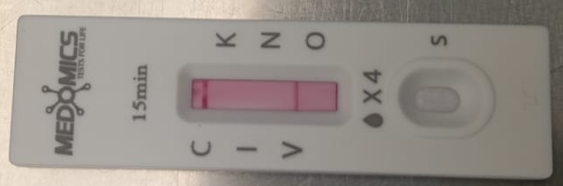

Figure 1: Picture of the NG test Carba 5:
C(Control); I(IMP); V(VIM); K(KPC); N(NDM); O(Oxa-48)

