Bioproduction, Optimisation, and Spectral Characterisation of Red Pigment from Deinococcus proteolyticus as a Sustainable Natural Pigment for Industrial Applications
Authors
Ifeoluwa Victoria Daramola^{1*}, Kehinde Olusayo Awojobi¹

Authors’ Affiliation
¹Department of Microbiology, Obafemi Awolowo University, Ile-Ife, 220005, Nigeria.

*Corresponding Author
Ifeoluwa Victoria Daramola (iv.daramola@gmail.com)
Department of Microbiology, Obafemi Awolowo University, Ile-Ife, 220005, Nigeria

ORCID of Authors
Ifeoluwa Victoria Daramola (https://orcid.org/0009-0008-4827-3938)
Kehinde Olusayo Awojobi (https://orcid.org/0000-0002-3035-8703)

Table S1. FTIR Spectroscopic Analysis and Interpretation of the Red Pigment Extracted from Deinococcus proteolyticus
FTIR Spectral peaks (cm⁻¹) of pigment extracted from Deinococcus proteolyticus | Functional Groups
3347.1 | H bonded OH stretch
2974.4, 2929.7, 2892.4 | C-H stretch
1654.9 | C=C stretch
1453.7, 1420.1 | C-H bend
1382.8, 1326.9, 1274.7 | OH bend
1088.4 | Secondary alcohol C-O stretch
1043.7 | Primary alcohol C-O stretch
950.5, 879.7 | Skeletal C-C vibrations
618.7 | Alkyne C-H bend

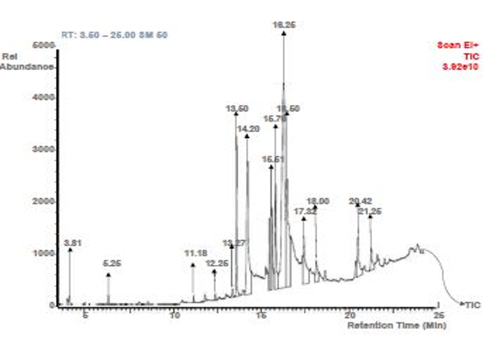

Fig. S1: Gas Chromatogram of Red Pigment Produced by Deinococcus proteolyticus

Table S2. Name and Structure of Compounds detected by GC-MS Analysis of Red Pigment Produced by Deinococcus proteolyticus
Peak | RT | Compound Detected | Mol. Formula | MW | Peak Area % | Comp %wt | m/z | Structures
1 | 3.81 | 2-Tridecenal, (E)- | C₁₃H₂₄O | 196 | 0.88 | 1.64 | 43, 70, 196 | 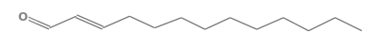
2 | 5.25 | Nonanoic acid, 9-oxo-, methyl ester | C₁₀H₁₈O₃ | 186 | 0.97 | 0.25 | 74, 87, 186 | 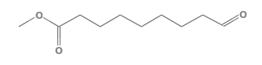
3 | 11.18 | 1,2-Benzenedicarboxylic acid | C₈H₆O₄ | 166 | 0.99 | 1.73 | 78. 104, 166 | 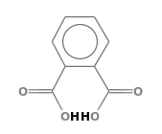
4 | 12.25 | Pentadecane, 2,6,10,14-tetramethyl- | C₁₉H₄₀ | 268 | 1.16 | 1.29 | 57, 71, 268 | 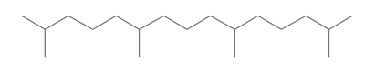
5 | 13.27 | Germacrene D | C₁₅H₂₄ | 204 | 1.18 | 0.18 | 41, 161, 204 | 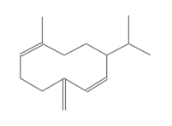
6 | 13.50 | 9,12-Octadecadienoic acid (Z,Z)- | C₁₈H₃₂O₂ | 280 | 7.18 | 8.06 | 67, 95, 280 | 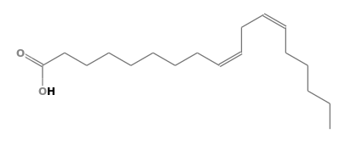
7 | 14.20 | 9,12,15-Octadecatrien-1-ol, (Z,Z,Z)- | C₁₈H₃₂O | 264 | 12.40 | 13.54 | 67, 79, 264 | 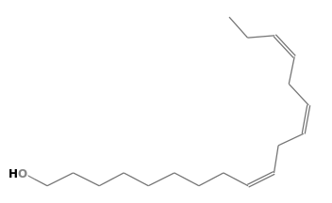
8 | 15.51 | 1,1,1,3,5,5,5-Heptamethyltrisiloxane | C₇H₂₂O₂Si₃ | 222 | 7.91 | 8.40 | 73, 207, 7.91 | 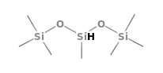
9 | 15.76 | Phytol | C₂₀H₄₀O | 296 | 10.55 | 11.92 | 87, 71, 296 | 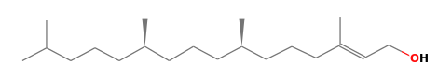
10 | 16.25 | n-Hexadecanoic acid | C₁₆H₃₂O₂ | 256 | 19.27 | 20.36 | 43, 73, 256 | 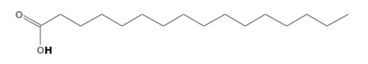
11 | 16.50 | 9,12-Octadecadienoic acid, ethyl ester | C₂₀H₃₆O₂ | 308 | 10.34 | 11.38 | 67, 81, 308 | 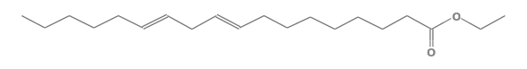
12 | 17.32 | Hexadecanoic acid, 2-hydroxy-1-(hydroxymethyl)ethyl ester | C₁₉H₃₈O₄ | 330 | 6.16 | 6.90 | 43, 98, 330 | 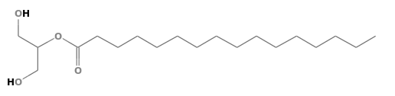
13 | 18.00 | Squalene | C₃₀H₅₀ | 410 | 4.40 | 5.18 | 69, 81, 410 | 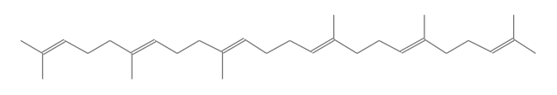
14 | 20.42 | Campesterol | C₂₈H₄₈O | 400 | 5.32 | 4.71 | 43, 55, 400 | 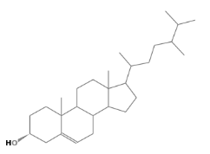
15 | 21.25 | Stigmasterol | C₂₉H₄₈O | 412 | 4.42 | 4.05 | 55, 83, 412 | 