The future of northern bobwhites and urbanization in Texas, Oklahoma, and Louisiana.
Appendix 1: Supplemental information

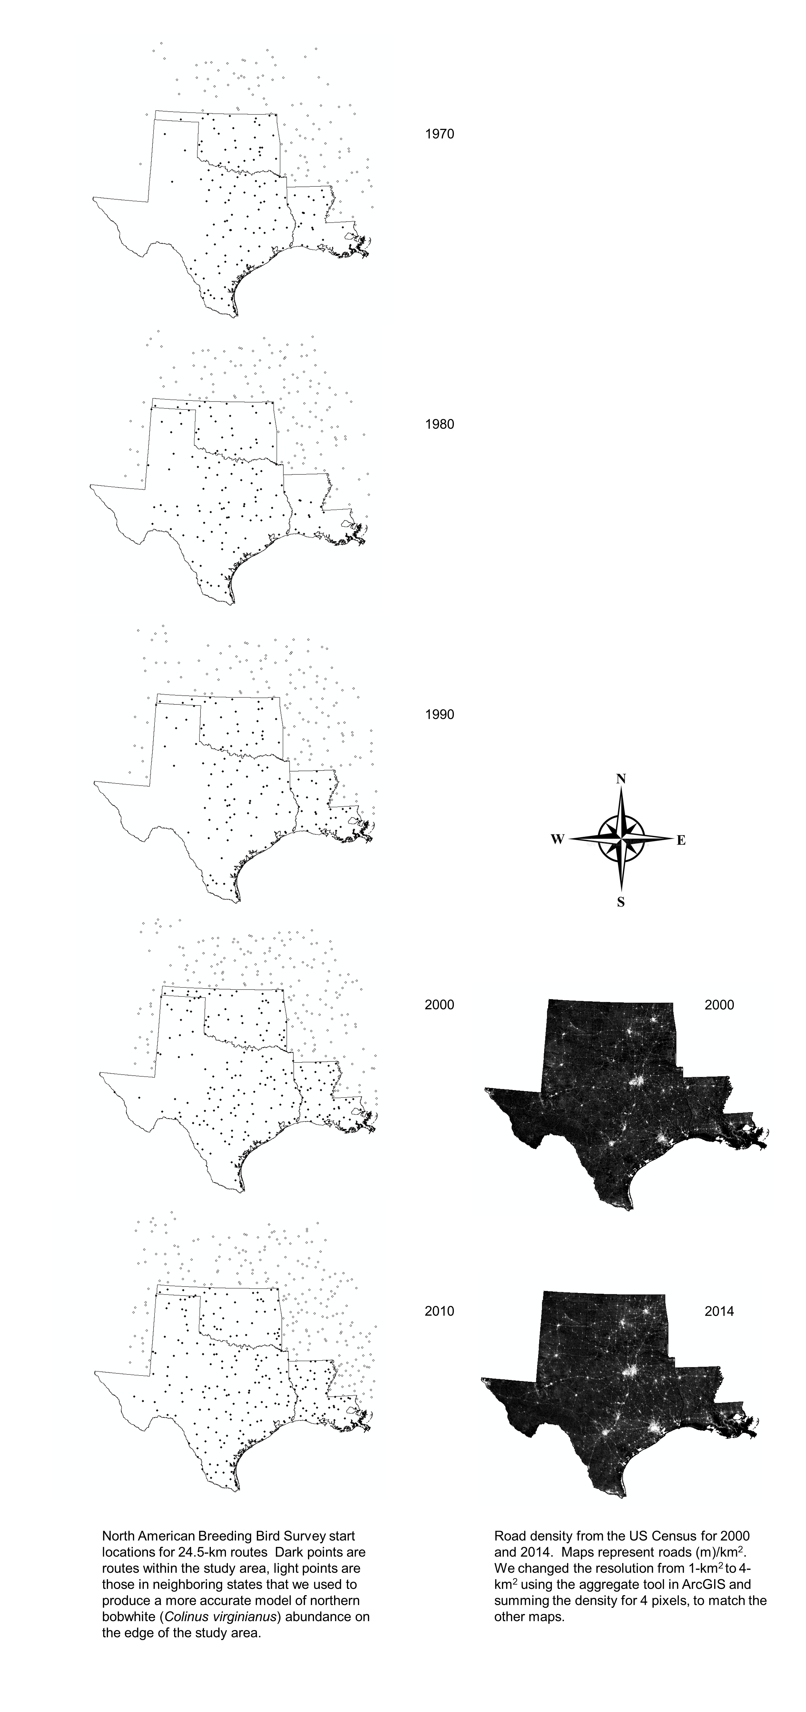

Fig. 1. North American Breeding Bird Survey route start points (left) and road density (right).

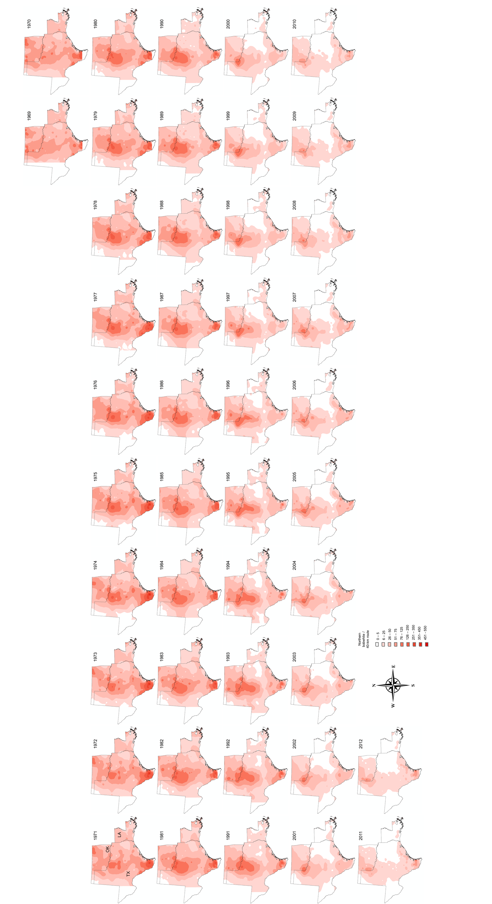
Fig. 2. Northern bobwhite abundance index maps, 5-year rolling averages for each year.
Appendix 2: R output for breakpoint analysis:
