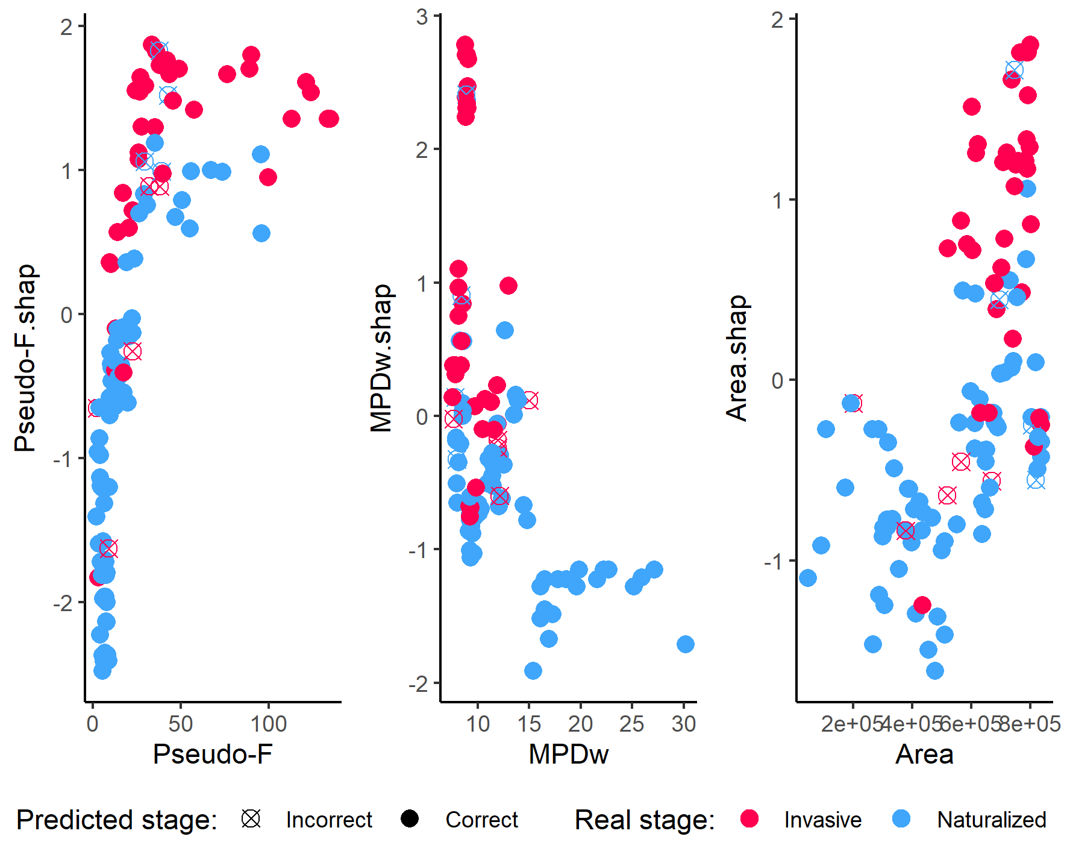
Supplementary Fig. 1 Univariate relationships between invasion model predictors and their corresponding SHAP values. Each point represents a species and shows the predictor value and its SHAP value for that predictor. Pseudo-F: Pseudo-F statistic from a PERMANOVA comparing native and non-native ranges using bioclimatic variables. MPDw: Mean phylogenetic distance from the non-native species to all co-occurring native species, weighted by the relative frequency of native plants. Area: Predicted suitable area in the Caatinga (in square kilometers) based on the ENM. On the y-axis, the “.shap” suffix indicates the direction of the variable’s influence on the classification: positive SHAP values increase the probability of a positive prediction (invasive), whereas negative values increase the probability of a negative prediction (naturalized).
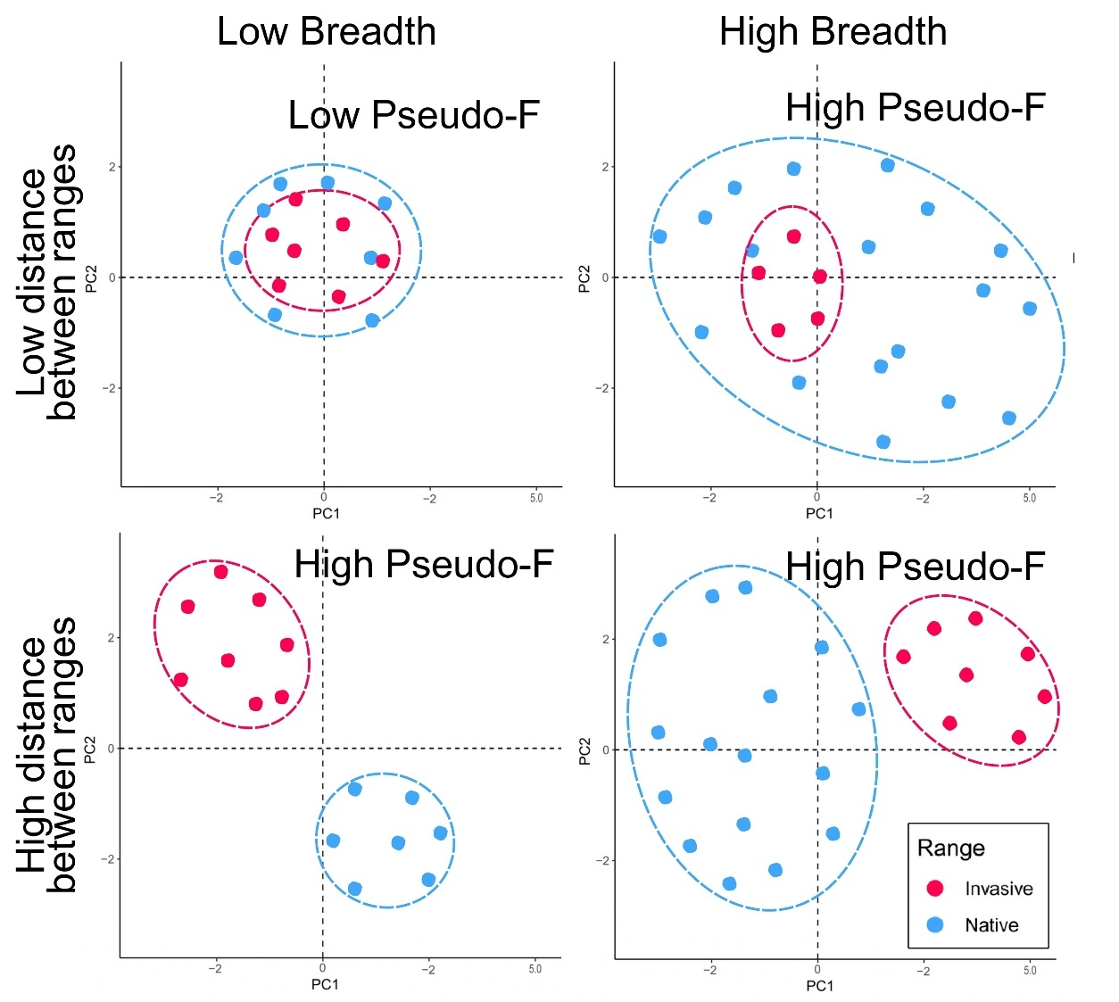
Supplementary Fig. 2 Schematic representation of the potential influence of niche position and niche breadth on the pseudo-F metric. Low pseudo-F values indicate that the native and invaded ranges share similar environmental conditions and range sizes. In contrast, higher pseudo-F values may result from: (1) small environmental distance but a broader native range, (2) similar range sizes but high environmental distance between native and invaded ranges, or (3) both high environmental distance and large range sizes.

