Supplementary Material
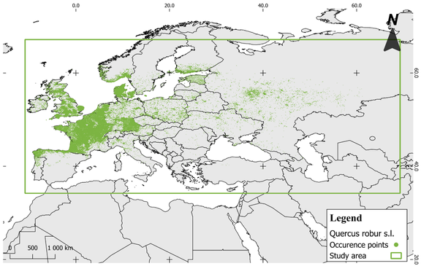
Supplementary Fig. 1 Quercus robur s.l. geographic records and study used to perform the model (Coordinate System: Datum WGS1984 / UTM 30 N) (EPSG: 32630) aggregated into 1x1 km (before thinning).
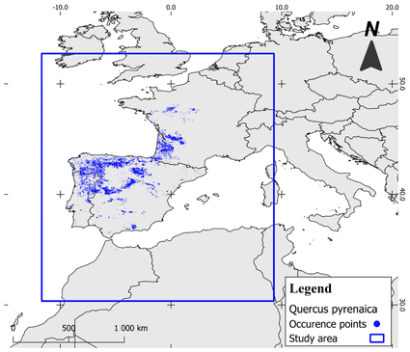
Supplementary Fig. 2 Quercus pyrenaica geographic records and study area used to perform the model (Coordinate System: Datum WGS1984 / UTM 30 N) (EPSG: 32630) aggregated into 1x1 km.
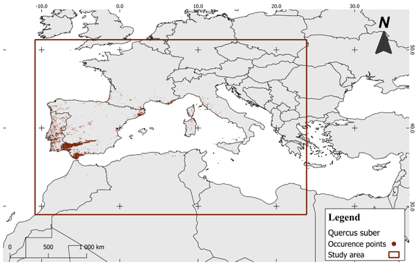
Supplementary Fig. 3 Quercus suber geographic records and study area used to perform the model (Coordinate System: Datum WGS1984 / UTM 30 N) (EPSG: 32630) aggregated into 1x1 km.

Supplementary Table 1 Occurrence records used for modelling after cleaning and thinning, aggregated into 1x1 km. N/A: "Not Applicable".
Species | Occurrences | Occurrences after thinning | Pseudo-absences | Access date
Q. robur s.l. | 205,348 | 27,119 | 25,000 | https://doi.org/10.15468/dl.b93538 (accessed on 15 July 2024)  and https://doi.org/10.15468/dl.ghjyx2 (accessed on 26 January 2024)
Q.pyrenaica | 14,554 | N/A | 10,000 | https://doi.org/10.15468/dl.vggh4j (accessed on 13 March 2024)
Q.suber | 24,929 | N/A | 25,000 | https://doi.org/10.15468/dl.fcwut5 (accessed on 29 March 2025)

Supplementary Table 2 Quercus robur s.l. geographic records used to perform the model (Coordinate System: Datum WGS1984 / UTM 30 N) (EPSG: 32630) aggregated into 1x1 km.
Supplementary Table 3 Quercus pyrenaica geographic records used to perform the model (Coordinate System: Datum WGS1984 / UTM 30 N) (EPSG: 32630) aggregated into 1x1 km.
Supplementary Table 4 Quercus suber geographic records used to perform the model (Coordinate System: Datum WGS1984 / UTM 30 N) (EPSG: 32630) aggregated into 1x1 km.

Supplementary Table 5 Original set of the 19 bioclimatic variables that were retrieved for modelling, and selected variables for each species.
Variable | Code | Unit | Quercus robur s.l. | Quercus pyrenaica | Quercus suber
Annual mean temperature | BIO1 | °C * 10 |  |  | X
Mean diurnal range (mean of monthly (max temp - min temp)) | BIO2 | °C * 10
Isothermality (BIO2/BIO7) (* 100) | BIO3 | % | X | X | X
Temperature seasonality (standard deviation *100) | BIO4 | -
Max. temperature of warmest month | BIO5 | °C * 10
Min. Temperature of Coldest Month | BIO6 | °C * 10 | X | X | X
Temperature annual range (BIO5-BIO6) | BIO7 | °C * 10
Mean temperature of the wettest quarter | BIO8 | °C * 10 | X
Mean temperature of the driest quarter | BIO9 | °C * 10
Mean temperature of the warmest quarter | BIO10 | °C * 10 |  | X
Mean temperature of the coldest quarter | BIO11 | °C * 10
Annual precipitation | BIO12 | mm | X | X | X
Precipitation of the wettest month | BIO13 | mm
Precipitation of the driest month | BIO14 | mm
Precipitation seasonality (coefficient of variation) | BIO15 | % | X | X | X
Precipitation of the wettest quarter | BIO16 | mm
Precipitation of the driest quarter | BIO17 | mm
Precipitation of the warmest quarter | BIO18 | mm | X | X
Precipitation of the coldest quarter | BIO19 | mm |  |  | X
Topographic Ruggedness Index | TRI | m | X | X | X
Topographic Wetness Index | TWI | - | X | X | X
Soil pH data at 5 cm depth | PH | H₂O and KCl solution | X | X | X
Soil texture class at 5 cm depth | TEX | weight % | X | X | X

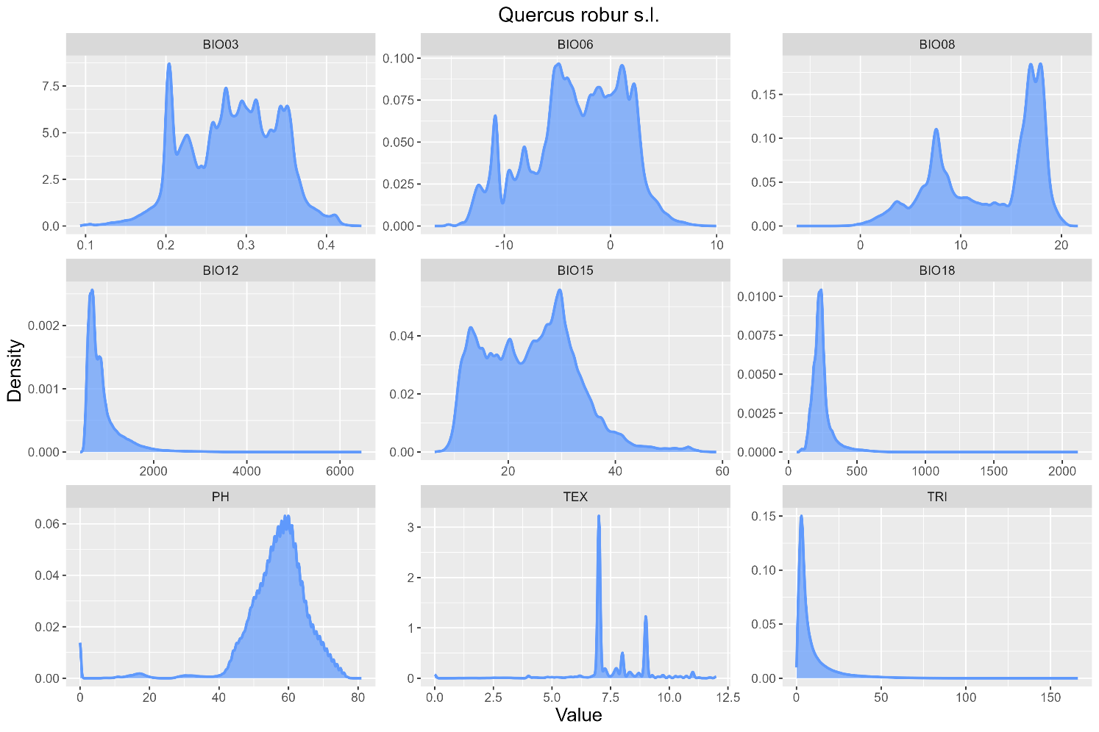
Supplementary Fig. 4 Density estimation for selected environmental variables, with contributions for the Q. robur s.l. model: topographic: Bio03 – isothermality (Bio02/Bio07) (×100); Bio06 – minimum temperature of the coldest month; Bio8 – mean temperature of wettest quarter; Bio12 – annual precipitation; Bio15 – precipitation seasonality (coefficient of variation); Bio18 – precipitation of the warmest quarter; pH (soil pH at 5cm); TEX (soil texture class at 5 cm); TRI (Topographic Ruggedness Index).

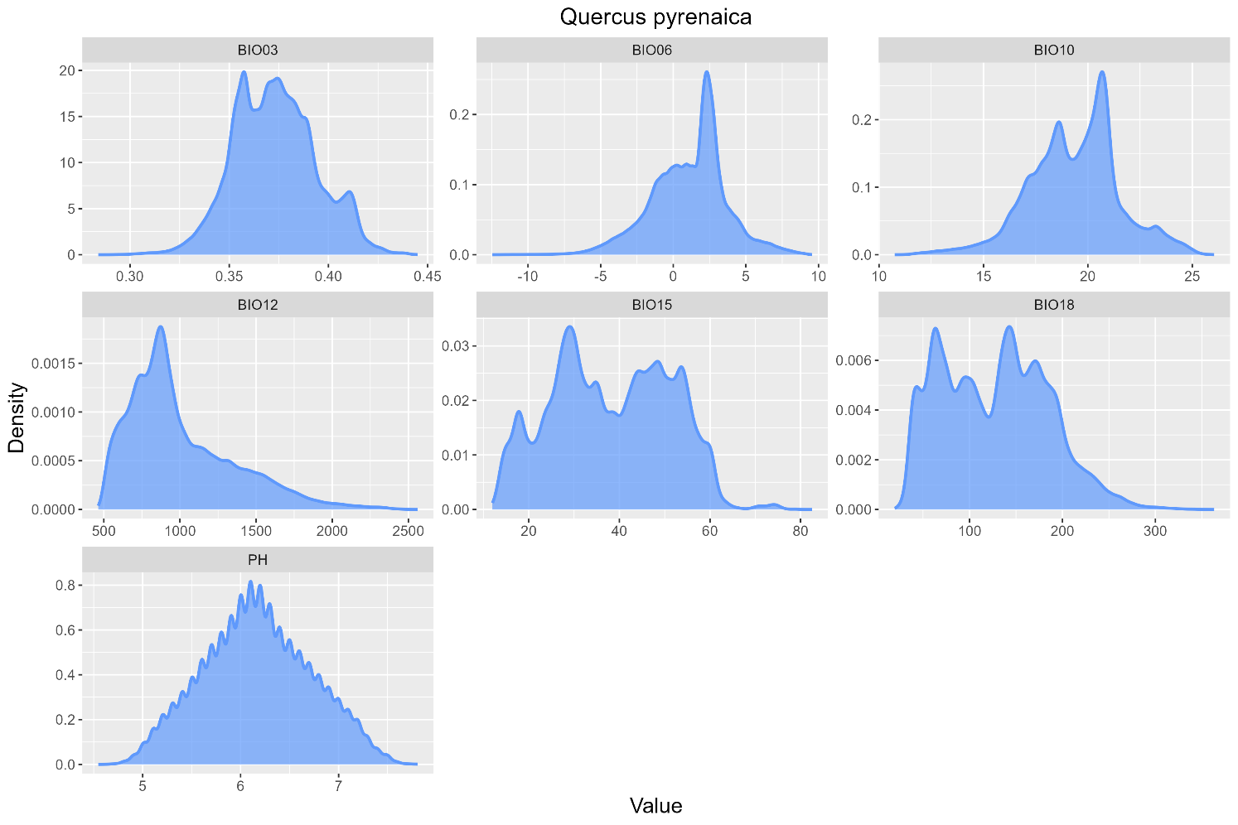
Supplementary Fig. 5 Density estimation for selected environmental variables, with contributions for Q. pyrenaica model: topographic: Bio03 – isothermality (Bio02/Bio07) (×100); Bio06 – minimum temperature of the coldest month; Bio10 – mean temperature of the warmest quarter; Bio12 – annual precipitation; Bio15 – precipitation seasonality (coefficient of variation); Bio18 – precipitation of the warmest quarter; pH (soil pH at 5cm).

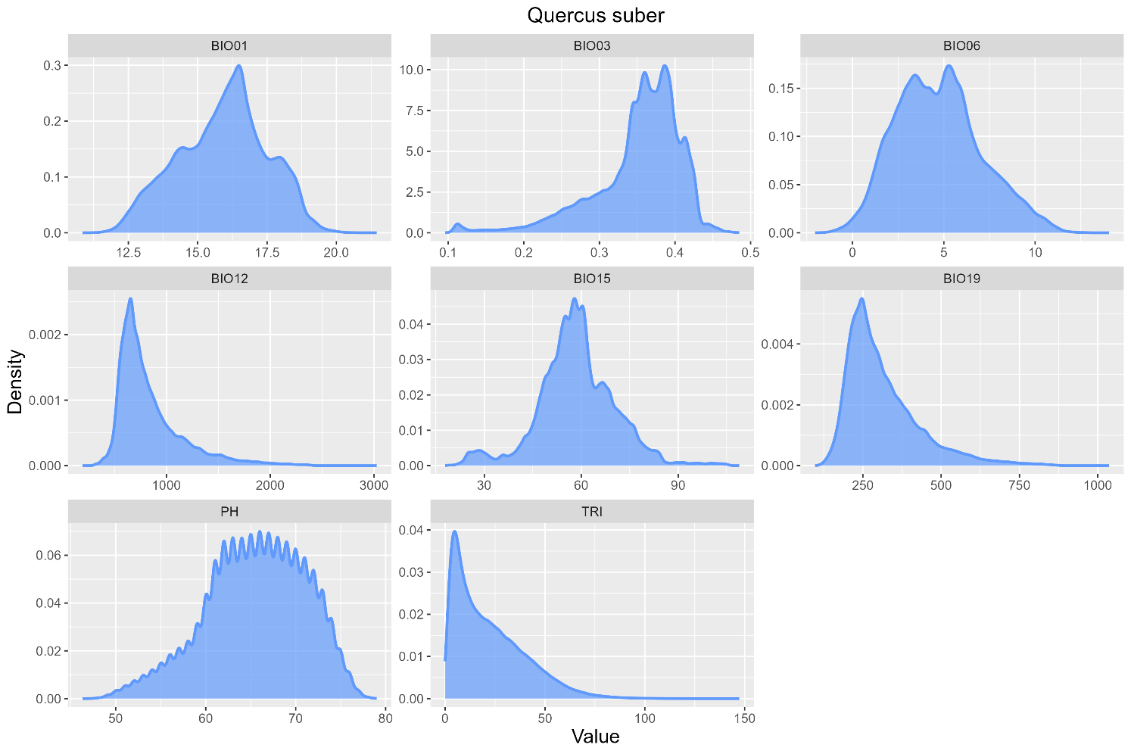
Supplementary Fig. 6 Density estimation for selected environmental variables, with contributions for the model of each species: topographic: Bio01 – annual mean temperature; Bio03 – isothermality (Bio02/Bio07) (×100); Bio06 – minimum temperature of the coldest month; Bio12 – annual precipitation; Bio15 – precipitation seasonality (coefficient of variation); Bio19 – precipitation of the coldest quarter; pH (soil pH at 5cm); TRI (Topographic Ruggedness Index).

Supplementary Fig. 7 Total suitable area in ha (stable plus gained in future scenarios) for each species in the IP.
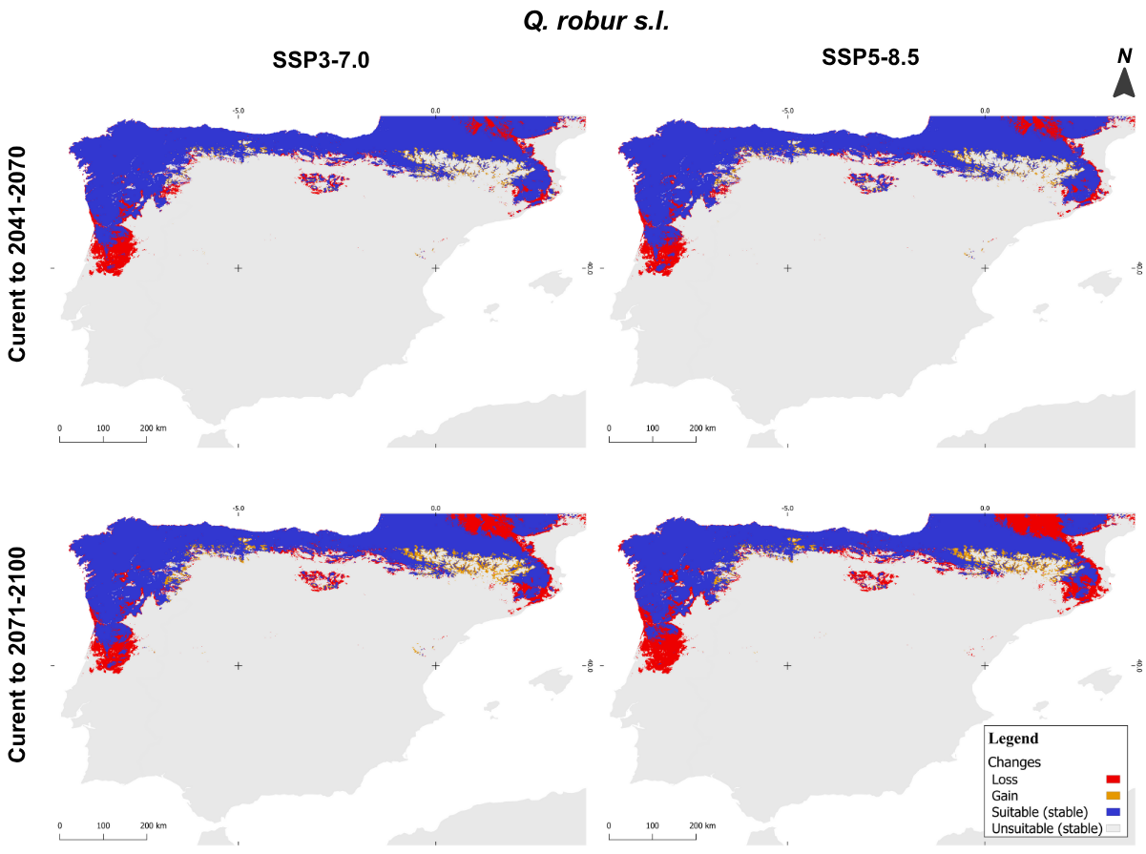
Supplementary Fig. 8 Changes in predicted distributions (gain=orange, lost=red, or stable=blue) of Q. robur s.l. in the IP: a) 2041-2070 SSP370; b) 2071-2100 SSP370; c) 2041-2070 SSP585; d) 2071-2100 SSP585.
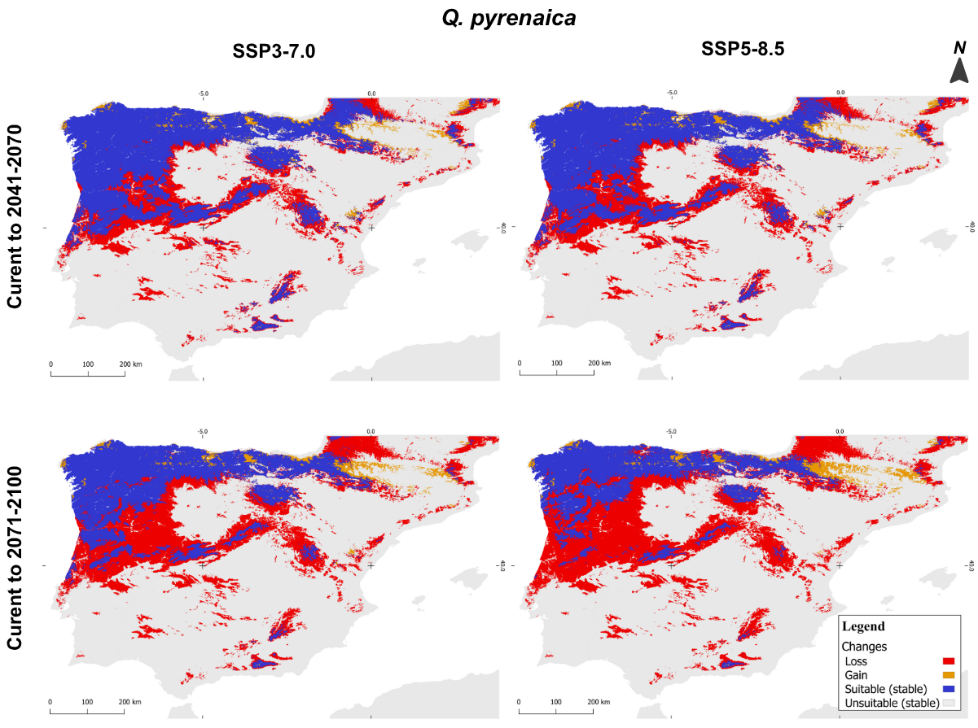
Supplementary Fig. 9 Changes in predicted distributions (gain=orange, lost=red, or stable=blue) of Q. pyrenaica in the IP: a) 2041-2070 SSP370; b) 2071-2100 SSP370; c) 2041-2070 SSP585; d) 2071-2100 SSP585.
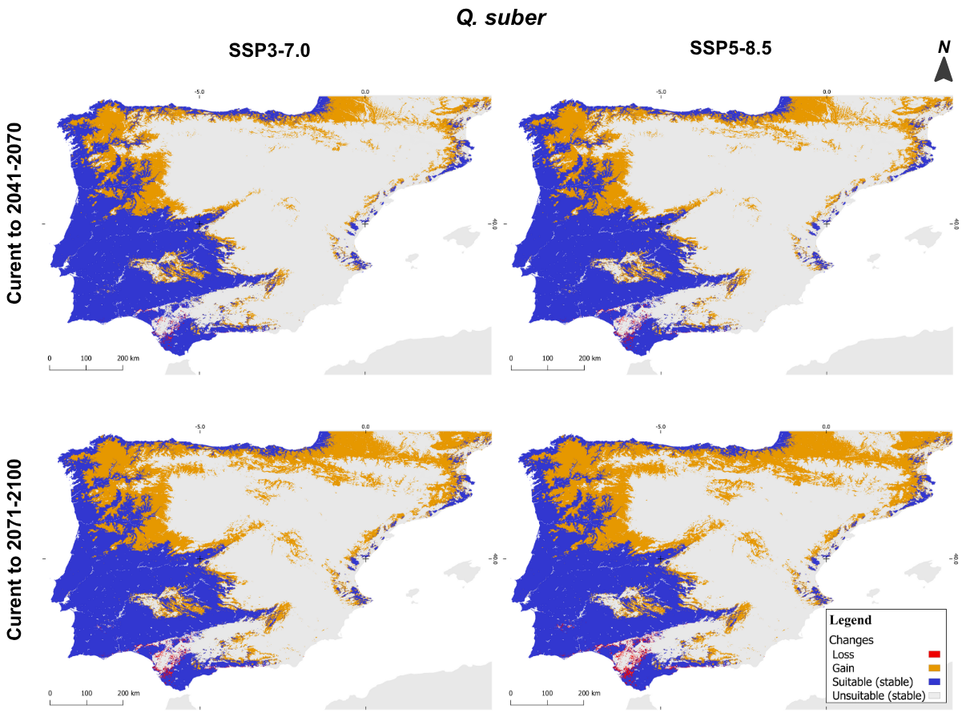
Supplementary Fig. 10 Changes in predicted distributions (gain=orange, lost=red, or stable=blue) of Q. suber in the IP: a) 2041-2070 SSP370; b) 2071-2100 SSP370; c) 2041-2070 SSP585; d) 2071-2100 SSP585.
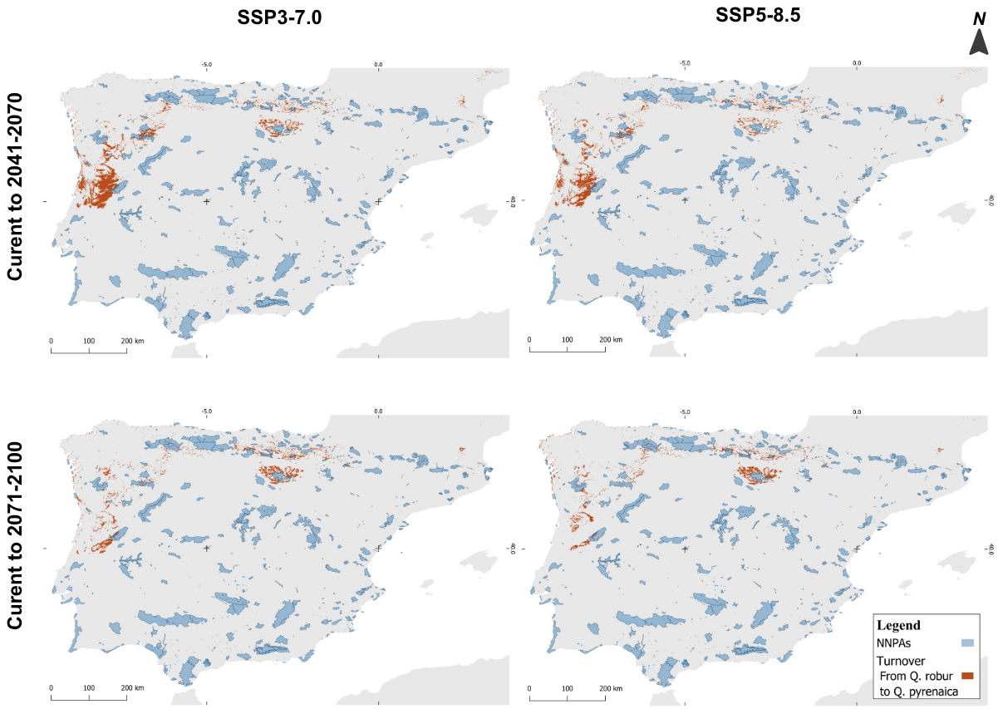
Supplementary Fig. 11 Overlap between Portugal and Spain National Network of Protected Areas (NNPAs) and turnover from Q. robur s.l. to Q. pyrenaica in different future scenarios and time frames.
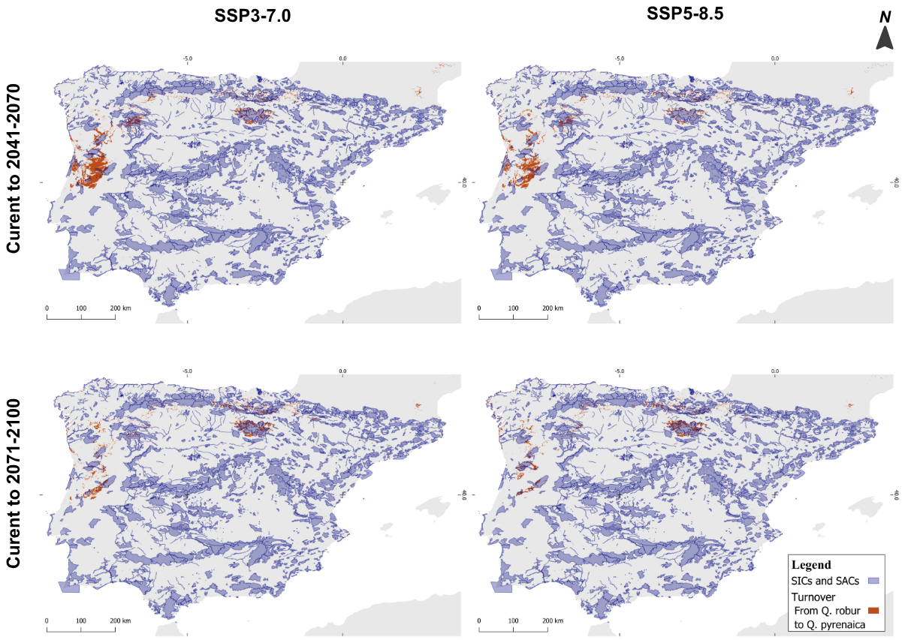
Supplementary Fig. 12 Overlap between Portugal and Spain Habitats Directive - Sites of Community Importance (SCIs) and Special Areas of Conservation (SACs) and turnover from Q. robur s.l. to Q. pyrenaica in different future scenarios and time frames.
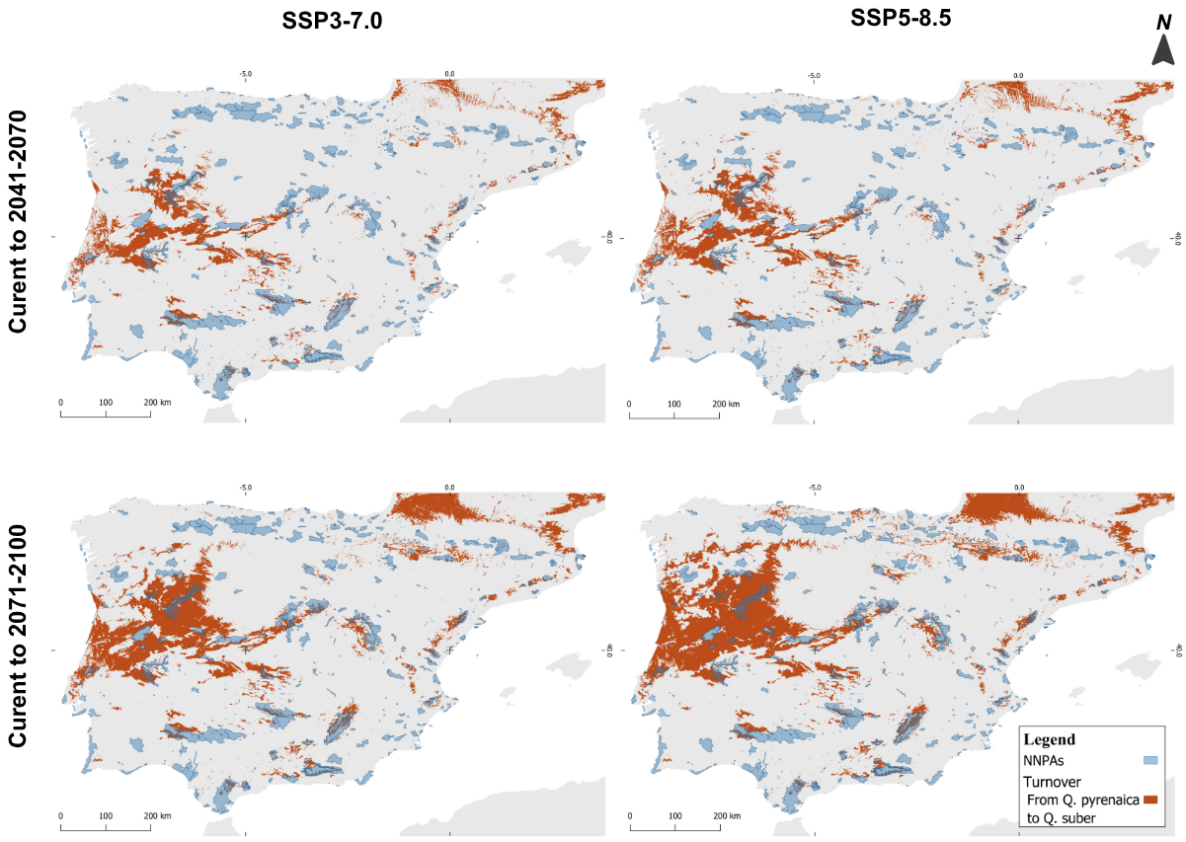
Supplementary Fig. 13 Overlap between Portugal and Spain National Network of Protected Areas (NNPAs) and turnover from Q. pyrenaica to Q. suber in different future scenarios and time frames.
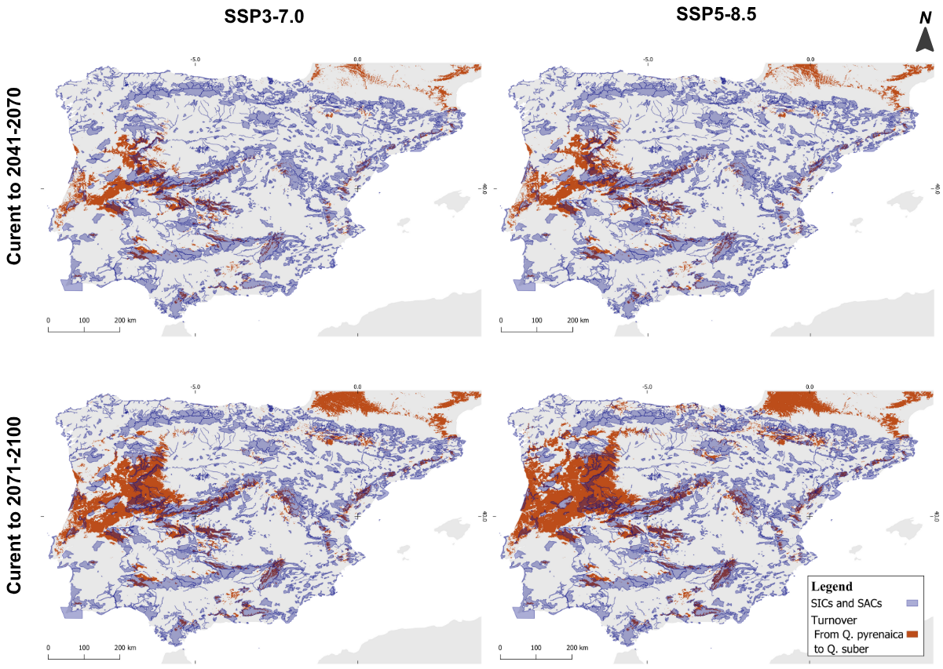
Supplementary Fig. 14 Overlap between Portugal and Spain Habitats Directive - Sites of Community Importance (SCIs) and Special Areas of Conservation (SACs) and turnover from Q. pyrenaica to Q. suber in different future scenarios and time frames.
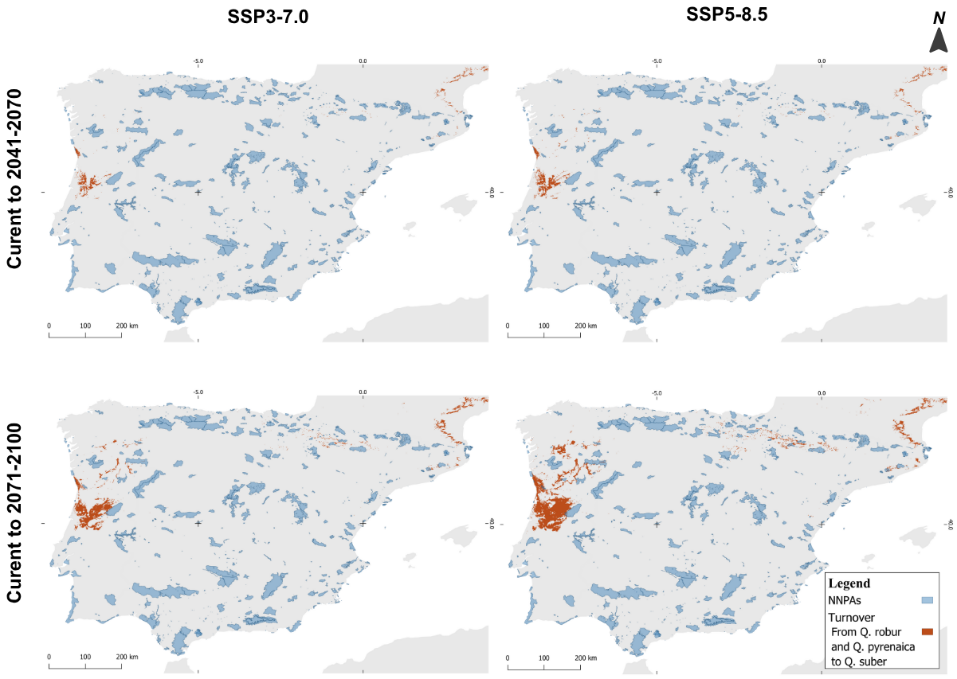
Supplementary Fig. 15 Overlap between Portugal and Spain National Network of Protected Areas (NNPAs) and turnover from Q. robur s.l. and Q. pyrenaica to Q. suber in different future scenarios and time frames.
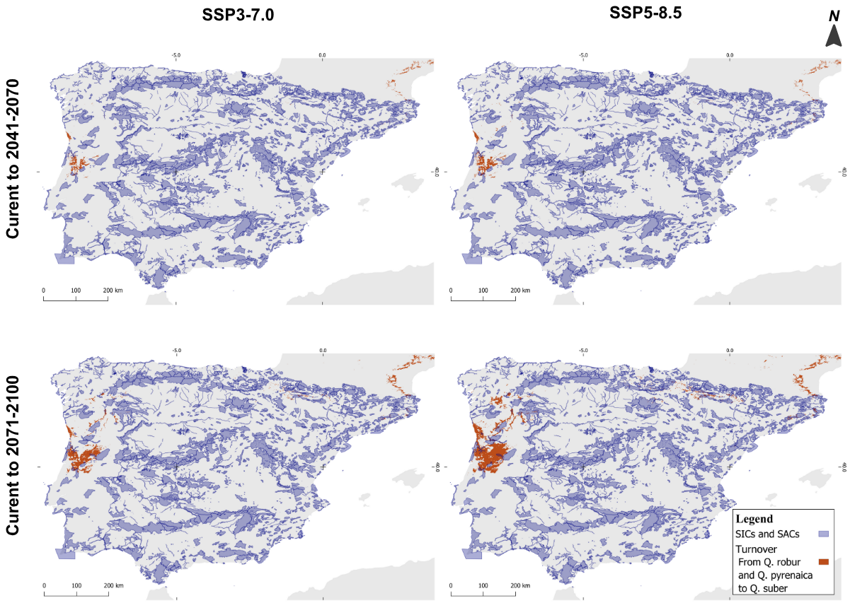
Supplementary Fig. 16 Overlap between Portugal and Spain Habitats Directive - Sites of Community Importance (SCIs) and Special Areas of Conservation (SACs) and turnover from Q. robur s.l. and Q. pyrenaica to Q. suber in different future scenarios and time frames.

