Depth use and thermal environment of adult male Mediterranean loggerhead sea turtles

ALan F. Rees^{1*}, Panagiotis Batzios², Panagiotis Dendrinos^{2,3}, Tasos Dimalexis⁴, George Mikoniatis⁵, Odysseas Paxinos³, and Yannis Vavassis⁵

¹ Turtles from Above, 48 Beaumont Road, Plymouth, PL4 9BW, UK. *Correspondence: Tel: +44 (0)7758-406-250. E-mail: alanfrees@gmail.com (Rees)
² BIOTOPIA GP, Galissas, Syros 84100, Greece.
³ MOm/Hellenic Society for the Study and Protection of the Monk Seal, 18 Solomou St. Athens 10682, Greece.
⁴ Nature Conservation Consultants (NCC) Ltd, 20 Pentelis Avenue, GR 15235 Vrilissia Athens, Greece.
⁵ HELLENiQ UPSTREAM S.A., HELLENiQ ENERGY Holdings S.A, 8A Chimarras Street., GR 151 25 Maroussi Athens, Greece.

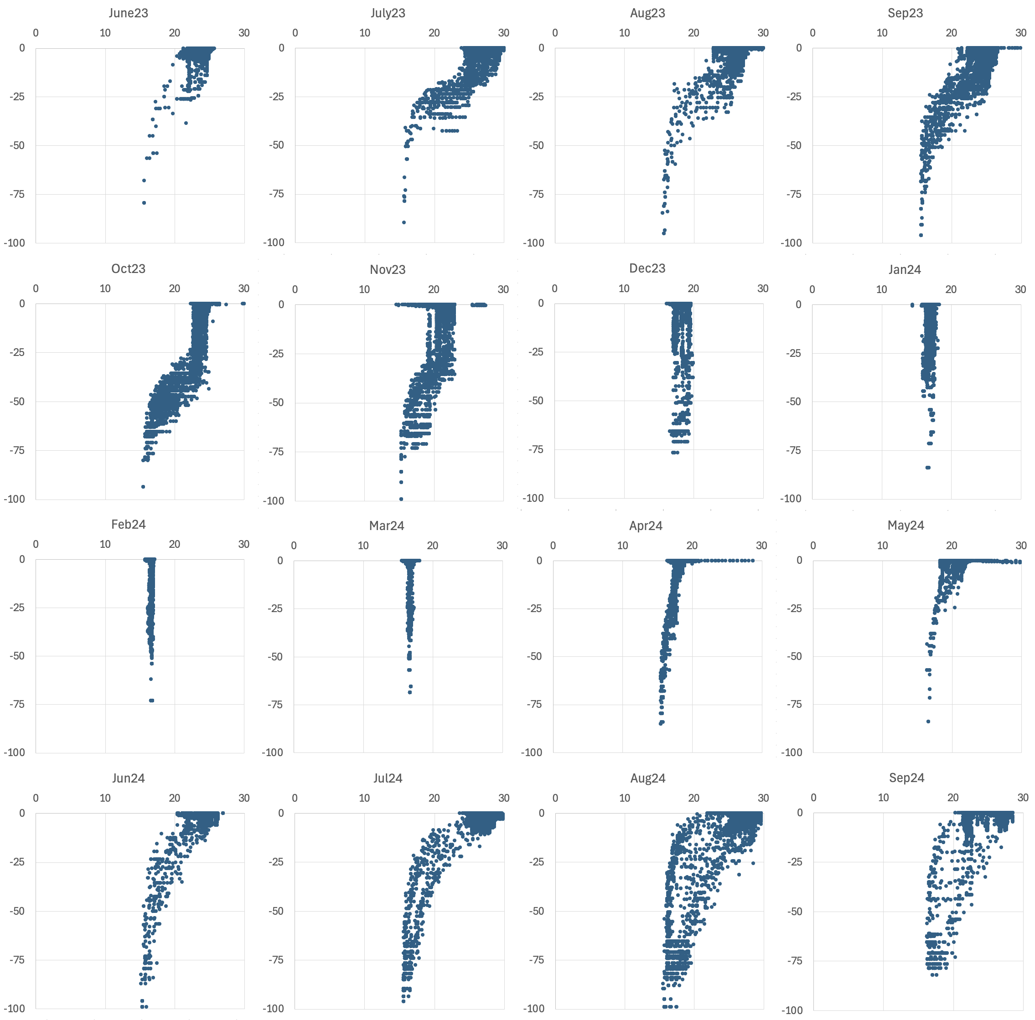
Fig. S1 Monthly depth (y-axis) vs temperature (x-axis) data recorded for turtle J, which displayed nomadic post-breeding behaviour, moving around the northern Ionian and Adriatic seas

