Acute Kidney Injury in Elderly Patients in Saudi Arabia: Retrospective Single-Center Study
Abrar F. Alshehri ^{1,}*, Nouf Alotaibi ¹, Abdulaziz Alhossan ²
Affiliation 1; Department of Pharmaceutical Services, College of Pharmacy, Umm Al-Qura University, Makkah, Saudi Arabia
Affiliation 2; Department of Clinical Pharmacy, College of Pharmacy, King Saud University, Riyadh, Saudi Arabia
*Correspondence: Abrar Fayez Alshehri, Pharm.D, MSc, BCPS, BCCP.
Lecturer in Department of Pharmaceutical Services, College of Pharmacy, Umm Al-Qura University, Makkah, Saudia Arabia. P.O. Box: 13578 Zip Code: 21955.
Email: afashahri@uqu.edu.sa; abrar.f.alshehri@gmail.com
Mobile Number: 00966563693616
ORCID: 0000-0001-6311-3721

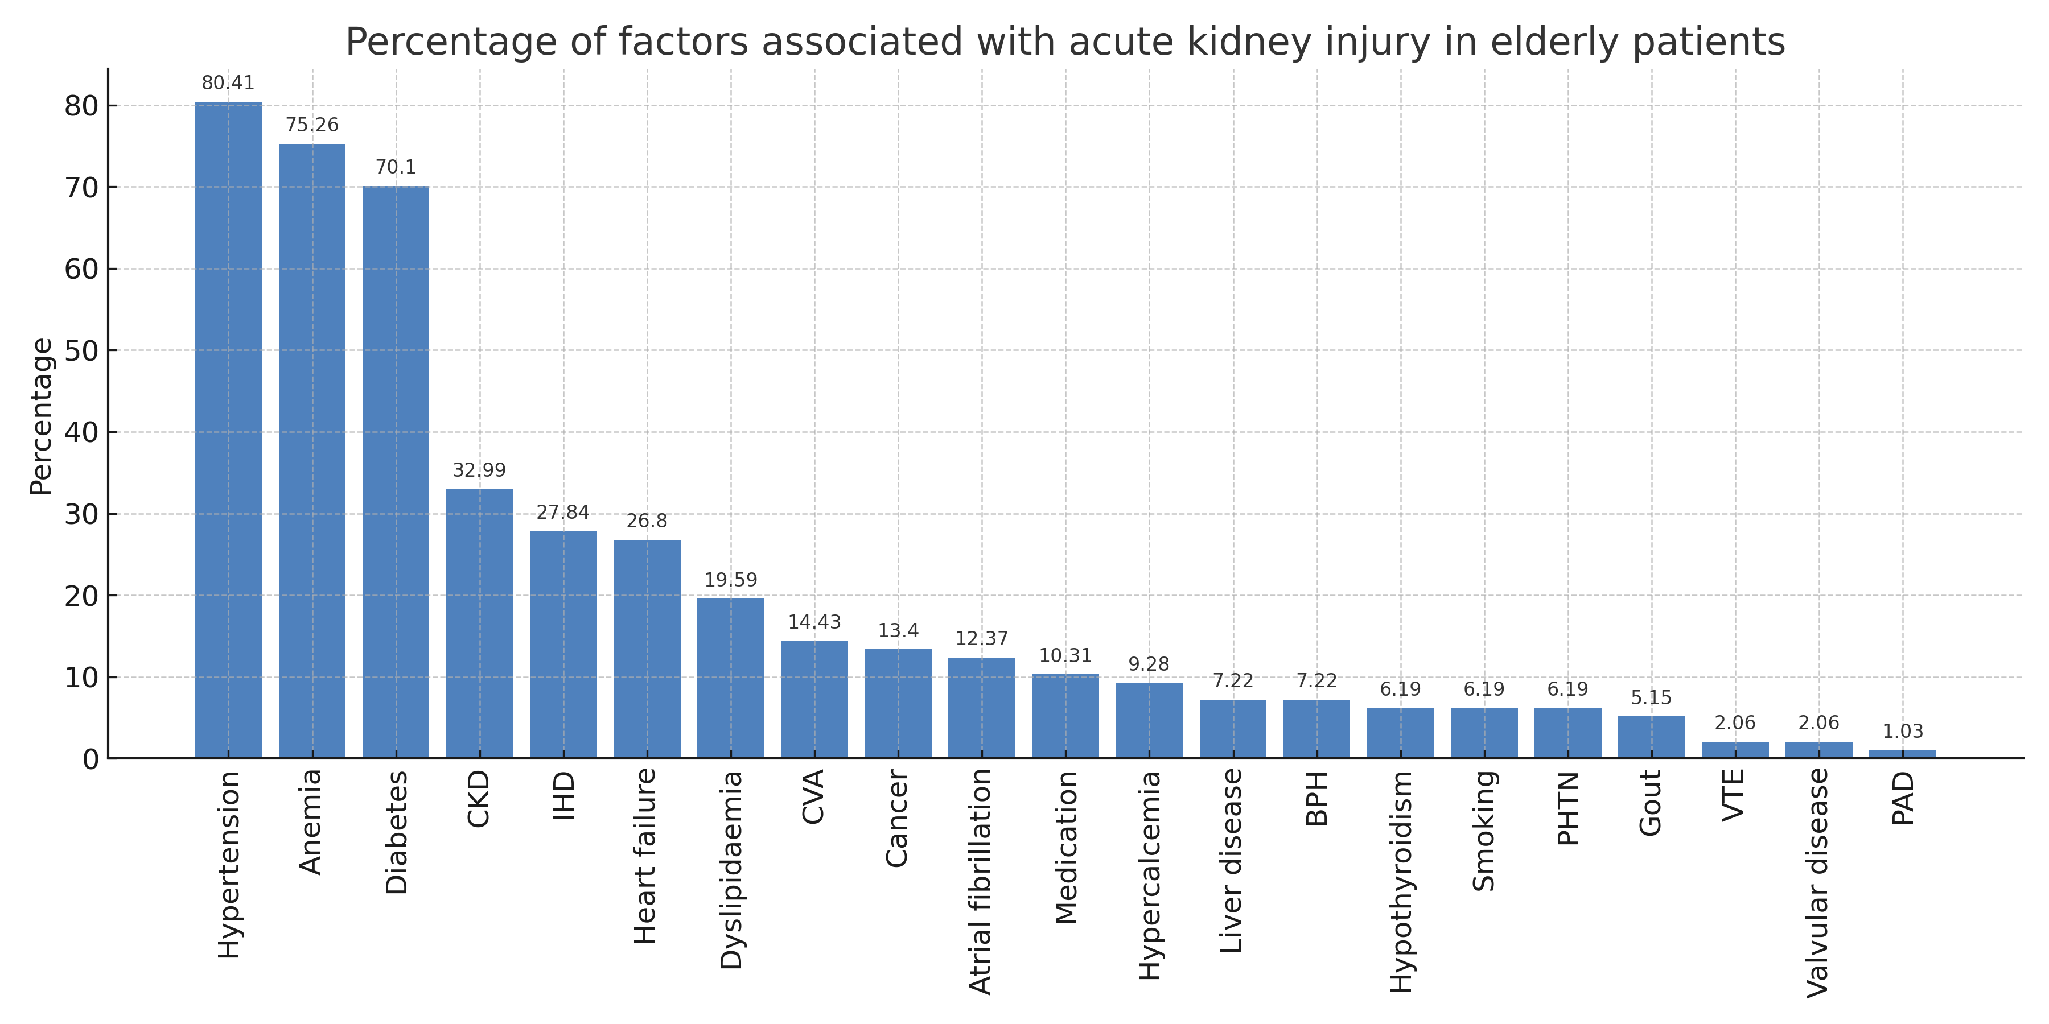
Figure S1. Percentage of factors associated with acute kidney injury in elderly patients.
CKD: Chronic Kidney Disease, IHD: Ischemic Heart Disease, BPH: Benign Prostatic Hypertrophy, PHTN: Pulmonary hypertension, VTE: Venous Thromboembolism, PAD: Peripheral Arterial Disease. Medication: Furosemide (35 patients), Aspirin (33 patients), Angiotensin-converting enzyme inhibitor (29 patients), Piperacillin–tazobactam (6 patients), Meropenem (5 patients), Vancomycin (4 patients), Angiotensin receptor blocker(4 patients), Ciprofloxacin (2 patients), Colistin (2 patients), Voriconazole (1 patient), Cefepime (1 patient), Hydrochlorothiazide (1 patient), Valganciclovir (1 patient), Entecavir (1 patient), Trimethoprim–sulfamethoxazole (1 patient). Note: This figure represents medication exposures, not the proportion of AKI cases caused by medications. Some patients were exposed to more than one nephrotoxic agent.

(a)

(b)

(c)

Figure S2. Reason categories of acute kidney injury in the elderly: (a) Number of overall causes of acute kidney injury in elderly patients. (b) Number of causes of community acute kidney injury in elderly patients. (c) Number of causes of hospital-acquired acute kidney injury in elderly patients. Comorbidity: Acute decompensated heart failure, Atrial fibrillation, Chronic kidney disease, Diabetic nephropathy, Nephrotic syndrome, Hypertension, and Stroke. Medications: frusemide (12 patients), Antibiotics (2 patients), Acyclovir (1 patient), Cisplatin (1 patient), hydrochlorothiazide (1 patient) and Aluminum (1 patient); Postrenal AKI such as benign prostate hyperplasia; Postoperative AKI: happened after major surgery; Hypovolemia /prerenal: (BUN/Creatinine ratio >20:1). Note: This figure shows the number of cases in which each factor was determined to be the primary cause of AKI, including overall, community-acquired, and hospital-acquired settings.

