APPENDIX

Appendix 1: Consent to Participate
Master's Thesis Survey Participation Consent Statement
Dear Participant,
I am a graduate student in the PIEGL program of Business Administration at Zhejiang University.
Thank you for taking the time to participate in this research, which aims to examine how social media information influences purchase intent.
This questionnaire seeks to assess your perceptions and views regarding content on social media platforms. Your responses will help us explore the relationship between information processing and online shopping behavior.
Rest assured, all responses will be kept confidential, and personal information will remain anonymous. Your participation is entirely voluntary, and you may withdraw at any time without consequence.
For each section, you will see content using Xiaohongshu as an example and be asked to share your opinions and perspectives. Please answer based on your genuine impressions. There are no right or wrong answers.
Thank you for your cooperation!

Appendix 2: Study 1 Questionnaire
1. Your gender: [single answer]
○ man | ○ woman
2. Your age: [single answer]
○ Under 18 | ○18~25 | ○26~30 | ○31~40
○ 50 years and older
3. Your educational background: [single answer]
○ Junior high school and below
○ High school/technical secondary school
○ junior college
○ undergraduate college
○ Graduate degree or above

4. Your current occupation: [single answer]
○ student | ○ office worker
○ liberal professions | ○ unemployed
○ Other _________________
5. How much time do you spend on Xiaohongshu on average every day? [single answer]
○ Less than 1 hour
○ 1-3 hours
○ 4-5 hours
○ 6 hours or more
6. How long have you been using Xiaohongshu? [single answer]
○ Less than six months
○ 6 months to 1 year
○ 1-2 years
○ 3 years or more
7. What kind of content do you like to watch on Xiaohongshu? [single answer]
○ Product evaluation
○ fine food
○ travel
○ vogue
○ mode of life
○ Other _________________
8. How often do you make a purchase decision based on what you see on Xiaohongshu? [single answer]
○ everyday
○ several times per week
○ once a week
○ several times per month
○ rarely

When answering the following questions, please answer according to your experience and impression of using the little Red book platform.

Please rate the following statements based on your impression and memory of the quality of information in the product reviews on Xiaohongshu. Information quality refers to the persuasiveness of the post, including objectivity, accuracy, timeliness, relevance and adequacy.
Your sincere answer will have an important impact on our research. Thank you for your time and thoughtful comments.

9. Information quality [matrix scale questions]
 | strongly disagree | disagree | neutral​ | agree | strongly agree
I think the information on xiaohongshu posts related to products is objective. | ○ | ○ | ○ | ○ | ○
I believe the product reviews on Xiaohongshu are accurate. | ○ | ○ | ○ | ○ | ○
I think the product reviews on Xiaohongshu are updated in a timely manner. | ○ | ○ | ○ | ○ | ○
I think the product reviews on Xiaohongshu are relevant to my needs. | ○ | ○ | ○ | ○ | ○
I think the product reviews on Xiaohongshu have enough reason to support this view. | ○ | ○ | ○ | ○ | ○

When answering the following questions, please answer according to your experience and impression of using the little Red book platform.
Based on your impressions and memories of content creators on Xiaohongshu (a Chinese social media platform), including influencers, bloggers, and regular users, please rate the following statements. The credibility of information sources refers to the trust recipients have in content providers, encompassing dimensions such as trustworthiness and professionalism. Your sincere responses will significantly impact our research. Thank you for your time and thoughtful input.
10. Trust in information sources [matrix scale questions]
 | strongly disagree | disagree | neutral​ | agree | strongly agree
I trust content creators on Xiaohongshu. | ○ | ○ | ○ | ○ | ○
I believe content creators share real user experiences on Xiaohongshu. | ○ | ○ | ○ | ○ | ○
I think the content created by content creators on Xiaohongshu is authentic and credible. | ○ | ○ | ○ | ○ | ○

11. This question requires you to choose "1" [Multiple Choice]
○1
○2 (Please jump to the end of the questionnaire and submit the answer)
○3 (Please jump to the end of the questionnaire and submit the answer)

12. Expertise of information sources [matrix scale questions]
 | strongly disagree | disagree | neutral​ | agree | strongly agree
I believe content creators on Xiaohongshu can provide me with useful information. | ○ | ○ | ○ | ○ | ○
I think the number of likes and collections from content creators on Xiaohongshu reflects the level of evaluation they have for the product experience. | ○ | ○ | ○ | ○ | ○
I believe the content creators on Xiaohongshu have enough experience in product reviews. | ○ | ○ | ○ | ○ | ○

When answering the following questions, please provide your honest responses based on your experience and impressions of Xiaohongshu platform, and rate the questions regarding purchasing intentions. Your sincere answers will significantly impact our research. Thank you for your time and thoughtful input.

13. Willingness to buy [matrix scale questions]
 | strongly disagree | disagree | same as | agree | strongly agreed
After I found information on Xiaohongshu, I am very likely to buy this product. | ○ | ○ | ○ | ○ | ○
I will buy the product when I need it, based on what I see on Xiaohongshu. | ○ | ○ | ○ | ○ | ○
I would love to use this product. | ○ | ○ | ○ | ○ | ○
If a friend asks me for advice on such products, I will recommend them to him or her based on the information on Xiaohongshu. | ○ | ○ | ○ | ○ | ○

Appendix 3: Study 2 Experimental Material
Demographic questions were the same as study 1. Below is the stimulus material for information quality, source credibility and eWOM sponsorship disclosure. Participants were exposed to one out of four conditions for each variable (IQ, SC), and answered questions on purchase intention, same as study 1. Below are the stimuli material for all eight conditions.
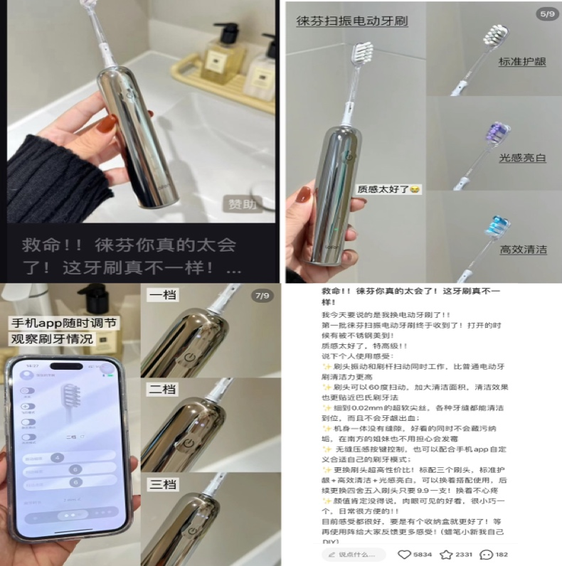
1. High information quality and explicit eWOM sponsorship disclosure

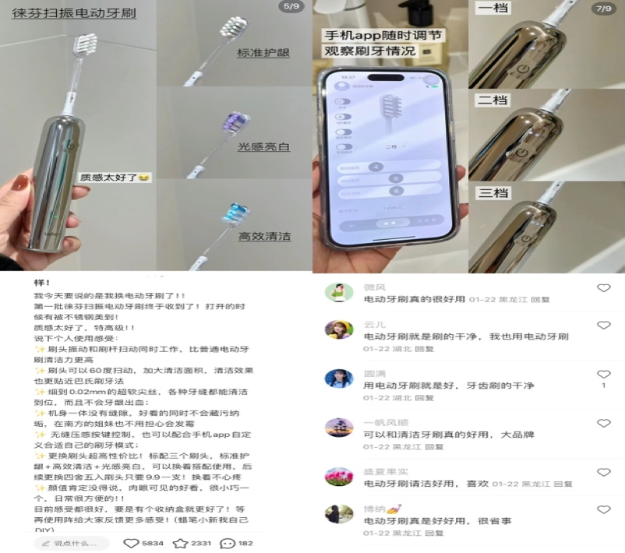
2. High information quality and implicit eWOM sponsorship disclosure

3. Low information quality and explicit eWOM sponsorship disclosure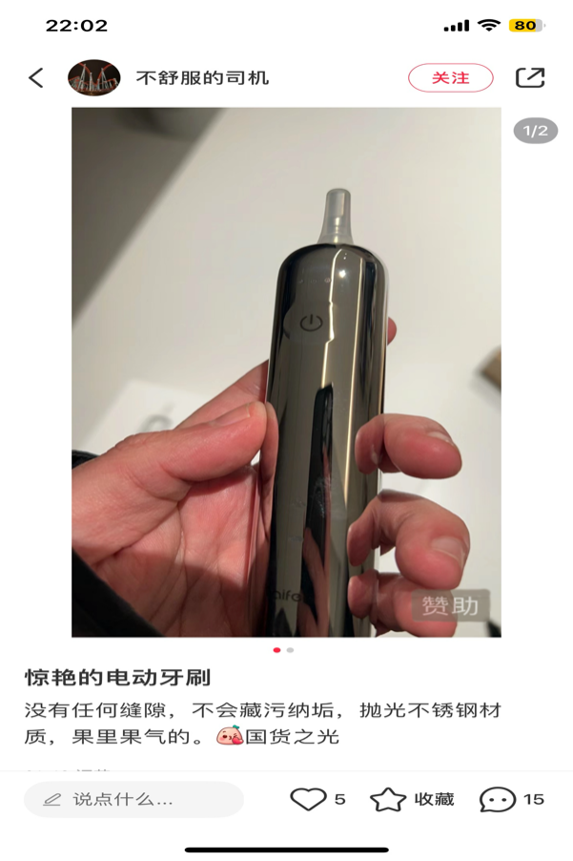

4. Low information quality and implicit eWOM sponsorship disclosure
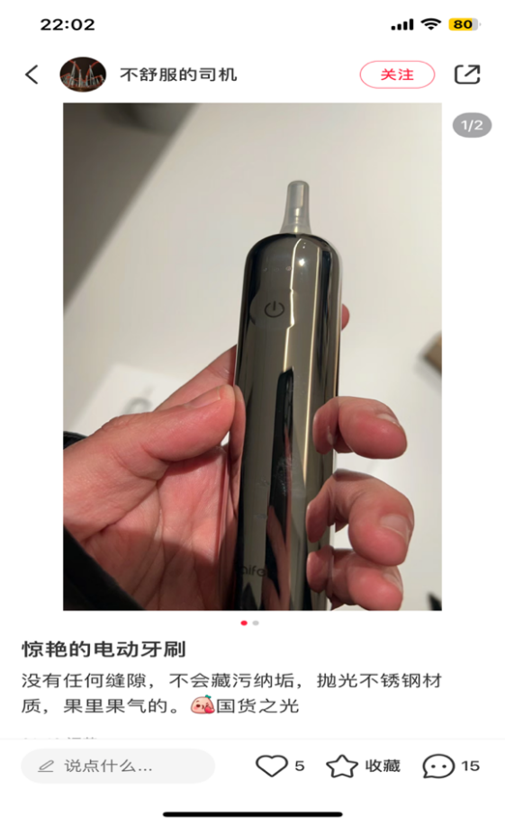
5. High source credibility and explicit eWOM sponsorship disclosure
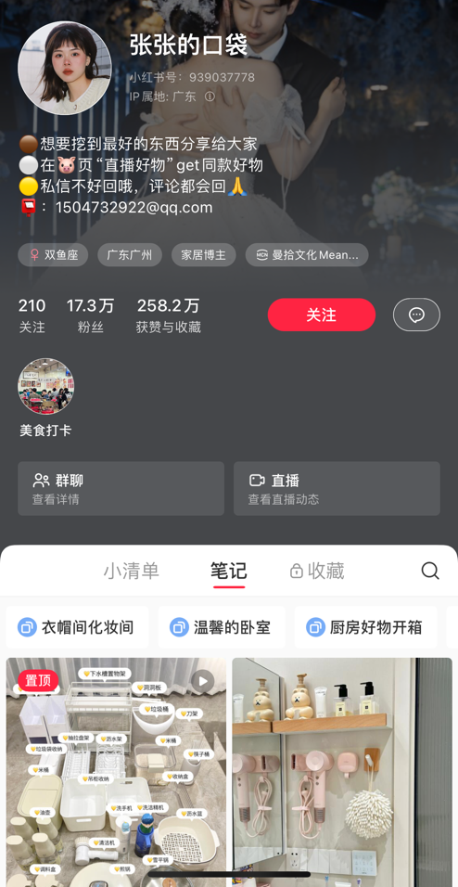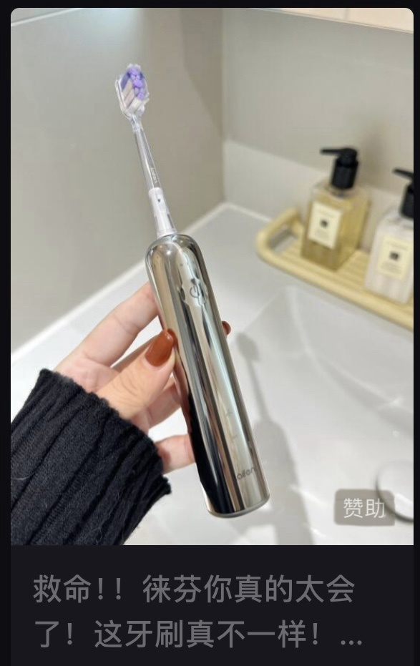
6. High source credibility and implicit eWOM sponsorship disclosure
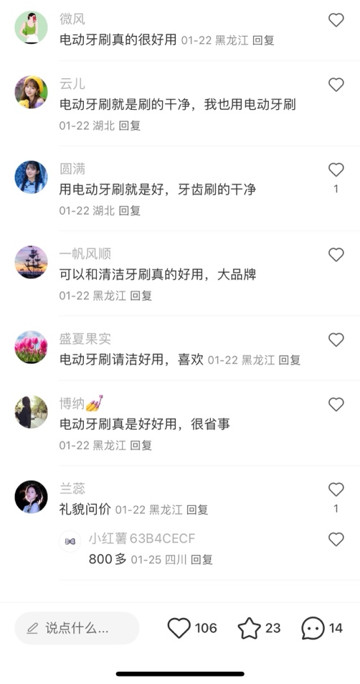
7. Low source credibility and explicit eWOM sponsorship disclosure
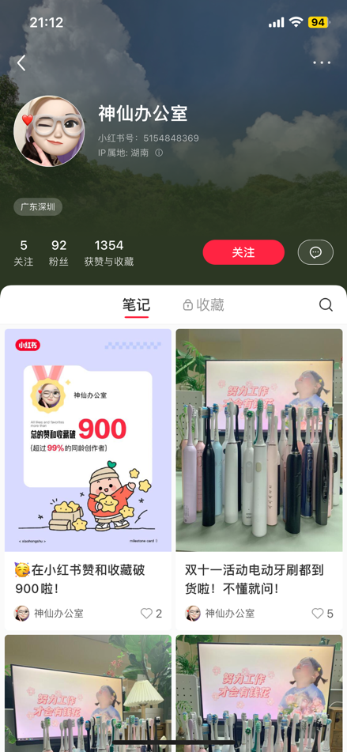

8. Low source credibility and implicit eWOM sponsorship disclosure

