Supplementary material 1
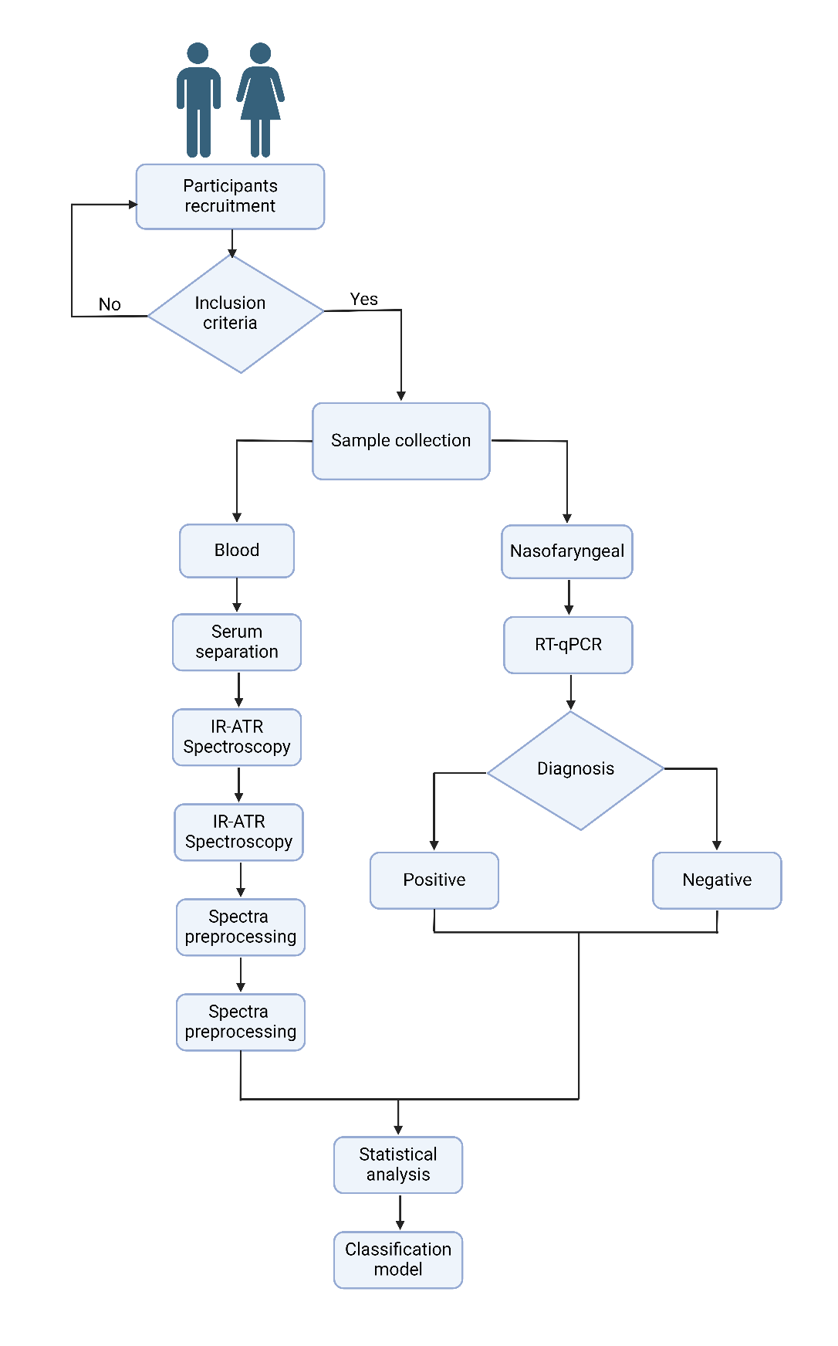
Figure 1 Supplementary material. General Methodology flow chart.

