Quantum computational, spectroscopic analysis, and Molecular Docking studies of 2-chloroethyl benzene
Km. Garima¹, Sandhya Savita^{2,7}, J. N. Cheerlin Mishma³, V.S. Jeba Reeda⁴, S. Muthu⁵, Nazia Siddiqui⁶, and Saleem Javed⁷
- Department of Chemistry, CMP College, University of Allahabad, Prayagraj, UP., 211002, India
- Department of Chemistry, Guru Ghasidas Vishwavidyalaya, Bilaspur, Chhattisgarh, 495009, India
- Department of Physics, Women’s Christian College, Nagercoil
- Department of Physics, Easwari Engineering College, Ramapuram, Chennai 600 089, Tamil Nadu, India
- Department of Physics, Arignar Anna Govt. Arts College, Cheyyar, Tamilnadu 604407, India
- Department of Chemistry, Dayalbagh Educational Institute, Agra U.P, 282005, India
- Department of Chemistry, Jamia Millia Islamia, New Delhi, 110025, Delhi, India

Corresponding Authors: dr.naazsiddiqui@gmail.com and saleem.7javed@gmail.com

Table ST1 Calculated vibrational frequencies (cm⁻¹) assignments of 2-CEB based on B3LYP/6–311++G(d,p) basis set

Mode no. | Experimental wave number (cm⁻¹) | Theoretical wave number (cm⁻¹) |  | I_{IR}^{c} | Assignments (PED)^{a,b}
Mode no. | FT-IR | Unscaled | Scaled | I_{IR}^{c} | Assignments (PED)^{a,b}
48 | 3064 | 3189 | 3065 | 26 | γ CH(65)
47 |  | 3179 | 3055 | 61 | γ CH(56)
46 |  | 3171 | 3047 | 24 | γ CH(62)
45 |  | 3162 | 3039 | 1 | γ CH(85)
44 | 3030 | 3149 | 3026 | 20 | γ CH(31)
43 |  | 3142 | 3020 | 27 | γ CH(57)
42 |  | 3086 | 2965 | 56 | γ CH(52)
41 | 2958 | 3072 | 2952 | 16 | γ CH(40)
40 | 2867 | 3018 | 2901 | 46 | γ CH(47)
39 | 1605 | 1645 | 1581 | 8 | γ CC(50) + β HCC(11)
38 |  | 1624 | 1561 | 2 | γ CC(29) + β HCC (15) + β CCC(12)
37 | 1498 | 1527 | 1468 | 21 | β HCC(37) + β CCC(11)
36 | 1454 | 1484 | 1426 | 13 | γ CC(11) + β HCC(18)
35 |  | 1480 | 1423 | 9 | β HCH(70)
34 |  | 1477 | 1420 | 22 | β HCH(68) + 𝜏 HCCC(11)
33 |  | 1371 | 1317 | 3 | β HCC(26) + 𝜏 HCCC(22)
32 |  | 1359 | 1306 | 13 | β HCC(18) + 𝜏 HCCC(17)
31 | 1293 | 1344 | 1291 | 21 | γ CC(44) + β HCC(11) + 𝜏 HCCC(19)
30 | 1247 | 1324 | 1273 | 47 | γ CC(12) + 𝜏 HCCC(29)
29 |  | 1235 | 1187 | 2 | β HCCl(28) + 𝜏 HCCC(12)
28 |  | 1217 | 1170 | 5 | γ CC(26) + β HCC(12) + β HCCl(11)
27 |  | 1204 | 1157 | 0 | γ CC(22) + β HCC(41)
26 |  | 1182 | 1136 | 0 | γ CC(15) + β HCC(42)
25 |  | 1168 | 1122 | 3 | β HCC(26) + β HCCl(24) + 𝜏 HCCC(16)
24 | 1076 | 1102 | 1059 | 13 | γ CC(37) + β HCC(17)
23 | 1032 | 1051 | 1010 | 11 | γ CC(36) + β HCC(10) + β CCC(12)
22 |  | 1028 | 988 | 12 | γ CC(41) + β CCC(10) + 𝜏 HCCC(11)
21 |  | 1018 | 978 | 0 | γ CC(38) + β CCC(57)
20 |  | 1001 | 962 | 0 | 𝜏 HCCC(29) + 𝜏 CCCC(20)
19 |  | 981 | 943 | 0 | 𝜏 HCCC(31)
18 |  | 952 | 915 | 6 | γ CC(29) + 𝜏 HCCC(13)
17 |  | 934 | 897 | 21 | 𝜏 HCCC(32)
16 |  | 900 | 865 | 14 | 𝜏 HCCC(31)
15 |  | 853 | 819 | 0 | 𝜏 HCCC(56)
14 |  | 772 | 742 | 13 | γ CC(20) + β CCC(13)
13 |  | 763 | 733 | 45 | 𝜏 HCCC(18) + 𝜏 CCCC(23)
12 | 697 | 712 | 684 | 100 | 𝜏 HCCC(46) + 𝜏 CCCC(39)
11 |  | 649 | 624 | 67 | γ ClC(77)
10 |  | 636 | 611 | 1 | β CCC(53)
09 |  | 571 | 548 | 30 | β CCC(20) + 𝜏 CCCC(10)
08 | 491 | 496 | 476 | 16 | γ CC(16) + β CCC(26) + 𝜏 CCCC(12)
07 |  | 414 | 398 | 0 | 𝜏 HCCC(18) + 𝜏 CCCC(74)
06 |  | 382 | 367 | 4 | β CCC(14) + β ClCC(28) + 𝜏 CCCC(14)
05 |  | 349 | 335 | 1 | β CCC(39) + 𝜏 HCCC(12) + 𝜏 CCCC(11)
04 |  | 222 | 213 | 0 | β CCC(14) + β ClCC(39) + 𝜏 CCCC(12)
03 |  | 150 | 144 | 5 | β CCC(11) + 𝜏 CCCC(15)
02 |  | 69 | 68 | 3 | 𝜏 ClCCC(40)
01 |  | 37 | 33 | 2 | 𝜏 CCCC(70) + 𝜏 ClCCC(18)
a γ-stretching, γa-Symmetrical stretching, γas-asymmetrical stretching, β-bending, τ -torsion, vs-very strong, s-strong, m-medium, w-weak.
b scaling factor: 0.961 for B3LYP/6-311++ G (d, p).
c Relative absorption intensities normalized with highest peak absorption equal to 100.

Table ST2 Calculated Theoretical and experimental NMR chemical Shifts of 2-CEB
Atoms | Experimental chemical shift (ppm) | Calculated chemical shift (ppm) B3LYP
7H | 7.28 | 7.58
8H | 7.36 | 7.63
9H | 7.35 | 7.61
10H | 7.24 | 7.53
11H | 7.37 | 7.65
13H | 1.55 | 2.82
14H | 3.08 | 3.15
16H | 3.75 | 4.09
17H | 3.11 | 3.66

Table ST3 Mullikan charge distribution and Fukui function corresponding to (0,1), (−1,2) and (1,2) charge and multiplicity of 2-CEB
Atom | Mulliken atomic charges |  |  | Fukui Functions
Atom | N (0, 1) | N-1(+1, 2) | N + 1 (−1, 2) | fr₊ | fr₋ | ∆f | fr₀
C1 | -0.20 | -0.11 | 1.65 | 1.85 | -0.09 | 1.94 | 0.92
C2 | -0.37 | -0.26 | 0.06 | 0.42 | -0.11 | 0.53 | 0.21
C3 | -0.70 | -0.61 | -1.53 | -0.82 | -0.10 | -0.72 | -0.41
C4 | 1.16 | 0.95 | -1.24 | -2.40 | 0.21 | -2.61 | -1.20
C5 | -0.04 | 0.10 | -0.53 | -0.49 | -0.13 | -0.35 | -0.24
C6 | -0.30 | -0.30 | 0.78 | 1.08 | 0.00 | 1.08 | 0.54
C12 | -0.19 | -0.16 | 2.02 | 2.21 | -0.03 | 2.24 | 1.10
C15 | -0.88 | -0.89 | 1.46 | 2.34 | 0.01 | 2.33 | 1.17
Cl18 | 0.04 | 0.18 | -0.29 | -0.33 | -0.15 | -0.18 | -0.16

Table ST4 Second-order perturbation theory of the Fock matrix NBO analysis of 2-CEB.
DONOR | TYPE | ED/e | ACCEPTOR | TYPE | ED/e | E(2) kcal/mol | E(j)-E(i) a.u. | u. F(i,j) a.u.
C 1 - C 2 | σ | 1.97952 | C 1 - C 6 | σ٭ | 0.01627 | 2.69 | 1.28 | 0.052
 |  |  | C 1 - H 7 | σ٭ | 0.01367 | 0.93 | 1.14 | 0.029
 |  |  | C 2 - C 3 | σ٭ | 0.01551 | 2.73 | 1.28 | 0.053
 |  |  | C 2 - H 8 | σ٭ | 0.01358 | 0.93 | 1.14 | 0.029
 |  |  | C 3 - H 9 | σ٭ | 0.01425 | 2.43 | 1.14 | 0.047
 |  |  | C 6 - H 11 | σ٭ | 0.01361 | 2.44 | 1.14 | 0.047
 |  |  | C 3 - C 4 | σ٭ | 0.34259 | 19.98 | 0.29 | 0.068
 |  |  | C 5 - C 6 | σ٭ | 0.33214 | 20.86 | 0.28 | 0.068
C 1 - C 6 | σ | 1.97937 | C 1 - C 2 | σ٭ | 0.33111 | 2.69 | 1.28 | 0.052
 |  |  | C 1 - H 7 | σ٭ | 0.01367 | 0.92 | 1.14 | 0.029
 |  |  | C 2 - H 8 | σ٭ | 0.01358 | 2.42 | 1.14 | 0.047
 |  |  | C 5 - C 6 | σ٭ | 0.33214 | 2.77 | 1.28 | 0.053
 |  |  | C 5 - H 10 | σ٭ | 0.01470 | 2.51 | 1.13 | 0.048
 |  |  | C 6 - H 11 | σ٭ | 0.01361 | 0.93 | 1.14 | 0.029
C 1 - H 7 | σ | 1.98028 | C 1 - C 2 | σ٭ | 0.33111 | 0.59 | 1.10 | 0.023
 |  |  | C 1 - C 6 | σ٭ | 0.01627 | 0.58 | 1.10 | 0.023
 |  |  | C 2 - C 3 | σ٭ | 0.01551 | 3.78 | 1.10 | 0.058
 |  |  | C 2 - H 8 | σ٭ | 0.01358 | 0.51 | 0.96 | 0.020
 |  |  | C 5 - C 6 | σ٭ | 0.33214 | 3.79 | 1.10 | 0.058
 |  |  | C 6 - H 11 | σ٭ | 0.01361 | 0.51 | 0.96 | 0.020
C 2 - C 3 | σ | 1.97835 | C 1 - C 2 | σ٭ | 0.33111 | 2.71 | 1.28 | 0.053
 |  |  | C 1 - H 7 | σ٭ | 0.01367 | 2.38 | 1.14 | 0.047
 |  |  | C 2 - H 8 | σ٭ | 0.01358 | 0.93 | 1.14 | 0.029
 |  |  | C 3 - C 4 | σ٭ | 0.34259 | 3.39 | 1.28 | 0.059
 |  |  | C 3 - H 9 | σ٭ | 0.01425 | 0.96 | 1.14 | 0.030
 |  |  | C 4 - C 12 | σ٭ | 0.02345 | 3.74 | 1.11 | 0.058
C 2 - H 8 | σ | 1.98033 | C 1 - C 2 | σ٭ | 0.33111 | 0.57 | 1.10 | 0.022
 |  |  | C 1 - C 6 | σ٭ | 0.01627 | 3.70 | 1.10 | 0.057
 |  |  | C 1 - H 7 | σ٭ | 0.01367 | 0.52 | 0.96 | 0.020
 |  |  | C 2 - C 3 | σ٭ | 0.01551 | 0.59 | 1.10 | 0.023
 |  |  | C 3 - C 4 | σ٭ | 0.34259 | 3.79 | 1.10 | 0.058
C 3 - C 4 | σ | 1.97327 | C 2 - C 3 | σ٭ | 0.01551 | 3.10 | 1.28 | 0.056
 |  |  | C 2 - H 8 | σ٭ | 0.01358 | 2.10 | 1.14 | 0.044
 |  |  | C 3 - H 9 | σ٭ | 0.01425 | 0.98 | 1.14 | 0.030
 |  |  | C 4 - C 5 | σ٭ | 0.02487 | 3.48 | 1.27 | 0.059
 |  |  | C 4 - C 12 | σ٭ | 0.02345 | 1.85 | 1.11 | 0.041
 |  |  | C 5 - H 10 | σ٭ | 0.01470 | 2.56 | 1.13 | 0.048
 |  |  | C 12 - H 14 | σ٭ | 0.01412 | 0.54 | 1.08 | 0.022
 |  |  | C 1 - C 2 | σ٭ | 0.33111 | 20.89 | 0.28 | 0.069
 |  |  | C 5 - C 6 | σ٭ | 0.33214 | 20.26 | 0.28 | 0.067
 |  |  | C 12 - H 14 | σ٭ | 0.01412 | 1.45 | 0.63 | 0.030
 |  |  | C 12 - C 15 | σ٭ | 0.02423 | 3.46 | 0.61 | 0.045
C 3 - H 9 | σ | 1.97915 | C 1 - C 2 | σ٭ | 0.33111 | 3.71 | 1.09 | 0.057
 |  |  | C 2 - C 3 | σ٭ | 0.01551 | 0.65 | 1.09 | 0.024
 |  |  | C 2 - H 8 | σ٭ | 0.01358 | 0.56 | 0.96 | 0.021
 |  |  | C 3 - C 4 | σ٭ | 0.34259 | 0.86 | 1.09 | 0.027
 |  |  | C 4 - C 5 | σ٭ | 0.02487 | 4.72 | 1.09 | 0.064
C 4 - C 5 | σ | 1.97331 | C 3 - C 4 | σ٭ | 0.34259 | 3.41 | 1.27 | 0.059
 |  |  | C 3 - H 9 | σ٭ | 0.01425 | 2.49 | 1.14 | 0.048
 |  |  | C 4 - C 12 | σ٭ | 0.02345 | 1.78 | 1.11 | 0.040
 |  |  | C 5 - C 6 | σ٭ | 0.33214 | 3.19 | 1.27 | 0.057
 |  |  | C 5 - H 10 | σ٭ | 0.01470 | 0.95 | 1.13 | 0.029
 |  |  | C 6 - H 11 | σ٭ | 0.01361 | 2.12 | 1.14 | 0.044
 |  |  | C 12 - H 13 | σ٭ | 0.01361 | 0.71 | 1.09 | 0.025
C 4 - C 12 | σ | 1.97730 | C 2 - C 3 | σ٭ | 0.01551 | 2.32 | 1.21 | 0.047
 |  |  | C 3 - C 4 | σ٭ | 0.34259 | 1.95 | 1.21 | 0.043
 |  |  | C 4 - C 5 | σ٭ | 0.02487 | 1.88 | 1.21 | 0.043
 |  |  | C 5 - C 6 | σ٭ | 0.33214 | 2.35 | 1.21 | 0.048
 |  |  | C 12 - H 13 | σ٭ | 0.01361 | 0.57 | 1.02 | 0.022
 |  |  | C 12 - H 14 | σ٭ | 0.01412 | 0.58 | 1.01 | 0.022
 |  |  | C 12 - C 15 | σ٭ | 0.02423 | 0.95 | 1.00 | 0.027
 |  |  | C 15 - H 16 | σ٭ | 0.01812 | 1.18 | 1.02 | 0.031
C 5 - C 6 | σ | 1.97837 | C 1 - C 6 | σ٭ | 0.01627 | 2.71 | 1.28 | 0.053
 |  |  | C 1 - H 7 | σ٭ | 0.01367 | 2.37 | 1.14 | 0047
 |  |  | C 4 - C 5 | σ٭ | 0.02487 | 3.48 | 127 | 0.060
 |  |  | C 4 - C 12 | σ٭ | 0.02345 | 3.64 | 1.11 | 0.057
 |  |  | C 5 - H 10 | σ٭ | 0.01470 | 0.98 | 1.13 | 0.030
 |  |  | C 6 - H 11 | σ٭ | 0.01361 | 0.94 | 1.14 | 0.029
 |  |  | C 1 - C 2 | σ٭ | 0.33111 | 19.76 | 0.28 | 0.067
 |  |  | C 3 - C 4 | σ٭ | 0.34259 | 20.84 | 0.29 | 0.070
C 5 - H 10 | σ | 1.97945 | C 1 - C 6 | σ٭ | 0.01627 | 3.67 | 1.10 | 0.057
 |  |  | C 3 - C 4 | σ٭ | 0.34259 | 4.62 | 1.10 | 0.064
 |  |  | C 4 - C 5 | σ٭ | 0.02487 | 0.80 | 1.09 | 0.026
 |  |  | C 5 - C 6 | σ٭ | 0.33214 | 0.63 | 1.10 | 0.024
 |  |  | C 6 - H 11 | σ٭ | 0.01361 | 0.53 | 0.96 | 0.020
C 6 - H 11 | σ | 1.98046 | C 1 - C 2 | σ٭ | 0.33111 | 3.64 | 1.10 | 0.057
 |  |  | C 1 - C 6 | σ٭ | 0.01627 | 0.58 | 1.10 | 0.022
 |  |  | C 1 - H 7 | σ٭ | 0.01367 | 0.51 | 0.96 | 0.020
 |  |  | C 4 - C 5 | σ٭ | 0.02487 | 3.79 | 1.09 | 0.058
 |  |  | C 5 - C 6 | σ٭ | 0.33214 | 0.59 | 1.10 | 0.023
C 12 - H 13 | σ | 1.97763 | C 3 - C 4 | σ٭ | 0.34259 | 0.59 | 0.54 | 0.017
 |  |  | C 4 - C 5 | σ٭ | 0.02487 | 3.83 | 1.08 | 0.058
 |  |  | C 15 - H 17 | σ٭ | 0.02013 | 2.76 | 0.89 | 0.044
C 12 - H 14 | σ | 1.96193 | C 3 - C 4 | σ٭ | 0.34259 | 3.33 | 1.08 | 0.054
 |  |  | C 3 - C 4 | σ٭ | 0.34259 | 1.66 | 0.54 | 0.029
 |  |  | C 15 -Cl 18 | σ٭ | 0.02649 | 5.93 | 0.60 | 0.053
C 12 - H 15 | σ | 1.98228 | C 3 - C 4 | σ٭ | 0.34259 | 0.74 | 1.22 | 0.027
 |  |  | C 3 - C 4 | σ٭ | 0.34259 | 2.06 | 0.68 | 0.036
 |  |  | C 4 - C 12 | σ٭ | 0.02345 | 1.16 | 1.06 | 0.031
C 15 - H 16 | σ | 1.98678 | C 4 - C 12 | σ٭ | 0.02345 | 2.96 | 0.95 | 0.048
 |  |  | C 15 -Cl 18 | σ٭ | 0.02649 | 0.98 | 0.63 | 0.022
C 15 - H 17 | σ | 1.98758 | C 12 - H 13 | σ٭ | 0.01361 | 2.49 | 0.93 | 0.043
 |  |  | C 15 -Cl 18 | σ٭ | 0.02649 | 1.09 | 0.63 | 0.024
C 15 -Cl 18 | σ | 1.99058 | C 12 - H 14 | σ٭ | 0.01412 | 1.56 | 1.03 | 0.036
Cl 18 (LP 1) |  | 1.97811 | C 15 - H 16 | σ٭ | 0.01812 | 2.41 | 0.70 | 0.037
 |  |  | C 15 - H 17 | σ٭ | 0.02013 | 3.58 | 0.70 | 0.045
Cl 18 (LP 2) |  | 1.97360 | C 12 - H 14 | σ٭ | 0.01412 | 0.70 | 0.69 | 0.020
 |  |  | C 12 - C 15 | π٭ | 0.02423 | 3.73 | 0.68 | 0.045
 |  |  | C 15 - H 16 | σ٭ | 0.01812 | 1.51 | 0.70 | 0.029
C 3 - C 4 | π | 0.34259 | C 12 - H 14 | π٭ | 0.01412 | 0.55 | 0.34 | 0.029
 |  |  | C 12 - C 15 | π٭ | 0.02423 | 1.67 | 0.33 | 0.049

Table ST5 Hybrid, Polarization coefficient and Atomic Orbital contribution in selected Natural Bond Orbitals of 2-CEB.
Bond Orbital | Hybrid A (hA) | Atomic Orbital (%) | Polarization Coefficient (cA) | Hybrid B (hB) | Atomic Orbital (%) | Polarization Coefficient (cB)
C 1 - C 2 | sp^{1.80} | s( 35.73%)p 1.80( 64.23%)d 0.00( 0.04%) | 0.7068 | sp^{1.79} | s( 35.81%)p 1.79( 64.15%)d 0.00( 0.04%) | 0.7074
C 1 - C 6 | sp^{1.80} | s( 35.66%)p 1.80( 64.30%)d 0.00( 0.04%) | 0.7064 | sp^{1.79} | s( 35.81%)p 1.79( 64.14%)d 0.00( 0.04%) | 0.7078
C 1 - H 7 | sp^{2.49} | s( 28.61%)p 2.49( 71.34%)d 0.00( 0.04%) | 0.7766 | sp^{0.00} | s( 99.95%)p 0.00( 0.05%) | 0.6299
C 2 - C 3 | sp^{1.79} | s( 35.84%)p 1.79( 64.12%)d 0.00( 0.04%) | 0.7057 | sp^{1.80} | s( 35.70%)p 1.80( 64.25%)d 0.00( 0.04%) | 0.7085
C 2 - H 8 | sp^{2.53} | s( 28.36%)p 2.53( 71.60%)d 0.00( 0.04%) | 0.7767 | sp^{0.00} | s( 99.95%)p 0.00( 0.05%) | 0.6299
C 3 - C 4 | sp^{1.78} | s( 35.97%)p 1.78( 63.99%)d 0.00( 0.04%) | 0.7018 | sp^{1.89} | s( 34.60%)p 1.89( 65.36%)d 0.00( 0.04%) | 0.7124
C 3 - H 9 | sp^{2.53} | s( 28.31%)p 2.53( 71.64%)d 0.00( 0.04%) | 0.7777 | sp^{0.00} | s( 99.95%)p 0.00( 0.05%) | 0.6287
C 4 - C 5 | sp^{1.92} | s( 34.22%)p 1.92( 65.74%)d 0.00( 0.04%) | 0.7113 | sp^{1.77} | s( 36.10%)p 1.77( 63.87%)d 0.00( 0.04%) | 0.7029
C 4 - C 12 | sp^{2.21} | s( 31.16%)p 2.21( 68.82%)d 0.00( 0.03%) | 0.7063 | sp^{2.38} | s( 29.59%)p 2.38( 70.37%)d 0.00( 0.04%) | 0.7080
C 5 - C 6 | sp^{1.78} | s( 35.90%)p 1.78( 64.06%)d 0.00( 0.04%) | 0.7091 | sp^{1.79} | s( 35.82%)p 1.79( 64.13%)d 0.00( 0.04%) | 0.7051
C 5 - H 10 | sp^{2.57} | s( 28.00%)p 2.57( 71.96%)d 0.00( 0.04%) | 0.7749 | sp^{0.00} | s( 99.95%)p 0.00( 0.05%) | 0.6321
C 6 - H 11 | sp^{2.52} | s( 28.37%)p 2.52( 71.59%)d 0.00( 0.04%) | 0.7765 | sp^{0.00} | s( 99.95%)p 0.00( 0.05%) | 0.6302
C 12 - H 13 | sp^{3.48} | s( 22.29%)p 3.48( 77.65%)d 0.00( 0.06%) | 0.7801 | sp^{0.00} | s( 99.97%)p 0.00( 0.03%) | 0.6256
C 12 - H 14 | sp^{3.69} | s( 21.30%)p 3.69( 78.63%)d 0.00( 0.07%) | 0.7783 | sp^{0.00} | s( 99.96%)p 0.00( 0.04%) | 0.6279
C 12 - C 15 | sp^{2.72} | s( 26.89%)p 2.72( 73.07%)d 0.00( 0.04%) | 0.7056 | sp^{2.13} | s( 31.97%)p 2.13( 68.00%)d 0.00( 0.04%) | 0.7087
C 15 - H 16 | sp^{3.03} | s( 24.78%)p 3.03( 75.14%)d 0.00( 0.08%) | 0.7778 | sp^{0.00} | s( 99.96%)p 0.00( 0.04%) | 0.6285
C 15 - H 17 | sp^{2.98} | s( 25.09%)p 2.98( 74.84%)d 0.00( 0.08%) | 0.7783 | sp^{0.00} | s( 99.96%)p 0.00( 0.04%) | 0.6279
C 15 -Cl 18 | sp^{4.47} | s( 18.24%)p 4.47( 81.58%)d 0.01( 0.18%) | 0.6611 | sp^{5.69} | s( 14.86%)p 5.69( 84.64%)d 0.03( 0.49%) | 0.7503
Cl 18 (LP 1) | sp^{99.99} | s( 0.02%)p99.99( 99.96%)d 0.62( 0.02%) | -- | -- | -- | --
Cl 18 (LP 2) | sp^{99.99} | s( 0.56%)p99.99( 99.42%)d 0.03( 0.02%) | -- | -- | -- | --

Table ST6 Natural Hybrid Orbital directionality and bond bending (deviations from line of nuclear centers) of 2-CEB.
Bond Orbital | Deviation angle (°) |  | Line of centers
Bond Orbital | Hybrid A | Hybrid B | Polar (ϴ) | Azimuthal (ɸ)
C 1 - C 2 | 89.9 | 89.9 | 59.2 | 315.0
C 1 - C 6 | -- | 1.1 | 100.8 | 73.2
C 2 - C 3 | 1.4 | -- | 71.2 | 20.5
C 3 - C 4 | 90.1 | 89.4 | 100.6 | 72.6
C 4 - C 12 | -- | 1.6 | 71.7 | 20.6
C 5 - C 6 | 89.8 | 89.9 | 109.0 | 200.3
C 12 - C 15 | 3.1 | 4.0 | 133.7 | 358.7
C 15 -Cl 18 | 2.6 | -- | 104.1 | 286.8
Cl 18 (LP 1) | -- | -- | -- | --
Cl 18 (LP 2) | -- | -- | -- | --

Supplementary Figures

Fig. S1 Quadratic equation plot representing the dependence of entropy, Gibbs free enthalpy and enthalpy on temperature of 2-CEB
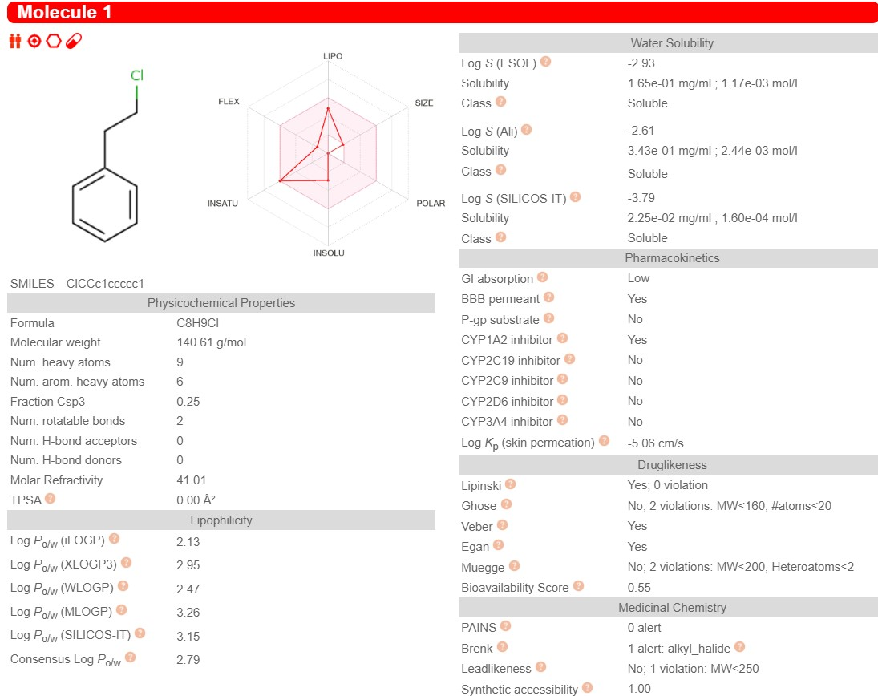
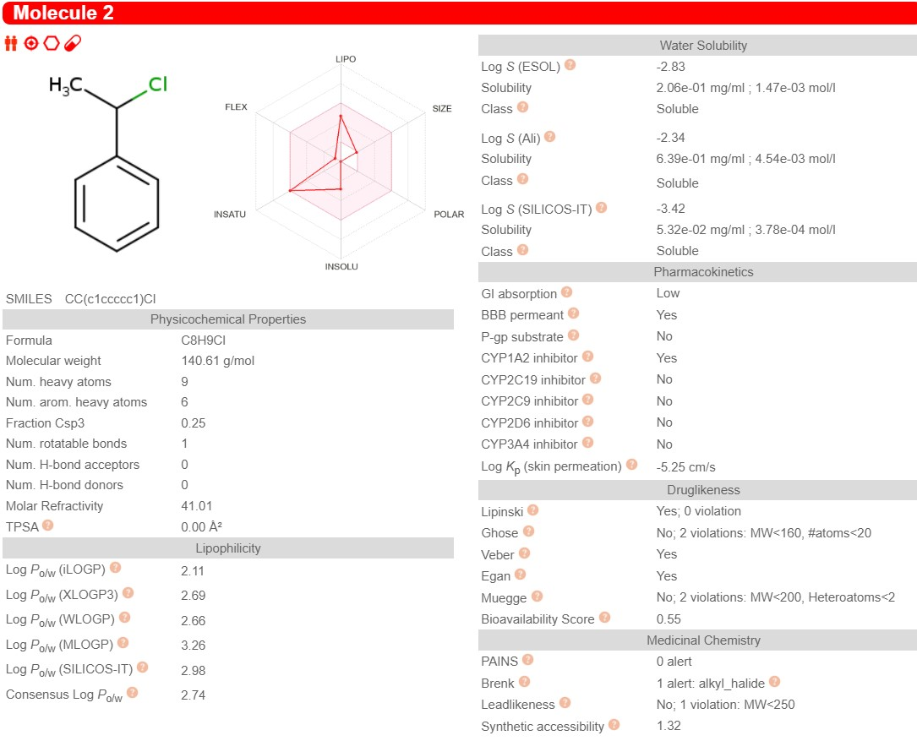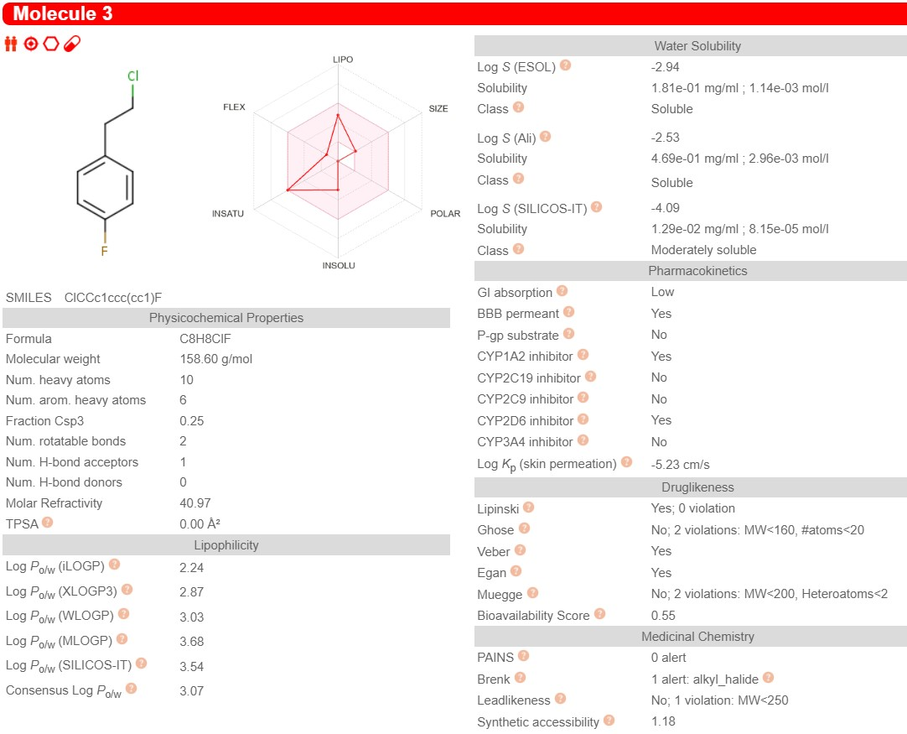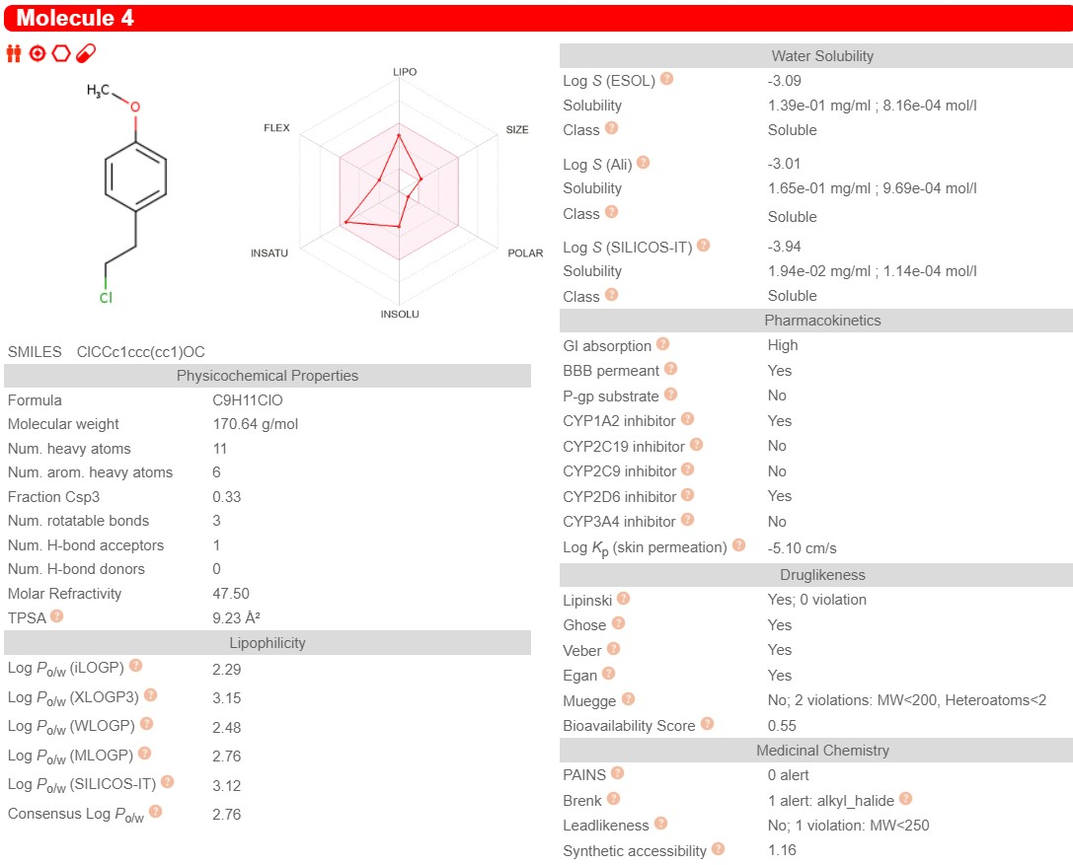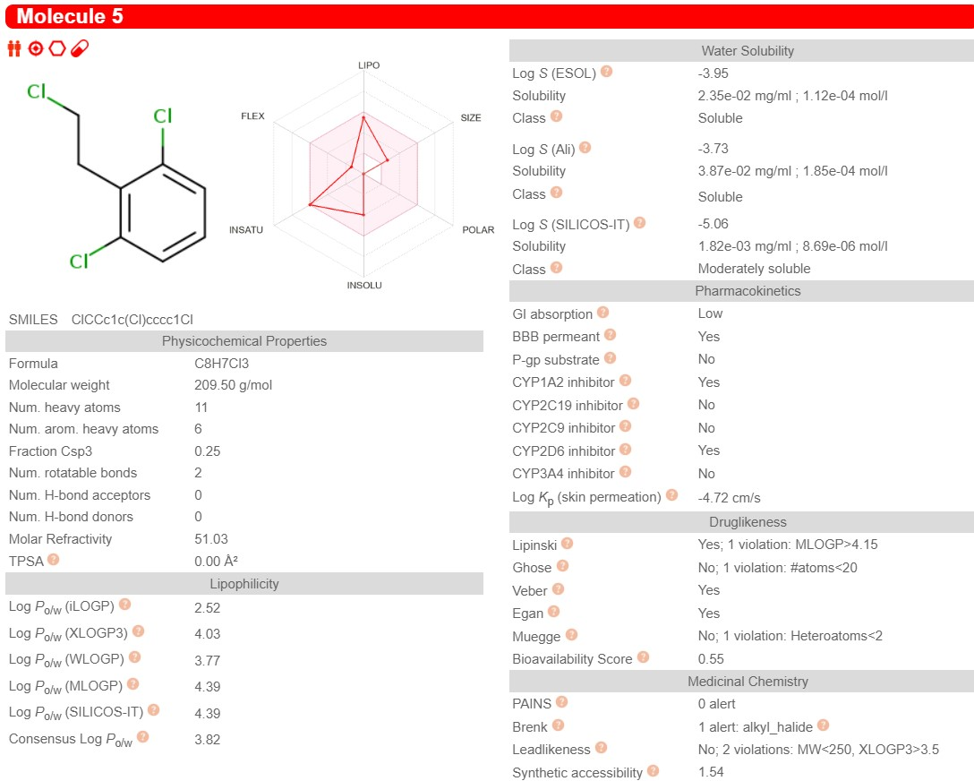

Fig. S2 ADME properties of 2-CEB and its derivatives

