Physicochemical, biological, and toxicological studies of Pyridine and its derivatives: An in-silico approach
Md. Byzed Hasan^{1, 8}, Md. Jubaer Rahman ^{2, 8}, Rahul Das^{3, 8}, Tawhida Akter^{4, 8}, Md. Sinbad Hosen^{5, 8}, Umme Mahfuza Parvin Kona^{6, 8}, Monir Uzzaman^{7, 8, 9*}
¹Department of Chemistry, Pabna University of Science and Technology, Pabna-6600, Pabna, Bangladesh
²Department of Theoretical and Computational Chemistry, University of Dhaka, Dhaka-1100, Dhaka, Bangladesh
³Department of Chemistry, Feni Govt. College, National University, Gazipur-1704, Dhaka, Bangladesh
⁴Department of Pharmacy, Comilla University, Cumilla-3506, Cumilla, Bangladesh
⁵Department of Biochemistry & Molecular Biology, Noakhali Science and Technology University, Noakhali-3814, Noakhali, Bangladesh
⁶Department of Pharmacy, Jahangirnagar University, Savar, Dhaka-1342, Dhaka, Bangladesh
⁷Department of Chemistry, University of Chittagong, Chittagong-4331, Chittagong, Bangladesh
⁸Department of Drug Design, Computers in Chemistry and Medicine Laboratory, Dhaka, Bangladesh
⁹Department of Applied Chemistry, Graduate School of Engineering, Mie University, Tsu, Mie 514-8507, Japan

Correspondence: monircu92@gmail.com; byzed.che040@gmail.com.

Table of contents
- Optimized geometry structures of the analyzed pyridine derivatives.…………..……...[2]
- HOMO-LUMO energy gap (eV), hardness (𝜂), softness (S), and chemical potential (𝜇) of the investigated pyridine derivatives.………………………..…..……………….…..…[2]
- Molecular electrostatic potential map of the analyzed pyridine derivatives……………[3]
- FT-IR spectral data of pyridine and its analyzed derivatives……..…………………..[4-6]
- FT-IR spectra of (a) P1, P2, and P3, (b) P5, P6, and P8, and (c) P9, P10, and P12, illustrating their characteristic functional group vibrations…………………………..…[7]
- UV-Vis spectral data of pyridine and its investigated derivatives………………...…..[8-9]
- UV-Visible spectra of some pyridine derivatives analyzed in this study.…...….……….[9]
- Superimposed 3D structures of redocked (S)-enastron and co-crystallized (S)-enastron: (a) alignment within the binding pocket of 2X7C and (b) alignment visualized without the protein.………………………………………………………………………..…….[10]
- Docked conformations and molecular interactions of (a) P1, P2, P3, P5, and P6, and (b) P8, P9, P10, and P12 at the inhibition binding site of receptor protein 2X7C…………[10]

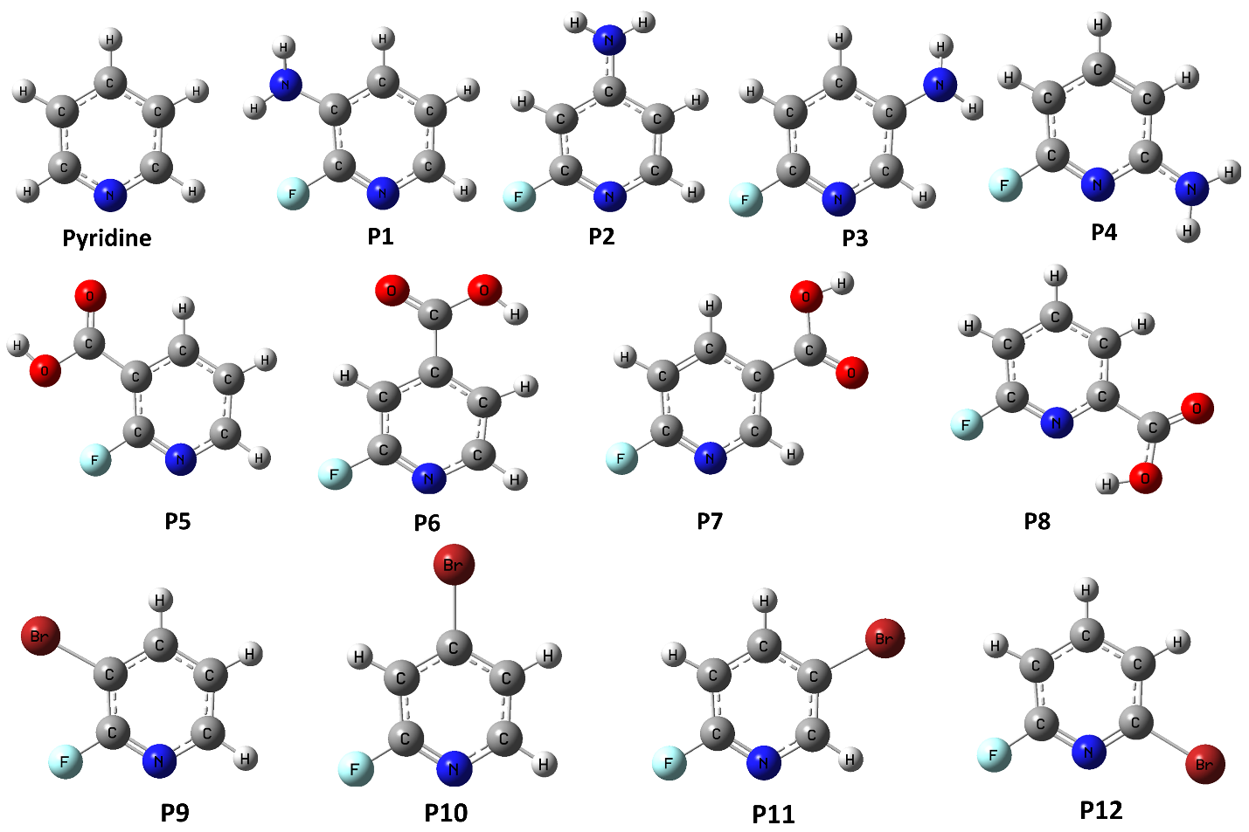

Fig. S1. Optimized geometry structures of the analyzed pyridine derivatives.

Table S1. HOMO-LUMO energy gap (eV), hardness (𝜂), softness (S), and chemical potential (𝜇) of the investigated pyridine derivatives.
Name | εHOMO | εLUMO | Gap | η | S | μ
Pyr | -7.223 | -1.133 | 6.089 | 3.045 | 0.164 | -4.178
P1 | -6.230 | -1.085 | 5.145 | 2.573 | 0.194 | -3.658
P2 | -6.797 | -0.893 | 5.904 | 2.952 | 0.169 | -3.845
P3 | -6.055 | -1.155 | 4.900 | 2.450 | 0.204 | -3.605
P4 | -6.220 | -0.890 | 5.330 | 2.660 | 0.187 | -3.550
P5 | -7.891 | -2.367 | 5.524 | 2.762 | 0.181 | -5.130
P6 | -8.109 | -2.776 | 5.333 | 2.667 | 0.187 | -5.450
P7 | -8.218 | -2.340 | 5.878 | 2.939 | 0.170 | -5.280
P8 | -7.865 | -2.430 | 5.435 | 2.717 | 0.183 | -5.140
P9 | -7.390 | -1.750 | 5.650 | 2.820 | 0.176 | -4.570
P10 | -7.858 | -1.767 | 6.091 | 3.046 | 0.164 | -4.813
P11 | -7.359 | -1.815 | 5.544 | 2.772 | 0.180 | -4.587
P12 | -7.380 | -1.730 | 5.650 | 2.830 | 0.176 | -4.560

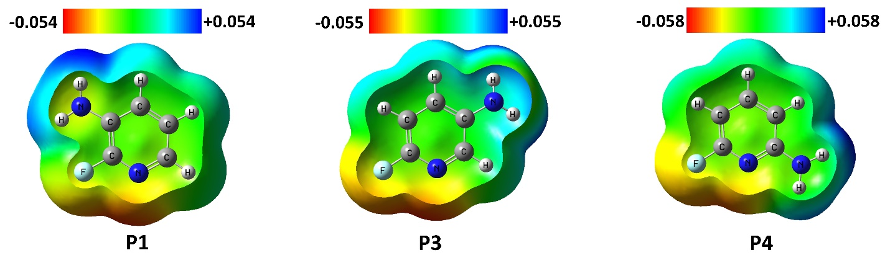
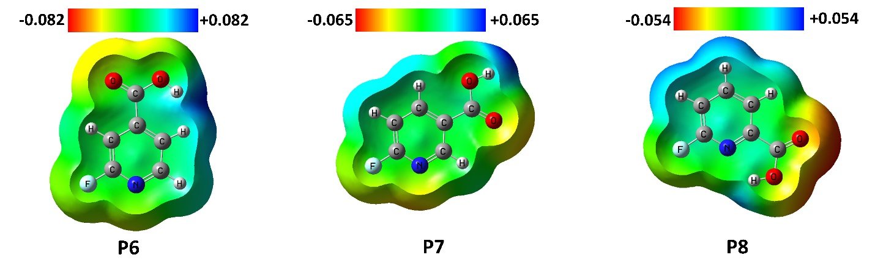
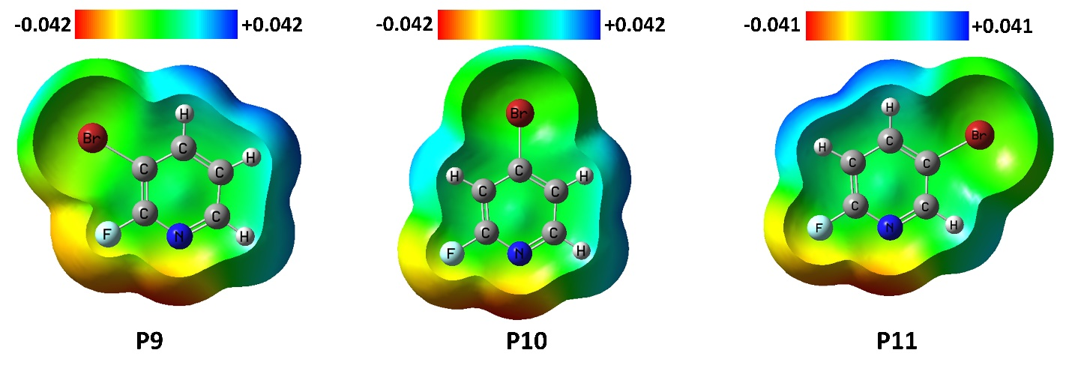

Fig. S2. Molecular electrostatic potential map of the analyzed pyridine derivatives.

Table S2. FT-IR spectral data of pyridine and its analyzed derivatives.
Name | Assignment | FT-IR vibrational frequency (cm⁻¹)
Name | Assignment | Calculated | Scaled
Pyr | νC-H ^{bend}  νC-H ^{stretch} | 714-954  3146-3192 | 692-924  3048-3092
Pyr | νC=C ^{stretch} | 1617 | 1566
Pyr | νC=N ^{stretch} | 1623 | 1572
P1 | νC-F ^{stretch} | 1224 | 1186
P1 | νC-H ^{bend}  νC-H ^{stretch} | 800-965  3166-3196 | 775-935  3067 -3096
P1 | νC=C ^{stretch} | 1496-1614 | 1449-1564
P1 | νC=N ^{stretch} | 1635 | 1584
P1 | νC-N ^{stretch} | 1327 | 1286
P1 | νN-H ^{stretch} | 3578-3682 | 3466-3567
P2 | νC-F ^{stretc88h} | 1188 | 1151
P2 | νC-H ^{bend}  νC-H ^{stretch} | 821-842  3159-3195 | 795-816  3060-3095
P2 | νC=C ^{stretch} | 1465 | 1419
P2 | νC=N ^{stretch} | 1612 | 1562
P2 | νC-N ^{stretch} | 1361 | 1318
P2 | νN-H ^{stretch} | 3592-3698 | 3480-3583
P3 | νC-F ^{stretch} | 1262 | 1223
P3 | νC-H ^{bend}  νC-H ^{stretch} | 837  3141-3207 | 811  3043-3107
P3 | νC=C ^{stretch} | 1447-1627 | 1402-1576
P3 | νC=N ^{stretch} | 1639 | 1588
P3 | νC-N ^{stretch} | 1307 | 1266
P3 | νN-H ^{stretch} | 3567-3663 | 3456-3549
P4 | νC-F ^{stretch} | 1256 | 1217
P4 | νC-H ^{bend}  νC-H ^{stretch} | 793-846  3173-3222 | 768-820  3074-3121
P4 | νC=C ^{stretch} | 1480-1609 | 1434-1559
P4 | νC=N ^{stretch} | 1660 | 1608
P4 | νC-N ^{stretch} | 1367 | 1324
P4 | νN-H ^{stretch} | 3624-3756 | 3511-3639
P5 | νC-F ^{stretch} | 1254 | 1215
P5 | νC-H ^{bend}  νC-H ^{stretch} | 834  3165-3208 | 808  3066-3108
P5 | νC=C ^{stretch} | 1463-1606 | 1417-1556
P5 | νC=N ^{stretch} | 1639 | 1588
P5 | νC=O ^{stretch} | 1777 | 1721
P5 | νO-H ^{stretch} | 3757 | 3640
P6 | νC-F ^{stretch} | 1268 | 1228
P6 | νC-H ^{bend}  νC-H ^{stretch} | 818-922  3162-3224 | 792-893  3063-3123
P6 | νC=C ^{stretch} | 1433-1606 | 1388-1556
P6 | νC=N ^{stretch} | 1639 | 1588
P6 | νC=O ^{stretch} | 1824 | 1767
P6 | νO-H ^{stretch} | 3822 | 3703
P7 | νC-F ^{stretch} | 1274 | 1234
P7 | νC-H ^{bend}  νC-H ^{stretch} | 855  3190-3217 | 828  3090 -3117
P7 | νC=C ^{stretch} | 1620 | 1569
P7 | νC=N ^{stretch} | 1632 | 1581
P7 | νC=O ^{stretch} | 1794 | 1738
P7 | νO-H ^{stretch} | 3767 | 3649
P8 | νC-F ^{stretch} | 1290 | 1250
P8 | νC-H ^{bend}  νC-H ^{stretch} | 837  3188-3220 | 811  3088-3119
P8 | νC=C ^{stretch} | 1463-1618 | 1417-1567
P8 | νC=N ^{stretch} | 1639 | 1588
P8 | νC=O ^{stretch} | 1827 | 1770
P8 | νO-H ^{stretch} | 3632 | 3519
P9 | νC-Br ^{stretch} | 670 | 649
P9 | νC-F ^{stretch} | 1293 | 1253
P9 | νC-H ^{bend}  νC-H ^{stretch} | 806  3171-3206 | 780.8528  3073-3106
P9 | νC=C ^{stretch} | 1458-1605 | 1412-1555
P9 | νC=N ^{stretch} | 1614 | 1564
P10 | νC-Br ^{stretch} | 690 | 668
P10 | νC-F ^{stretch} | 1244 | 1205
P10 | νC-H ^{bend}  νC-H ^{stretch} | 834  3168-3224 | 808  3069-3123
P10 | νC=C ^{stretch} | 1416-1602 | 1372-1552
P10 | νC=N ^{stretch} | 1613 | 1563
P11 | νC-Br ^{stretch} | 623 | 603
P11 | νC-F ^{stretch} | 1268 | 1228
P11 | νC-H ^{bend}  νC-H ^{stretch} | 841  3184-3213 | 815  3085-3113
P11 | νC=C ^{stretch} | 1609 | 1559
P11 | νC=N ^{stretch} | 1619 | 1568
P12 | νC-Br ^{stretch} | 678 | 657
P12 | νC-F ^{stretch} | 1278 | 1238
P12 | νC-H ^{bend}  νC-H ^{stretch} | 803  3184-3217 | 778  3085-3117
P12 | νC=C ^{stretch} | 1443-1612 | 1398-1562
P12 | νC=N ^{stretch} | 1617 | 1566

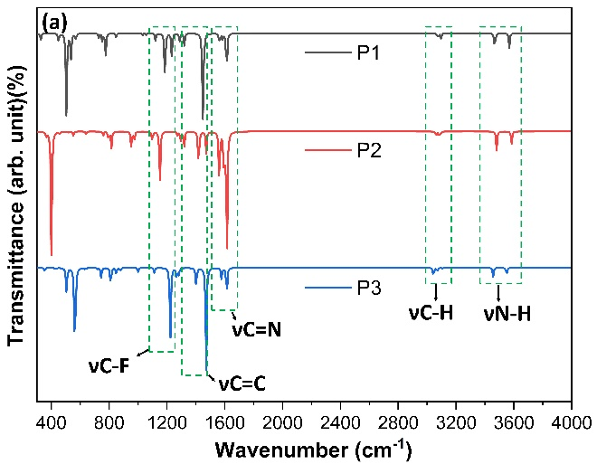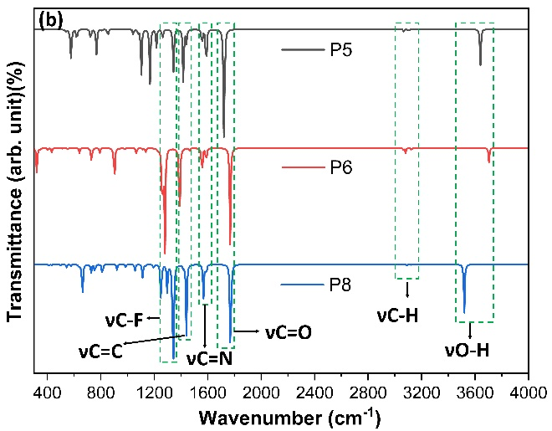
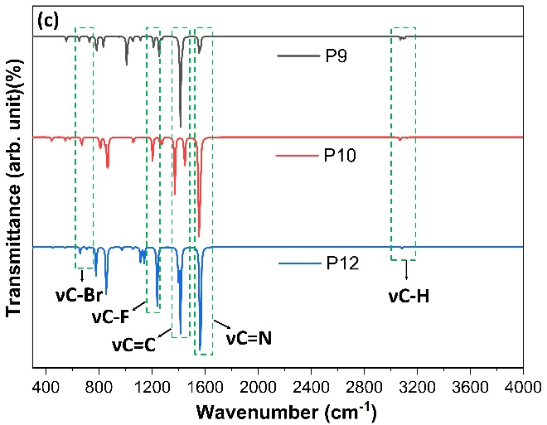
Fig. S3. FT-IR spectra of (a) P1, P2, and P3, (b) P5, P6, and P8, and (c) P9, P10, and P12, illustrating their characteristic functional group vibrations.

Table S3. UV-Vis spectral data of pyridine and its investigated derivatives.

Name | Excited state | Wavelength (nm) | Excitation energy (eV) | Configuration’s composition | Oscillator strength
Pyridine | S₀→S₁ | 259.41 | 4.7794 | 0.70547 (H→L) | 0.0044
Pyridine | S₀→S₂ | 244.70 | 5.0669 | 0.70617 (H→L+1) | 0.0000
P1 | S₀→S₁ | 284.56 | 4.3570 | -0.14672 (H-2→L+2),  0.67992 (H→L) | 0.0769
P1 | S₀→S₂ | 259.82 | 4.7719 | 0.66608 (H→L+1),  0.20904 (H→L+2) | 0.0057
P2 | S₀→S₁ | 256.44 | 4.8348 | -0.10479 (H-2→L),  -0.14310 (H-2→L+1),  0.19238 (H-2→L+2),  0.61860 (H→L),  -0.14988 (H→L+1),  0.12095 (H→L+2) | 0.0192
P2 | S₀→S₂ | 250.59 | 4.9476 | -0.17282 (H-2→L),  0.66733 (H-1→L),  -0.11249 (H-1→L+1) | 0.0011
P3 | S₀→S₁ | 283.13 | 4.3791 | -0.13072 (H-2→L+1),  0.69000 (H→L), | 0.0574
P3 | S₀→S₂ | 257.87 | 4.8080 | 0.68907 (H→L+1)  0.13305 (H→L+2), | 0.0058
P4 | S₀→S₁ | 280.05 | 4.4272 | -0.15303 (H-2→L+1),  0.68803 (H→L) | 0.0970
P4 | S₀→S₂ | 238.59 | 5.1965 | 0.69914 (H→L+2) | 0.0027
P5 | S₀→S₁ | 274.78 | 4.5122 | 0.69351 (H-1→L) | 0.0005
P5 | S₀→S₂ | 257.23 | 4.8199 | 0.69231 (H-2 → L),  -0.10467 (H-1→L+5) | 0.0007
P6 | S₀→S₁ | 328.89 | 3.7697 | 0.69500 (H-1→L),  0.10672 (H-1→L) | 0.0000
P6 | S₀→S₂ | 303.92 | 4.0795 | 0.70009 (H-2 → L), | 0.0017
P7 | S₀→S₁ | 319.45 | 3.8811 | 0.69462 (H→L) | 0.0000
P7 | S₀→S₂ | 269.39 | 4.6024 | 0.67680 (H-2 → L),  -0.11339 (H-2→L+1),  0.13334 (H→L+1) | 0.0001
P8 | S₀→S₁ | 331.88 | 3.7358 | 0.69807 (H→L) | 0.0002
P8 | S₀→S₂ | 292.09 | 4.2447 | 0.69940 (H-2→L) | 0.0009
P9 | S₀→S₁ | 246.90 | 5.0216 | -0.18176 (H-2→L+1),  0.64839 (H→L),  -0.16236 (H→L+1) | 0.0950
P9 | S₀→S₂ | 239.65 | 5.1736 | 0.17479 (H-3→L),  0.68282 (H-1→L) | 0.0039
P10 | S₀→S₁ | 236.22 | 5.2487 | 0.70085 (H-2→L) | 0.0037
P10 | S₀→S₂ | 234.93 | 5.2775 | 0.10323 (H-4→L+1),  -0.35177 (H-1→L+1),  0.59147 (H→L) | 0.0415
P11 | S₀→S₁ | 254.11 | 4.8791 | -0.18249 (H-2→L+1),  0.67664 (H→L) | 0.0416
P11 | S₀→S₂ | 239.75 | 5.1714 | 0.18775 (H-3→L),  0.67878 (H-1→L) | 0.0042
P12 | S₀→S₁ | 246.63 | 5.0271 | 0.10848 (H-4→L+1),  -0.16784 (H-3→L+1),  0.65487 (H→L),  -0.15153 (H→L+1) | 0.1035
P12 | S₀→S₂ | 229.00 | 5.4141 | 0.42592 (H-2→L),  0.55811 (H-1→L) | 0.0025

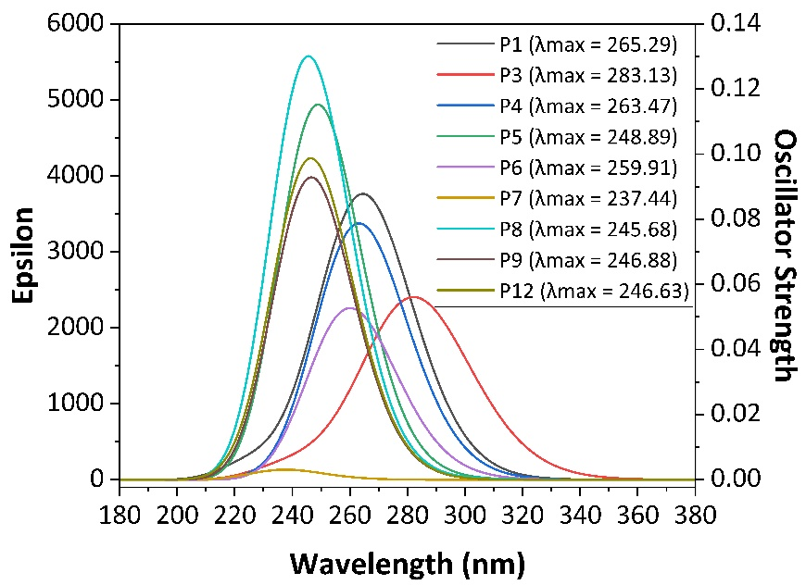
Fig. S4. UV-Visible spectra of some pyridine derivatives analyzed in this study.
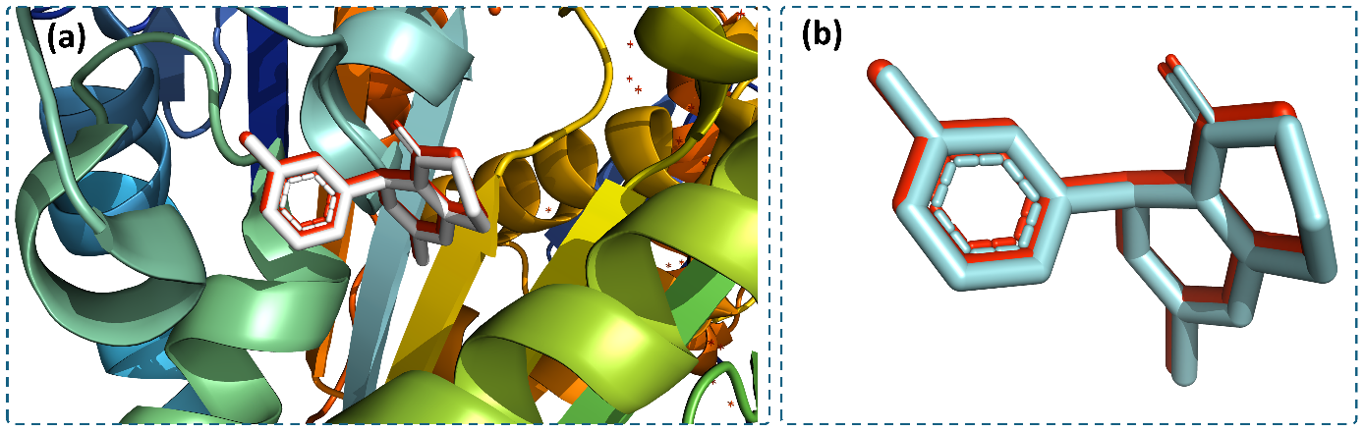
Fig. S5. Superimposed 3D structures of redocked (S)-enastron and co-crystallized (S)-enastron: (a) alignment within the binding pocket of 2X7C and (b) alignment visualized without the protein.
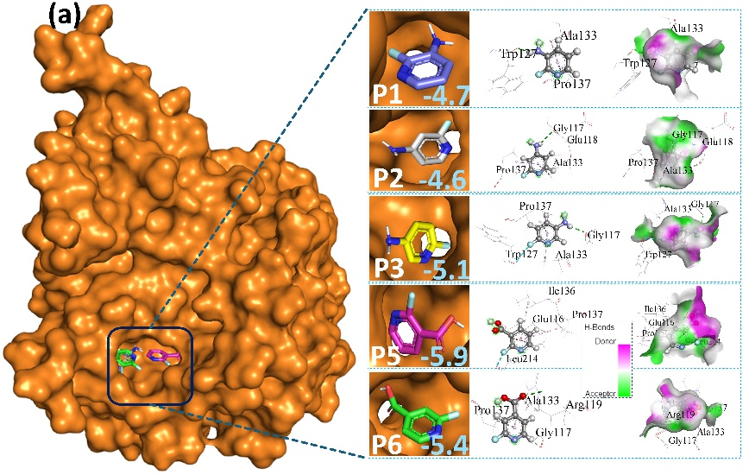
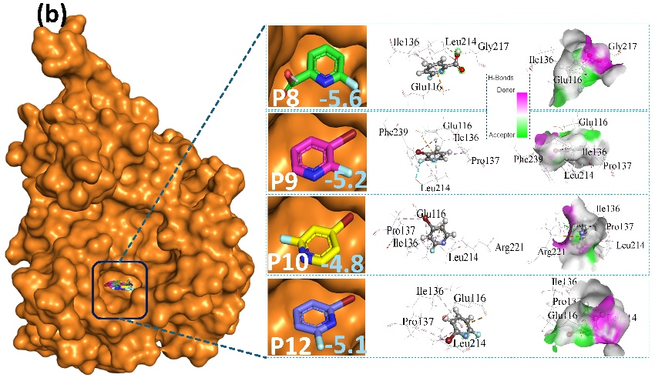
Fig. S6. Docked conformations and molecular interactions of (a) P1, P2, P3, P5, and P6, and (b) P8, P9, P10, and P12 at the inhibition binding site of receptor protein 2X7C.

