SUPPORTING INFORMATION

Ratiometric Detection of Nucleic Acid Using Hybridization Chain Reaction and Color-Switching DNA-templated Silver Nanoclusters

Jessica Sui Ying Ooiª , Wong Zheng Weiª and Siu Yee New^{a,*}
ª School of Pharmacy, University of Nottingham Malaysia, Jalan Broga, 43500, Semenyih, Selangor, Malaysia.
*Corresponding author e-mail: SiuYee.New@nottingham.edu.my.

Table S1. Oligonucleotide sequences used in this work. Underlined and italicised letters indicate toehold region and loop respectively. Bolded letters indicate the AgNCs nucleation sequence. Identical font colour indicates complementary segments, and each colour also corresponds to the text annotations (lower case, italics) for those segments as depicted in Scheme 1. Pink font indicates mismatched base.
Name | Sequence [5’–3’]
H1-S13  (d x y x* d* c* ) | CGC TTA TAT TAC CGG GGT TGG TAA TAT AAG CGC AGA AT
H2-S13  (y*x*d*c d x N) | AAC CCC GGT AAT ATA AGC GAT TCT GCG CTT ATA TTA CCA CCC ACC CA
H1-S14 | CGC TTA ATA TTA CCG GGG TTG GTA ATA TTA AGC GCA GAA T
H2-S14 | AAC CCC GGT AAT ATT AAG CGA TTC TGC GCT TAA TAT TAC CAC CCA CCC A
H1-S15 | CGC TTA ACT ATT ACC GGG GTT GGT AAT AGT TAA GCG CAG AAT
H2-S15 | AAC CCC GGT AAT AGT TAA GCG ATT CTG CGC TTA ACT ATT ACC ACC CAC CCA
H1-S16 | CGC TTA ACC TAT TAC CGG GGT TGG TAA TAG GTT AAG CGC AGA AT
H2-S16 | AAC CCC GGT AAT AGG TTA AGC GAT TCT GCG CTT AAC CTA TTA CCA CCC ACC CA
H1-S17 | CGC TTA ACC ATA TTA CCG GGG TTG GTA ATA TGG TTA AGC GCA GAA T
H2-S17 | AAC CCC GGT AAT ATG GTT AAG CGA TTC TGC GCT TAA CCA TAT TAC CAC CCA CCC A
H1-S18 | CGC TTA ACC AGT ATT ACC GGG GTT GGT AAT ACT GGT TAA GCG CAG AAT
H2-S18 | AAC CCC GGT AAT ACT GGT TAA GCG ATT CTG CGC TTA ACC AGT ATT ACC ACC CAC CCA
CP-S15  (a*bcde) | AGG GGC CTC AGC CTC CTG GTT AAT TCT GCG CTT AAC CAG GAG GCT G
CP-S16 | AGG GGC CTC AGC CTC CTG GTT AAT TCT GCG CTT AAC CAG GAG GCT GA
CP-S17 | AGG GGC CTC AGC CTC CTG GTT AAT TCT GCG CTT AAC CAG GAG GCT GAG
CP-S18 | AGG GGC CTC AGC CTC CTG GTT AAT TCT GCG CTT AAC CAG GAG GCT GAG G
I (cd) | ATT CTG CGC TTA
DNA-665 (a) | ACC AGG AGG CTG AGG CCC CT
mismatch-1 | ACC AGG AGG CTG AGG CCC AT
mismatch-2 | ACC AGG AGG CTG CGG CCC AT
mismatch-3 | ACC ATG AGT CTG CGG CCC CT
DNA-21-5p | TAG CTT ATC AGA CTG ATG TTG A
DNA-141-3p | TAA CAC TGT CTG GTA AAG ATG G
DNA-144 | TAC AGT ATA GAT GAT GTA CT
DNA-200a-3p | TAA CAC TGT CTG GTA ACG ATG T

Table S2. Conformation and free energy, ΔG of DNA hairpins (H1-SX and H2-SX) and capture probes (CP-SX) as determined using NUPACK [1] where X indicates the number of bp in the stem region. Melting temperature, T_{m} was obtained with the OligoAnalyzer™ Tool[2]. Coloured dots depicting conformation indicate the base types (green – A; red – T; black – G; blue – C).
Name | Conformation | ΔG (kcal.mol⁻¹) | T_{m} (⁰C)
H1-S13 | 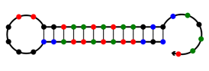 | -15.09 | 72.5
H2-S13 | 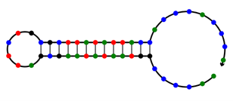 | -15.57 | 71.1
H1-S14 | 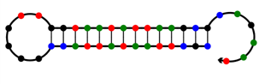 | -15.76 | 72.8
H2-S14 | 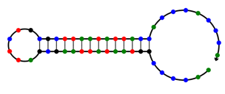 | -16.79 | 71.4
H1-S15 | 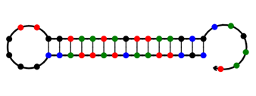 | -16.06 | 75.3
H2-S15 | 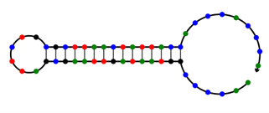 | -17.10 | 73.9
H1-S16 | 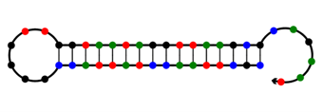 | -17.97 | 77.9
H2-S16 | 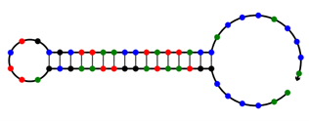 | -19.00 | 76.5
H1-S17 | 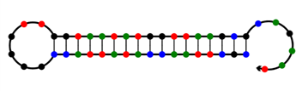 | -19.10 | 78.0
H2-S17 | 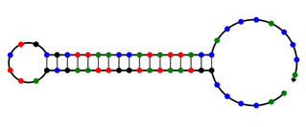 | -20.13 | 76.6
H1-S18 | 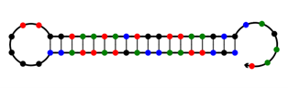 | -21.03 | 79.8
H2-S18 | 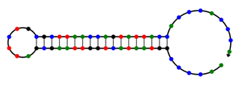 | -22.06 | 78.4
CP-S15 | 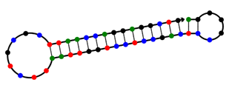 | -21.89 | 79.9
CP-S16 | 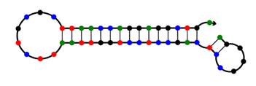 | -21.91 | 81.9
CP-S17 | 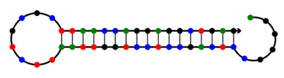 | -23.28 | 80.8
CP-S18 | 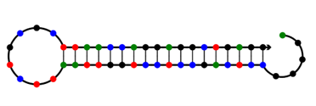 | -25.51 | 83.1

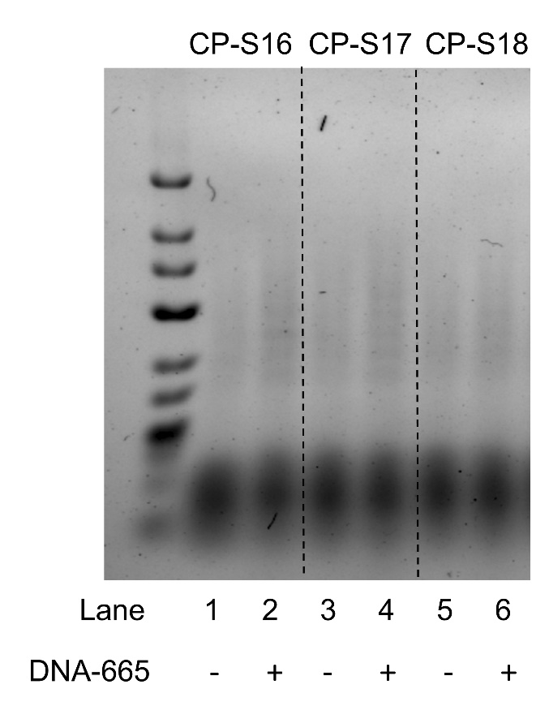
Figure S1. Agarose gel electrophoresis result showing H1-S13 and H2-S13 incubated with CP-S16, CP-S17, and CP-S18 in absence and presence of DNA-665.

Figure S2. Fluorescence signal-to-background ratio (SBR) for samples incubated at 28, 30, and 32°C for 1.5 and 2 hours.

Figure S3. Fluorescence emission spectra of HCR-AgNCs biosensor showing peaks at 551 and 616 nm when excited at 467 nm and 561 nm, respectively, with increasing concentrations of DNA-665.

References
1. NUPACK [Internet]. [cited 2023 Jan 14]. Available from: https://www.nupack.org/
2. OligoAnalyzer Tool - Primer analysis and Tm Calculator [Internet]. Integrated DNA Technologies; [cited 2023 Jan 14]. Available from: https://www.idtdna.com/pages/tools/oligoanalyzer

