Supporting Information

For
Theoretical Investigation of Solvent Effects on Reactivity, Spectroscopic Properties, and Inhibitory Potential of a Dihydropyridine Derivative Against Vibrio Cholorae: DFT, Molecular Docking and Pharmacokinetics Evaluation
Israel A. Ekoro¹, Justina I. Mbonu¹, Christiana E. Ogwuche¹, Sabina C. Agu² , & Hamzah A. Bawa¹
¹Department of Chemistry, Federal University of Petroleum Resources, PMB 1221, Effurun, Delta State, Nigeria
²Faculty of Pharmaceutical Sciences, University of Nigeria, Nsukka 41001, Nigeria
Corresponding Author: israelekoro@gmail.com

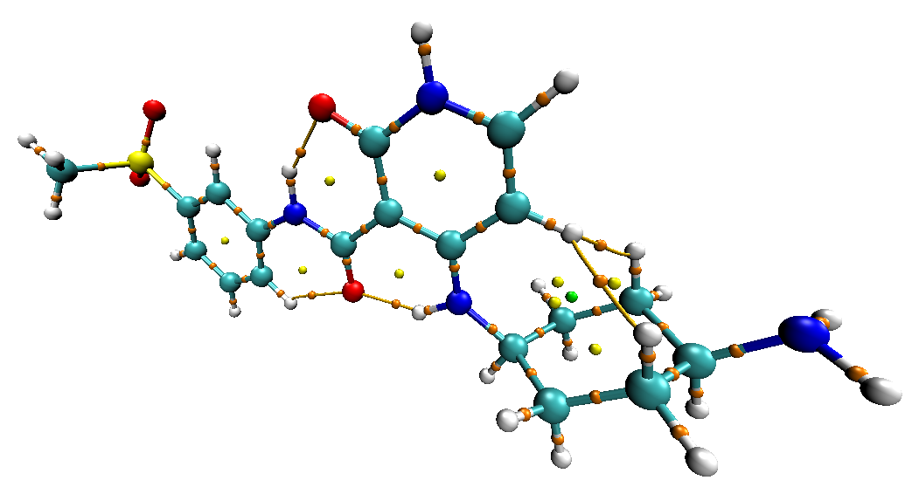
Figure S1: Visualization of BCPs of AMDC in Ethanol and Water
Ethanol
Water
(b)
(a)

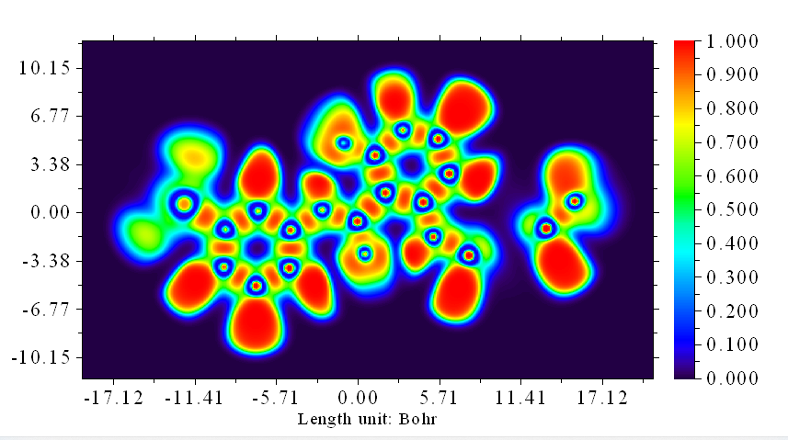
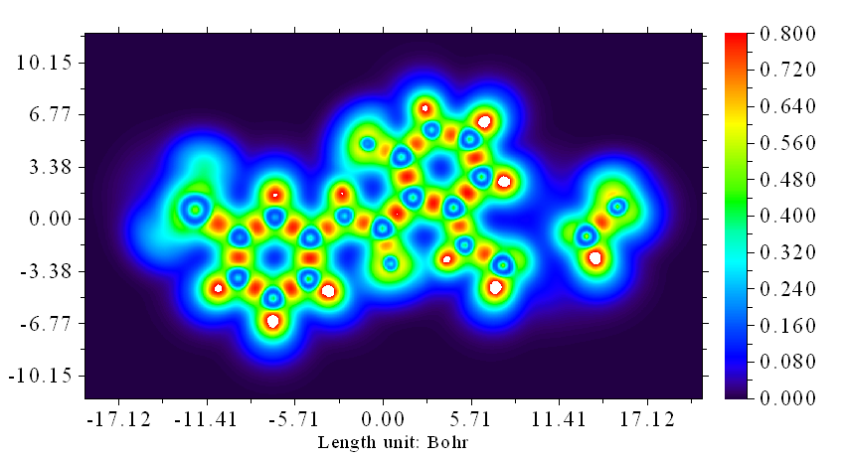
Ethanol
ELF
(a)
LOL
(b)
Water
ELF
(c)
LOL
(d)
Figure S2: ELF and LOL maps of AMDC in Ethanol and Water

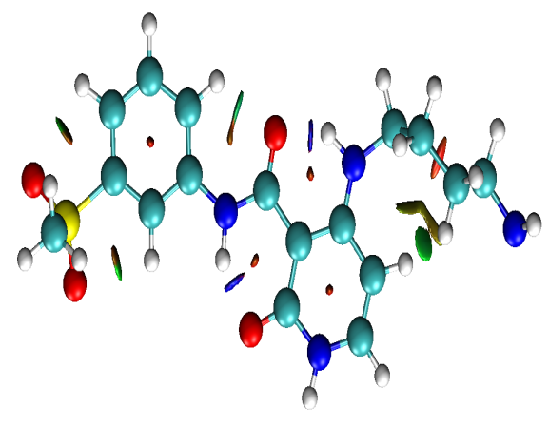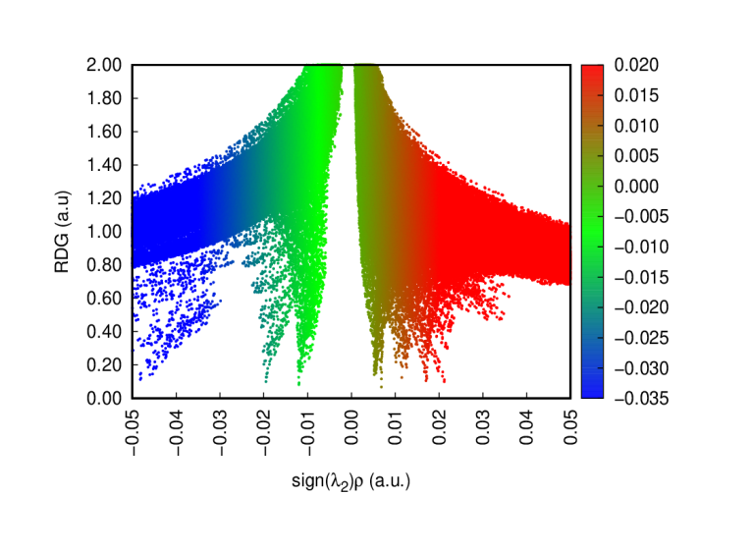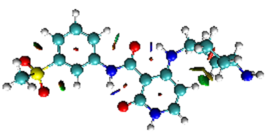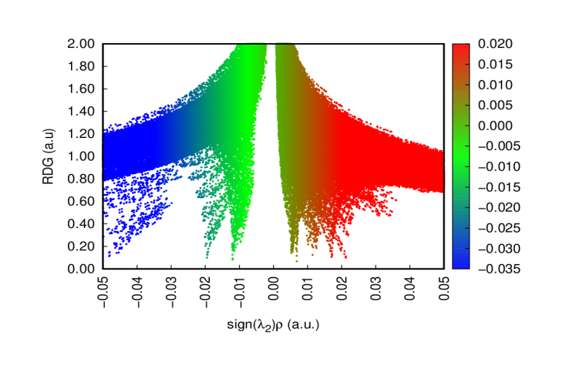
- AMDC_ETHANOL
(c) AMDC_WATER
Figure S3: NCI plots of AMDC in Ethanol and Water

Table S1: Bond Angle of AMDC in gaseous and solvent phase calculated using B3LYP/ 6-311G (d,p)
BOND LABEL
BOND LABEL | AMDC_GAS | AMDC_ETHANOL | AMDC_WATER
C₂ ̶ H₇ ̶ C₃ | 34.172 | 34.090 | 34.088
C₃ ̶ S₁₁ ̶ C₄ | 26.115 | 26.161 | 26.165
C₁₄ ̶ S₁₁ ̶ O₁₃ | 107.334 | 108.049 | 108.094
N₁₈ ̶ C₁₉ ̶ H₂₀ | 27.873 | 27.989 | 27.992
C₁₉ ̶ C₂₂ ̶ O₂₁ | 26.060 | 25.970 | 25.969
C₂₃ ̶ O₅₁ ̶ N₂₅ | 34.108 | 33.708 | 33.693
C₂₄ ̶ N₃₀ ̶ C₃₂ | 134.786 | 134.329 | 134.307
N₂₅ ̶ H₅₂ ̶ C₂₇ | 33.853 | 34.427 | 34.454
C₃₃ ̶ C₃₅ ̶ H₃₆ | 29.235 | 29.270 | 29.271
C₃₉ ̶ N₄₈ ̶ H₄₉ | 110.151 | 109.311 | 109.261

Table S2: Fukui function analysis for AMDC in DMSO and Water
Atom | Site | AMDC_WATER
Atom | Site | ƒ⁺ | ƒ ̄ | ƒ⁰ | ∆ƒ(r)
C | 1 | 0.0300 | 0.0096 | 0.0198 | 0.0203
C | 2 | 0.0126 | 0.0589 | 0.0357 | -0.0463
C | 3 | 0.0220 | 0.0006 | 0.0113 | 0.0214
C | 4 | 0.0775 | 0.0856 | 0.0815 | -0.0081
C | 5 | 0.0046 | 0.0066 | 0.0056 | -0.0019
C | 6 | 0.0541 | 0.0553 | 0.0547 | -0.0011
S | 11 | 0.0011 | -0.0009 | 0.0001 | 0.0002
O | 12 | 0.0094 | 0.0091 | 0.0093 | 0.0003
O | 13 | 0.0097 | 0.0100 | 0.0098 | -0.0002
C | 14 | 0.0024 | 0.0016 | 0.0020 | 0.0008
N | 18 | 0.0071 | 0.1224 | 0.0647 | -0.1153
C | 19 | 0.0952 | -0.0264 | 0.0344 | 0.0688
O | 21 | 0.0721 | 0.0342 | 0.0532 | 0.0378
C | 22 | 0.0208 | 0.1865 | 0.1036 | -0.1658
C | 23 | 0.0137 | -0.0016 | 0.0061 | 0.0121
C | 24 | 0.1005 | -0.0138 | 0.0434 | 0.0867
N | 25 | 0.0207 | 0.0171 | 0.0189 | 0.0036
C | 26 | 0.0182 | 0.0112 | 0.0147 | 0.0070
C | 27 | 0.1499 | 0.0289 | 0.0894 | 0.1211
N | 30 | 0.0563 | 0.1351 | 0.0957 | -0.0789
C | 32 | -0.0058 | -0.0104 | 0.0081 | -0.0046
C | 33 | 0.0005 | 0.0038 | 0.0022 | -0.0034
C | 34 | 0.0005 | 0.0038 | 0.0022 | -0.0034
C | 35 | -0.0006 | -0.0009 | 0.0008 | -0.0003
C | 37 | -0.0006 | -0.0009 | 0.0008 | -0.0003
C | 39 | -0.0008 | -0.0011 | 0.0009 | -0.0003
N | 48 | 0.0005 | 0.0008 | 0.0007 | -0.0004
O | 51 | 0.0395 | 0.0767 | 0.0581 | -0.0371

Table S3: Vibrational Frequencies and PED for AMDC_ETHANOL
Cm⁻¹ | Modes/potential energy distribution (PED %)
3601.3 | υ NH (100)
3537.37 | υ NH (100)
3468.36 | υ NH (100)
3370.77 | υ NH (99)
3303.51 | υ CH(99)
3257.39 | υ CH (98)
3250.27 | υ NH (97)
3221.33 | υ CH (99)
3212.33 | υ CH (94)
3194.13 | υ CH (99)
3183.26 | υ CH (93)
3174.78 | υ CH (100)
3164.71 | υ CH (98)
3081.29 | γ CH (11) + υ CH (65) + γ CH (17)
3078.1 | υ CH (81) + γ CH (17)
3070.81 | υ CH (81) + υ CH (16)
3066.83 | γ CH (81)
3064.5 | υ CH (98)
3063.33 | υ CH (84)
3030.09 | υ CH (14) + υ CH (77)
3027.36 | υ CH (18) + υ CH (77)
3021.5 | γ CH (86)
3020.62 | γ CH (86) + γ CH (12)
2918.63 | υ CH (97)
1691.17 | γ OC (20) + υ OC (13) + β HNC (47)
1679.87 | υ CC (45) + δ HCC (15)
1654.64 | υ OC (14) + υ OC (10) + β HNC (41)
1647.35 | β HNH (76) + τ HNCC (23)
1637.24 | γ CC (51)
1625.79 | υ OC (22) + β HNC (25)
1603.98 | υ CC (35)
1567.37 | υ OC (12) + δ HNC (14) + β HNC (13) + β HCC (10)
1546.27 | υ OC (12) + γ NC (10) + υ CC (13) + β HCC (29)
1511.72 | β HCH (81)
1508.68 | β HCC (14) + δ HCC (35)
1502.87 | β HCH (87)
1492.98 | υ NC (14) + β HNC (10) + δ HCN (25) + β HCH (10)
1478.32 | β HCH (71)
1474.69 | δ HCH (89)
1451.57 | β HNC (10) + β HCN (50)
1445.36 | β HCC (12) + γ HCH (42) + τ HCSC (14)
1445 | β HCC (14) + β HCH (30) + ω HCSC (12)
1438.6 | β HCH (65) + τ HCSC (22)
1418.33 | γ CC (11) + β HNC (19) + β HCC (42)
1409.84 | ω HCCC (62)
1391.78 | β HCC (10) + ω HCCC (19)
1382.74 | υ NC (10) + β HCC (20) + τ HCCC (12) + τ HCCC (17)
1378.88 | ω HCNC (41)
1362.91 | γ NC (39) + δ HNC (13) +δ HCC (12)
1353.16 | β HCC (30) + τ HCCC (32)
1353.12 | β HCH (96)
1345.1 | γ CC (52) + β HCC (10)
1344.21 | τ HCCC (38) ω HCCC (16) τ HCCC (10)
1334.98 | β HCC (48) + ω HCCC (12)
1326.03 | υ CC (12) + β HCC (15) + β HCC (42)
1301.79 | υ CC (31)
1286.66 | υ CC (15) + β HCC (15)
1275.88 | β HNC (35) + δ HCC (24)
1272.61 | γ NC (46) + β HCC (21)
1261.75 | β HCC (57) + τ HCCC (11)
1243.89 | υ SO (80)
1242.48 | υ SO (10) + β HCC (43)
1232.97 | γ CC (48)
1186.81 | β HCC (73)
1169.25 | β HNC (11) + δ HCC (15) + τ HCNC (51)
1149.17 | υ NC (12)
1145.64 | β HCC (27) + τ HCCC (32)
1142.65 | δ HCC (13)
1126.95 | υ CC (66)
1118.93 | υ CC (32) + β HCC (15) + β HCC (18)
1114.43 | γ NC (16)
1105.38 | γ CC(28) + β HCC (20)
1095.71 | υ CC (13) + υ NC (20)
1092.26 | γ NC (12) + υ NC (23)
1070.32 | γ CC (66)
1048.04 | υ CC (47) + υ CC (10)
1041.18 | γ CC (46) + γ HNC (23)
1008.87 | τ HCCN (73) + τ CCCC (12)
1004.06 | υ CC (13) + υ CC (15) + β CCC (53)
987.95 | γ CC (12) + υ NC (15)
983.73 | β HCH (19) + ω HCSC (48)
978.31 | τ HCCC (75) + ω CCCN (10)
976.98 | β HCH (22) + τ HCSC (54) + τ HCSC (11)
952.74 | γ NC (10) + β CCC (23) + τ HNCC (13)
942.34 | β HCC (31) + τ HCCC (17)
926.72 | τ HCCS (77)
909.41 | τ HNCC (25)
901.29 | τ HNCC (16)
898.84 | υ CC (41) + β CCC (16)
890.81 | ω HCCS (72)
886.26 | δ CNC (49)
835.38 | γ CC (15) + υ CC (10)
821.74 | τ HNCC (67)
816.73 | υ CC (21) + δ HCC (10)
804.26 | τ HCCN (57) + ω CCCN (10)
798.91 | ω HCCS (66)
785.58 | ω HCCS (15) + ω HNCC (54) + τ CCCN (10)
764.58 | σ OCNC (19) + τ HCCC (27)
763.1 | σ OCNC( 40)
752.7 | β NCC (11)
731.35 | υ SC (34)
725.77 | γ CC (10) + ω HNCC (19)
724.95 | σ OCNC (11) + τ HNCC (29)
703.39 | τ HCCN (14) + τ CCCN (52)
690.55 | τ CCCC(84)
684.35 | υ SC (10) + υ SC (15) β CCC (32)
641.68 | β CCC (24)
629.37 | τ HNCC (87)
617.52 | υ NC (10) + β OCN (39)
587.9 | γ SC (11) + τ CCCC (48)
578.75 | δ CCC (45)
539.54 | β CCC (10) + β CCC (59)
514.1 | δ OSO (18) + π OCOS (43)
494.25 | π NCCC (24)
478.08 | γ SC (10) + β OSO (27) + ω CCCC (11) + τ CCCC (16)
474.41 | β CCC (54) + ω CCCC (11)
454.59 | δ NCO (11) + β CCN (21) + π OCCS (19)
450.99 | τ HCCC (12) + τ CCCN (59)
447.86 | δ OCN (13) + β CNC (10) + π NCCC (11)
432.79 | β CCC (41)
427.41 | β CCN (47)
425.28 | β OSO (28) + τ CCCC (14) + ω CCCC (12)
412.19 | δ CCC (18) + β CCC (17)
392.8 | β NCO (26) + π OCCS (24)
335.71 | γ SC (11) + β CCC (20) + β OSC (12)
327.51 | β CCN (62)
304.06 | υ SC (13) + β OSC 32 + π OCOS (22)
282.24 | τ CCCC (14) + ω CNCC (30)
275.53 | δ OSC (13) + τ CNCC (13)
264.18 | τ HNCC (66)
257.33 | β CSC (33)
250.17 | π NCCC (13)
243.78 | τ HNCC (15) + ω CCCC (20) + ω CNCC (10)
225.34 | υ SC (10) + β CCC (13)
219.46 | ω CCCC (13) + τ CCCC (19) + τ CCCC (15)
203.26 | τ HCSC( 69)
179.07 | ω CNCC (49)
171.63 | δ CCC 17 + τ HCSC 12 + π OCCS 13
144.07 | δ CNC (45)
113.3 | δ CSC (19) + π SCCC (43)
103.87 | ω CCCN (15) + τ CCCC (16)
89.53 | β CNC (57)
86.47 | τ CCCN (46)
55.41 | δ CCN (23) + ω CCCN (47)
48.34 | ω CCNC (58) + τ CCCC (10)
44.28 | ω CCCC (11) + τ CNCC (45)
42.23 | δ CCN (47) + τ CCCN (16)
23.69 | τ CSCC (73)
21.99 | τ CNCC (78)
12.76 | τ CNCC (71)
υ = symmetrical stretching, γ= asymmetrical stretching, β = Bending, δ =asymmetrical bending, τ = symmetrical torsion, ω = asymmetrical torsion, σ = out of plane symmetry, π = out of plane asymmetry [20].

Table S4: Vibrational Frequencies and PED for AMDC_WATER
Cm⁻¹ | Modes/potential energy distribution (PED %)
3599.46 | υ NH (100)
3536.77 | υ NH (100)
3468.11 | υ NH (100)
3373.44 | υ NH (99)
3303.56 | υ CH (99)
3257.54 | υ CH (98)
3249.47 | υ NH (97)
3222.27 | υ CH (99)
3212.18 | υ CH (94)
3194.62 | υ CH (99)
3183.75 | υ CH (93)
3174.96 | υ CH (99)
3164.9 | υ CH (98)
3081.1 | υ CH (13) + υ CH (62) + γ CH (17)
3077.9 | υ CH (82) + υ CH (13)
3071.13 | υ CH (79) + υ CH (17)
3066.25 | γ CH (80)
3064.56 | υ CH (98)
3062.71 | υ CH (83)
3030.3 | υ CH (15) + υ CH (77)
3027.61 | υ CH (85)
3021.86 | γ CH (10) + γ CH (86)
3020.9 | γ CH (83) + γ CH (13)
2919.93 | υ CH (97)
1689.84 | γ OC (20) + υ OC (12) + β HNC (37)
1679.3 | υ CC (46) + δ HNC (14) + δ HCC (11)
1653.8 | υ OC (14) + β HNC (31)
1647.19 | β HNH (76) + ω HNCC (23)
1636.9 | γ CC (51)
1624.83 | υ OC (22) + δ HNC (12)
1603.57 | γ CC (43)
1566.24 | υ OC (13) + β HNC (22)
1546.06 | υ OC (13) + γ NC (10) + υ CC (14) + β HCC (27)
1511.29 | β HCH (79)
1508.31 | υ NC (10) + δ HCC (43)
1502.43 | β HCH (87)
1492.68 | υ NC (13) + β HNC (13) + β HCN (23)
1477.89 | β HCH (71)
1474.48 | δ HCH (89)
1451.74 | δ HNC (14) + β HCN (52)
1445.1 | υ CC (11) + υ CC (10) + β HCC (20) + β HCH (16)
1444.69 | β HCH (56) + τ HCSC (17)
1438.09 | β HCH (66) + ω HCSC (16)
1418.45 | γ CC (10) + β HNC (19) + β HCC (41)
1409.61 | τ HCCC (24) + π CCCH (38)
1391.51 | δ HCC (12) + ω HCCC (19)
1382.62 | β HCC (23) + ω HCCC (23)
1378.94 | ω HCNC (61)
1362.81 | γ CC (40) + δ HNC (10) + δ HCC (11)
1353.53 | β HCH (97)
1352.67 | β HCC (36) + π CCCH (39)
1344.88 | υ CC (56)
1344.32 | ω HCCC (56) + τ HCCC (11)
1334.96 | β HCC (39) + ω HCCC (20)
1325.72 | υ NC (10) β + HCC (57)
1301.42 | υ NC (26) + π CCCH (12)
1286.5 | υ NC (12) + β HCC (15) + σ CCCH (14)
1275.9 | β HNC (34) + δ HCC (24)
1272.16 | γ NC (45) + β HCC (10) + δ HCC (11)
1261.55 | β HCC (59)
1242.91 | β HNC (15) + β HCC (42)
1240.9 | υ SO (88)
1232.74 | γ CC (48)
1186.53 | υ CC (10) + β HCC (74)
1169.14 | β HNC (11) + δ HCC (17) + τ HCCC (45)
1149.2 | υ NC (12) + β HCC (12)
1145.68 | δ HCC (27) + β HCC (10) + ω HCCC (22)
1142.74 | β HCC (18)
1126.98 | υ CC (66)
1118.54 | υ CC (25) + β HCC (13) + δ HCC (19)
1114.22 | υ NC (23)
1105.19 | γ CC (27) + γ SO (12) + β HCC (24)
1095.52 | υ NC (12) + υ CC (15)
1092.14 | υ NC (36) + υ SO (62)
1069.43 | γ CC (10)
1047.92 | υ CC (47) + υ CC (10)
1041.24 | γ CC (45) + δ HNC (23)
1009.12 | ω HCCC (76)
1003.94 | υ CC (10) + υ CC (19) + β CCC (53)
987.86 | υ NC (15) + γ CC (12) + υ NC (16)
984.5 | δ HCH (18) + ω HCSC (54)
979.2 | τ HCCC (74) + ω CNCC (12)
977.36 | β HCH (21) + τ HCSC (56)
953.01 | υ NC (10) + δ CCC (21) + τ HNCC (13)
942.23 | β HCC (36) + δ HCC (11)
926.61 | τ HCCS (77)
910.19 | δ NCO (10) + ω HNCC (29)
901.69 | δ NCO (15) + τ HNCC (13)
899.03 | γ CC (39) + β CCC (13)
890.31 | ω HCCS (71)
886.09 | β NCO (31)
835.51 | γ CC (13) + υ CC (10)
820.25 | τ HNCC (70)
816.93 | υ CC (21)
803.94 | τ CCCN (10) + τ HCCN (55)
798.27 | ω HCCS (64) + π OCNC (12)
784.41 | ω HCCS (15) + σ OCNC (52)
764.49 | υ CC (11) + β HCC (10) + τ HCCC (36)
762.04 | τ HNCC (66)
752.49 | β NCC (11)
731.22 | υ SC (34)
725.62 | γ CC (13) + π OCNC (17)
724.71 | σ OCNC (59)
702.96 | ω CCCN (67) + τ HCCN (15)
690.46 | τ CCCC (16) + ω CCCC (62)
684.26 | υ SC (13) + δ CCC (39) + δ CCC (11)
641.64 | ̶
629.32 | τ HNCC (86)
617.51 | υ NC (10) β OCN (39)
587.97 | υ SC (14) + σ NCCC (37) + σ SCCC (16)
578.67 | β CCC (15) + δ NCO (17)
539.48 | β CCC (56)
513.65 | δ OSO (19) + π OCOS (41)
494.15 | π NCCC (24)
477.87 | δ OSO (25) + τ CCCC (19) π NCCC (13)
474.31 | β CCC (32) + ω HCCC (13)
454.44 | β CNC (16) + π OCCS (20)
450.99 | τ HCCC (12) + τ CNCC (63)
447.77 | δ OCN (13) + βCNC (10) + π NCCC (11)
432.66 | β CCC (39)
427.72 | β CCN (41)
425.19 | δ OSO (26) + ω CCCC (30)
412.09 | δ CCC (30)
392.68 | β CCC (32) + π OCCS (24)
335.66 | γ SC (12) + β CCC (15) + β OSC (13) + σ OCCS (10)
327.95 | β CCN (63)
304.13 | υ SC (13) + β OSC (31) + π OCOS (22)
282.18 | ω CCCC (14) + ω CCNC (12)
275.57 | δ OSC (14)
264.19 | τ HNCC (67)
257.53 | β CSC (31)
250.21 | δ CNC (13) σ NCCC (15)
243.83 | ω HNCC (14) + τ CCCC (19) + ω CCCC (10)
225.37 | β CNC (14)
219.49 | ω CCCC (30) + γ CH0 (11)
203.49 | τ HCSC (79)
179.22 | ω CNCC (54)
171.46 | β CCS (20) + τ HCSC (15) + π OCCS (12)
143.76 | β CNC (38) + β CNC (10)
113.36 | δ CSC (22) + σ SCCC (36)
103.89 | τ CCCC (44)
89.35 | δ CNC (10) + β CCS (52)
86.45 | τ CCCN (47)
54.77 | δ CNC (22) + ω CCCN (42)
48.85 | ω CCSC (13) + τ CCNC (12) + ω CNCC (35) + υ CH0 (15)
44.79 | τ CCCC (15) + τ CCSC (11) + τ CCNC (32) + ω CCCN (10)
41.64 | δ CNC (11) + β CNC (39) + ω CCCN (21)
23.08 | τ CCSC (21) + τ CNCC (14) + υ CH0 (25)
21.55 | * 22.10 τ CCSC (64) + τ CCNC (11)
12.67 | * 11.89 ω CCSC (52) + τ CNCC (10) + ω CCCN (18)
υ = symmetrical stretching, γ= asymmetrical stretching, β = Bending, δ =asymmetrical bending, τ = symmetrical torsion, ω = asymmetrical torsion, σ = out of plane symmetry, π = out of plane asymmetry [20].
^{* calculated by VEDA.}

