Thermochemical, Spectral and Biological Activity Prediction of Some Methylpyridine Derivatives: A Computational Approach

Md. Arifur Rahman ^{1, 2}, Sheikh Md Mehedi Afnan Rejve ^{2, 3}, Md. Ruhul Amin Niloy ^{2, 3}, Mim Afsari ^{2, 4}, Umma Hany Sawon ^{2, 5}, Fahima Akter ^{2, 6}, Rafi Ahmed Miah ^{2, 4, 7}, Md. Byzed Hasan ^{8, *}, Monir Uzzaman ^{2, 9,} *

¹ Faculty of Science, Department of Chemistry, Jagannath University, Dhaka-1100, Dhaka, Bangladesh
² Department of Drug Design, Computers in Chemistry and Medicine Laboratory, Dhaka-1209, Dhaka, Bangladesh
³ Faculty of Science, Department of Applied Chemistry & Chemical Engineering, University of Chittagong, Chittagong-4331, Chittagong, Bangladesh
⁴ Faculty of Science, Department of Chemistry, University of Barishal, Barishal-8254, Barishal, Bangladesh
⁵ Faculty of Science, Department of Pharmacy, Comilla University, Comilla-3506, Comilla, Bangladesh
⁶ Faculty of Science, Department of Microbiology, Noakhali Science and Technology University, Noakhali-3800, Noakhali, Bangladesh
⁷ Faculty of Science, Department of Chemistry, Bangladesh University of Engineering & Technology, Dhaka-1205, Dhaka, Bangladesh
⁸ Faculty of Science, Department of Chemistry, Pabna University of Science and Technology, Pabna-6600, Pabna, Bangladesh
⁹ Faculty of Science, Department of Chemistry, University of Chittagong, Chittagong-4331, Chittagong, Bangladesh

Correspondence: byzed.che040@gmail.com; monircu92@gmail.com

Table of contents
Content | Page no.
Fig. S1 Optimized geometry structures of the analyzed methylpyridine derivatives | 2
Table S1 Atomic coordinates of the optimized molecular geometry | 3
Fig. S2 HOMO-LUMO energy gap of analyzed methylpyridine derivatives | 8
Fig. S3 Electrostatic potential map of the analyzed methylpyridine derivatives | 9
Fig. S4 Docked conformer, interactions, and hydrogen bond surface of Pyr1, Pyr2, Pyr4, Pyr5, and Pyr6 with receptor protein 2X7C | 9

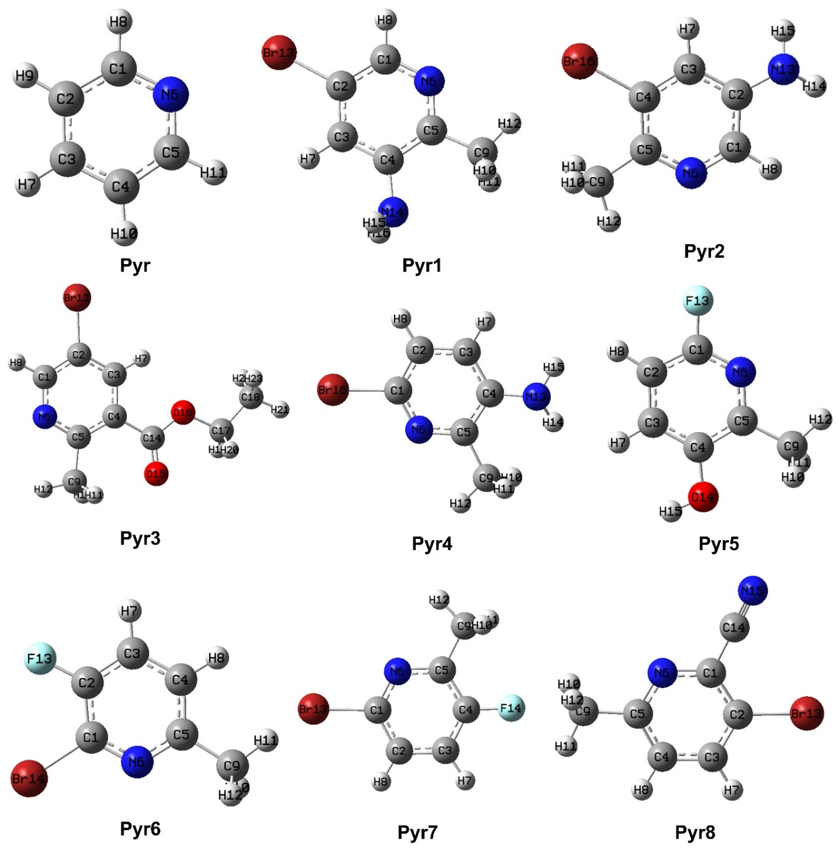

Fig. S1 Optimized geometry structures of the analyzed compounds

Table S1 Atomic coordinates of the optimized molecular geometry
Name | Atom | Coordinates
Name | Atom | X | Y | Z
Pyr | C1 | 0.0000000 | 1.1416560 | 0.7214330
Pyr | C2 | 0.0000000 | 1.1967440 | -0.6716850
Pyr | C3 | 0.0000000 | 0.0000000 | -1.3829570
Pyr | C4 | 0.0000000 | -1.1967440 | -0.6716850
Pyr | C5 | 0.0000000 | -1.1416560 | 0.7214330
Pyr | N6 | 0.0000000 | 0.0000000 | 1.4164420
Pyr | H7 | 0.0000000 | 0.0000000 | -2.4673830
Pyr | H8 | 0.0000000 | 2.0571560 | 1.3067810
Pyr | H9 | 0.0000000 | 2.1537000 | -1.1802490
Pyr | H10 | 0.0000000 | -2.1537000 | -1.1802490
Pyr | H11 | 0.0000000 | -2.0571560 | 1.3067810
Pyr1 | C1 | 0.0011480 | -1.4021790 | 0.0000540
Pyr1 | C2 | 0.5624900 | -0.1304460 | 0.0000660
Pyr1 | C3 | -0.2732750 | 0.9787140 | -0.0001000
Pyr1 | C4 | -1.6542820 | 0.7819550 | -0.0002600
Pyr1 | C5 | -2.1465410 | -0.5378550 | -0.0002590
Pyr1 | N6 | -1.3182360 | -1.5916150 | -0.0001150
Pyr1 | H7 | 0.1347550 | 1.9826240 | -0.0001010
Pyr1 | H8 | 0.6277210 | -2.2879520 | 0.0001740
Pyr1 | C9 | -3.6231900 | -0.8265470 | -0.0003970
Pyr1 | H10 | -4.1100400 | -0.3906910 | 0.8758630
Pyr1 | H11 | -4.1104730 | -0.3881150 | -0.8750930
Pyr1 | H12 | -3.7754640 | -1.9052130 | -0.0018150
Pyr1 | Br13 | 2.4672460 | 0.0831940 | 0.0003040
Pyr1 | N14 | -2.5900260 | 1.8733320 | -0.0004280
Pyr1 | H15 | -2.4805610 | 2.4616620 | 0.8195070
Pyr1 | H16 | -2.4798120 | 2.4620410 | -0.8199930
Pyr2 | C1 | -2.4118870 | 0.8357110 | 0.0028400
Pyr2 | C2 | -2.2087600 | -0.5517830 | 0.0062610
Pyr2 | C3 | -0.8805180 | -0.9902270 | 0.0076840
Pyr2 | C4 | 0.1341560 | -0.0452680 | 0.0023450
Pyr2 | C5 | -0.1455740 | 1.3286370 | -0.0007590
Pyr2 | N6 | -1.4256190 | 1.7263440 | -0.0009140
Pyr2 | H7 | -0.6455700 | -2.0479680 | 0.0166660
Pyr2 | H8 | -3.4233700 | 1.2364780 | 0.0049460
Pyr2 | C9 | 0.9141500 | 2.3957110 | -0.0064630
Pyr2 | H10 | 1.5617050 | 2.3226100 | 0.8722820
Pyr2 | H11 | 1.5592040 | 2.3158970 | -0.8864960
Pyr2 | H12 | 0.4291930 | 3.3710050 | -0.0093230
Pyr2 | N13 | -3.2763220 | -1.4446470 | 0.0683160
Pyr2 | H14 | -4.1685660 | -1.0831680 | -0.2354020
Pyr2 | H15 | -3.0996890 | -2.3746780 | -0.2816390
Pyr2 | Br16 | 1.9511790 | -0.6728210 | -0.0006940
Pyr3 | C1 | -1.9147030 | 1.5291120 | -0.0005980
Pyr3 | C2 | -1.6031000 | 0.1731470 | -0.0000830
Pyr3 | C3 | -0.2730010 | -0.2087780 | 0.0002620
Pyr3 | C4 | 0.7176240 | 0.7797790 | 0.0001710
Pyr3 | C5 | 0.3232260 | 2.1394310 | -0.0002190
Pyr3 | N6 | -0.9768880 | 2.4738690 | -0.0006670
Pyr3 | H7 | 0.0085650 | -1.2517670 | 0.0005540
Pyr3 | H8 | -2.9474480 | 1.8629140 | -0.0010420
Pyr3 | C9 | 1.2816410 | 3.2991780 | -0.0002770
Pyr3 | H10 | 1.9382030 | 3.2739270 | 0.8718890
Pyr3 | H11 | 1.9381120 | 3.2738610 | -0.8725730
Pyr3 | H12 | 0.7024510 | 4.2214140 | -0.0003940
Pyr3 | Br13 | -2.9976390 | -1.1363520 | 0.0001640
Pyr3 | C14 | 2.1577770 | 0.3773250 | 0.0004770
Pyr3 | O15 | 3.0958510 | 1.1410420 | 0.0006200
Pyr3 | O16 | 2.3060390 | -0.9646660 | 0.0006520
Pyr3 | C17 | 3.6684560 | -1.4636550 | 0.0008280
Pyr3 | C18 | 3.6018740 | -2.9766380 | -0.0016620
Pyr3 | H19 | 4.1791880 | -1.0750720 | 0.8845180
Pyr3 | H20 | 4.1806210 | -1.0721280 | -0.8807140
Pyr3 | H21 | 4.6152330 | -3.3867550 | -0.0013580
Pyr3 | H22 | 3.0825480 | -3.3492290 | 0.8840740
Pyr3 | H23 | 3.0842390 | -3.3463370 | -0.8895950
Pyr4 | C1 | -0.5232660 | -0.1705020 | -0.0013340
Pyr4 | C2 | -0.0443470 | -1.4771070 | -0.0078900
Pyr4 | C3 | 1.3328460 | -1.6457280 | -0.0068470
Pyr4 | C4 | 2.1764660 | -0.5286890 | -0.0009990
Pyr4 | C5 | 1.5756180 | 0.7485310 | -0.0016940
Pyr4 | N6 | 0.2449080 | 0.8945480 | 0.0016840
Pyr4 | H7 | 1.7560060 | -2.6453100 | -0.0133610
Pyr4 | H8 | -0.7169130 | -2.3236760 | -0.0116380
Pyr4 | C9 | 2.4102010 | 1.9998050 | -0.0106840
Pyr4 | H10 | 3.0363400 | 2.0763320 | 0.8873670
Pyr4 | H11 | 3.0776820 | 2.0271100 | -0.8792350
Pyr4 | H12 | 1.7562230 | 2.8696060 | -0.0429350
Pyr4 | N13 | 3.5620860 | -0.6691290 | -0.0595890
Pyr4 | H14 | 4.1086160 | 0.0957220 | 0.3063040
Pyr4 | H15 | 3.9256960 | -1.5693630 | 0.2162360
Pyr4 | Br16 | -2.4330780 | 0.1238220 | 0.0034080
Pyr5 | C1 | -1.5343980 | 0.1184740 | 0.0000630
Pyr5 | C2 | -1.2716320 | -1.2425340 | 0.0000970
Pyr5 | C3 | 0.0692030 | -1.6126540 | 0.0000530
Pyr5 | C4 | 1.0492150 | -0.6238570 | 0.0000230
Pyr5 | C5 | 0.6647000 | 0.7269990 | 0.0000400
Pyr5 | N6 | -0.6312790 | 1.0665900 | -0.0000120
Pyr5 | H7 | 0.3463520 | -2.6626250 | 0.0000700
Pyr5 | H8 | -2.0733500 | -1.9684980 | 0.0001300
Pyr5 | C9 | 1.6911430 | 1.8225340 | 0.0000400
Pyr5 | H10 | 2.3402520 | 1.7509340 | 0.8778390
Pyr5 | H11 | 2.3406290 | 1.7507600 | -0.8774530
Pyr5 | H12 | 1.1893550 | 2.7889220 | -0.0001460
Pyr5 | F13 | -2.8237100 | 0.5257420 | -0.0001240
Pyr5 | O14 | 2.3925140 | -0.8932830 | -0.0000960
Pyr5 | H15 | 2.5396020 | -1.8448110 | -0.0003720
Pyr6 | C1 | 0.1303910 | -0.0261530 | -0.0000540
Pyr6 | C2 | -0.1361510 | 1.3432370 | 0.0000020
Pyr6 | C3 | -1.4517990 | 1.7657400 | 0.0000410
Pyr6 | C4 | -2.4567880 | 0.8015850 | 0.0000390
Pyr6 | C5 | -2.1081750 | -0.5504430 | 0.0000340
Pyr6 | N6 | -0.8190450 | -0.9314250 | -0.0000170
Pyr6 | H7 | -1.6717190 | 2.8266080 | 0.0000580
Pyr6 | H8 | -3.4980680 | 1.0996190 | 0.0000930
Pyr6 | C9 | -3.1352990 | -1.6496430 | -0.0000320
Pyr6 | H10 | -3.0085740 | -2.2863210 | 0.8793430
Pyr6 | H11 | -4.1504630 | -1.2498620 | 0.0004240
Pyr6 | H12 | -3.0091060 | -2.2856680 | -0.8799610
Pyr6 | F13 | 0.8583050 | 2.2461980 | -0.0000600
Pyr6 | Br4 | 1.9512410 | -0.6258890 | 0.0000150
Pyr7 | C1 | -0.5054710 | -0.1683690 | 0.0000210
Pyr7 | C2 | -0.0437900 | -1.4831230 | 0.0006800
Pyr7 | C3 | 1.3346610 | -1.6657300 | 0.0001920
Pyr7 | C4 | 2.1386760 | -0.5398210 | -0.0003780
Pyr7 | C5 | 1.5985990 | 0.7455240 | -0.0013680
Pyr7 | N6 | 0.2653900 | 0.8974720 | -0.0013260
Pyr7 | H7 | 1.7801980 | -2.6530300 | 0.0003940
Pyr7 | H8 | -0.7267250 | -2.3208950 | 0.0011430
Pyr7 | C9 | 2.4666070 | 1.9705330 | 0.0004350
Pyr7 | H10 | 3.0696890 | 2.0215580 | 0.9118260
Pyr7 | H11 | 3.1612960 | 1.9622730 | -0.8438140
Pyr7 | H12 | 1.8364270 | 2.8564180 | -0.0591200
Pyr7 | Br13 | -2.4078370 | 0.1391380 | 0.0000720
Pyr7 | F14 | 3.4844420 | -0.6858370 | -0.0001280
Pyr8 | C1 | 0.4280310 | 0.8173220 | -0.0000030
Pyr8 | C2 | -0.2415550 | -0.4149300 | -0.0000110
Pyr8 | C3 | 0.5215870 | -1.5777870 | -0.0000550
Pyr8 | C4 | 1.9052500 | -1.4700840 | -0.0000750
Pyr8 | C5 | 2.5019000 | -0.2017440 | -0.0000460
Pyr8 | N6 | 1.7635640 | 0.9110000 | -0.0000390
Pyr8 | H7 | 0.0378010 | -2.5461870 | -0.0000800
Pyr8 | H8 | 2.5192710 | -2.3628420 | -0.0001440
Pyr8 | C9 | 3.9955160 | -0.0202440 | 0.0000830
Pyr8 | H10 | 4.3053280 | 0.5484740 | 0.8804300
Pyr8 | H11 | 4.5180280 | -0.9778630 | -0.0016150
Pyr8 | H12 | 4.3051170 | 0.5516750 | -0.8782270
Pyr8 | Br13 | -2.1411320 | -0.5215500 | 0.0000270
Pyr8 | C14 | -0.2916350 | 2.0639100 | -0.0000340
Pyr8 | N15 | -0.8579190 | 3.0693310 | -0.0000280

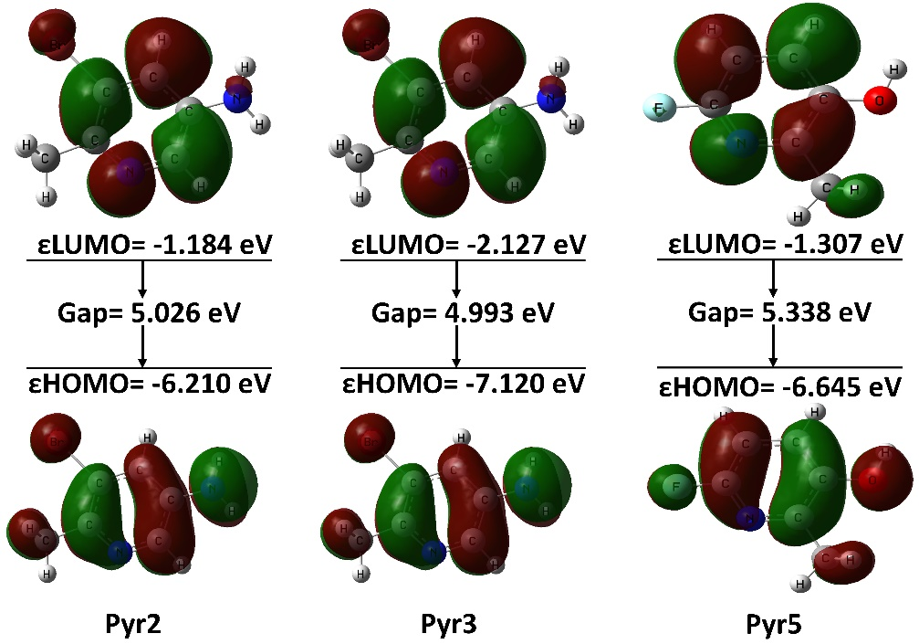
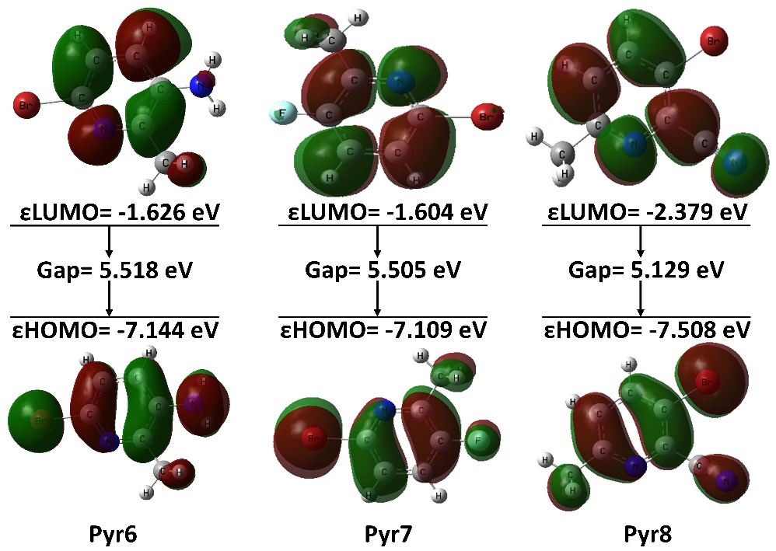
Fig. S2 HOMO-LUMO energy gap of analyzed methylpyridine derivatives

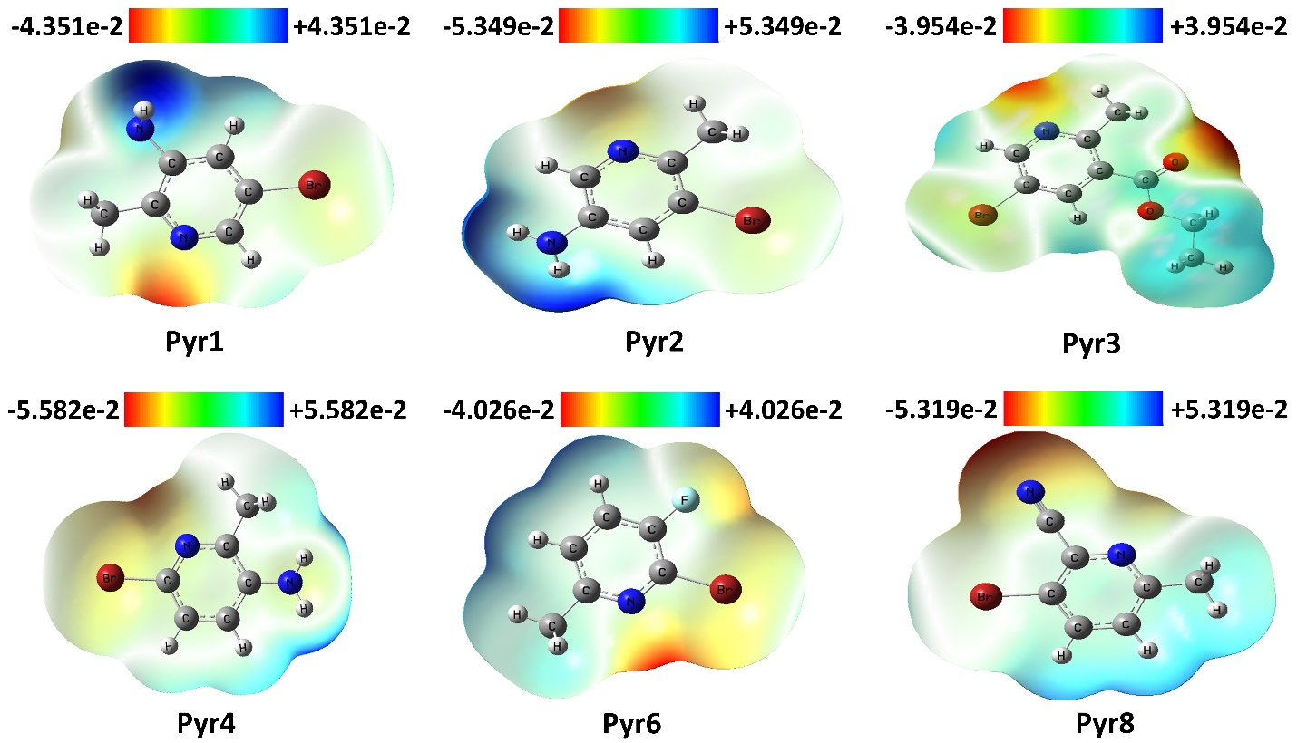
Fig. S3 Electrostatic potential map of the analyzed methylpyridine derivatives

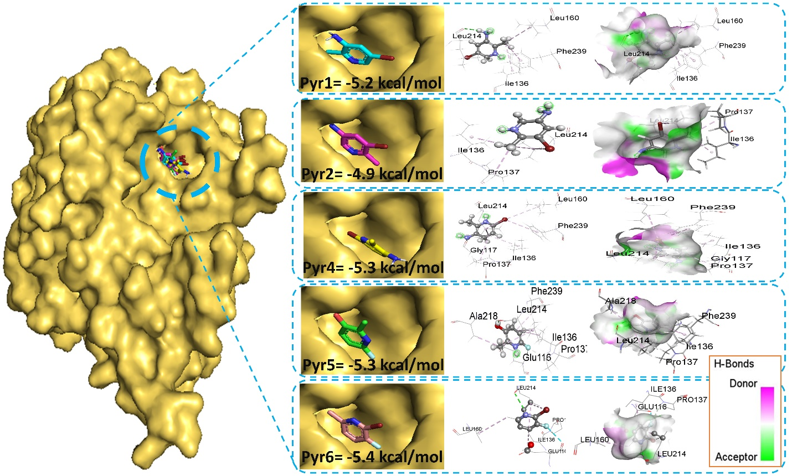
Fig. S4 Docked conformer, interactions, and hydrogen bond surface of Pyr1, Pyr2, Pyr4, Pyr5, and Pyr6 with receptor protein 2X7C

