Analysis of the DNA interaction activity of a Zn(II) phthalocyanine compound containing a peripheral tetra-4-(2-(N'-cyanoethyl)aminoethylsulfanyl) group

Ali Arslantas*^{1*}, Mehmet Salih Agirtas²
*¹Department of Biomedical Engineering, University of Bakırçay, 78050, Izmir, Turkey
*Corresponding author: Ali Arslantas (arsoz33@gmail.com)

²Chemistry Department, The Faculty of Science, Van Yüzüncü Yıl University, 65080, Van, Turkey

*Corresponding author: Ali Arslantas (arsoz33@gmail.com)

Supplementary File

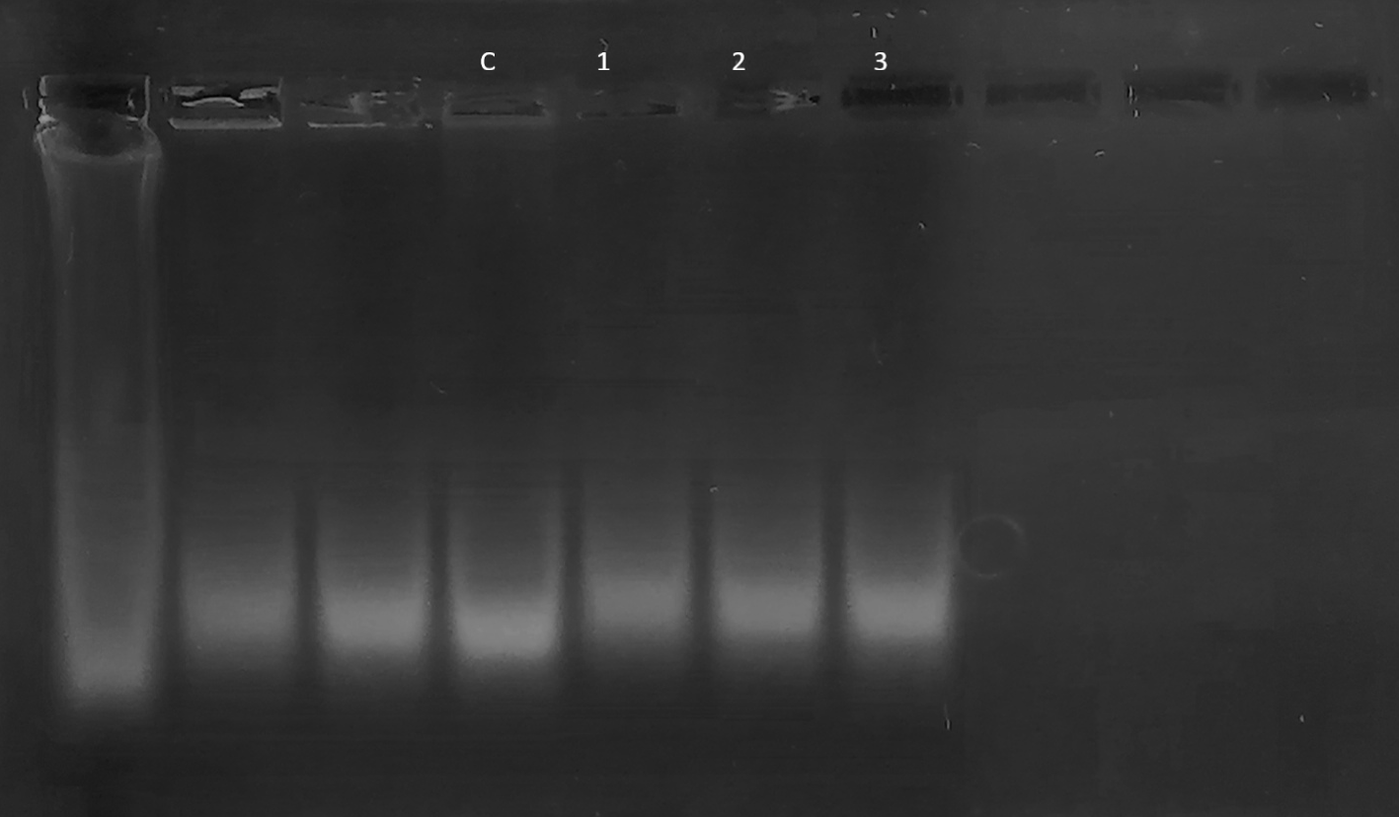
Supplementary Fig. S5 The full uncropped Gels and Blots image of ZnPc.

