Supporting Information

Anti-diabetic potentials of L-Prolinamides: a computational study.
Abosede A. Badeji,*¹ Samuel O. Olalekan,² Segun D. Oladipo,*^{3,4} Vincent A. Obakachi,⁵ Adejoke D. Osinubi,^{1,6} Oluwole Familoni,⁶ Olayinka T. Asekun,⁶ Oluwaseun H. Anselm¹

Contents
- Scheme S1 …….……...………………………………………………..……..…….......S2-S2
- Quantum chemical descriptors…….……...……...…………………..……..…….......S3-S3
- 3D visualization snapshots of the protein-ligand complexes..………………..….......S4-S7
- Cartesian Coordinates and Energies………...………………..……..……..……........S8-S13

Scheme S1: The series of L-prolinamides examined in this work

Quantum chemical descriptors
The quantum chemical descriptors were computed using the equations below.
$ΔE=E_{L}-E_{H}$ eq (1)
$η= \frac{E_{L}-E_{H} }{2}$ eq (2)
$σ= \frac{1 }{η}$ eq (3)
$μ= \frac{E_{H} + E_{L} }{2}$ eq (4)
$χ= -μ$ eq (5)
$ω= \frac{χ^{2} }{2η}$ eq (6)
where E_{L} and E_{H} are energies of LUMO and HOMO and $ΔE$ is the energy gap respectively, in electronVolt (eV).

3D visualization snapshots of the protein-ligand complexes
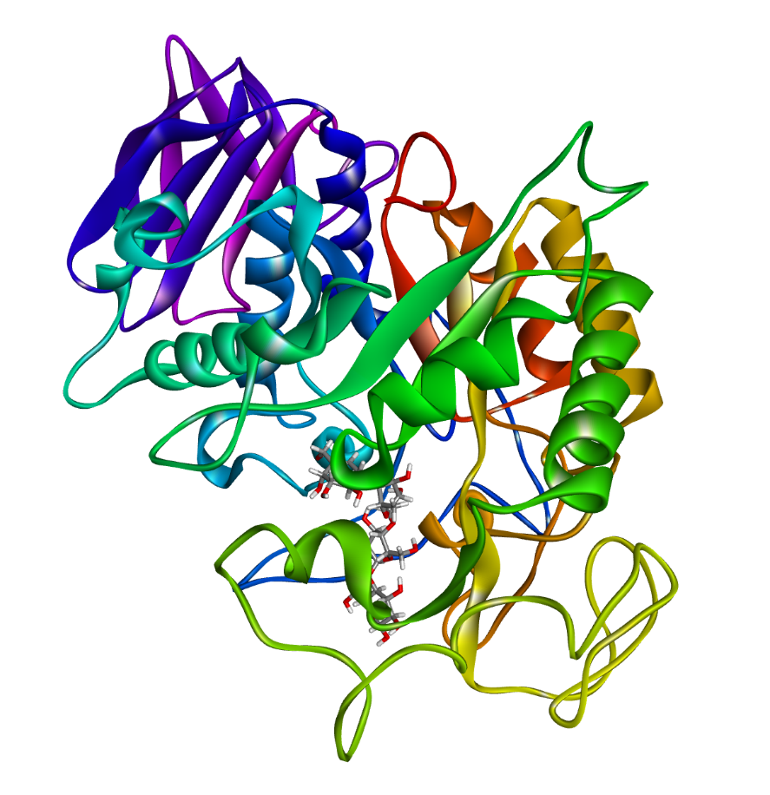
A. 3D snapshot of α-amylase + Acarbose
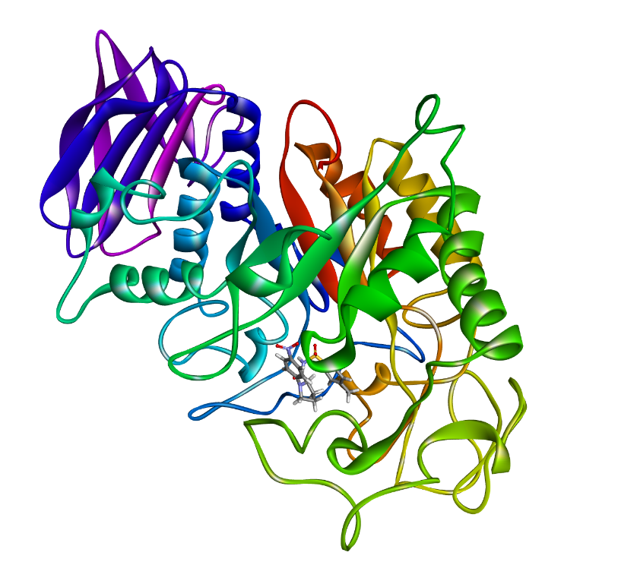
B. A. 3D snapshot of α-amylase + Q10

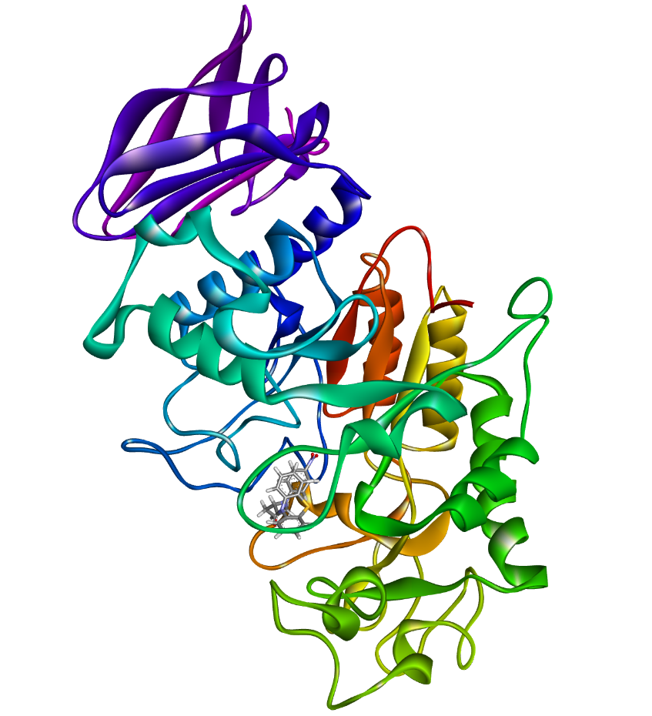
C. A. 3D snapshot of α-amylase + Q14

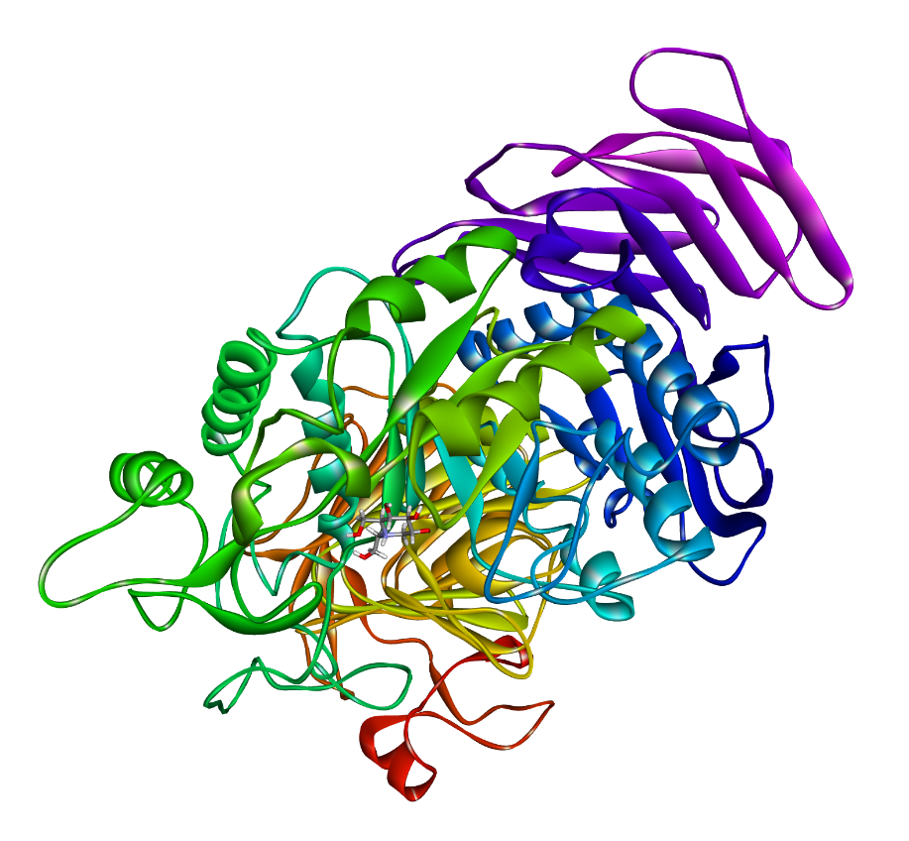
D. 3D snapshot of α-glucosidase + Miglitol
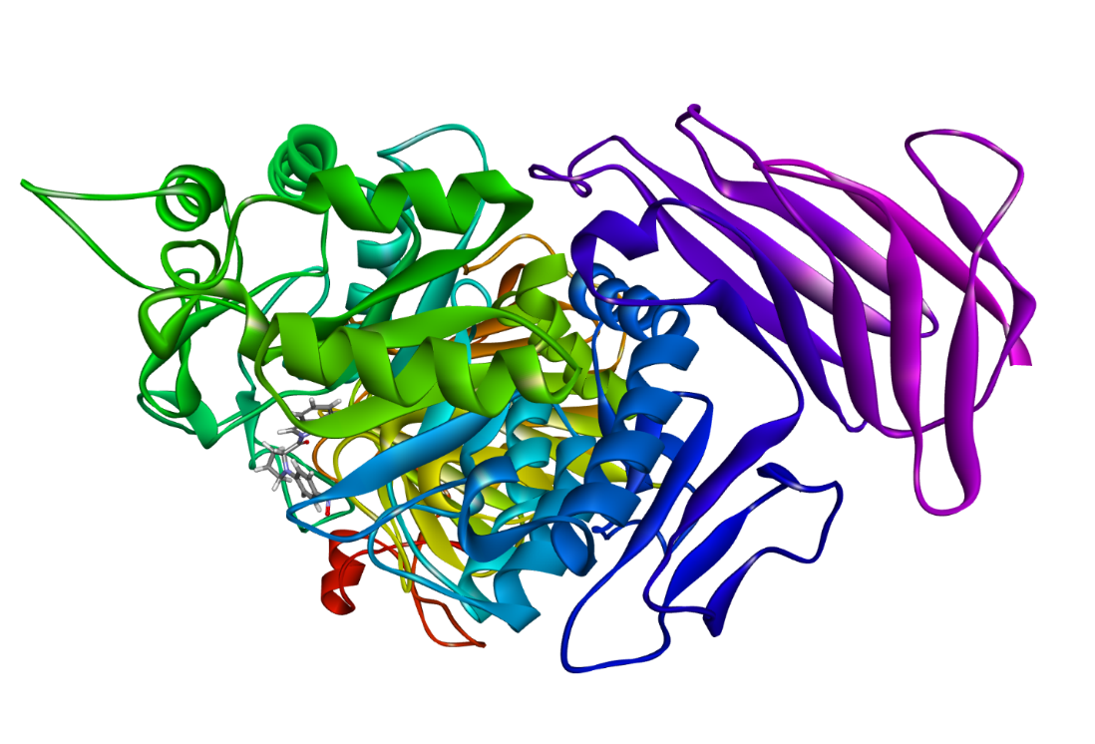
E. 3D snapshot of α-glucosidase + Q19
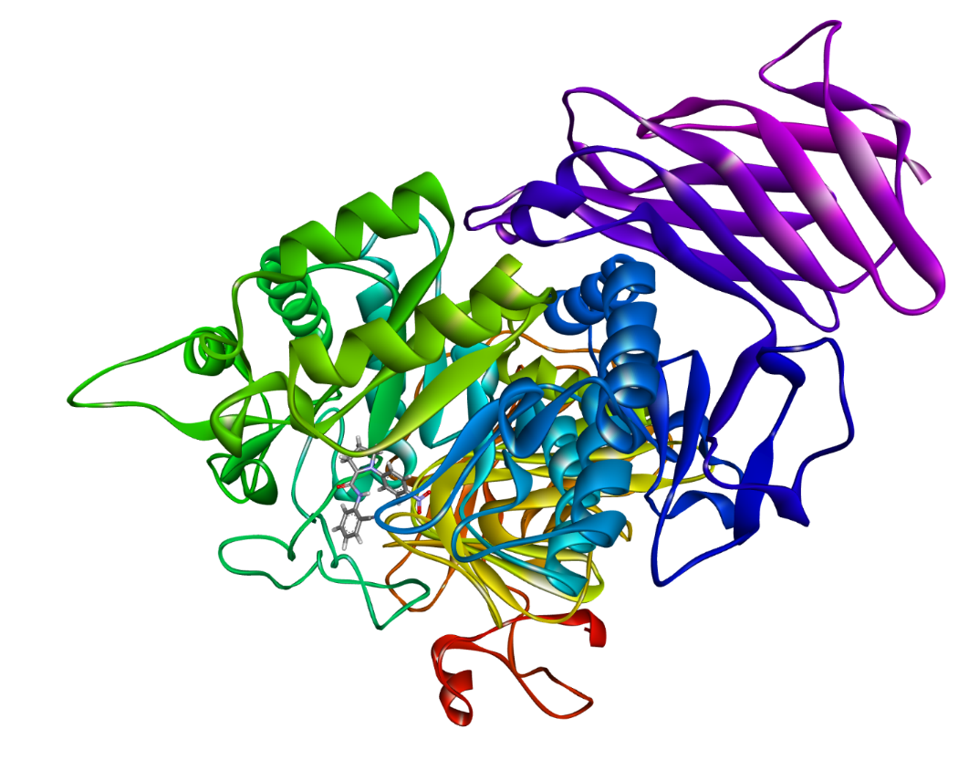
F. 3D snapshot of α-glucosidase + Q22

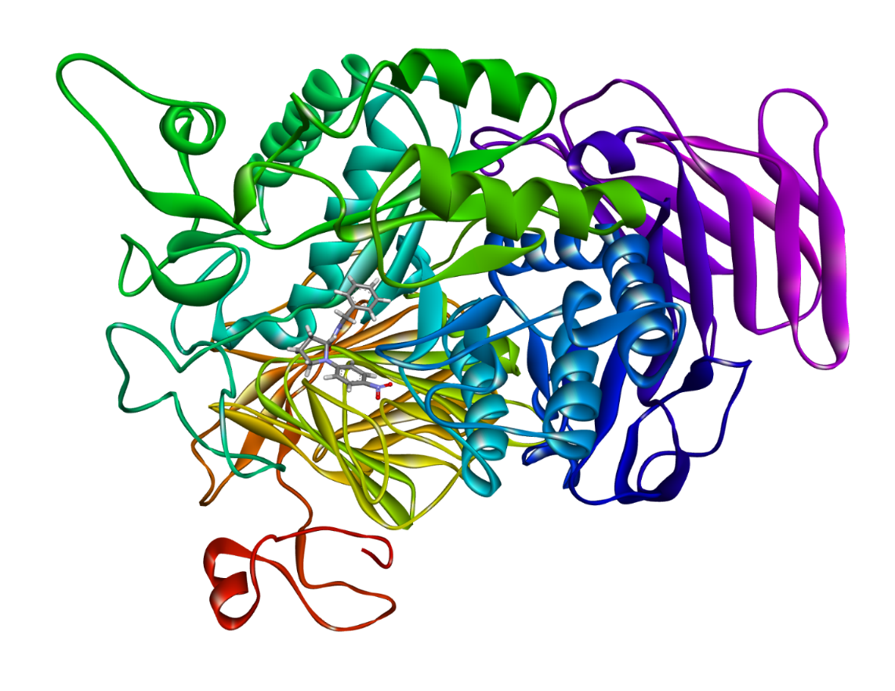
G. 3D snapshot of α-glucosidase + Q24
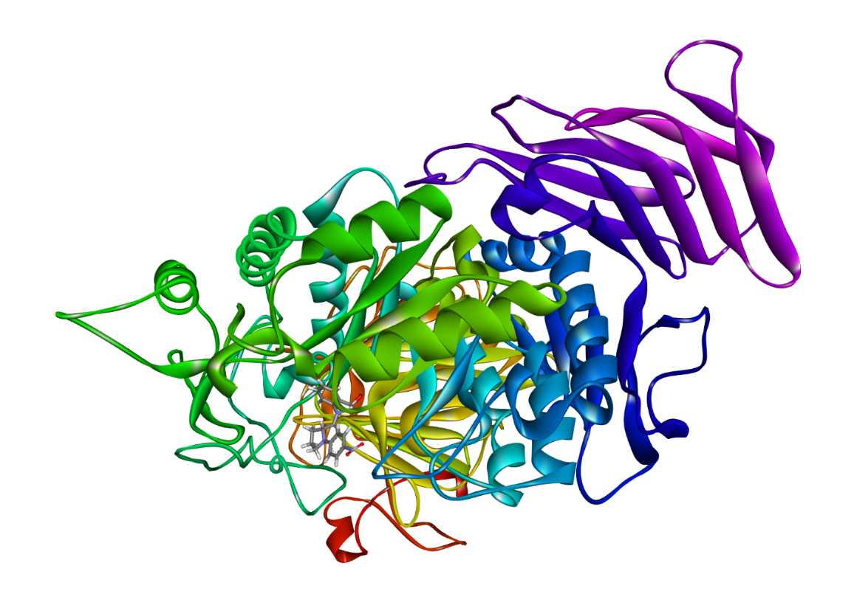
H. 3D snapshot of α-glucosidase + Q26

Cartesian coordinates and electronic energies for all of the calculated structure
Q10
B3LYP/6-311++G(d,p) energy = -1636.146824
Cartesian coordinates:
S -3.37377400 0.76754800 0.56892400
O -3.97599100 0.73937000 1.89846300
O -3.96120300 1.51902100 -0.52476900
C -3.03654400 -0.90267900 0.03640300
C -3.07150000 -1.92878600 0.97917600
C -2.76371900 -1.15352500 -1.30681600
C -2.81515700 -3.22998800 0.56110700
H -3.31334200 -1.71071700 2.01171900
C -2.50906400 -2.46231900 -1.70052600
H -2.74395400 -0.33985700 -2.01890500
C -2.52432400 -3.51670000 -0.77869100
H -2.84961200 -4.03573100 1.28633800
H -2.29673400 -2.66722500 -2.74418800
C -2.21379900 -4.92558200 -1.21585500
H -1.13581900 -5.11397100 -1.16822400
H -2.70378700 -5.66037700 -0.57390900
H -2.53131400 -5.10239300 -2.24556800
N -1.81369100 1.43736100 0.90933400
H -1.71189000 1.69703900 1.88282500
C -0.82643400 1.73196600 -0.01383000
O -0.88465400 1.40990300 -1.17804800
C 0.34573300 2.55155800 0.57575400
C 0.09462500 4.06356800 0.36706400
H 0.45981300 2.31563200 1.63941100
C 1.93402700 3.41058000 -1.05383500
C 0.70921000 4.33261400 -1.01405200
H 0.62529600 4.61875700 1.14514800
H -0.96296000 4.32512600 0.42670900
H 2.84068300 3.92378200 -0.70803800
H 2.12261500 3.02649100 -2.05980900
H 0.97729600 5.38042100 -1.15596300
H 0.00569300 4.05034200 -1.79911900
N 1.58788800 2.31541500 -0.13707300
C 2.34324400 1.18184000 0.00436500
C 3.58111200 1.04906600 -0.67211300
C 1.92460000 0.11143700 0.83270700
C 4.35404900 -0.08747700 -0.52534000
H 3.93765100 1.84392500 -1.31210000
C 2.70107300 -1.02271200 0.97745000
H 0.97796100 0.15710300 1.35322000
C 3.91535100 -1.12308100 0.29944500
H 5.29902000 -0.18546400 -1.04213400
H 2.37619300 -1.84030600 1.60631700
N 4.72876500 -2.32377000 0.44943600
O 5.79459500 -2.37923700 -0.16131600
O 4.30624600 -3.21968800 1.17906100

Q14
B3LYP/6-311++G(d,p) energy = -1676.284043
Cartesian coordinates:
C -4.34658400 -3.49882200 0.25038700
C -4.75986300 -2.20886500 -0.07022800
C -3.83164400 -1.16694100 -0.06565800
C -2.49844500 -1.41401900 0.27702600
C -2.09694000 -2.70101800 0.62787000
C -3.01952800 -3.74299400 0.60281100
C -2.01459300 0.87318400 0.93032100
C -3.29182400 1.37637900 0.64748200
C -3.74526600 2.53455600 1.28219000
H -4.73887400 2.90943500 1.06620100
C -2.92810800 3.18853900 2.19946300
C -1.67816800 2.66084400 2.52349300
C -1.23445300 1.49406700 1.90753700
H -5.06545200 -4.30979500 0.23876800
H -5.79529400 -2.00691600 -0.31795900
H -1.06321700 -2.88214100 0.88950600
H -2.70076000 -4.74589600 0.86066700
H -3.28101800 4.09089700 2.68481700
H -1.05716600 3.14498600 3.26769700
H -0.27991800 1.06057100 2.18102300
S -4.33136800 0.49469000 -0.50182100
N -1.57478300 -0.31182600 0.25214300
C -0.50444900 -0.36248000 -0.64674200
O -0.19861000 -1.38942700 -1.21467800
C 0.22207200 0.96684800 -0.97157600
C -0.54080800 1.72239400 -2.08616400
H 0.32332800 1.58882300 -0.08444100
C 1.50696900 0.86058000 -3.03740600
C 0.03242400 1.11587500 -3.37504100
H -0.30045700 2.78657000 -2.01505500
H -1.62264700 1.61366700 -2.00430900
H 2.14418500 1.69883200 -3.34736800
H 1.88387100 -0.04843300 -3.51454500
H -0.08390700 1.77543800 -4.23629500
H -0.46617600 0.17150500 -3.60052200
N 1.52509900 0.72604400 -1.57475400
C 2.64088300 0.36944700 -0.87222500
C 3.88927300 0.20965700 -1.52611500
C 2.60178500 0.15883300 0.52911600
C 5.02729700 -0.12553300 -0.81761600
H 3.96351200 0.35355500 -2.59479600
C 3.74179600 -0.17517600 1.23399700
H 1.66716600 0.24116400 1.06544200
C 4.95696100 -0.31429400 0.56295100
H 5.97776600 -0.24307500 -1.32010100
H 3.70632600 -0.33806500 2.30260700
N 6.15749900 -0.66414500 1.30870000
O 7.21137900 -0.78493100 0.68528400
O 6.05763200 -0.81977300 2.52563300

Q19
B3LYP/6-311++G(d,p) energy = -1125.614862

Cartesian coordinates:
C 4.00354800 -0.78828300 0.73361000
C 3.82281900 -0.72822600 -0.64661600
C 4.74114400 -1.31162800 -1.51394800
C 5.85227200 -1.96091900 -0.97575500
C 6.03528000 -2.02262200 0.40796000
C 5.11100900 -1.43632700 1.27272300
C 2.88257400 -0.08801900 1.45125100
C 2.55654200 0.01619400 -0.98674200
H 4.60107000 -1.26696000 -2.58885000
H 6.57820500 -2.42179200 -1.63566800
H 6.90261200 -2.53139400 0.81280300
H 5.25657700 -1.48774000 2.34633800
H 3.22185200 0.75720200 2.05913500
H 1.85071900 -0.61889900 -1.53619000
N 2.03247300 0.38520400 0.34187600
H 2.75702400 0.90149900 -1.60154700
C 0.91438600 1.10980000 0.61675800
O 0.57917100 1.37255100 1.76341000
C 0.10864300 1.63877200 -0.59309900
C 0.57217400 3.06554200 -0.96830800
H 0.20510900 0.96023700 -1.44389200
C -1.63637700 3.23313600 -0.00579100
C -0.28759500 3.96158100 -0.06433100
H 0.34782900 3.24858900 -2.02290100
H 1.64356700 3.21216500 -0.81997800
H -2.33171700 3.60536500 -0.76957000
H -2.11455800 3.34009800 0.97177100
H -0.38435800 4.97759700 -0.45016200
H 0.14767300 4.01239100 0.93481700
H 2.31393500 -0.75001400 2.11254400
N -1.29810900 1.82886200 -0.26795300
C -2.20282600 0.80920100 -0.17805000
C -1.81519000 -0.54418300 -0.34703000
C -3.57254100 1.07562900 0.07467900
C -2.74378700 -1.56510100 -0.28342000
H -0.77683500 -0.79864900 -0.50895200
C -4.49738800 0.05105100 0.13950500
H -3.90941600 2.09295800 0.21640300
C -4.08608300 -1.26941700 -0.04431700
H -2.44375700 -2.59648900 -0.40935100
H -5.54167900 0.25870100 0.32926400
N -5.06263200 -2.34760400 0.01977600
O -6.23665200 -2.05269400 0.24074200
O -4.66472000 -3.49950500 -0.15244900

Q22
B3LYP/6-311++G(d,p) energy = -1140.453393
Cartesian coordinates:
N 2.13353300 0.21407500 -0.29939500
C 1.14342900 0.94101000 0.33124600
O 1.01165700 1.02728900 1.53464800
C 0.22838500 1.70247700 -0.65708600
C 0.73254500 3.15245900 -0.85131300
H 0.19640400 1.17059200 -1.61446700
C -1.35396200 3.24887600 0.35621600
C 0.01873800 3.92605900 0.26627300
H 0.41347900 3.50615400 -1.83525300
H 1.82008100 3.22916100 -0.80372800
H -2.09730200 3.75292800 -0.27511400
H -1.73372100 3.23172600 1.38128200
H -0.06118500 4.99278400 0.05221200
H 0.55459500 3.80527000 1.20929500
N -1.11310400 1.88423500 -0.13122600
C -2.05941000 0.89422600 -0.09500400
C -3.37299500 1.16760800 0.36011400
C -1.76771400 -0.42627900 -0.51678500
C -4.33761500 0.17782600 0.38629800
H -3.63694700 2.16223600 0.69095600
C -2.73605300 -1.41252500 -0.49133900
H -0.77454900 -0.68857500 -0.85461400
C -4.02082800 -1.11109100 -0.04136400
H -5.33994100 0.38991600 0.73266100
H -2.50939000 -2.42025700 -0.81176700
N -5.04026100 -2.15381300 -0.01390100
O -6.16175400 -1.85361700 0.39167600
O -4.72557300 -3.27864400 -0.39869600
H 2.12006200 0.23221500 -1.31161700
C 3.18600400 -0.51981100 0.27006600
C 4.12923200 -1.11357200 -0.60547900
C 3.34351800 -0.69953500 1.64938800
C 5.19612300 -1.86639000 -0.09791800
C 4.41151500 -1.44973500 2.13210400
H 2.62920200 -0.25313200 2.32312500
C 5.33975800 -2.03547000 1.27133200
H 5.90079400 -2.30941000 -0.79059800
H 4.51462900 -1.57839000 3.20345600
C 3.98024700 -0.93327900 -2.01309100
N 3.80261800 -0.74773900 -3.14149800
H 6.16414700 -2.61787900 1.66334700

Q24
B3LYP/6-311++G(d,p) energy = -1087.502733
Cartesian coordinates:
N -2.88489800 0.54023300 -1.33814200
C -1.82010600 1.37537600 -1.12660600
O -1.30397100 1.99212400 -2.04220200
C -1.35529700 1.56438600 0.33744700
C -2.16052700 2.70146500 1.00931700
H -1.45393800 0.62873500 0.89166200
C 0.08647800 3.50400100 0.61922600
C -1.37824600 3.96247800 0.61256400
H -2.14223600 2.55705800 2.09313000
H -3.20296700 2.72861500 0.68744100
H 0.57624500 3.72438000 1.57644600
H 0.66414800 3.98195900 -0.17703100
H -1.55200400 4.79571400 1.29512700
H -1.66251900 4.27912700 -0.39228800
N 0.01365900 2.05237000 0.41224000
C 1.11956700 1.26327500 0.25549100
C 2.42153600 1.81482400 0.36180800
C 1.01026700 -0.12666300 0.00085800
C 3.54472400 1.02024500 0.23075300
H 2.54977100 2.87168700 0.54877400
C 2.13599300 -0.91670300 -0.12729200
H 0.04057500 -0.59247300 -0.10460900
C 3.40422100 -0.34639200 -0.01128400
H 4.53604800 1.44459100 0.31354400
H 2.04693700 -1.97686300 -0.32074800
N 4.58766700 -1.18309500 -0.14676800
O 5.69086400 -0.64853600 -0.03783200
O 4.42595400 -2.38441200 -0.36220600
H -3.16746400 0.49435900 -2.30744500
C -3.57504700 -0.31851300 -0.38021100
H -4.55474100 -0.53920700 -0.81511100
H -3.77947200 0.23663800 0.53873100
C -2.87300900 -1.62541500 -0.03607600
C -2.12404400 -2.32476400 -0.98691200
C -3.01156700 -2.16765200 1.24479300
C -1.52760100 -3.54209200 -0.66262700
H -1.99451100 -1.91316200 -1.98176400
C -2.41733000 -3.38579100 1.57086700
H -3.58569700 -1.63335200 1.99610900
C -1.67273700 -4.07645300 0.61684700
H -0.94693400 -4.07160500 -1.40955300
H -2.52892900 -3.78950800 2.57084800
H -1.20373700 -5.02032700 0.86955600

Q26
B3LYP/6-311++G(d,p) energy = -1162.744856
Cartesian coordinates:
N -1.89392000 -0.10574000 0.97300300
C -1.11241000 0.71800300 0.20123000
O -1.20869000 0.81508600 -1.00687500
C -0.12566400 1.58752400 1.01807400
C -0.71443700 2.99616400 1.26435300
H 0.10438300 1.09305600 1.96879000
C 1.14732900 3.23235400 -0.24861200
C -0.25035400 3.79331000 0.03722200
H -0.27892900 3.40641900 2.17974300
H -1.79853900 2.98004600 1.38633200
H 1.92852600 3.81357500 0.25905700
H 1.37239700 3.22150100 -1.31840600
H -0.23357000 4.86944900 0.21632900
H -0.90830000 3.59489800 -0.81029700
N 1.10011900 1.86521500 0.28548200
C 2.11818800 0.96396700 0.13081100
C 3.32807700 1.34090900 -0.50414700
C 2.00906800 -0.36685600 0.60499000
C 4.36866500 0.44219900 -0.64454600
H 3.45142100 2.34535600 -0.88397300
C 3.05276200 -1.26181300 0.46409400
H 1.09428600 -0.70916800 1.06843600
C 4.23398600 -0.85762100 -0.15701500
H 5.29166000 0.73416700 -1.12670500
H 2.96470200 -2.27806200 0.82334700
N 5.33396500 -1.80306800 -0.30185500
O 6.35823600 -1.41598800 -0.86196600
O 5.18181800 -2.93883500 0.14562700
H -1.62174700 -0.21150400 1.94005500
C -2.84242600 -1.06401500 0.49160400
C -3.94588900 -0.69351000 -0.29333900
C -2.66245500 -2.39591300 0.87553800
C -4.83714000 -1.69523300 -0.69078200
C -3.56784400 -3.37469600 0.48352200
H -1.79888100 -2.66125800 1.47643600
C -4.65650300 -3.02108900 -0.31001900
H -5.69406900 -1.40785900 -1.28541200
H -3.41630400 -4.40385600 0.78737300
C -4.18806200 0.74013400 -0.69834000
H -3.89719300 1.40481100 0.12548700
H -3.55150200 0.98293000 -1.55529800
O -5.56862600 0.92490200 -1.01677500
H -5.65254900 1.72101700 -1.54831700
H -5.36818600 -3.77459100 -0.62730200

