Supplementary Information
Development and Validation of a RP-HPLC Method for the Multi-Residue Analysis of Herbicides in Complex Pesticide Formulations
Prasad Munipalli^{a,b}, Sahadev Katam^{a,b}, Peddiahgari Vasu Govardhana Reddy^{b}, Balram Bhavani*ª
ª R&D-Coromandel International Ltd., Lab. No: 8A & 8B, Phase-II, IKP Knowledge Park, Genome valley, Turkapally, Shameerpet, Hyderabad, Malkangiri District, Telangana, India-500101
^{b}Yogi Vemana University, Department of Chemistry,Vemanapuram, Kadapa, Andhra Pradesh, India- 516005
*Corresponding author
Email: bharathram09@gmail.com

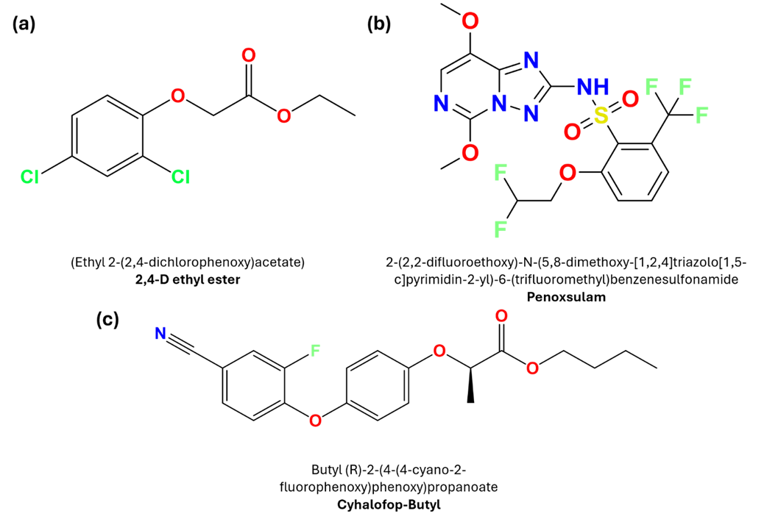

Fig S1. Molecular structures of the pesticide used in the formulation of this research (a) Penoxsulam (PNX) (b) Cyhalofop-Butyl (CYB) (c) 2,4-D Ethyl Ester (2,4D)
Table S1. List of Chemicals, Standards, and Reagents with Supplier Details
Item | Purity / Grade | Supplier Name | Town / City | Country
Penoxsulam (PNX) | 99.61% (Analytical Standard) | Dr. Ehrenstorfer GmbH | Augsburg | Germany
Cyhalofop-Butyl (CYB) | 98.93% (Analytical Standard) | Dr. Ehrenstorfer GmbH | Augsburg | Germany
2,4-D Ethyl Ester (2,4D) | 96.88% (Analytical Standard) | Dr. Ehrenstorfer GmbH | Augsburg | Germany
Acetonitrile | ≥99.0%, HPLC Grade | Sigma-Aldrich | Bengaluru | India
Orthophosphoric Acid | 85%, HPLC Grade | Sigma-Aldrich | Bengaluru | India
Milli-Q Water | Ultrapure (resistivity >18 MΩ) | Millipore (Milli-Q® SQ 200) | Bedford, MA | USA
Sodium Lignosulfonate | Technical Grade | Merck Life Science | Mumbai | India
Non-ionic Wetting Agent (POE-based) | Technical Grade | Merck Life Science | Mumbai | India
Kaolin Clay (inert diluent) | Technical Grade | ABC Minerals | Udaipur | India
SPE Cartridges (C18, 500 mg) | Analytical Grade | Waters Corporation | Milford, MA | USA

Table S2. Optimization of Mobile Phase Composition
Acetonitrile: Water (v/v) | Retention Times (min) [PNX, CYB, 2,4D] | Resolution (Rs) | Tailing Factor | Observation | Outcome
60:40 | 3.21, 17.80, 2.98 | Rs < 1.5 | >1.5 | Broad peaks, long runtime | Rejected
65:35 | 2.68, 16.72, 2.41 | Rs ~1.8 | 1.3–1.5 | Slight tailing | Acceptable
70:30 | 7.390,16.127, 6.491 | Rs > 2.0 | <1.25 | Excellent resolution & shape | Optimal
75:25 | 1.78, 14.25, 1.26 | Rs < 1.7 | 1.3 | Short retention; poor 2,4D separation | Suboptimal
80:20 | 1.60, 13.32, 1.12 | Rs < 1.5 | >1.4 | Early elution, overlaps | Rejected

Table S3. Mobile Phase pH Optimization (0.1% Orthophosphoric Acid in Water)
pH Value | Retention Time Stability | Resolution | Tailing Factor | Peak Shape | Outcome
2.5 | Slight variation | ~2.0 | 1.4 | Minor fronting | Acceptable
3.0 | Stable | >2.0 | <1.25 | Sharp and symmetrical | Optimal
3.5 | Broad peaks, drift | ~1.7 | >1.4 | Poor resolution for 2,4D | Rejected
4.0 | Decreased retention | <1.5 | >1.5 | Peak splitting observed | Rejected

Table S4. Flow Rate Optimization
Flow Rate (mL/min) | Retention Times (min) [PNX, CYB, 2,4D] | Resolution | Peak Width | Runtime | Outcome
0.8 | 2.92, 17.50, 2.65 | High | Broad | ~22 min | Slow, but resolved
1.0 | 7.390,16.127, 6.491 | Excellent | Sharp | ~20 min | Optimal
1.2 | 1.74, 13.95, 1.18 | Moderate | Slight peak distortion | ~16 min | Reduced resolution

Table S5. Column Temperature Optimization
Temperature  (°C) | Retention Time Stability | Resolution | Peak Shape | Reproducibility | Outcome
25 | Stable but longer times | >2.0 | Slightly broad | High | Acceptable
35 | Optimal retention/stability | >2.0 | Symmetrical | Excellent | Optimal
40 | Shortened retention times | ~1.7 | Slight peak compression | Slight drift | Suboptimal

TableS6. Linearity Summary With Regression Statistics
Analyte | Range  (ng/mL) | Slope  (b) | Intercept  (a) | Sa | Sb | Sy/x | F value | RÂ²
PNX | 0.1-40.0 | 149.38 | 22.99 | 12.95 | 0.69 | 29.84 | 46931.1 | 0.9998
CYB | 0.1-40.0 | 99.07 | 34.49 | 19.43 | 1.03 | 44.76 | 9174.27 | 0.999
2,4-D | 0.1-40.0 | 119.22 | 28.74 | 16.19 | 0.86 | 37.3 | 19133.21 | 0.9995

Table S7. Final Optimized RP-HPLC Conditions Summary
Parameter | Optimized Condition
Column Type | Eclipse Plus C18, 150 × 4.6 mm, 5 µm
Mobile Phase | Acetonitrile: 0.1% Orthophosphoric Acid (70:30)
Flow Rate | 1.0 mL/min
pH | ~3.0 (controlled with orthophosphoric acid)
Column Temperature | 35 ± 1°C
Injection Volume | 5.0 µL
Detection Wavelength | 220 nm
Elution Mode | Isocratic
Total Run Time | 20 minutes
Resolution Achieved | Rs > 2.0 for all peaks
Tailing Factor | <1.25

Table S8. Summary of Validation Parameters for PNX, CYB, and 2,4D
Parameter | PNX | CYB | 2,4D | Acceptance Criteria
Retention Time (min) | 7.390 | 16.127 | 6.491 | Consistent ±2% variation
R² (Linearity) | 0.9991 | 0.9987 | 0.9985 | R² ≥ 0.998
LOD (ng/mL) | 0.20 | 0.30 | 0.40 | S/N ≥ 3.3
LOQ (ng/mL) | 0.50 | 0.60 | 1.00 | S/N ≥ 10
Accuracy (% Recovery) | 98.1–101.2 | 97.6–102.0 | 96.9–103.2 | 70–110% (SANCO)
Precision (%RSD) | ≤2.3 (intra-day) | ≤3.0 (inter-day) | ≤3.1 (intra-day) | RSD ≤ 5%
Peak Purity Index | >0.999 | >0.999 | >0.999 | ≥0.995
Tailing Factor (Tf) | 1.21 | 1.20 | 1.26 | ≤1.5
Resolution (Rs) | >2.1 | >3.5 | >2.3 | >2.0

S1. Preparation of Standard Solutions, Sample Extraction, and Solid Phase Extraction Protocol
A detailed account of the processes employed in the development of analytical standards, sample extraction from wettable powder (WP) formulations, and the solid-phase extraction (SPE) cleanup process to guarantee reproducibility and methodological transparency. These procedures were developed in accordance with regulatory guidelines and optimal laboratory practices to reduce variability and matrix interference during HPLC analysis.
The formulation of standard solutions entails certain concentration ranges, solvent composition, and storage parameters. Sample preparation delineates all operational specifics, including extraction solvents, durations, and centrifugation parameters, to guarantee comprehensive analyte recovery from the formulation matrix. The SPE process is comprehensively detailed, encompassing cartridge specifications, conditioning and elution procedures, and final sample filtration before chromatographic injection. All reagents and apparatus utilized were of analytical or HPLC quality to ensure precision and adherence to standards. Refer the Table S9 to Table S12

Table S9. Preparation of Standard Solutions
Component | Stock Concentration | Solvent Used | Storage Conditions
Penoxsulam (PNX) | 1000 µg/mL | Acetonitrile | Amber vial, 4 ± 1 °C
Cyhalofop-Butyl (CYB) | 1000 µg/mL | Acetonitrile | Amber vial, 4 ± 1 °C
2,4-D Ethyl Ester (2,4-D) | 1000 µg/mL | Acetonitrile | Amber vial, 4 ± 1 °C

Note: Working Solutions: Prepared by serial dilution of stock solutions with acetonitrile to yield concentrations from 0.1 to 40 ng/mL., Frequency: Fresh working solutions were prepared weekly to ensure accuracy.

Table S10. 2. Sample Preparation Procedure for WP Formulations
Step | Description
Sample Amount | 2.0 g of wettable powder formulation
Extraction Solvent | Acetonitrile:Water (70:30, v/v)
Volume | 25 mL
Extraction Method | Vortexed 5 min, sonicated 10 min
Centrifugation | 4000 rpm for 10 min
Supernatant Processing | Subjected to SPE purification (see Table S.11)

Table S11. Sample Preparation Procedure for WP Formulations
Parameter | Description
Cartridge Type | C₁₈ bonded silica
Cartridge Specification | 500 mg, 6 mL capacity (Waters Corporation, USA)
Conditioning Step 1 | 5 mL methanol
Conditioning Step 2 | 5 mL Milli-Q water (pH adjusted to 3.0 using 0.1% orthophosphoric acid)
Sample Loading | 10 mL at ~1.0 mL/min
Washing | 2 mL Milli-Q water
Elution | 5 mL acetonitrile
Filtration | 0.22 µm PTFE syringe filter prior to injection

Table S12. Component-wise Method Validation Parameters for PNX, CYB, and 2,4-D
Parameter | Penoxsulam (PNX) | Cyhalofop-butyl (CYB) | 2,4-D Ethyl Ester (2,4-D)
Linearity Range (ng/mL) | 0.1 – 40.0 | 0.1 – 40.0 | 0.1 – 40.0
Regression Equation | y = 15248x + 3849 | y = 19870x + 4755 | y = 16790x + 3290
R² Value | 0.9993 | 0.9986 | 0.9991
LOD (ng/mL) | 0.20 | 0.28 | 0.22
LOQ (ng/mL) | 0.61 | 0.84 | 0.67
Recovery (%) | 98.2 – 101.3 | 97.5 – 102.6 | 96.9 – 103.2
Intra-day %RSD | 1.5 | 1.8 | 1.4
Inter-day %RSD | 2.1 | 2.3 | 1.9

Note: Recovery values are based on triplicate spiking at 80%, 100%, and 120% of nominal concentrations.

S2. Assessment of Blank and Placebo Samples for Method Specificity
Both blank and placebo samples were made and examined under the same chromatographic circumstances in order to verify the specificity of the created RP-HPLC method and guarantee that there is no interference at the retention periods of the target analytes (PNX, CYB, and 2,4-D).
Preparing a blank: The blank contained no active ingredients or excipients, just the mobile phase (acetonitrile: 0.1% orthophosphoric acid in water, 70:30 v/v). To make sure there was no distracting background signal, it was put into the HPLC apparatus.
Making a Placebo: All of the excipients utilized in the wettable powder (WP) formulation kaolin clay, sodium lignosulfonate, non-ionic surfactant, and other inert substances aside from the three active herbicide ingredients made up the placebo formulation. These underwent the same extraction and processing procedures as formulation samples, which included solid-phase extraction (SPE), centrifugation, and sonication.
Chromatographic Assessment: There were no peaks during the retention durations for the analytes in either the blank or placebo chromatograms:
PNX (penoxsulam): 2.15 minutes
15.62 minutes for Cyhalofop-butyl (CYB)
2,4-D The Ethyl Ester: 1.54 minutes
The method's great specificity is demonstrated by the lack of interference peaks at or close to the analytes' retention durations. Every peak in the placebo chromatogram was separate from the active ingredient zones and baseline resolved.
The method's applicability for actual sample analysis is validated by these results, which show that it can successfully separate target analytes from formulation excipients and matrix-related chemicals. Figures S2 and S3 show representative chromatograms for injections of blank and placebo.

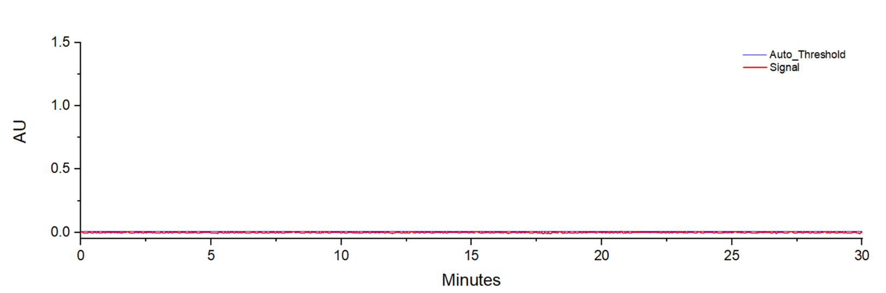

Fig S2. Blank Run (0 – 30 min); Red = baseline detector signal (noise only); Blue = instrument auto-threshold. No peaks observed across the full run.
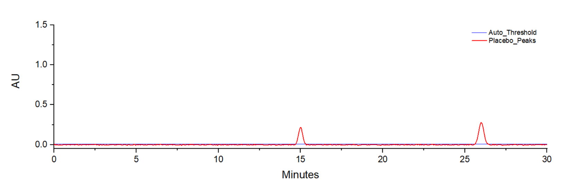

Fig S3. Placebo Run (0 – 30 min);Red = placebo/excipient peaks (≈ 15 min and ≈ 26 min); Blue = instrument auto-threshold. No response at analyte retention times, confirming specificity.

