Supplementary Material
Spectral Analysis of Compound:
- 1 H -NMR DATA
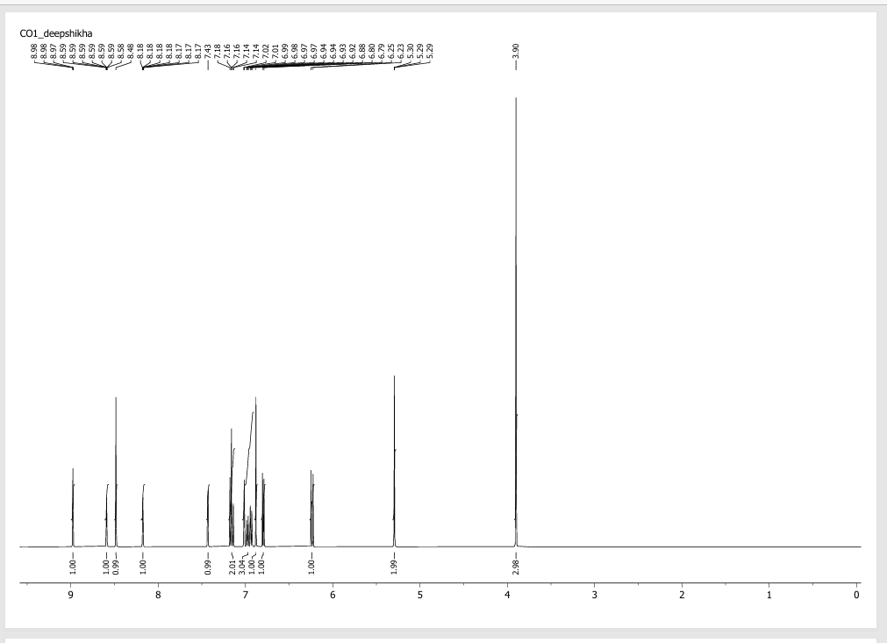

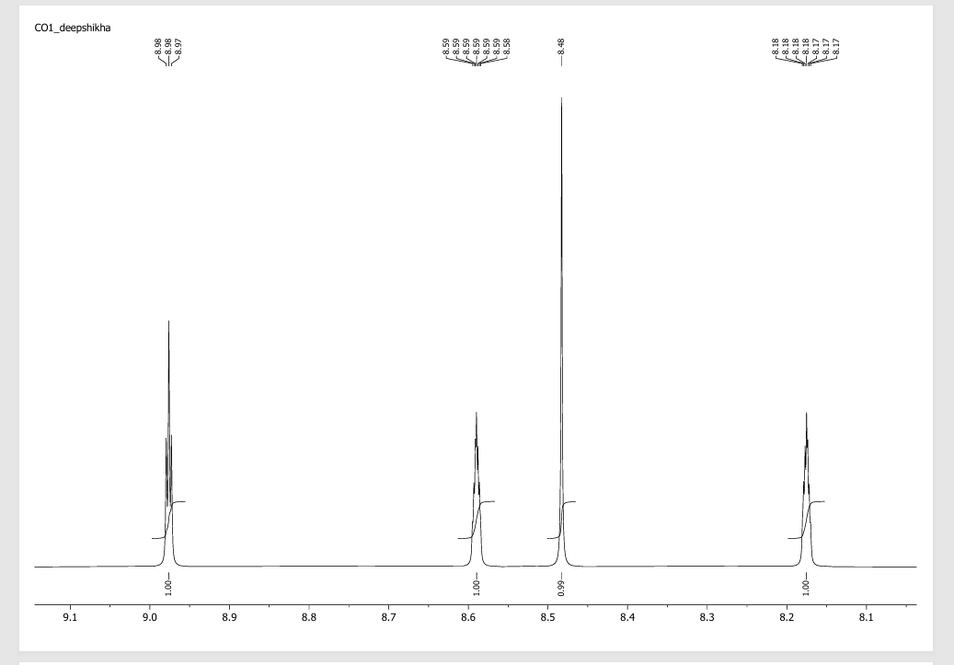

- 13 C-NMR DATA
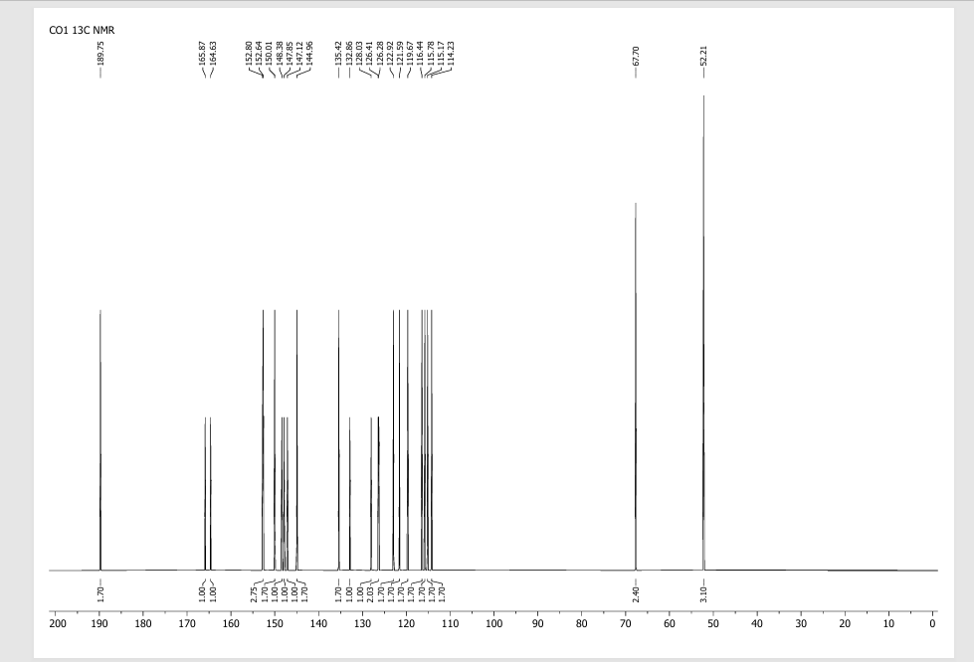
- IR DATA

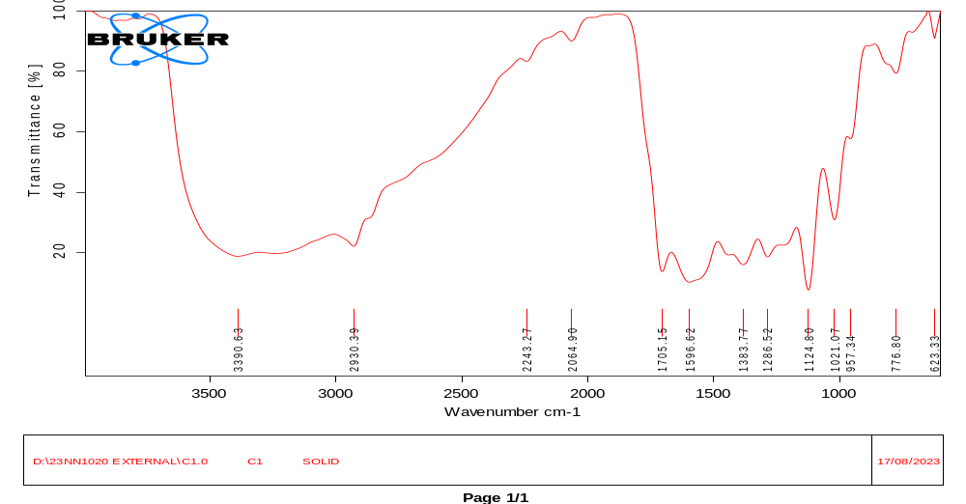

- MASS DATA
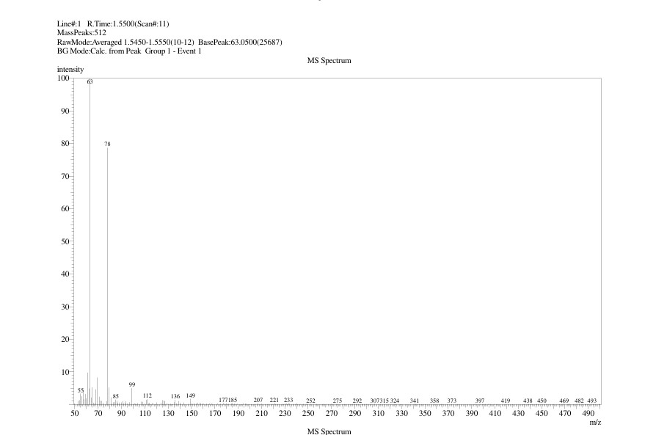

- Human Blood smear test:
Normal RBCs
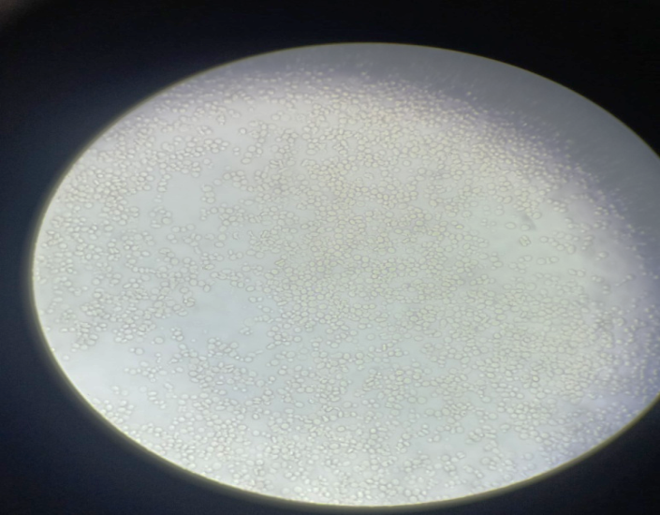
Normal Blood smear before adding Sodium Metabisulphite

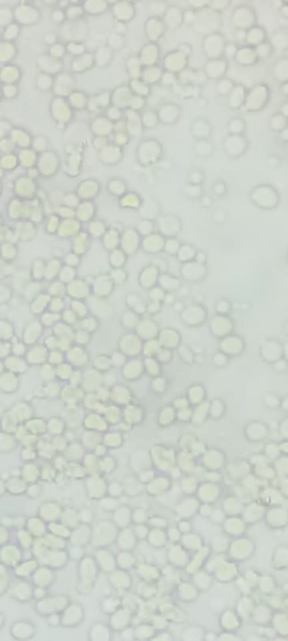
Normal RBCs
Before induction of Sodium meta -bisulphite
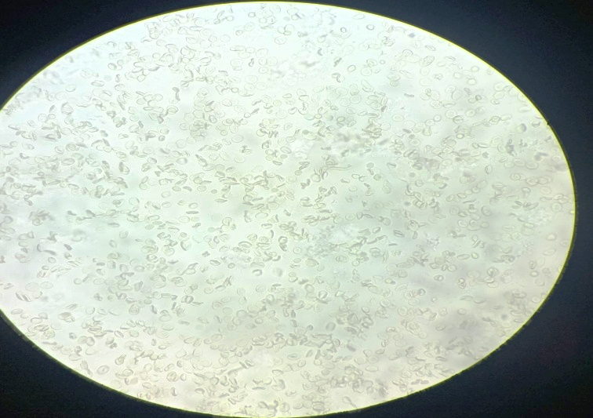
Sickled polymerized RBCs
After induction compound C1
After induction of Sodium meta- bisulphite

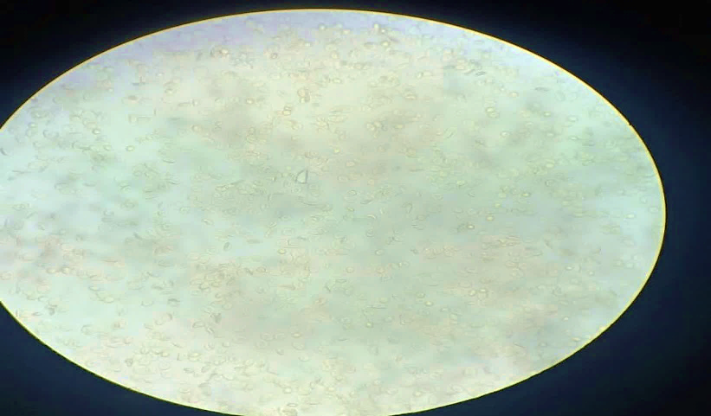
Treated with C1 Changed into Normal RBCs

