SUPPLEMENTARY MATERIAL

1. Homology modeling and validation
1.1 Parameters of YASARA in homology modeling of proteins
SM-Table 1: Modeling Parameters used in YASARA structure software (for both NS2B and NS4B proteins)
Parameter | Value / Setting | Purpose
Modeling speed | Slow (highest accuracy) | Ensures optimal refinement of alignments, loops, and side chains
PSI-BLAST iterations | 3 | Builds robust sequence profile for template search
Maximum BLAST E-value cutoff | 0.5 | Excludes weak templates
Maximum templates used | 5 | Balances accuracy and computational cost
Max. templates per same sequence | 1 | Prevents redundancy
Maximum oligomerization state considered | 10 (decameric) | Allows detection of biologically relevant oligomers
Alignment variations per template | 5 | Increases chances of best local alignment
Loop conformations sampled | 50 | Improves accuracy in flexible regions
Termini extension allowed | 10 residues | Accounts for missing residues in template structures

1.2 Template details used for homology modeling of NS2B protein
SM-Table 2: Template details used in NS2B protein modeling
Template (PDB ID, Chain) | Source Virus / Protein | Method | Resolution | Sequence Coverage | Quality Score (WHAT_CHECK) | Remark
8V0H-A | Flavivirus NS2B | NMR | – | 100% | 0.762 | Best template, full coverage
4M9T-A | Dengue virus type 2 polyprotein | X-ray | 1.74 Å | 64% | 0.797 | High-quality X-ray structure
4M9K-A | Dengue virus type 2 polyprotein | X-ray | 1.46 Å | 58% | 0.798 | High-resolution, complementary
3L6P-A | Dengue virus type 1 polyprotein | X-ray | 2.20 Å | 65% | 0.744 | Good coverage, moderate resolution
2M9P-A | Dengue virus type 2 polyprotein | NMR | – | 55% | 0.414 | Lower quality, but supports loop modeling

The final NS2B model was primarily built from 8V0H-A (full sequence coverage), complemented by high-resolution Dengue virus templates (4M9T-A, 4M9K-A, 3L6P-A) and an NMR model (2M9P-A) to optimize loop and flexible regions.

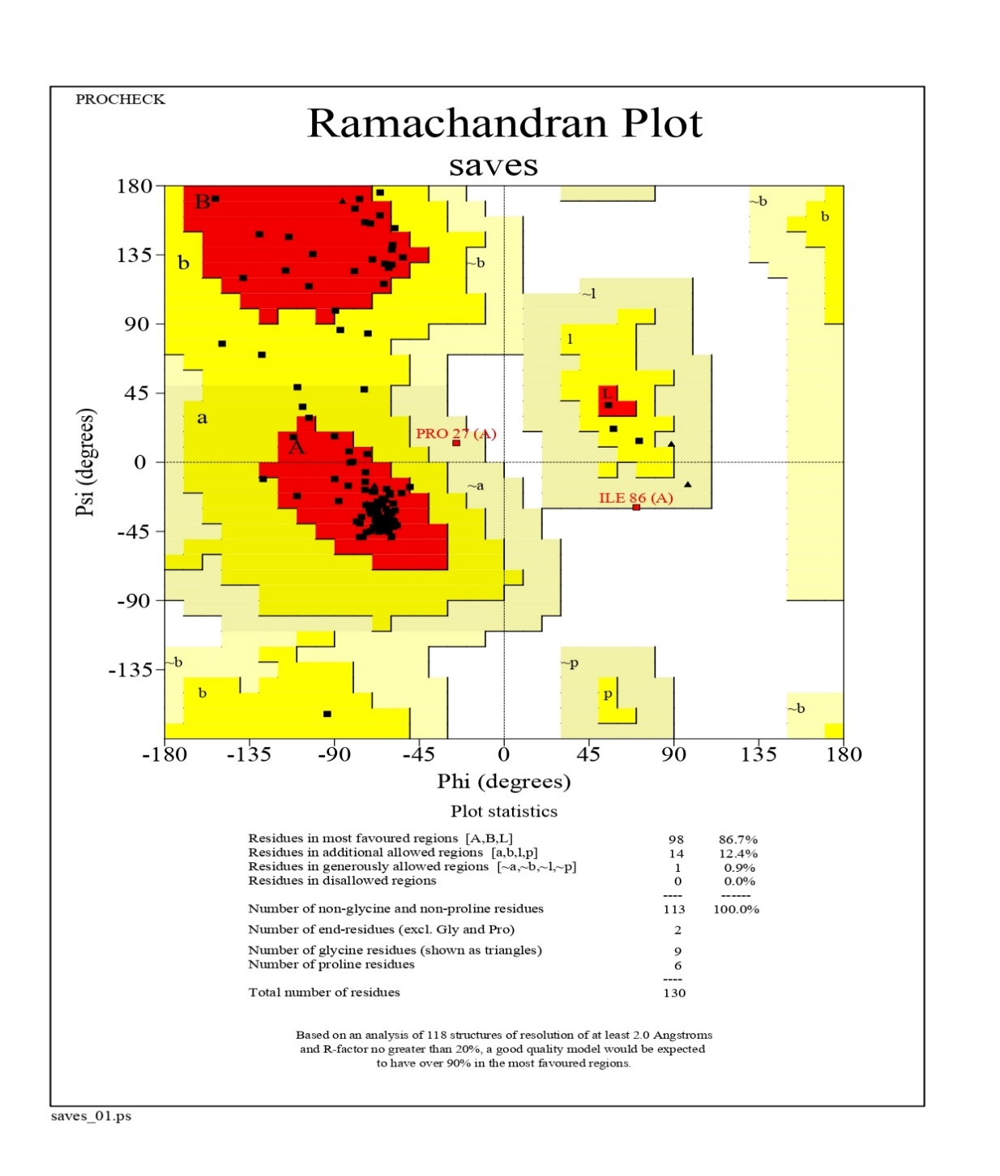
1.3 Model validation parameters for the model NS2B

SM -Figure 1.1: Ramachandran plot of NS2B model computed by PROCHECK Program

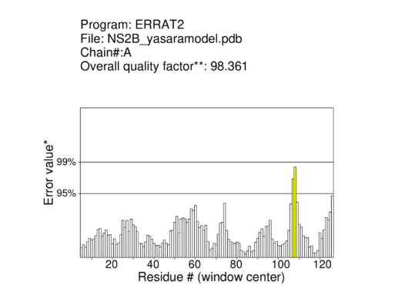

SM -Figure 1.2: Quality factor of the of NS2B model by ERRAT program (https://saves.mbi.ucla.edu/results?job=325051&p=errat)
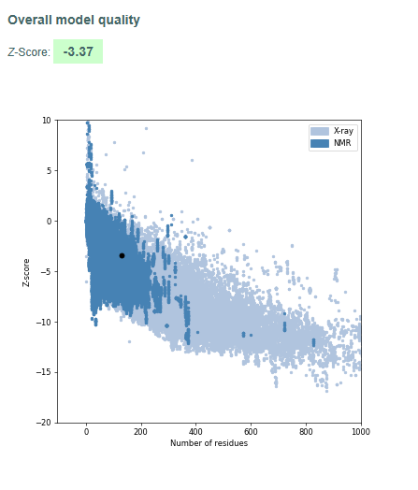

SM -Figure 1.3: Prosa-Web Result of the NS2B model computed from https://prosa.services.came.sbg.ac.at/prosa.php
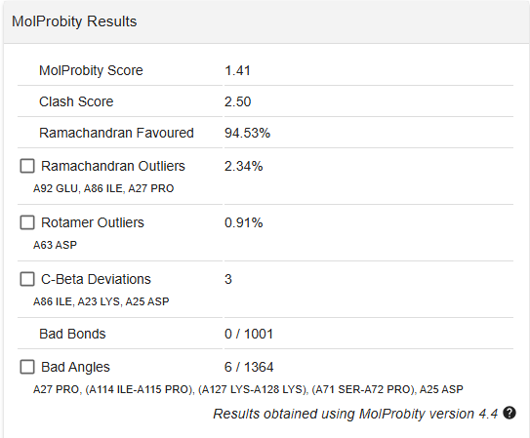

SM -Figure 1.4: MolProbity result of the NS2B model computed from swissmodel.expasy.org/assess/

1.4 Template details used for homology modeling of NS4B protein
SM-Table 3: Template details used in NS4B protein modeling
Template (PDB ID, Chain) | Source / Protein | Method | Resolution | Sequence Coverage | Quality Score (WHAT_CHECK) | Remark
7SII-C | Human STING protein | Cryo-EM | 3.45 Å | 29% | 0.773 | Best scoring template; partial coverage
6LKQ-n | Protein “T” (163 aa) | X-ray | 3.10 Å | 58% | 0.172 | Lower quality but extends coverage
Other hits (e.g., 4EMT-B, 6UKZ-A, 4QXO-A, 8T5K-B, etc.) | STING variants, SMT3, etc. | X-ray | 1.7–3.5 Å | 5–12% | 0.685–0.915 | All discarded due to low scores (<30% of best template) and no added coverage

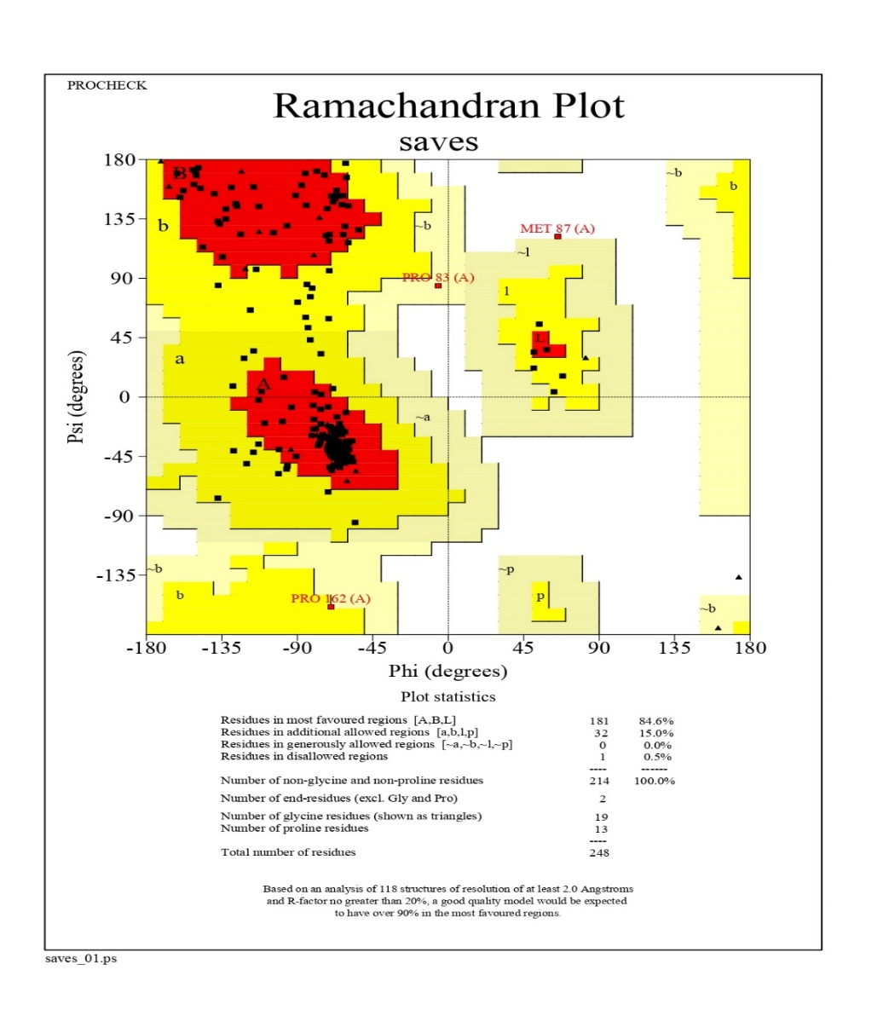
1.5 Model validation parameters for the model NS4B

SM -Figure 1.5: Ramachandran plot of NS4B model computed by PROCHECK Program

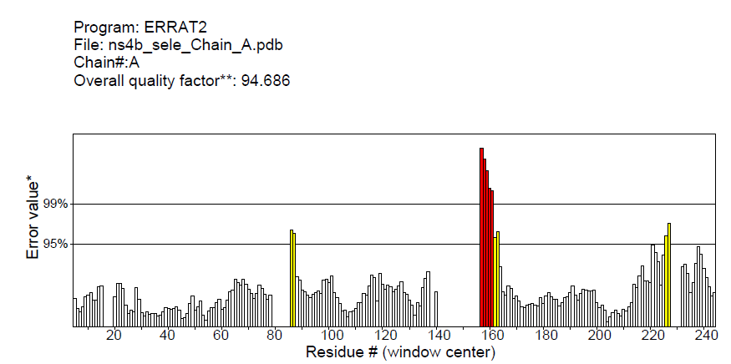

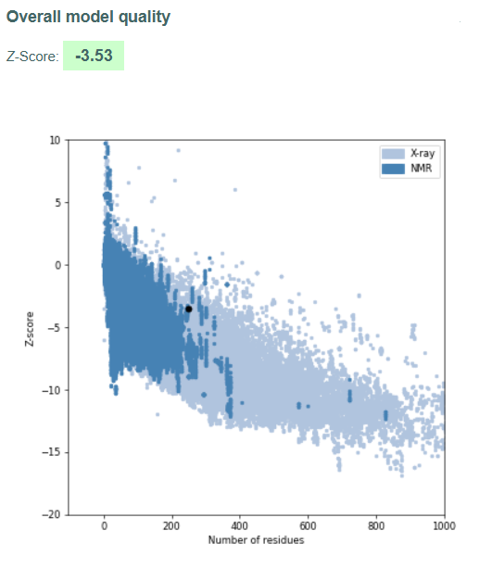
SM -Figure 1.6: Quality factor of the of NS4B model by ERRAT program (https://saves.mbi.ucla.edu/ errat)

SM -Figure 1.7: Prosa-Web Result of the NS4B model computed from https://prosa.services.came.sbg.ac.at/prosa.php
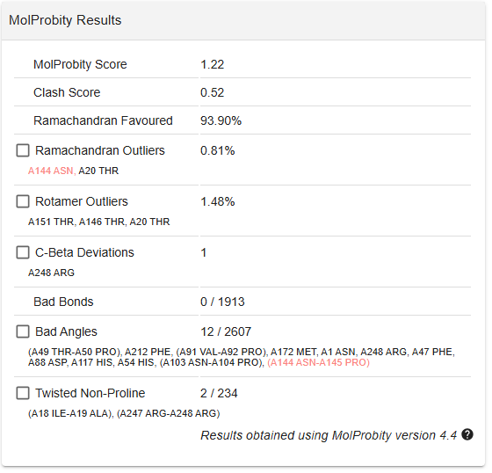

SM -Figure 1.8: MolProbity result of the NS4B model computed from swissmodel.expasy.org/assess/

2. Protein-protein-docking study (NS33 wild type with other NSPS)

SM Figure 2.1: Protein–Protein Interaction (PPI) Network of Dengue Virus NS1–NS3 Complex
The 2D interaction diagram illustrates the protein–protein interaction (PPI) interface between NS1 (chain B, blue labels) and NS3 (chain A, green labels) proteins of dengue virus. Hydrogen bonds are represented as green dashed lines with corresponding bond lengths (Å). Residues involved in hydrogen bonding are highlighted, while hydrophobic contacts are indicated by red arc lines around the interacting residues. NS1 residues are shown in blue, whereas NS3 residues are shown in green. The interaction network highlights key stabilizing contacts including Arg254, Glu255, and Gly253 of NS3 with Gln31, Asn166, and Tyr158 of NS1, as well as multiple stabilizing interactions formed by Arg236, Arg241, and Arg268 with Ser2, Asp1, and Val6. These interactions suggest potential molecular hotspots critical for NS1–NS3 complex stability.

SM Figure 2.2: Protein–Protein Interaction (PPI) Network of Dengue Virus NS2B–NS3 Complex
The 2D interaction diagram depicts the protein–protein interaction (PPI) interface between NS2B (chain B, blue labels) and NS3 (chain A, green labels) proteins of dengue virus. Hydrogen bonds are represented as green dashed lines with bond distances (Å). Residues involved in hydrogen bonding are highlighted, while hydrophobic contacts are shown as red arc lines surrounding the interacting residues. NS2B residues are labeled in blue and NS3 residues in green. Key stabilizing contacts include Arg539, Arg617, and Arg538 of NS3 with Leu123, Glu80, Asp25, and Ser15 of NS2B, as well as Arg225 and Glu609 forming interactions with Glu6 and Asn5. These molecular contacts suggest critical hotspots that contribute to the structural stability and functional regulation of the NS2B–NS3 protease complex.

SM Figure 2.3: Protein–Protein Interaction (PPI) network of the NS4B–NS3 complex
Residues from NS4B (chain A, green) and NS3 (chain B, blue) form multiple hydrogen bonds (green dashed lines with distances) and hydrophobic contacts (purple arcs). Key interacting residues include Glu468(A)–His117(B), Glu177(A)–Thr186(B), and Asp192(A)–Gln180(B), highlighting critical sites at the NS4B–NS3 interface.

SM Figure 2.4: Protein–Protein Interaction (PPI) Network of the NS5–NS3 Complex
Key interactions include Arg254(A)–Asp534(B), Lys213(A)–Glu843(B), Arg214(A)–Arg842(B), Ile240(A)–Gln340(B), Glu232(A)–Arg698(B), and Gln243(A)–Asp690(B), among others. These hydrogen bonds, electrostatic attractions, and hydrophobic interactions stabilize the NS5–NS3 protein interface, highlighting critical residues for complex formation.

3. Protein-protein-docking study (NS3 wild type withNS4B Mutants)

DOCKING COMPLEX NS3-NS4B MUTANT(G124A)

SM Figure 3.1: Protein–Protein Interaction (PPI) Network of the NS3–NS4B Complex with G124A Mutation
Key interactions observed include Ser171(A)–Glu192(B), Glu177(A)–Thr186(B), Asn329(A)–Gln170(B), Asp174(A)–Asn103(B), Glu468(A)–His117(B), Asp192(A)–Gln180(B), Lys213(A)–Gly77(B), and Arg254(A)–Gln71(B). These hydrogen bonding and hydrophobic interactions highlight structural rearrangements at the NS3–NS4B interface induced by the G124A mutation.
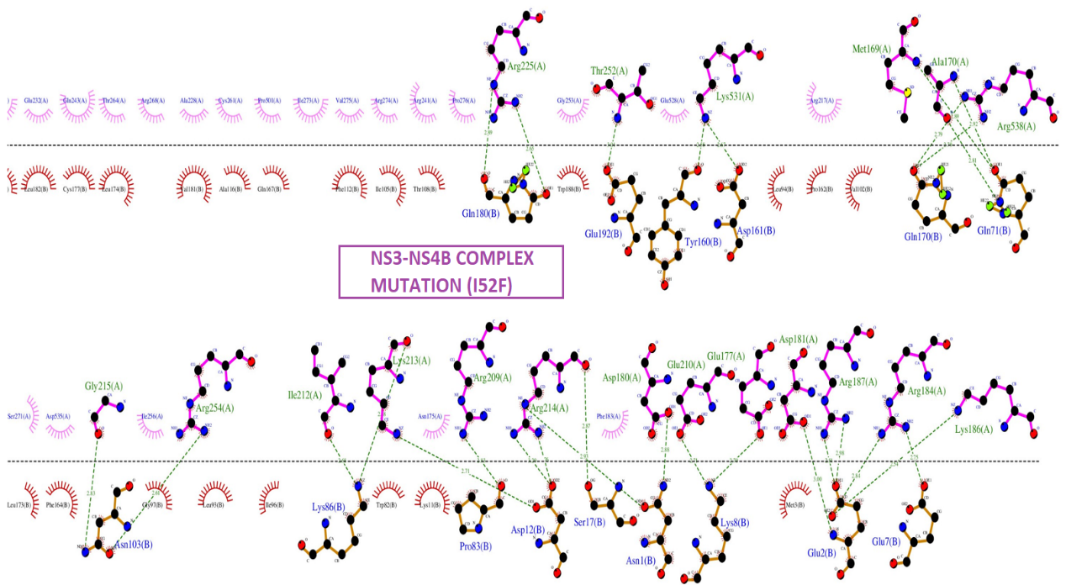

SM Figure 3.2: Protein–Protein Interaction (PPI) Network of the NS3–NS4B Complex with I52F Mutation
Key interactions involve Arg225(A)–Gln180(B), Thr252(A)–Trp188(B), Lys531(A)–Asp161(B), Arg538(A)–Gln71(B), Arg254(A)–Asn103(B), Lys213(A)–Lys86(B), Glu210(A)/Glu177(A)/Asp181(A)–multiple NS3 residues, and Arg184(A)–Lys186(B). These hydrogen bonds and hydrophobic contacts indicate extensive rearrangements at the NS3–NS4B interface due to the I52F mutation, potentially altering protein stability and interaction dynamics.
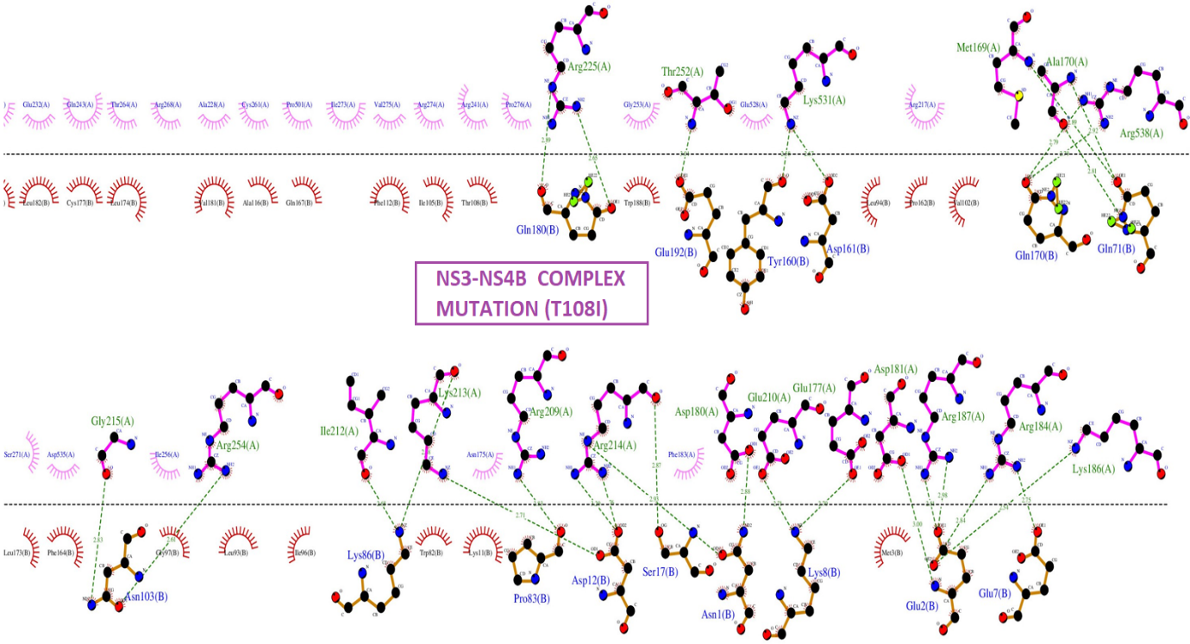

SM Figure 3.3: Protein–Protein Interaction (PPI) Network of the NS3–NS4B Complex with T108I Mutation
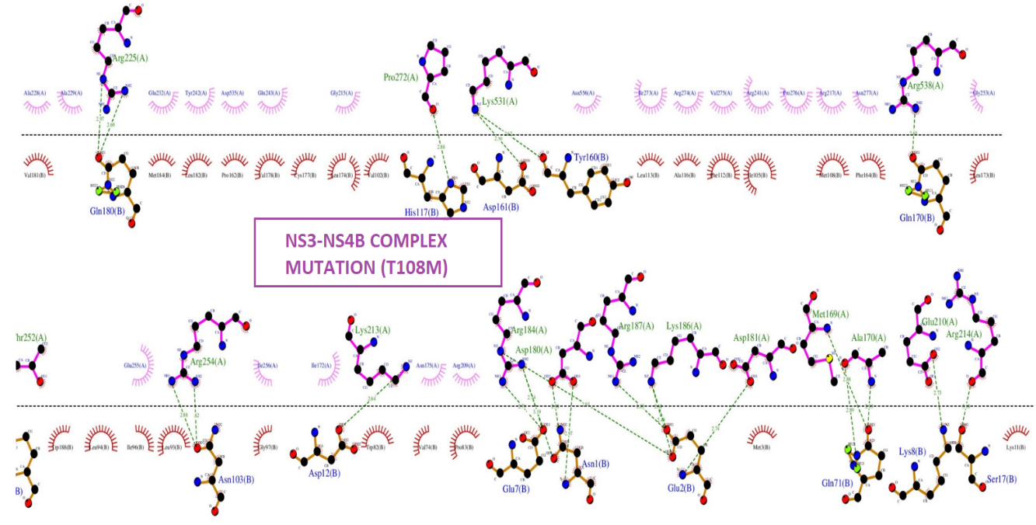
Key interactions include Arg225(A)–Gln180(B), Thr252(A)–Trp188(B), Lys531(A)–Asp161(B), Arg538(A)–Gln71(B), Arg254(A)–Asn103(B), Lys213(A)–Lys86(B), Arg214(A)–Asp12(B), Glu210(A)/Glu177(A)/Asp181(A)–multiple NS3 residues, and Arg184(A)–Lys186(B). These hydrogen bonding and hydrophobic contacts suggest structural rearrangements at the NS3–NS4B interface caused by the T108I mutation, potentially altering interaction strength and stability.

SM Figure 3.4: protein–Protein Interaction (PPI) Network of the NS3–NS4B Complex with T108M Mutation
Key interactions include Arg225(A)–Gln180(B), Pro272(A)/Lys531(A)–His117(B)/Asp161(B)/Tyr160(B), Arg538(A)–Gln170(B), Arg254(A)–Asn103(B), Lys213(A)–Asp12(B), Glu210(A)/Arg214(A)–Glu2(B)/Gln71(B)/Ser17(B), and Arg184(A)/Arg187(A)/Asp181(A)–Asn1(B)/Lys86(B). These hydrogen bonds and hydrophobic contacts suggest structural rearrangements at the NS3–NS4B interface induced by the T108M mutation, with possible effects on binding affinity and stability.

4. Protein-ligand docking study (NS3 wild type with the phytochemical naringenin and experimental inhibitor ST-610)
SM-Table 4.1: Comparative docking results of Naringenin and ST-610 with the 2BMF receptor obtained from MzDOCK Program
Mode | Naringenin – Binding Affinity (kcal/mol) | RMSD lower bound (Å) | RMSD upper bound (Å) | ST-610 – Binding Affinity (kcal/mol) | RMSD lower bound (Å) | RMSD upper bound (Å)
1 | −9.2 | 0.000 | 0.000 | −8.9 | 0.000 | 0.000
2 | −9.1 | 14.685 | 17.870 | −8.9 | 24.815 | 26.160
3 | −8.9 | 1.744 | 6.641 | −8.8 | 19.174 | 23.932
4 | −8.3 | 23.149 | 25.082 | −8.6 | 21.762 | 25.007
5 | −8.3 | 21.056 | 23.571 | −8.3 | 23.605 | 25.261
6 | −8.2 | 24.069 | 26.610 | −8.1 | 24.025 | 25.475
7 | −8.1 | 13.240 | 16.629 | −8.1 | 21.719 | 25.287
8 | −8.0 | 1.990 | 6.715 | −8.0 | 17.572 | 21.223
9 | −7.9 | 22.444 | 24.089 | −7.6 | 22.389 | 25.245

Comparative protein–ligand docking results of naringenin and the experimental inhibitor ST-610 with the NS3 (2BMF) receptor, showing binding affinities (kcal/mol) and RMSD values obtained using the MzDOCK program.

5. Molecular dynamics simulation parameters
SM-Table 5: Detailed Simulation Parameters used in YASARA structure tool for performing MD simulation of Protein-ligand and protein-protein simulation
Parameter | Value
pH | 7.4
Ions | Na⁺, Cl⁻ (0.9%)
Temperature | 298 K (controlled with Berendsen thermostat, τ = 0.1 ps)
Pressure control | SolventProbe method with Berendsen barostat (τ = 1.0 ps)
Density | 0.99342 g/cm³
Cell shape | Cube
Simulation duration | 50,000 ps (50 ns)
Save interval | Every 10,000 steps
Force field | AMBER14
Cutoff | 8 Å (van der Waals interactions)
Boundary condition | Periodic
Electrostatics | Long-range Coulomb with PME
Integrator | Multiple time step leapfrog/Verlet (Δt = 1.25 fs)
Constraints | All bonds to hydrogen atoms constrained with LINCS-like algorithm (YASARA implementation)
Drift correction | Enabled
Random seed | 1
MM-PBSA Calculation Parameters
Number of frames extracted | 250
Extraction interval | 200 ps
Solvation model (polar) | Poisson–Boltzmann (PB)
Solvation model (non-polar) | Surface area-based term
Surface tension parameter | 0.65 kJ·mol⁻¹·Å⁻²
Temperature | 298 K
Dielectric constant (solute) | 1.0
Dielectric constant (solvent) | 80.0
Cell shape | Converted to cuboid for PB
Energy components computed | Epot(rec), Esol(rec), Epot(lig), Esol(lig), Epot(complex), Esol(complex)
Binding energy formula | ΔG_bind = (G_rec + G_lig) – G_complex

6. Interface energetics and interfacial contact of protein -protein complexes

SM-Table 6: Interface energetics and interfacial contact composition of protein -protein complexes computed by PRODIGY server
Protein–protein complex | ΔG (kcal/mol) | Kd (M) at 25 °C | ICs charged–charged | ICs charged–polar | ICs charged–apolar | ICs polar–polar | ICs polar–apolar | ICs apolar–apolar | NIS charged (%) | NIS apolar (%)
NS3–NS1 complex | –11.7 | 2.8 × 10⁻⁹ | 5.0 | 16.0 | 22.0 | 5.0 | 26.0 | 23.0 | 36.47 | 36.65
NS3–NS2B complex | –11.3 | 5.1 × 10⁻⁹ | 5.0 | 9.0 | 46.0 | 2.0 | 15.0 | 21.0 | 35.78 | 41.67
NS3–NS4B complex | –13.4 | 1.5 × 10⁻¹⁰ | 5.0 | 14.0 | 39.0 | 4.0 | 28.0 | 57.0 | 29.94 | 44.82
NS3–NS5 complex | –15.1 | 9.1 × 10⁻¹² | 26.0 | 20.0 | 37.0 | 1.0 | 21.0 | 15.0 | 37.48 | 34.48

SM-Table 6 shows the predicted binding energies and the composition of the interfacial contact for four DENV2 NS3–cofactor/protein complexes. The predicted binding free energy (ΔG) and dissociation constant (Kd at 25 °C) are given for each complex. There are six types of interfacial contacts (ICs): charged–charged, charged–polar, charged–apolar, polar–polar, polar–apolar, and apolar–apolar. The percentages of charged and apolar non-interacting surface (NIS) areas are also given. This shows how the physicochemical properties of the interface affect the stability of the complex.

7. Comparative Interfacial Interaction Profile of the DENV2 NS3–NS4B Wild-Type and G124A Mutant Complexes
SM-Table 7.1 Interaction Profile of the DENV2 NS3–NS4B Wild-Type protein complexes
Interaction type | NS3 |  | NS4B WILD TYPE
Interaction type | Position | Residue | Position | Residue
Hydrophobic  (Total no.=45) | 197 | Ala | 177 | Cys
Hydrophobic  (Total no.=45) | 194 | His | 174 | Leu
Hydrophobic  (Total no.=45) | 198 | Gly | 178 | Val
Hydrophobic  (Total no.=45) | 203 | Tyr | 185 | Val
Hydrophobic  (Total no.=45) | 202 | Arg | 184 | Met
Hydrophobic  (Total no.=45) | 179 | Glu | 93 | Leu
Hydrophobic  (Total no.=45) | 178 | Ile | 164 | Phe
Hydrophobic  (Total no.=45) | 173 | Glu | 173 | Leu
Hydrophobic  (Total no.=45) | 172 | Ile | 112 | Phe
Hydrophobic  (Total no.=45) | 209 | Arg | 116 | Ala
Hydrophobic  (Total no.=45) | 328 | Ser | 90 | Gly
Hydrophobic  (Total no.=45) | 327 | Gln | 94 | Leu
Hydrophobic  (Total no.=45) | 465 | Pro | 91 | Val
Hydrophobic  (Total no.=45) | 466 | Lys | 95 | Ala
Hydrophobic  (Total no.=45) | 170 | Ala | 76 | Met
Hydrophobic  (Total no.=45) | 169 | Met | 84 | Leu
Hydrophobic  (Total no.=45) | 212 | Ile | 85 | Ser
Hydrophobic  (Total no.=45) | 237 | Gly | 83 | Pro
Hydrophobic  (Total no.=45) | 239 | Pro | 181 | Val
Hydrophobic  (Total no.=45) | 189 | Thr | 182 | Leu
Hydrophobic  (Total no.=45) | 193 | Leu | 75 | Leu
Hydrophobic  (Total no.=45) | 191 | Met | 74 | Val
Hydrophobic  (Total no.=45) | 215 | Gly
 |  |  |  |  | H bond Distance (Angstrom)
Hydrogen Bonds (Total no. =10) | 468 | Glu | 117 | His | 3.12
Hydrogen Bonds (Total no. =10) | 177 | Glu | 186 | Thr | 2.02
Hydrogen Bonds (Total no. =10) | 177 | Glu | 188 | Trp | 2.74
Hydrogen Bonds (Total no. =10) | 174 | Asp | 103 | Asn | 3.03
Hydrogen Bonds (Total no. =10) | 329 | Asn | 170 | Gln | 2.87, 2.94
Hydrogen Bonds (Total no. =10) | 171 | Ser | 192 | Glu | 3
Hydrogen Bonds (Total no. =10) | 213 | Lys | 77 | Gly | 2.6
Hydrogen Bonds (Total no. =10) | 192 | Asp | 180 | Gln | 2.84
Hydrogen Bonds (Total no. =10) | 254 | Arg | 71 | Gln | 2.66

SM-Table 7.2: Interaction Profile of the DENV2 NS3–NS4B mutant protein complexes
Interaction type | NS3 |  | NS4B(G124A)
Interaction type | Position | Residue | Position | Residue
Hydrophobic  (Total no.=43) | 169 | Met | 95 | Ala
Hydrophobic  (Total no.=43) | 170 | Ala | 91 | Val
Hydrophobic  (Total no.=43) | 173 | Glu | 94 | Leu
Hydrophobic  (Total no.=43) | 172 | Ile | 90 | Gly
Hydrophobic  (Total no.=43) | 179 | Glu | 189 | Ala
Hydrophobic  (Total no.=43) | 178 | Ile | 185 | Arg
Hydrophobic  (Total no.=43) | 202 | Arg | 184 | Met
Hydrophobic  (Total no.=43) | 203 | Tyr | 178 | Val
Hydrophobic  (Total no.=43) | 198 | Gly | 174 | Leu
Hydrophobic  (Total no.=43) | 328 | Ser | 164 | Phe
Hydrophobic  (Total no.=43) | 327 | Gln | 173 | Leu
Hydrophobic  (Total no.=43) | 465 | Pro | 112 | Phe
Hydrophobic  (Total no.=43) | 209 | Arg | 93 | Leu
Hydrophobic  (Total no.=43) | 237 | Gln | 83 | Pro
Hydrophobic  (Total no.=43) | 239 | Pro | 84 | Leu
Hydrophobic  (Total no.=43) | 212 | Ile | 85 | Ser
Hydrophobic  (Total no.=43) | 189 | Thr | 181 | Val
Hydrophobic  (Total no.=43) | 191 | Met | 177 | Cys
Hydrophobic  (Total no.=43) | 193 | Leu | 76 | Met
Hydrophobic  (Total no.=43) | 194 | His | 75 | Leu
Hydrophobic  (Total no.=43) | 197 | Ala | 74 | Val
Hydrophobic  (Total no.=43) | 215 | Gly
Hydrophobic  (Total no.=43) |  |  |  |  | H Bond Distance (Angstrom)
Hydrophobic  (Total no.=43) | 171 | Ser | 192 | Glu | 3
Hydrogen bond (Total no. 11) | 177 | Glu | 188 | Trp | 2.73
Hydrogen bond (Total no. 11) | 177 | Glu | 186 | Thr | 2.82
Hydrogen bond (Total no. 11) | 329 | Asn | 170 | Gln | 2.87,2.94
Hydrogen bond (Total no. 11) | 174 | Asp | 103 | Asn | 3.03
Hydrogen bond (Total no. 11) | 468 | Glu | 117 | His | 3.11
Hydrogen bond (Total no. 11) | 192 | Asp | 180 | Gln | 2.82
Hydrogen bond (Total no. 11) | 213 | Lys | 88 | Asp | 2.56
Hydrogen bond (Total no. 11) | 213 | Lys | 77 | Gly | 2.60
Hydrogen bond (Total no. 11) | 254 | Arg | 71 | Gln | 2.66

