Supplementary Information

Figure. S1 UV-Vis spectra of compound in different solvent medium.

Figure. S2 IR-Spectrum of the title compound.

Figure. S3 Numbering atoms of the title compound.

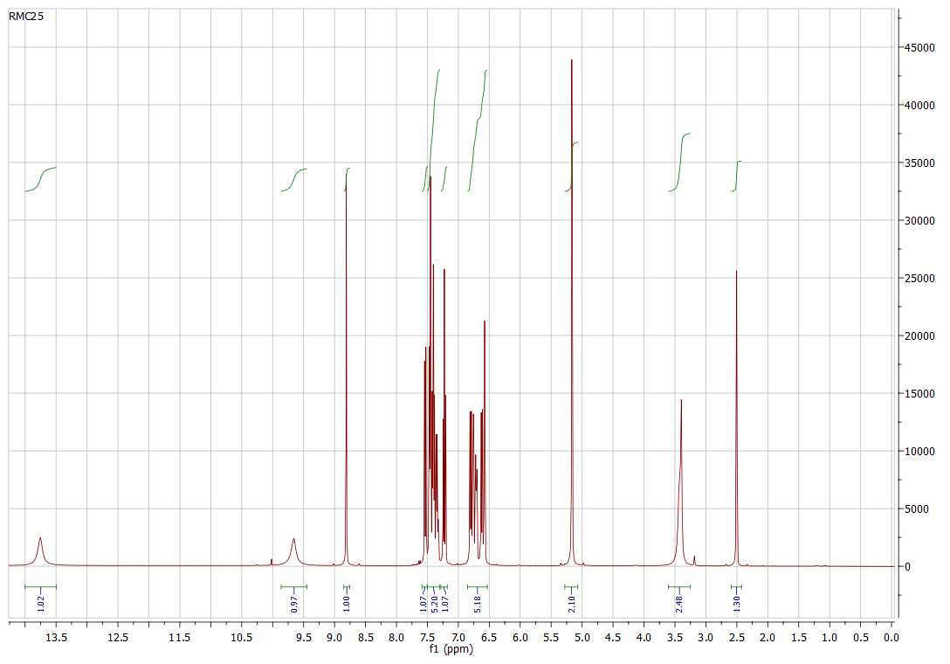
Figure. S4 ¹H NMR Spectrum the title compound.

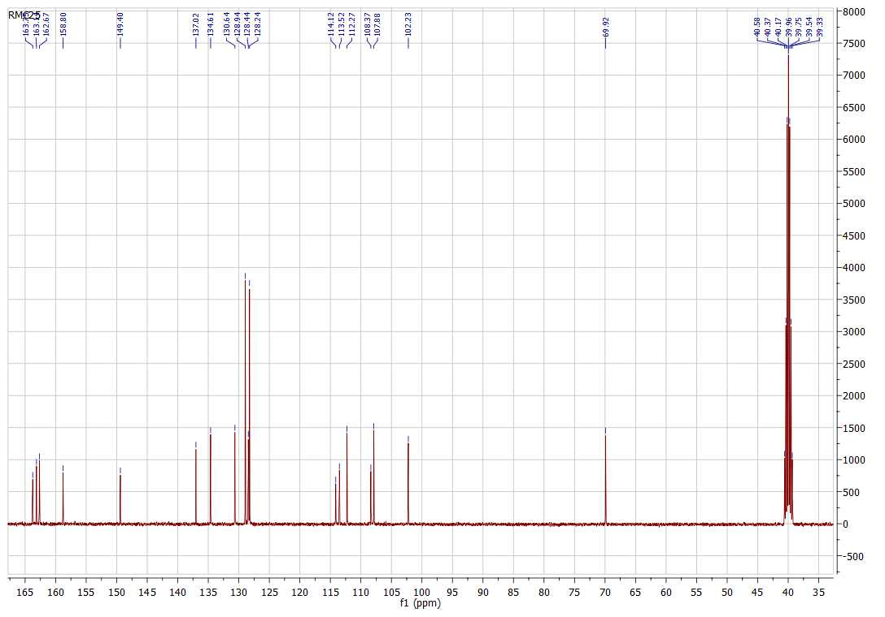
Figure. S5 ¹³C NMR Spectrum of the title compound.
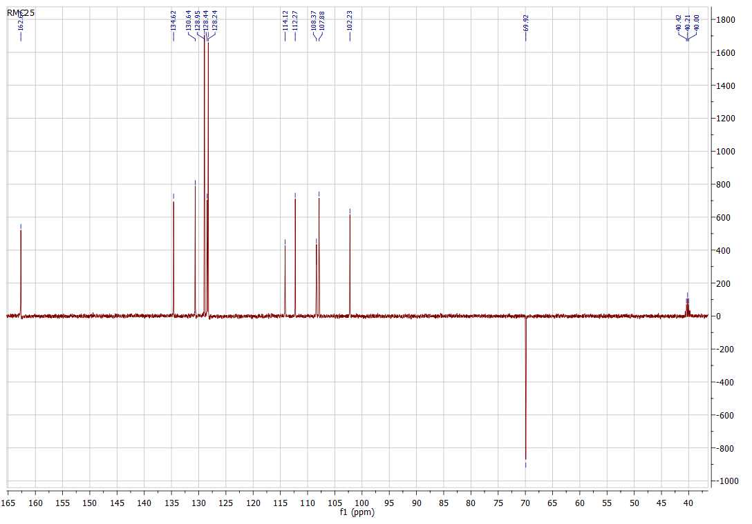
Figure. S6 ¹³C DEPT-135 Spectrum of the title compound.

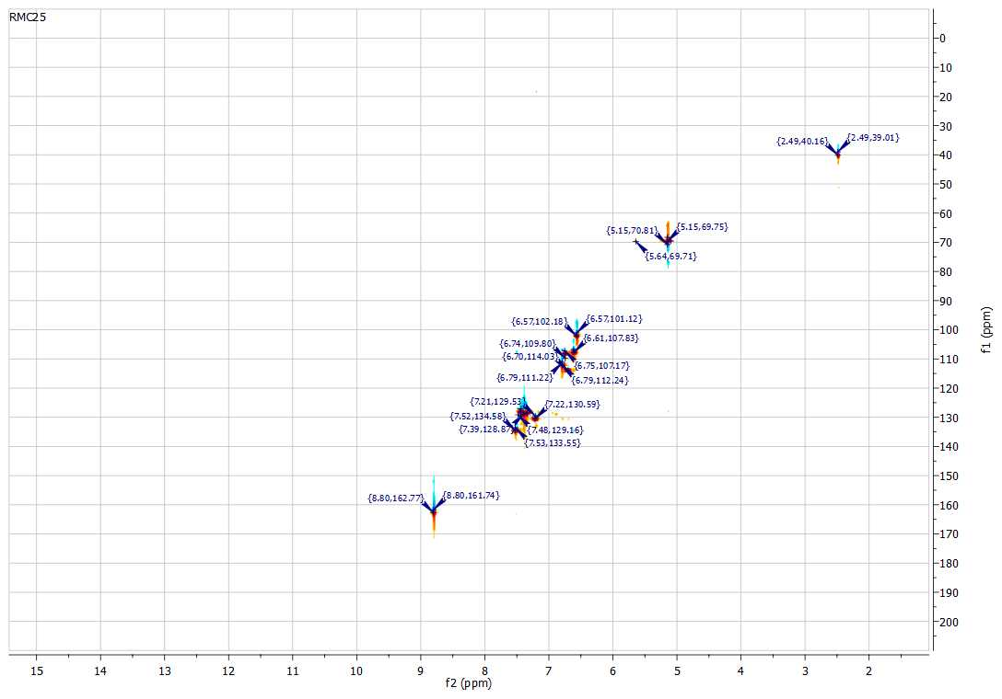
Figure. S7 HSQC Spectrum of the title compound.
Table A1. Results of Uv-visible absorption.
Solvent | 𝛑⟶𝛑* (nm) | n⟶𝛑* (nm)
Chloroform (CHCl₃) | 339.09 | 416.31
Dichloromethane (CH₂Cl₂) | 335.38 | 410.87
Isopropyl alcohol (C₃H₈O) | 338.70 | 408.70
Methanol (CH₃OH) | 333.20 | 417.53

Table A2. Results of the 1 H. NMR and 2d. NMR.
 | ¹³C NMR | Cn | ¹H. NMR |  | 2d. NMR
01 | 163.7 | C 05 | - | O-C_{Ar} | -
02 | 163.1 | C 03 | 13.75 (s, 1H, OH) | C-OH | -
03 | 162.6 | C 01 | 8.81 (s, 1H, CHN) | CHN | 8.80, 162.77
04 | 158.8 | C 17 | 9.66 (s, 1H, OH) | C-OH | -
05 | 149.4 | C 15 | - | N-C_{Ar} | -
06 | 137.2 | C 09 | - | CH₂-C_{Ar} | -
07 | 134.6 | C 07 | 7.53 (d, J = 7.5Hz. 1H, H⁷_{Ar}) Proton aromatique (cycle B) | CH_{Ar} | 7.52, 134.58
08 | 130.6 | C 19 | 7.23 (t, J = 8.0 Hz, 1H, H_{Ar}) Proton aromatique (cycle A, position para) | CH_{Ar} | 7.22 ,130.59
09 | 128.9 | C 13 | 7.40 (d, J = 7.3, 1.7Hz. 2H, H_{Ar}) Proton métha du groupement benzyle | CH_{Ar}
10 | 128.9 | C 11 |  | CH_{Ar}
11 | 128.4 | C 12 | 7.37 – 7.31 (m, 1H, H_{Ar}) Proton para du groupement benzyle | CH_{Ar}
12 | 128.2 | C 14 | 7.46 (d, J = 8.0Hz. 2H, H_{Ar}) Proton ortho du groupement benzyle | CH_{Ar}
13 | 128.2 | C 10 |  | CH_{Ar}
14 | 114.1 | C 20 | 6.73 – 6.69 (m, 1H, H_{Ar}) Proton aromatique (cycle A) | CH_{Ar} | 6.70, 114.03
15 | 113.5 | C 02 | - | N=C-C_{Ar} | -
16 | 112.2 | C 18 | 6.80 (dd, J = 7.9, 1.1 Hz. 1H, H_{Ar}) Proton aromatique (cycle A) | CH_{Ar} | 6.79, 111.22
17 | 108.3 | C 16 | 6.76 – 6.75 (m, 1H, H_{Ar}) Proton aromatique (cycle A) | CH_{Ar} | 6.74, 109.80
18 | 107.8 | C 06 | 6.62 (dd, J = 8.6, 2.4 Hz. 1H, H_{Ar}) Proton aromatique (cycle B) | CH_{Ar} | 6.61, 107.83
19 | 102.2 | C 04 | 6.58 (s, 1H, H_{Ar}) Proton aromatique (cycle B) | CH_{Ar} | 6.57, 102.18
20 | 69.9 | C 08 | 5.17 (s, 2H, OCH₂), | O-CH₂ | 5.17, 69.90
Table A3. Hydrogen-bond geometry (lengths Å, angles °)
Cg2, Cg3 and Cg5 are the centroids of rings C9-C14, C15-C20 and C39-C44.
D—H···A | D—H | H···A | D···A | D—H···A
N1—H1N···O1 | 0.928 (14) | 1.801 (14) | 2.6063 (12) | 143.5 (12)
O3—H3O···O31 ^{i} | 0.93 (1) | 1.70 (1) | 2.6185 (12) | 171 (2)
N31—H31N···O31 | 0.967 (15) | 1.749 (15) | 2.5915 (13) | 143.5 (13)
O33—H33O···O1 ^{ii} | 0.94 | 2.59 | 3.2424 (14) | 171 (2)
C34—H34···O3 ^{ii} | 0.94 | 2.59 | 3.2424 (14) | 127
C13—H13···Cg5 ^{iii} | 0.94 | 2.84 | 3.6364 (14) | 144
C19—H19···Cg5 ^{iv} | 0.94 | 2.81 | 3.5496 (14) | 136
C37—H37···Cg3 ^{v} | 0.94 | 2.70 | 3.5636 (13) | 154
C40—H40···Cg2 ^{vi} | 0.94 | 2.85 | 3.5681 (14) | 135

Symmetry codes: (i) −x+1, y+1/2, −z+1/2; (ii) x, −y+1/2, z+1/2; (iii) x, −y+3/2, z+1/2; (vi) −x, y−1/2, −z+1/2.

Table A4. Selected dihedral angles (°) for compounds I-VII
I_1 is molecule 1 of compound I, I_2 is molecule 2 of compound I.

 | A/B | A/C | B/C
I_1 | 4.26 (5) | 72.77 (6) | 70.58 (6)
I_2 | 9.59 (6) | 34.13 (6) | 24.60 (6)
II ª | 3.42 (8) | 70.3 (1) | 70.0 (1)
III ^{b} | 9.13 (8) | 13.58 (9) | 21.95 (9)
IV ^{c} | 5.11 (9) | 58.42 (11) | 63.53 (11)
 | A/B | A/C | B/C
V ^{d} | 46.8 (1) | 78.2 (1) | 32.8 (1)
VI ^{e} | 53.52 (11) | 49.91 (12) | 10.73 (13)
VII ^{f} | 4.34 (10) | 27.66 (11) | 31.40 (12)
a) Ghichi et al., 2014a, b) Ghichi et al., 2014b, c) Ghichi et al., 2018a, d) Ghichi et al., 2018a, e) Ghichi et al., 2018b, f) Ghichi et al., 2015.

Table A5. Selected bond lengths (Å) for compounds I-VII
I_1 is molecule 1 of compound I, I_2 is molecule 2 of compound I.

Compound | d1 | d2 | d3 | d4 | d5 | d6 | d7 | d8 | d9 | d10
I_1 | 1.415 (2) | 1.311 (2) | 1.396 (2) | 1.412 (2) | 1.358 (2) | 1.416 (2) | 1.378 (2) | 1.405 (2) | 1.443 (2) | 1.299 (1)
I_2 | 1.409 (2) | 1.314 (2) | 1.395 (2) | 1.417 (2) | 1.352 (2) | 1.415 (2) | 1.377 (2) | 1.408 (2) | 1.441 (2) | 1.295 (1)
II ª | 1.407 | 1.314 | 1.393 | 1.42 | 1.346 | 1.416 | 1.369 | 1.407 | 1.439 | 1.293
III ^{b} | 1.413 | 1.31 | 1.396 | 1.421 | 1.344 | 1.408 | 1.369 | 1.416 | 1.433 | 1.287
IV ^{c} | 1.406 | 1.309 | 1.395 | 1.422 | 1.35 | 1.416 | 1.373 | 1.418 | 1.445 | 1.277
V ^{d} | 1.414 | 1.288 | 1.435 | 1.401 | 1.364 | 1.393 | 1.384 | 1.381 | 1.406 | 1.35
VI ^{e} | 1.418 | 1.286 | 1.441 | 1.39 | 1.373 | 1.389 | 1.386 | 1.388 | 1.403 | 1.343
VII ^{f} | 1.410 | 1.284 | 1.436 | 1.388 | 1.381 | 1.394 | 1.382 | 1.375 | 1.419 | 1.348
a) Ghichi et al., 2014a, b) Ghichi et al., 2014b, c) Ghichi et al., 2018a, d) Ghichi et al., 2018a, e) Ghichi et al., 2018b, f) Ghichi et al., 2015.

Table A6. Relative percentage contributions (%) of close contacts to the Hirshfeld surfaces of compounds I-VII.
I_1 is molecule 1 of compound I, I_2 is molecule 2 of compound I.

Contact | I | I_1 | I_2 | II ª | III ^{b} | IV ^{c} | V ^{d} | VI ^{e} | VII ^{f}
H···H | 44.3 | 46.6 | 39.8 | 43.9 | 53.0 | 39.1 | 48.9 | 36.4 | 35.7
C···H/H···C | 30.7 | 28.4 | 35.8 | 33.1 | 24.1 | 28.0 | 32.9 | 37.8 | 23.2
N···H/H···N | 1.1 | 0.6 | 1.4 | 1.9 | 0.5 | 0.5 | 2.9 | 2.0 | 4.0
O···H/H···O | 17.0 | 19.1 | 15.9 | 16.0 | 13.5 | 11.5 | 9.7 | 7.3 | 24.5
Cl···H/H···Cl | - | - | - | - | - | 9.2 | - | 13.4 | -
C···C | 4.5 | 3.7 | 4.9 | 4.3 | 6.5 | 2.7 | 3.8 | 0.8 | 6.8
Cl···C/C···Cl | - | - | - | - | - | 3.5 | - | 0.11 | -
N···C/C···N | 1.4 | 1.1 | 1.4 | 0 | 1.5 | 1.0 | 0.4 | 0.2 | 1.2
O···C/C···O | 0.9 | 0.7 | 0.8 | 0.7 | 0.7 | 2.4 | 0.5 | 1.3 | 4.0

a) Ghichi et al., 2014a, b) Ghichi et al., 2014b, c) Ghichi et al., 2018a, d) Ghichi et al., 2018a, e) Ghichi et al., 2018b, f) Ghichi et al., 2015.

Table A7. Calculated thermodynamic parameters: Enthalpy (H, Hartree), Free Energy (G, Hartree), Heat Capacity (Cv, cal/ mol-kelvin), Entropy (S, cal/mol-kelvin) and Energy (E, Hartree) in gas and water.
Gas |  |  |  | Water
 | I1 | I2 | I3 | I1 | I2 | I3
E | -1052.452338 | -1052.459960 | -1052.424615 | -1052.476007 | -1052.477501 | -1052.455458
H | -1052.101415 | -1052.109036 | -1052.073395 | -1052.124908 | -1052.126760 | -1052.104046
G | -1052.174822 | -1052.181321 | -1052.146567 | -1052.197176 | -1052.198184 | -1052.177011
Cv | 77.974 | 77.795 | 78.960 | 77.859 | 77.732 | 78.528
S | 154.498 | 152.138 | 154.003 | 152.100 | 150.325 | 153.568

Table A8. Structural parameters calculated in gas and different solvents at room temperature, using ωB97X-D/6-311+g(d) level theory in gas (ε=1) and water (ε=78.355).
 | Exp. | I1 |  | I2 |  | I3
 |  | Gas | water | Gas | water | Gas | water
Dipole  moment (D) |  | 3.814 | 6.296 | 3.596 | 5.211 | 5.528 | 9.186
C32-N5 (Å) | 1.415 | 1.406 | 1.413 | 1.408 | 1.410 | 1.423 | 1.422
N5-C7 (Å) | 1.311 | 1.328 | 1.322 | 1.286 | 1.287 | 1.347 | 1.334
C7-C9 (Å) | 1.396 | 1.389 | 1.398 | 1.448 | 1.450 | 1.379 | 1.393
C10-O1 (Å) | 1.299 | 1.260 | 1.272 | 1.338 | 1.345 | 1.238 | 1.253
N5-H6 (Å) | 0.927 | 1.039 | 1.033 | 1.773 | 1.749 | 1.010 | 1.012
O1-H6 (Å) | 1.802 | 1.711 | 1.774 | 0.989 | 0.993 | 3.915 | 3.991
C32-C5-C7-C9 (°) | 178 | 178 | 179 | 178 | 178 | -26 | -21
H6-C5-C7-H8 (°) | 178 | 177 | 177 | - | - | -8 | -8
H6-01-C10-C9 (°) | - | - | - | 0 | 0 | - | -

Table A9. Local reactivity descriptors were calculated for (I) in gas and solvent.
 | Gas
 | I1 |  |  |  | I2 |  |  |  | I3
 | f⁻ | f⁺ | Δf | Δω | f⁻ | f⁺ | Δf | Δω | f⁻ | f⁺ | Δf | Δω
1 O | 0.1935 | 0.0815 | -0.112 | -0.0049 | 0.0612 | 0.0405 | -0.0207 | -0.0008 | 0.1998 | 0.0982 | -0.1017 | -0.0042
2 O | 0.0284 | 0.0258 | -0.0025 | -0.0001 | 0.0703 | 0.0246 | -0.0457 | -0.0018 | 0.0386 | 0.0253 | -0.0134 | -0.0005
3 O | 0.0207 | 0.0219 | 0.0012 | 0.0001 | 0.0282 | 0.0231 | -0.0051 | -0.0002 | 0.0208 | 0.0202 | -0.0007 | 0
5 N | 0.1134 | 0.0407 | -0.0727 | -0.0032 | 0.1118 | 0.1162 | 0.0043 | 0.0002 | 0.0901 | 0.0442 | -0.0459 | -0.0019
7 C | -0.0028 | 0.2112 | 0.2084 | 0.0094 | -0.0439 | 0.2068 | 0.1628 | 0.0097 | 0.0379 | 0.2036 | 0.1657 | 0.0068
9 C | 0.1095 | -0.0483 | -0.0612 | -0.0069 | 0.1488 | -0.0699 | -0.0789 | -0.0084 | 0.065 | -0.04 | -0.025 | -0.0043
10 C | -0.0295 | 0.0496 | 0.0201 | 0.0035 | 0.0249 | 0.0558 | 0.0309 | 0.0012 | -0.045 | 0.0513 | 0.0063 | 0.0039
11 C | 0.1324 | 0.0311 | -0.1014 | -0.0045 | 0.0004 | 0.0139 | 0.0135 | 0.0005 | 0.1772 | 0.0395 | -0.1377 | -0.0056
13 C | -0.023 | 0.0756 | 0.0526 | 0.0043 | 0.0644 | 0.101 | 0.0367 | 0.0014 | -0.0063 | 0.0702 | 0.0638 | 0.0031
14 C | 0.1616 | 0.0412 | -0.1204 | -0.0053 | 0.1101 | -0.0056 | -0.1045 | -0.0045 | 0.1193 | 0.0509 | -0.0683 | -0.0028
 | Water (ε=78.355)
1 O | 0.2346 | 0.0821 | -0.1524 | -0.0138 | 0.0751 | 0.0386 | -0.0366 | -0.0026 | 0.2339 | 0.0963 | -0.1376 | -0.0124
2 O | 0.0188 | 0.0254 | 0.0066 | 0.0006 | 0.0759 | 0.0232 | -0.0527 | -0.0038 | 0.0233 | 0.0252 | 0.0019 | 0.0002
3 O | 0.0055 | 0.0089 | 0.0034 | 0.0003 | 0.0087 | 0.0107 | 0.0019 | 0.0001 | 0.0063 | 0.0081 | 0.0018 | 0.0002
5 N | 0.0902 | 0.0704 | -0.0197 | -0.0018 | 0.1296 | 0.1356 | 0.0059 | 0.0004 | 0.0754 | 0.0631 | -0.0123 | -0.0011
7 C | 0.0162 | 0.2489 | 0.2326 | 0.0211 | -0.0472 | 0.2408 | 0.1935 | 0.0208 | 0.0343 | 0.2395 | 0.2052 | 0.0185
9 C | 0.1182 | -0.0459 | -0.0723 | -0.0149 | 0.2027 | -0.0566 | -0.1461 | -0.0188 | 0.0961 | -0.0409 | -0.0551 | -0.0124
10 C | -0.0141 | 0.067 | 0.0528 | 0.0074 | 0.0429 | 0.0709 | 0.028 | 0.002 | -0.0305 | 0.0692 | 0.0387 | 0.009
11 C | 0.1629 | 0.0264 | -0.1365 | -0.0124 | 0.005 | 0.0077 | 0.0027 | 0.0002 | 0.1941 | 0.0331 | -0.1611 | -0.0145
13 C | -0.0337 | 0.085 | 0.0513 | 0.0108 | 0.0776 | 0.094 | 0.0164 | 0.0012 | -0.0276 | 0.0818 | 0.0542 | 0.0099
14 C | 0.1834 | 0.024 | -0.1594 | -0.0145 | 0.1506 | -0.0072 | -0.1434 | -0.0114 | 0.1625 | 0.0339 | -0.1286 | -0.0116

Table A10. Local reactivity descriptors were calculated for the I1.
I1: Gas | f⁻ | f⁺ | f⁰ | Dual | ω⁻ | ω⁺ | Δω
1 O | 0.1935 | 0.0815 | 0.1375 | -0.1120 | 0.0085 | 0.0036 | -0.0049
2 O | 0.0284 | 0.0258 | 0.0271 | -0.0025 | 0.0012 | 0.0011 | -0.0001
3 O  4 H | 0.0207  0.0061 | 0.0219  0.0076 | 0.0213  0.0068 | 0.0012  0.0014 | 0.0009  0.0003 | 0.0010  0.0003 | 0.0001  0.0001
5 N | 0.1134 | 0.0407 | 0.0770 | -0.0727 | 0.0050 | 0.0018 | -0.0032
6 H | 0.0013 | 0.0120 | 0.0066 | 0.0108 | 0.0001 | 0.0005 | 0.0005
7 C | -0.0028 | 0.2112 | 0.1042 | 0.2084 | -0.0001 | 0.0093 | 0.0094
8 H | 0.0283 | 0.0355 | 0.0319 | 0.0072 | 0.0012 | 0.0016 | 0.0003
9 C  10 C | 0.1095  -0.0295 | -0.0483  0.0496 | 0.0306  0.0101 | -0.0612  0.0201 | 0.0048  -0.0013 | -0.0021  0.0022 | -0.0069  0.0035
11 C | 0.1324 | 0.0311 | 0.0817 | -0.1014 | 0.0058 | 0.0014 | -0.0045
12 H  13 C | 0.0295  -0.0230 | 0.0287  0.0756 | 0.0291  0.0263 | -0.0009  0.0526 | 0.0013  -0.0010 | 0.0013  0.0033 | 0.0000  0.0043
14 C | 0.1616 | 0.0412 | 0.1014 | -0.1204 | 0.0071 | 0.0018 | -0.0053
15 H  16 C | 0.0312  -0.0110 | 0.0303  0.0796 | 0.0308  0.0343 | -0.0009  0.0687 | 0.0014  -0.0005 | 0.0013  0.0035 | 0.0000  0.0040
17 H | 0.0320 | 0.0261 | 0.0290 | -0.0059 | 0.0014 | 0.0011 | -0.0003
18 C  19 H  20 H  21 C  22 C  23 H  24 C  25 H  26 C  27 H  28 C  29 H  30 C  31 H  32 C  33 C  34 H  35 C  36 C  37 H  38 C  39 H  40 C  41 H | -0.0060  0.0026  0.0074  -0.0222  -0.0028  -0.0071  0.0065  0.0082  0.0163  0.0110  0.0084  0.0104  0.0055  0.0026  -0.0422  0.0260  0.0057  0.0037  0.0613  0.0203  0.0025  0.0195  0.0351  0.0058 | -0.0048  0.0064  0.0100  -0.0217  -0.0025  -0.0062  0.0067  0.0079  0.0156  0.0106  0.0081  0.0099  0.0051  0.0023  -0.0147  0.0316  0.0120  0.0114  0.0708  0.0233  0.0069  0.0213  0.0360  0.0041 | 0.0054  0.0045  0.0087  0.0219  0.0027  0.0066  0.0066  0.0081  0.0159  0.0108  0.0083  0.0101  0.0053  0.0025  0.0284  0.0288  0.0089  0.0075  0.0660  0.0218  0.0047  0.0204  0.0356  0.0049 | -0.0012  0.0039  0.0026  -0.0005  -0.0003  -0.0008  0.0002  -0.0003  -0.0008  -0.0004  -0.0003  -0.0005  -0.0004  -0.0004  -0.0275  0.0056  0.0063  0.0077  0.0095  0.0030  0.0044  0.0019  0.0009  -0.0016 | -0.0003  0.0001  0.0003  -0.0010  -0.0001  -0.0003  0.0003  0.0004  0.0007  0.0005  0.0004  0.0005  0.0002  0.0001  -0.0019  0.0011  0.0003  0.0002  0.0027  0.0009  0.0001  0.0009  0.0015  0.0003 | -0.0002  0.0003  0.0004  -0.0010  -0.0001  -0.0003  0.0003  0.0003  0.0007  0.0005  0.0004  0.0004  0.0002  0.0001  -0.0006  0.0014  0.0005  0.0005  0.0031  0.0010  0.0003  0.0009  0.0016  0.0002 | 0.0001  0.0002  0.0001  0.0000  0.0000  0.0000  0.0000  0.0000  0.0000  0.0000  0.0000  0.0000  0.0000  0.0000  0.0012  0.0002  0.0003  0.0003  0.0004  0.0001  0.0002  0.0001  0.0000  -0.0001

Table A11. Local reactivity descriptors were calculated for the I2 in gas
I2:gas | f⁻ | f⁺ | f⁰ | Dual | ω⁻ | ω⁺ | Δω
1 O  2 O  3 O  4 H  5 N  6 H | 0.0612  0.0703  0.0282  0.0108  0.1118  0.0047 | 0.0405  0.0246  0.0231  0.0083  0.1162  0.0027 | 0.0508  0.0475  0.0257  0.0095  0.1140  0.0037 | -0.0207  -0.0457  -0.0051  -0.0025  0.0043  -0.0019 | 0.0024  0.0027  0.0011  0.0004  0.0043  0.0002 | 0.0016  0.0009  0.0009  0.0003  0.0045  0.0001 | -0.0008  -0.0018  -0.0002  -0.0001  0.0002  -0.0001
7 C | -0.0439 | 0.2068 | 0.0814 | 0.1628 | -0.0017 | 0.0080 | 0.0097
8 H  9 C  10 C  11 C  12 H  13 C | 0.0256  0.1488  0.0249  0.0004  0.0288  0.0644 | 0.0345  -0.0699  0.0558  0.0139  0.0273  0.1010 | 0.0301  0.0395  0.0403  0.0071  0.0280  0.0827 | 0.0088  -0.0789  0.0309  0.0135  -0.0016  0.0367 | 0.0010  0.0057  0.0010  0.0000  0.0011  0.0025 | 0.0013  -0.0027  0.0022  0.0005  0.0011  0.0039 | 0.0003  -0.0084  0.0012  0.0005  -0.0001  0.0014
14 C | 0.1101 | -0.0056 | 0.0523 | -0.1045 | 0.0042 | -0.0002 | -0.0045
15 H  16 C | 0.0287  -0.0213 | 0.0281  0.1021 | 0.0284  0.0404 | -0.0006  0.0808 | 0.0011  -0.0008 | 0.0011  0.0039 | 0.0000  0.0048
17 H  18 C  19 H  20 H  21 C  22 C  23 H  24 C  25 H  26 C  27 H  28 C  29 H  30 C  31 H  32 C  33 C  34 H  35 C  36 C  37 H  38 C  39 H  40 C  41 H | 0.0279  -0.0130  0.0104  0.0130  -0.0262  -0.0006  -0.0029  0.0073  0.0093  0.0175  0.0112  0.0077  0.0103  0.0050  0.0017  -0.0046  0.0256  0.0158  0.0067  0.1031  0.0238  -0.0086  0.0246  0.0686  0.0130 | 0.0233  -0.0047  0.0085  0.0103  -0.0224  -0.0005  -0.0034  0.0066  0.0080  0.0148  0.0100  0.0073  0.0091  0.0041  0.0011  -0.0216  0.0374  0.0148  0.0107  0.0771  0.0252  0.0109  0.0239  0.0320  0.0082 | 0.0256  0.0089  0.0095  0.0117  0.0243  0.0006  0.0031  0.0069  0.0087  0.0161  0.0106  0.0075  0.0097  0.0045  0.0014  0.0131  0.0315  0.0153  0.0087  0.0901  0.0245  0.0011  0.0243  0.0503  0.0106 | -0.0046  -0.0082  -0.0020  -0.0027  -0.0038  -0.0002  0.0005  -0.0007  -0.0013  -0.0026  -0.0011  -0.0005  -0.0012  -0.0010  -0.0006  0.0171  0.0118  -0.0010  0.0040  -0.0260  0.0014  0.0023  -0.0007  -0.0366  -0.0047 | 0.0011  -0.0005  0.0004  0.0005  -0.0010  0.0000  -0.0001  0.0003  0.0004  0.0007  0.0004  0.0003  0.0004  0.0002  0.0001  -0.0002  0.0010  0.0006  0.0003  0.0040  0.0009  -0.0003  0.0009  0.0026  0.0005 | 0.0009  -0.0002  0.0003  0.0004  -0.0009  0.0000  -0.0001  0.0003  0.0003  0.0006  0.0004  0.0003  0.0004  0.0002  0.0000  -0.0008  0.0014  0.0006  0.0004  0.0030  0.0010  0.0004  0.0009  0.0012  0.0003 | -0.0002  0.0003  -0.0001  -0.0001  0.0001  0.0000  0.0000  0.0000  0.0000  -0.0001  0.0000  0.0000  0.0000  0.0000  0.0000  -0.0007  0.0005  0.0000  0.0002  -0.0010  0.0001  0.0008  0.0000  -0.0014  -0.0002

Table A12. Local reactivity descriptors were calculated for the I3 in gas
I3: gas | f⁻ | f⁺ | f⁰ | Dual | ω⁻ | ω⁺ | Δω
1 O  2 O  3 O  4 H  5 N  6 H  7 C  8 H  9 C  10 C  11 C  12 H  13 C  14 C  15 H | 0.1998  0.0386  0.0208  0.0075  0.0901  0.0262  0.0379  0.0304  0.0650  -0.0450  0.1772  0.0289  -0.0063  0.1193  0.0329 | 0.0982  0.0253  0.0202  0.0076  0.0442  0.0302  0.2036  0.0406  -0.0400  0.0513  0.0395  0.0291  0.0702  0.0509  0.0322 | 0.1490  0.0320  0.0205  0.0076  0.0672  0.0282  0.1207  0.0355  0.0125  0.0031  0.1083  0.0290  0.0319  0.0851  0.0325 | -0.1017  -0.0134  -0.0007  0.0002  -0.0459  0.0040  0.1657  0.0102  -0.0250  0.0063  -0.1377  0.0002  0.0638  -0.0683  -0.0008 | 0.0082  0.0016  0.0009  0.0003  0.0037  0.0011  0.0015  0.0012  0.0027  -0.0018  0.0072  0.0012  -0.0003  0.0049  0.0013 | 0.0040  0.0010  0.0008  0.0003  0.0018  0.0012  0.0083  0.0017  -0.0016  0.0021  0.0016  0.0012  0.0029  0.0021  0.0013 | -0.0042  -0.0005  0.0000  0.0000  -0.0019  0.0002  0.0068  0.0004  -0.0043  0.0039  -0.0056  0.0000  0.0031  -0.0028  0.0000
16 C  17 H  18 C  19 H  20 H  21 C  22 C  23 H  24 C  25 H  26 C  27 H  28 C  29 H  30 C  31 H  32 C  33 C  34 H  35 C  36 C  37 H  38 C  39 H  40 C  41 H | 0.0309  0.0328  -0.0073  0.0073  0.0086  -0.0235  -0.0031  -0.0079  0.0071  0.0088  0.0173  0.0117  0.0093  0.0111  0.0053  0.0029  -0.0463  0.0161  0.0131  0.0104  0.0398  0.0199  0.0030  0.0166  -0.0031  -0.0044 | 0.0896  0.0292  -0.0051  0.0079  0.0086  -0.0220  -0.0026  -0.0065  0.0070  0.0084  0.0163  0.0111  0.0086  0.0103  0.0048  0.0022  -0.0279  0.0283  0.0141  0.0095  0.0530  0.0218  0.0083  0.0182  0.0067  -0.0027 | 0.0603  0.0310  0.0062  0.0076  0.0086  0.0227  0.0029  0.0072  0.0071  0.0086  0.0168  0.0114  0.0090  0.0107  0.0051  0.0026  0.0371  0.0222  0.0136  0.0099  0.0464  0.0209  0.0056  0.0174  0.0018  0.0035 | 0.0587  -0.0037  -0.0022  0.0006  0.0000  -0.0016  -0.0005  -0.0014  -0.0001  -0.0005  -0.0011  -0.0006  -0.0007  -0.0008  -0.0005  -0.0008  -0.0184  0.0122  0.0010  -0.0010  0.0132  0.0019  0.0053  0.0016  0.0036  -0.0017 | 0.0013  0.0013  -0.0003  0.0003  0.0004  -0.0010  -0.0001  -0.0003  0.0003  0.0004  0.0007  0.0005  0.0004  0.0005  0.0002  0.0001  -0.0019  0.0007  0.0005  0.0004  0.0016  0.0008  0.0001  0.0007  -0.0001  -0.0002 | 0.0037  0.0012  -0.0002  0.0003  0.0004  -0.0009  -0.0001  -0.0003  0.0003  0.0003  0.0007  0.0005  0.0004  0.0004  0.0002  0.0001  -0.0011  0.0012  0.0006  0.0004  0.0022  0.0009  0.0003  0.0007  0.0003  -0.0001 | 0.0024  -0.0001  0.0001  0.0000  0.0000  0.0001  0.0000  0.0001  0.0000  0.0000  0.0000  0.0000  0.0000  0.0000  0.0000  0.0000  0.0007  0.0005  0.0000  0.0000  0.0005  0.0001  0.0002  0.0001  0.0004  0.0001

Table 13. Local reactivity descriptors were calculated for the I1 in water.
I1: water | f⁻ | f⁺ | f⁰ | Dual | ω⁻ | ω⁺ | Δω
1 O  2 O  3 O  4 H  5 N  6 H  7 C  8 H  9 C  10 C  11 C  12 H  13 C | 0.2346  0.0188  0.0055  0.0021  0.0902  0.0057  0.0162  0.0226  0.1182  -0.0141  0.1629  0.0289  -0.0337 | 0.0821  0.0254  0.0089  0.0033  0.0704  0.0181  0.2489  0.0409  -0.0459  0.0670  0.0264  0.0217  0.0850 | 0.1584  0.0221  0.0072  0.0027  0.0803  0.0119  0.1325  0.0317  0.0362  0.0264  0.0947  0.0253  0.0257 | -0.1524  0.0066  0.0034  0.0012  -0.0197  0.0124  0.2326  0.0182  -0.0723  0.0528  -0.1365  -0.0072  0.0513 | 0.0213  0.0017  0.0005  0.0002  0.0082  0.0005  0.0015  0.0021  0.0107  -0.0013  0.0148  0.0026  -0.0031 | 0.0075  0.0023  0.0008  0.0003  0.0064  0.0016  0.0226  0.0037  -0.0042  0.0061  0.0024  0.0020  0.0077 | -0.0138  0.0006  0.0003  0.0001  -0.0018  0.0011  0.0211  0.0017  -0.0149  0.0074  -0.0124  -0.0007  0.0108
14 C  15 H  16 C | 0.1834  0.0238  0.0059 | 0.0240  0.0208  0.1000 | 0.1037  0.0223  0.0529 | -0.1594  -0.0030  0.0941 | 0.0167  0.0022  0.0005 | 0.0022  0.0019  0.0091 | -0.0145  -0.0003  0.0085
17 H | 0.0285 | 0.0259 | 0.0272 | -0.0026 | 0.0026 | 0.0024 | -0.0002
18 C  19 H  20 H  21 C  22 C  23 H  24 C  25 H  26 C  27 H  28 C  29 H  30 C  31 H  32 C  33 C  34 H  35 C  36 C  37 H  38 C  39 H  40 C  41 H | -0.0047  0.0059  0.0059  -0.0052  0.0029  0.0012  0.0007  0.0011  0.0038  0.0011  0.0007  0.0012  0.0030  0.0012  -0.0225  0.0227  0.0066  -0.0009  0.0314  0.0062  -0.0002  0.0065  0.0262  0.0057 | -0.0057  0.0095  0.0094  -0.0061  0.0031  0.0013  0.0010  0.0012  0.0040  0.0011  0.0010  0.0013  0.0033  0.0013  -0.0168  0.0346  0.0112  0.0025  0.0497  0.0101  0.0023  0.0099  0.0397  0.0085 | 0.0052  0.0077  0.0077  0.0057  0.0030  0.0012  0.0009  0.0012  0.0039  0.0011  0.0008  0.0012  0.0032  0.0012  0.0197  0.0286  0.0089  0.0008  0.0405  0.0082  0.0011  0.0082  0.0330  0.0071 | 0.0010  0.0036  0.0035  0.0009  0.0002  0.0001  0.0003  0.0001  0.0002  0.0001  0.0002  0.0001  0.0002  0.0001  -0.0057  0.0120  0.0046  0.0015  0.0183  0.0039  0.0021  0.0034  0.0135  0.0028 | -0.0004  0.0005  0.0005  -0.0005  0.0003  0.0001  0.0001  0.0001  0.0003  0.0001  0.0001  0.0001  0.0003  0.0001  -0.0020  0.0021  0.0006  -0.0001  0.0028  0.0006  0.0000  0.0006  0.0024  0.0005 | -0.0005  0.0009  0.0009  -0.0006  0.0003  0.0001  0.0001  0.0001  0.0004  0.0001  0.0001  0.0001  0.0003  0.0001  -0.0015  0.0031  0.0010  0.0002  0.0045  0.0009  0.0002  0.0009  0.0036  0.0008 | -0.0001  0.0003  0.0003  -0.0001  0.0000  0.0000  0.0000  0.0000  0.0000  0.0000  0.0000  0.0000  0.0000  0.0000  0.0005  0.0011  0.0004  0.0003  0.0017  0.0004  0.0002  0.0003  0.0012  0.0003

Table A14. Local reactivity descriptors were calculated for the I2 in water.
I2:water | f⁻ | f⁺ | f⁰ | Dual | ω⁻ | ω⁺ | Δω
1 O  2 O  3 O  4 H  5 N  6 H  7 C  8 H  9 C  10 C | 0.0751  0.0759  0.0087  0.0035  0.1296  0.0075  -0.0472  0.0246  0.2027  0.0429 | 0.0386  0.0232  0.0107  0.0040  0.1356  0.0078  0.2408  0.0409  -0.0566  0.0709 | 0.0568  0.0495  0.0097  0.0037  0.1326  0.0077  0.0968  0.0327  0.0730  0.0569 | -0.0366  -0.0527  0.0019  0.0005  0.0059  0.0003  0.1935  0.0163  -0.1461  0.0280 | 0.0054  0.0055  0.0006  0.0003  0.0094  0.0005  -0.0034  0.0018  0.0147  0.0031 | 0.0028  0.0017  0.0008  0.0003  0.0098  0.0006  0.0174  0.0030  -0.0041  0.0051 | -0.0026  -0.0038  0.0001  0.0000  0.0004  0.0000  0.0208  0.0012  -0.0188  0.0020
11 C  12 H  13 C  14 C  15 H  16 C | 0.0050  0.0264  0.0776  0.1506  0.0252  -0.0273 | 0.0077  0.0187  0.0940  -0.0072  0.0179  0.1101 | 0.0063  0.0226  0.0858  0.0717  0.0215  0.0414 | 0.0027  -0.0078  0.0164  -0.1434  -0.0074  0.0829 | 0.0004  0.0019  0.0056  0.0109  0.0018  -0.0020 | 0.0006  0.0014  0.0068  -0.0005  0.0013  0.0080 | 0.0002  -0.0006  0.0012  -0.0114  -0.0005  0.0099
17 H | 0.0285 | 0.0242 | 0.0263 | -0.0043 | 0.0021 | 0.0017 | -0.0003
18 C  19 H  20 H  21 C  22 C  23 H  24 C  25 H  26 C  27 H  28 C  29 H  30 C  31 H  32 C  33 C  34 H  35 C  36 C  37 H  38 C  39 H  40 C  41 H | -0.0129  0.0147  0.0153  -0.0102  0.0047  0.0021  0.0015  0.0020  0.0066  0.0018  0.0015  0.0020  0.0053  0.0021  -0.0179  0.0337  0.0103  -0.0022  0.0577  0.0097  -0.0033  0.0100  0.0466  0.0096 | -0.0048  0.0086  0.0088  -0.0057  0.0027  0.0011  0.0010  0.0011  0.0037  0.0011  0.0009  0.0011  0.0031  0.0011  -0.0142  0.0435  0.0148  0.0029  0.0624  0.0125  0.0050  0.0124  0.0436  0.0124 | 0.0088  0.0117  0.0120  0.0080  0.0037  0.0016  0.0013  0.0016  0.0051  0.0014  0.0012  0.0016  0.0042  0.0016  0.0161  0.0386  0.0125  0.0004  0.0601  0.0111  0.0009  0.0112  0.0451  0.0110 | -0.0081  -0.0061  -0.0065  -0.0046  -0.0020  -0.0010  -0.0006  -0.0008  -0.0029  -0.0008  -0.0006  -0.0009  -0.0022  -0.0010  -0.0037  0.0099  0.0044  0.0008  0.0047  0.0028  0.0017  0.0024  -0.0031  0.0028 | -0.0009  0.0011  0.0011  -0.0007  0.0003  0.0001  0.0001  0.0001  0.0005  0.0001  0.0001  0.0001  0.0004  0.0002  -0.0013  0.0024  0.0007  -0.0002  0.0042  0.0007  -0.0002  0.0007  0.0034  0.0007 | -0.0003  0.0006  0.0006  -0.0004  0.0002  0.0001  0.0001  0.0001  0.0003  0.0001  0.0001  0.0001  0.0002  0.0001  -0.0010  0.0031  0.0011  0.0002  0.0045  0.0009  0.0004  0.0009  0.0032  0.0009 | 0.0006  -0.0004  -0.0005  0.0003  -0.0001  -0.0001  0.0000  -0.0001  -0.0002  -0.0001  0.0000  -0.0001  -0.0002  -0.0001  0.0003  0.0007  0.0003  0.0004  0.0003  0.0002  0.0006  0.0002  -0.0002  0.0002

Table A15. Local reactivity descriptors were calculated for the I3 in water.
I3:water | f⁻ | f⁺ | f⁰ | Dual | ω⁻ | ω⁺ | Δω
1 O  2 O  3 O  4 H  5 N  6 H  7 C  8 H  9 C  10 C  11 C  12 H  13 C  14 C  15 H  16 C | 0.2339  0.0233  0.0063  0.0022  0.0754  0.0190  0.0343  0.0254  0.0961  -0.0305  0.1941  0.0299  -0.0276  0.1625  0.0248  0.0295 | 0.0963  0.0252  0.0081  0.0031  0.0631  0.0285  0.2395  0.0438  -0.0409  0.0692  0.0331  0.0228  0.0818  0.0339  0.0217  0.0960 | 0.1651  0.0243  0.0072  0.0027  0.0692  0.0238  0.1369  0.0346  0.0276  0.0194  0.1136  0.0264  0.0271  0.0982  0.0233  0.0628 | -0.1376  0.0019  0.0018  0.0008  -0.0123  0.0095  0.2052  0.0185  -0.0551  0.0387  -0.1611  -0.0071  0.0542  -0.1286  -0.0032  0.0665 | 0.0211  0.0021  0.0006  0.0002  0.0068  0.0017  0.0031  0.0023  0.0087  -0.0028  0.0175  0.0027  -0.0025  0.0147  0.0022  0.0027 | 0.0087  0.0023  0.0007  0.0003  0.0057  0.0026  0.0216  0.0040  -0.0037  0.0063  0.0030  0.0021  0.0074  0.0031  0.0020  0.0087 | -0.0124  0.0002  0.0002  0.0001  -0.0011  0.0009  0.0185  0.0017  -0.0124  0.0090  -0.0145  -0.0006  0.0099  -0.0116  -0.0003  0.0060
17 H  18 C  19 H  20 H  21 C  22 C  23 H  24 C  25 H  26 C  27 H  28 C  29 H  30 C  31 H  32 C  33 C  34 H  35 C  36 C  37 H  38 C  39 H  40 C  41 H | 0.0289  -0.0049  0.0071  0.0068  -0.0058  0.0029  0.0013  0.0009  0.0013  0.0041  0.0012  0.0008  0.0013  0.0035  0.0013  -0.0298  0.0184  0.0074  0.0038  0.0242  0.0064  0.0056  0.0072  0.0032  0.0041 | 0.0266  -0.0059  0.0097  0.0093  -0.0060  0.0029  0.0013  0.0011  0.0013  0.0041  0.0012  0.0009  0.0013  0.0034  0.0013  -0.0231  0.0336  0.0110  0.0019  0.0443  0.0095  0.0066  0.0098  0.0213  0.0077 | 0.0278  0.0054  0.0084  0.0081  0.0059  0.0029  0.0013  0.0010  0.0013  0.0041  0.0012  0.0009  0.0013  0.0035  0.0013  0.0264  0.0260  0.0092  0.0028  0.0342  0.0079  0.0061  0.0085  0.0123  0.0059 | -0.0023  0.0010  0.0026  0.0025  0.0002  0.0000  0.0000  0.0002  0.0000  -0.0001  0.0000  0.0002  0.0000  0.0000  0.0000  -0.0067  0.0152  0.0035  -0.0019  0.0200  0.0031  0.0009  0.0026  0.0181  0.0036 | 0.0026  -0.0004  0.0006  0.0006  -0.0005  0.0003  0.0001  0.0001  0.0001  0.0004  0.0001  0.0001  0.0001  0.0003  0.0001  -0.0027  0.0017  0.0007  0.0003  0.0022  0.0006  0.0005  0.0007  0.0003  0.0004 | 0.0024  -0.0005  0.0009  0.0008  -0.0005  0.0003  0.0001  0.0001  0.0001  0.0004  0.0001  0.0001  0.0001  0.0003  0.0001  -0.0021  0.0030  0.0010  0.0002  0.0040  0.0009  0.0006  0.0009  0.0019  0.0007 | -0.0002  -0.0001  0.0002  0.0002  0.0000  0.0000  0.0000  0.0000  0.0000  0.0000  0.0000  0.0000  0.0000  0.0000  0.0000  0.0006  0.0014  0.0003  -0.0002  0.0018  0.0003  0.0001  0.0002  0.0016  0.0003

