Uptake studies of fluoride ions from an aqueous media using triethylamine modified watermelon rind biowastes

Samuel Ndung’u^{1*}, Esther Kinuthia¹, Thomas Nyahanga², Samuel Kirkok¹
^{1*}Department of Chemistry and Biochemistry, Laikipia University, P.O Box 1100-20300, Nyahururu, Kenya
²Department of Physical Sciences, Karatina University, Karatina, Kenya
^{1*}Corresponding author: samuelndungu530@gmail.com
ABSTRACT
The current study utilized triethylamine modified watermelon rind biowastes in defluoridation of water. The raw adsorbent was chemically modified using thionyl chloride and triethylamine. Both raw and modified adsorbent were characterized using Thermogravimetric Analyzer (TGA), Fourier Transform Infrared (FT-IR) and Scanning Electron Microscope-Energy Dispersive X-Ray (SEM-EDX). The FT-IR results showed functional groups of hydroxyl (-OH), carbonyl (-C=O), carboxylate (-COO-) (raw adsorbent) and additional anchored amine (-⁺N(CH₂CH₃)₃) groups (modified adsorbent) as important adsorption sites for fluoride ions removal. The presence of nitrogen (N) element (EDX results) confirmed the modification process. The SEM results showed a more porous adsorbent which also took part in the adsorption process. Thermal stability of the modified adsorbent was up to a temperature of 400 ºC. Maximum efficiency of 85.97 % was obtained at optimal values of pH (1), 50 minutes, 70 mg and 50 mg/L. The optimal conditions were confirmed by 3D surface plots. Adsorption of the F⁻ ions fitted Langmuir isotherm model and pseudo-second-order (R² > 0.9) which was more suitable in explaining the chemisorption process. Water samples from Lake Baringo water reported fluoride ion concentration of 3.59 mg/L (above WHO levels) which was reduced to 0.76 mg/L. The regeneration showed a good reusability of the adsorbent with > 50 % desorption efficiency. The research findings report a potential adsorbent that can be applied in defluoridation of water to safe levels both at household and industrial scale.
Keywords: adsorption, Central Composite Design (CCD), fluoride, multivariate analysis, one analysis at a time (OVAT), triethylamine

1. INTRODUCTION
Fluoride is a vitally and indispensable element for maintenance of animal and human health [1]. It facilitates bone mineralization if consumed at permissible concentration [2]. Although trace doses of fluoride are needed by human beings, excess fluoride has negative effects on human being and livestock [3]. According to the World Health Organization, the allowed fluoride levels in drinking water is 1.5 mg/L [4]. Low fluoride amounts in water is necessary for prevention of tooth decay and the developing proper bone structure [5]. Excess fluoride have severe effects on human wellbeing by the way they interact with calcium in the bones resulting to dental fluorosis and/or skeletal fluorosis (bone cancer) [6]. Other health effects are such as impotence, brittle bones, cancer, Alzheimer’s disease, brain damage and thyroid disorders [7].
Besides the natural sources, discharge of the laden wastewaters from industries producing various fluoride containing products such as cosmetics, drugs, fluoridated dental product like toothpaste, glass and ceramic production, coal power plants, food, beverages, electroplating, rubber and fertilizer manufacturing industry, also contribute to surface and groundwater contamination with fluoride [1,8]. Fluoride contamination has been reported as one of the major global problem, resulting to serious human health threat [2]. Several countries including Kenya have embraced this WHO standard as the key guideline of reducing fluoride levers in water in levels that is safe for consumption. However, as at the present, millions of folks depend on the only available fluoridated groundwater with levels exceeding WHO value. According to previous researches, this is an issue affecting both developed and developing countries [9]. In Kenya, majority of folks especially those living in Rift Valley region are facing acute fluoride problems. Even to their level of acceptance (< 1.5 mg/L), prolonged use leads to their accumulation in tissues. Therefore, to overcome the negative health effects of fluoride in water, there is need for their decontamination.
Numerous techniques, including electro dialysis, adsorption, ion-exchange, coagulation-precipitation, nanofiltration, reverse osmosis, membrane processes and biological methods [10,11] amongst others have been used to defluoridate water. The adsorption has remained the best technique because of its greater efficacy, simplicity, environmental friendliness, easy in operation and low cost [12]. Several adsorbents, including Maize Tassels [13], Palm Kernel Shell [14], polythene [15], zirconium-based metal organic frameworks [2], Natural Pumice [6], water hyacinth [16] and seashell [17] among many others have been utilized for defluoridation.
Interaction of water and agricultural biowaste in their raw form causes leaching of soluble organic compounds leading to high chemical, biological and total oxygen demand (COD, BOD and TOD) in water leading to secondary pollution [18]. They also register low adsorption capacity. To offer a solution to the above problems, the biomass needs to be stabilized by chemical modification. The study sought to use triethylamine to modify the watermelon rind biowastes. This aimed at improving its surface porosity and efficiency compared to the reported adsorbents in the literature. The cellulose is first chlorinated and then modified as shown by Figures 1 A and B.

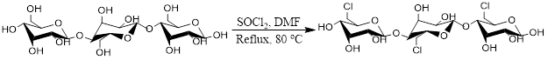
Figure 1 A: Chlorination of the cellulose
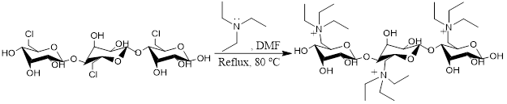
Figure 1 B: Modification reaction scheme

The modified adsorbent material possesses a positively charged amine groups that are capable of complexing fluoride ions in water without leaching soluble organic secondary pollutants in the treated water [13]. The study of chemical modification of watermelon rind biowastes via thionyl chloride activation followed by triethylamine (TEA) and the utilization of the modified adsorbent in water defluoridation remains unexplored. This forms the basis of the current study.
2. MATERIALS AND METHODS
2.1 Research design
The research study employed an experimental approach that entailed sample collection and pre-treatment, chemical modification, characterization, optimization of adsorption parameters, equilibrium, kinetic and interactive batch experiments using synthetic waters samples.

2.2 Chemicals and reagents
Hydrochloric acid (HCl), Sodium Chloride (NaCl), Sodium Fluoride (NaF), 1,2-cyclohexanedinitrilo-tetraacetic acid (CDTA), Potassium hydroxide (KOH), Thionyl chloride (SOCl₂), triethylamine (TEA), N, N-dimethylformamide (DMF), Acetic acid (CH₃COOH) and Ammonia (NH₃) analytical grade reagents and chemicals were obtained from Kobian Kenya Limited, which is a Sigma Aldrich’s outlet in Kenya. Distilled water was used to prepare reagents and for dilution.

2.3 Preparation of fluoride stock solution
A fluoride standard stock solution (1000 mg/L) was prepared by dissolving 2.21 g of NaF salt in a total ionic strength adjustment buffer (TISAB) media in a 1000 mL mark in a volumetric flask to maintain a constant ionic strength. Then, the prepared solution was used to prepare subsequent dilute working solutions. A solution of 1.0 × 10⁻¹ mol dm⁻³ KOH and HCl was used to adjust the working solutions’ pH to the values dictated by each experiment. Fresh dilutions were used in each adsorption experiment.

The total ionic strength adjustment buffer (TISAB) was prepared by mixing 57 ml of acetic acid, 58 g of sodium chloride and 4 g of 1,2-cyclohexanedinitrilo-tetraacetic acid (CDTA) in 1000 ml of distilled water.

2.4 Sample collection and pre-treatment
The watermelon rind biowastes were randomly collected around Othaya markets in Nyeri County, Kenya (-0.551751’S, 36.944703’E). They were then transported to the laboratory, cleaned thoroughly with distilled water, chopped into small pieces, oven-dried for 1 day at 105 ºC to remove moisture, ground into a fine powder and kept in an airtight bottle awaiting subsequent experiments.

2.5 Chemical modification
Chemical modification was done by first chlorination followed by amination of watermelon rind biowastes as described by [13]. This involved grinding the dried sample, followed by pre-activation at 80 ºC for 12 hours. The pre-activated powder (10.000 g) was transferred into a three necked flask containing DMF (200 mL). This was followed by slowly adding SOCl₂ (35 mL) and mechanically stirring the mixture under reflux for 4 hours at 80 ºC. This was followed by washing the chlorinated material thrice with 2 M NH₄OH (25 mL) solution to adjust the pH to neutral and finally with double-distilled water. The material was filtered and vacuo dried at a room temperature. The product (5.000 g) was transferred to a three necked flask that containing DMF (100 mL). 25 mL of the TEA was added slowly while stirring under reflux continued for 3 hours at 80 ºC. The resultant mixture was filtered and the modified adsorbent vacuo dried at a room temperature and stored in airtight container awaiting characterization and subsequent studies.

2.6 Instruments and equipments
The used instruments and equipment were Field Emission Scanning Electron Microscope (FEI ESEM, Vega3 Tescan LMH), pH meter (PHS-3C), X-Ray Diffractometer, XRD (Rigaku MiniFlex II; made in Tokyo, Japan), Grinding mill (Retsch SR 200), Thermogravimetric Analyzer (TGA-50 SHIMADZU), Drying oven (WTC binder FD53), Distiller (WSB 14), Fourier Transform Infra-red (FT-IR) spectrophotometer (JASCO FT/IR-4700), Lab-line mechanical reciprocating shaker model (DKZ-1NO.1007827), Analytical weighing balance (ATX224 Shimadzu) and Fluoride ion selective electrode (HACH ISEF12101).

2.7 Batch Experiments
Adsorption experiments were performed at a room temperature (298 K) by batch mode on a mechanical shaker at 150 rpm using plastic screw cap bottles (100 mL). The process parameters of pH (1-13), contact time (10-130 minutes), adsorbent mass (10-130 mg) and initial concentration (50-170 mg/L) were varied in 40 mL of the test solution. This was done by adjusting a single parameter while keeping the other parameters constant (OVAT). The experiments were done thrice at an agitation speed of 150 rpm. The amount of fluoride ions adsorbed per unit mass of the adsorbent was determined using Equation 1.
$$\% Removal=\frac{(C_{i}-C_{e})}{C_{i}}×100$$
Where, $C_{i}$ is the initial fluoride ion concentration (mg/L) and $C_{e}$ is the fluoride ion concentration at equilibrium (mg/L).

2.8 Experimental design and statistical analysis
Central composite design (CCD) was applied as an optimization tool of RSM, to explore the impact the interactions of the various parameters has on the sorption process. To determine the optimum conditions, four process parameters were considered: pH (X₁), contact time (X₂), adsorbent mass (X₃), initial concentration (X₄) and their interactive influence on the F⁻ ions uptake. The variables and their levels are presented in Table 1.

Table 1: Experimental ranges and levels of independent factors

Factors | Factors Code | Central Composite Levels
Factors | Factors Code | Low (-1) | Medium (0) | High (+1)
pH | X₁ | 1 | 7 | 13
Contact time (min) | X₂ | 10 | 70 | 130
Adsorbent mass (mg) | X₃ | 10 | 70 | 130
Initial concentration (mg/L) | X₄ | 50 | 110 | 170

The CCD involves 2^{n} factorial runs, 2n axial runs and n_{c} center runs. The total experimental runs conducted are computed by Equation 5.
N = 2^{n} + 2n + n_{c}

where n is number of independent variables (factors), nc is number of center points and N is the overall total of experimental runs. This indicated that 32 experimental runs comprising 16 factorial runs, 8 axial runs and 8 center runs were prerequisites for the modeling and optimization process. This is as shown by Table 2.
Table 2: Experimental runs generated by CCD in minitab software
Run | Actual values
Run | pH  (X₁) | Contact time (X₂, min) | Adsorbent mass (X₃, mg) | Initial concentration  (X₄, mg/L)
1 | 7 | 70 | 70 | 230
2 | 13 | 130 | 10 | 170
3 | 1 | 70 | 70 | 110
4 | 7 | 70 | 70 | 110
5 | 19 | 70 | 70 | 110
6 | 13 | 10 | 130 | 50
7 | 7 | 70 | 70 | 110
8 | 7 | 70 | 50 | 110
9 | 13 | 10 | 130 | 170
10 | 1 | 10 | 130 | 170
11 | 7 | 70 | 190 | 110
12 | 7 | 70 | 70 | 110
13 | 7 | 70 | 70 | 10
14 | 1 | 10 | 10 | 50
15 | 1 | 130 | 10 | 50
16 | 1 | 50 | 70 | 50
17 | 13 | 130 | 130 | 170
18 | 7 | 70 | 70 | 110
19 | 7 | 70 | 70 | 110
20 | 1 | 10 | 10 | 170
21 | 13 | 130 | 130 | 50
22 | 7 | 190 | 70 | 110
23 | 1 | 10 | 130 | 50
24 | 1 | 130 | 10 | 170
25 | 7 | 70 | 70 | 110
26 | 13 | 10 | 10 | 50
27 | 1 | 130 | 130 | 170
28 | 13 | 130 | 10 | 50
29 | 1 | 130 | 130 | 50
30 | 7 | 70 | 70 | 110
31 | 13 | 10 | 10 | 170
32 | 7 | 50 | 50 | 50

The optimum values of the test variables were obtained using the numerical point prediction tool in MINITAB statistical software (Version 17.0, PA, USA). The optimum values of the process variables were first obtained in coded units and then converted to uncoded forms.

Adsorption isotherms
The experimental data obtained at optimal process parameters was modelled using Langmuir and Freundlich isotherm to determine the maximum adsorption capacity of the modified adsorbent. The linearized equation for Langmuir isotherm is expressed in Equation 2.
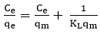
Where $q_{e}$ and $q_{m}$ is the respective experimental and calculated sorption capacity (mg/g), $K_{L}$ (L/g): the constant and $C_{e}$ (mg/L): the concentration at equilibrium.

The equation for Freundlich isotherm is given by Equation 3.
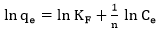
Where $\frac{1}{n}$ (adsorbent heterogeneity), $K_{F}$ (sorption capacity, mg/g) and n (adsorption intensity) parameters are calculated from linear plots of $\ln{q_{e}}$ against ${ ln C}_{e}$.

2.9 Kinetic studies
The time data was fitted using pseudo-first-order and pseudo second-order kinetic models to determine the rate and adsorption mechanisms. The linearized kinetic rate equation for pseudo-first-order and pseudo second-order model can be written a given by Equation 4 and 5.
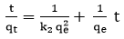
Where $q_{e}$ (mg/g) and $q_{t}$ (mg/g): the respective uptake capacity at equilibrium and at time (t) while $K_{1}$ (min⁻¹) and $k_{2}$ (mg/g/min) are rate constants.

2.10 Adsorbent performance using environmental water samples
The environmental water samples were obtained from Lake Baringo. They were taken randomly from seven different sampling points along the shores of the river. Water samples of 1 L were taken from each sampling point along the randomly selected 7 sampling points on the shores of Lake Baringo to provide a wide range in water composition and concentrated HNO₃ acid (5 mL) solution added to each water sample, bottles sealed and samples were transported to the laboratory. A 50 mL of the water sample from each of the sampling point was placed in a beaker. The analysis of the amount of F⁻ ions in the solution found in environmental water samples was determined. Then, batch experiments using the modified adsorbent were executed at optimal pH (1), contact time (50 minutes) and adsorbent mass (70 mg) and the amount of fluoride ions determined. The retained fluoride ions in the adsorbent were stripped with 1.0 × 10⁻¹ mol dm⁻³ NaOH eluent solution. The regeneration efficiency was calculated using Equation 6.
Where, $C_{ads}$ and $C_{des}$ (mg/L) are the respective flouride concentration adsorbed and desorbed.

3. RESULTS AND DISCUSSION
3.1 Adsorption mechanism
The mechanism of adsorption formed at the surface of the adsorbent with fluoride ions is shown by Figure 2.
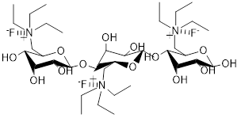
Figure 2: Adsorption mechanism of F⁻ ions onto the modified adsorbent

The modified adsorbent provides many centers for fluoride ions adsorption on their surfaces compared to the raw biomass material. The main mechanism of uptake is mainly electrostatic interactions (ion exchange) between the negatively charged fluoride (F⁻) ions and the positively charged amine groups (⁺N(CH₂CH₃)₃) on the adsorbent surface. The presence of more binding centers could improve its adsorption properties in defluoridation of water.

3.2 Characterization
The raw biomass and the modified adsorbent from watermelon rind biowastes was characterized using FT-IR, TGA and SEM-EDX. The results are discussed in the following sub-sections.

3.2.1 FT-IR characterization
The FT-IR analysis for the raw biomass and modified adsorbent was carried out at a mid-IR range of 4000-500 cm⁻¹ and at average of 10 scans per spectrum and a resolution of 4 cm⁻¹. The results are shown by Figure 3.
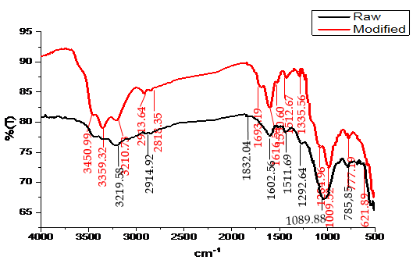
Figure 3: FT-IR spectrum of raw biomass and the modified adsorbent

The results in FT-IR spectrum of raw biomass showed a broad band at 3219.58 cm⁻¹ is ascribed to hydroxyl groups (-OH) stretching vibrations of alcoholic and carboxylic acid groups [19]. A weak peak at 2914.92 cm⁻¹ is attributed to symmetric and asymmetric sp³ –CH stretching vibrations [20]. The absorbance at 1602.56 cm⁻¹ correspond to carbonyl (C=O) stretch in carboxylic acid and its derivatives [21]. An absorbance at 1511.69 cm⁻¹ could be due to carbon-carbon (C=C) stretching vibrations of aromatic hydrocarbons [22]. This The peaks at 1292.64 cm⁻¹ and 1089.88 cm⁻¹ could be due to C-O stretch vibrations of carboxylic acid derivatives and alcoholic groups [23].

The results in FT-IR spectrum of modified adsorbent shows that the (-OH) absorption peak is shifted to 3359.32 cm⁻¹ from 3219.58 cm⁻¹ (raw) an indication that some –OH groups were replaced with –NR₃ groups during the modification process. The shifting of symmetric –CH₂ stretching vibration from 2914.92 cm⁻¹ (raw) to 2913.64 cm⁻¹ (modified) together with a new band at 2818.35 cm⁻¹ is an indication of methylene groups of TEA moiety in the modified adsorbent [24]. The band at 621.89 cm⁻¹ could be assigned to –CN stretching [14]. The results showed a successful synthesis of the adsorbents.

3.2.2 SEM characterization
The SEM micrograph for the raw biomass and the modified adsorbent were obtained at 20.0 kV (voltage) and 6.50 K X (magnification). The results are as shown in Figures 4 A, B and C.

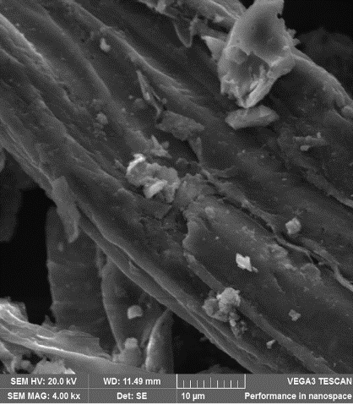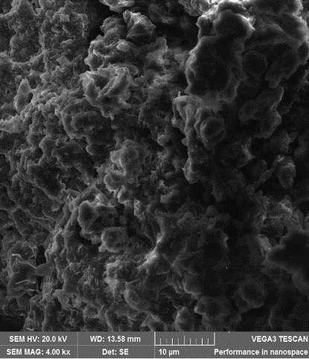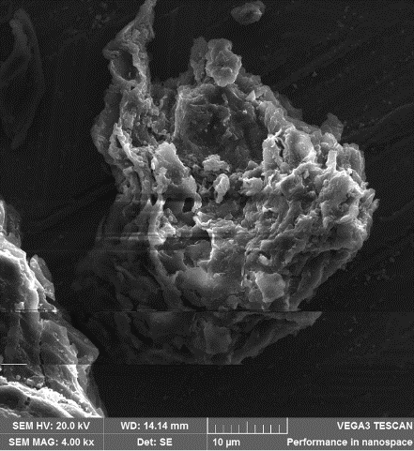
C
B
A
Figure 4: SEM images of raw biomass (A), Modified adsorbent (B) and fluoride loaded adsorbent (C)
From the results in Figure 4, the SEM micrographs showed that the surface texture and morphology of the raw biomass material was rigid, regular, less porous and constrained, as seen in Figure 4 A. After chemical modification, the adsorbent surface became rugged and more porous (Figure 4 B). This was attributed to cellulose and hemicellulose breakdown due to heat during the chemical modification [23].
Before adsorption of F⁻ ions (B), the adsorbent surface evidenced pores of different shapes and sizes. The fluoride-loaded adsorbent surface (C) is more rigid and restrained which is contributed to fluoride ions having occupied the pores. The results showed that the porous nature of the adsorbent also facilitated the uptake process.
3.2.3 EDX characterization
The elemental constitution of the raw biomass and the modified adsorbent was determined and the results are as shown by the Figures 5 A and B.

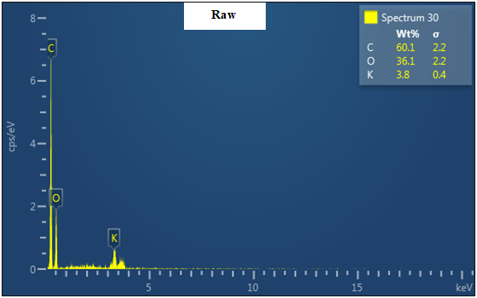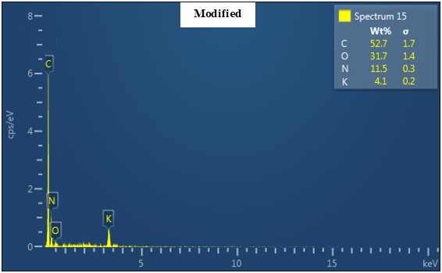
Figure 5: The EDX spectra of raw biomass and the modified adsorbent

From the EDX results in Figure 5, the main elemental composition of the raw biomass was carbon (60.1 %), oxygen (36.1 %) and potassium (3.8 %). This showed that carbon (C) was the main constituent of raw biomass material. The elemental oxygen could also be as attributed to surface oxides of potassium element.

The presence of nitrogen content (11.5 %) in the modified adsorbent showed that TEA was successively anchored on the surface of the watermelon rind biowastes. The percentage of carbon decreased from 60.1 % (raw) to 52.7 % (modified). This is due to the degradation of cellulose polymeric compounds during the pre-activation, chlorination and amination processes [24].

3.2.4 TGA characterization
The evaluation of thermal stability of the raw biomass and the modified adsorbent was done at a varied temperature of 0 ºC to 600 ºC. The TG curves are presented by Figure 6.

Figure 6: The TG curve for raw biomass and the modified adsorbent

In a temperature range of 10-100 ºC, the raw biomass material experienced a weight loss from 8.8 g to 6.6 g (25 %) due to the vaporization of free water, hydrocarbons and other volatile organic compounds [25]. In contrast, the modified adsorbent exhibited a lower weight loss range (9.0 g – 7.0 g) of around 22.22 %. The modified adsorbents exhibited a maximum weight loss temperature range between 100 and 400 ºC, demonstrating that it is more thermally stable even at high temperatures and therefore suitable in treatment of fluoride laden wastewater.

3.3 Batch optimization studies
The impact of adsorbent mass, contact time, pH and initial concentration on F⁻ ions uptake onto the modified adsorbent were investigated. The chosen process parameters are the most key and impactful in an uptake process. The results are presented by Figures 7 A, B, C and D.
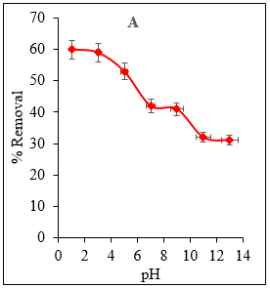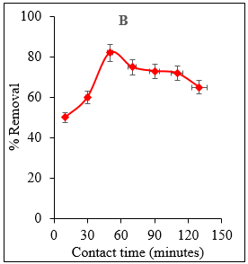
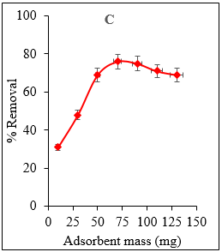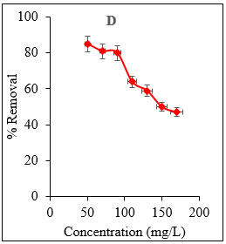
Figure 7: Effect of pH (A), contact time (B), adsorbent mass (C) and initial concentration (D) on F⁻ ions uptake

From the results in Figure 7 A, a maximum removal efficiency of 60.09 % was obtained at an optimal pH of 1. This means that the uptake of F- ions onto the modified adsorbent is best in strongly acidic media. This followed a decrease in uptake to 31.94 % with increased in solution pH. At a pH of 1, the H⁺ ions concentration is raised initiating electrostatic repulsions between the ions in the solution and the positively charged amine groups in the adsorbent. This favour adsorption of F⁻ ions. At pH>1, the solution becomes more alkaline as a result of excess OH⁻ ions causing its competition with the F₋ ions for the adsorbent sites weakening the efficiency of the modified adsorbent [26]. Similar observations have been reported by [27].

According to the results in Figure 7 B, increasing contact time of interaction increases the F⁻ ions from 51.39 % to maximum of 82.43 %, at optimal value (50 minutes) beyond which no significant change was registered. The rapid uptake of F⁻ ions at initial stages was due to the availability of binding sites leading to faster rate of adsorption [28]. Subsequently, the uptake decreased beyond 50 minutes due to the saturation of all the active sites present on the adsorbent which do not allow for further adsorption to take place [1]. These findings compare well with those reported by [29].

The results in Figure 7 C show that the percentage of F⁻ ions removal increased from 31.67 to 76.11 % with an increase in adsorbent mass from 10 mg to 70 mg beyond which an insignificant decrease is observed. The results illustrate an increase in removal uptake with an increase in adsorbent mass, because of an increase in the number of available active sites on the adsorbent surface until the adsorption achieved equilibrium [2]. Similar trend is reported in the literature [30].

The results (Figure 7 D) showed that the removal efficiency decreased from 85.97 % to 47.64 % as the concentration was increased from of 50 mg/L to 170 mg/L. This can be attributed to availability of a large number of adsorption sites at low concentration which gets saturated as the concentration increases.

3.4 Multivariate (statistical) analysis
3.4.1 Regression model equation
In the present study, four process parameters, pH (X₁), contact time (X₂), adsorbent mass (X₃) and initial concentration (X₄) were chosen as the independent variables while the removal of F⁻ ions at equilibrium (Y) was selected as the response (dependent variable) of the study. The final central composite design obtained for percentage removal with significant terms was quadratic as suggested by the software, and is given by equation 6.

Y= 65.89 + 0.705 X₁ - 0.0000 X₂- 0.0172 X₃ + 0.1459 X₄ - 0.0228 (X₁)² + 0.000451 (X₂)² + 0.000233 (X₃)² - 0.000300 (X₄)² - 0.00404 X₁X₂ + 0.00486 X₁X₃ - 0.00519 X₁X₄+ 0.000356 X₂X₃ - 0.000725 X₂X₄ - 0.000286 X₃X₄
The predicted removal efficiency (%) obtained by equation 6 shows experimental design matrix with response is shown in Table 3.

Table 3: Experimental design matrix with response

Run | Actual values |  |  |  | Coded values |  |  |  | Removal efficiency (%)
Run | pH | Contact time | Adsorbent mass | Initial concentration | X₁ | X₂ | X₃ | X₄ | Experimental | Predicted | Residual
1 | 7 | 70 | 70 | 230 | 0 | 0 | 0 | 2 | 68.25 | 67.06 | 1.19
2 | 13 | 130 | 10 | 170 | 1 | 1 | -1 | 1 | 60.64 | 61.10 | -0.46
3 | 1 | 70 | 70 | 110 | -2 | 0 | 0 | 0 | 72.59 | 74.59 | -2.00
4 | 7 | 70 | 70 | 110 | 0 | 0 | 0 | 0 | 73.55 | 74.64 | -1.09
5 | 19 | 70 | 70 | 110 | 2 | 0 | 0 | 0 | 70.59 | 69.82 | 0.77
6 | 13 | 10 | 130 | 50 | 1 | -1 | 1 | -1 | 82.54 | 82.05 | 0.49
7 | 7 | 70 | 70 | 110 | 0 | 0 | 0 | 0 | 75.11 | 74.64 | 0.47
8 | 7 | 70 | 50 | 110 | 0 | 0 | -2 | 0 | 72.01 | 73.88 | -1.86
9 | 13 | 10 | 130 | 170 | 1 | -1 | 1 | 1 | 77.93 | 78.21 | -0.28
10 | 1 | 10 | 130 | 170 | -1 | -1 | 1 | 1 | 78.18 | 77.07 | 1.11
11 | 7 | 70 | 190 | 110 | 0 | 0 | 2 | 0 | 82.45 | 83.14 | -0.69
12 | 7 | 70 | 70 | 110 | 0 | 0 | 0 | 0 | 70.32 | 74.63 | -4.32
13 | 7 | 70 | 70 | 10 | 0 | 0 | 0 | -2 | 75.18 | 74.36 | 0.82
14 | 1 | 10 | 10 | 50 | -1 | -1 | -1 | -1 | 70.02 | 72.29 | -2.27
15 | 1 | 130 | 10 | 50 | -1 | 1 | -1 | -1 | 76.98 | 75.46 | 1.52
16 | 1 | 50 | 70 | 50 | 0 | -2 | 0 | 0 | 73.23 | 72.49 | 0.74
17 | 13 | 130 | 130 | 170 | 1 | 1 | 1 | 1 | 69.78 | 70.25 | -0.47
18 | 7 | 70 | 70 | 110 | 0 | 0 | 0 | 0 | 75.43 | 74.64 | 0.79
19 | 7 | 70 | 70 | 110 | 0 | 0 | 0 | 0 | 74.41 | 74.64 | -0.23
20 | 1 | 10 | 10 | 170 | -1 | -1 | -1 | 0 | 79.12 | 80.04 | -0.92
21 | 13 | 130 | 130 | 50 | 1 | 1 | 1 | -1 | 83.69 | 84.53 | -0.84
22 | 7 | 190 | 70 | 110 | 0 | 2 | 0 | 0 | 77.48 | 78.74 | -1.26
23 | 1 | 10 | 130 | 50 | -1 | -1 | 1 | -1 | 72.13 | 73.44 | -1.31
24 | 1 | 130 | 10 | 170 | -1 | 1 | -1 | 1 | 74.56 | 72.77 | 1.79
25 | 7 | 70 | 70 | 110 | 0 | 0 | 0 | 0 | 76.59 | 74.64 | 1.95
26 | 13 | 10 | 10 | 50 | 1 | -1 | -1 | -1 | 74.93 | 73.91 | 1.02
27 | 1 | 130 | 130 | 170 | -1 | 1 | 1 | 1 | 75.14 | 74.93 | 0.21
28 | 13 | 130 | 10 | 50 | 1 | 1 | -1 | -1 | 72.42 | 71.26 | 1.16
29 | 1 | 130 | 130 | 50 | -1 | 1 | 1 | -1 | 82.69 | 81.73 | 0.96
30 | 7 | 70 | 70 | 110 | 0 | 0 | 0 | 0 | 74.46 | 74.64 | -0.18
31 | 13 | 10 | 10 | 170 | 1 | -1 | -1 | 1 | 75.55 | 74.18 | 1.32
32 | 7 | 50 | 50 | 50 | 1 | 0 | -1 | 0 | 73.69 | 73.94 | -0.25

The residuals between the predicted and experimental (actual) values were found to be low implying that both the predicted and experimental responses had strong agreements. This was confirmed by a parity linear plots as shown by the Figure 8.

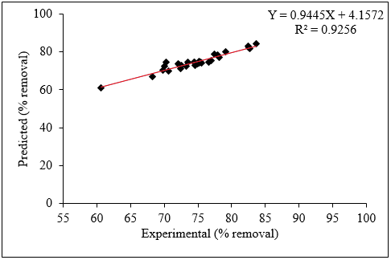
Figure 8: Parity plot for the experimental and predicted % removal value for F⁻ ions uptake

The correlation coefficient (R²) used to determine the relationship between the experimental (actual) and predicted responses was 0.9256 as established by the model. This suggests that the process parameters analyzed explain 92.56 % of the % removal variability and that the model could not explain only 7.44 % of the variation of the response. The derived quadratic equations using the CCD matrix were found to be suitable for predicting independent process variables’ influence on removal efficiency of for F⁻ ions onto the modified adsorbent [31]. The results are in good coherent with those reported by [32].

The adequacy of the models was justified by the analysis of variance (ANOVA). The ANOVA of fluoride ions adsorption is given in Table 4.

Table 4: ANOVA analysis for CCD response surface quadratic model for fluoride ions adsorption

Response source | Degree of freedom  (DF) | Sum of squares  (SS) | Mean square  (MS) | F value | P value | Comment
Model | 14 | 642.473 | 45.891 | 22.55 | 0.000 | Significant
Linear | 4 | 186.526 | 46.631 | 22.91 | 0.000 | Significant
X₁ | 1 | 11.844 | 11.844 | 5.82 | 0.028 | Significant
X₂ | 1 | 15.626 | 15.626 | 7.68 | 0.014 | Significant
X₃ | 1 | 96.330 | 96.330 | 47.33 | 0.000 | Significant
X₄ | 1 | 62.711 | 62.711 | 30.81 | 0.000 | Significant
Quadratic | 4 | 66.366 | 16.592 | 8.15 | 0.001 | Significant
(X₁)² | 1 | 9.268 | 9.268 | 4.55 | 0.049 | Significant
(X₂)² | 1 | 29.840 | 29.840 | 14.66 | 0.001 | Significant
(X₃)² | 1 | 13.731 | 13.731 | 6.75 | 0.019 | Significant
(X₄)² | 1 | 6.530 | 6.530 | 3.21 | 0.092 | Not significant
2-way interaction | 6 | 352.510 | 58.752 | 28.87 | 0.000 | Significant
X₁X₂ | 1 | 72.204 | 72.204 | 35.48 | 0.000 | Significant
X₁X₃ | 1 | 33.034 | 33.034 | 16.23 | 0.001 | Significant
X₁X₄ | 1 | 74.825 | 74.825 | 36.77 | 0.000 | Significant
X₂X₃ | 1 | 14.996 | 14.996 | 7.37 | 0.015 | Significant
X₂X₄ | 1 | 135.164 | 135.164 | 66.41 | 0.000 | Significant
X₃X₄ | 1 | 14.996 | 14.996 | 7.37 | 0.015 | Significant
Residual Error | 16 | 32.563 | 2.035
Lack of fit | 10 | 8.953 | 0.895 | 0.23 | 0.980 | Not significant
Pure Error | 6 | 23.610 | 3.935
Total | 30 | 675.036

The model F-value for percentage removal of 22.55 implies the model is significant. Also, low p-values for removal efficiency less than 0.05 except for (X₄)² indicate model terms are significant. The Lack-of-Fit F-value for % removal of 0.23 implies the Lack of- Fit is significant. High F-value, correlation coefficient (R) tending to 1, low p-value and most importantly the results of lack of fill test indicates the high statistical significance of the developed model with high accuracy [33]. The removal of the F⁻ ions is influenced significantly by the interaction of contact time and concentration with F value of 66.41 and less with other parameters interactions 35.48, 16.23, 36.77 and 7.37 for pH and contact time, pH and adsorbent mass, pH and concentration, time, adsorbent mass and concentration respectively.

The results compiled by ANOVA predict the adequate representation of the actual relation between the response function, i.e., removal %, and independent variables (pH, adsorbent dose, initial concentration and contact time) by a second-order polynomial equation. The results mirror those reported in the literature [34,35,36].

3.4.2 Response surface plots
The 3D surface plots indicating the combined effects of pH (X₁), contact time (X₂), adsorbent mass (X₃) and initial concentration (X₄) and their effect on the removal efficiency (%) of F⁻ ions are shown in Figures 9 A, B, C, D, E and F.
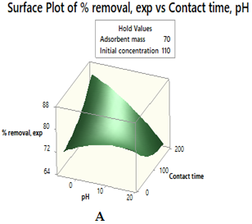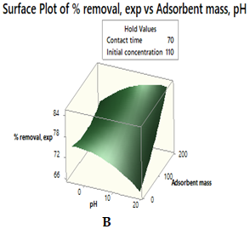
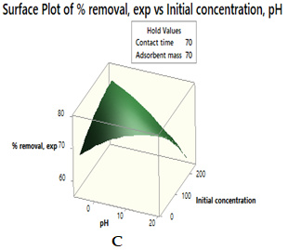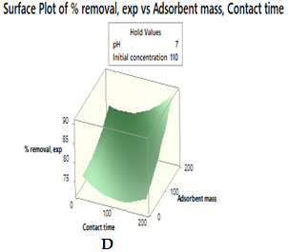
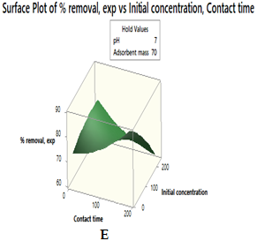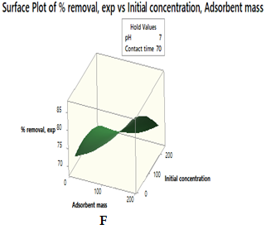
Figure 9 A, B, C, D, E and F: 3D surface plots showing interactive effects of chosen variables in F⁻ ions adsorption
The 3D surface plots of the interactive effect of pH, contact time, adsorbent mass and initial concentration on the adsorption of F- ions, are presented in Figures 10 A–F. These 3D plots are analysed to pinpoint the optimal or near-optimal adsorption areas. The adsorption process is greatly influenced by the interaction of contact time and concentration followed by that of pH and concentration. The interaction of parameters confirmed what is reported by Table 4. From the surface plots, the uptake of F⁻ ions by the modified adsorbent is predicted by CCD RSM to be high at lower pH values (1), contact time (50 minutes), higher adsorbent mass (70 mg) and less concentrations (50 mg/L). The results confirm optimal conditions reported earlier in Figure 7 A-D (OVAT). Similar findings are reported by [37].

3.5 Efficacy studies
The plotting of $\frac{C_{e}}{q_{e}}$ against $C_{e}$ (Langmuir) and $\ln{q_{e}}$against ${ ln C}_{e}$ (Freundlich) yields graphs were employed to determine isotherm parameters and constants. The results are represented in Table 5.

Table 5: Langmuir and Freundlich parameters for F⁻ ions adsorption onto the modified adsorbent
Langmuir |  |  |  | Freundlich |  |  | Best model
Q_{exp}  (mg/g) | Q_{cal}  (mg/g) | K_{L}  (L/g) | R² | 1/n | K_{F}  (mg/g) | R² | Langmuir
41.09 ± 0.09 | 44.64 ± 0.02 | 1.08 × 10⁻¹ | 0.9973 | 2.59 × 10⁻¹ | 13.61 | 0.8513 | Langmuir

From the outcomes in Table 5, correlation coefficients (R²) of > 0.99 were obtained for Langmuir isotherm. This was corroborated by the closeness of Q_{exp} (mg/g) and Q_{cal} (mg/g). This implies that the Langmuir gave better regression coefficient than those of Freundlich. This is as shown by Figure 10. This suggested a monolayer chemisorption interaction between the F⁻ ions and the adsorbent sites [38]. The values of K_{L} < 1 showed the favorability of F⁻ ions sorption onto the adsorbent [39]. The results mirror those reported by [16].

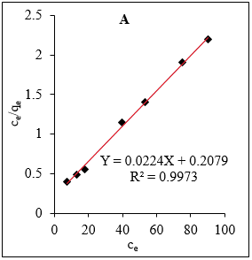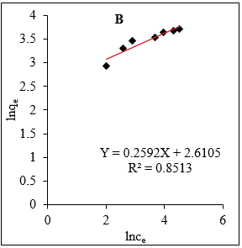
Figure 10: Langmuir (A) and Freundlich (B) Isotherm plots
A comparable adsorption capacity of the adsorbent under study with other adsorbents for F- ions removals is shown in Table 6.

Table 6: Adsorption capacity of different adsorbents for the adsorption of fluoride ions

Adsorbent | Adsorption capacity  (mg/g) | Reference
MgO nanocomposites | 15.59 | [40]
Fe(III)-doped scoria | 0.32 | [41]
carbon@SnO₂ nano composites | 4.89 | [42]
Silicon nitride | 13.90 | [29]
Bio- filters sorbent | 5.53 | [43]
Polythene | 18.55 | [15]
Construction wastes | 15.16 | [44]
Metallic phosphates | 31.61 | [45]
Activated carbon supported Ce–Al oxides | 17.97 | [46]
Modified watermelon rind | 41.09 | Current study

3.6 Kinetic studies
The two different kinetic parameters (Pseudo-first-order and Pseudo-second-order) calculated by linear regression of time data for F⁻ ions uptake are shown in Table 7.

Table 7: Pseudo-first-order and Pseudo-second-order parameters for F- ions adsorption
Pseudo-first-order |  |  |  | Pseudo-second-order |  |  | Best model
Q_{exp}  (mg/g) | Q_{cal}  (mg/g) | K₁  (min⁻¹) | R² | Q_{cal}  (mg/g) | K₂  (mg g⁻¹min⁻¹) | R² | Pseudo-second-order
19.56 ± 0.02 | 6.02 ± 0.01 | 6.30 × 10⁻³ | 0.2100 | 17.89 | 5.56 × 10⁻³ | 0.9486 | Pseudo-second-order

Pseudo-second-order kinetic plots showed a better correlation with the experimental data than Pseudo-first-order plots as shown by the Figure 11. Kinetic data shows R² value of 0.2100 for pseudo-first-order model and 0.9486 for pseudo-second-order model. The experimental Q_{exp} value (19.56 mg/g) is closer to calculated Q_{cal} value (17.89 mg/g) as compared to those in pseudo-first-order (6.02 mg/g). The K₂ value (5.56 × 10⁻³ (mg g⁻¹min⁻¹) is higher than K₁ value (6.30 × 10⁻³ (min⁻¹).

The closeness of Q_{cal} and Q_{exp} with higher R² values (> 0.94) and higher K₂ values indicated that the pseudo-second-order model best fit the experimental data for F⁻ ions removal compared to pseudo-first-order. The model assumes chemisorption as the rate determining step that controlled the adsorption process [47]. [11] made similar observations.

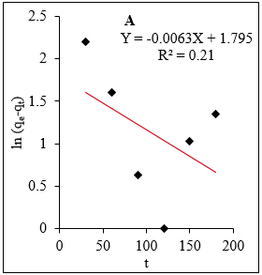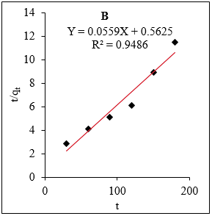
Figure 11: Pseudo-first-order (A) and Pseudo-second-order (B) kinetic plots

3.7 Analysis of environmental water samples
Analysis of fluoride levels in the water sample from Lake Baringo and the batch results are presented in Table 8.

Table 8: Analysis of environmental water samples

Found in environmental water sample  (mg/L) | Found in water sample after adsorption  (mg/L) | (% Removal ± S.D)
3.59 ± 0.03 | 0.76 ± 0.02 | 78.83 ± 0.06
The results in Table 8 showed that the level of fluoride ions in Lake Baringo water was 3.59 mg/L higher than the recommended WHO limits (1.5 mg/L). The pH of the water sample (not reported in the table) was 7.50. After treatment using the modified adsorbent, the concentration reduced to 0.76 mg/L with removal efficiency of 78.83 %. The lower efficiency than the reported using the synthetic solution (85.97 %) could be due to high pH values (7.50) and the existence of other interfering species in the water samples such as NO₃⁻, Cl⁻ and NO₂⁻which competed for the available adsorbent sites with the F⁻ ions resulting to faster saturation of the adsorbent sites [48,49].
3.8 Regeneration studies
The reusability of the modified adsorbent in F⁻ ions adsorption was investigated, and the results are presented in Table 9.

Table 9: Regeneration efficiency of the modified adsorbent in F⁻ ions adsorption
Cycle | Found  (mg/L) | Desorbed  (mg/L) | Adsorbed  (mg/L) | Regeneration efficiency  (% R ± S.D)
1 | 3.59 ± 0.03 | 2.01 ± 0.01 | 2.83 ± 0.00 | 71.02
2 | 3.59 ± 0.03 | 0.64 ± 0.02 | 1.05 ± 0.02 | 60.95
3 | 3.59 ± 0.03 | 0.44 ± 0.00 | 0.81 ± 0.01 | 54.32
4 | 3.59 ± 0.03 | 0.29 ± 0.00 | 0.56 ± 0.00 | 51.79

From the findings in Table 9, regeneration experiments revealed that desorption percentage decreased as the adsorption/desorption cycles advanced upto 4th cycle. The decrease in the uptake capacity was due to the ignorable mass of the adsorbent that got lost during the adsorption-desorption processes [50]. The regeneration efficiency was > 50 %. The results demonstrated that the modified adsorbent can be re-used repeatedly for defluoridation of water with a high efficiency lowering the fluoride levels to (< 1.5 mg/L (below WHO permissible levels).
4. CONCLUSIONS
In the present work, raw watermelon rind biowastes were chemically modified with thionyl chloride followed by triethylamine in a N, N-dimethylformamide solvent. This was confirmed by FT-IR, SEM-EDX and TGA results which showed a thermally stable and porous adsorbent surface with the presence of functional groups of carbonyl (-C=O), hydroxyl (OH-), carboxylate (-COO-) and additional anchored amine (-⁺N(CH₂CH₃)₃) groups (modified adsorbent) as important adsorption sites for fluoride (F⁻) ions removal. The adsorption process was greatly influenced by adsorption parameters of pH, contact time, adsorbent mass and initial concentration. The optimum values were pH (1), 50 minutes, 70 mg and 50 mg/L. The central composite design (CCD) response surface plots confirmed the optimal batch optimization experiments. The uptake of fluoride (F⁻) ions was well described by Langmuir isotherm model with a maximum adsorption capacity of 44.64 ± 0.02 mg/g. This implied a chemical interaction between fluoride (F⁻) ions and the adsorbent sites. Pseudo-second-order kinetic model fitted well in describing adsorption of F⁻ ions and that chemisorption was the rate determining step. A regeneration efficiency of > 50 % was obtained for the adsorption/desorption cycles for F⁻ ions uptake.

Data Availability
All the data obtained as results of the research study are available in this manuscript. There is no hidden or unavailable data.

Conflict of interest
The authors declare no competing interests.

Funding
No external or internal funding was received.

Declarations
Author’s contribution
Author 1 and 3 (Samuel Ndung’u & Thomas Nyahanga) contributed in the concept and design of the research study, data collection and interpretation of data. Author 2 (Esther Kinuthia) contributed to drafting of the manuscript. Author 4 (Samuel Kirkok) contributed to critical review and final approval for submission to Discover Chemistry Journal.

Ethics approval: This declaration is not applicable.

Consent to participate: Not applicable.

Consent for publication: Not applicable.

5. REFERENCES
1. Sengupta P, Saha S, Banerjee S, Dey A, Sarkar, P. Removal of fluoride ion from drinking water by a new Fe(OH)₃/ nano CaO impregnated chitosan composite adsorbent. Polymer-Plastics Technology and Materials. 2020; 59 (11): 1191-1203.
https://doi.org/10.1080/25740881.2020.1725567
2. Tan T.L, Krusnamurthy P, Nakajima H, Rashid S.A. Adsorptive, kinetics and regeneration studies of fluoride removal from water using zirconium-based metal organic frameworks. RSC Advances. 2020; 10: 1-13. https://doi.org/10.1039/d0ra01268h
3. Iizuka A, Ho H-J, Yamasaki A. Removal of fluoride ions from aqueous solution by metaettringite. PLoS ONE. 2022; 17 (3): 1-18. https://doi.org/10.1371/journal.pone.0265451
4. World Health Organization (WHO) Drinking water standards and health advisories office of water US environmental protection agency Washington. 2011. http://www.epa.gov/IRIS.T
5. Akafu T, Chimdi A, Gomoro K. Removal of Fluoride from Drinking Water by Sorption Using Diatomite Modified with Aluminum Hydroxide. Hindawi Journal of Analytical Methods in Chemistry. 2019; 2019 (1): 1-12. https://doi.org/10.1155/2019/4831926
6. AL-Hamadi M, Alnedhary A, Quria’a H, Al-Mutawakel G. Adsorption Isotherm, Kinetic and Thermodynamic Studies for Removal of Fluoride Ions from Drinking Water Using Modified Natural Pumice. Sana’a University Journal of Applied Sciences and Technology. 2024; 2 (5): 403-412. https://doi.org/10.59628/jast.v2i5.1151
7. Ishtiaq H, Amina N, Irfan A, Mohsin H, Shahbaz A. Removal of fluoride from drinking water through low-cost techniques. Advances in Civil and Architectural Engineering. 2023; 14 (26): 80-94. https://doi.org/10.13167/2023.26.6
8. Karunanithi M, Agrawal R, Qanungo K. A review of fluoride removal from ground water by various adsorption techniques. Journal of the Chilean Chemical Society. 2023; 68 (2): 5839-5846. http://dx.doi.org/10.4067/s0717-97072023000205839
9. Telkapalliwar N, Shivankar V. Fruit Peel and Shell as a Low-cost Bioadsorbents for Fluoride Removal from Aqueous Solution: A Review. International Journal of Innovative Research in Science, Engineering and Technology. 2016; 5 (6): 10248-10257.
http://dx.doi.org/10.15680/IJIRSET.2015.0506141
10. Wei Y, Wang L, Li H, Yan W, Feng J. Synergistic Fluoride Adsorption by Composite Adsorbents Synthesized from Different Types of Materials—A Review. Frontiers in Chemistry. 2022; 10: 1-23. https://doi.org/10.3389/fchem.2022.900660
11. Mutai I, Kiriamiti H, M’Arimi M, Tewo R. Fluoride removal from water using Al(OH)₃-surface modified diatomite mixed with brick: optimization, isotherm and kinetic studies. AIMS Environmental Science. 2024; 11 (3): 360-379.
https://doi.org/10.3934/environsci.2024017
12. Mawira K, Nthiga E, Muthakia G. Efficacy of Quaternary Ammonium Functionalized Waste Paper Bio-Coagulant for Removal of Fluoride Ions from Aqueous Solution. International Journal of Scientific Research in Chemical Sciences. 2023; 10 (2): 29-37.
https://ijsrcs.isroset.org/index.php/j/article/view/130
13. Mwangi C, Mwangi I, Wanjau R, Swaleh S, Ram M, Ngila J. Remediation of fluoride laden water by complexation with triethylamine modified maize tassels. Environment and Natural Resources Research, 2016; 6 (1): 44-58. http://dx.doi.org/10.5539/enrr.v6n1p44

14. Bakar A, Abdullah L, Zahri N, Alkhatib M. Column Efficiency of Fluoride Removal Using Quaternized Palm Kernel Shell (QPKS). Hindawi International Journal of Chemical Engineering. 2019; 2019: 1-13. https://doi.org/10.1155/2019/5743590
15. Mbugua G, Mwangi I., Wanjau R.N., Ram M, Ngila J. Remediation of fluoride laden water by complexation with triethylamine modified waste polythene material. Materials Science: An Indian Journal. 2017; 15 (1): 1-8. https://www.tsijournals.com/articles/remediation-of-fluoride-laden-water-by-complexation-with-triethylamine-modified-waste-polythene-material-12644.html
16. Mandeliya R, Dubey R. Bio-Sorption of fluoride from Aqueous Solution Using Low-Cost Adsorbent: Water Hyacinth. Journal of Scientific and Technical Research. 2023; 6 (4): 1-9. https://doi.org/10.19080/TTSR.2023.06.555693
17. Hashemkhani M, Ghalhari M, Bashardoust P, Hosseini S, Mesdaghinia A, Amir Mahvi H. Fluoride removal from aqueous solution via environmentally friendly adsorbent derived from seashell. Scientific Reports. 2022; 12: 1-13. https://doi.org/10.1038/s41598-022-13756-3
18. Ndung’u S, Wanjau R, Nthiga E, Ndiritu J, Mbugua G. Complexation equilibrium studies of Cu²⁺, Cd²⁺ and Pb²⁺ ions onto ethylenediamine quaternised Artocarpus heterophyllus L. seeds from aqueous solution. IOSR Journal of Applied Chemistry. 2020; 13 (12): 1-12.
https://doi.org/10.9790/5736-1312010112
19. Patel H. Adsorptive batch and column studies of Congo Red onto gulmohar leaf powder. European Journal of Chemistry 2018; 9 (2) (2018) 107-114.
https://dx.doi.org/10.5155/eurjchem.9.2.107-114.1707
20. Aloulou H, Ghorbel A, Aloulou W, Amar R, Khemakhem S. Removal of fluoride ions (F⁻) from aqueous solutions using modified Turkish zeolite with quaternary ammonium. Environmental Technology, 2021; 42 (9): 1353-1365.
https://doi.org/10.1080/09593330.2019.1668863
21. Ndung’u S, Nthiga E, Wanjau, R. Characterization of amorphous silicon nitride prepared from sand and coffee husk wastes by carbothermal reduction-nitridation. African Journal of Pure and Applied Sciences. 2023; 4 (3): 24-34. https://dx.doi.org/10.33886/ajpas.v4i3.426
22. Mansuri I, Farzana R, Rajarao R, Sahajwalla V. Carbon dissolution using waste biomass—A sustainable approach for iron-carbon alloy production. Metals. 2018; 8 (4): 290-301. https://doi.org/10.3390/met8040290
23. Njeri J, Nthiga E, Muthakia G. The Efficacy of Coffee Husks Biochar in the Adsorption of Methyl Red from Textile Dyeing Wastewater. International Journal of Scientific Research in Chemical Sciences. 2023; 10 (4): 1-9. https://doi.org/10.26438/ijsrcs/v10i4.19
24. Bakar A, Koay Y, Ching Y, Abdullah L, Choong T, Alkhatib M, Mobarekeh M, Zahri M. Removal of fluoride using Quaternized Palm Kernel Shell as adsorbents: Equilibrium isotherms and kinetic studies. BioResources, 2016; 11 (2): 4485-4511.
https://doi.org/10.15376/biores.11.2.4485-4511
25. Ren J, Zhang S, Wang Y, Yang H. Adsorption Properties and Mechanisms of Methylene Blue by Modified Sphagnum Moss Bio-Based Adsorbents. Materials, 2024; 17: 1-18.
https://doi.org/10.3390/ma17174329
26. Mbugua G, Mwangi I, Wanjau R, Ollengo M, Nthiga E, Ngila J. Facile removal of Fluoride Ions from water using Triethylamine Modified Polyethylene Adsorbent. Asian Journal of Research in Chemistry. 2020; 13 (1): 60-64. https://doi.org/10.5958/0974-4150.2020.00013.9

27. Dan S, Chattree A. Sorption of fluoride using chemically modified Moringa oleifera leaves. Applied Water Science, 2018; 8: 76-83. https://doi.org/10.1007/s13201-018-0718-6
28. Araga R, Sharma C. Amine Functionalized Electrospun Cellulose Nanofibers for Fluoride Adsorption from Drinking Water. Journal of Polymers and the Environment, 2019; 1-11.
https://doi.org/10.1007/s10924-019-01394-2
29. Abdulhameed A, Mbuvi H, Changamu E. Removal of Fluoride Ion by Silicon Nitride Powder. International Journal of Water and Wastewater Treatment. 2017; 3 (1): 1-7.
http://dx.doi.org/10.16966/2381-5299.137
30. Srikanth N, Reddemma S, Hannsika K, Riyaz S, Reddy G, Chakradhar C, Vishnu P. Removal of Fluorides Using a Low Cost Adsorbent. International Journal of Innovative Research in Engineering & Management, 2023; 10 (1): 126-133. https://doi.org/10.55524/ijirem.2023.10.1.23
31. Singh R, Bhateria R. Optimization and Experimental Design of the Pb²⁺ Adsorption Process on a Nano-Fe₃O₄‑Based Adsorbent Using the Response Surface Methodology. ACS Omega, 2020; 5: 28305−28318. https://dx.doi.org/10.1021/acsomega.0c04284
32. Chauhan S, Dikshit, P. Optimization of batch study parameters for the adsorption of lead(II) ions onto spent tea grains. AQUA —Water Infrastructure, Ecosystems and Society. 2023; 72 (6): 996-1024. https://doi.org/10.2166/aqua.2023.020
33. El‑Mekkawi S, Abdelghaffar R, Abdelghaffar F, El‑Enin S. Application of response surface methodology for color removing from dyeing effluent using de‑oiled activated algal biomass. Bulletin of the National Research Centre, 2021; 45: 80-89.
https://doi.org/10.1186/s42269-021-00542-w
34. Asadzadeh F, Maleki-Kaklar M, Soiltanalinejad N, Shabani F. Central Composite Design Optimization of Zinc Removal from Contaminated Soil, Using Citric Acid as Biodegradable Chelant. Scientific Reports, 2018; 8:2633-2640. https://doi.org/10.1038/s41598-018-20942-9
35. Bayuo J, Abukari M, Pelig‑Ba K. Optimization using central composite design (CCD) of response surface methodology (RSM) for biosorption of hexavalent chromium from aqueous media. Applied Water Science, 2020; 10: 135-146. https://doi.org/10.1007/s13201-020-01213-3
36. Tony M. Central composite design optimization of Bismarck Dye oxidation from textile effluent with Fenton’s reagent. Applied Water Science, 2020; 10: 108-116.
https://doi.org/10.1007/s13201-020-01192-5
37. Atta H, Hummadi K, M-Ridha M. The application of response surface methodology and Design-Expert® for analysis of ciprofloxacin removal from aqueous solution using raw rice husk: kinetic and isotherm studies. Desalination and Water Treatment, 2022; 248: 203-216. https://doi.org/10.5004/dwt.2022.28074
38. Singh S, Murugesan G, Vinayagam R, Varadavenkatesan T, Selvaraj R. Adsorptive removal of fluoride from water using hydroxyapatite synthesized from marine shell waste. Scientific Reports. 2025; 15: 25598-25610. https://doi.org/10.1038/s41598-025-11132-5
39. Kiana M, Amid P, James W. Adsorption of fluoride from water using Al–Mg–Ca ternary metal oxide-coated sand. Water Supply. 2023; 23 (11): 4699-4713. https://doi.org/10.2166/ws.2023.269
40. Rahdar S, Mohammadi L, Rahdar A, Ahmadi S, Sistani S, Hasan Susan A. Application of response surface methodology for optimization of fluoride adsorption from aqueous solution using MgO-based nanocomposites. Journal of Nanoanalysis, 2020; 7 (2): 105-116.
https://sanad.iau.ir/Journal/jnanoanalysis/Article/988599/FullText
41. Pirsaheb M, Mohammadi H, Sharafi K, Asadi A. Fluoride and nitrate adsorption from water by Fe(III)-doped scoria: optimizing using response surface modeling, kinetic and equilibrium study. Water Supply, 2017; 18 (3): 1117-1132. https://doi.org/10.2166/ws.2017.185
42. Mohanta D, Ahmaruzzaman M. Bio-inspired adsorption of arsenite and fluoride from aqueous solutions using activated carbon@ SnO₂ nanocomposites: Isotherms, kinetics, thermodynamics, cost estimation and regeneration studies. Journal of Environmental Chemical Engineering, 2018; 6: 356-366. https://doi.org/10.1016/j.jece.2017.11.076
43. Yadav M, Singh N, Brighu U, Mathur S. Adsorption of F on Bio-Filter sorbent: kinetics, equilibrium, and thermodynamic study. Desalination and Water Treatment, 2015; 56: 463-474. https://doi.org/10.1080/19443994.2014.938305
44. Neeti K, Singh R, Ahmad, S. Adsorptive removal of fluoride uptake from aqueous media using novel composite adsorbent. Environmental Pollution and Management, 2024; 1: 49-61. https://doi.org/10.1016/j.epm.2024.03.001

45. Wang R, Gu Y, Ma M, Sun Y. Evaluation of Fluoride Adsorptive Removal by Metallic Phosphates. Applied Sciences, 2025; 15 (19): 1-14. https://doi.org/10.3390/app151910454
46. Guo S, Zheng F, Xu J, Jiang J, Cui Z, Wu C, Lin Y, Sun Q, Zheng Y, Sa, B. Enhanced fluoride removal from drinking water by activated carbon supported Ce–Al oxides: performance and mechanism. RSC advances, 2025; 15 (18): 14363-14374. https://doi.org/10.1039/D5RA00397K
47. Somkiattiyot P, Wongrueng A, Induvesa P, Yodsin N, Phuphisith S, Sittisom P, Rakruam P, Srisom W, Gavila P, Chamnanprai S, Takizawa S. Enhanced Fluoride Removal from Groundwater Using Napier Grass-Derived Adsorbent: Experimental and DFT Study. Trends in Sciences. 2025; 22 (3): 9217-9232. https://doi.org/10.48048/tis.2025.9217
48. Ng’ang’a N, Wanja N, Nduta W, Mwangi G. Fixed-Bed Column Adsorption Studies of Methylene Blue Dye from an Aqueous Solution Using Silicon Nitride Adsorbent Synthesized from Sand and Coffee Husk Wastes. Progress in Chemical and Biochemical Research, 2024; 7 (3): 283-292. https://doi.org/10.48309/PCBR.2024.446161.1343
49. Isaac M, Gerald M, Ruth W, Swaleh S, Titus M, Jane C. Removal of Fluoride Ions in Stored Drinking Water by Triethylamine Chemically Modified Polyethylene Containers. International Journal of Environmental Research, 2019, 1-10. https://doi.org/10.1007/s41742-018-0163-2
50. Tauqir A, Mohammad S, Saif U, Izzat W, Nuhu D, Nisar U. Synthesis and Adsorptive Performance of a Novel Triazine Core-Containing Resin for the Ultrahigh Removal of Malachite Green from Water. Arabian Journal for Science and Engineering, 2023; 48: 8571-8584. https://doi.org/10.1007/s13369-022-07015-w

