Supplementary information for

Design and Optimization of Anaerobic Digestion Systems by Advanced Microbial Community Dynamics Modelling

Stella Suanu Leh-Togi Zobeashia¹, Olabisi Peter Abioye², Udeme Joshua Josiah Ijah², Oluwafemi Adebayo Oyewole², Sesan Abiodun Aransiola³*, Naga Raju Maddela⁴, Ram Prasad⁵*

¹ National Biotechnology Development Agency, Lugbe, Abuja, Nigeria
² Department of Microbiology, Federal University of Technology, PMB 65, Minna, Nigeria
³ Department of Microbiology, Faculty of Science, University of Abuja, PMB 117, Abuja, Nigeria
⁴ Departamento de Ciencias Biol´ogicas, Facultad de Ciencias de La Salud, Universidad Tecnica de Manabí, Portoviejo 130105, Ecuador
⁵Department of Botany, Mahatma Gandhi Central University, Motihari-845401, Bihar, India

*Corresponding Author:
Dr. Sesan Abiodun Aransiola, Assistant Professor, Department of Microbiology, Faculty of Science, University of Abuja, PMB. 117. Abuja, Nigeria. sesan.aransiola@uniabuja.edu.ng
Dr. Ram Prasad, Department of Botany, Mahatma Gandhi Central University, Motihari-845401, Bihar, India; rpjnu2001@gmail.com

Supplementary Table 1. ANOVA of Regression Model for BGY and COD
 | Biogas yield |  |  |  |  | COD
Source | SS | df | MS | F-Value | P-Value | SS | df | MS | F-Value | P-Value
Model | 1.417E+05 | 9 | 15746.22 | 44.39 | 0.0003** | 167.60 | 9 | 18.62 | 97.07 | < 0.0001**
A-SC | 1128.13 | 1 | 1128.13 | 3.18 | 0.1346 | 0.1800 | 1 | 0.1800 | 0.9383 | 0.3772
B-pH | 4324.50 | 1 | 4324.50 | 12.19 | 0.0174 | 0.1513 | 1 | 0.1513 | 0.7884 | 0.4152
C-Time | 71631.12 | 1 | 71631.12 | 201.92 | < 0.0001 | 2.10 | 1 | 2.10 | 10.95 | 0.0212
AB | 16.00 | 1 | 16.00 | 0.0451 | 0.8402 | 1.44 | 1 | 1.44 | 7.51 | 0.0408
AC | 110.25 | 1 | 110.25 | 0.3108 | 0.6012 | 4.00 | 1 | 4.00 | 20.85 | 0.0060
BC | 2601.00 | 1 | 2601.00 | 7.33 | 0.0424 | 4.62 | 1 | 4.62 | 24.10 | 0.0044
A² | 1179.75 | 1 | 1179.75 | 3.33 | 0.1278 | 15.58 | 1 | 15.58 | 81.22 | 0.0003
B² | 58968.52 | 1 | 58968.52 | 166.23 | < 0.0001 | 143.27 | 1 | 143.27 | 746.85 | < 0.0001
C² | 636.06 | 1 | 636.06 | 1.79 | 0.2382 | 7.54 | 1 | 7.54 | 39.31 | 0.0015
Residual | 1773.75 | 5 | 354.75 |  |  | 0.9592 | 5 | 0.1918
Lack of Fit | 723.75 | 3 | 241.25 | 0.4595 | 0.7394* | 0.6325 | 3 | 0.2108 | 1.29 | 0.4645*
Pure Error | 1050.00 | 2 | 525.00 |  |  | 0.3267 | 2 | 0.1633
Cor Total | 1.435E+05 | 14 |  |  |  | 168.56 | 14
SS: Sum of squares, df: Degrees of freedom, MS: mean of squares, SC: substrate concentration, ** : significant, *: not significant
P-Valve: Probability

Supplementary Table 2. ANOVA of Regression Model for VFA and MRC

 | VFA |  |  |  |  | MCD
Source | SS | Df | MS | F-Value | P-Value | SS | df | MS | F-Value | P-Value
Model | 1454.82 | 9 | 161.65 | 180.14 | < 0.0001** | 1.893E+08 | 3 | 6.308E+07 | 130.37 | < 0.0001**
A-SC | 118.58 | 1 | 118.58 | 132.15 | < 0.0001 | 14028.13 | 1 | 14028.13 | 0.0290 | 0.8679
B-pH | 32.00 | 1 | 32.00 | 35.66 | 0.0019 | 9.793E+07 | 1 | 9.793E+07 | 202.39 | < 0.0001
C-Time | 5.12 | 1 | 5.12 | 5.71 | 0.0625 | 9.131E+07 | 1 | 9.131E+07 | 188.70 | < 0.0001
AB | 7.29 | 1 | 7.29 | 8.12 | 0.0358
AC | 56.25 | 1 | 56.25 | 62.69 | 0.0005
BC | 20.25 | 1 | 20.25 | 22.57 | 0.0051
A² | 162.87 | 1 | 162.87 | 181.51 | < 0.0001
B² | 1110.40 | 1 | 1110.40 | 1237.44 | < 0.0001
C² | 14.65 | 1 | 14.65 | 16.32 | 0.0099
Residual | 4.49 | 5 | 0.8973 |  |  | 5.323E+06 | 11 | 4.839E+05
Lack of Fit | 3.88 | 3 | 1.29 | 4.26 | 0.1958* | 1.504E+06 | 9 | 1.672E+05 | 0.0876 | 0.9966*
Pure Error | 0.6067 | 2 | 0.3033 |  |  | 3.818E+06 | 2 | 1.909E+06
Cor Total | 1459.30 | 14 |  |  |  | 1.946E+08 | 14
SS: Sum of squares, df: Degrees of freedom, MS: mean of squares, SC: substrate concentration, **: significant, *: not significant
P-Valve: Probability
Supplementary Table 3. Model fit summary for biogas yield

(a) Response 1: Biogas Yield
Source | Sequential p-value | Lack of Fit p-value | Adjusted R² | Predicted R²
Linear | 0.0318 | 0.0692 | 0.4110 | 0.1036
2FI | 0.9493 | 0.0487 | 0.2234 | -0.9653
Quadratic | 0.0003 | 0.7394 | 0.9654 | 0.9028 | Suggested
Cubic | 0.7394 |  | 0.9488 |  | Aliased

(b) Sequential Model Sum of Squares [Type I]
Source | Sum of Squares | df | Mean Square | F-value | p-value
Mean vs Total | 6.623E+05 | 1 | 6.623E+05
Linear vs Mean | 77083.75 | 3 | 25694.58 | 4.26 | 0.0318
2FI vs Linear | 2727.25 | 3 | 909.08 | 0.1142 | 0.9493
Quadratic vs 2FI | 61904.98 | 3 | 20634.99 | 58.17 | 0.0003 | Suggested
Cubic vs Quadratic | 723.75 | 3 | 241.25 | 0.4595 | 0.7394 | Aliased
Residual | 1050.00 | 2 | 525.00
Total | 8.058E+05 | 15 | 53722.00
Select the highest order polynomial where the additional terms are significant and the model is not aliased.
(c) Lack of Fit Tests
Source | Sum of Squares | df | Mean Square | F-value | p-value
Linear | 65355.98 | 9 | 7261.78 | 13.83 | 0.0692
2FI | 62628.73 | 6 | 10438.12 | 19.88 | 0.0487
Quadratic | 723.75 | 3 | 241.25 | 0.4595 | 0.7394 | Suggested
Cubic | 0.0000 | 0 |  |  |  | Aliased
Pure Error | 1050.00 | 2 | 525.00
The selected model should have insignificant lack-of-fit.
(d) Fit Statistics
Std. Dev. | 18.83 |  | R² | 0.9876
Mean | 210.13 |  | Adjusted R² | 0.9654
C.V. % | 8.96 |  | Predicted R² | 0.9028
 |  |  | Adeq Precision | 25.9696

Factor | Coefficient Estimate | df | Standard Error | 95% CI Low | 95% CI High | VIF
Intercept | 275.00 | 1 | 10.87 | 247.05 | 302.95
A-Substrate Conc | 11.88 | 1 | 6.66 | -5.24 | 28.99 | 1.0000
B-pH | 23.25 | 1 | 6.66 | 6.13 | 40.37 | 1.0000
C-Time | 94.62 | 1 | 6.66 | 77.51 | 111.74 | 1.0000
AB | 2.00 | 1 | 9.42 | -22.21 | 26.21 | 1.0000
AC | 5.25 | 1 | 9.42 | -18.96 | 29.46 | 1.0000
BC | -25.50 | 1 | 9.42 | -49.71 | -1.29 | 1.0000
A² | 17.87 | 1 | 9.80 | -7.32 | 43.07 | 1.01
B² | -126.37 | 1 | 9.80 | -151.57 | -101.18 | 1.01
C² | -13.12 | 1 | 9.80 | -38.32 | 12.07 | 1.01

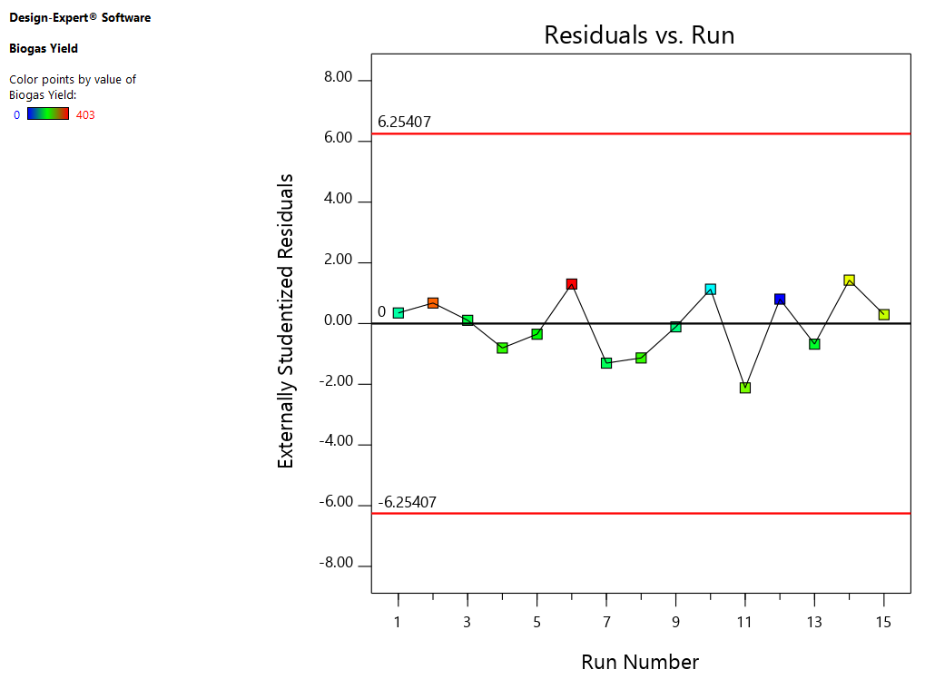

Supplementary table 4. Microbial community response model fit summary

Source | Sequential p-value | Lack of Fit p-value | Adjusted R² | Predicted R²
Linear | < 0.0001 | 0.9966 | 0.9652 | 0.9616 | Suggested
2FI | 0.6954 | 0.9967 | 0.9596 | 0.9619
Quadratic | 0.9136 | 0.9839 | 0.9413 | 0.9345
Cubic | 0.9839 |  | 0.8626 |  | Aliased

(a) Sequential Model Sum of Squares [Type I]
Source | Sum of Squares | df | Mean Square | F-value | p-value
Mean vs Total | 3.985E+09 | 1 | 3.985E+09
Linear vs Mean | 1.893E+08 | 3 | 6.308E+07 | 130.37 | < 0.0001 | Suggested
2FI vs Linear | 8.341E+05 | 3 | 2.780E+05 | 0.4955 | 0.6954
Quadratic vs 2FI | 4.108E+05 | 3 | 1.369E+05 | 0.1679 | 0.9136
Cubic vs Quadratic | 2.595E+05 | 3 | 86506.08 | 0.0453 | 0.9839 | Aliased
Residual | 3.818E+06 | 2 | 1.909E+06
Total | 4.180E+09 | 15 | 2.787E+08
Select the highest order polynomial where the additional terms are significant and the model is not aliased.
(b) Lack of Fit Tests
Source | Sum of Squares | df | Mean Square | F-value | p-value
Linear | 1.504E+06 | 9 | 1.672E+05 | 0.0876 | 0.9966 | Suggested
2FI | 6.703E+05 | 6 | 1.117E+05 | 0.0585 | 0.9967
Quadratic | 2.595E+05 | 3 | 86506.08 | 0.0453 | 0.9839
Cubic | 0.0000 | 0 |  |  |  | Aliased
Pure Error | 3.818E+06 | 2 | 1.909E+06
The selected model should have insignificant lack-of-fit.
(c) Coefficients in Terms of Coded Factors
Factor | Coefficient Estimate | df | Standard Error | 95% CI Low | 95% CI High | VIF
Intercept | 16300.13 | 1 | 179.61 | 15904.82 | 16695.44
A-Substrate Conc | 41.87 | 1 | 245.94 | -499.43 | 583.18 | 1.0000
B-pH | -3498.75 | 1 | 245.94 | -4040.05 | -2957.45 | 1.0000
C-Time | 3378.37 | 1 | 245.94 | 2837.07 | 3919.68 | 1.0000

Supplementary table 5. Fit Summary Response for COD
Source | Sequential p-value | Lack of Fit p-value | Adjusted R² | Predicted R²
Linear | 0.9827 | 0.0088 | -0.2544 | -0.6342
2FI | 0.9124 | 0.0063 | -0.6203 | -1.9276
Quadratic | < 0.0001 | 0.4645 | 0.9841 | 0.9356 | Suggested
Cubic | 0.4645 |  | 0.9864 |  | Aliased

(a) Sequential Model Sum of Squares [Type I]
Source | Sum of Squares | df | Mean Square | F-value | p-value
Mean vs Total | 3814.44 | 1 | 3814.44
Linear vs Mean | 2.43 | 3 | 0.8108 | 0.0537 | 0.9827
2FI vs Linear | 10.06 | 3 | 3.35 | 0.1719 | 0.9124
Quadratic vs 2FI | 155.10 | 3 | 51.70 | 269.51 | < 0.0001 | Suggested
Cubic vs Quadratic | 0.6325 | 3 | 0.2108 | 1.29 | 0.4645 | Aliased
Residual | 0.3267 | 2 | 0.1633
Total | 3983.00 | 15 | 265.53
Select the highest order polynomial where the additional terms are significant and the model is not aliased

(b) Model Summary Statistics
Source | Std. Dev. | R² | Adjusted R² | Predicted R² | PRESS
Linear | 3.89 | 0.0144 | -0.2544 | -0.6342 | 275.46
2FI | 4.42 | 0.0741 | -0.6203 | -1.9276 | 493.46
Quadratic | 0.4380 | 0.9943 | 0.9841 | 0.9356 | 10.86 | Suggested
Cubic | 0.4041 | 0.9981 | 0.9864 |  | * | Aliased

(c) Coefficients in Terms of Coded Factors
Factor | Coefficient Estimate | df | Standard Error | 95% CI Low | 95% CI High | VIF
Intercept | 10.77 | 1 | 0.2529 | 10.12 | 11.42
A-Substrate Conc | 0.1500 | 1 | 0.1549 | -0.2481 | 0.5481 | 1.0000
B-pH | -0.1375 | 1 | 0.1549 | -0.5356 | 0.2606 | 1.0000
C-Time | -0.5125 | 1 | 0.1549 | -0.9106 | -0.1144 | 1.0000
AB | 0.6000 | 1 | 0.2190 | 0.0371 | 1.16 | 1.0000
AC | -1.00 | 1 | 0.2190 | -1.56 | -0.4371 | 1.0000
BC | 1.08 | 1 | 0.2190 | 0.5121 | 1.64 | 1.0000
A² | 2.05 | 1 | 0.2279 | 1.47 | 2.64 | 1.01
B² | 6.23 | 1 | 0.2279 | 5.64 | 6.82 | 1.01
C² | 1.43 | 1 | 0.2279 | 0.8432 | 2.02 | 1.01

Supplementary Table 6. Fit Summary Response for VFA
Source | Sequential p-value | Lack of Fit p-value | Adjusted R² | Predicted R²
Linear | 0.7303 | 0.0021 | -0.1369 | -0.5207
2FI | 0.9049 | 0.0015 | -0.4628 | -1.8016
Quadratic | < 0.0001 | 0.1958 | 0.9914 | 0.9565 | Suggested
Cubic | 0.1958 |  | 0.9971 |  | Aliased

(a) Sequential Model Sum of Squares [Type I]
Source | Sum of Squares | df | Mean Square | F-value | p-value
Mean vs Total | 38435.77 | 1 | 38435.77
Linear vs Mean | 155.70 | 3 | 51.90 | 0.4379 | 0.7303
2FI vs Linear | 83.79 | 3 | 27.93 | 0.1832 | 0.9049
Quadratic vs 2FI | 1215.33 | 3 | 405.11 | 451.46 | < 0.0001 | Suggested
Cubic vs Quadratic | 3.88 | 3 | 1.29 | 4.26 | 0.1958 | Aliased
Residual | 0.6067 | 2 | 0.3033
Total | 39895.07 | 15 | 2659.67
Select the highest order polynomial where the additional terms are significant and the model is not aliased.

(b) Model Summary Statistics
Source | Std. Dev. | R² | Adjusted R² | Predicted R² | PRESS
Linear | 10.89 | 0.1067 | -0.1369 | -0.5207 | 2219.10
2FI | 12.35 | 0.1641 | -0.4628 | -1.8016 | 4088.35
Quadratic | 0.9473 | 0.9969 | 0.9914 | 0.9565 | 63.44 | Suggested
Cubic | 0.5508 | 0.9996 | 0.9971 |  | * | Aliased

(c) Coefficients in Terms of Coded Factors
Factor | Coefficient Estimate | df | Standard Error | 95% CI Low | 95% CI High | VIF
Intercept | 36.77 | 1 | 0.5469 | 35.36 | 38.17
A-Substrate Conc | -3.85 | 1 | 0.3349 | -4.71 | -2.99 | 1.0000
B-pH | -2.00 | 1 | 0.3349 | -2.86 | -1.14 | 1.0000
C-Time | 0.8000 | 1 | 0.3349 | -0.0609 | 1.66 | 1.0000
AB | 1.35 | 1 | 0.4736 | 0.1325 | 2.57 | 1.0000
AC | -3.75 | 1 | 0.4736 | -4.97 | -2.53 | 1.0000
BC | -2.25 | 1 | 0.4736 | -3.47 | -1.03 | 1.0000
A² | 6.64 | 1 | 0.4930 | 5.37 | 7.91 | 1.01
B² | 17.34 | 1 | 0.4930 | 16.07 | 18.61 | 1.01
C² | 1.99 | 1 | 0.4930 | 0.7244 | 3.26 | 1.01

Supplementary figure 1. Production of biogas – preparation of slurry (top left), gas build-up in digester 1 (top right), digester 2 (bottom left) and digester 3 (bottom right).
