Supporting Information
Synthesis and characterization of some new metal complexes of amitrole derivatives and investigation of their catalytic ability

Zainab Zahid Ahmed*
Department of Chemistry, College of Science, University of Baghdad, Baghdad, Iraq

E-mail addresses: zainab.ahmed@sc.uobaghdad.edu.iq
*Corresponding

Experimental
The purity of the ligand and all complexes was detected using the TLC technique, which uses a mixture of acetone and chloroform (1:1, 1:2, and 2:1) and acetone, chloroform, and ethanol only as eluent.
Instrumental
Melting points were determined on the Gallenkamp M.F.D 600-010f melting point apparatus. The Infrared spectra were recorded using (KBr) and (CsI) discs on a SHIMADZU FTIR-8400S, Fourier Transform, Infrared spectrophotometer, Department of Chemistry, University of Baghdad. Electronic spectra of compounds in the UV-visible in different solvents were recorded on a UV-visible spectrophotometer, Varian AUSTRALIA PTY LTD region (200-1100) nm in the Biology department, College of Science, University of Baghdad. Moreover, elemental microanalyses were performed on Eurovector EA 3000A, Mass spectra were recorded on Shimadzu Qp 5050A, ¹H- & ¹³C-NMR were performed by using Bruker Ultra Shield 300 MHz NMR, Alal-Bayt University (Jordan). The metal contents were determined by atomic absorption technique using a Shimadzu AA 6200 Flame Atomic Absorption Spectrophotometer, Ministry of Science and Technology. Additionally, a Varian-AA 6200 Flame Atomic Absorption spectrophotometer, Department of Chemistry, Science College, University of Baghdad. Moreover, Mohr's method determined the chloride contents for complexes in the Department of Biology, College of Science, University of Baghdad.

Materials and Methods
All chemicals were of high purity and were used, except for ethanol and DMF, which were dried and distilled before use. Converted to super dry methanol according to reference [1]. Dichloro bis (benzonitrile) Palladium (ll). [PdCl₂(PhCN)₂] was prepared from palladium (II) chloride(60%(Pd)) according to the method described by E.G. Rochow [2]. Potassium hexachloroplatinate (IV) [K₂PtCl₆] was prepared from (H₂PtCl₆.xH₂O) (38%(Pt)) according to the method reported [3]. Potassium tetrachloroplatinate (II) [K₂PtCl₄] was prepared from (K₂PtCl₆) according to the method reported elsewhere [3]. Cis-PtCl₂(PPh₃)₂ complex [3] was prepared according to the method reported in the literature [3].
Synthesis of Ligands:
Synthesis of (N-(1H-1,2,4-triazole-3-yl) acetamide, NTA):
In a boiling glacial acetic acid (99.5%) (8.9 mL), a solution of 3-amino-1,2,4-triazole (0.3954 g, 4.7 mmol) (99%) was dissolved in 3.5 mL of the same solvent. Reflux was continued for 4.5h, and a precipitate was formed after four days. The product was washed with hot ethanol several times, followed by ether, and vacuum dried for 5h. The synthetic route of NTA is illustrated in Scheme S1.
Scheme S 1 Synthesis of NTA ligand.
Metal complexes of NTA:
Synthesis of Co (II), Ni (II) complexes (C, N): -
The Co(II), and Ni(II) complexes (abbreviation in C and N, respectively): To stirred solution of (NTA) (0.05 g, 0.23 mmol) in absolute butanol (6 ml) was added an alcoholic solution of Co(II), Ni(II) chlorides (0.0446 g, 0.0446 g) respectively, 0.23 mmol). And the mixture was heated under reflux with continuous stirring. The Ni(II) complex was formed after 5 min, while the Co(II) complex was formed after 30 min. Reflux was continued for 1h to allow complete precipitation. The products were filtered, washed with hot butanol, followed by cold ether, and vacuum dried.

Synthesis of Pt(II) complex (P):
A solution of NTA (0.01167 g, 0.0548 mmol) in dry methanol was added to a stirred suspension of cis-[PtCl₂(PPh₃)₂] (0.0432 g, 0.0548 mmol)in methanol then 0.5ml of Et₃N and the mixture was heated on a water bath at (45 - 50)°C for (3.5 h) with continuous stirring. The solvent was evaporated under reduced pressure to result in a red, solid residue. The product was redissolved in dichloromethane (20 mL). Water (75 ml) was used to extract the NEt₃H⁺Cl⁻, produced in the reaction. The organic layer was separated, dried with MgSO₄.H₂O, and filtered. The filtrate was left to evaporate to dryness overnight. A pale pink solid was formed and recrystallized from light petroleum ether (30 - 40 °C). The product was filtered, washed with light petroleum ether, and dried under a vacuum.
Synthesis of Pd(II), complexes (D₁, D₂):-
Palladium Pd(II) complexes(D₁ and D₂): this complex of Pd(II) was prepared by adding to a stirred solution of NTA (0.1412 g, 0.41 m.mol) in absolute methanol (10 ml) then heated to boiling was added an alcoholic solution of PdCl₂(PhCN)₂ (0.0532 g, 0.205 m.mol) then 0.5 ml of Et₃Nwith continuous stirring and the mixture was heated under reflux for 1 h. A light green precipitate was formed after less than 10 min. Reflux was continued for 1 h to allow complete precipitation. The product was washed and purified from reactants using hot ethanol, followed by ether, and vacuum dried. The second complex of Pd(II) is prepared by a stirred solution of (NTA) (0.05 g, 0.23 mmol) in absolute butanol (6 ml) added an alcoholic solution of NTA was added an alcoholic solution of PdCl₂(PhCN)₂ (0.0532g, 0.205 m.mol) continuous stirring pale yellowish brown precipitate was formed after 30min the mixture was heated under reflux for 1 h to complete precipitation. The product was washed and purified from reactants using hot ethanol, followed by ether, and vacuum dried.
Synthesis of ((3-acetamido-1H-1,2,4-triazol-1-yl) (methoxycarbonyl)mercury, H):
Mercury Hg(II) complex (H): the complex of Hg(II)prepared by adding to a stirred solution of NTA (0.05 g, 0.23 mmol) in absolute methanol (7ml) then heated to boiling was added an alcoholic solution of Hg(CH₃COO)₂ (0.0532g, 0.205 mmol) then 0.5ml of Et₃Nwith continuous stirring then the mixture was heated for 5min only white precipitate was formed and continuous stirring under reflux for 1 h without heat to allow complete precipitation. The product was washed and purified from reactants using hot ethanol, followed by ether, and vacuum dried.
Spectroscopic characterization of NTA and its metal complexes
FT-iR analysis
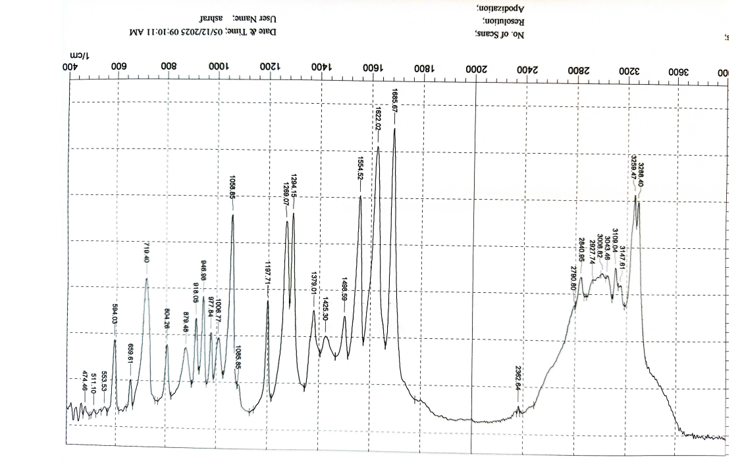
Figure S 1 FTIR synthesized NTA ligand.

Figure S 2 FTIR of Pd complexes (D1) synthesized using butanol solvent.
Figure S 3 FTIR of Pd complexes (D1) (Zoom from 200 to 400 nm region) synthesized using butanol solvent.
Figure S 4 FTIR of Pd complexes (D₂) synthesized using methanol solvent and triethylamine as a catalyst for forming the Metal-Nitrogen bond.
Figure S 5 FTIR of Pd complexes (D2) (Zoom from 200 to 400 nm region) synthesized using methanol solvent and triethylamine as a catalyst for forming the Metal-Nitrogen bond.
Figure S 6 FTIR of the Co complex (C) synthesized using butanol solvent.
Figure S 7 FTIR of Co complexes (C) (Zoom from 200 to 400 nm region) synthesized using butanol solvent.

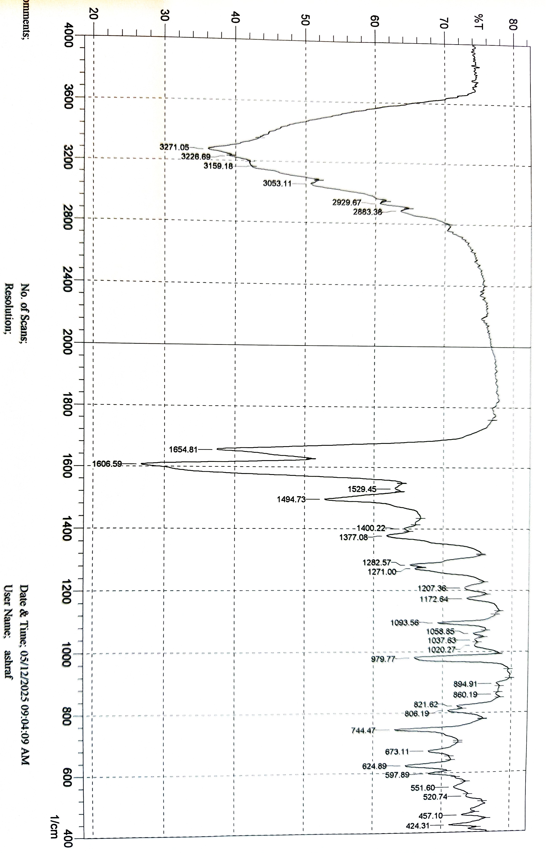
Figure S 8. FTIR of the Ni complex (N) synthesized using butanol solvent
Figure S 9 FTIR of the Hg complex (H) synthesized using methanol and Et₃N as a catalyst.
Figure S 10 FTIR of Hg complexes (Zoom from 200 to 400 nm region) synthesized using butanol solvent.

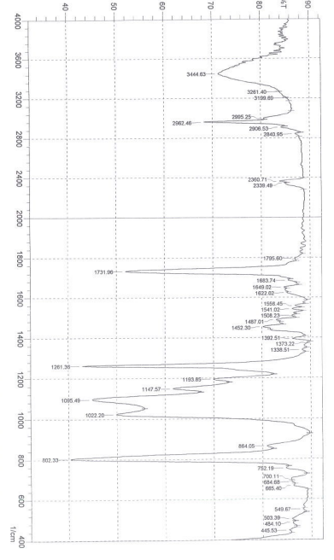

Figure S 11 MMA-1H copolymer synthesized using palladium catalyst (D₂).

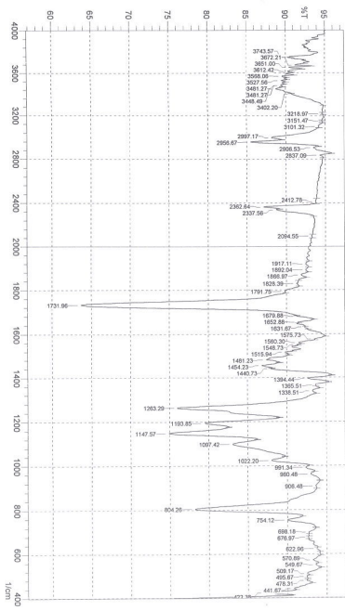
Figure S 12 MMA-1H copolymer synthesized using Nickel catalyst (N).

UV-visible spectroscopy

Figure S 13 UV-visible spectrum of Co(NTA) complex.

Figure S 14 Pd(NTA) complex was synthesized using butanol.

Figure S 15 UV-visible of the synthesized Ni(NTA) complex.

Figure S 16 UV-visible spectrum of Pd(NTA) complex synthesized using methanol and Et₃N.

References
[1] Y. Wang, L. Gudiño, J. Bedia, and C. Belver, “Solar photocatalytic hydrogen production through metal sulfide/UiO-66-NH2 heterojunctions,” Sep. Purif. Technol., vol. 353, no. June 2024, pp. 1–8, 2025, doi: 10.1016/j.seppur.2024.128663.
[2] A. J. Abdulghani and Z. Z. Ahmed, Synthesis and characterization of some new metal complexes of condensation reaction products of 3-amino-1,2,4-triazole with isatin, n-acetylisatin and bis(2,3-dioxoindolin-1-yl)mercury(II). 2014. doi: 10.1007/978-94-007-7389-9_20.
[3] A. J. Abdulghani and Z. Z. Ahmed, “Synthesis, Structure and Characterization of New Metal Complexes of Schiff Bases Derived from Isatin N-Benzylisatin and 4-Aminoantipyrine,” Pakistan J. Chem., vol. 1, no. 3, pp. 100–113, 2011, doi: 10.15228/2011.v01.i03.p01.

