Supporting Information
Nanoparticle-enabled antifungal agents: Design, synthesis and docking studies of functionalized Lactose derivatives
Shankesh C. Zyate,^{a†} Nikita V. Awajare,^{a†} Sanjay S. Gaikwad,^{b} Kunal Raut,^{c} Vikas Jha,^{d} Amardeep R. Jadhao,^{e} and Poonam T. Agrawalaª*
ªDepartment of Chemistry, Shri. R. L. T. College of Science, Civil Lines, Akola Maharashtra-444001, India.
^{b}Department of Chemistry, MES, Abasaheb Garware College, Karve Road, Pune Maharashtra-411004, India.
^{c}Department Pharmaceutical Sciences, School of Health Sciences & Technology, MIT World Peace University, Kothrud, Pune Maharashtra-411038, India.
^{d}National Facility for Biopharmaceuticals, G. N. Khalsa College, Mumbai, Maharashtra-400019, India.
^{e}Department of Chemistry, Late Pushpadevi Patil Arts and Science College, Risod Dist. Washim, Maharashtra-444506, India.
†Both the authors contributed equally.

Content
Sr. No. | Particulars | Page No.
 | General Information | S1
 | Synthetic procedures | S2
 | Spectral data of some synthesized NPs | S5
 | ¹H NMR data and Spectra | S13
 | Images of zone of inhibition studies | S34
 | Images of MIC study of synthesized NPs using REMA (resazurin microtiter plate assay) | S35

1. General information:
Sigma Aldrich, Alfa Aesar, and Spectrochem were the commercial suppliers of all the reagents and solvents utilised. Analytical thin-layer chromatography (TLC) was used to track the reactions after they were sonicated at 55°C and magnetically agitated. Merck 60 F254 0.25 mm silica gel. TLC plates were exposed to either an aqueous solution of potassium permanganate (KMnO4) or ultraviolet light (UV, 254 nm) before being heated with a heat gun. Silica gel (100–200 mesh) column chromatography was used to isolate the chemicals, and solvents were distilled before use. Using CDCl3 as a solvent, 1H NMR spectra were captured on a 400 MHz spectrometer. In 1H NMR, TMS (0.00 ppm) was used as an internal standard. Coupling constants (J) were measured in Hz, and chemical shifts were measured in δ ppm. The abbreviations used to indicate multiplicities in NMR spectra are s: singlet, d: doublet, t: triplet, m: multiplet, bs: wide singlet, and dd: doublet of doublet for proton spectra.
The test organisms were cultivated in Mueller Hinton broth for a 24-hour incubation period before being used in the investigation to assess antibiotic activity. After adjusting the bacterial culture's optical density using 0.5 McFarland standards (108 CFU/ml), the cell suspension was homogeneously mixed to achieve a final density of 1 x 106 CFU/ml. The antimicrobial activity was then assessed using the agar cup diffusion method. 10 mg/ml was added to each sample. The samples were placed into 100 μl wells on each plate, and the plates were incubated for 24 hours at 37 °C room temperature.
Using PyRx 8.0 software, molecular docking study was conducted to assess the D-lactosyl hybrids' (DLH) binding affinity with the antifungal protein target, 1EA1. The Protein Data Bank (PDB) provided the target protein's three-dimensional (3D) structure (PDB ID: 1EA1). Using Biovia Discovery Studio 2024, the protein structure was created by eliminating co-crystallized ligands, heteroatoms, and water molecules. To guarantee structural stability, the CHARM force field was used to minimise the protein's energy. ^{1, 2}

2. Synthetic procedures:
2.1 Synthesis of Lactose Octabenzoate (II):
In a 500 mL amber colored chemical bottle having a tight cork, dry chloroform and of dry pyridine 110 mL was taken (1:1, v/v). The bottle was cooled in an ice-salt bath and to this ice-cold solution, precooled solution of 55 mL of benzoyl chloride (473.27 mmol, 8.1 equiv.) in 55 mL of dry chloroform was added with constant stirring, followed by addition of 20.0 g dry α-D-Lactose I powder (58.43 mmol, 1.0 equiv.) in several portions (20-25 equal portions) with constant stirring and maintaining the reaction temperature < 5 ºC. After 24 h reaction mixture was washed with dilute aqueous sulphuric acid plenty of times (5-6 times), followed by treatment with aqueous sodium bicarbonate and water. The product was separated out in chloroform layer and after triturated many times with petroleum ether to obtain pure white granular solid product.
2.2 Preparation of brominating reagent:
In 40 mL glacial acetic acid 4.0 g red phosphorous was added. To this, mixture 15 mL molecular bromine in acetic acid (1:1) was added slowly with constant stirring under ice-cold condition. The resultant mixture was allowed to stand for about 30 min. in an ice bath maintaining temperature <5 ºC.

2.3 Synthesis of hepta-O-benzoyl-β-D-lactosyl bromide (III):
The fine powder of Lactosyl Octa benzoate II 20.0 g (18.67 mmol) was added to the brominating agent with continuous stirring. After 2 h chloroform (70 mL) was added to the reaction mixture with constant stirring for about 15 min. The resultant mixture was added to the ice-cold water and wash several times with aqueous sodium bicarbonate to remove excess of acetic acid followed by aqueous sodium metabisulphite to remove excess of bromine and finally 2-3 times by water. The desired product was separated out in chloroform layer and after trituration many times with petroleum ether pure white granular solid comes out as a product.
2.4 Preparation of lead thiocyanate:
The lead thiocyanate was prepared by mixing aqueous solution of ammonium thiocyanate and lead nitrate. After filtration the white granular solid was obtained i.e. lead thiocyanate. Finally washed with water and dried at 50 °C.
2.5 Synthesis of hepta-O-benzoyl-β-D-lactosyl isothiocyanate (1):
Lead thiocyanate (5.0 g, 15.87 mmol, 2.0 equiv.) was added to the suspension of hepta-O-benzoyl-β-D-lactosyl bromide III (15.0 g, 13.23 mmol, 1.0 equiv.) in dry xylene (60 mL). The reaction mixture was refluxed for 3 h, after cooling residual lead bromide was removed by filtration and the filtrate was treated many times with hot petroleum ether with stirring to obtain pure white solid mass as a product in 75% yield (11.0 g).

2.6 Synthesis of 1-hepta-O-benzoyl-β-D-lactosyl-5-phenyl benzothiazolyl thiocarbamides (3a-3g):
To the solution of 1-hepta-O-benzoyl-β-D-lactosyl isothiocyanate 1 (3.0 g, 2.70 mmol, 1.0 equiv.) in benzene (30.0 mL) was added benzo[d]thiazol-2-amine 2 (446 mg, 2.97 mmol, 1.20 equiv.) and the reaction mixture was refluxed over water bath for 3 h. After refluxing solvent was distilled off and the obtained sticky mass was triturated several times with petroleum ether to obtain a pure white granular solid product 3.
2.7 Synthesis of 1-hepta-O-benzoyl-β-D-lactosyl-5-phenyl-4-S-benzyl-2,4- isodithiobiurets (3h-3n):
To the solution of 1-hepta-O-benzoyl-β-D-lactosyl isothiocyanate 1 (3.0 g, 2.70 mmol) in benzene solvent (30 mL) was added 1-(benzylthio)-N-phenylmethanediamine 4 (791 mg, 2.97 mmol, 1.20 equiv.) and the reaction mixture was refluxed over water bath for 3 h. After refluxing solvent was distilled off and the sticky mass obtained as residue was triturated several times with petroleum ether. A white granular solid was obtained as a product 3h.
2.8 Synthesis of 1-hepta-o-benzoyl-β-D-lactosyl-5-phenyl 2,4-dithiobiurets (3o-3u):
To a solution of 1-hepta-O-benzoyl-β-D-lactosyl isothiocyanate 1 (3.0 g, 2.70 mmol. 1.0 equiv.) in benzene solvent (30 mL) was added phenyl thiourea 5 (493 mg, 2.97 mmol, 1.20 equiv.). The reaction mixture was refluxed over water bath for 3 hrs. After refluxing solvent was distilled off and the sticky mass obtained as residue was triturated several times with petroleum ether. A white granular solid was obtained as a product 3o.
2.9 Synthesis of Nanoparticles of 3:
The nanoparticles of compound 3 were synthesized in an Ultra Sound Sonicator by providing 3 cycles of 10 minutes each in chloroform solvent. Synthesized NPs were triturated several times with petroleum ether. Formation of NPs were confirmed by SEM, TEM and XRD analysis.¹¹
3. Characterisation of NPs
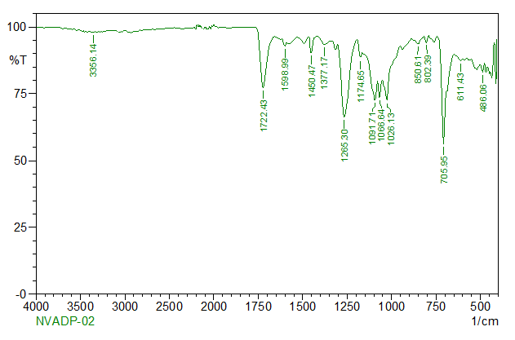
IR spectra of NPs of 3a

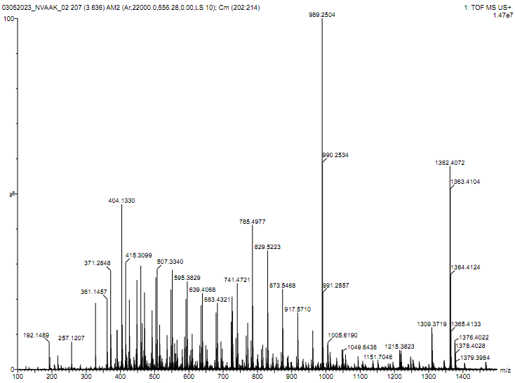
EI mass spectra of compound 3a

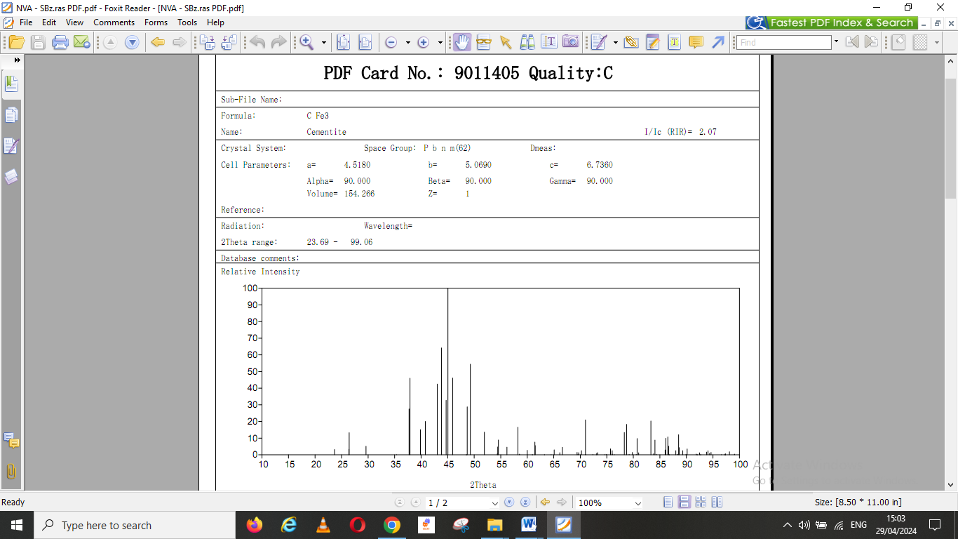
PDF card and graph of XRD of compound 3a
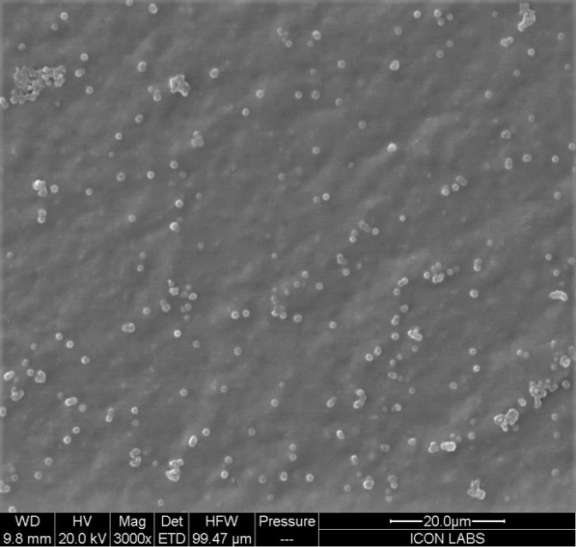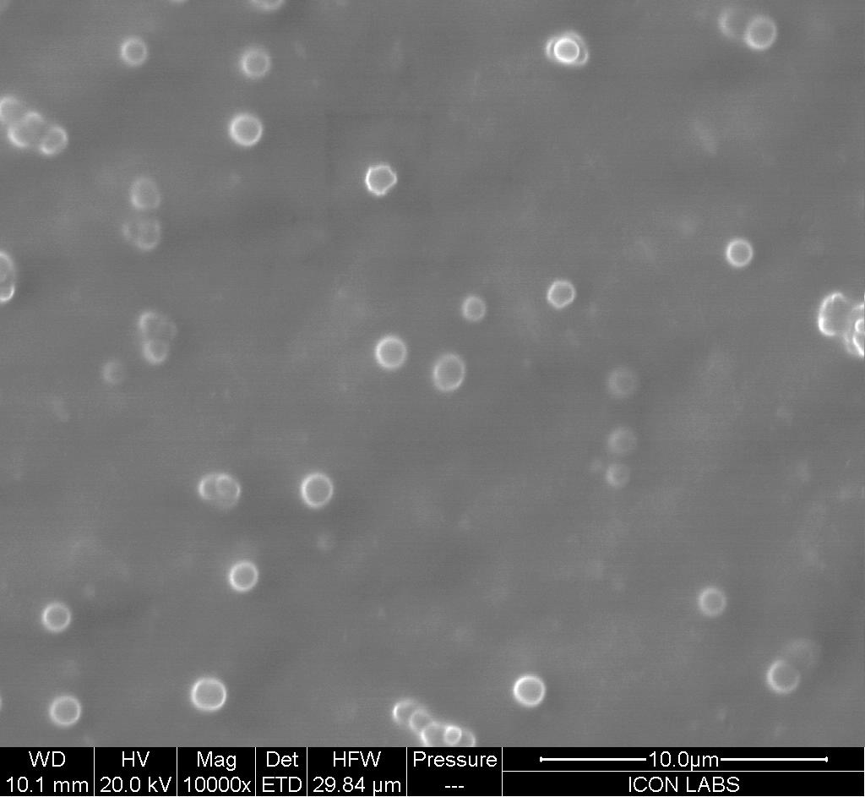

FESEM images of 3a : Model- Quanta 200F,
Magnification range: 30 x to 2 lac x, Resolution: 2.5 nm
FESEM graph of Size distribution in nm with respect to number of particles

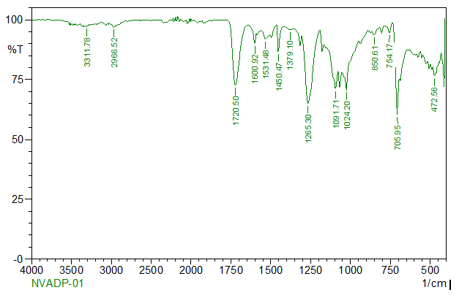
FTIR image of compound 3h

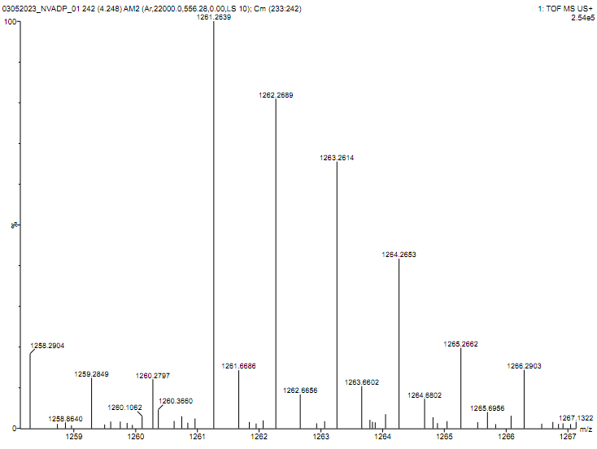
EI mass spectra of compound 3h
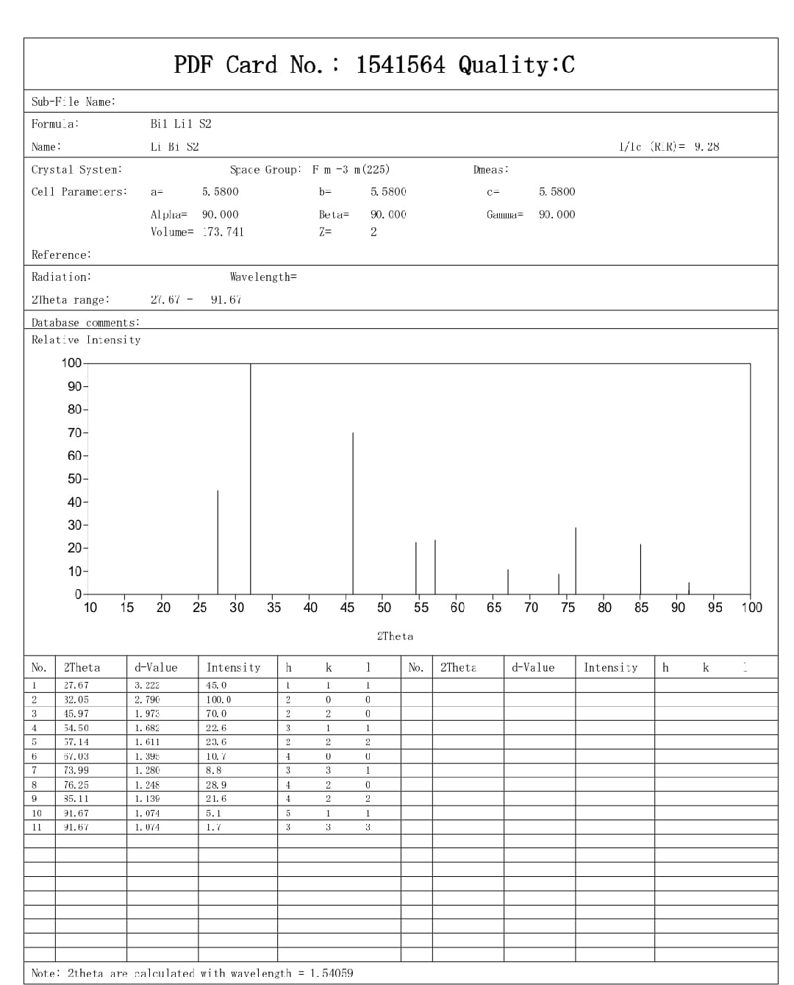
PDF card and graph of XRD of compound 3h

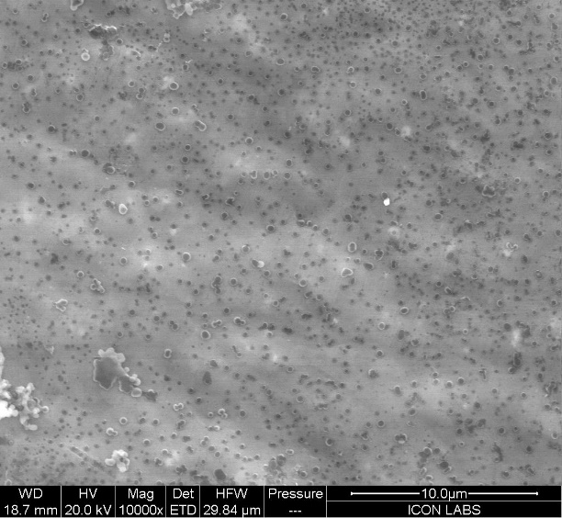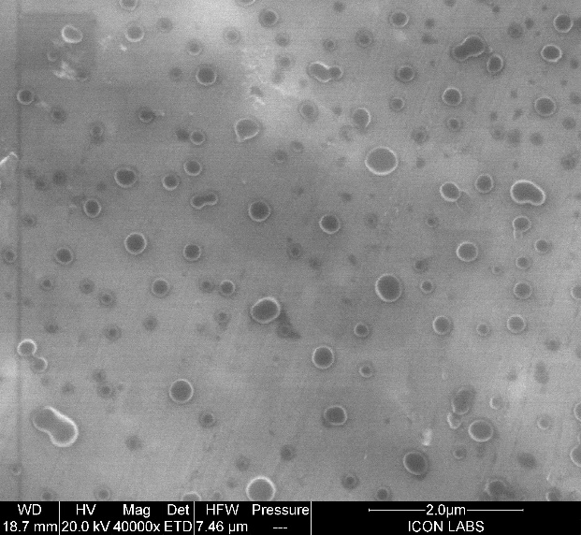

FESEM images of 3h : Model- Quanta 200F,
Magnification range: 30 x to 2 lac x, Resolution: 2.5 nm
FESEM graph of Size distribution in nm with respect to number of particles

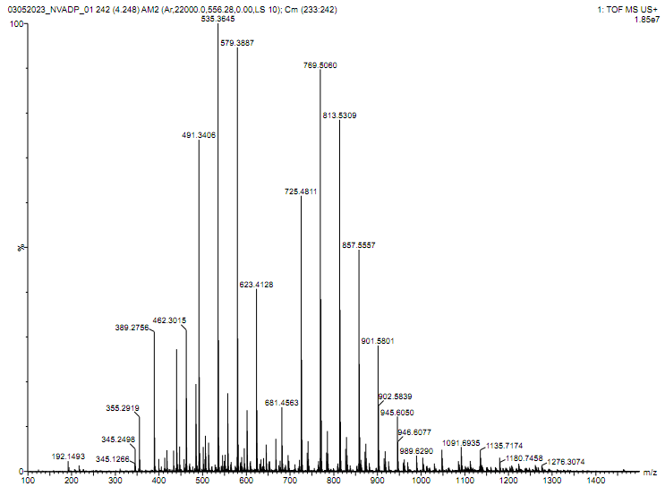
EI mass spectra of compound 3s

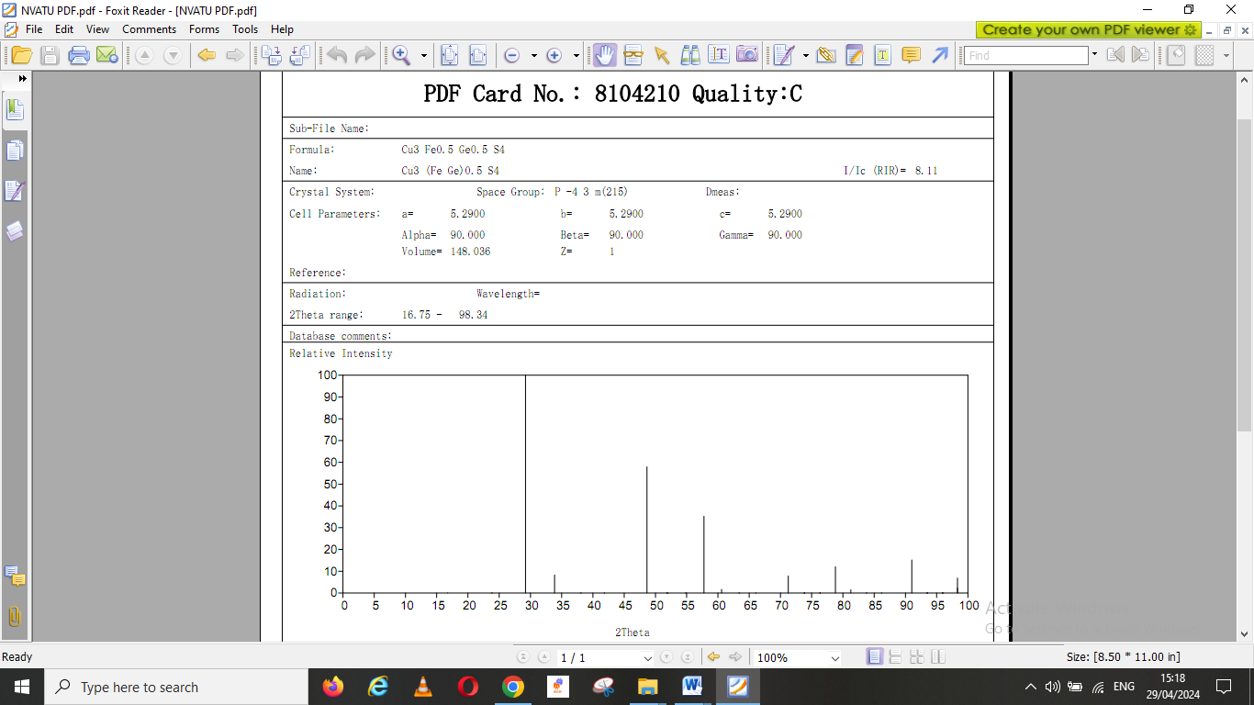
PDF card and XRD graphs of compound 3s

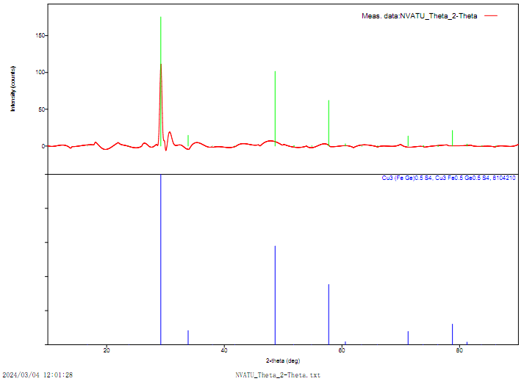
XRD graphs of compound 3s

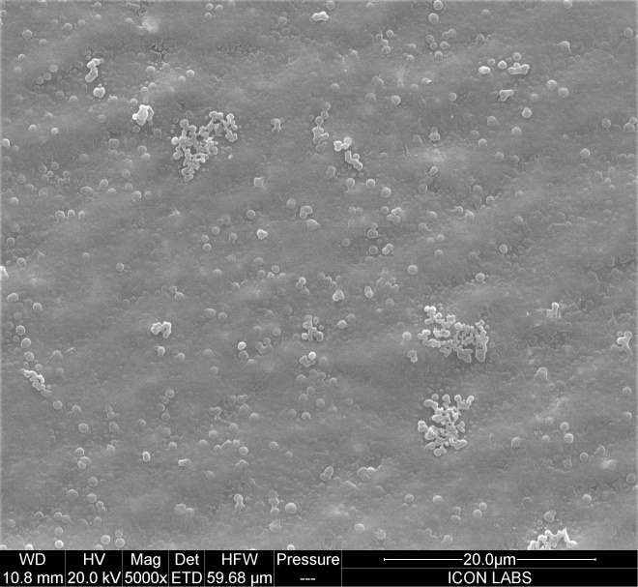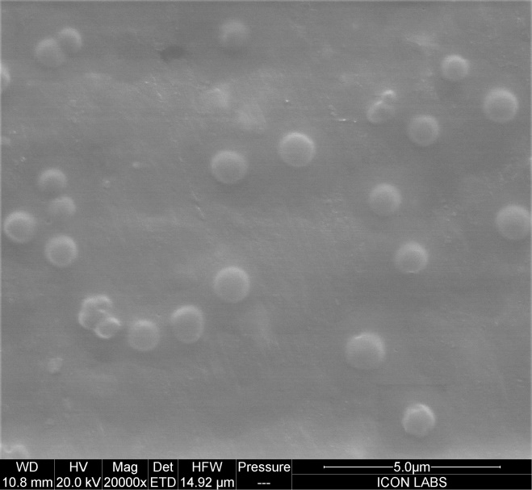

FESEM images of 3s : Model- Quanta 200F,
Magnification range: 30 x to 2 lac x, Resolution: 2.5 nm
FESEM graph of Size distribution in nm with respect to number of particles

4. ¹H NMR Data and spectra
1-hepta-o-benzoyl-β-D-lactosyl-5-phenyl-4-S-benzyl-2,4- isodithiobiurets (3a):¹H NMR (400 MHz, CDCl₃) δ:– 2.33 (s, 1H), 3.85 (t, 1H), 4.22 (s, 2H), 4.16- 5.56 (m, 11H), 5.99 (d, 1H), 6.47 (d, 1H), 6.85 (s, 1H), 7.00-8.02 (m, 45 H).

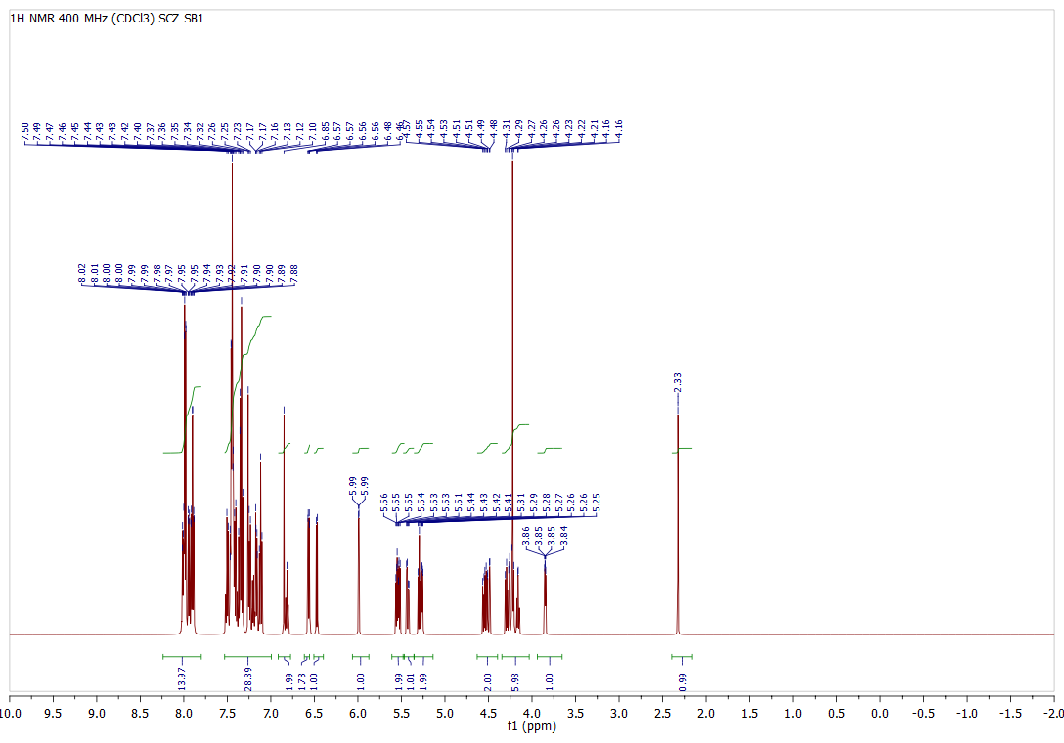
¹H NMR OF COMPOUND 3a

1-hepta-o-benzoyl-β-D-laltosyl-5-o-chlorophenyl-4-S-benzyl-2,4- isodithiobiurets (3b):¹H NMR (400 MHz, CDCl₃) δ :– 1.1 (s, 1H), 3.81 (t, 1H), 4.22 (s, 2H), 4.22- 5.57 (m, 11H), 5.99 (d, 1H), 6.46 (d, 1H), 7.04 (s, 1H), 7.04-8.03 (m, 44 H).
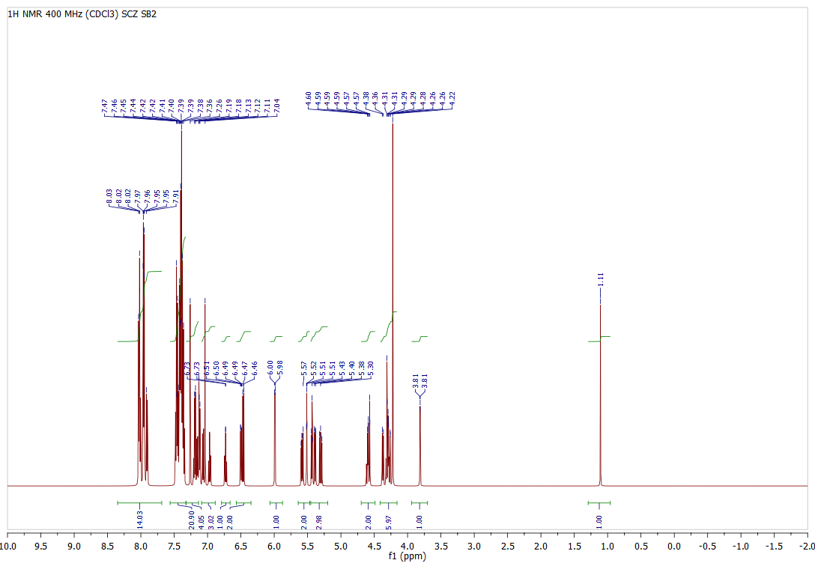
¹H NMR OF COMPOUND 3b

1-hepta-o-benzoyl-β-D-lactosyl-5-m-chlorophenyl-4-S-benzyl-2,4- isodithiobiurets (3c): ¹H NMR (400 MHz, CDCl₃) δ :– 1.80 (s, 1H), 3.76 (t, 1H), 4.41 (s, 2H), 4.24- 5.71 (m, 11H), 5.99 (d, 1H), 6.41 (d, 1H), 7.27 (s, 1H), 7.41-8.11 (m, 44 H).

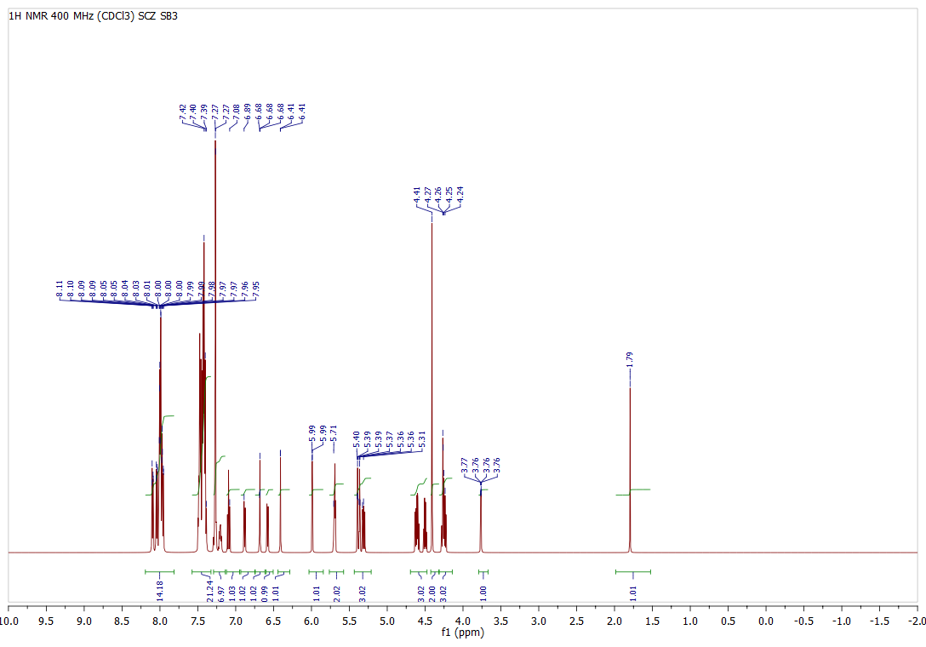
¹H NMR OF COMPOUND 3c

1-hepta-o-benzoyl-β-D-lactosyl-5-p-chlorophenyl-4-S-benzyl-2,4- isodithiobiurets (3d):¹H NMR (400 MHz, CDCl₃) δ :– 2.32 (s, 1H), 3.71 (t, 1H), 4.40 (s, 2H), 4.10- 5.58 (m, 11H), 5.56 (d, 1H), 5.99 (d, 1H), 7.51 (s, 1H), 7.51-8.07 (m, 44 H).
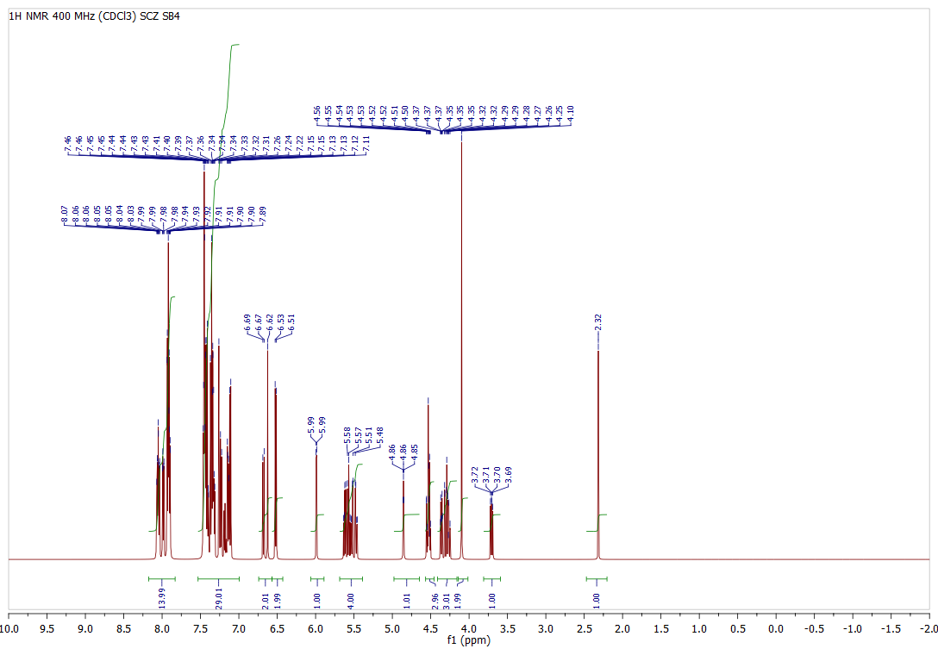
¹H NMR OF COMPOUND 3d

1-hepta-o-benzoyl-β-D-lactosyl-5-o-tolyl-4-S-benzyl-2,4-isodithiobiurets (3e):¹H NMR (400 MHz, CDCl₃) δ :– 1.44 (s, 1H), 3.95 (t, 1H), 4.40 (s, 2H), 4.00- 5.63 (m, 11H), 5.60 (d, 1H), 5.99 (d, 1H), 7.51 (s, 1H), 6.49-8.08 (m, 47 H).

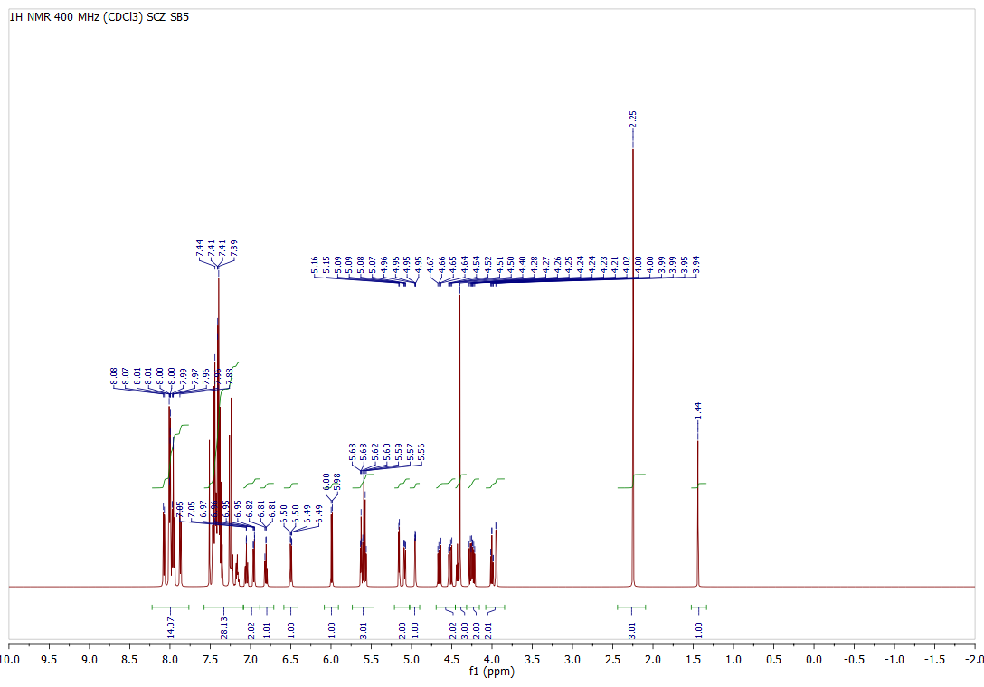
¹H NMR OF COMPOUND 3e

1-hepta-o-benzoyl-β-D-lactosyl-5-m-tolyl-4-S-benzyl-2,4- isodithiobiurets (3f):¹H NMR (400 MHz, CDCl₃) δ :– 2.23 (s, 1H), 3.96 (t, 1H), 4.34 (s, 2H), 4.31- 5.71 (m, 11H), 5.99 (d, 1H), 6.65 (d, 1H), 7.01 (s, 1H), 6.70-8.10 (m, 47 H).

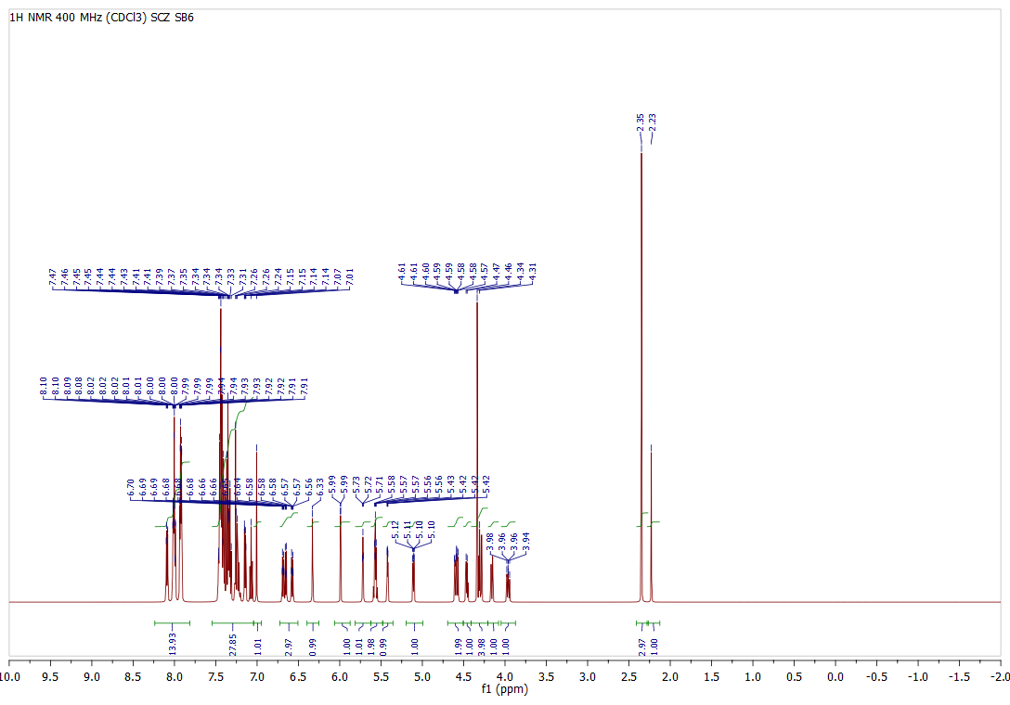
¹H NMR OF COMPOUND 3f

1-hepta-o-benzoyl-β-D-lactosyl-5-p-tolyl-4-S-benzyl-2,4-isodithiobiurets (3g):¹H NMR (400 MHz, CDCl₃) δ :– 2.06 (s, 1H), 3.79 (t, 1H), 4.55 (s, 2H), 4.24- 5.76 (m, 11H), 5.99 (d, 1H), 6.56 (d, 1H), 6.98 (s, 1H), 6.19-8.15 (m, 47 H).
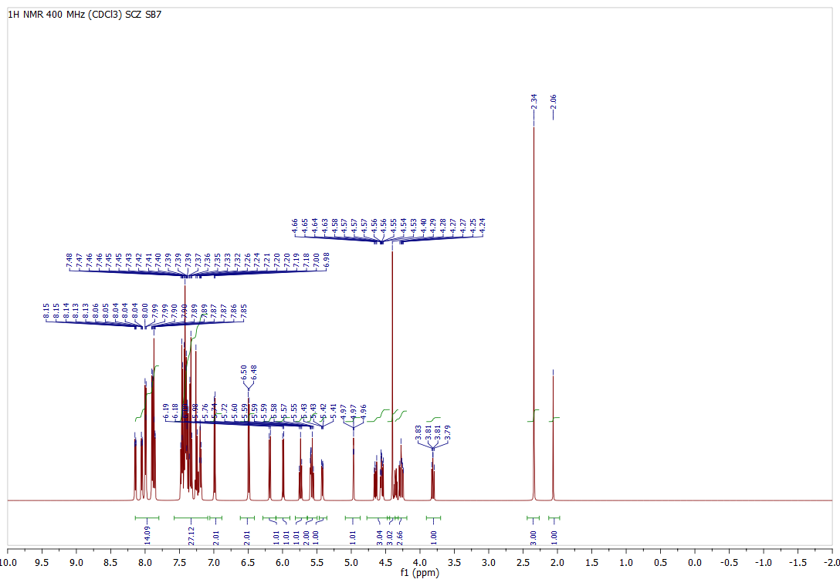
¹H NMR OF COMPOUND 3g

¹H NMR of 1-hepta-o-benzoyl-β-D-Lactosyl-5-phenyl 2,4-dithiobiurets (3h): ¹H NMR (400 MHz, CDCl₃) δ :– 3.92 (t, 1H), 4.15- 5.38 (m, 11H), 5.98 (d, 1H), 6.19 (d, 1H), 6.56 (s, 1H),8.08 (s, 1H) 8.78 (s, 1H), 7.26- 8.08 (m, 40 H).

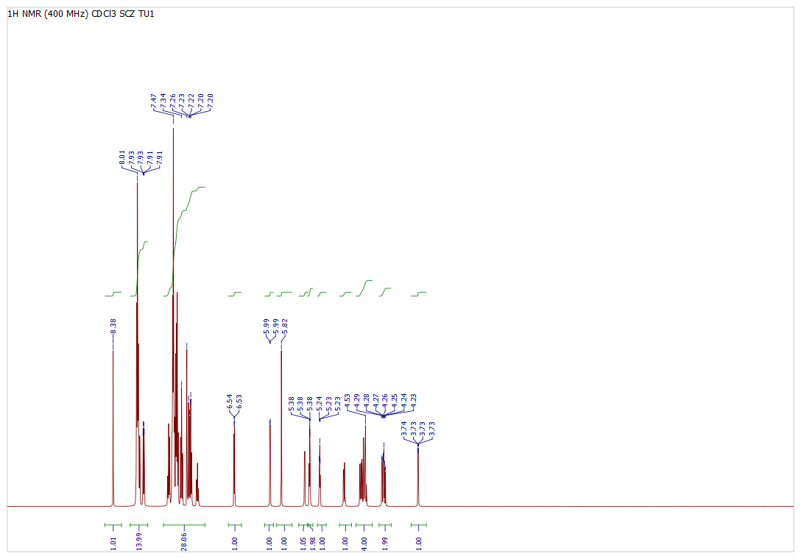
¹H NMR OF COMPOUND 3h

¹H NMR of 1-hepta-o-benzoyl-β-D-lactosyl-5-o-chlorophenyl 2,4-dithiobiurets (3i): ¹H NMR (400 MHz, CDCl₃) δ :– 4.02 (t, 1H), 4.21- 5.59 (m, 11H), 5.60 (s, 1H), 5.99 (s, 1H), 6.56 (s, 1H), 7.91 (s, 1H), 9.00 (s, 1H), 7.21- 8.05 (m, 39 H).

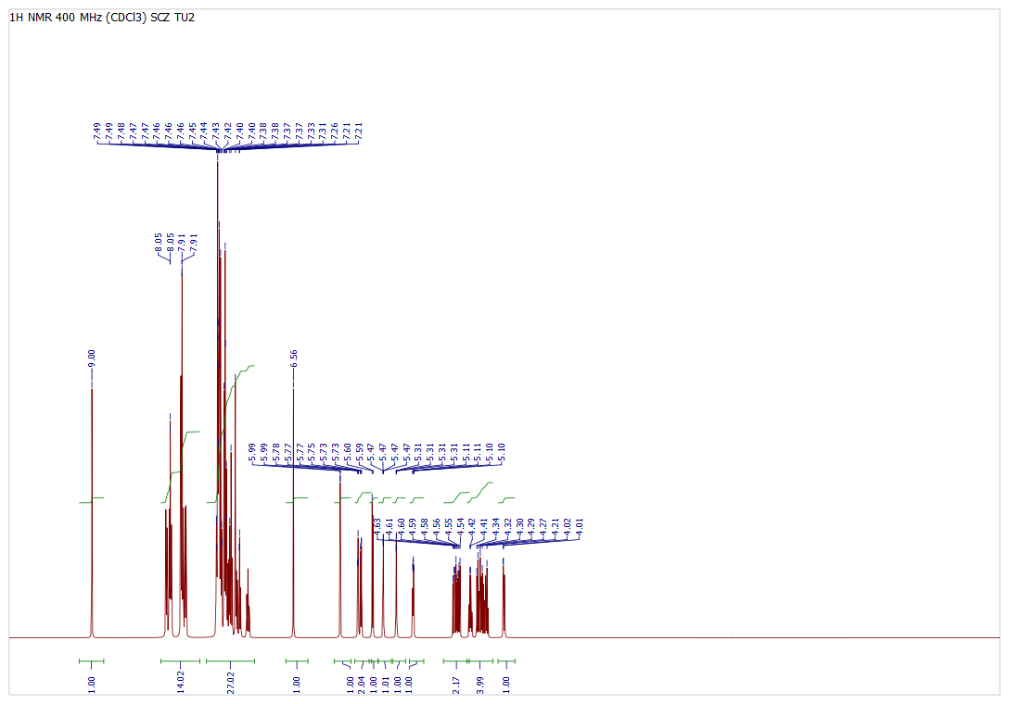
¹H NMR OF COMPOUND 3i
¹H NMR of 1-hepta-o-benzoyl-β-D-lactosyl-5-m-chlorophenyl 2,4-dithiobiurets (3j): ¹H NMR (400 MHz, CDCl₃) δ :– 3.59-3.60 (t, 1H), 4.21- 5.69 (m, 11H), 5.70 (s, 1H), 5.99 (d, 1H), 6.41 (d, 1H), 6.80 (s, 1H), 7.97 (s, 1H), 6.94- 8.12 (m, 39 H).

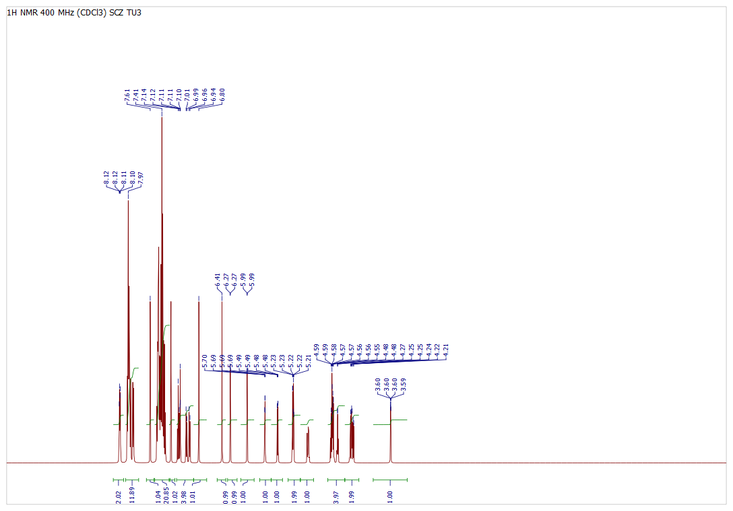
¹H NMR OF COMPOUND 3j

¹H NMR of 1-hepta-o-benzoyl-β-D-lactosyl-5-p-chlorophenyl 2,4-dithiobiurets (3k): ¹H NMR (400 MHz, CDCl₃) δ :– 3.72 (t, 1H), 4.27- 5.40 (m, 11H), 5.20 (s, 1H), 5.71 (s, 1H), 5.98 (d, 1H), 6.30-6.32 (d, 1H), 8.40 (s, 1H), 7.26- 8.09 (m, 39 H).

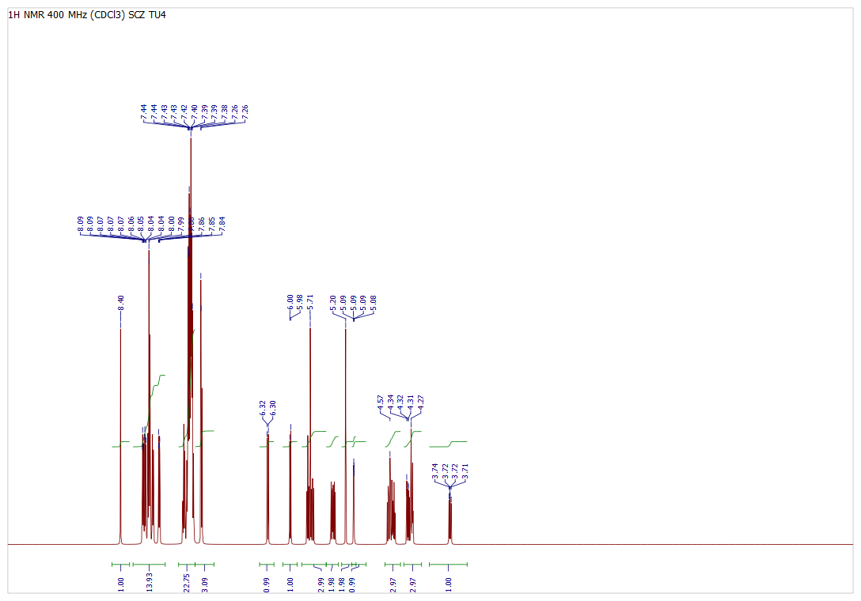
¹H NMR OF COMPOUND 3k

¹H NMR of 1-hepta-o-benzoyl-β-D-lactosyl-5-phenyl 2,4-dithiobiurets (3l): ¹H NMR (400 MHz, CDCl₃) δ :– 2.19 (s, 3H), 3.43 (t, 1H), 4.29- 5.57 (m, 11H), 5.45 (s, 1H), 5.71 (d, 1H), 5.98 (d, 1H), 6.50 (s, 1H), 6.69 (s, 1H), 7.18- 7.99 (m, 39 H).

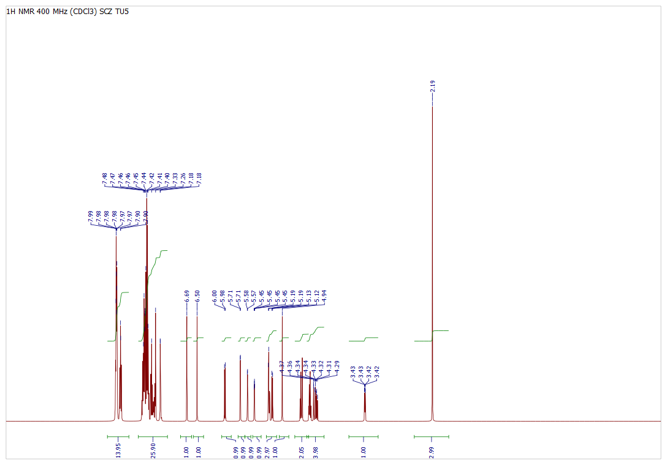
¹H NMR OF COMPOUND 3l

¹H NMR of 1-hepta-o-benzoyl-β-D-lactosyl-5-phenyl 2,4-dithiobiurets (3m): ¹H NMR (400 MHz, CDCl₃) δ:– 2.37 (s, 3H), 3.86 (t, 1H), 4.21- 6.18 (m, 11H), 5.99 (d, 1H), 6.18 (d, 1H), 6.55 (s, 1H), 7.03 (s, 1H), 7.82 (s, 1H), 7.03- 8.03 (m, 39 H).

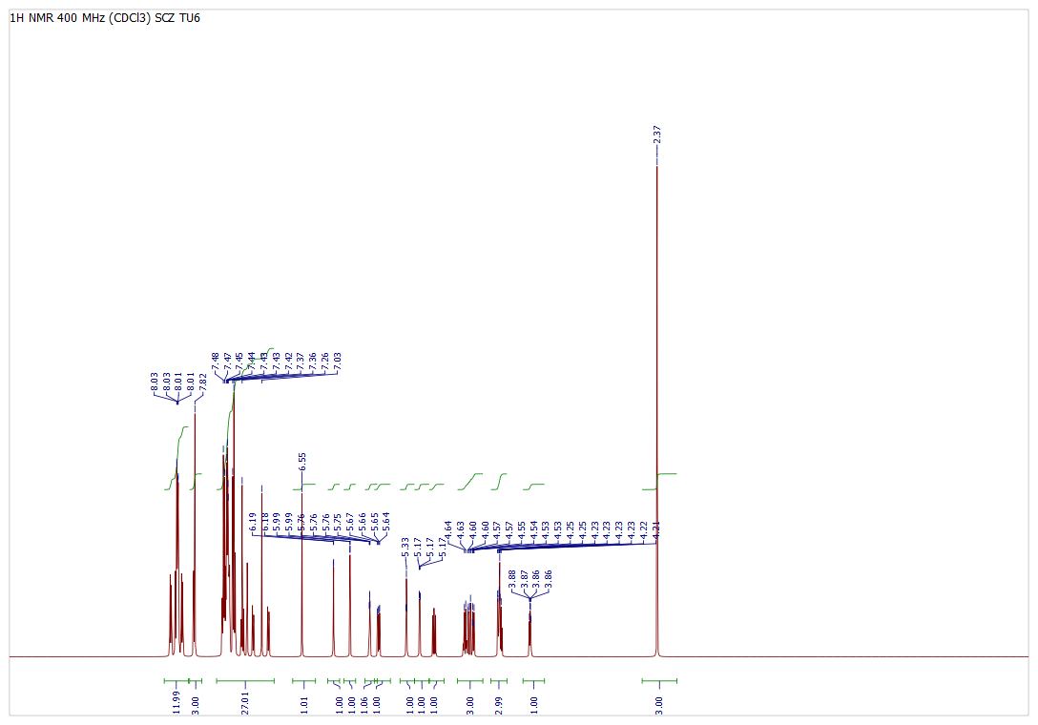
¹H NMR OF COMPOUND 3m

¹H NMR of 1-hepta-o-benzoyl-β-D-lactosyl-5-phenyl 2,4-dithiobiurets (3n): ¹H NMR (400 MHz, CDCl₃) δ :– 2.32 (s, 3H), 3.83 (t, 1H), 4.13- 5.40 (m, 11H), 5.80 (s, 1H), 5.99 (d, 1H), 6.30 (d, 1H), 6.66 (s, 1H), 7.87 (s, 1H), 7.13- 8.06 (m, 39 H).

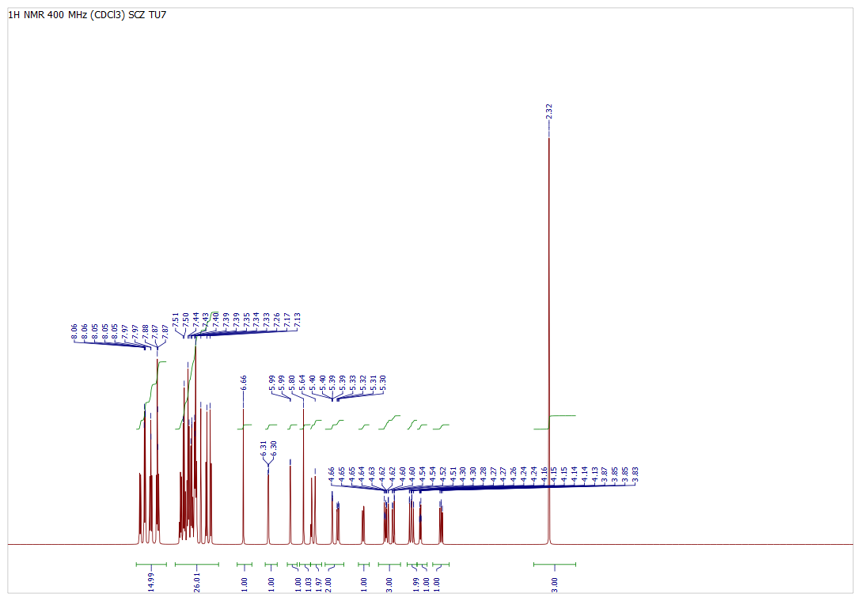
¹H NMR OF COMPOUND 3n

¹H NMR of 1- hepta-O-benzoyl-β-D-lactosyl-5-phenyl benzothiazolyl thiocarbamides (3o): ¹H NMR (400 MHz, CDCl₃) δ :– 3.70 (t, 1H), 4.28- 5.69 (m, 11H), 5.99 (d, 1H), 6.07 (d, 1H), 8.10 (s, 1H), 8.62 (s, 1H), 7.26-8.62 (m, 39 H).

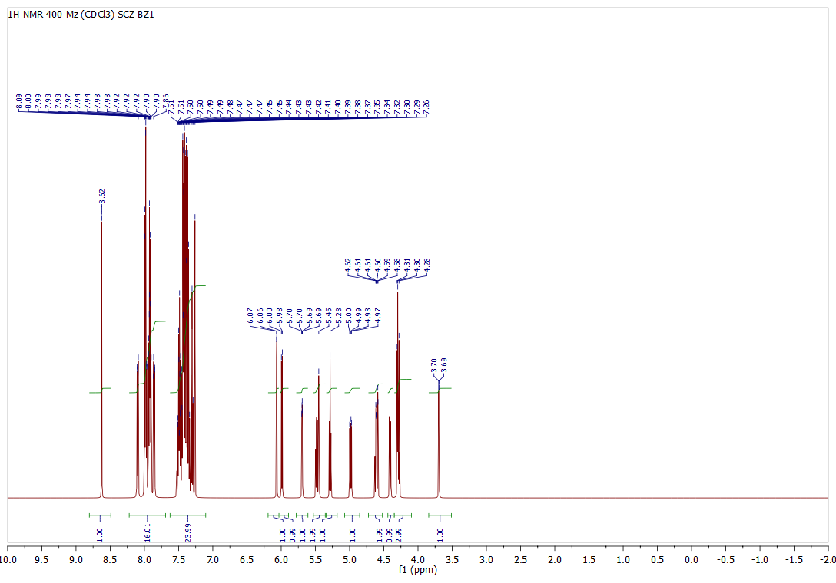
¹H NMR OF COMPOUND 3o
¹H NMR of 1- hepta-O-benzoyl-β-D-lactosyl-5-o-chlorophenyl benzothiazolyl thiocarbamides (3p): ¹H NMR (400 MHz, CDCl₃) δ :– 3.60 (t, 1H), 4.09- 5.65 (m, 11H), 5.99 (d, 1H), 6.02 (d, 1H), 7.64 (s, 1H), 8.41 (s, 1H), 7.26-8.41 (m, 38 H).

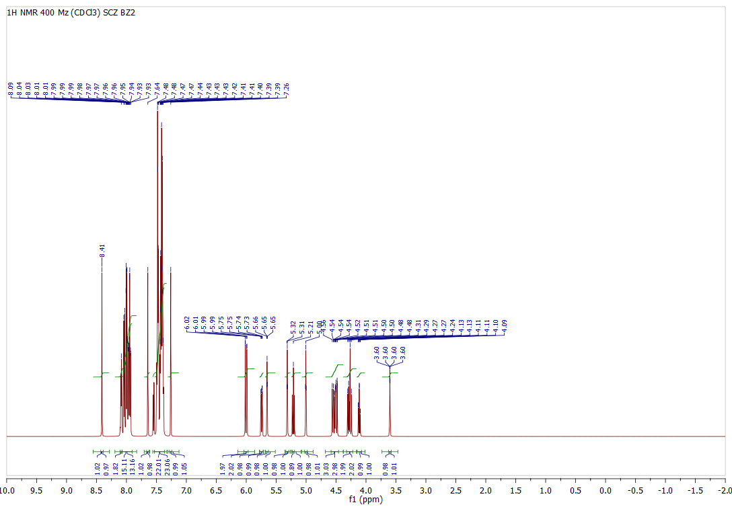
¹H NMR OF COMPOUND 3p
¹H NMR of 1- hepta-O-benzoyl-β-D-lactosyl-5-m-chlorophenyl benzothiazolyl thiocarbamides (3q): ¹H NMR (400 MHz, CDCl₃) δ :– 3.62 (t, 1H), 4.23- 5.82 (m, 11H), 5.99 (d, 1H), 6.13 (d, 1H), 7.85 (s, 1H), 8.94 (s, 1H), 7.39-8.91 (m, 38 H).

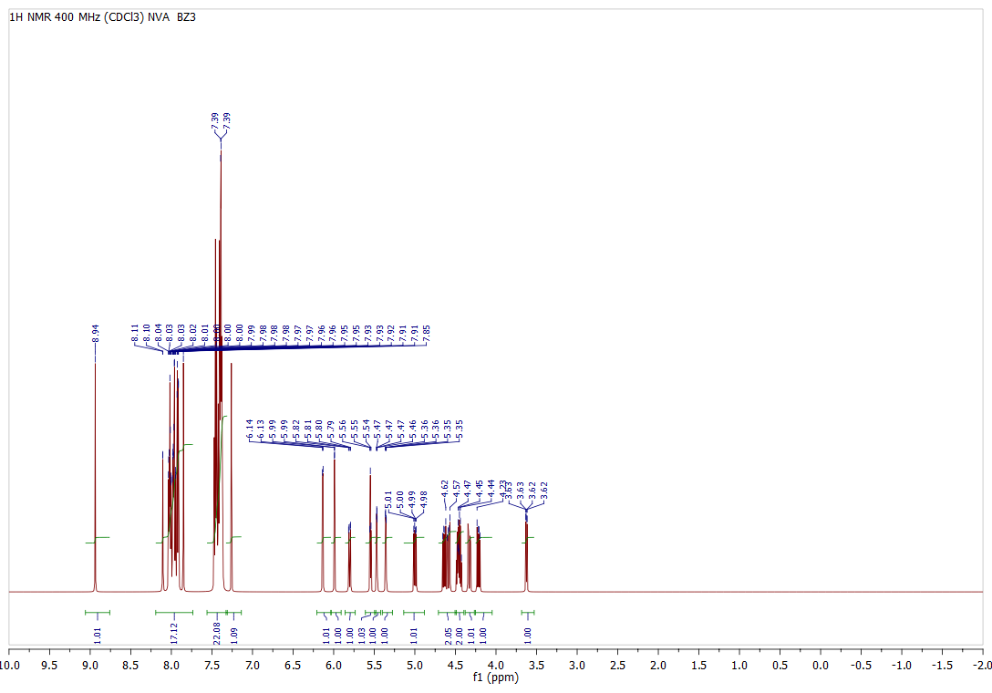¹H NMR OF COMPOUND 3q
¹H NMR of 1- hepta-O-benzoyl-β-D-lactosyl-5-p-chlorophenyl benzothiazolyl thiocarbamides (3r): ¹H NMR (400 MHz, CDCl₃) δ :– 3.59 (t, 1H), 4.23- 5.65 (m, 11H), 5.99 (d, 1H), 6.64 (d, 1H), 7.07 (s, 1H), 8.15 (s, 1H), 7.07-8.16 (m, 38 H).

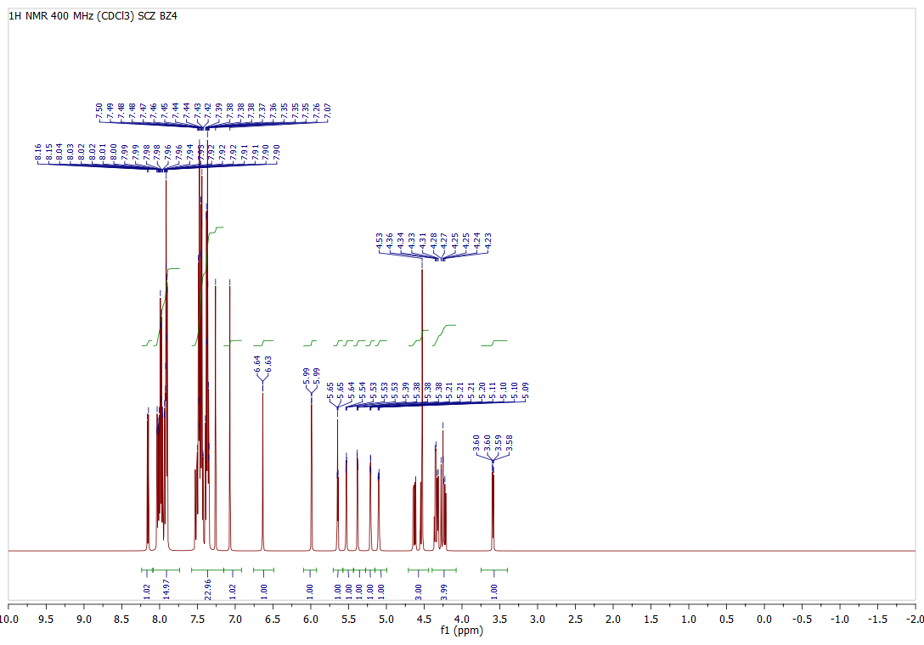
¹H NMR OF COMPOUND 3r

¹H NMR of 1- hepta-O-benzoyl-β-D-lactosyl-5-o-tolylbenzothiazolyl thiocarbamides (3s): ¹H NMR (400 MHz, CDCl₃) δ :– 2.70 (s, 3H), 3.84 (t, 1H), 4.31- 5.88 (m, 11H), 5.92(s, 1H), 5.99 (d, 1H), 6.46 (d, 1H), 7.55 (s, 1H), 7.26-8.02 (m, 41 H).

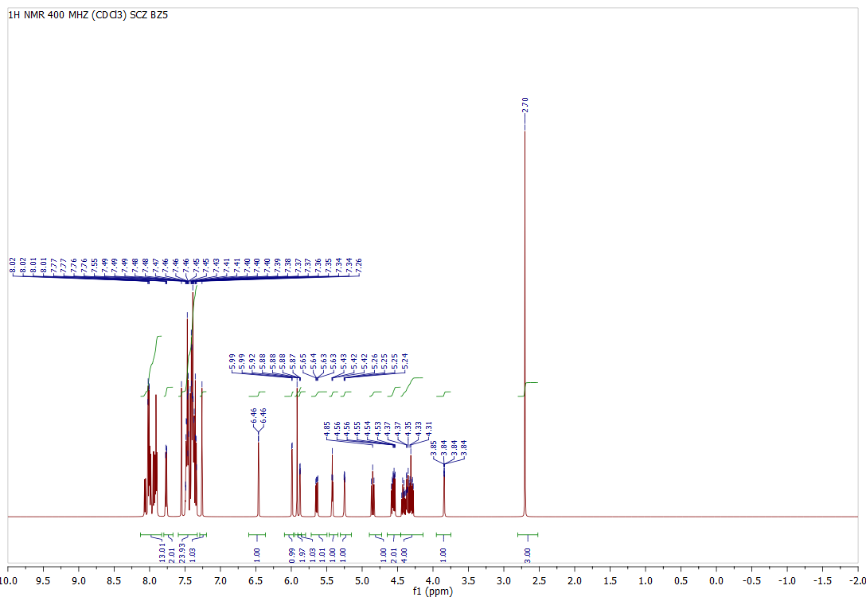
¹H NMR OF COMPOUND 3s

¹H NMR of 1- hepta-O-benzoyl-β-D-lactosyl-5-m-tolylbenzothiazolyl thiocarbamides (3t): ¹H NMR (400 MHz, CDCl₃) δ :– 2.47 (s, 3H), 3.89 (t, 1H), 4.32- 5.76 (m, 11H), 5.99 (d, 1H), 6.00 (s, 1H), 6.66 (d, 1H), 6.82 (s, 1H), 7.26-8.07 (m, 41 H).

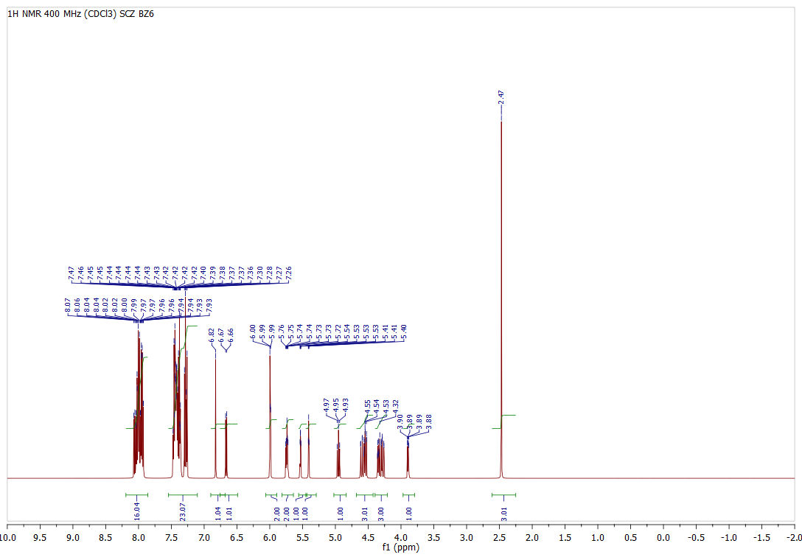
¹H NMR OF COMPOUND 3t

¹H NMR of 1- hepta-O-benzoyl-β-D-lactosyl-5-p-tolylbenzothiazolyl thiocarbamides (3u): ¹H NMR (400 MHz, CDCl₃) δ :– 2.43 (s, 3H), 3.34 (t, 1H), 4.23- 5.70 (m, 11H), 5.99 (d, 1H), 6.29 (d, 1H), 7.74 (s, 1H), 7.93 (s, 1H), 7.26-8.03 (m, 41 H).
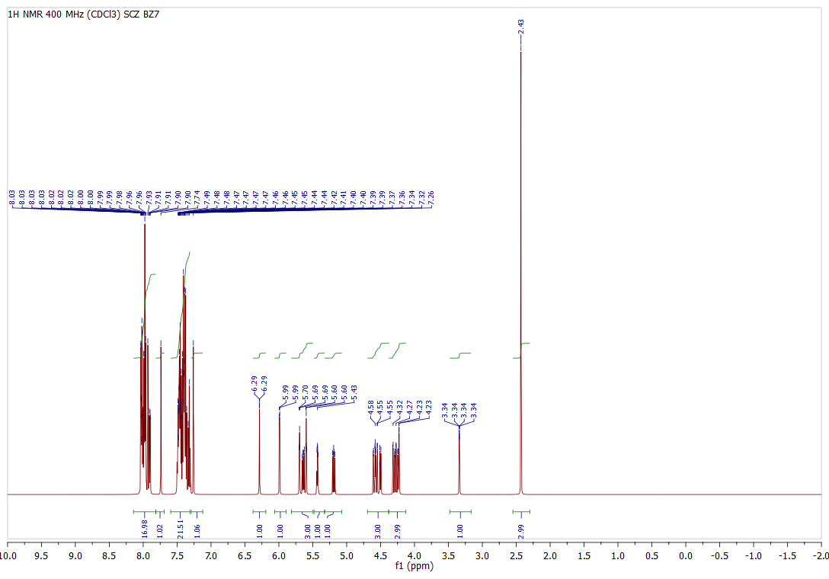
¹H NMR OF COMPOUND 3u
- Images of Zone of Inhibition studies
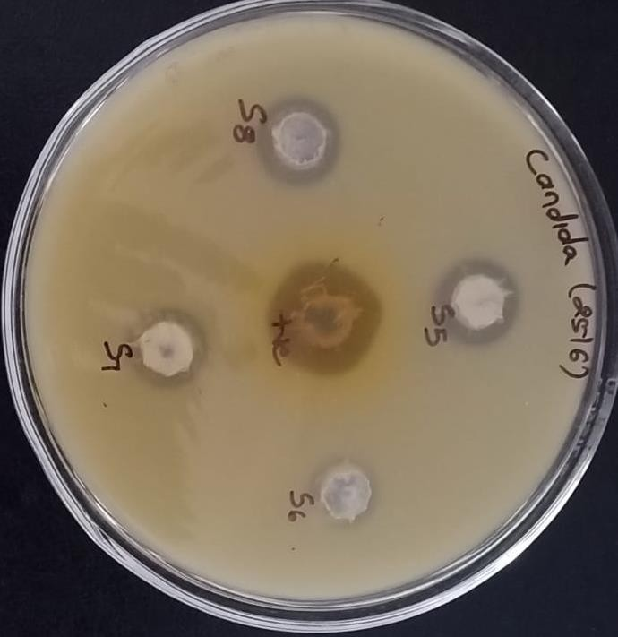
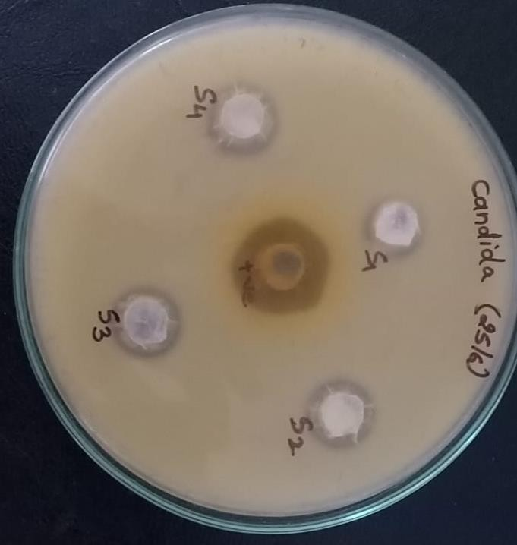
Figure.2 - Plate 22: Samples – S5, S6, S7 and S8 against Candida albicans
Figure.1 - Plate 21: Samples – S1, S2, S3 and S4 against Candida albicans

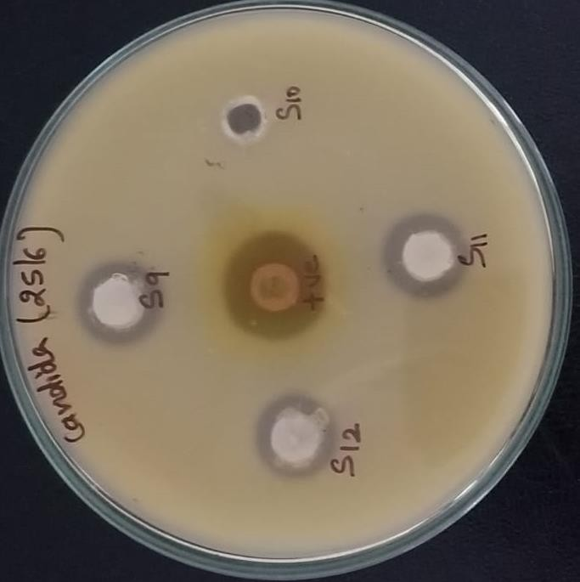
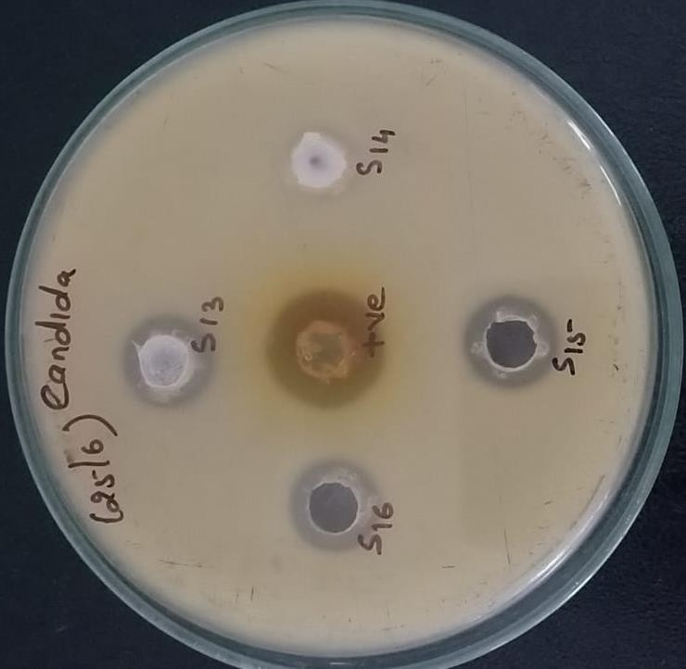

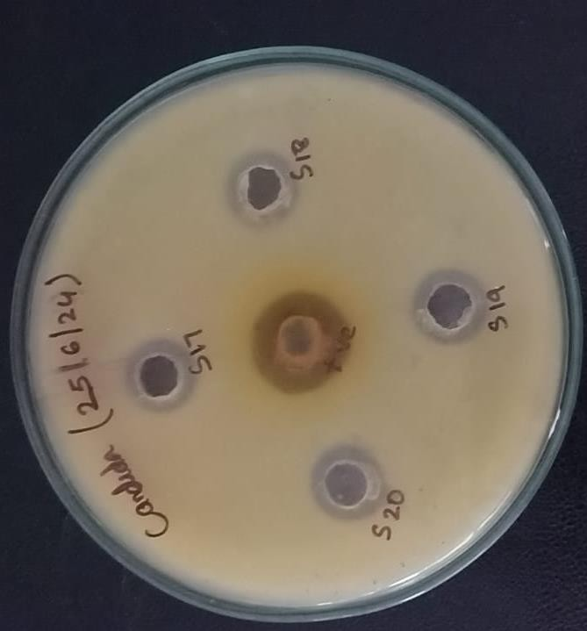
Figure.5 - Plate 25: Samples – S17, S18, S19 and S20 against Candida albicans
Figure.4 - Plate 24: Samples – S13, S14, S15 and S16 against Candida albicans
Figure.3 - Plate 23: Samples – S9, S10, S11 and S12 against Candida albicans
- Images of MIC study of synthesized NPs using REMA (resazurin microtiter plate assay)
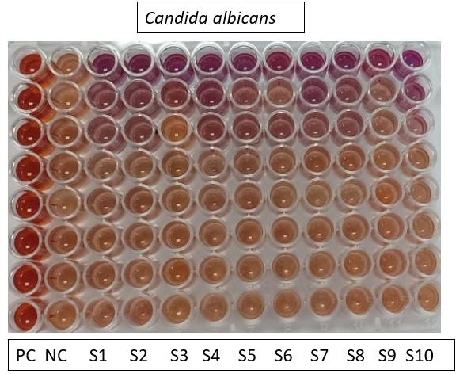
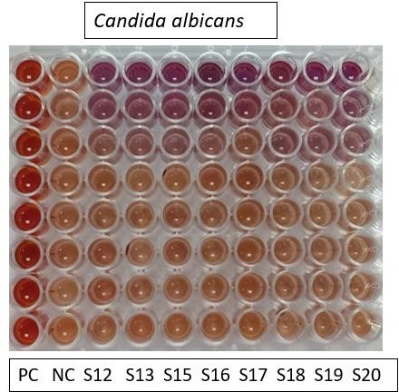

References:
- Nanaware, RB; Chabukswar, AR; Rokade, DD; Jain, PH; ‘In silico screening of antitubercular and anti-Inflammatory activity of indazole based natural alkaloids and a novel indazole derivative’. J. Pharm. Negat. Results 2022, 13, 647–655
- Pawar, RP; Rohane, SH; ‘Role of autodock vina in PyRx molecular docking.’ 2021, 132-134

